Apache Jena  
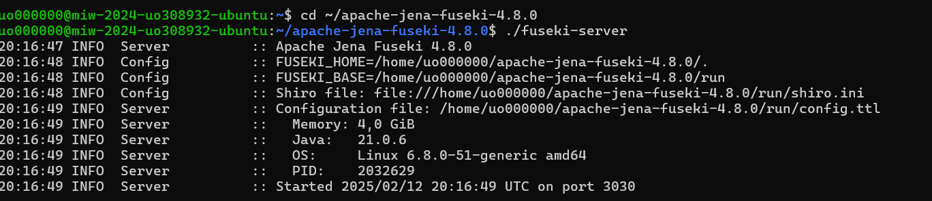

Datos cargados

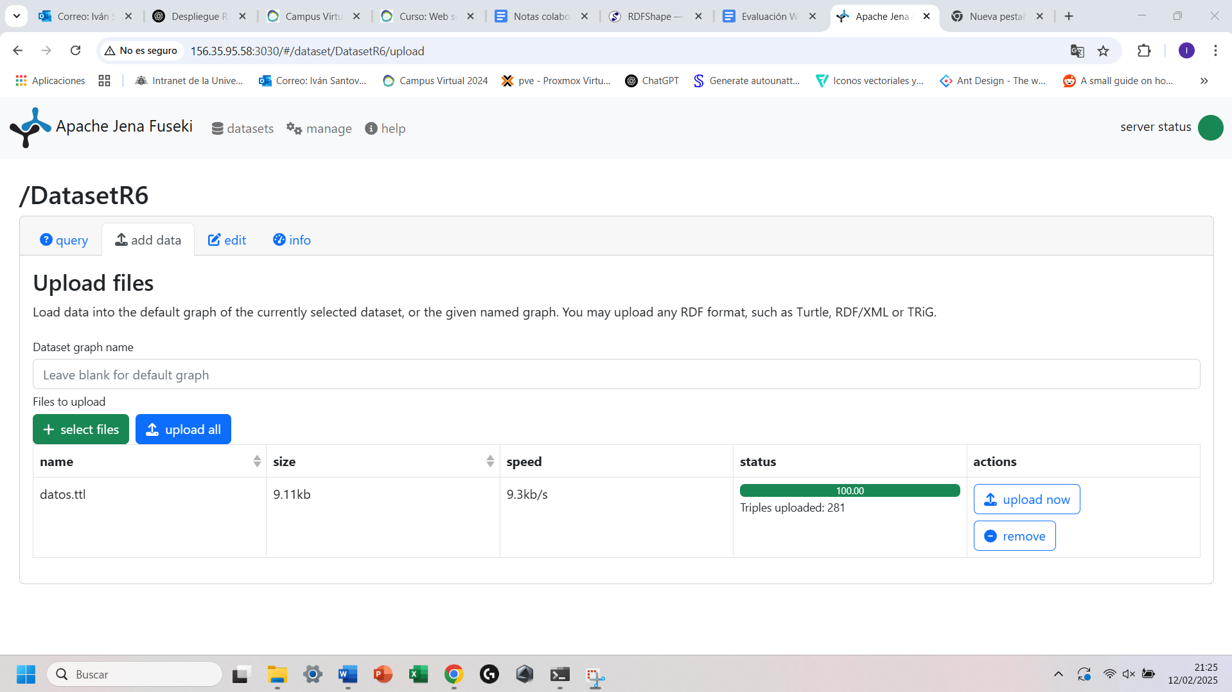

Querys:  
Query1:

PREFIX rdfs: <http://www.w3.org/2000/01/rdf-schema#>

PREFIX ex: <http://example.org/characters/>

SELECT ?character ?role WHERE {

?character ex:Role ?role .

}

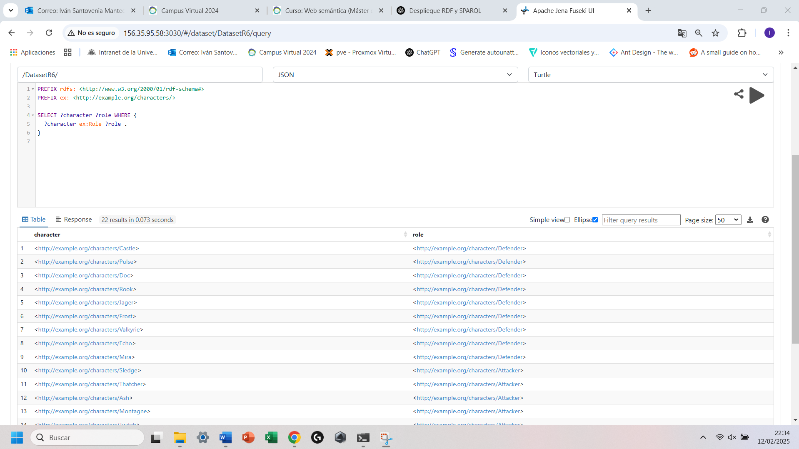

Query2:

PREFIX rdfs: <http://www.w3.org/2000/01/rdf-schema#>

PREFIX ex: <http://example.org/characters/>

SELECT ?character WHERE {

?character ex:Country ex:France .

}

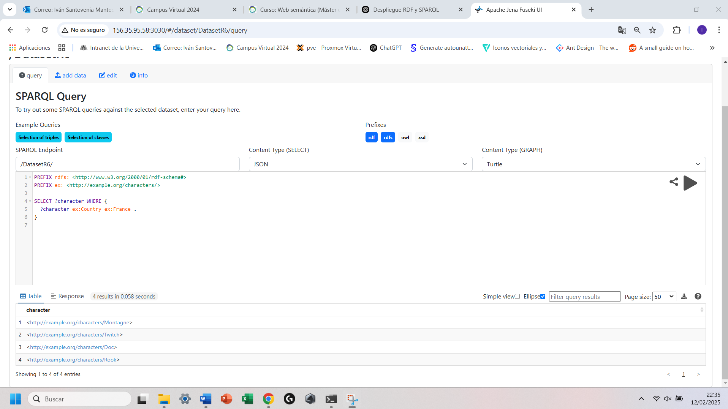

Query3:

PREFIX ex: <http://example.org/characters/>

PREFIX xsd: <http://www.w3.org/2001/XMLSchema#>

SELECT ?character WHERE {

?character ex:Armor "3"^^xsd:integer .

}

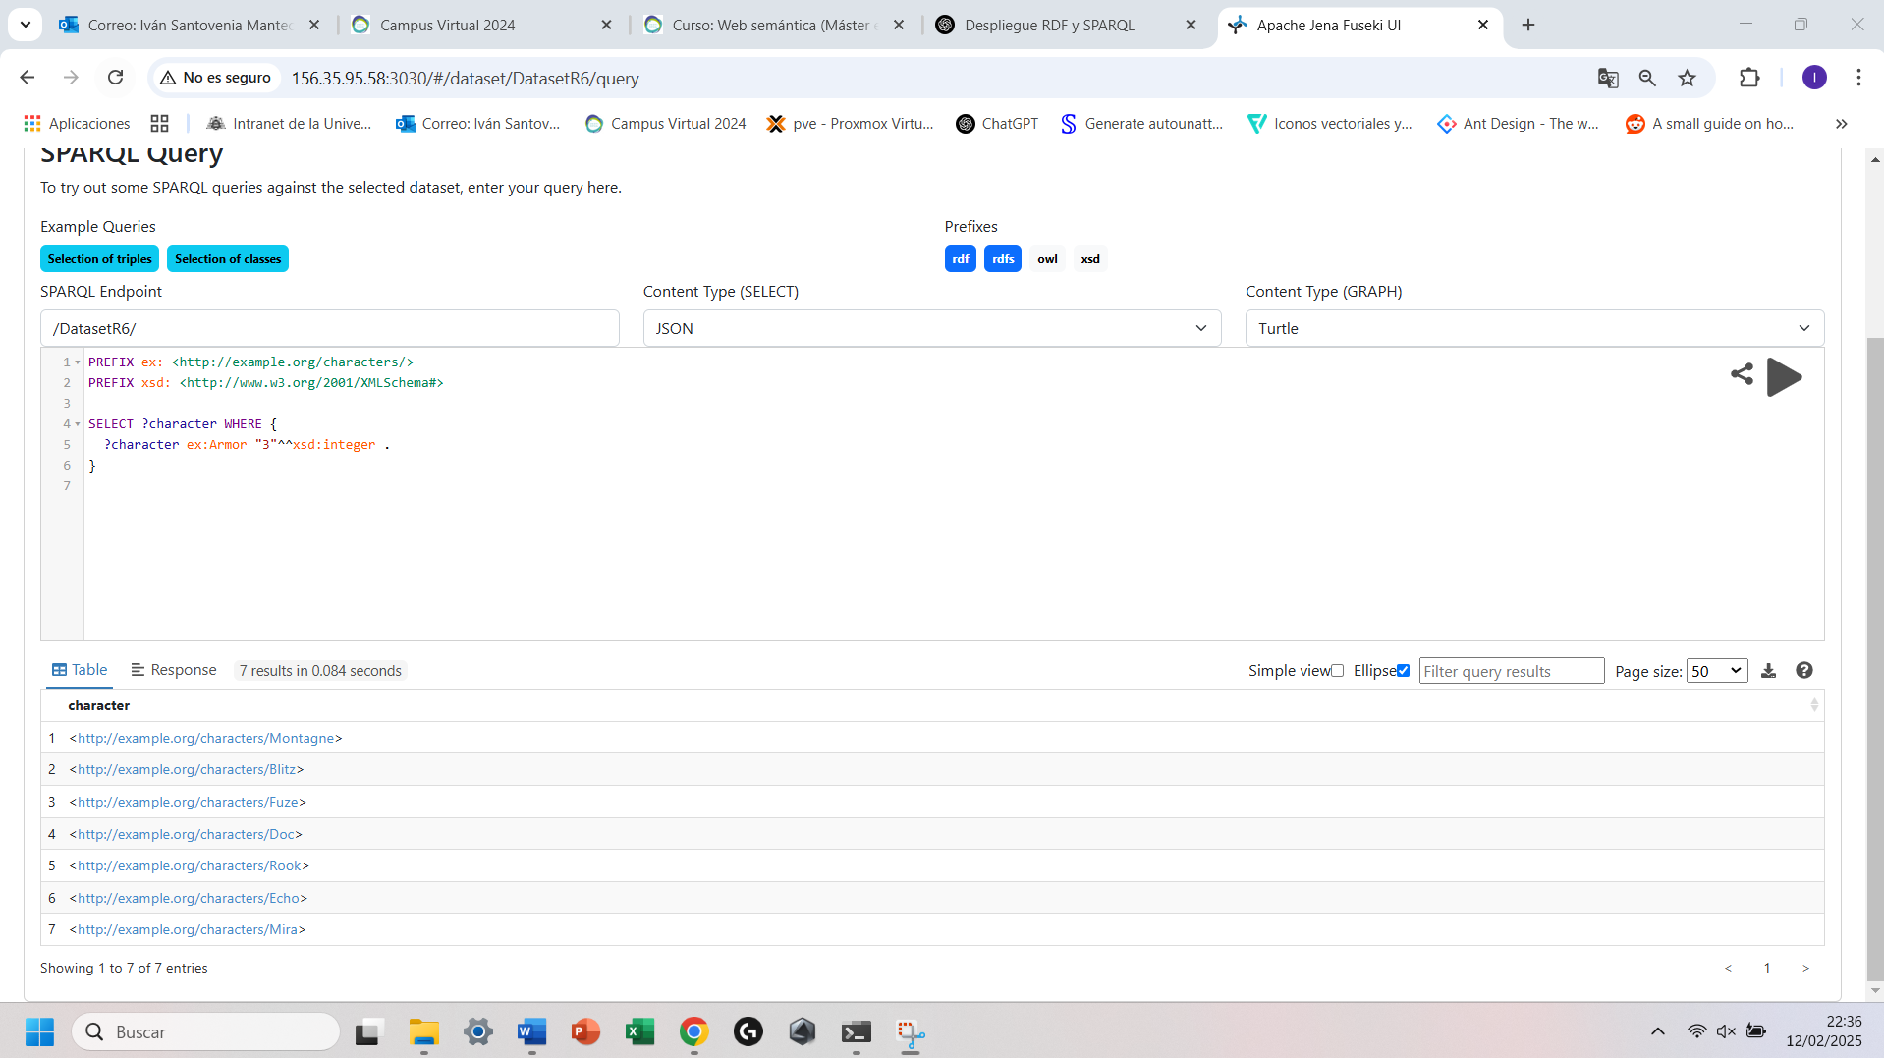

Query4:

PREFIX ex: <http://example.org/characters/>

PREFIX xsd: <http://www.w3.org/2001/XMLSchema#>

SELECT ?character WHERE {

?character ex:Speed "3"^^xsd:integer .

}

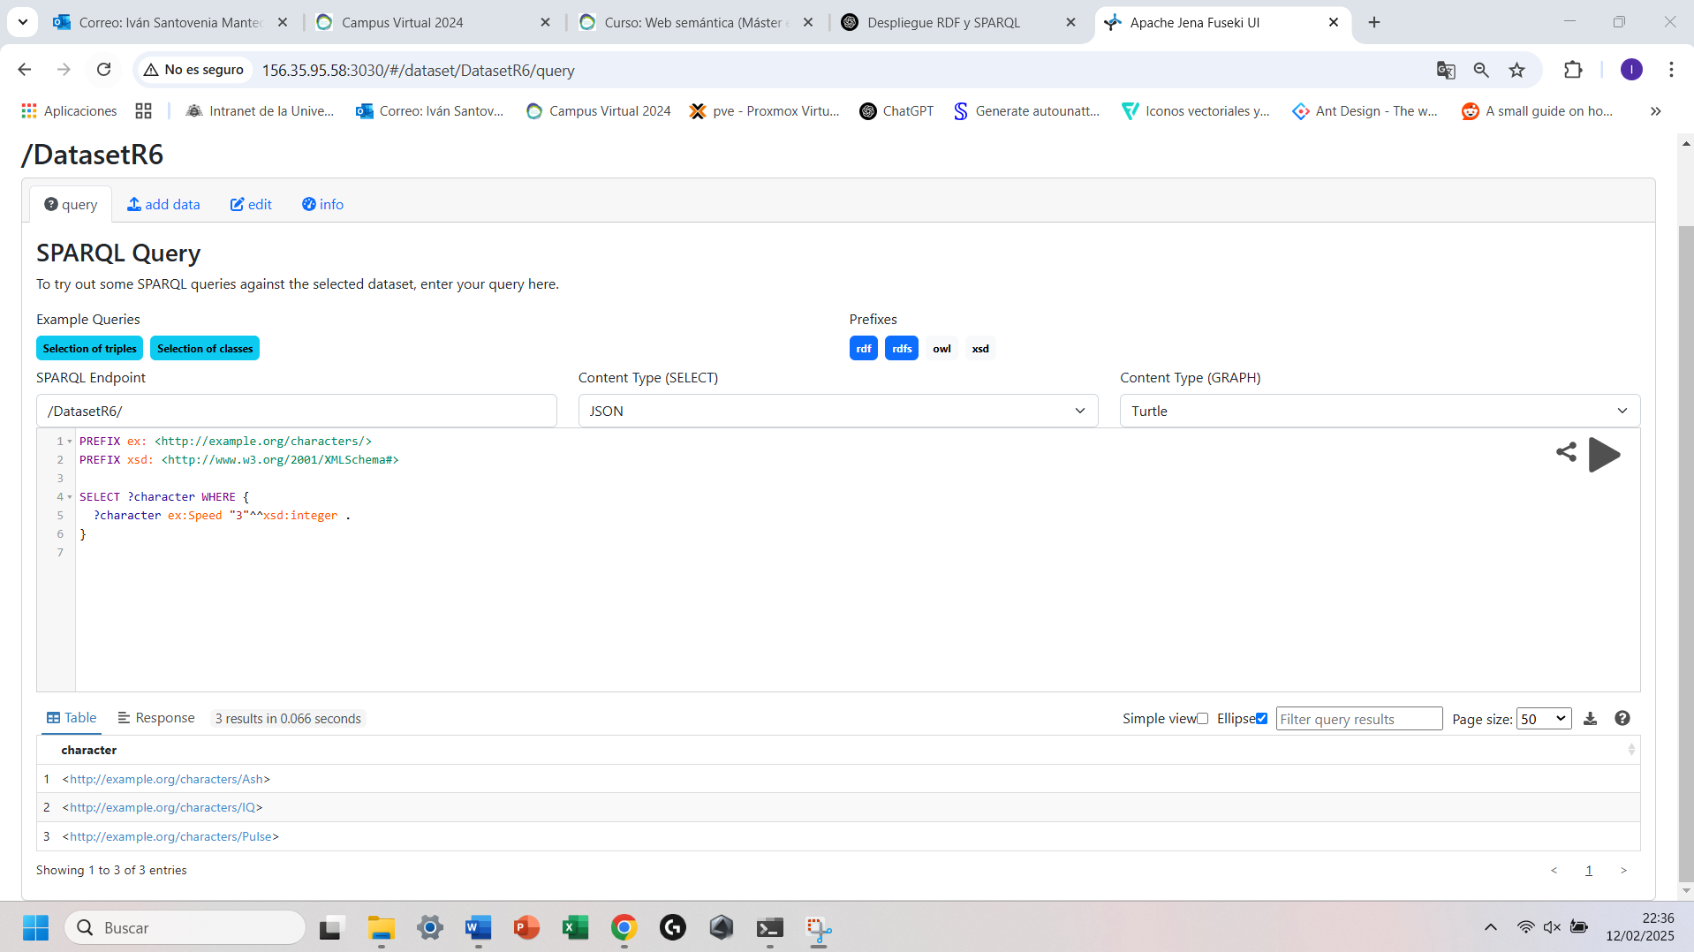

Ejemplo con Python desde mi maquina al servidor en la maquina virtual:

Codigo Python:

from SPARQLWrapper import SPARQLWrapper, JSON  
  
# URL del endpoint SPARQL  
sparql = SPARQLWrapper("http://156.35.95.58:3030/DatasetR6/query")  
  
# Consulta SPARQL  
query = """  
PREFIX ex: <http://example.org/characters/>  
PREFIX xsd: <http://www.w3.org/2001/XMLSchema#>  
  
SELECT ?character WHERE {  
 ?character ex:Speed "3"^^xsd:integer .  
}  
"""  
  
# Configurar la consulta  
sparql.setQuery(query)  
sparql.setReturnFormat(JSON)  
  
# Ejecutar la consulta y obtener resultados  
results = sparql.query().convert()  
  
# Imprimir resultados  
print("Resultados de la consulta SPARQL:")  
for result in results["results"]["bindings"]:  
 print(result["character"]["value"])

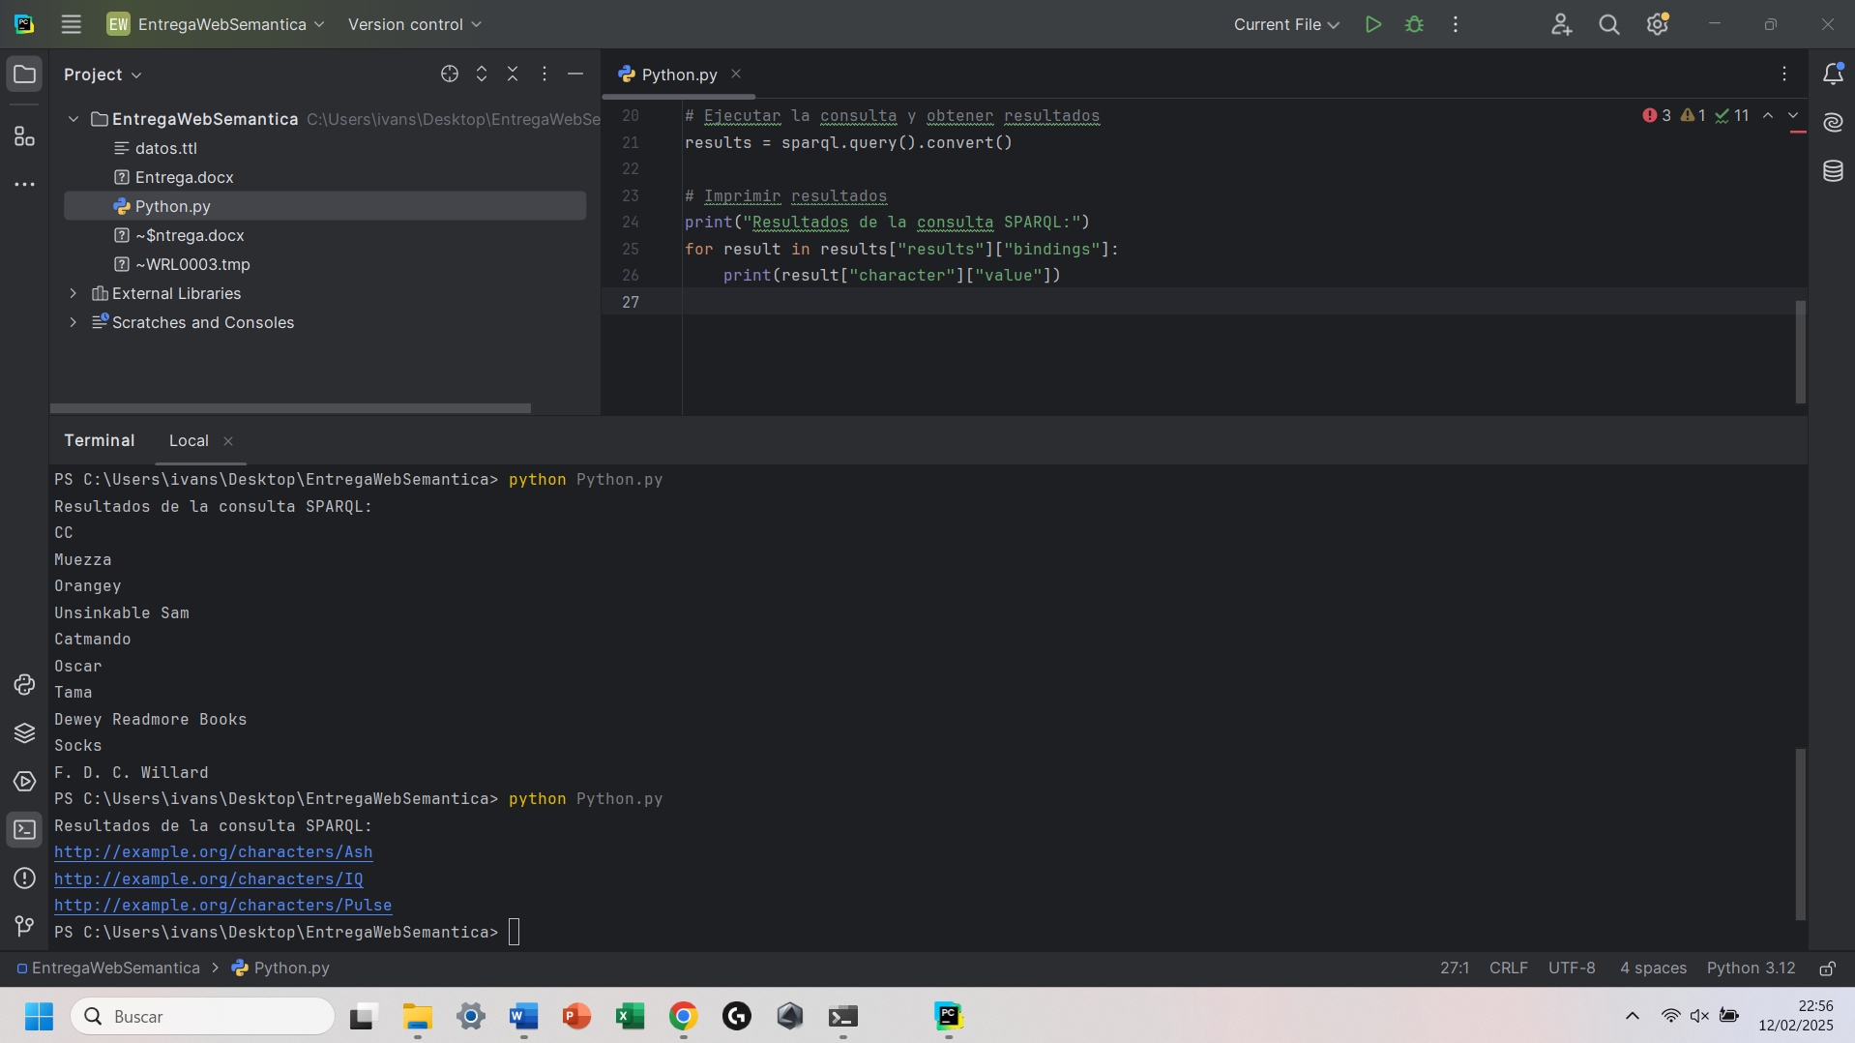

Query5:

PREFIX ex: <http://example.org/characters/>

SELECT ?gadget WHERE {

ex:Twitch ex:Gadget ?gadget .

}

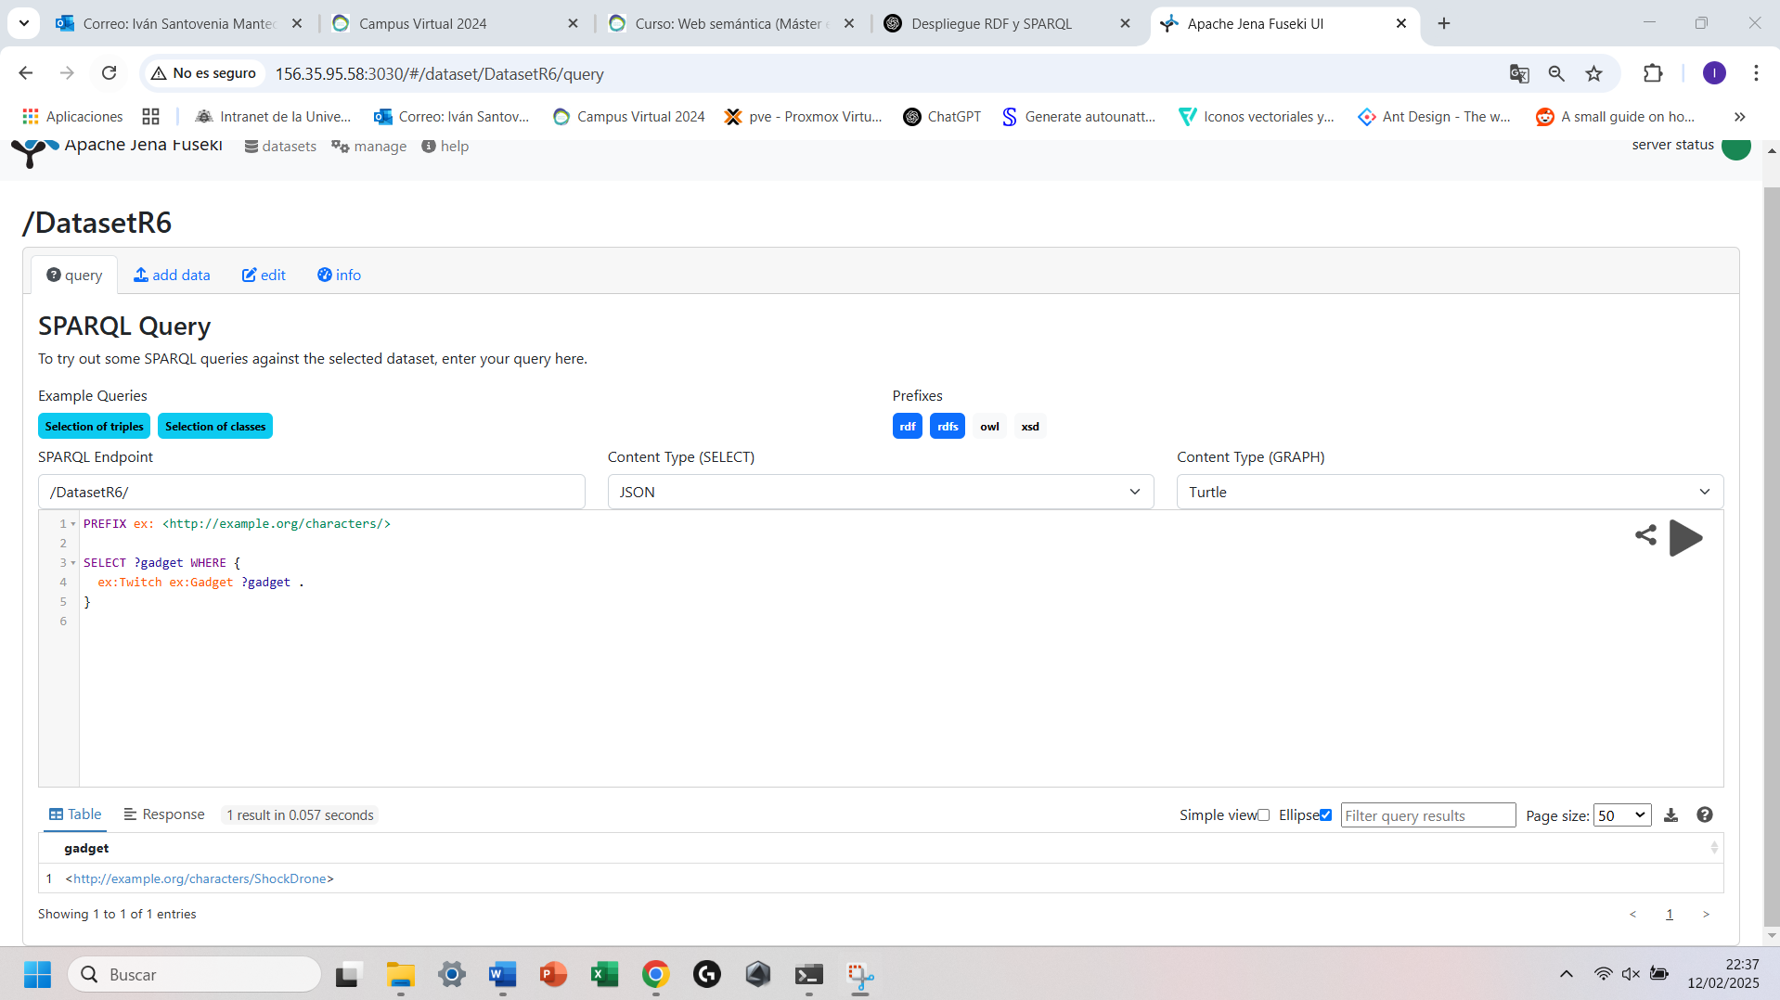

Query6:

PREFIX ex: <http://example.org/characters/>

SELECT ?character WHERE {

?character ex:Team ex:GIGN .

}

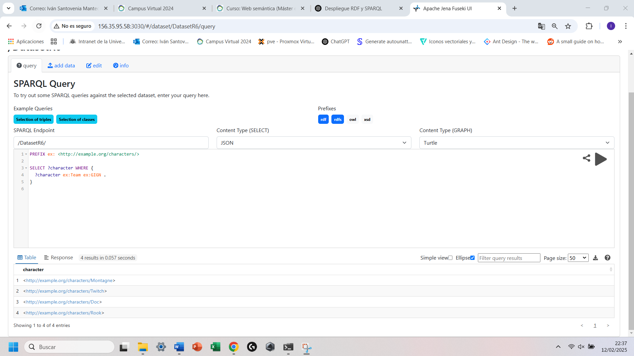

Querys Federadas:

Query1:

PREFIX wd: <http://www.wikidata.org/entity/>

PREFIX wdt: <http://www.wikidata.org/prop/direct/>

PREFIX rdfs: <http://www.w3.org/2000/01/rdf-schema#>

PREFIX ex: <http://example.org/characters/>

SELECT ?operatorName ?releaseDate WHERE {

SERVICE <https://query.wikidata.org/sparql> {

wd:Q17183996 wdt:P577 ?releaseDate.

}

?operator rdfs:label ?operatorName .

FILTER(LANG(?operatorName) = "en")

FILTER(?operatorName != "Male"@en && ?operatorName != "Female"@en) # Excluir géneros

}

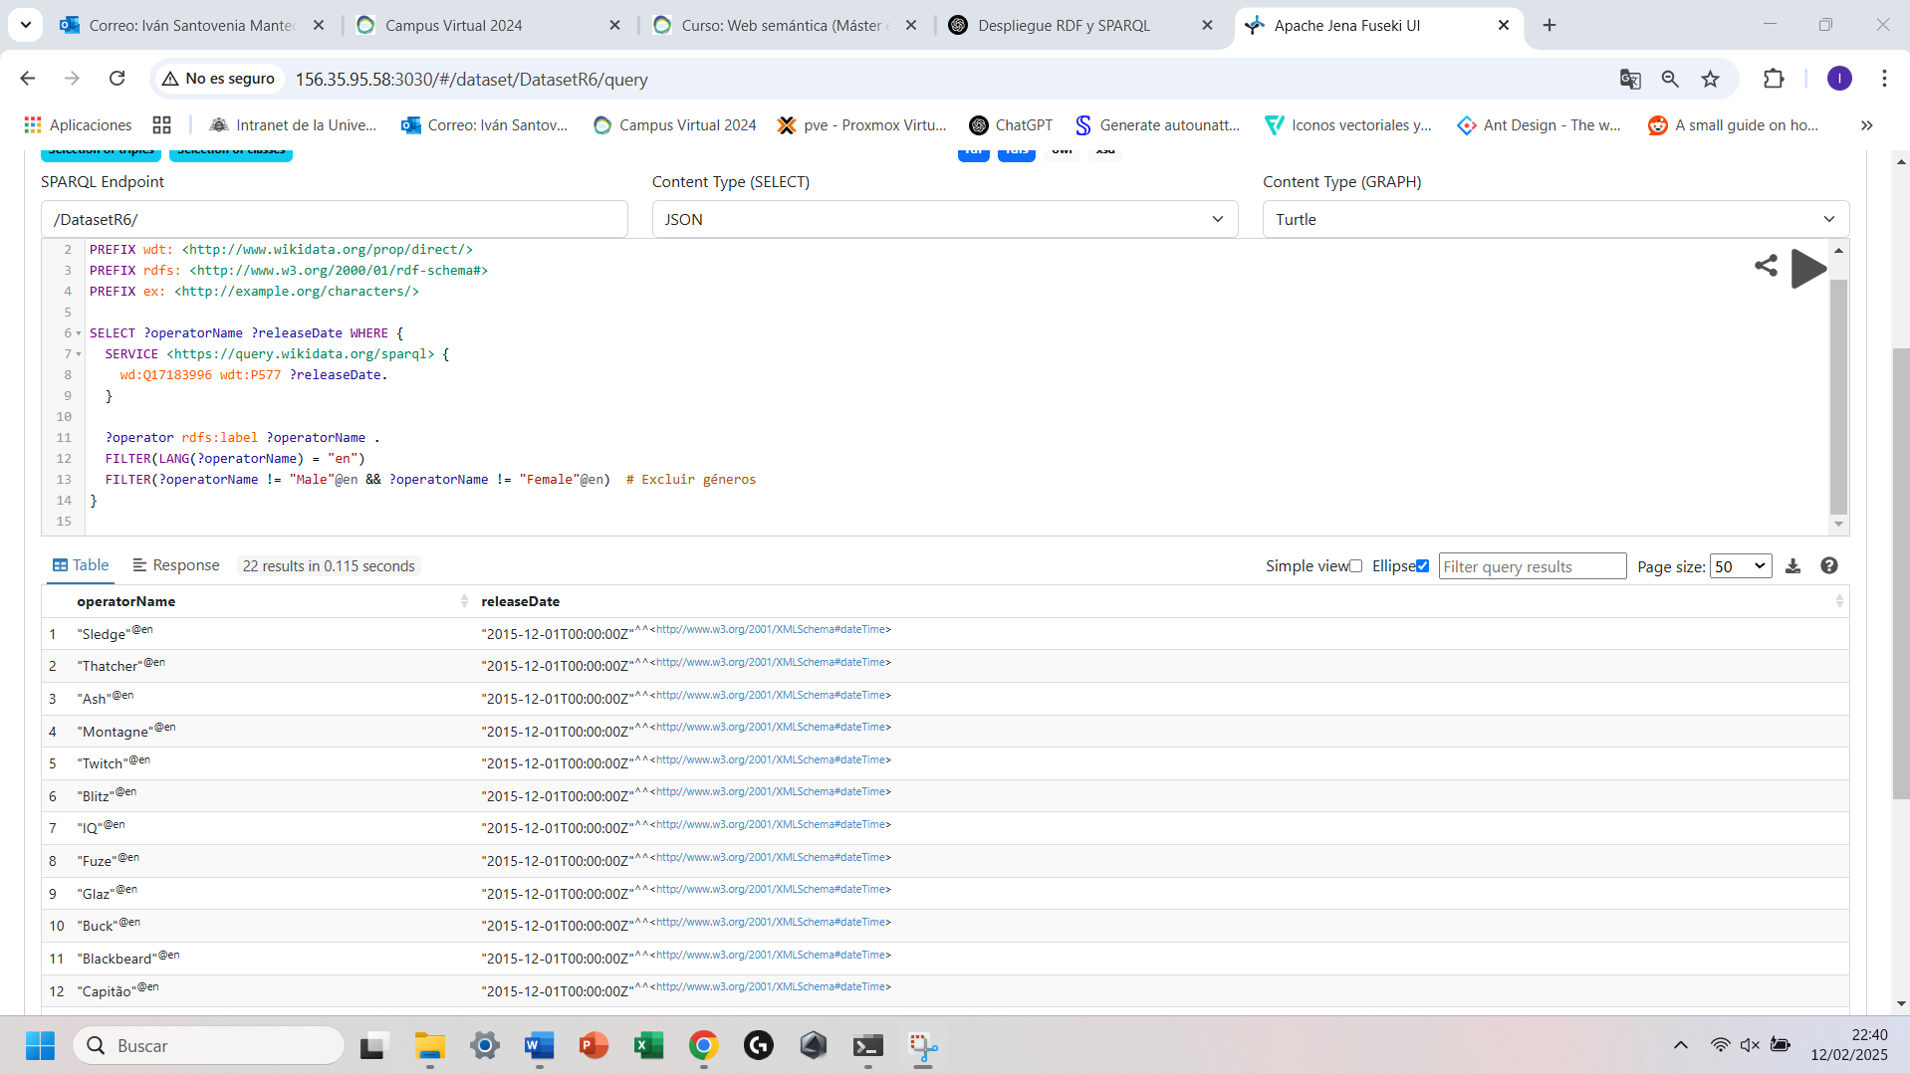

Query2:

PREFIX rdfs: <http://www.w3.org/2000/01/rdf-schema#>

PREFIX ex: <http://example.org/characters/>

PREFIX wd: <http://www.wikidata.org/entity/>

PREFIX wdt: <http://www.wikidata.org/prop/direct/>

SELECT ?operator ?name ?countryLabel WHERE {

?operator rdfs:label ?name ;

ex:Country ?country .

# Mapeo manual de los identificadores locales a Wikidata

VALUES (?country ?wikidataCountry) {

(ex:UnitedKingdom wd:Q145)

(ex:UnitedStates wd:Q30)

(ex:France wd:Q142)

(ex:Germany wd:Q183)

(ex:Russia wd:Q159)

(ex:Canada wd:Q16)

(ex:Brazil wd:Q155)

(ex:Spain wd:Q29)

}

# Consulta federada a Wikidata

SERVICE <https://query.wikidata.org/sparql> {

?wikidataCountry rdfs:label ?countryLabel .

FILTER (LANG(?countryLabel) = "en")

}

}

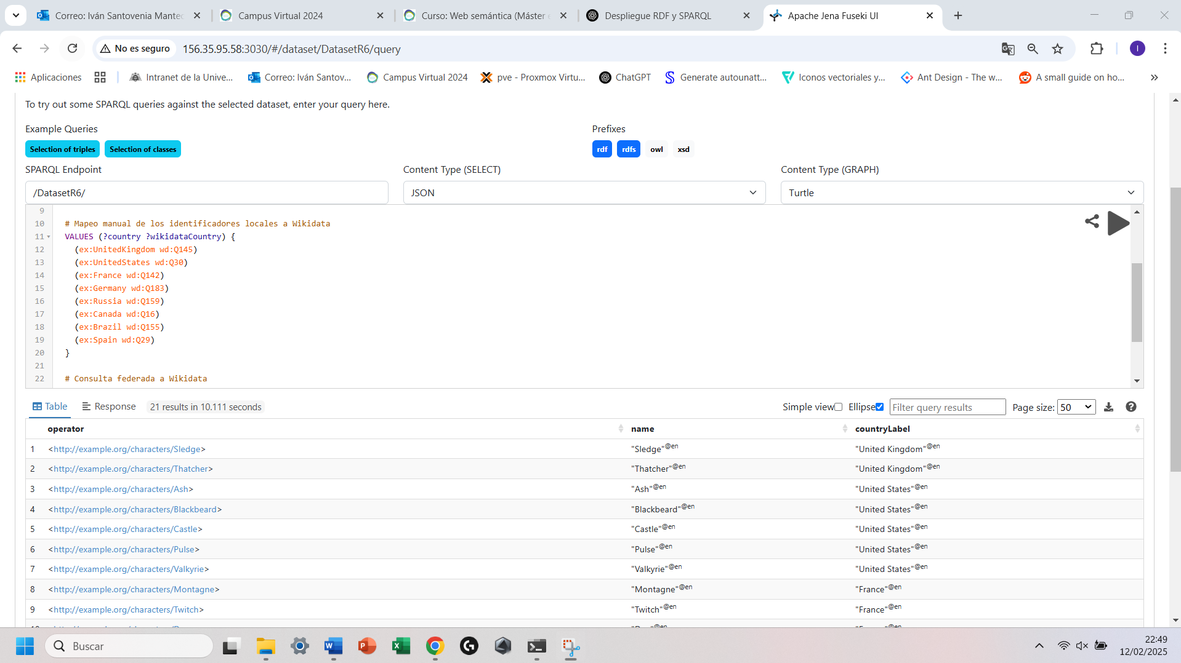

Virtuoso:  
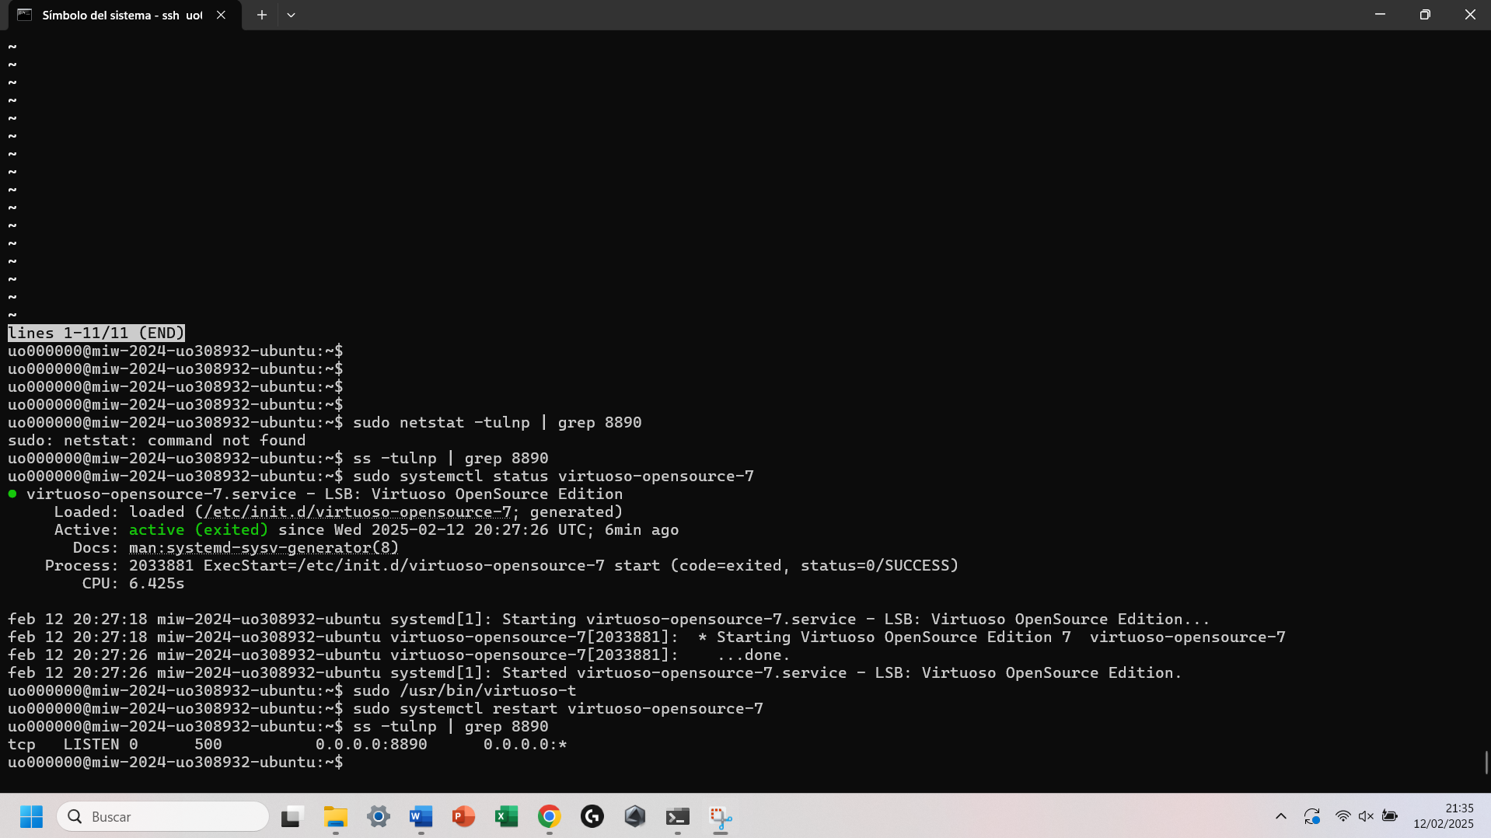

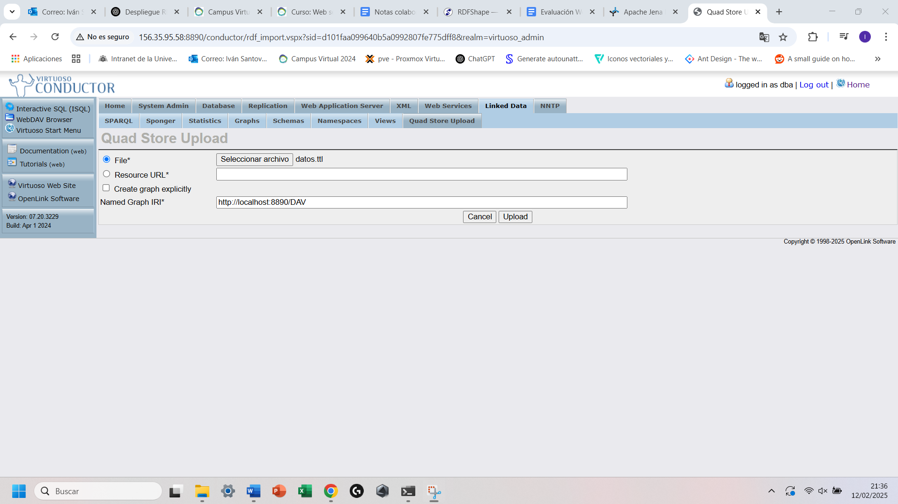

Ejemplo Query:

