Apache Jena
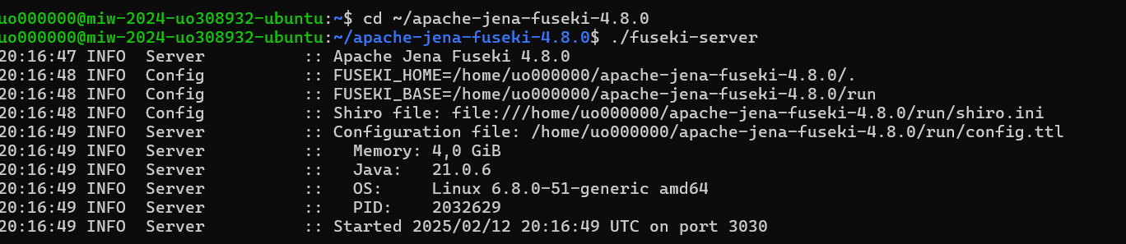
Datos cargados
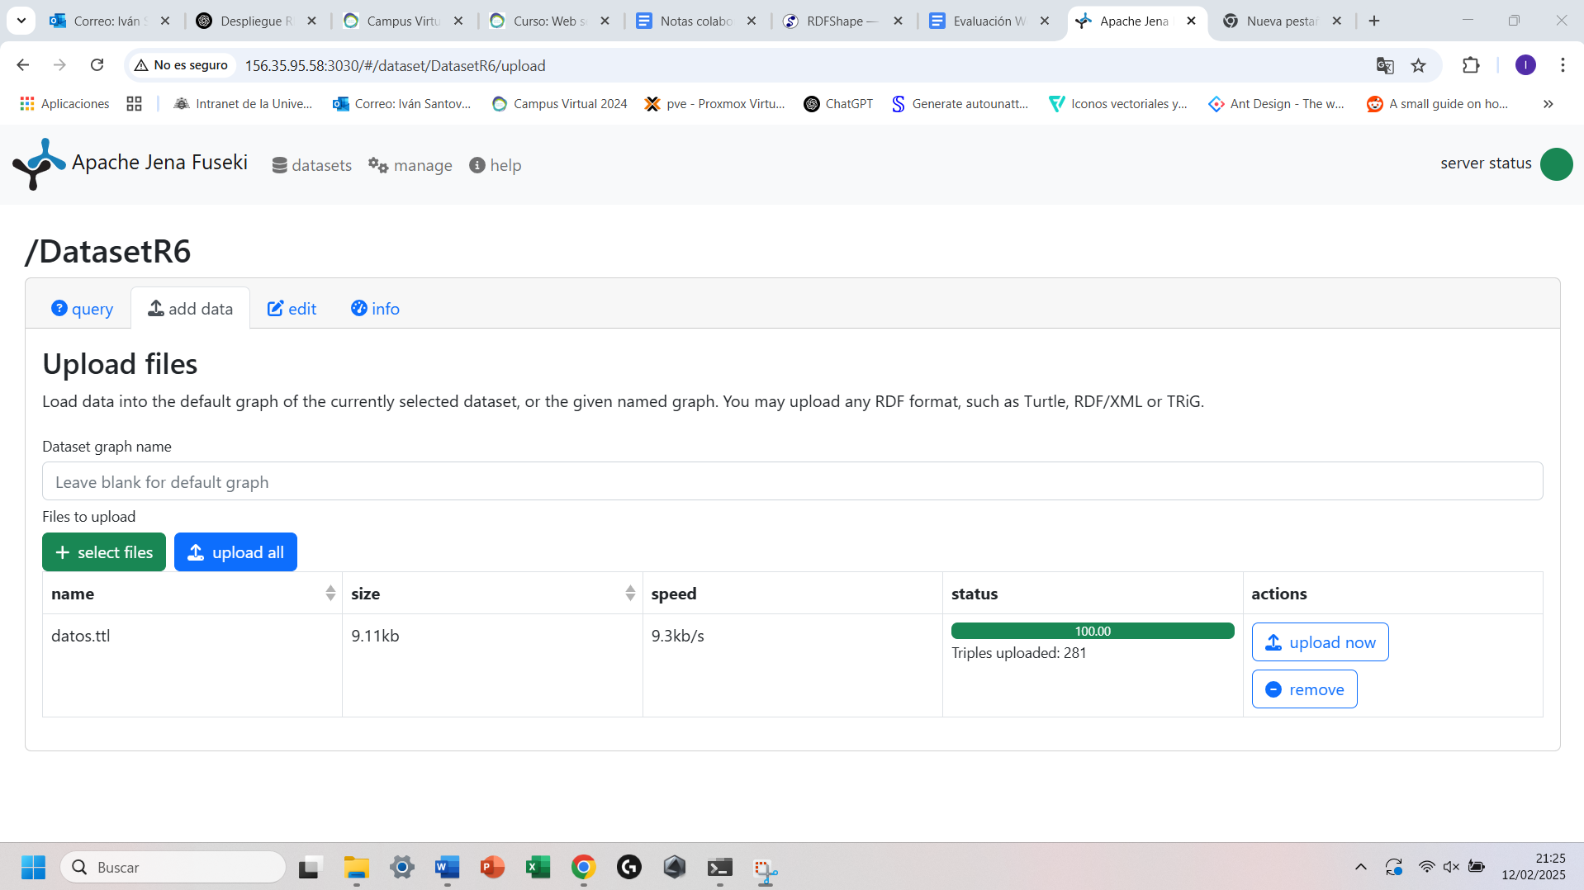
Querys:
Query1:
PREFIX rdfs: <http://www.w3.org/2000/01/rdf-schema#>
PREFIX ex: <http://example.org/characters/>

SELECT ?character ?role WHERE {
?character ex:Role ?role .
}
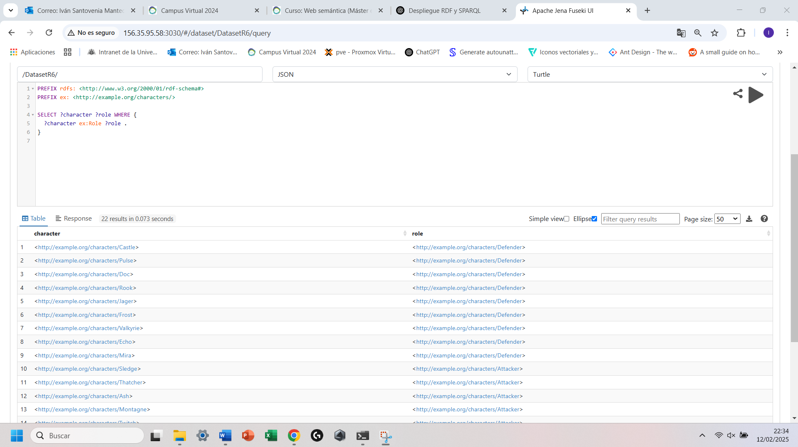
Query2:
PREFIX rdfs: <http://www.w3.org/2000/01/rdf-schema#>
PREFIX ex: <http://example.org/characters/>

SELECT ?character WHERE {
?character ex:Country ex:France .
}
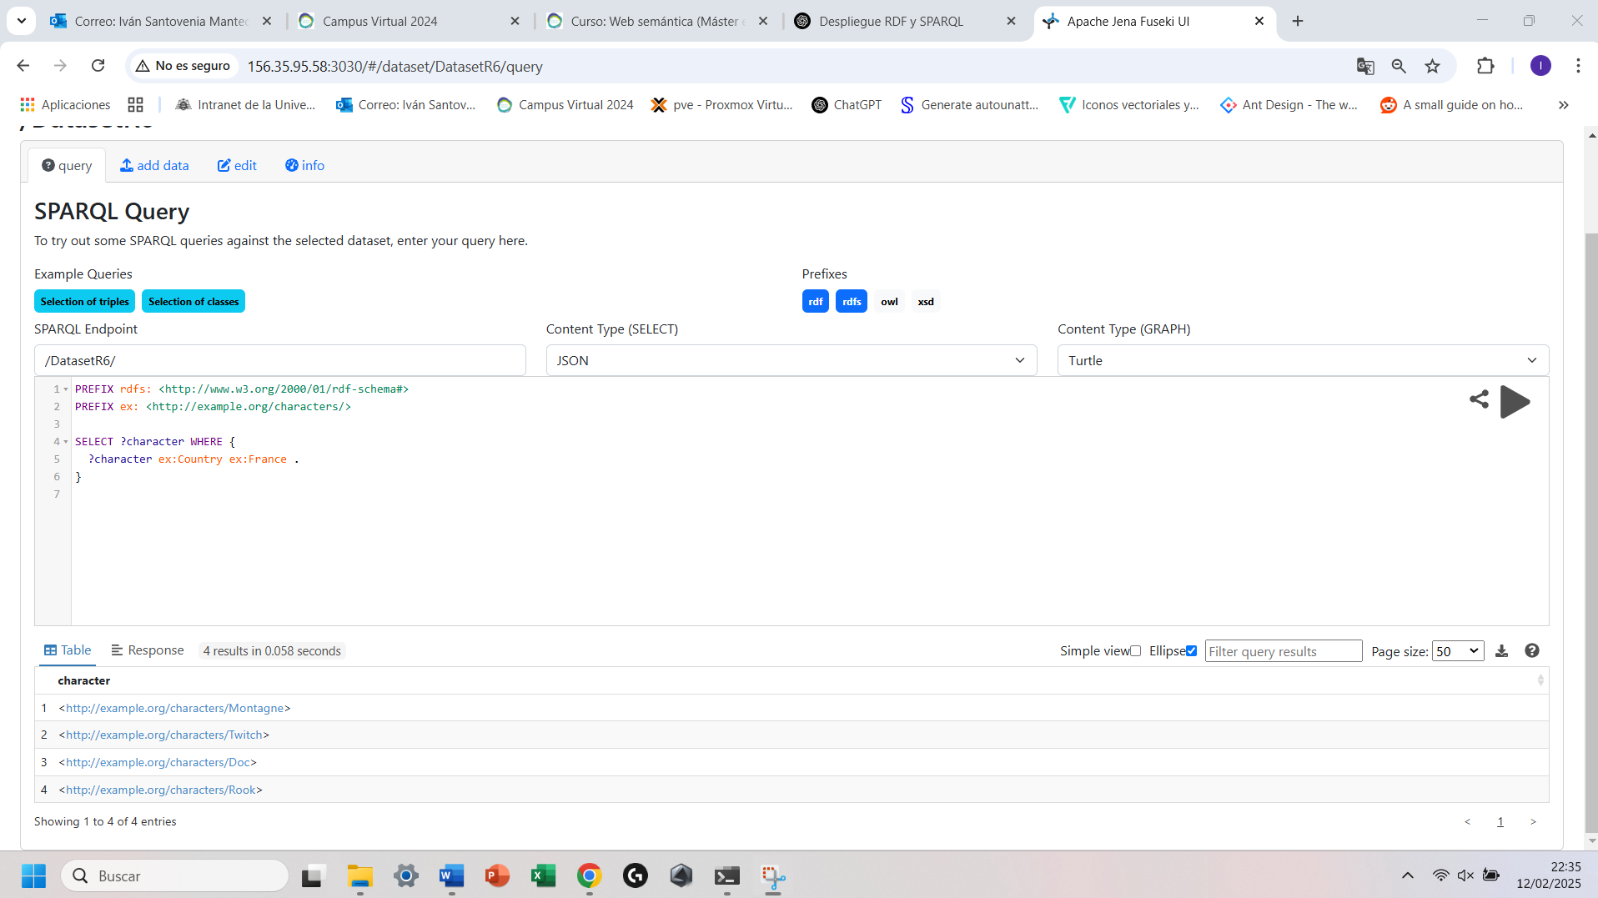
Query3:
PREFIX ex: <http://example.org/characters/>
PREFIX xsd: <http://www.w3.org/2001/XMLSchema#>

SELECT ?character WHERE {
?character ex:Armor "3"^^xsd:integer .
}
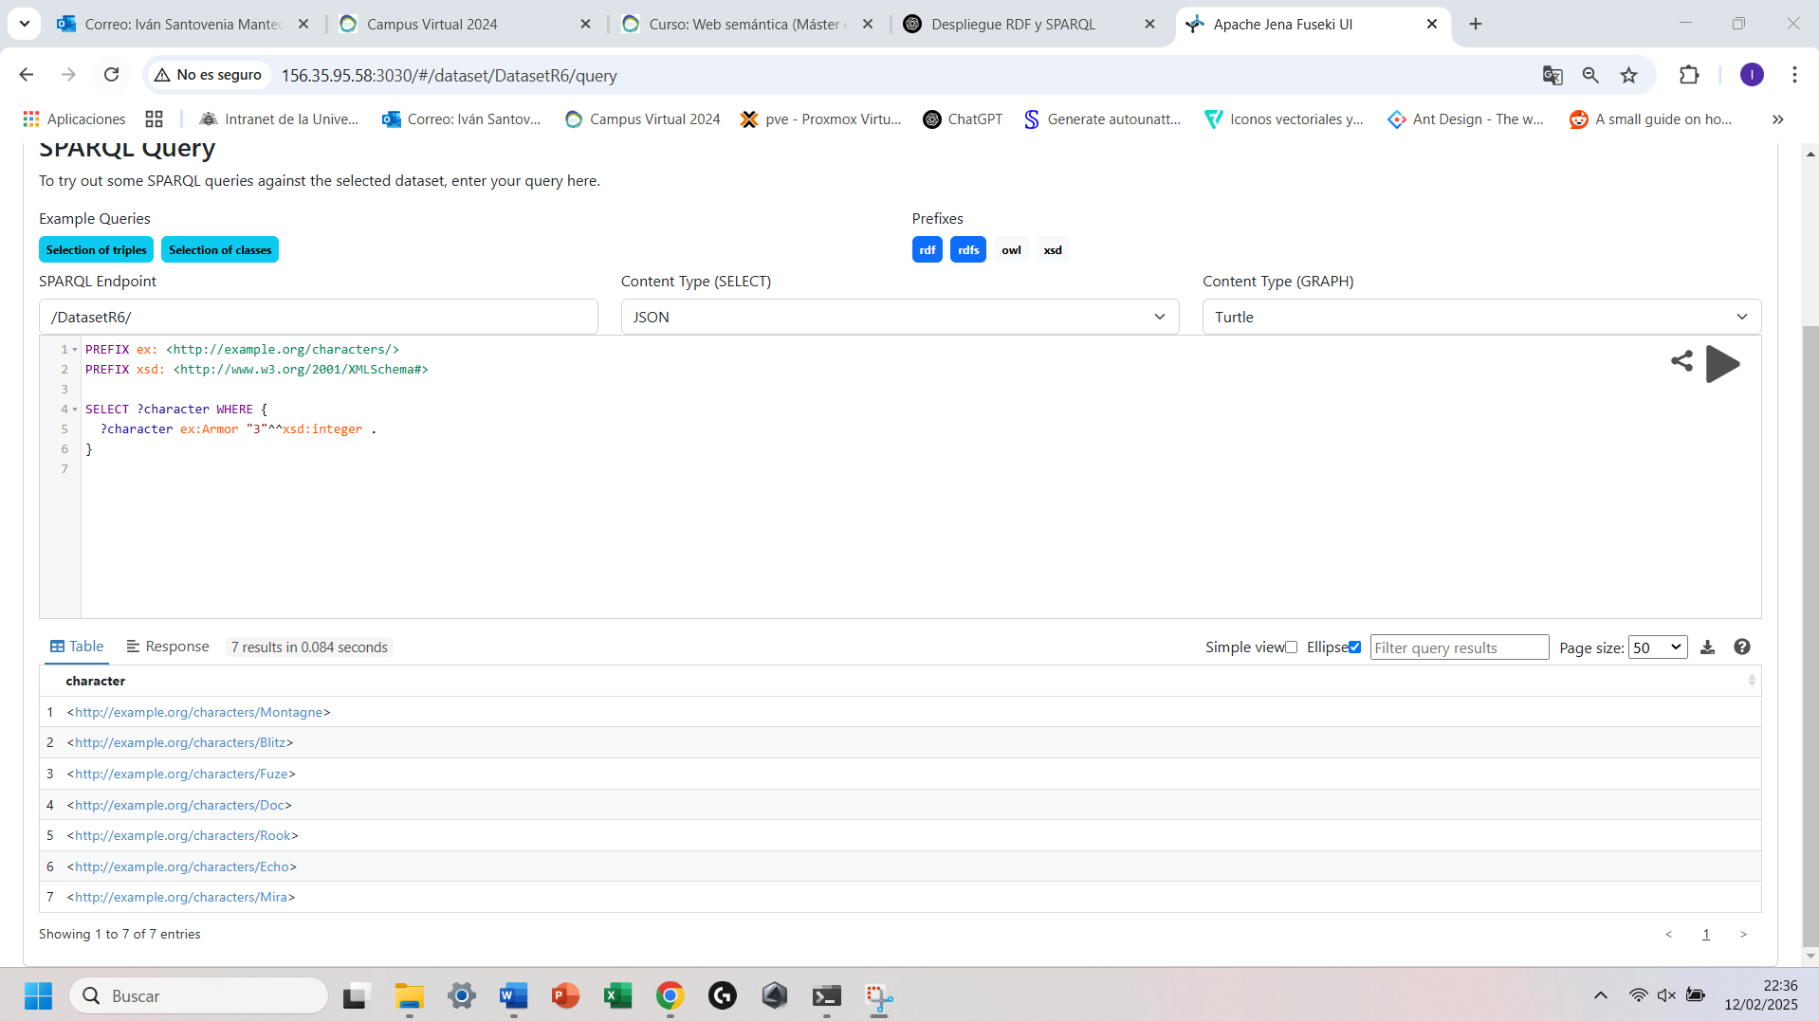
Query4:
PREFIX ex: <http://example.org/characters/>
PREFIX xsd: <http://www.w3.org/2001/XMLSchema#>

SELECT ?character WHERE {
?character ex:Speed "3"^^xsd:integer .
}

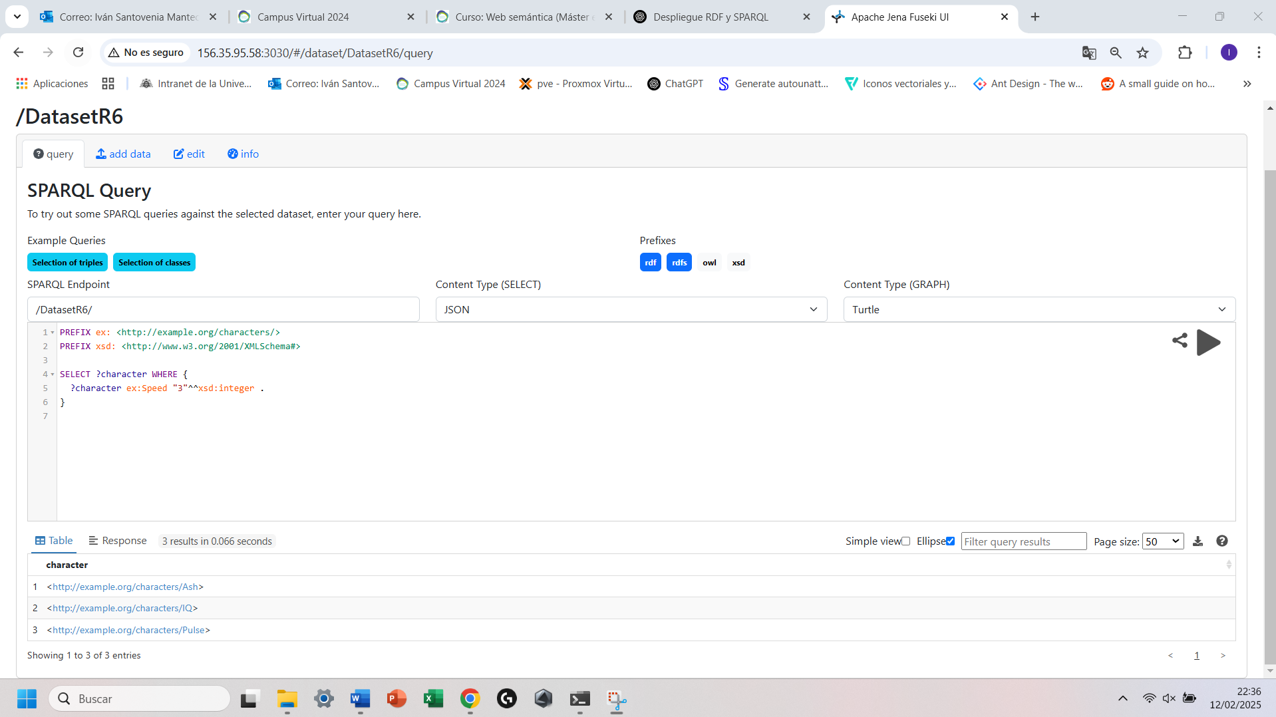
Ejemplo con Python desde mi maquina al servidor en la maquina virtual:
Codigo Python:
from SPARQLWrapper import SPARQLWrapper, JSON
# URL del endpoint SPARQL
sparql = SPARQLWrapper("http://156.35.95.58:3030/DatasetR6/query")
# Consulta SPARQL
query = """
PREFIX ex: <http://example.org/characters/>
PREFIX xsd: <http://www.w3.org/2001/XMLSchema#>
SELECT ?character WHERE {
?character ex:Speed "3"^^xsd:integer .
}
"""
# Configurar la consulta
sparql.setQuery(query)
sparql.setReturnFormat(JSON)
# Ejecutar la consulta y obtener resultados
results = sparql.query().convert()
# Imprimir resultados
print("Resultados de la consulta SPARQL:")
for result in results["results"]["bindings"]:
print(result["character"]["value"])

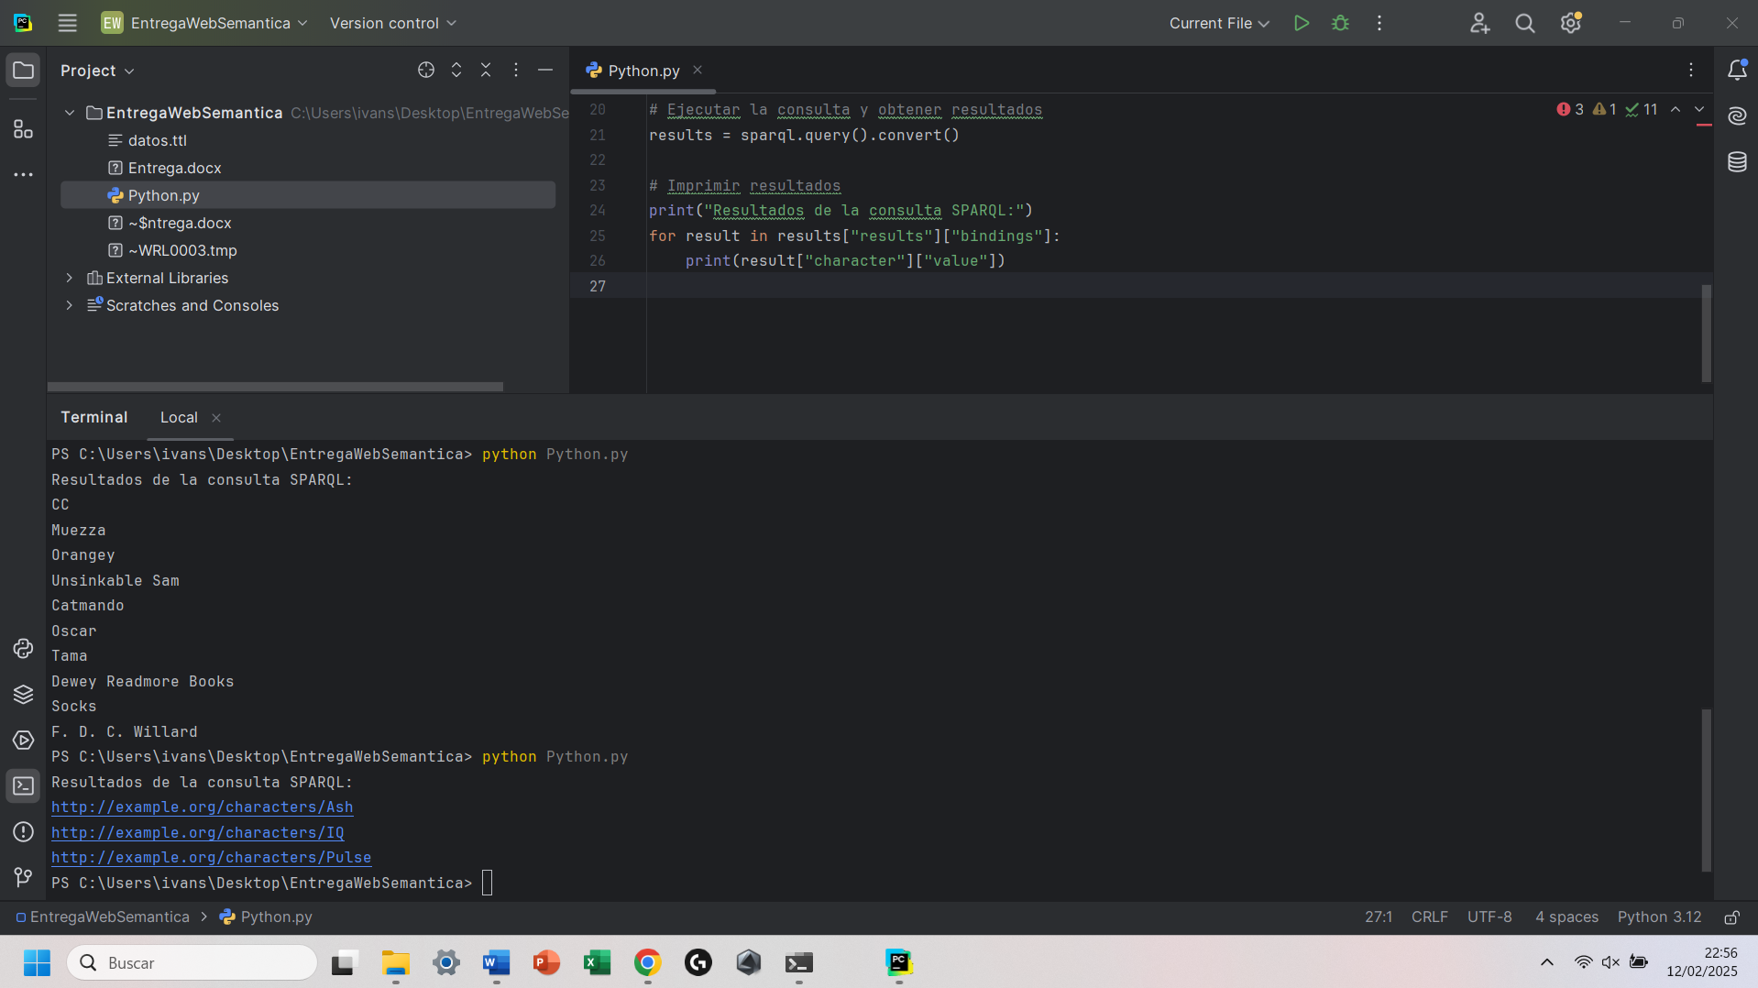
Query5:
PREFIX ex: <http://example.org/characters/>

SELECT ?gadget WHERE {
ex:Twitch ex:Gadget ?gadget .
}
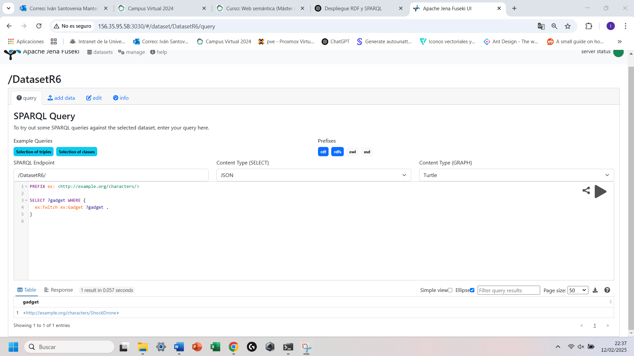
Query6:
PREFIX ex: <http://example.org/characters/>

SELECT ?character WHERE {
?character ex:Team ex:GIGN .
}
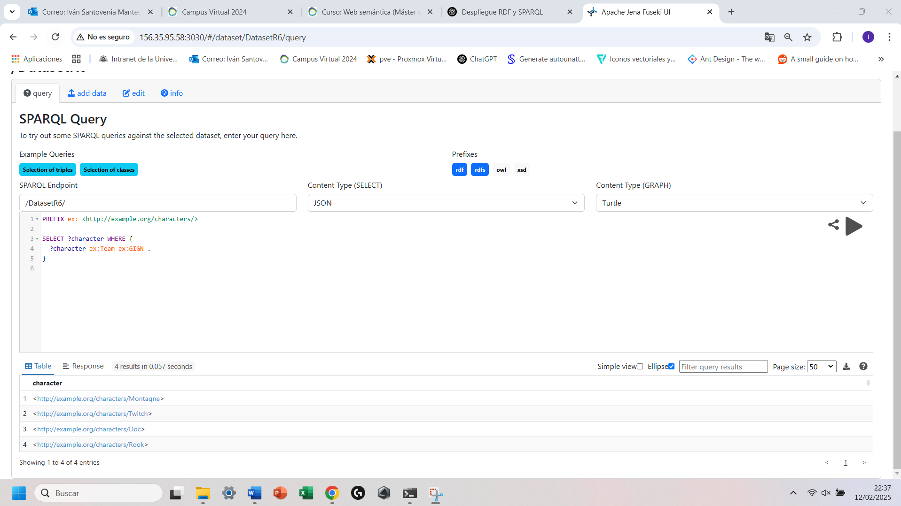

Querys Federadas:
Query1:
PREFIX wd: <http://www.wikidata.org/entity/>
PREFIX wdt: <http://www.wikidata.org/prop/direct/>
PREFIX rdfs: <http://www.w3.org/2000/01/rdf-schema#>
PREFIX ex: <http://example.org/characters/>

SELECT ?operatorName ?releaseDate WHERE {
SERVICE <https://query.wikidata.org/sparql> {
wd:Q17183996 wdt:P577 ?releaseDate.
}

?operator rdfs:label ?operatorName .
FILTER(LANG(?operatorName) = "en")
FILTER(?operatorName != "Male"@en && ?operatorName != "Female"@en) # Excluir géneros
}
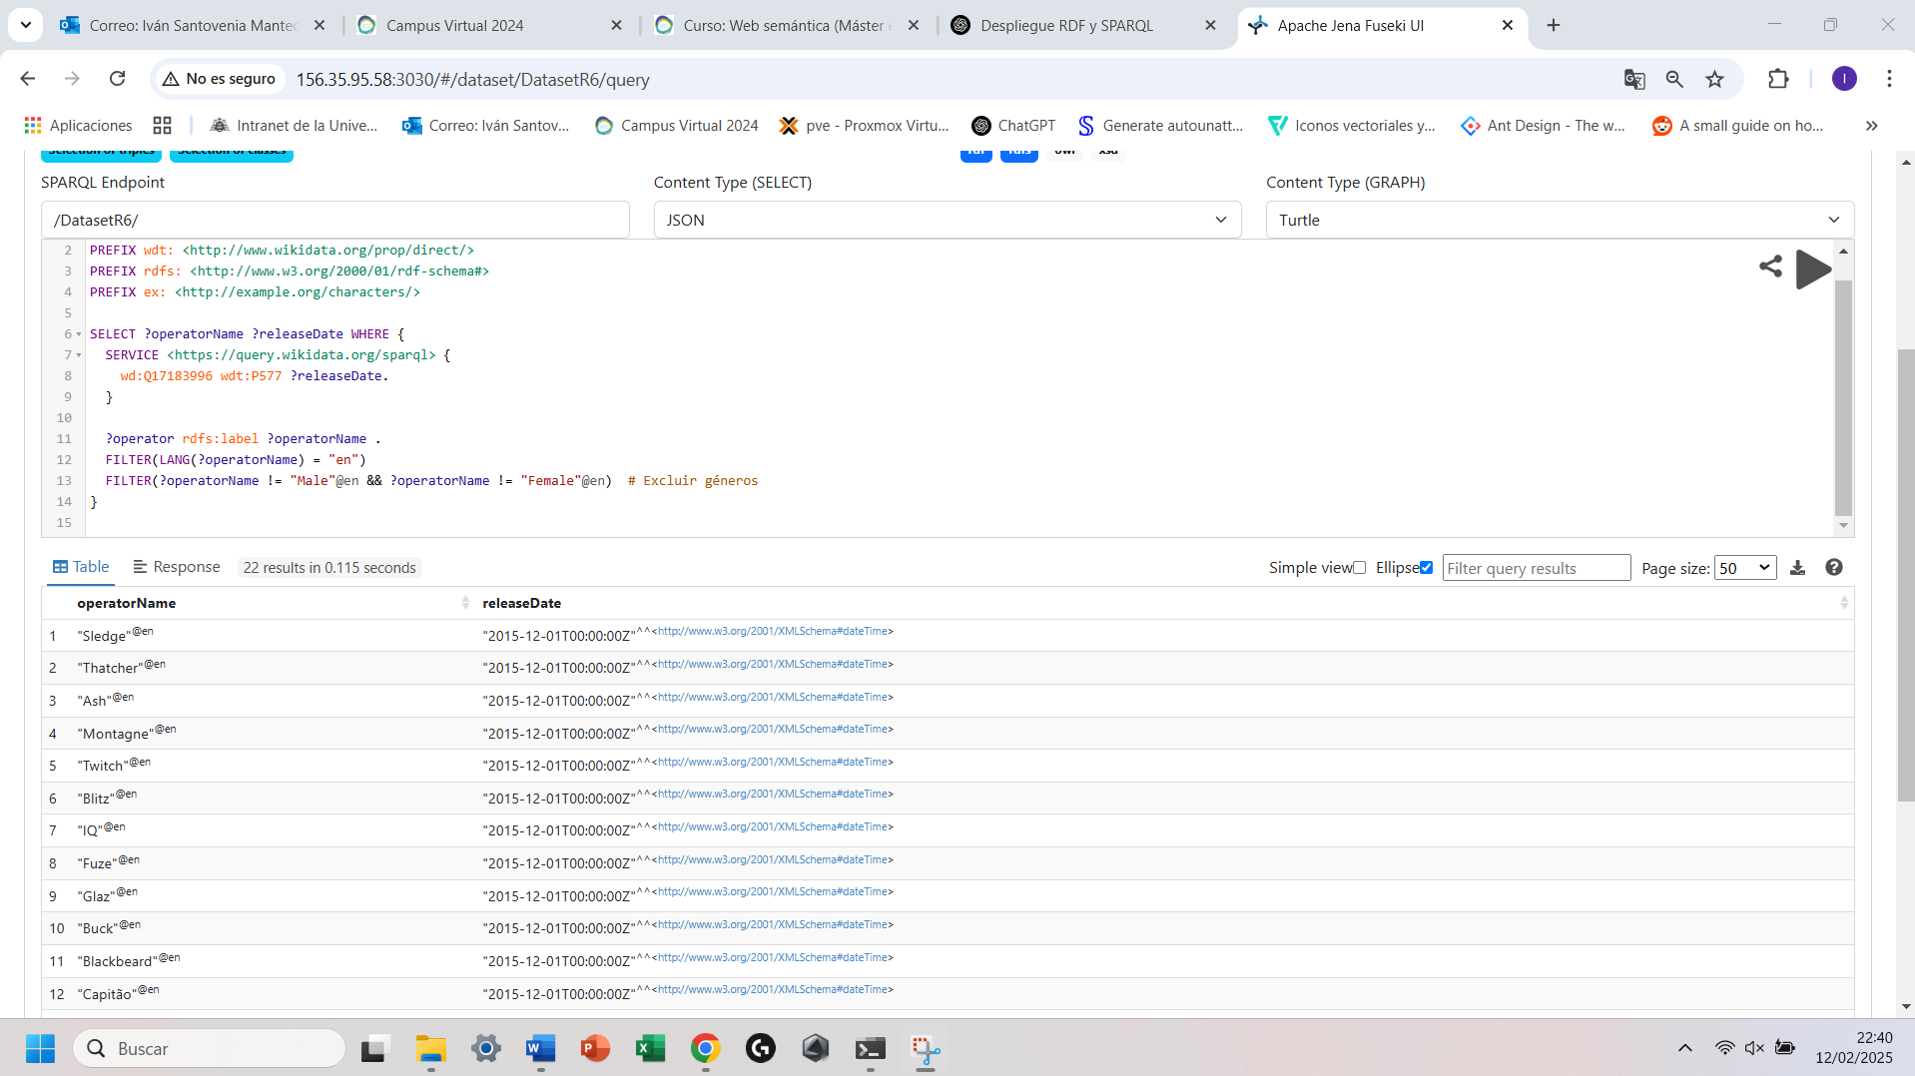
Query2:
PREFIX rdfs: <http://www.w3.org/2000/01/rdf-schema#>
PREFIX ex: <http://example.org/characters/>
PREFIX wd: <http://www.wikidata.org/entity/>
PREFIX wdt: <http://www.wikidata.org/prop/direct/>

SELECT ?operator ?name ?countryLabel WHERE {
?operator rdfs:label ?name ;
ex:Country ?country .

# Mapeo manual de los identificadores locales a Wikidata
VALUES (?country ?wikidataCountry) {
(ex:UnitedKingdom wd:Q145)
(ex:UnitedStates wd:Q30)
(ex:France wd:Q142)
(ex:Germany wd:Q183)
(ex:Russia wd:Q159)
(ex:Canada wd:Q16)
(ex:Brazil wd:Q155)
(ex:Spain wd:Q29)
}

# Consulta federada a Wikidata
SERVICE <https://query.wikidata.org/sparql> {
?wikidataCountry rdfs:label ?countryLabel .
FILTER (LANG(?countryLabel) = "en")
}
}
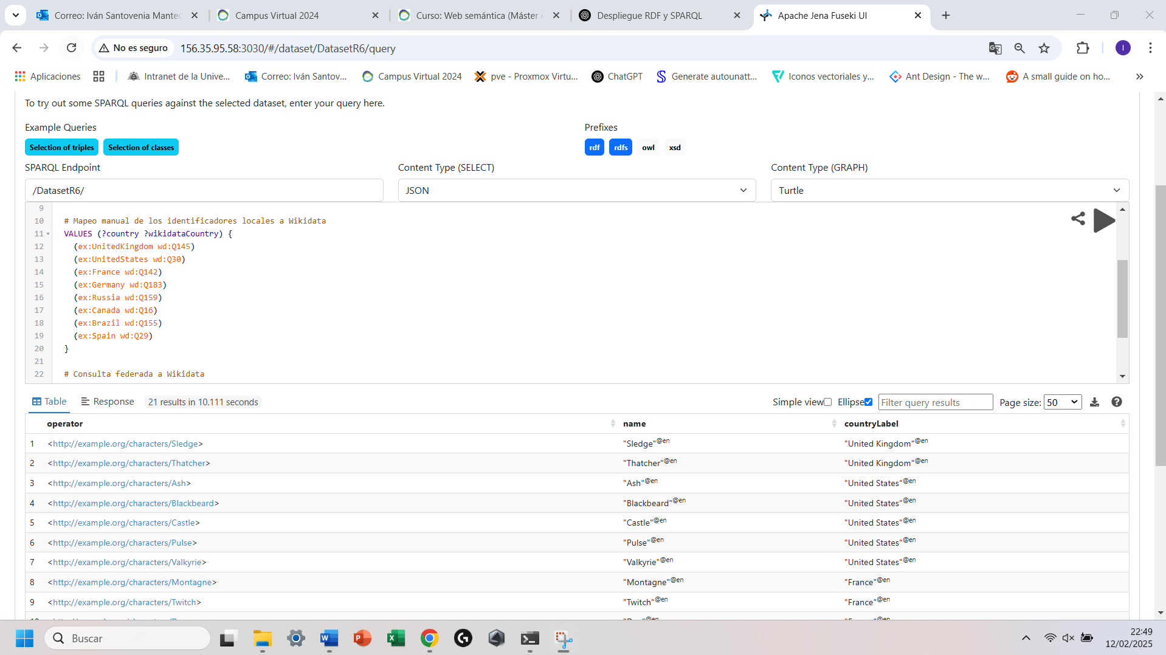

Virtuoso:
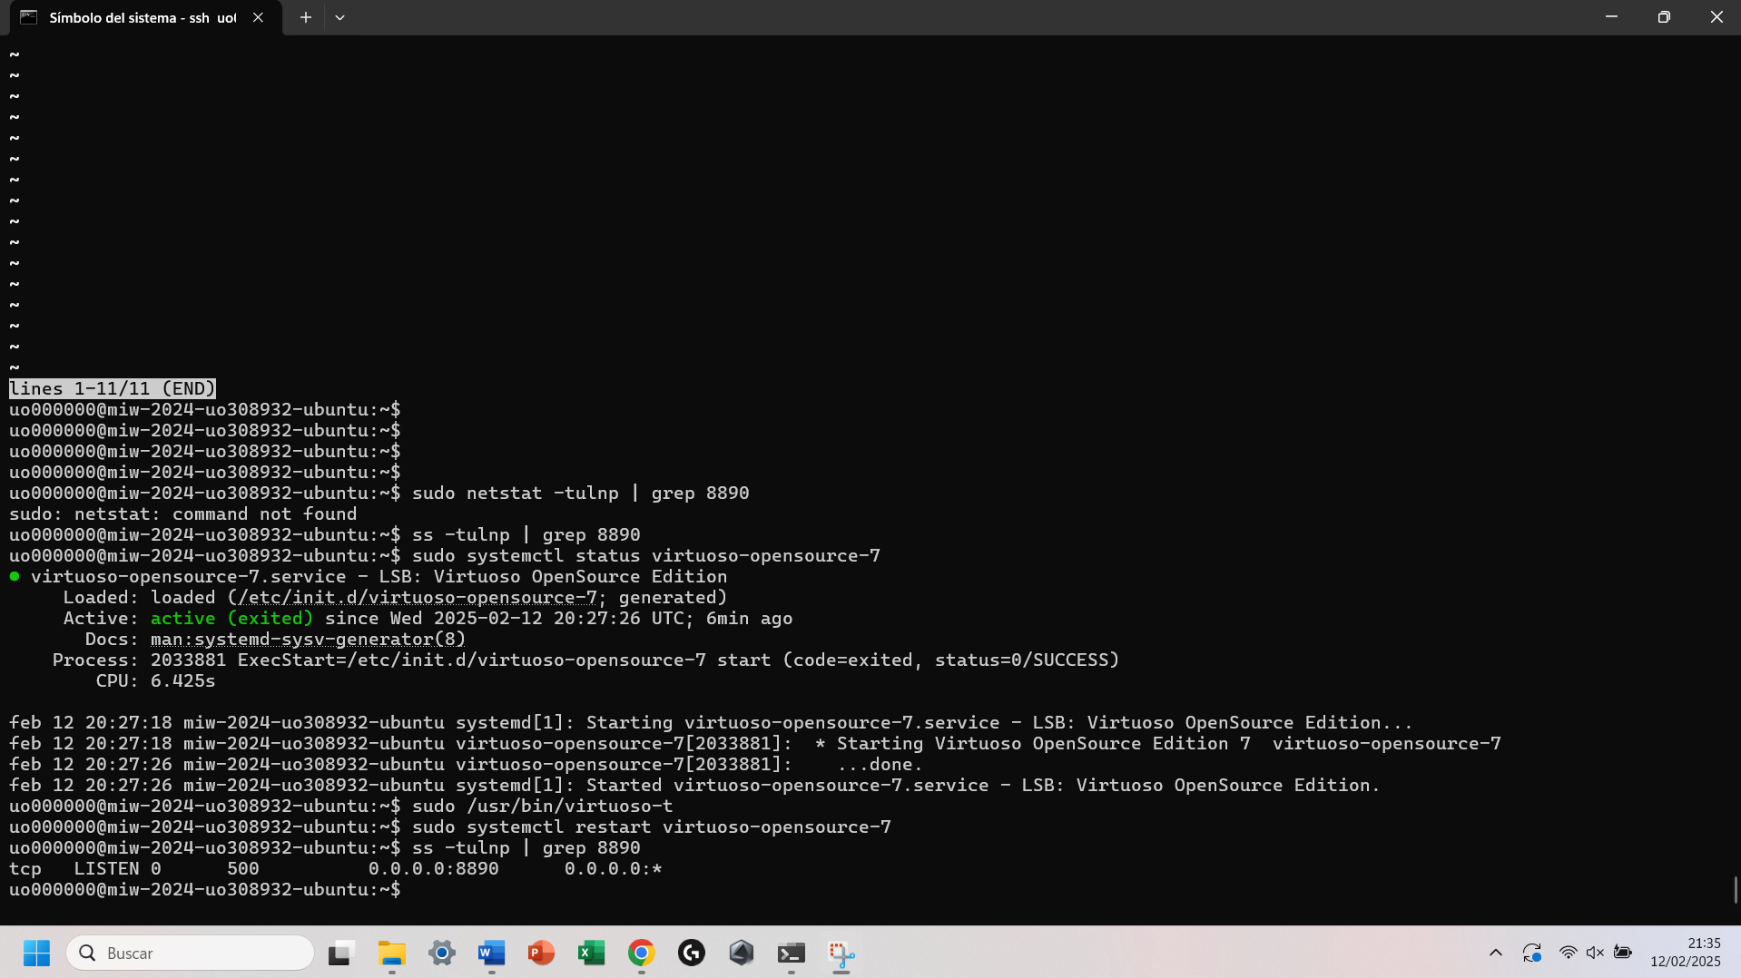
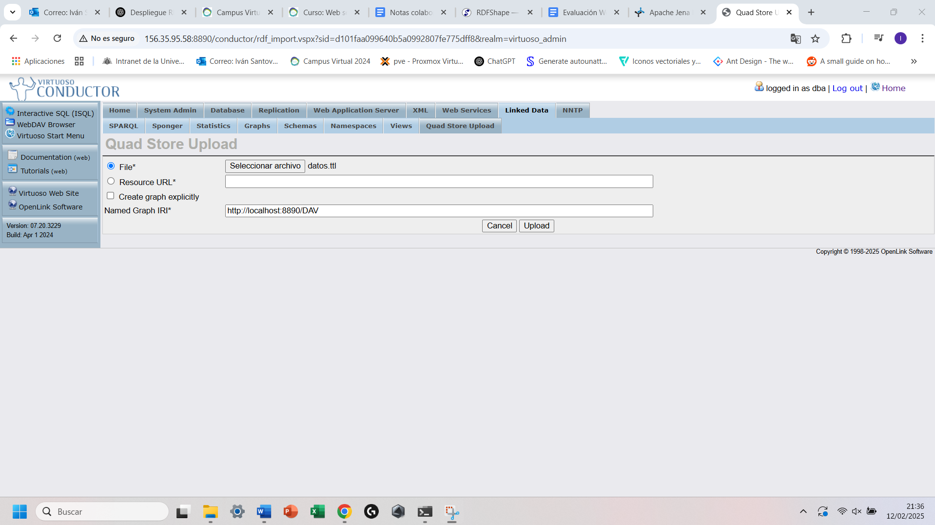
Ejemplo Query:
