1. Activate **PERSONAL** project in Epam Cloud

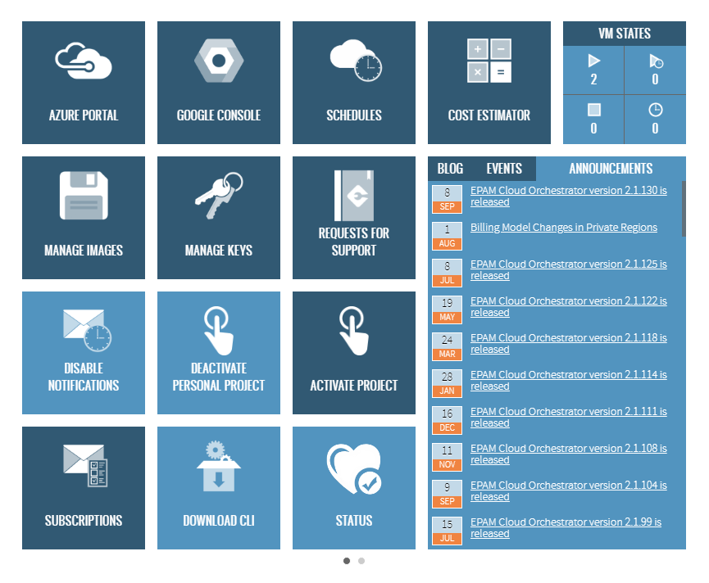

1. Download maestro-cli

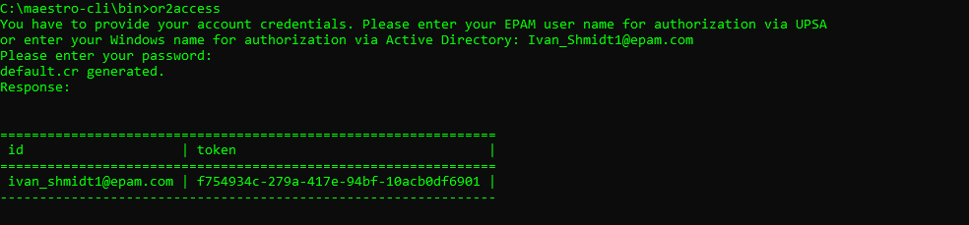

1. Execute describe regions command and choose region to run instance in it

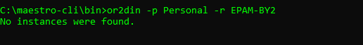

1. Run Linux instance and Windows instances in it

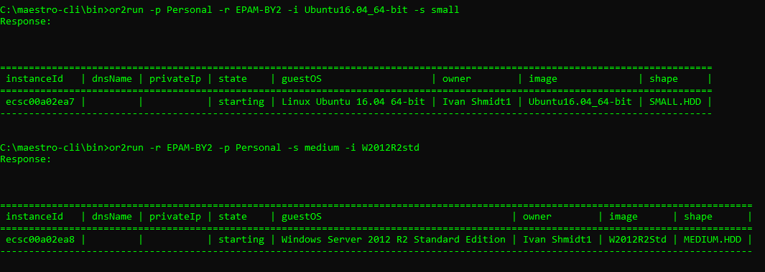

1. Execute describe instance command

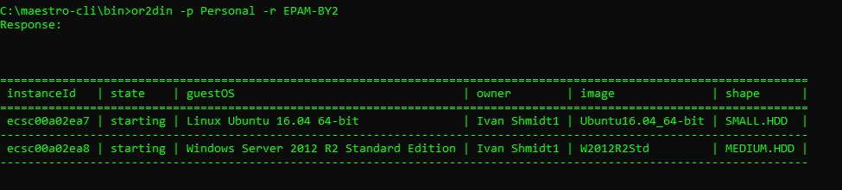

1. Login to Windows instance

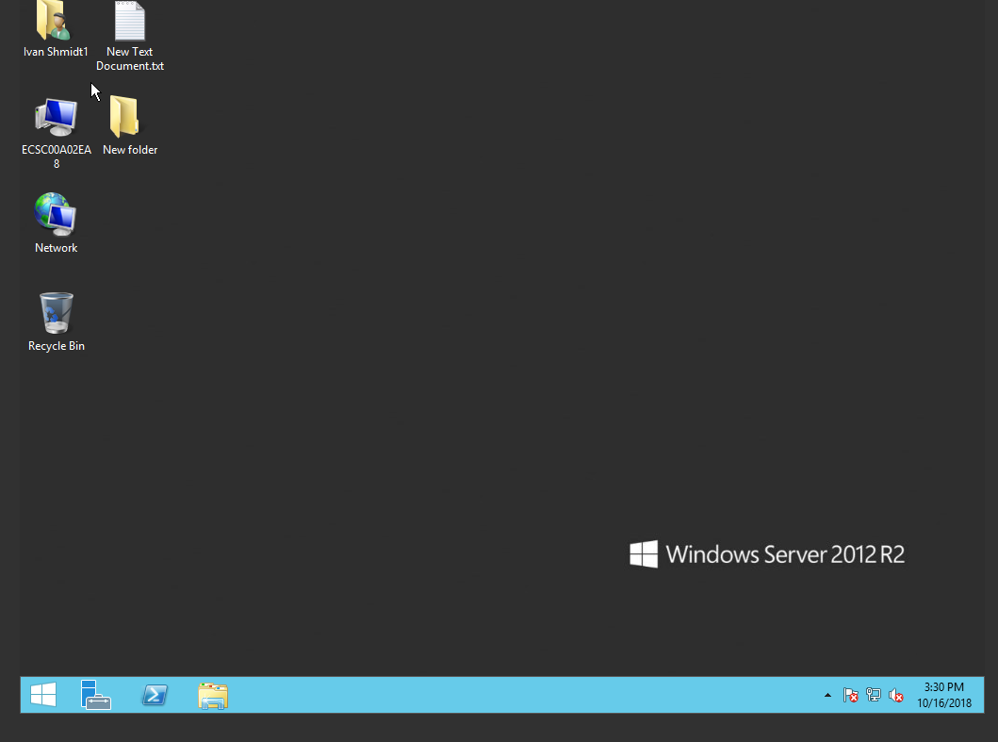

1. Login to Linux instance

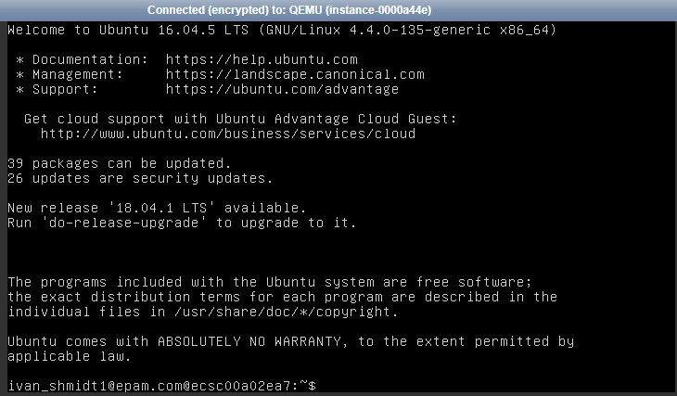

1. Reboot/suspend/stop instance

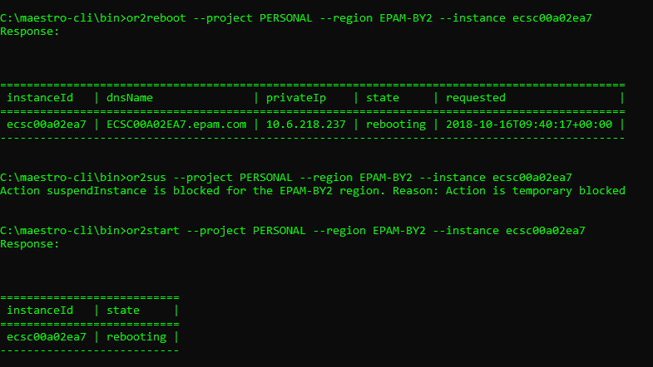

1. Change shape for instance



1. Create and attach volume. Write any information on attached volume (e.g. .doc file, .txt file, .jpg file, create any folder). Attach volume/detach volume

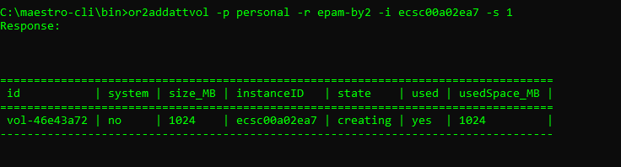

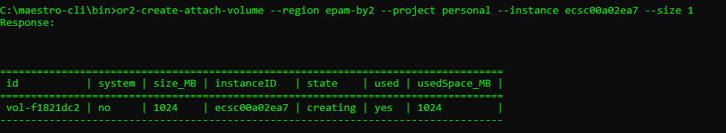

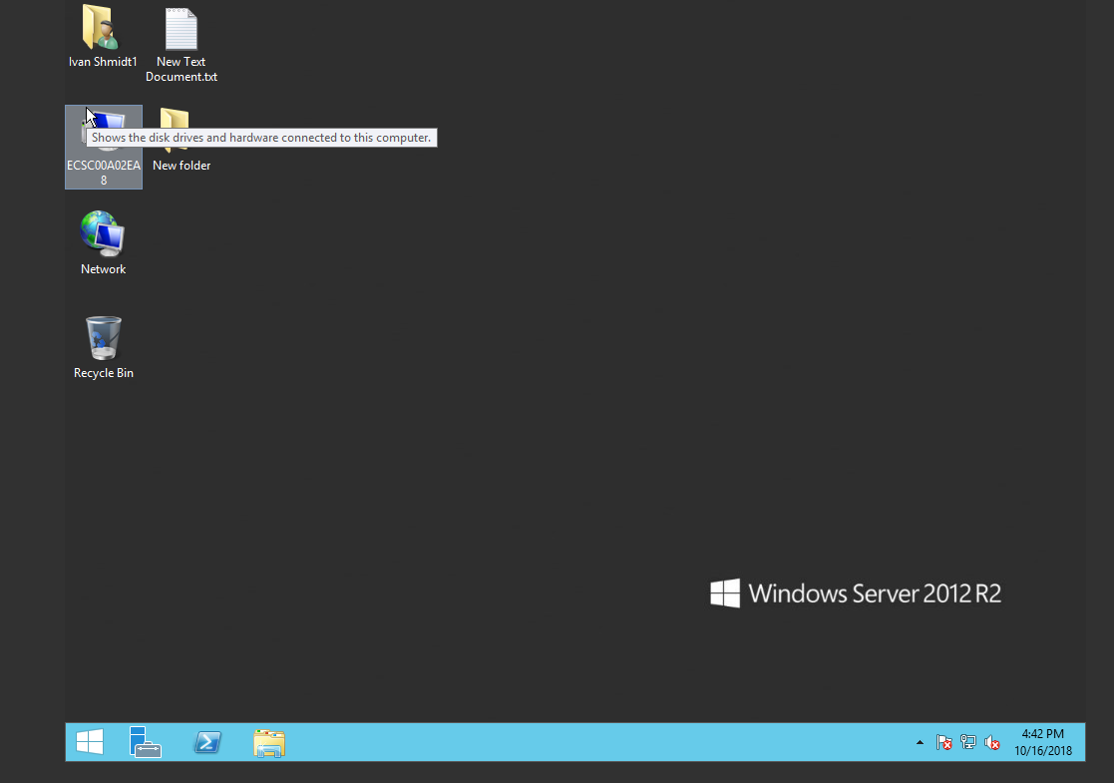

1. Create schedule for instance and check that it works

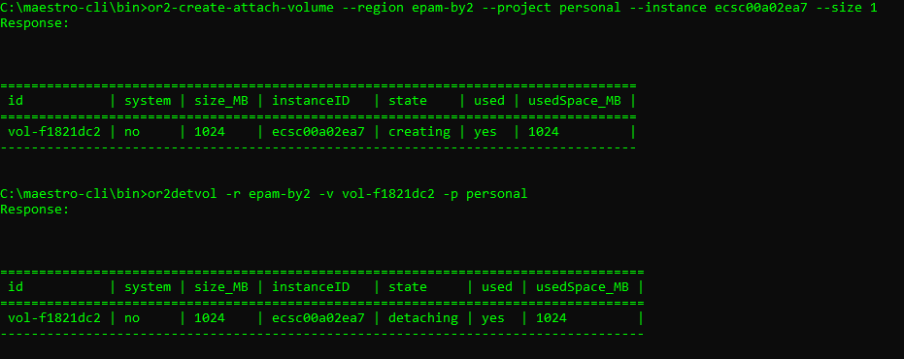

1. Add instance to schedule/remove instance from schedule

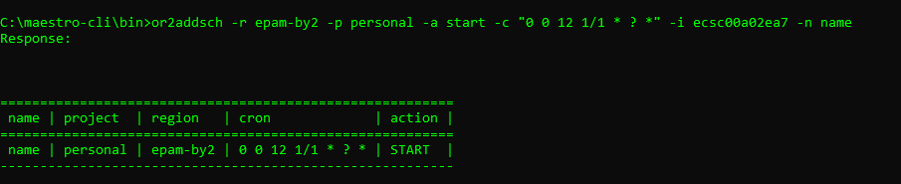

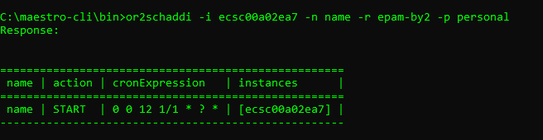

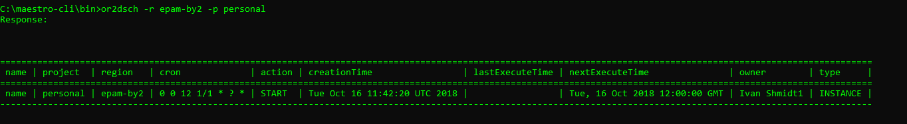

1. Create/describe/delete keypairs

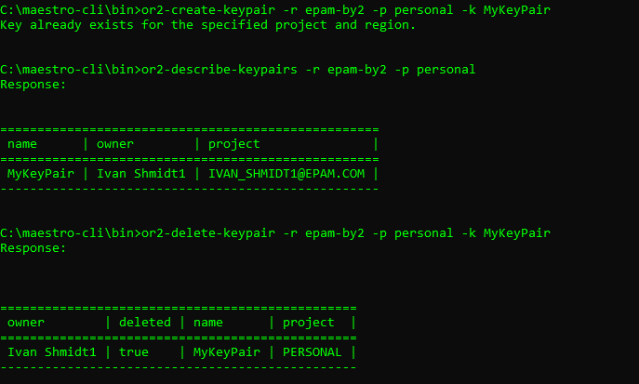

1. Set/describe tag for instance

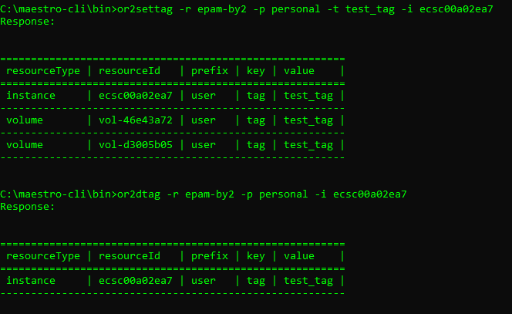

1. Set/describe instance property

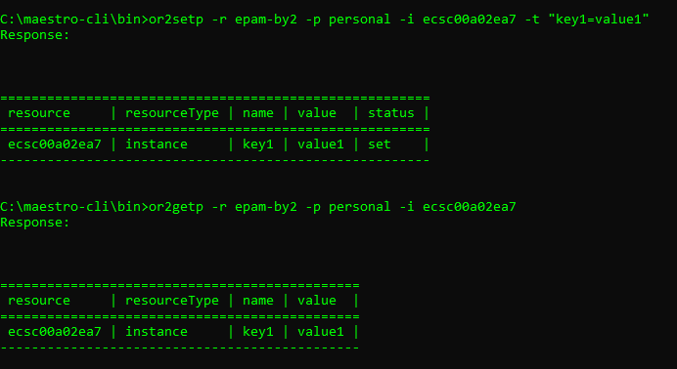

1. Retrieve instance/project audit

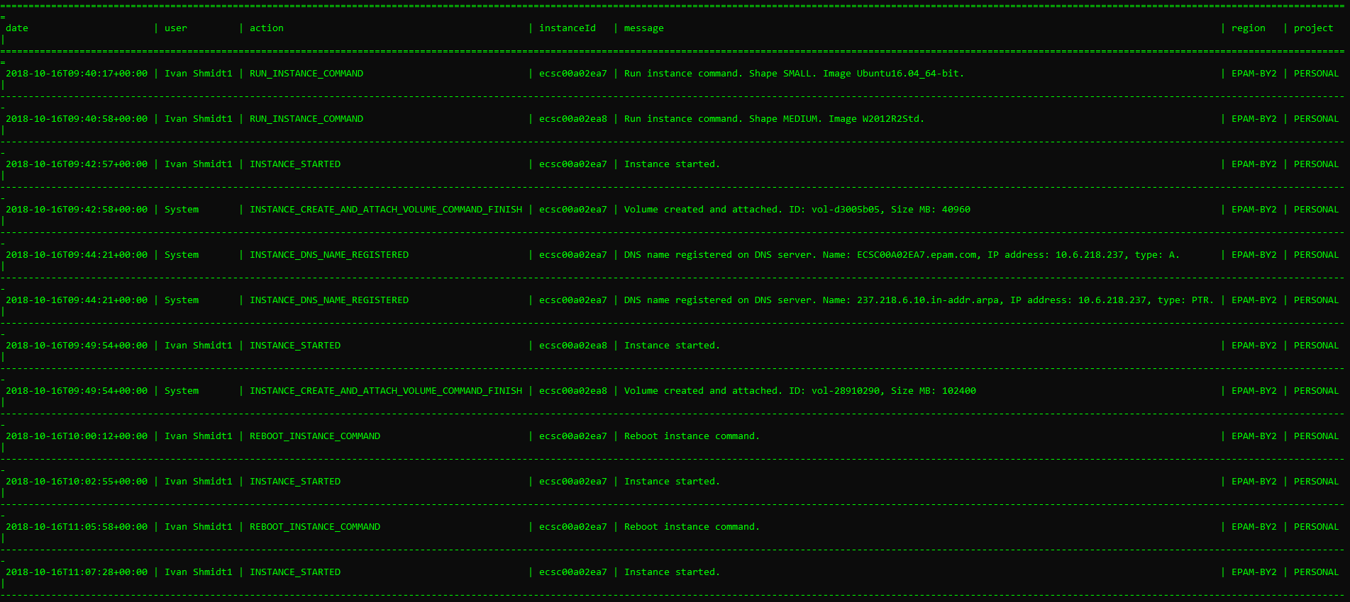

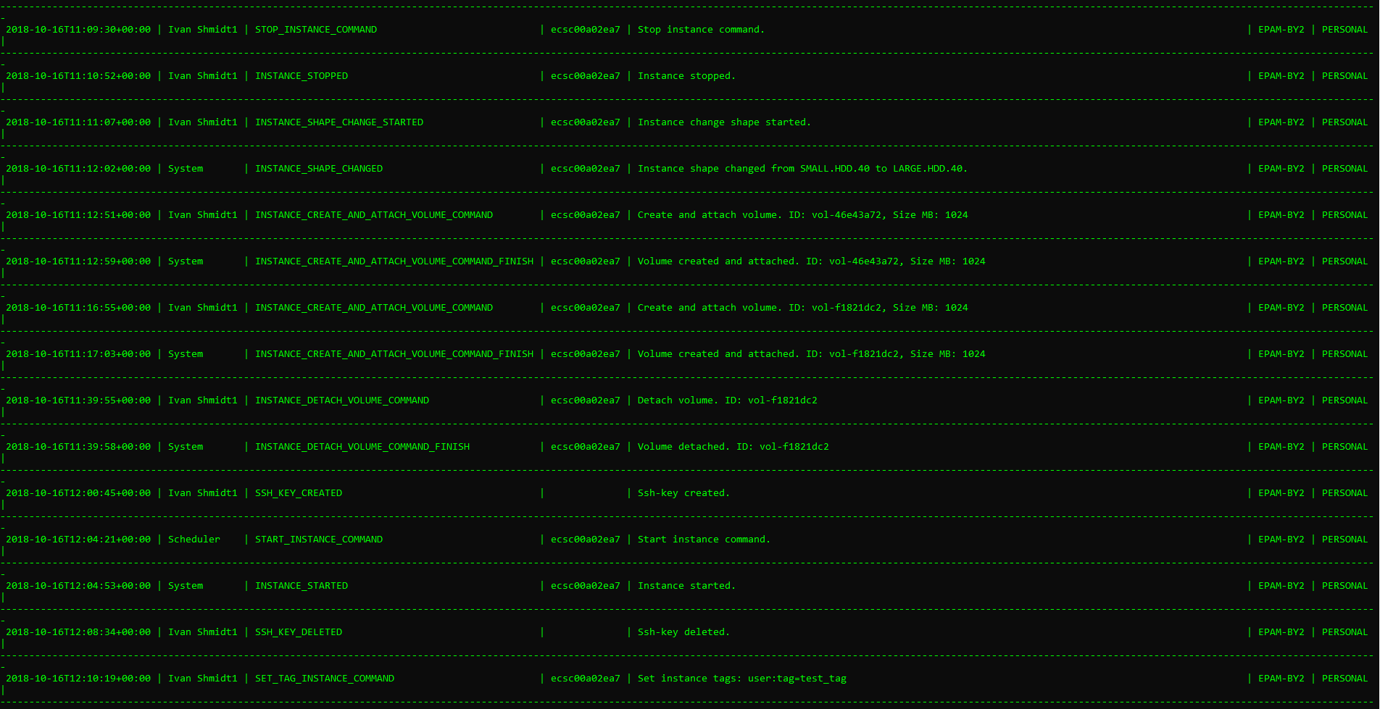

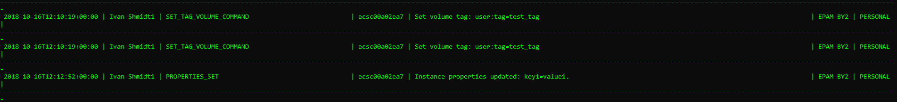

1. Generate different types of utilization report

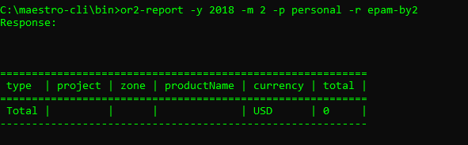

1. Analyze EPAM Cloud changes over the past six months. What of the features you are getting interested that were published to EPAM Cloud during last 6 months?