Практическая работа

Тема: Messanger

Ход работы:

Программный код activity_main:

<?xml version="1.0" encoding="utf-8"?>  
<androidx.constraintlayout.widget.ConstraintLayout xmlns:android="http://schemas.android.com/apk/res/android"  
 xmlns:app="http://schemas.android.com/apk/res-auto"  
 xmlns:tools="http://schemas.android.com/tools"  
 android:layout_width="match_parent"  
 android:layout_height="match_parent"  
 tools:context=".MainActivity">  
  
 <EditText  
 android:id="@+id/editTextMessage"  
 android:layout_width="0dp"  
 android:layout_height="wrap_content"  
 android:ems="10"  
 android:inputType="text"  
 android:hint="@string/hint_enter_msg"  
 app:layout_constraintEnd_toEndOf="parent"  
 app:layout_constraintStart_toStartOf="parent"  
 app:layout_constraintTop_toTopOf="parent" />  
  
 <Button  
 android:id="@+id/button"  
 android:layout_width="0dp"  
 android:layout_height="wrap_content"  
 android:text="@string/button_send"  
 android:onClick="onClickSendMsg"  
 app:layout_constraintEnd_toEndOf="parent"  
 app:layout_constraintStart_toStartOf="parent"  
 app:layout_constraintTop_toBottomOf="@+id/editTextMessage" />  
</androidx.constraintlayout.widget.ConstraintLayout>

Программный код MainActivity:

package com.example.messenger;  
  
import androidx.appcompat.app.AppCompatActivity;  
  
import android.content.Intent;  
import android.os.Bundle;  
import android.view.View;  
import android.widget.EditText;  
  
public class MainActivity extends AppCompatActivity {  
  
 private EditText editTextMsg;  
  
 @Override  
 protected void onCreate(Bundle savedInstanceState) {  
 super.onCreate(savedInstanceState);  
 setContentView(R.layout.activity_main);  
 editTextMsg = findViewById(R.id.editTextMessage);  
 }  
  
 public void onClickSendMsg(View view) {  
 String msg = editTextMsg.getText().toString();  
 Intent intent = new Intent(Intent.ACTION_SEND);  
 intent.setType("text/plain");  
 intent.putExtra(Intent.EXTRA_TEXT, msg);  
 Intent chosenIntent = Intent.createChooser(intent, getString(R.string.chooser_title));  
 startActivity(chosenIntent);  
 }  
}

Программный код activity_received_message:

<?xml version="1.0" encoding="utf-8"?>  
<androidx.constraintlayout.widget.ConstraintLayout xmlns:android="http://schemas.android.com/apk/res/android"  
 xmlns:app="http://schemas.android.com/apk/res-auto"  
 xmlns:tools="http://schemas.android.com/tools"  
 android:layout_width="match_parent"  
 android:layout_height="match_parent"  
 tools:context=".ReceivedMessageActivity">  
  
 <TextView  
 android:id="@+id/textViewReceivedMessage"  
 android:layout_width="0dp"  
 android:layout_height="wrap_content"  
 app:layout_constraintEnd_toEndOf="parent"  
 app:layout_constraintStart_toStartOf="parent"  
 app:layout_constraintTop_toTopOf="parent" />  
</androidx.constraintlayout.widget.ConstraintLayout>

Программный код ReceivedMainActivity:

package com.example.messenger;  
  
import androidx.appcompat.app.AppCompatActivity;  
  
import android.content.Intent;  
import android.os.Bundle;  
import android.widget.TextView;  
  
public class ReceivedMessageActivity extends AppCompatActivity {  
 private TextView textViewReceivedMessage;  
  
 @Override  
 protected void onCreate(Bundle savedInstanceState) {  
 super.onCreate(savedInstanceState);  
 setContentView(R.layout.activity_received_message);  
 textViewReceivedMessage = findViewById(R.id.textViewReceivedMessage);  
 Intent intent = getIntent();  
 String msg = intent.getStringExtra("msg");  
 textViewReceivedMessage.setText(msg);  
 }  
}

Программный код strings:

<resources>  
 <string name="app_name">Messenger</string>  
 <string name="button_send">Отправить</string>  
 <string name="hint_enter_msg">Введите сообщение</string>  
 <string name="chooser_title">Как вы хотите отправить сообщение?</string>  
</resources>

Макет:

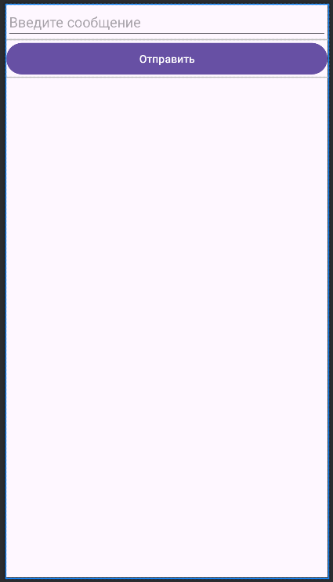

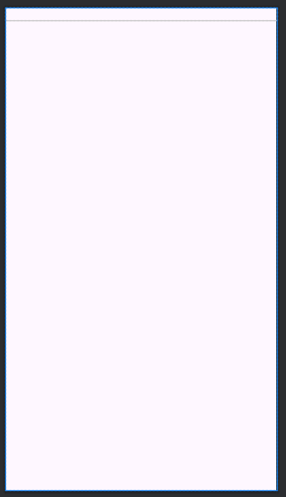

Протокол:

