Практическая работа

Тема: TheRavenCounter

Ход работы:

Программный код activity_main:

<?xml version="1.0" encoding="utf-8"?>  
<androidx.constraintlayout.widget.ConstraintLayout xmlns:android="http://schemas.android.com/apk/res/android"  
 xmlns:app="http://schemas.android.com/apk/res-auto"  
 xmlns:tools="http://schemas.android.com/tools"  
 android:id="@+id/constraintlayout"  
 android:layout_width="match_parent"  
 android:layout_height="match_parent"  
 tools:context=".MainActivity">  
  
 <Button  
 android:id="@+id/green_button"  
 android:layout_width="wrap_content"  
 android:layout_height="wrap_content"  
 android:onClick="onGreenButtonClick"  
 android:text="@string/green"  
 app:layout_constraintBottom_toBottomOf="parent"  
 app:layout_constraintEnd_toEndOf="parent"  
 app:layout_constraintStart_toStartOf="parent"  
 app:layout_constraintTop_toBottomOf="@+id/yellow_button"  
 app:layout_constraintVertical_bias="0.5" />  
  
 <Button  
 android:id="@+id/yellow_button"  
 android:layout_width="wrap_content"  
 android:layout_height="wrap_content"  
 android:text="@string/yellow"  
 app:layout_constraintBottom_toTopOf="@+id/green_button"  
 app:layout_constraintEnd_toEndOf="parent"  
 app:layout_constraintStart_toStartOf="parent"  
 app:layout_constraintTop_toBottomOf="@+id/red_button"  
 app:layout_constraintVertical_bias="0.5" />  
  
 <Button  
 android:id="@+id/red_button"  
 android:layout_width="wrap_content"  
 android:layout_height="wrap_content"  
 android:onClick="onRedButtonClick"  
 android:text="@string/red"  
 app:layout_constraintBottom_toTopOf="@+id/yellow_button"  
 app:layout_constraintEnd_toEndOf="parent"  
 app:layout_constraintStart_toStartOf="parent"  
 app:layout_constraintTop_toTopOf="parent"  
 app:layout_constraintVertical_bias="0.5" />  
  
 <TextView  
 android:id="@+id/textViewInfo"  
 android:layout_width="wrap_content"  
 android:layout_height="wrap_content"  
 android:textAppearance="@style/TextAppearance.AppCompat.Display1"  
 app:layout_constraintBottom_toBottomOf="parent"  
 app:layout_constraintEnd_toEndOf="parent"  
 app:layout_constraintStart_toStartOf="parent"  
 app:layout_constraintTop_toBottomOf="@+id/green_button"  
 app:layout_constraintVertical_bias="0.496" />  
</androidx.constraintlayout.widget.ConstraintLayout>

Программный код MainActivity:

package com.example.svetofor;  
  
import androidx.appcompat.app.AppCompatActivity;  
import androidx.constraintlayout.widget.ConstraintLayout;  
import androidx.core.content.ContextCompat;  
  
import android.annotation.SuppressLint;  
import android.os.Bundle;  
import android.view.View;  
import android.widget.Button;  
import android.widget.TextView;  
  
public class MainActivity extends AppCompatActivity {  
  
 private ConstraintLayout mConstraintLayout;  
 private TextView mInfoTextView;  
  
 @Override  
 protected void onCreate(Bundle savedInstanceState) {  
 super.onCreate(savedInstanceState);  
 setContentView(R.layout.activity_main);  
  
 mConstraintLayout = findViewById(R.id.constraintlayout);  
 mInfoTextView = findViewById(R.id.textViewInfo);  
  
 Button yellowButton = (Button) findViewById(R.id.yellow_button);  
 yellowButton.setOnClickListener(v -> {  
 mInfoTextView.setText(R.string.yellow);  
 mConstraintLayout.setBackgroundColor(ContextCompat.getColor(MainActivity.this, R.color.yellowColor));  
 });  
 }  
 public void onRedButtonClick(View view) {  
 mInfoTextView.setText(R.string.red);  
 mConstraintLayout.setBackgroundColor(ContextCompat.getColor(this, R.color.redColor));  
 }  
  
 public void onGreenButtonClick(View view) {  
 mInfoTextView.setText(R.string.green);  
 mConstraintLayout.setBackgroundColor(ContextCompat.getColor(this, R.color.greenColor));  
 }  
}

Программный код strings:

<resources>  
 <string name="app_name">Svetofor</string>  
 <string name="red">Красный</string>  
 <string name="yellow">Жёлтый</string>  
 <string name="green">Зелёный</string>  
</resources>

Программный код color:

<?xml version="1.0" encoding="utf-8"?>  
<resources>  
 <color name="black">#FF000000</color>  
 <color name="white">#FFFFFFFF</color>  
 <color name="greenColor">#FF00FF00</color>  
 <color name="yellowColor">#FFFF00</color>  
 <color name="redColor">#FF0000</color>  
</resources>

Макет:

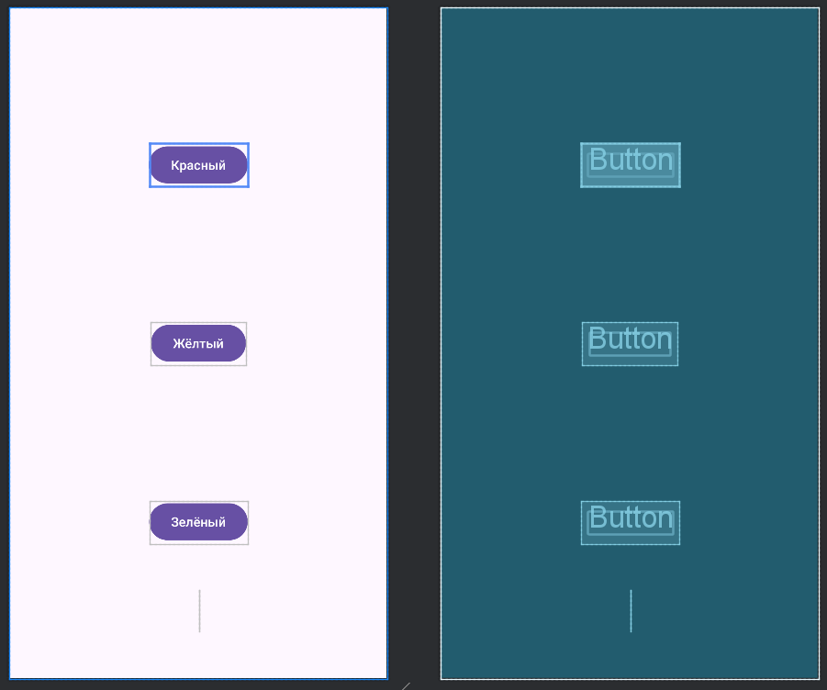

Протокол:

