Практическая работа

Тема: TheRavenCounter

Ход работы:

Программный код activity_main:

<?xml version="1.0" encoding="utf-8"?>  
<androidx.constraintlayout.widget.ConstraintLayout xmlns:android="http://schemas.android.com/apk/res/android"  
 xmlns:app="http://schemas.android.com/apk/res-auto"  
 xmlns:tools="http://schemas.android.com/tools"  
 android:layout_width="match_parent"  
 android:layout_height="match_parent"  
 tools:context=".MainActivity">  
  
 <TextView  
 android:id="@+id/textView2"  
 android:layout_width="wrap_content"  
 android:layout_height="wrap_content"  
 android:layout_marginTop="80dp"  
 android:text="Я насчитал 0 ворон"  
 android:textAppearance="@style/TextAppearance.AppCompat.Display1"  
 app:layout_constraintEnd_toEndOf="parent"  
 app:layout_constraintHorizontal_bias="0.495"  
 app:layout_constraintStart_toStartOf="parent"  
 app:layout_constraintTop_toTopOf="parent" />  
  
 <ImageButton  
 android:id="@+id/imageButton"  
 android:layout_width="301dp"  
 android:layout_height="397dp"  
 android:onClick="onClick"  
 android:scaleType="centerInside"  
 app:layout_constraintBottom_toBottomOf="parent"  
 app:layout_constraintEnd_toEndOf="parent"  
 app:layout_constraintStart_toStartOf="parent"  
 app:layout_constraintTop_toBottomOf="@+id/textView2"  
 app:srcCompat="@drawable/vorona"  
 tools:ignore="MissingConstraints,SpeakableTextPresentCheck"  
 tools:srcCompat="@drawable/vorona" />  
  
</androidx.constraintlayout.widget.ConstraintLayout>

Программный код MainActivity:

package com.example.crow;  
  
import androidx.appcompat.app.AppCompatActivity;  
  
import android.os.Bundle;  
import android.view.KeyEvent;  
import android.view.View;  
import android.widget.ImageButton;  
import android.widget.TextView;  
  
public class MainActivity extends AppCompatActivity {  
 private ImageButton crowButton;  
 private TextView textView;  
 private boolean isPress=false;  
 private int crowCount=0;  
 @Override  
 protected void onCreate(Bundle savedInstanceState) {  
 super.onCreate(savedInstanceState);  
 setContentView(R.layout.activity_main);  
 }  
 public void onClick(View view) {  
 crowButton=findViewById(R.id.imageButton);  
 textView=findViewById(R.id.textView2);  
 textView.setText("Я насчитал "+ ++crowCount+" ворон");  
 }  
}

Программный код strings:

<resources>  
 <string name="app_name">Crow</string>  
</resources>

Макет:

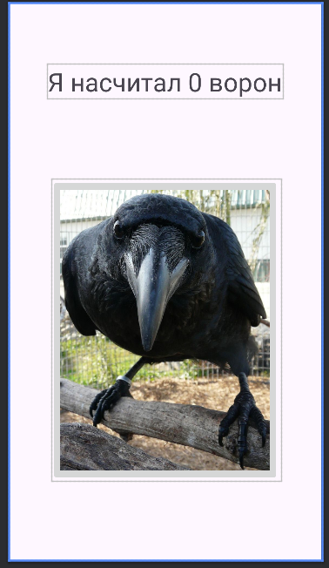

Протокол:

