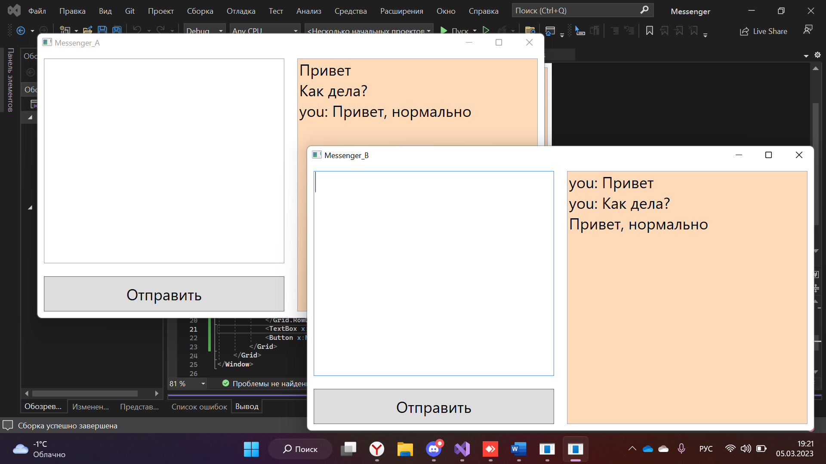

Messanger_A

MainWindow.xmal

<Window x:Class="Messanger_A.MainWindow"

xmlns="http://schemas.microsoft.com/winfx/2006/xaml/presentation"

xmlns:x="http://schemas.microsoft.com/winfx/2006/xaml"

xmlns:d="http://schemas.microsoft.com/expression/blend/2008"

xmlns:mc="http://schemas.openxmlformats.org/markup-compatibility/2006"

xmlns:local="clr-namespace:Messanger_A"

mc:Ignorable="d"

Title="Messenger_A" Height="450" Width="800" Closing="Window_Closing" Loaded="Window_Loaded">

<Grid Background="White">

<Grid.ColumnDefinitions>

<ColumnDefinition Width="1*"/>

<ColumnDefinition Width="1*"/>

</Grid.ColumnDefinitions>

<TextBox x:Name="TextBoxAnswer" Grid.Column="1" Margin="10" FontSize="24" Background="PeachPuff" IsReadOnly="True"/>

<Grid Grid.Column="0">

<Grid.RowDefinitions>

<RowDefinition Height="1*"/>

<RowDefinition Height="75"/>

</Grid.RowDefinitions>

<TextBox x:Name="TextBoxUser" Grid.Row="0" Margin="10" FontSize="24"/>

<Button x:Name="ButtonSendMessage" Grid.Row="1" Margin="10" Content="Отправить" FontSize="24" Click="ButtonSendMessage_Click"/>

</Grid>

</Grid>

</Window>

MainWindow.xmal.cs

using System;

using System.Collections.Generic;

using System.Linq;

using System.Net.Http;

using System.Net;

using System.Text;

using System.Threading.Tasks;

using System.Windows;

using System.Windows.Controls;

using System.Windows.Data;

using System.Windows.Documents;

using System.Windows.Input;

using System.Windows.Media;

using System.Windows.Media.Imaging;

using System.Windows.Navigation;

using System.Windows.Shapes;

namespace Messanger_A

{

/// <summary>

/// Логика взаимодействия для MainWindow.xaml

/// </summary>

public partial class MainWindow : Window

{

HttpListener _HttpListener = new HttpListener();

public MainWindow()

{

_HttpListener

.Set_Prefixes_Add("http://127.0.0.1:8888/connection/", _IsOpen: false)

.Set_Start()

;

InitializeComponent();

}

private void ButtonSendMessage_Click(object sender, RoutedEventArgs e)

{

_HttpListener

.Get_ContextAsync(a =>

{

System.String _strResponse = TextBoxUser.Text;

a.Response.Set_Bytes(_strResponse.Get_Encoding_UTF8_Bytes());

}

);

TextBoxAnswer.Text += "you: " + TextBoxUser.Text + "\n";

TextBoxUser.Text = String.Empty;

}

private void Window_Closing(object sender, System.ComponentModel.CancelEventArgs e)

{

_HttpListener.Set_Stop();

}

async private void Window_Loaded(object sender, RoutedEventArgs e)

{

while (true)

{

string asnwerText = await Task.Run(() => new HttpClient().GetStringAsync("http://127.0.0.2:8889/connection/?qweBFYUWEFGUYSDADSDFW").GetAwaiter().GetResult());

TextBoxAnswer.Text += asnwerText + "\n";

}

}

}

}

Messanger_B

MainWindow.xmal

<Window x:Class="Messanger_B.MainWindow"

xmlns="http://schemas.microsoft.com/winfx/2006/xaml/presentation"

xmlns:x="http://schemas.microsoft.com/winfx/2006/xaml"

xmlns:d="http://schemas.microsoft.com/expression/blend/2008"

xmlns:mc="http://schemas.openxmlformats.org/markup-compatibility/2006"

xmlns:local="clr-namespace:Messanger_B"

mc:Ignorable="d"

Title="Messenger_B" Height="450" Width="800" Closing="Window_Closing" Loaded="Window_Loaded">

<Grid Background="White">

<Grid.ColumnDefinitions>

<ColumnDefinition Width="1*"/>

<ColumnDefinition Width="1*"/>

</Grid.ColumnDefinitions>

<TextBox x:Name="TextBoxAnswer" Grid.Column="1" Margin="10" FontSize="24" Background="PeachPuff" IsReadOnly="True"/>

<Grid Grid.Column="0">

<Grid.RowDefinitions>

<RowDefinition Height="1*"/>

<RowDefinition Height="75"/>

</Grid.RowDefinitions>

<TextBox x:Name="TextBoxUser" Grid.Row="0" Margin="10" FontSize="24"/>

<Button x:Name="ButtonSendMessage" Grid.Row="1" Margin="10" Content="Отправить" FontSize="24" Click="ButtonSendMessage_Click"/>

</Grid>

</Grid>

</Window>

MainWindow.xmal.cs

using System;

using System.Collections.Generic;

using System.Linq;

using System.Net;

using System.Net.Http;

using System.Text;

using System.Threading;

using System.Threading.Tasks;

using System.Windows;

using System.Windows.Controls;

using System.Windows.Data;

using System.Windows.Documents;

using System.Windows.Input;

using System.Windows.Media;

using System.Windows.Media.Imaging;

using System.Windows.Navigation;

using System.Windows.Shapes;

namespace Messanger_B

{

/// <summary>

/// Логика взаимодействия для MainWindow.xaml

/// </summary>

public partial class MainWindow : Window

{

HttpListener _HttpListener = new HttpListener();

public MainWindow()

{

_HttpListener

.Set_Prefixes_Add("http://127.0.0.2:8889/connection/", _IsOpen: false)

.Set_Start()

;

InitializeComponent();

}

private void ButtonSendMessage_Click(object sender, RoutedEventArgs e)

{

_HttpListener

.Get_ContextAsync(a =>

{

System.String _strResponse = TextBoxUser.Text;

a.Response.Set_Bytes(_strResponse.Get_Encoding_UTF8_Bytes());

}

);

TextBoxAnswer.Text += "you: " + TextBoxUser.Text + "\n";

TextBoxUser.Text = String.Empty;

}

private void Window_Closing(object sender, System.ComponentModel.CancelEventArgs e)

{

_HttpListener.Set_Stop();

}

async private void Window_Loaded(object sender, RoutedEventArgs e)

{

while (true)

{

string asnwerText = await Task.Run(() => new HttpClient().GetStringAsync("http://127.0.0.1:8888/connection/?qweBFYUWEFGUYSDADSDFW").GetAwaiter().GetResult());

TextBoxAnswer.Text += asnwerText + "\n";

}

}

}

}