**Федеральное государственное образовательное бюджетное учреждение  высшего образования**

**«Финансовый университет при Правительстве РФ»**

КОЛЛЕДЖ ИНФОРМАТИКИ И ПРОГРАММИРОВАНИЯ

Лабораторная работа № 8

по дисциплине инфокоммуникационные системы и сети

Выполнил студент

Гаджалиев И. А.

Группа 3ПКС-420

Вариант:    ____

Проверил

Сибирев И. В

____________ ___________

оценка подпись

Москва 2023

Цель: разобраться и переписать консольное HTTP приложение под WPF

XAML

<Window x:Class="WpfApp1.MainWindow"

xmlns="http://schemas.microsoft.com/winfx/2006/xaml/presentation"

xmlns:x="http://schemas.microsoft.com/winfx/2006/xaml"

xmlns:d="http://schemas.microsoft.com/expression/blend/2008"

xmlns:mc="http://schemas.openxmlformats.org/markup-compatibility/2006"

xmlns:local="clr-namespace:WpfApp1"

mc:Ignorable="d"

Title="Gadzhaliev_420 smski" Height="500" Width="800" Background="LightGreen" ResizeMode="CanMinimize">

<Grid>

<Grid.ColumnDefinitions>

<ColumnDefinition Width="30"/>

<ColumnDefinition Width="765"/>

</Grid.ColumnDefinitions>

<TextBlock Text="Собеседник" TextWrapping="Wrap" Margin="409,21,91,349" Foreground="White" FontSize="40" FontWeight="Bold" TextAlignment="Center" FontFamily="Times New Roman" Grid.Column="1" RenderTransformOrigin="0.5,0.5"></TextBlock>

<TextBlock Text="Вы" TextWrapping="Wrap" Margin="106,21,543,349" Foreground="White" FontSize="40" FontWeight="Bold" TextAlignment="Center" FontFamily="Times New Roman" Grid.Column="1"/>

<TextBox VerticalContentAlignment="Center" Name="SendMessage" Text="" TextWrapping="Wrap" Margin="24,377,495,29" Background="White" Foreground="Black" FontFamily="Times New Roman" FontSize="18" Grid.Column="1"></TextBox>

<ListBox Name="Messages" Margin="24,79,400,123" Background="White" Foreground="Black" FontFamily="Times New Roman" FontSize="16" Grid.Column="1"></ListBox>

<Button Content=">" Margin="276,377,400,29" Click="Send_Message" VerticalContentAlignment="Center" Background="White" Foreground="Black" FontSize="45" FontWeight="Bold" Cursor="Hand" Grid.Column="1" FontFamily="Bahnschrift"></Button>

<ListBox x:Name="Messages_Copy" Margin="371,79,53,123" Background="White" Foreground="Black" FontFamily="Times New Roman" FontSize="16" Grid.Column="1"></ListBox>

<Button Content=">" Margin="623,377,53,29" Click="Send_Message_Copy" VerticalContentAlignment="Center" Background="White" Foreground="Black" FontSize="45" FontWeight="Bold" Cursor="Hand" Grid.Column="1" FontFamily="Bahnschrift"></Button>

<TextBox VerticalContentAlignment="Center" x:Name="SendMessage_Copy" Text="" TextWrapping="Wrap" Margin="371,377,148,29" Background="White" Foreground="Black" FontFamily="Times New Roman" FontSize="18" Grid.Column="1"></TextBox>

</Grid>

</Window>

xaml.cs

using System.Text;

using System.Threading.Tasks;

using System.Windows;

using System.Net;

using System.Net.Http;

using System.IO;

namespace Лабораторная_8

{

public static class Ext_HttpListener

{

public static System.Net.HttpListener Set_Prefixes_Add(this System.Net.HttpListener _this, string _str = "http://127.0.0.1:8888/connection/", System.Boolean _IsOpen = false)

{

_this.Prefixes.Add(_str);

if (_IsOpen) System.Diagnostics.Process.Start(_str);

return _this;

}

public static System.Net.HttpListener Set_Start(this System.Net.HttpListener _this)

{ _this.Start(); return _this; }

public static System.Net.HttpListener Get_ContextAsync(this System.Net.HttpListener _this, System.Action<HttpListenerContext> A)

{ A(_this.GetContextAsync().GetAwaiter().GetResult()); return _this; }

public static System.Net.HttpListener Get_ContextAsync_WhileTrue(this System.Net.HttpListener _this, System.Action<HttpListenerContext> A)

{ while (true) _this.Get_ContextAsync(A); }

}

public static class Ext_String

{

public static byte[] Get_Encoding_UTF8_Bytes(this System.String _this) { return Encoding.UTF8.GetBytes(_this); }

}

public static class Ext_HttpListenerResponse

{

public static System.Net.HttpListenerResponse Set_Bytes(this System.Net.HttpListenerResponse _this, byte[] _Bytes)

{

_this.ContentLength64 = _Bytes.Length;

Stream output = _this.OutputStream;

output.WriteAsync(_Bytes, 0, _Bytes.Length);

output.FlushAsync();

return _this;

}

}

public partial class MainWindow : Window

{

string msg1 = "";

string msg2 = "";

public MainWindow()

{

InitializeComponent();

System.Threading.Tasks.Task _TaskA = new Task(() =>

new HttpListener()

.Set_Prefixes_Add("http://127.0.0.1:8881/connection/", _IsOpen: false)

.Set_Start()

.Get_ContextAsync_WhileTrue(a => {

System.String _strResponse = msg1;

msg1 = "";

Dispatcher.InvokeAsync(() => this.Messages_Copy.Items.Add(_strResponse));

a.Response.Set_Bytes(_strResponse.Get_Encoding_UTF8_Bytes());

})

);

_TaskA.Start();

System.Threading.Tasks.Task _TaskB = new Task(() =>

new HttpListener()

.Set_Prefixes_Add("http://127.0.0.2:8882/connection/", _IsOpen: false)

.Set_Start()

.Get_ContextAsync_WhileTrue(a => {

System.String _strResponse = msg2;

msg2 = "";

Dispatcher.InvokeAsync(() => this.Messages.Items.Add(_strResponse));

a.Response.Set_Bytes(_strResponse.Get_Encoding_UTF8_Bytes());

})

);

_TaskB.Start();

}

private void Send_Message(object sender, RoutedEventArgs e)

{

msg1 = SendMessage.Text.Trim();

SendMessage.Clear();

if (msg1.Length == 0)

return;

new HttpClient().GetStringAsync("http://127.0.0.1:8881/connection/").GetAwaiter().GetResult();

}

private void Send_Message_Copy(object sender, RoutedEventArgs e)

{

msg2 = SendMessage_Copy.Text.Trim();

SendMessage_Copy.Clear();

if (msg2.Length == 0)

return;

new HttpClient().GetStringAsync("http://127.0.0.2:8882/connection/").GetAwaiter().GetResult();

}

}

}

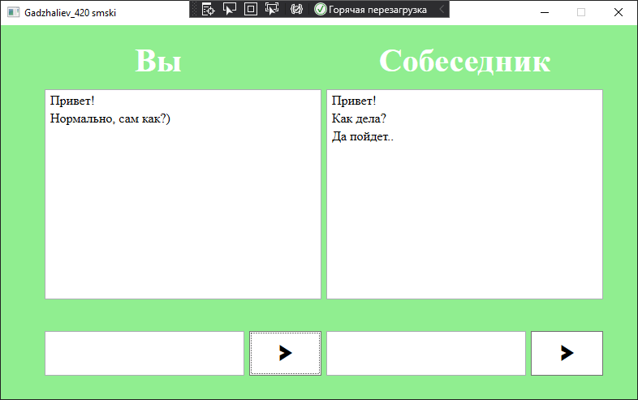

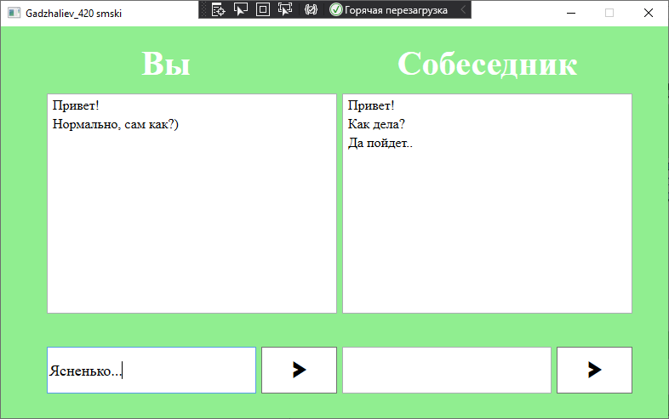

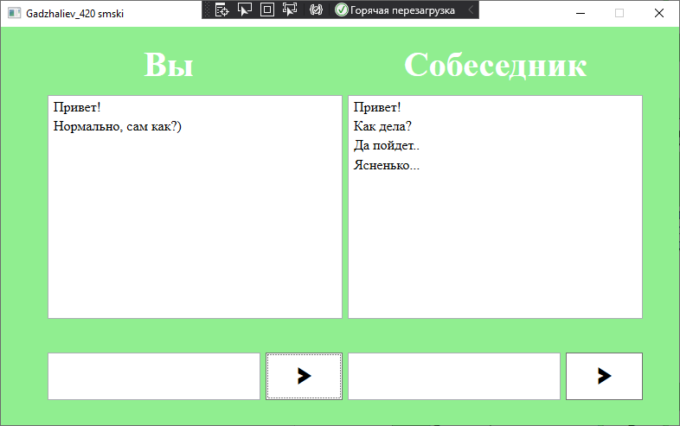

Вывод: я разобрался и переписал приложение под WPF.