Лабораторный практикум 2 по предмету

Программирование под Android

Тема: Приложение галерея моих любимых котиков.

Выполнил студент: Тетерин М.А.

Группы: ДБИ-301рки

Преподаватель: Сибирев И.В.

## Москва 2025

activity_main.xml

<?xml version="1.0" encoding="utf-8"?>  
<androidx.constraintlayout.widget.ConstraintLayout xmlns:android="http://schemas.android.com/apk/res/android"  
 xmlns:app="http://schemas.android.com/apk/res-auto"  
 xmlns:tools="http://schemas.android.com/tools"  
 android:id="@+id/main"  
 android:orientation="vertical"  
 android:layout_width="match_parent"  
 android:layout_height="match_parent"  
 tools:context=".MainActivity">  
  
 <TextView  
 android:id="@+id/tvTitle"  
 android:layout_width="420dp"  
 android:layout_height="32dp"  
 android:layout_marginStart="11dp"  
 android:layout_marginEnd="11dp"  
 android:layout_marginBottom="5dp"  
 android:text="Название картинки"  
 android:textAlignment="center"  
 app:layout_constraintBottom_toTopOf="@+id/btnAddCat"  
 app:layout_constraintEnd_toEndOf="parent"  
 app:layout_constraintHorizontal_bias="0.5"  
 app:layout_constraintStart_toStartOf="parent"  
 app:layout_constraintTop_toBottomOf="@+id/listViewCats" />  
  
 <Button  
 android:id="@+id/btnAddCat"  
 android:layout_width="wrap_content"  
 android:layout_height="wrap_content"  
 android:layout_marginBottom="28dp"  
 android:text="Добавить котика"  
 app:layout_constraintBottom_toBottomOf="parent"  
 app:layout_constraintEnd_toEndOf="parent"  
 app:layout_constraintStart_toStartOf="parent"  
 app:layout_constraintTop_toBottomOf="@+id/textView7" />  
  
 <ListView  
 android:id="@+id/listViewCats"  
 android:layout_width="420dp"  
 android:layout_height="0dp"  
 android:layout_marginTop="8dp"  
 android:layout_marginBottom="8dp"  
 android:dividerHeight="8dp"  
 app:layout_constraintBottom_toTopOf="@+id/textView7"  
 app:layout_constraintEnd_toEndOf="parent"  
 app:layout_constraintHorizontal_bias="0.5"  
 app:layout_constraintStart_toStartOf="parent"  
 app:layout_constraintTop_toTopOf="parent"  
 app:layout_constraintVertical_bias="0.5" />  
  
</androidx.constraintlayout.widget.ConstraintLayout>

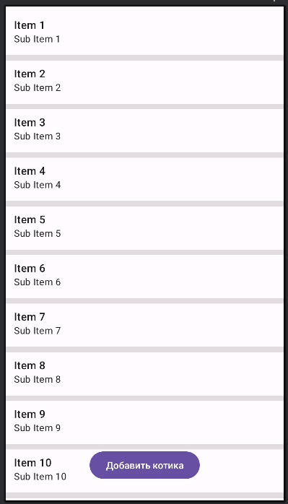

Рисунок 1 Лэйаут activity_main

item_cat.xml

<?xml version="1.0" encoding="utf-8"?>  
<LinearLayout xmlns:android="http://schemas.android.com/apk/res/android"  
 android:layout_width="match_parent"  
 android:layout_height="wrap_content"  
 android:orientation="horizontal"  
 android:padding="8dp">  
  
 <ImageView  
 android:id="@+id/imgCat"  
 android:layout_width="80dp"  
 android:layout_height="80dp"  
 android:scaleType="centerCrop"  
 android:src="@drawable/ic_launcher_foreground"/>  
  
 <TextView  
 android:id="@+id/tvCatName"  
 android:layout_width="wrap_content"  
 android:layout_height="wrap_content"  
 android:layout_marginStart="16dp"  
 android:text="Котик"  
 android:textSize="18sp"  
 android:gravity="center_vertical"/>  
  
</LinearLayout>

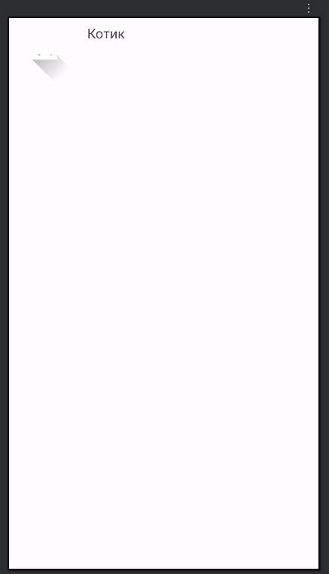

Рисунок 2 Лэйаут item_cat

MainActivity.java

package com.example.myapplication;  
  
  
import android.os.Bundle;  
  
import androidx.activity.EdgeToEdge;  
import androidx.appcompat.app.AppCompatActivity;  
import androidx.core.graphics.Insets;  
import androidx.core.view.ViewCompat;  
import androidx.core.view.WindowInsetsCompat;  
  
import android.os.Bundle;  
import android.view.View;  
import android.widget.Button;  
import android.widget.ListView;  
import android.widget.TextView;  
  
import androidx.appcompat.app.AppCompatActivity;  
  
import java.util.ArrayList;  
  
public class MainActivity extends AppCompatActivity {  
 private ArrayList<Cat> catList;  
 private CatAdapter adapter;  
 private int counter = 1; // для добавления новых котиков  
  
  
  
  
 @Override  
 protected void onCreate(Bundle savedInstanceState) {  
 super.onCreate(savedInstanceState);  
 setContentView(R.layout.*activity_main*);  
  
 TextView tvTitle = findViewById(R.id.*tvTitle*);  
 Button btnAddCat = findViewById(R.id.*btnAddCat*);  
 ListView listViewCats = findViewById(R.id.*listViewCats*);  
  
 // список котиков  
 catList = new ArrayList<>();  
 catList.add(new Cat("Барсик", R.drawable.*cat1*));  
 catList.add(new Cat("Мурка", R.drawable.*cat2*));  
  
 // адаптер  
 adapter = new CatAdapter(this, catList);  
 listViewCats.setAdapter(adapter);  
  
 // обработка кнопки  
 btnAddCat.setOnClickListener(new View.OnClickListener() {  
 @Override  
 public void onClick(View v) {  
 catList.add(new Cat("Котик " + counter, R.drawable.*cat_placeholder*));  
 counter++;  
 adapter.notifyDataSetChanged();  
 }  
 });  
 }  
}

Cat.java

package com.example.myapplication;  
  
public class Cat {  
 private String name;  
 private int imageResId;  
  
 public Cat(String name, int imageResId) {  
 this.name = name;  
 this.imageResId = imageResId;  
 }  
  
 public String getName() {  
 return name;  
 }  
  
 public int getImageResId() {  
 return imageResId;  
 }  
}

CatAdapter.java

package com.example.myapplication;  
import android.content.Context;  
import android.view.LayoutInflater;  
import android.view.View;  
import android.view.ViewGroup;  
import android.widget.BaseAdapter;  
import android.widget.ImageView;  
import android.widget.TextView;  
import java.util.List;  
  
public class CatAdapter extends BaseAdapter {  
 private Context context;  
 private List<Cat> catList;  
  
 public CatAdapter(Context context, List<Cat> catList) {  
 this.context = context;  
 this.catList = catList;  
 }  
  
 @Override  
 public int getCount() {  
 return catList.size();  
 }  
  
 @Override  
 public Object getItem(int position) {  
 return catList.get(position);  
 }  
  
 @Override  
 public long getItemId(int position) {  
 return position;  
 }  
  
 @Override  
 public View getView(int position, View convertView, ViewGroup parent) {  
 if (convertView == null) {  
 convertView = LayoutInflater.*from*(context).inflate(R.layout.*item_cat*, parent, false);  
 }  
  
 Cat currentCat = catList.get(position);  
  
 ImageView imgCat = convertView.findViewById(R.id.*imgCat*);  
 TextView tvCatName = convertView.findViewById(R.id.*tvCatName*);  
  
 imgCat.setImageResource(currentCat.getImageResId());  
 tvCatName.setText(currentCat.getName());  
  
 return convertView;  
 }  
}

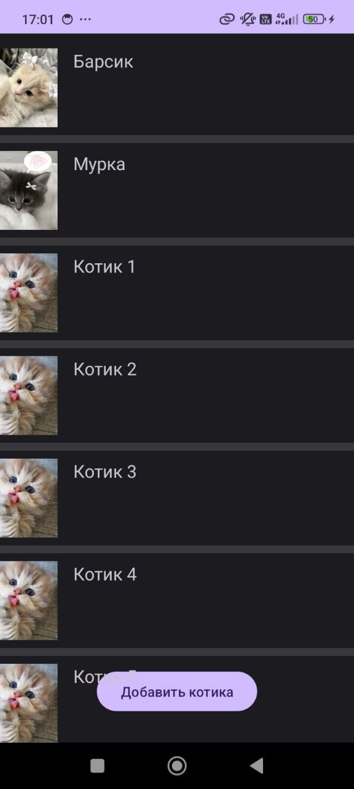

Рисунок 3 Скриншот работы приложения