Software Requirements Specification

for

QA Automation Course Blog

April 2019
Version 0.1

Prepared By
Team Errol

Table of Contents
1. Introduction 1
1.1 Purpose 1
1.2 Scope 1
1.3 Overview 1
2. Overall Description 2
2.1. Product Functions 2
2.1.1. User Types 2
2.1.2. Page Content 2
2.1.3. Articles 2
2.2. General Constraints 3
2.3. Format Fields Constrains: 3
2.4. Assumptions and Dependencies: 4
3. Specific Requirements 5
3.1. Functional Requirements 5
3.1.1. Use case diagrams 6
3.2 Non-Functional Requirements 8
3.2.1 Performance 8
3.2.2 Availability 8
3.2.3 Supportability 9
3.2.4 Security 9
3.2.5 Portability 10
4 Mock-ups 10
4.1 Home page 10
4.2 Login page 10
4.3 Register page 11
4.4 Articles 11
4.5 Manage Users 12

Introduction

Purpose

Scope

Overview

2. Overall Description

2.1. Product Functions

2.1.1. User Types

2.1.2. Page Content

2.1.3. Articles

2.2. General Constraints
- Application requires Internet connection.
- The application must be Web-based.
- The product will only work within a particular network environment
- The system should be up 24/7

2.3. Format Fields Constrains:
“Email address” field:
Emails are considered to be in format <user>@<host>, where:
- <user> is a sequence of letters and digits, where '.', '-' and '_' can appear between them.
- <host> is a sequence of at least two words, separated by dots '.'. Each word is sequence of letters and can have hyphens '-' between the letters
“Full Name” field:
- “full name” is a sequence of letters, special symbols, blank spaces and digits
- Small and capital letters from Latin alphabet
- Minimum length of 3 characters
- Maximum length of 50 characters
- Each name must start with small or capital letter
“Password” field:
- A minimum of 6 characters is required.
- Maximum length of 50 characters
- Small and capital letters from Latin alphabet
- Password can be mix of uppercase and lowercase characters, numbers and punctuation.
“Confirm password” field:
- Exact match with “Password” field input
“Current password” field:
- Exact match with “Password” field input upon login

“Article Title” field:
- Minimum length of 5 characters
- Maximum length of 50 characters
“Article Content” field:
- Minimum length of 100 characters
- Maximum length of 2000 characters

2.4. Assumptions and Dependencies:
The availability and load time of the Blog depends on user’s internet connection strength which also depends on the media from which the product is run.
The performance depend upon hardware components of the user’s machine.

3. Specific Requirements

3.1. Functional Requirements
The application should support the following use cases:

CLASS OF USE CASES | № | USE CASES | DESCRIPTION OF USE CASES
Related to System Authentication | 1 | Register | Register in the blog
Related to System Authentication | 2 | Log in | Login in the blog
Related to Articles | 3 | View articles | View articles with/without login
 | 4 | Create article | Only Logged user is able to create article
 | 5 | Edit article | Only Logged user is able to edit his own article. Admins are able to edit all articles.
 | 6 | Delete article | Only Logged user is able to delete his own article. Admins are able to delete all articles.
 | 7 | Comment article | Only Logged user is able to comment articles.
Related to Admin Rights | 8 | Edit user | Admins can edit other user’s “Email”, “Full Name”, “Password”, “User Status”(from user to admin and vice versa)
 | 9 | Delete user | Admins can delete other user’s profiles(this should not include deleting of admin profiles)

3.1.1. Use case diagrams
Use Case Diagram №1: Register
Primary Actor: User
Pre Condition: Installed browser and active internet connection. User hits „QA Automation blog” url in the address bar. User is redirected to “QA Automation blog” main page. From there user hits “Register” and is redirected to registration page of the blog.

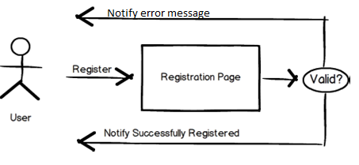

Use case Diagram №2: Login
Primary Actor: Registered User
Pre Condition: Registered user select the “Log in” button and is redirected to “Log in” page of the blog.

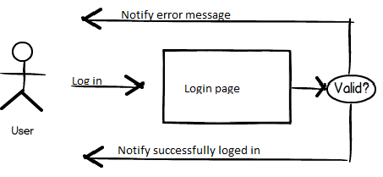

Use case Diagram №3: Create article
Primary Actor: Registered User
Pre Condition: Registered user is logged into „QA Automation blog” page. User selects “Create” button in order to create article.
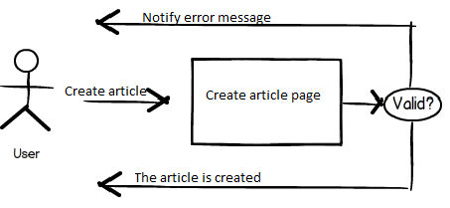

Use case Diagram №4: Edit article
Primary Actor: Registered User
Pre Condition: Registered user is logged into „QA Automation blog” page and selects an own article in order to modify(edit, delete). User selects “Create” button in order to create article.

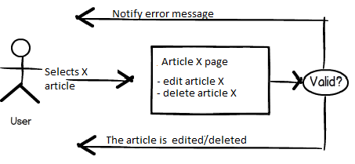

3.2 Non-Functional Requirements

3.2.1 Performance

3.2.2 Availability

3.2.3 Supportability
Compatible with Browsers
- Microsoft Internet Explorer
- Mozilla Firefox
- Google Chrome
- Opera mini
- Safari

3.2.4 Security

Data Transfer

Data Storage

3.2.5 Portability

Mock-ups

Home page
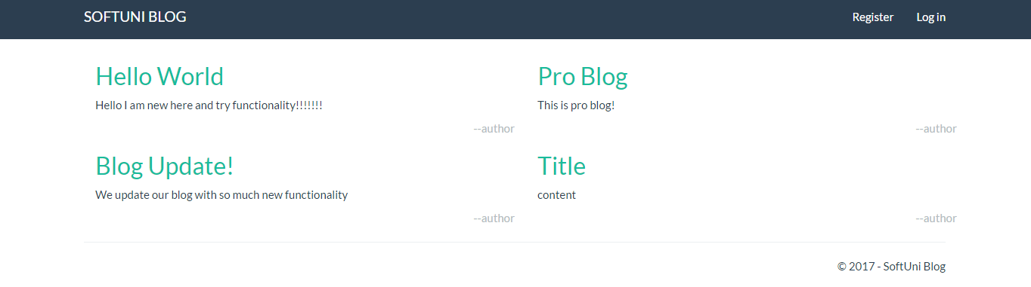

Login page
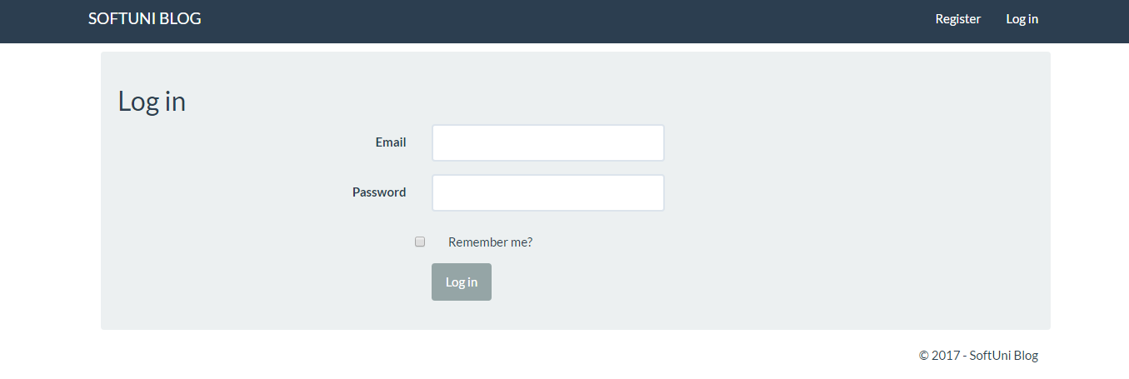

Register page

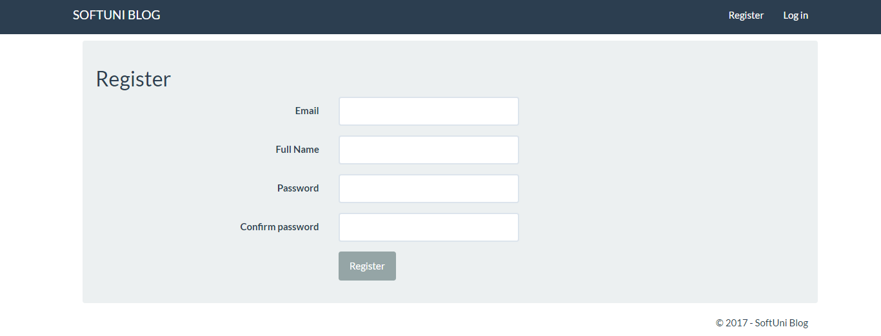

Articles

- Create article

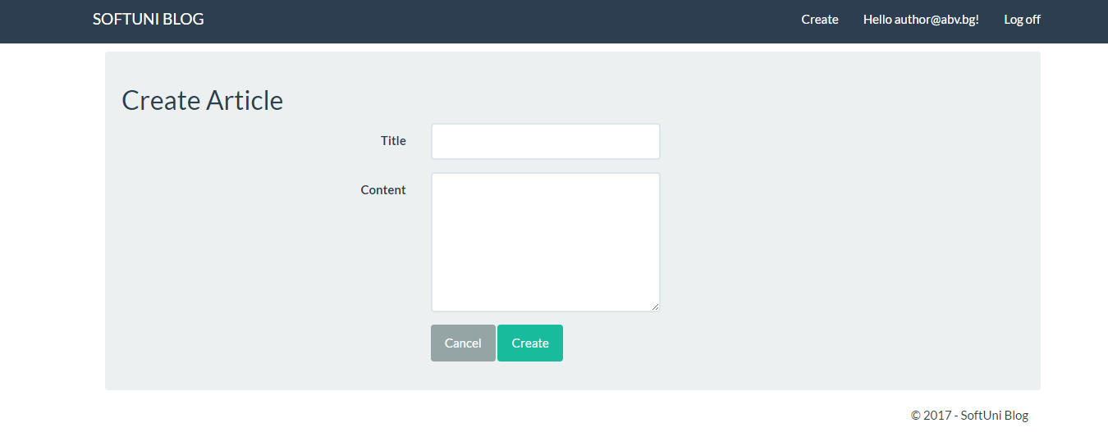
- Update article

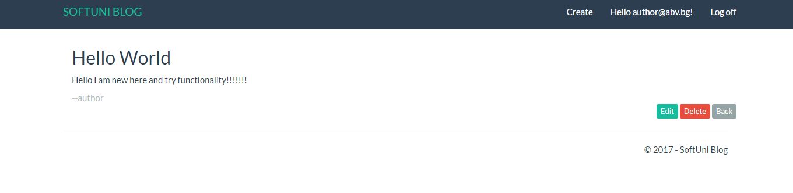

Manage Users

- View users

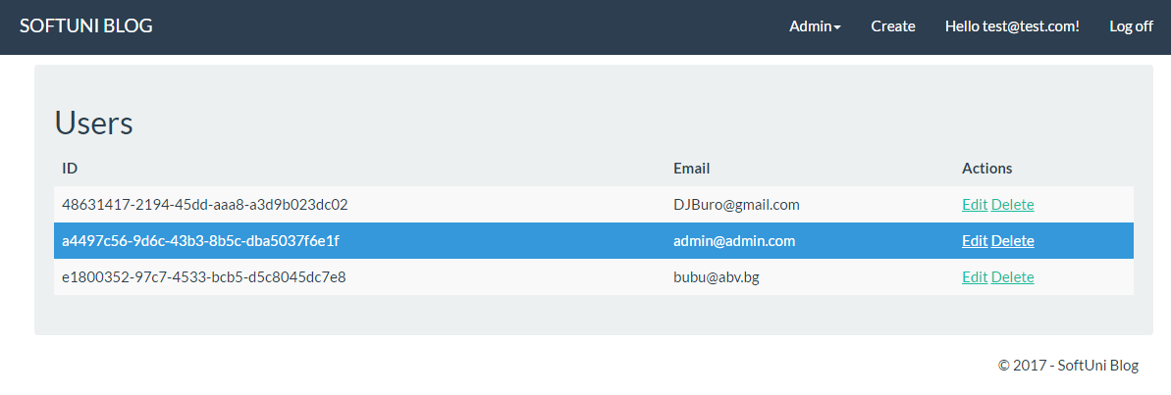

- Edit users

