PERSONAL DATA

|  |  |
| --- | --- |
| **Name:** | Strazhevich Ivan |
| **Location:** | Belarus, Minsk |
| **Mobile:** | +375 (29) 7554895 |
| **E-mail:** | vanechkas@gmail.com |
| **Skype:** | busiksky |
| **LinkedIn:** | [www.linkedin.com/in/ivan-strazhevich-658b54148/](http://www.linkedin.com/in/ivan-strazhevich-658b54148/) |
|  |  |

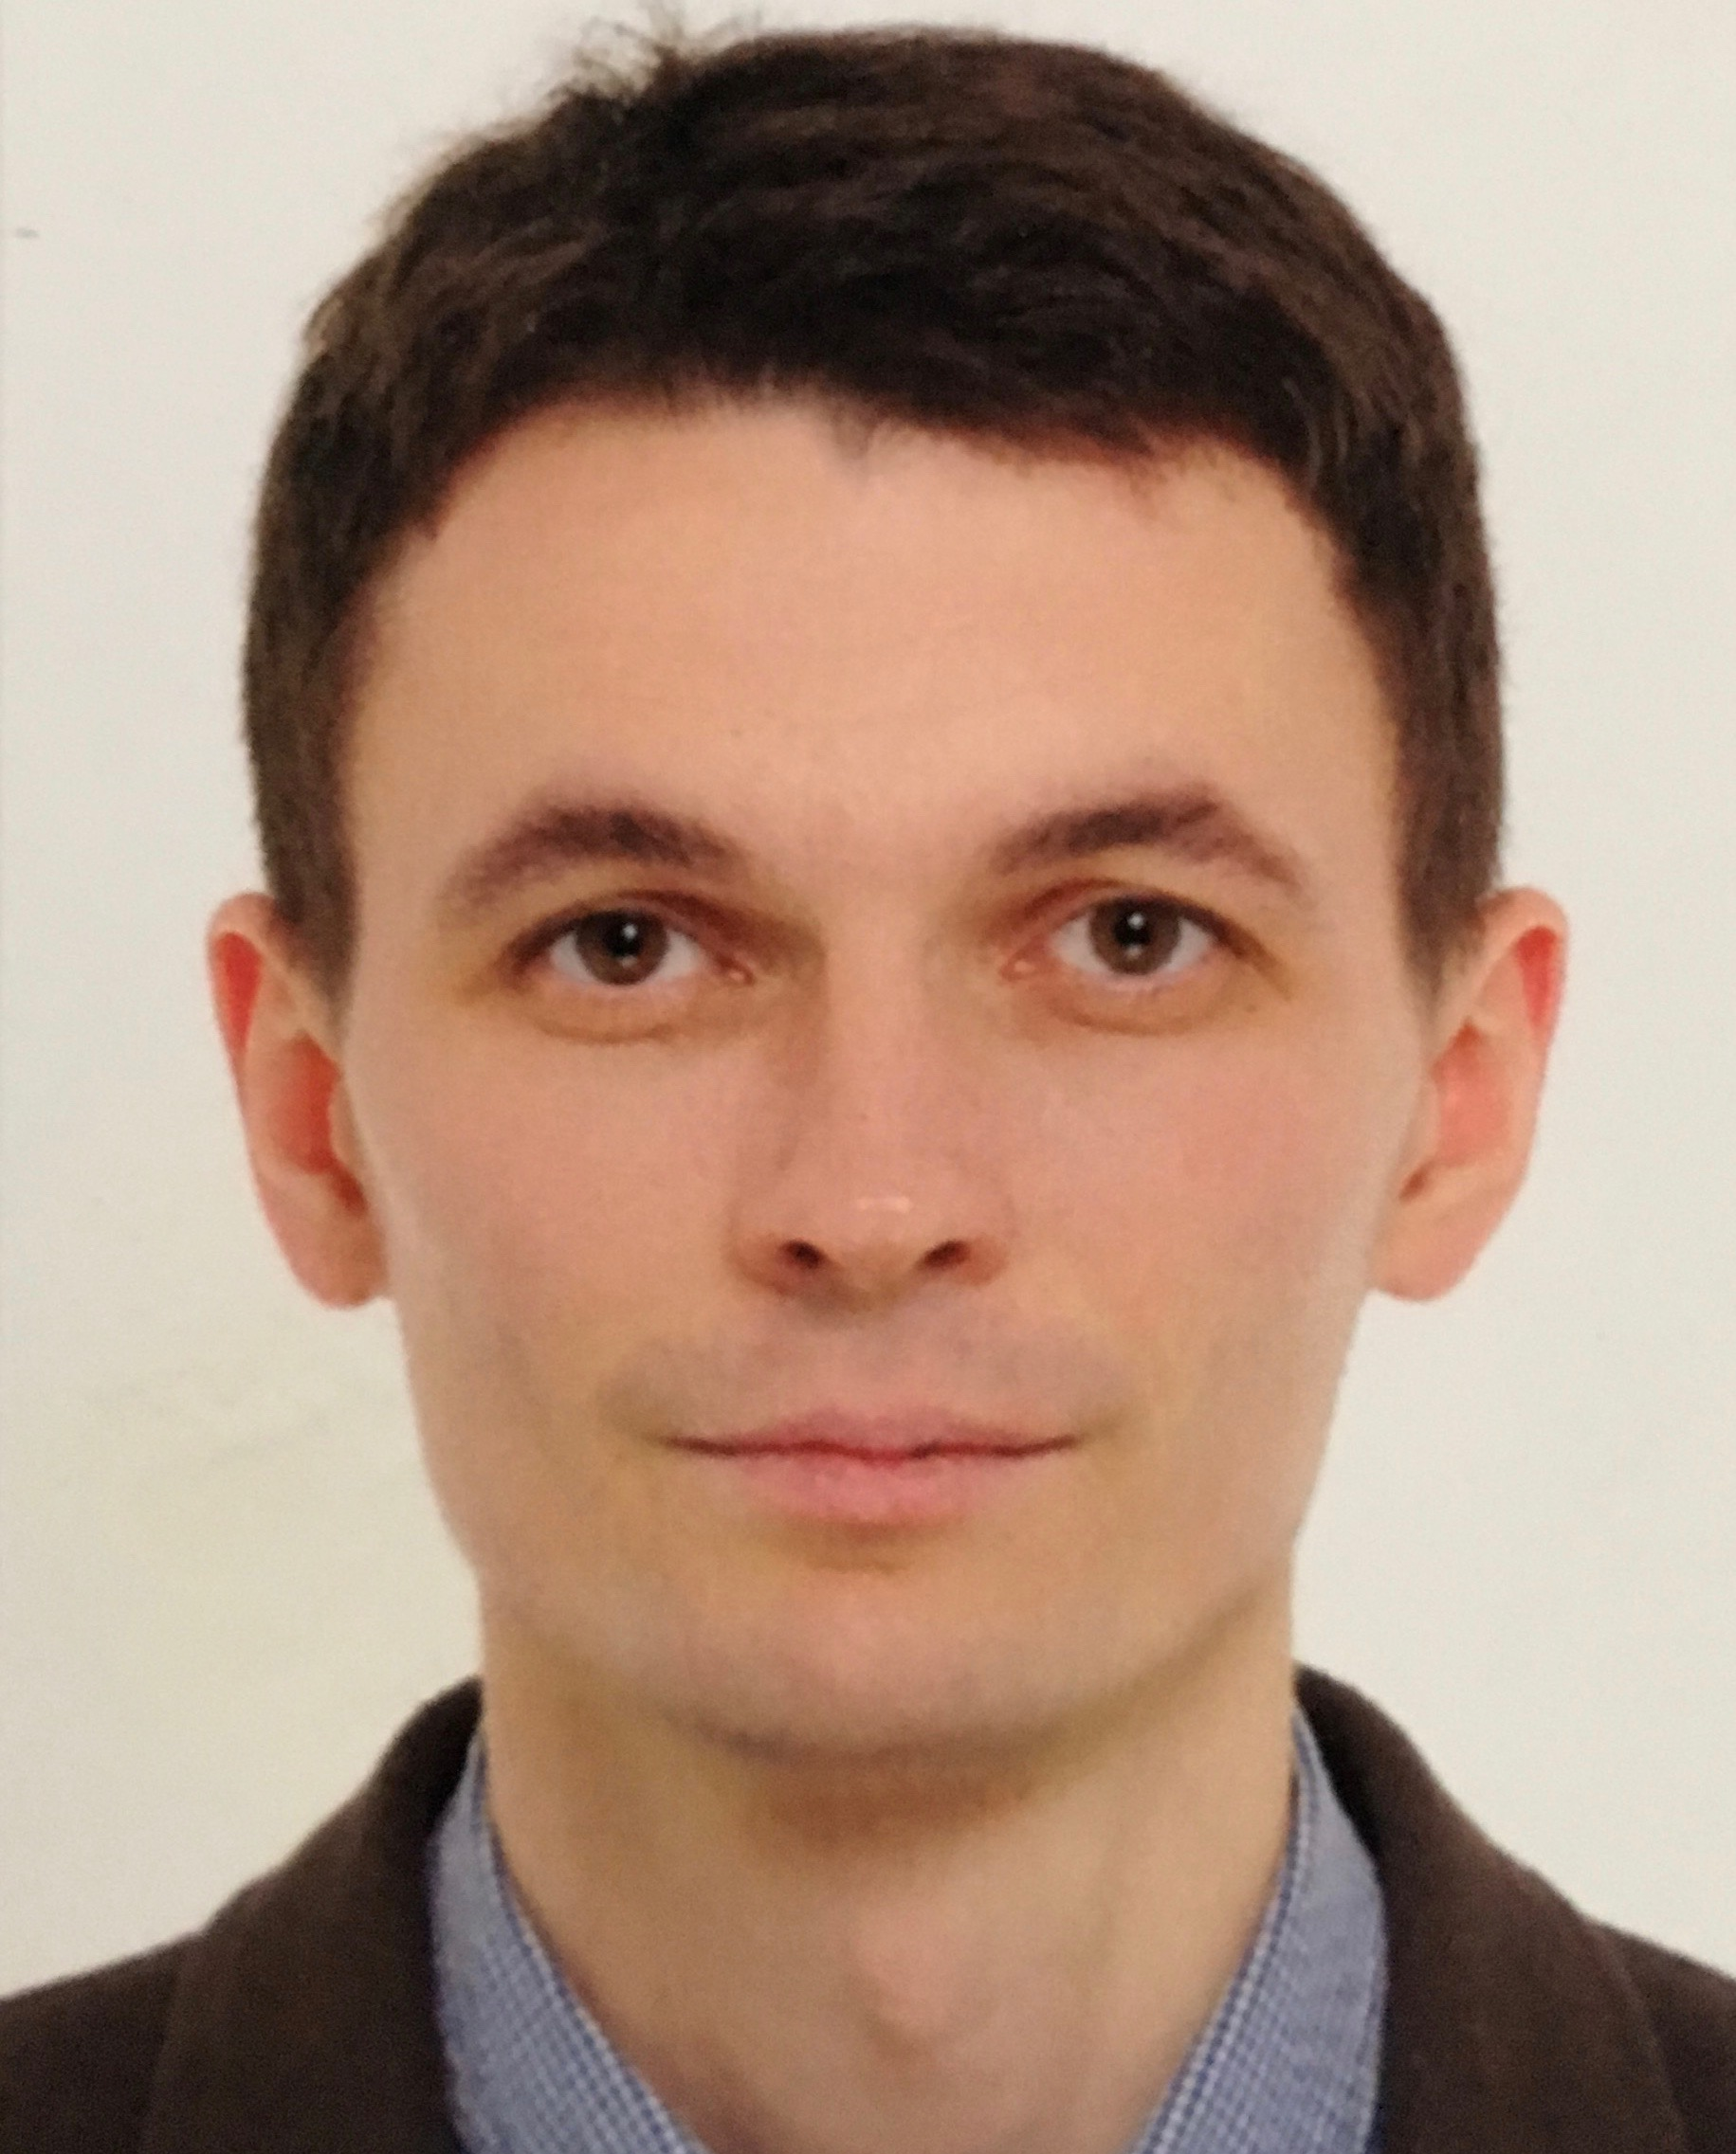

OBJECTIVE

|  |  |
| --- | --- |
| **Desired Position:** | Junior Java developer |

SUMMARY OF QUALIFICATION

|  |
| --- |
| I am working with Java platform starting from the **end of 2016**.  My current stack of technologies is:  **Java EE, JSF, Spring, Hibernate, MySQL**  My github account : <https://github.com/IvanStrazhevich> |

TECHNICAL SKILLS

* Java SE, Java EE
* Spring(basics), EJB
* MySQL, PostgreSQL,
* Hibernate, JPA (Eclipcelink)
* HTML5, JSP, JSF
* Git, Maven
* Junit,
* IntelliJIDEA,

RELEVANT EXPERIENCE

* Small web-apps development
* Small features development
* Work with technical documentation
* Good communication skills
* Knowledge sharing

LANGUAGES

* Russian – Native Speaker
* English – Intermediate
* Italian - Elementary

EDUCATION

* 05/2018-present time Web Development EPAM Systems training.by / Minsk, Belarus
* 01/2018-04/2018 Java From Scratch EPAM Systems training.by / Minsk, Belarus
* 2016-2017 / Pavel Veinik’s programming school itStart.by / Minsk, Belarus
* 2000-2005 / Belarusian institute of law/ Lawyer / Minsk, Belarus
* 1997-2000 / Belarusian college of business and law / Lawyer / Minsk, Belarus

OTHER INFORMATION

|  |
| --- |
| I am married and have a son, born on 2012. From 2000 I’ve worked as self-employe enterpreneur B2C and B2B sales BY->RU. On my free time I love to read, travel, skiing, snorkeling, hiking. Also, I spend my free time on self-education. I do yoga as professional hobby and lead individual and group classes. |

PROFESSIOANL EXPERIENCE

|  |  |
| --- | --- |
| **E-learning assistant “PUSHka”** | |
| **Company:** | OOO “Obrazovatel'noye programmnoye obespecheniye” (Education software, Ltd.) |
| **Project Industry:** | E-learning, distance learning, MOOC |
| **Solution Web Site:** | [www.pushkaapp.com](http://www.pushkaapp.com),  [http://pushka.azurewebsites.net](http://pushka.azurewebsites.net" \t "_blank) |
| **Business Location:** | Belarus |
| **Duration:** | 11/2017 – 01/2018 |
| **Project Description:** | The development of cross-platform solutions for choosing and planning of the distance learning. It includes the development of mechanisms for planning courses sites like “coursera.org” etc., a variety of the UI, the course catalog, a personal assistant. The solution for B2B and B2C sectors. |
| **Position:** | Java developer, trainee |
| **Overall Team Size:** | 2 developers, 1 system architect, 1 QA engineer, 1 designer, 1 manager, 1 marketer |
| **Responsibilities:** | * Fetching data console app development |
| **Tools & Technologies:** | **Platforms:**   * Java EE   **Tools:**   * IntelliJIdea * MySQL Workbench   **Languages & Technologies:**   * JavaEE * Hibernate * MySQL * JUnit * Spring |

|  |  |
| --- | --- |
|  | |
| **Company:** | ItStart.by |
| **Company Web Site:** | www.ItStart.by |
| **Company Location:** | Minsk, Belarus |
| **Duration:** | 11/2016 – 07/2017 |
| **Position:** | Student (paid training) |
| **Responsibilities:** | * Learning Java platform and related technologies   Here is a link to my project while I was studying: <https://bitbucket.org/IvanStrazhevich/cskhib/src/9f17530f40a932f8c4688726b3858a2177d02c24?at=master> |
| **Tools & Technologies:** | * Java SE * Java EE * MySQL * JDBC * Maven * Git * Junit(basics) * Hibernate ORM * Spring (basics) * Tomcat |

And another link to one project after I finished courses, using JSF 2.0, JPA (Eclipselink), EJB, Postgresq:  
<https://bitbucket.org/IvanStrazhevich/sccoffeeshoprl/src/7ebafdea84076a2392f8b8567a0bee844c594e5c?at=master>