Introduction to Vision and Robotics
coursework report
by Ivan Sun s1800640 & Michitatsu Sato

Part 2: Robot Vision
Algorithm:
In this part we used two python files named image1.py and image2.py to receive the image information from the two cameras and then process it. In image1.py we can get the image from camera01 and then get the coordinates of the y axis and z axis. If the joints might not be visible from the camera01, we can not get the z coordinates( y will be the same as the ones which block the joints) and we will set the y coordinate 0 and we will get the y coordinates in the other py file. And we will publish the result as “/robot/y_z”. The same for image2.py and we will publish “/robot/x_z”. Now we create a py file named joint_state_estimation.py which will subscribe the two previous publishers using two callback functions and use another function to estimate the angles.
Validation:
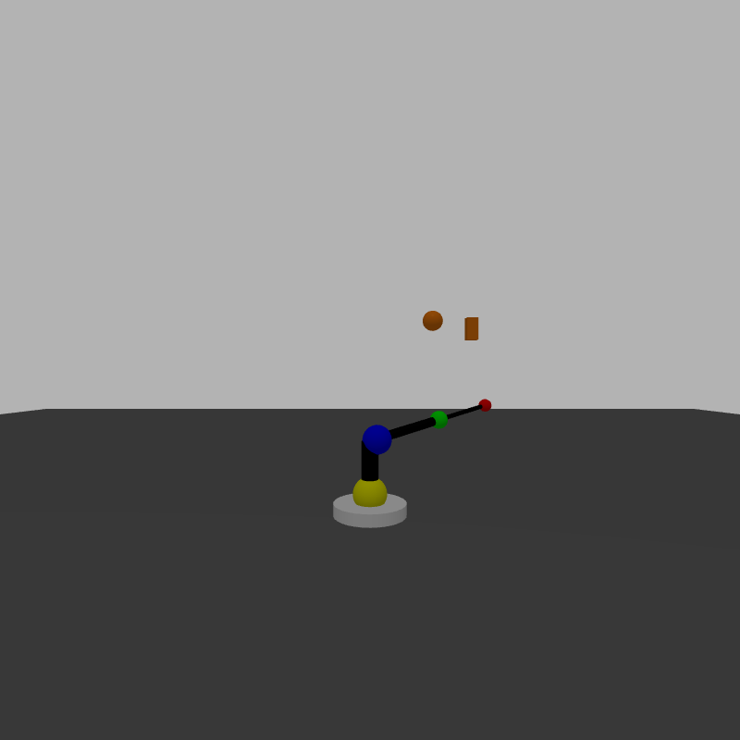
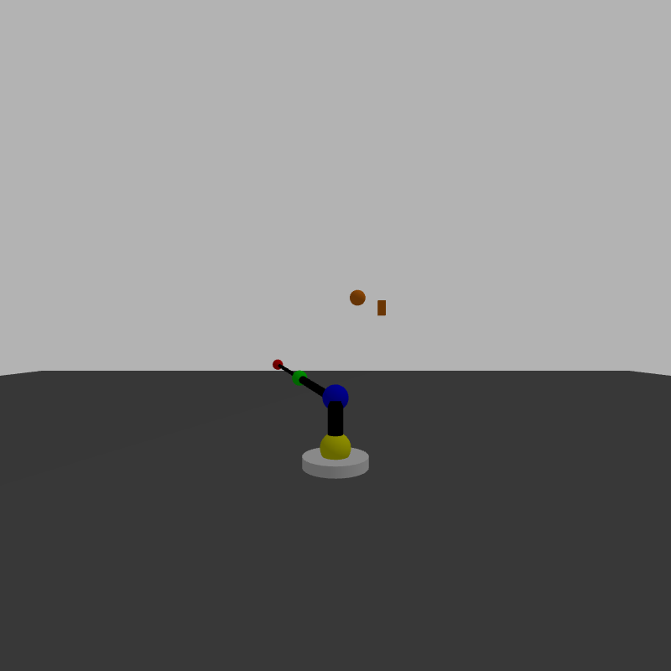
t = 20
joint2 = (pi/2)*Sin[(pi/15)*20] = -1.360
joint3 = (pi/2)*Sin[(pi/18)*20] = -0.537
joint4 = (pi/2)*Sin[(pi/20)*20]] = 0.0
estimation:
joint2 = -1.289 joint3 = -0.542 joint4 = -0.096
image_copy_1.png image_copy_2.png
t = 50
joint2 = (pi/2)*Sin[(pi/15)*50] = -1.360
joint3 = (pi/2)*Sin[(pi/18)*50] = 1.010
joint4 = (pi/2)*Sin[(pi/20)*50] = 1.571
estimation:
joint2 = -1.530 joint3 = 0.986 joint4 = 1.648

