ROLLS-ROYCE HOLDINGS PLC
Independent Equity Research & Valuation
LSE: RR. • Aerospace & Defence • Valuation date 8 October 2026
Rating: SELL
Blended fair value £8.66 vs share price £13.67: 36.7% downside
A high-quality turnaround priced for considerably more than its published targets
Ivan Tan • BSc Mathematics with Statistics, University of Bath
Prepared October 2026 • Market data as at 8 October 2026 • Latest results: H1 2026 (30 July 2026)
Independent educational research project. Not investment advice.

Contents

1. Executive summary
Recommendation: SELL. Rolls-Royce has delivered one of the most successful industrial turnarounds in Europe. Underlying operating profit rose from £2.5bn in 2024 to £3.5bn in 2025 and guidance for 2026 has been raised to £4.7–4.9bn. Free cash flow has risen sixfold since 2022, and the balance sheet has moved to net cash. The business is far better than it was. Our concern is the price.
At £13.67 the shares trade on 32.6x our 2026E underlying EPS of 41.9p and a 2026E free-cash-flow yield of 3.5%. Our base-case DCF, which assumes Rolls-Royce meets its 2028 targets (operating profit £4.9–5.2bn, FCF £5.0–5.3bn), gives £6.58 per share. A blend of DCF, peer P/E and peer EV/Revenue gives £8.66, 36.7% below the current price. Even our bull case (£8.36), in which the targets are beaten and 2030 FCF reaches about £7bn, falls short of the share price.
A reverse DCF puts numbers on the gap. To justify the share price, investors need cash flows about 2.1x our base case, or a discount rate of about 7% rather than our CAPM-based 12.3%. The market is pricing several more years of upgrades. That may happen, because the H1 2026 margin of 22.5% is already above the 18–20% 2028 target. But it leaves little room for error in a business with 42% annualised share-price volatility and a 55% drawdown within the last five years.
Key data
Share price (8 Oct 2026) | £13.67 | Market cap £112.5bn
DCF value (FCFF/WACC, base) | £6.58 | (51.8%)
Bear / bull DCF | £5.37 / £8.36 | Prob.-weighted £6.72
Peer P/E value (LTM) | £10.88 | Engine peers £12.61
Peer EV/Revenue value (LTM) | £8.37 | Engine peers £14.72
Blended value (40/40/20) | £8.66 | (36.7%)
2026E P/E / FCF yield | 32.6x | 3.5%
WACC / terminal growth | 12.3% | 2.5%
Market-implied cash flows vs base | 2.1x | Implied WACC ≈ 7%
Sources: Rolls-Royce FY2025 and H1 2026 results; market data snapshot 8 October 2026; Rolls_Royce_Equity_Research_Model.xlsx.

Investment thesis in brief
- Quality — positive. A large installed base of Trent engines earning flying-hour-linked aftermarket revenue, high barriers to entry, structural tailwinds in defence and data-centre power, and a cost base that has been reset (TCC/GM 0.36x vs 0.47x).
- Momentum — positive. Margin expansion in every division, raised 2026 guidance, a £7–9bn buyback programme for 2026–28 and dividends reinstated.
- Valuation — negative. The share price already discounts outcomes well beyond management's published targets. On every method we use, value is below the current price.
- What would change our view: a new set of mid-term targets with operating profit materially above £5.2bn, sustained 20%+ group margins, or a share price below c.£9–10 (our blended value plus a margin of safety).

2. Company and business model
Rolls-Royce Holdings plc designs, manufactures and services power and propulsion systems for safety-critical uses. It is not connected with Rolls-Royce Motor Cars, which BMW owns. It reports three main divisions:
- Civil Aerospace (52% of 2025 underlying revenue). Trent engines for widebody aircraft, plus business-aviation engines. About 69% of divisional revenue comes from services, mostly long-term service agreements (LTSAs) priced per flying hour. LTSA invoiced receipts were c.£6.0bn in 2025 (2024: £5.5bn).
- Defence (24%). Combat and transport aircraft engines, naval and submarine propulsion including the UK nuclear programme, the F130 engine for the US B-52, and GCAP. The defence order backlog is c.£17.5bn, more than three years of revenue.
- Power Systems (24%). mtu engines and generator sets for data centres, government, marine and industrial customers, plus battery storage. Rolls-Royce SMR (small modular reactors) is long-term optionality and not material to earnings today.
The economics turn on original equipment vs aftermarket. New engines are often sold at low or negative margins to win platform positions. The profit comes later from decades of servicing an installed fleet. That makes flying hours, engine time-on-wing and LTSA pricing the main value drivers in Civil Aerospace. Management's plan to more than double the durability of in-production Trent engines by the end of 2027 cuts shop-visit costs under fixed-price contracts.

3. Historical financial performance
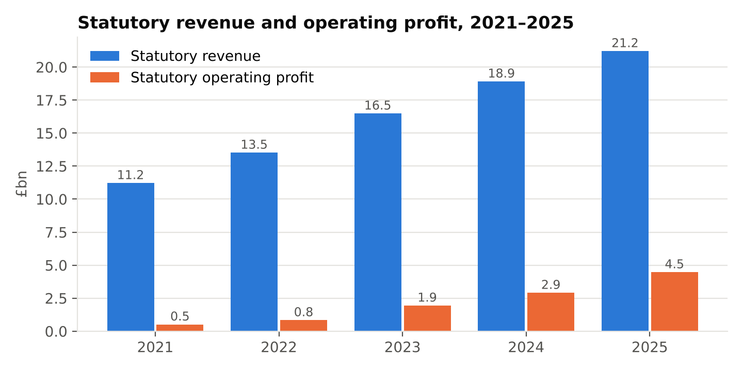
£m (statutory) | 2021 | 2022 | 2023 | 2024 | 2025
Revenue | 11,218 | 13,520 | 16,486 | 18,909 | 21,207
Revenue growth | – | 20.5% | 21.9% | 14.7% | 12.2%
Operating profit | 513 | 837 | 1,944 | 2,906 | 4,468
Operating margin | 4.6% | 6.2% | 11.8% | 15.4% | 21.1%
Operating cash flow | (259) | 1,850 | 2,485 | 3,782 | 4,565
Free cash flow (company-defined) | (1,485) | 505 | 1,285 | 2,425 | 3,270
Net debt / (net cash) | 5,157 | 3,251 | 1,952 | (475) | (1,895)
Total equity | (4,636) | (6,016) | (3,629) | (881) | 2,753
Source: Rolls-Royce annual reports 2021–2025; model tab Historicals. Free cash flow and net cash are company-defined measures.
Statutory revenue grew at a 17.3% CAGR from 2021 to 2025. Growth slowed from 21.9% in 2023 to 12.2% in 2025 as the post-COVID recovery in flying hours matured. Profit grew much faster: statutory operating margin rose from 4.6% to 21.1%. Cash conversion improved too, with FCF moving from an outflow of £1.5bn to an inflow of £3.3bn. Shareholders' equity turned positive in 2025 for the first time in the period. As a result, ROE (212% in 2025) is not meaningful and we do not use it.
Statutory vs underlying. Statutory operating profit (£4.5bn) exceeds underlying (£3.5bn) in 2025 mainly because of foreign-exchange hedging. Underlying results use the rates achieved on hedges, while statutory results include mark-to-market movements. Statutory profit before tax of £6.9bn is inflated further by those hedge gains. Our forecasts and valuation use underlying figures throughout. We also normalise the tax rate to 26%. The reported 2025 underlying tax charge of 17.7% included a one-off £277m deferred-tax credit, which the company itself excludes from underlying EPS.

4. Segment analysis
Underlying, £m | Revenue 2024 | Revenue 2025 | Organic growth 2025 | OP 2025 | Margin 2025 | Margin H1 2026 | H1 2026 organic growth
Civil Aerospace | 9,040 | 10,382 | 15% | 2,130 | 20.5% | 25.3% | 29%
Defence | 4,522 | 4,772 | 8% | 689 | 14.4% | 21.0% | 17%
Power Systems | 4,271 | 4,892 | 19% | 852 | 17.4% | 20.3% | 28%
Other / corporate | 15 | 13 | – | (209) | n.m. | n.m. | –
Group | 17,848 | 20,059 | – | 3,462 | 17.3% | 22.5% | –
Source: FY2025 and H1 2026 results; model tab Segments.
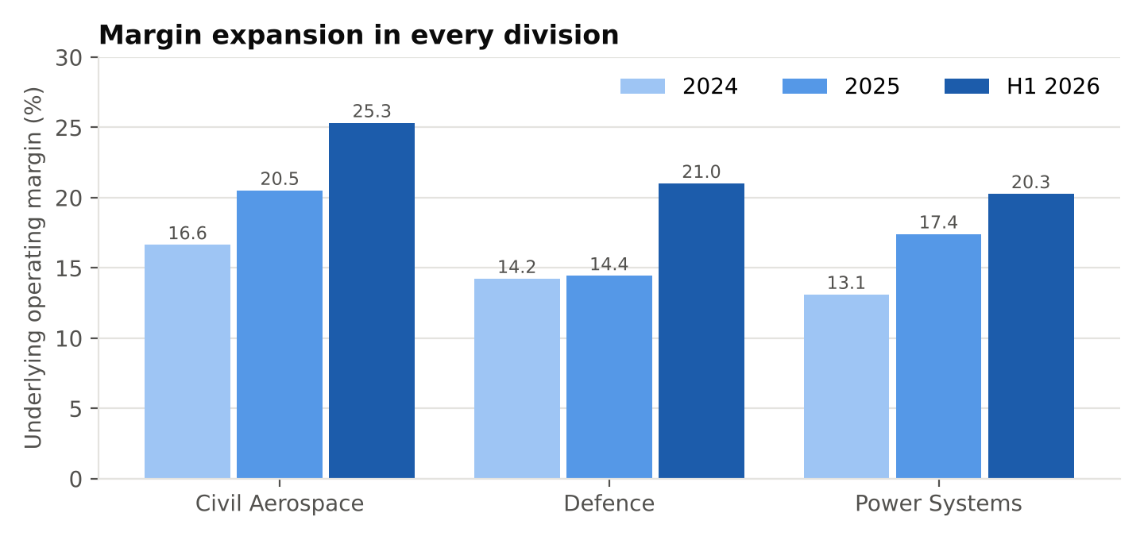
Civil Aerospace is the profit engine: 58% of divisional operating profit in 2025, before corporate costs. Its H1 2026 margin of 25.3% reflects pricing, contract renegotiation and better time-on-wing. Defence margins jumped to 21.0% in H1 2026, against a 14–16% mid-term target. That partly reflects timing, so we would not extrapolate it. Power Systems has the fastest growth in operating profit (+52% reported in 2025). It is driven by data-centre gensets, and management targets c.20% annual OE growth in power generation. Half-year growth rates should not be annualised: H1 2026 benefited from a weaker comparison period and contract timing.

5. 2026 trading and guidance
The H1 2026 results (30 July 2026) were strong: underlying revenue £11.3bn (+24.5%), operating profit £2.53bn (+46%), margin 22.5% (H1 2025: 19.1%), FCF £1.96bn, net cash £2.14bn and return on capital 22.0%. Full-year 2026 guidance rose from £4.0–4.2bn to £4.7–4.9bn operating profit and from £3.6–3.8bn to £3.8–4.0bn FCF. The 2026 buyback is £2.5bn (£1.4bn completed by the results date), with an interim dividend of 6.0p.
The upgraded 2026 guidance is already near the bottom of the 2028 operating-profit target range of £4.9–5.2bn. A new set of mid-term targets is likely at some point. This is the main argument against our base case, and we test it in the bull scenario.

6. Forecasts (base case)
£m | 2024A | 2025A | 2026E | 2027E | 2028E | 2029E | 2030E
Underlying revenue | 17,848 | 20,059 | 23,008 | 24,204 | 25,802 | 26,808 | 27,612
Revenue growth | – | 12.4% | 14.7% | 5.2% | 6.6% | 3.9% | 3.0%
Underlying operating profit | 2,464 | 3,462 | 4,800 | 4,950 | 5,050 | 5,100 | 5,150
Operating margin | 13.8% | 17.3% | 20.9% | 20.5% | 19.6% | 19.0% | 18.7%
Underlying EPS (p) | 20.3 | 29.6 | 41.9 | 44.3 | 46.4 | 48.0 | 49.4
Free cash flow | 2,425 | 3,270 | 3,900 | 4,500 | 5,150 | 5,300 | 5,460
FCF margin | 13.6% | 16.3% | 17.0% | 18.6% | 20.0% | 19.8% | 19.8%
Source: model tabs Inputs and Forecast. Tax rate 26%; average shares fall from 8.28bn (2026E) to 7.55bn (2030E) as buybacks continue.
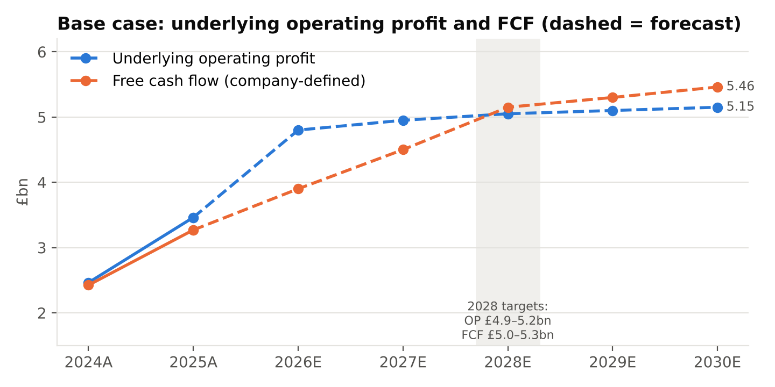
The base case anchors on raised 2026 guidance (mid-point) and lands inside every 2028 target range: operating profit £5.05bn, margin 19.6% and FCF £5.15bn. Beyond 2028 we assume low growth. Margin drifts down to 18.7% in 2030 as revenue mix shifts towards lower-margin OE deliveries and LTSA pricing benefits fade. This is a deliberately conservative base case. If H1 2026 margins persist, it will prove too low. Underlying EPS grows from 29.6p (2025A) to 49.4p (2030E), a 10.8% CAGR helped by buybacks.

7. Valuation

7.1 Discounted cash flow (primary method)
We discount free cash flow to the firm (FCFF) at the weighted average cost of capital (WACC). FCFF equals company-defined FCF plus after-tax net finance costs. Net finance costs are small because the group has net cash. We value from the 30 June 2026 balance sheet, include only H2 2026 cash flow for 2026, use mid-period discounting and add reported net cash of £2.1bn to reach equity value.
WACC build | Value | Basis
Risk-free rate | 5.43% | UK 10-year gilt, 8 Oct 2026
Equity beta | 1.58 | FT; Python estimate 1.65 vs FTSE 100
Equity risk premium | 4.5% | Assumption (UK range c.4–6%)
Cost of equity | 12.5% | CAPM
After-tax cost of debt | 4.8% | Gilt + 1.0%, 26% tax
Weights (E / D) | 96% / 4% | Market cap £112.5bn; debt + leases £4.3bn
WACC | 12.3%
Terminal growth | 2.5% | Long-run nominal GDP proxy

DCF output | £bn
PV of explicit FCFF (H2 2026–2030) | 17.4
PV of terminal value | 34.6
Enterprise value | 52.0
Add: net cash (30 Jun 2026) | 2.1
Equity value | 54.2
Value per share (8.23bn shares) | £6.58
Terminal value share of EV | 66.5%
The original draft method (company FCF discounted at the cost of equity) gives £6.31, within 5% of the FCFF result, so the conclusion does not depend on which DCF variant is used.

7.2 Sensitivity
WACC \ g | 1.5% | 2.0% | 2.5% | 3.0% | 3.5%
8.0% | £10.01 | £10.67 | £11.44 | £12.38 | £13.52
9.0% | £8.71 | £9.18 | £9.73 | £10.37 | £11.12
10.0% | £7.71 | £8.07 | £8.47 | £8.93 | £9.46
11.0% | £6.93 | £7.20 | £7.51 | £7.85 | £8.24
12.0% | £6.30 | £6.51 | £6.75 | £7.02 | £7.31
13.0% | £5.78 | £5.95 | £6.14 | £6.35 | £6.58
Value per share (£). Rows: WACC; columns: terminal growth. Base case highlighted (WACC 12.3% sits between the 12% and 13% rows). Model tab Sensitivity.
Even at an 8% WACC and 3.5% terminal growth (£13.52), the base-case cash flows do not reach the share price. The discount rate matters, but the gap comes mainly from the cash-flow path.

7.3 Relative valuation
Against four peers (BAE Systems, Airbus, Safran, GE Aerospace), Rolls-Royce trades at a premium. Applying the peer median trailing P/E of 30.2x to Rolls-Royce's last-twelve-months underlying EPS of 36.0p gives £10.88. Using only the closest business-model peers, Safran and GE Aerospace (35.0x), gives £12.61. The peer median EV/Revenue of 2.88x gives £8.37. That method penalises Rolls-Royce for Airbus's and BAE's lower margins, so it carries only a 20% weight. On engine-peer EV/Revenue (5.1x) the value is £14.72, the only method that gets above the share price.

7.4 Scenarios and reverse DCF
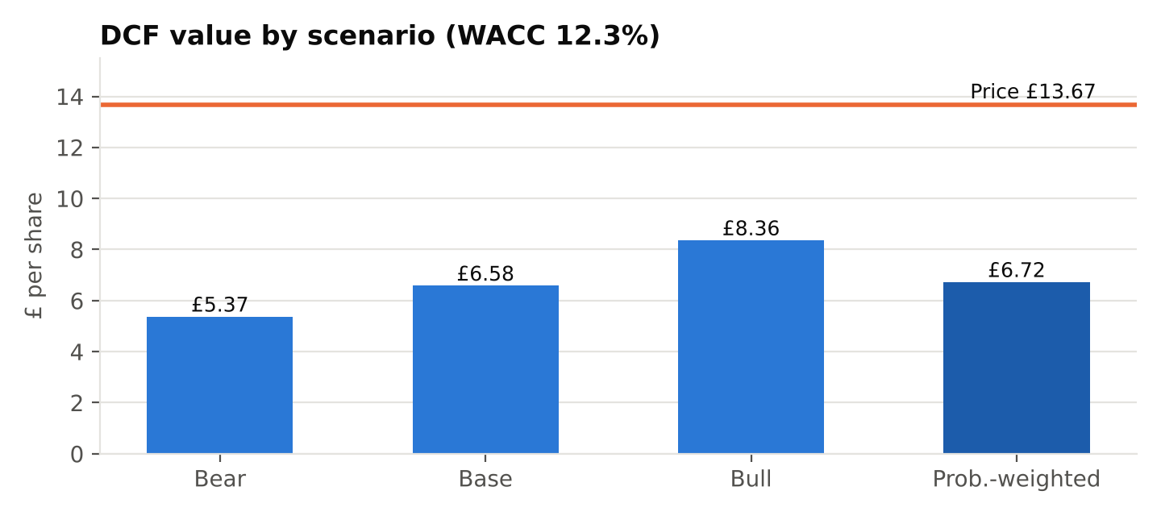
Scenario | 2028E FCF | 2030E FCF | Terminal g | Value / share | Narrative
Bear | £4.3bn | £4.5bn | 2.0% | £5.37 | Aviation slowdown or supply-chain constraints; targets missed
Base | £5.15bn | £5.46bn | 2.5% | £6.58 | 2028 targets met; low growth after
Bull | £5.6bn | £7.0bn | 3.0% | £8.36 | Targets beaten and upgraded; c.22% margins sustained
Probability-weighted (25/50/25) |  |  |  | £6.72
Reverse DCF. The market capitalisation implies an enterprise value of £110bn, against our base-case DCF of £52bn. Holding WACC at 12.3%, the share price needs cash flows 2.1x our base case throughout, i.e. 2030 FCF of about £11–12bn. Alternatively, it needs a discount rate of about 7% on base-case cash flows (£13.93 at 7%).

7.5 Valuation summary
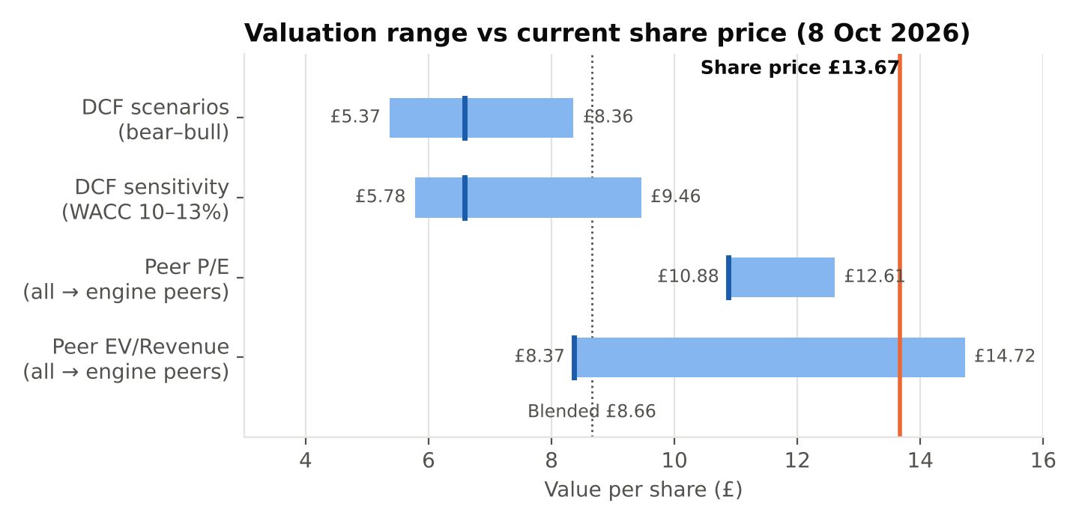
Method | Value / share | Weight | Contribution
DCF (FCFF/WACC) | £6.58 | 40% | £2.63
Peer P/E (LTM) | £10.88 | 40% | £4.35
Peer EV/Revenue (LTM) | £8.37 | 20% | £1.67
Blended value |  |  | £8.66
Share price (8 Oct 2026) |  |  | £13.67
Upside / (downside) |  |  | (36.7%)
Our rating rule is BUY above +15% upside, SELL below −15% and HOLD in between. The blended value implies (36.7%), so the rating is SELL. The rating does not depend on the weights. No reasonable weighting of the three methods reaches the share price, and the probability-weighted DCF (£6.72) is lower still.

8. Share-price and event analysis
The Python analysis compares Rolls-Royce's adjusted share price with the FTSE 100 from January 2021 to 8 October 2026.
Metric (Jan 2021 – 8 Oct 2026) | Rolls-Royce | FTSE 100
Annualised volatility | 41.8% | 12.6%
Maximum drawdown | −55.1% (Sep 2021 – Oct 2022) | −13.4%
Correlation / beta vs FTSE 100 | 0.50 / 1.65 | –
Peak 30-day volatility | 92.2% (29 Mar 2022) | –
Calendar returns 2022 / 2023 / 2024 / 2025 | −24.2% / +221.6% / +89.7% / +102.3% | –
2026 year to date (8 Oct) | +18.9% | –
Source: Rolls_Royce_Share_Price_Analysis.ipynb (Yahoo Finance adjusted prices).
Information events, measured relative to the FTSE 100 on the day of the announcement:
- FY2022 results (23 Feb 2023): +23.7% vs FTSE −0.3%. Market-model abnormal return c.+24.1% (p < 0.0001). This marked the start of the re-rating, and the shares regained their 2021 peak within a week.
- July 2023 trading update (26 Jul 2023): +21.2% vs FTSE −0.2%, after profit guidance was raised.
- Capital Markets Day (28 Nov 2023): +6.2%, when the first mid-term targets were set.
- FY2024 results (27 Feb 2025): +15.9% vs FTSE +0.3%.
- April 2022 sell-off (12 Apr 2022): abnormal return c.−4.1%, not significant at 5% (p ≈ 0.14).
Two implications follow. First, most of the return came from a few information events in which expectations reset sharply upwards. Second, the risk was mostly stock-specific: a correlation of 0.5 means the FTSE 100 explains only about a quarter of daily variance. The historical beta (1.65) supports the 1.58 used in our CAPM, but it was measured through a turnaround and is unstable. That is why section 7.2 tests a wide range of discount rates. Event studies show association, not causation.

9. Bull and bear debate
Bull case | Bear case (our view on valuation)
H1 2026 margin (22.5%) already above the 2028 target; upgraded targets are likely | The price already needs cash flows about twice the targets path; upgrades are expected, not a surprise
Aftermarket annuity: installed widebody base, flying hours 115–120% of 2019 | Civil Aerospace is cyclical: a recession, pandemic or airline stress hits flying hours directly
Defence spending rising across NATO; £17.5bn backlog | Defence margins of 21% in H1 2026 partly reflect timing; target is 14–16%
Data-centre power demand; SMR optionality | Data-centre orders can be lumpy; SMR is unproven commercially
£7–9bn buybacks 2026–28 lift EPS | Buybacks at 33x earnings create less value per £ than at lower prices
Net cash and investment-grade balance sheet | Supply-chain constraints, LTSA contract assumptions and FX are persistent risks

10. Risks to our rating (upside risks)
- Further guidance upgrades or new mid-term targets well above £5.2bn operating profit. This is the main risk to a SELL rating.
- Lower discount rates. If gilt yields fall or investors accept a lower risk premium, value rises sharply (section 7.2).
- Faster Power Systems growth from data-centre demand, or an earlier commercial SMR contribution.
- Capital returns larger than planned, or M&A interest.
Downside risks to the business, which would widen the valuation gap: supply-chain disruption, a civil aviation downturn, LTSA cost overruns, FX, defence budget changes, technology shifts (hydrogen, open-fan), and execution of the transformation programme.

11. What to monitor
- Large-engine flying hours vs 2019, shop-visit volumes and Trent time-on-wing progress.
- Group and segment margins vs the 18–20% target; LTSA pricing and contract margin catch-ups.
- FCF vs guidance (£3.8–4.0bn for 2026), working capital and net cash.
- Any new mid-term targets (likely the key share-price catalyst), order intake and backlog.
- Buyback pace, gilt yields and the market-implied discount rate.

Appendix A — Methodology and data notes
- Valuation date: market data 8 October 2026 (price £13.67, 8.23bn shares, market cap £112.5bn); balance sheet 30 June 2026. These are dated inputs and should be refreshed before reuse.
- Company-defined free cash flow is not statutory operating cash flow less capex. It is used because it is the measure management guides on.
- Peer multiples are a trailing snapshot from StockAnalysis (8 Oct 2026) and are applied to Rolls-Royce's trailing (LTM) figures so the bases match.
- Corrections made during review: the DCF per-share formula (previously #VALUE!), group margin in the segment tab, 2024 equity (£(881)m), 2025 revenue growth (12.4%, not 14%), tax normalisation (26%, not 17.7%), the share count, and P/E and EV/Revenue basis mismatches. Full log in the model's Checks tab and the accompanying change log.

Sources
- Rolls-Royce 2025 Annual Report — https://www.rolls-royce.com/~/media/Files/R/Rolls-Royce/documents/annual-report/2026/2025-annual-report-interactive.pdf
- Rolls-Royce 2025 Full Year Results (26 Feb 2026) — https://www.rolls-royce.com/media/press-releases/2026/26-02-2026-rr-holdings-plc-2025-full-year-results.aspx
- Rolls-Royce 2026 Half Year Results (30 Jul 2026) — https://www.rolls-royce.com/media/press-releases/2026/30-07-2026-rr-holdings-plc-2026-half-year-results.aspx
- Rolls-Royce 2024 Full Year Results (27 Feb 2025) — https://www.rolls-royce.com/media/press-releases/2025/27-02-2025-rr-holdings-plc-2024-full-year-results.aspx
- Rolls-Royce 2023 Full Year Results (22 Feb 2024) — https://www.rolls-royce.com/media/press-releases/2024/22-02-2024-rr-holdings-plc-2023-full-year-results.aspx
- Rolls-Royce 2022 Full Year Results (23 Feb 2023) — https://www.rolls-royce.com/investors/results-reports-and-presentations/financial-results/rr-holdings-plc-2022-full-year-results.aspx
- July 2023 Trading Update — https://www.rolls-royce.com/media/press-releases/2023/26-07-2023-rr-holdings-trading-update.aspx
- Capital Markets Day (28 Nov 2023) — https://www.rolls-royce.com/media/press-releases/2023/28-11-2023-capital-markets-day.aspx
- StockAnalysis — RR. and peer statistics (8 Oct 2026) — https://stockanalysis.com/quote/lon/RR/statistics/
- UK 10-year gilt yield — https://www.investing.com/rates-bonds/uk-10-year-bond-yield-historical-data

Disclaimer: this is an independent educational research project. It is not investment advice or a recommendation to buy or sell any security. Figures are from public company disclosures and dated market data. Forecasts are the author's illustrative assumptions.

