**Лабораторная работа #2**

**Ткачев Иван**

Вариант 14

Задание 2.1.

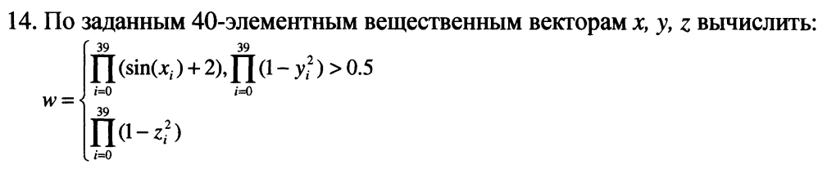

**Листинг**

**public class** Main {  
  
 **public static void** main(String[] args) {  
 **double**[] x = **new double**[40];  
 **double**[] y = **new double**[40];  
 **double**[] z = **new double**[40];  
  
 **for** (**int** i = 0; i < 40; i++) {  
 x[i] = Math.*random*() * 100;  
 y[i] = Math.*random*() * 100;  
 z[i] = Math.*random*() * 100;  
 }  
  
 **double** var1 = 0;  
 **for** (**int** j = 0; j < 40; j++) {  
 **double** v = 1 - Math.*pow*(y[j], 2);  
 **if**(j == 0){  
 var1 = v;  
 } **else** {  
 var1 = var1 * v;  
 }  
 }  
 **double** w = 0;  
 **for** (**int** i = 0; i < 40; i++) {  
 **double** v = 0;  
 **if**(var1 > 0.5){  
 v = Math.*sin*(x[i]) + 2;  
 } **else** {  
 v = 1 - Math.*pow*(z[i], 2);  
 }  
 **if**(i == 0){  
 w = v;  
 } **else** {  
 w = w * v;  
 }  
 }  
 System.***out***.println(w);  
 }  
}

**Результат**

1. При x, y, z = {1,1,1…}

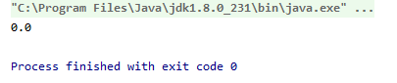

1. При x, y, z = {2,2,2…}

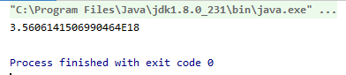

1. x, y, z = {0,0,0…}

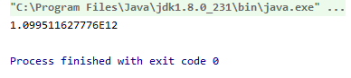

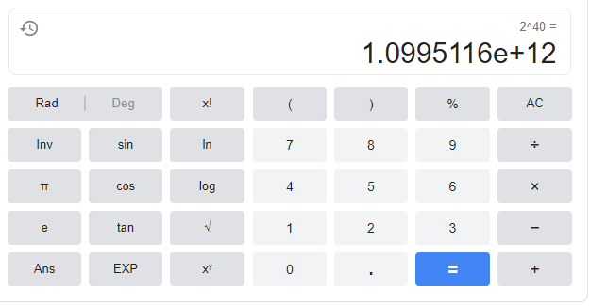

Задание 2.2.



**Листинг**

**import** java.util.Scanner;  
  
**public class** Main {  
  
 **public static void** main(String[] args) {  
 **int** x;  
 **int** y;  
  
 **int**[][] mass;  
  
 Scanner in = **new** Scanner(System.***in***);  
 System.***out***.println(**"Input line count"**);  
 x = in.nextInt();  
 System.***out***.println(**"Input column count"**);  
 y = in.nextInt();  
  
 mass = **new int**[x][y];  
  
 **for** (**int** i = 0; i < x; i++) {  
 **for** (**int** j = 0; j < y; j++) {  
 mass[i][j] = (**int**)(Math.*random*() * 10);  
 }  
 }  
 **int** shift;  
 System.***out***.println(**"Input shift number"**);  
 shift = in.nextInt();  
 **int** mod;  
 System.***out***.println(**"Input right(1)/down(0) mod: "**);  
 mod = in.nextInt();  
  
 *showMatrix*(mass);  
 **if**(mod == 0){  
 *shiftDown*(mass, shift, x, y);  
 } **else if**(mod == 1){  
 *shiftRight*(mass, shift, x, y);  
 }  
 }  
  
 **private static void** shiftRight(**int**[][] array, **int** step, **int** x, **int** y) {  
 **int** count = 0;  
 **while** (count < step) {  
 **int** temp, j;  
 **for** (**int** i = 0; i < x; i++) {  
 temp = array[i][y - 1];  
 **for** (j = y - 1; j > 0; j--) {  
 array[i][j] = array[i][j - 1];  
 }  
 array[i][j] = temp;  
 }  
 count++;  
 }  
 *showMatrix*(array);  
 }  
  
 **private static void** shiftDown(**int**[][] array, **int** step, **int** x, **int** y) {  
 **int**[] temp;  
 **for** (**int** i = 0; i < step; i++) {  
 temp = array[array.**length** - 1];  
 System.*arraycopy*(array, 0, array, 1, array.**length** - 1);  
 array[0] = temp;  
 }  
 *showMatrix*(array);  
 }  
  
  
 **public static void** showMatrix(**int**[][] m) {  
 **for** (**int**[] s : m) {  
 **for** (**int** k : s) {  
 System.***out***.print(k + **" "**);  
 }  
 System.***out***.println();  
 }  
 System.***out***.println();  
 }  
}

**Результат**

**Right** **Down**

|  |  |
| --- | --- |
|  |  |

Задание 2.3.



**Листнинг**

**public static void** main(String[] args) {  
 Scanner in = **new** Scanner(System.***in***);  
  
 System.***out***.println(**"Input amount of candidates:"**);  
  
 **int** amountOfCandidates = in.nextInt();  
 in.nextLine();  
 String[][] mass = **new** String[amountOfCandidates][8];  
 **boolean**[] bSatisfies = **new boolean**[amountOfCandidates];  
 Arrays.*fill*(bSatisfies, **true**);  
  
 String[] aEducation = {**"Average"**, **"Special"**, **"Higher"**};  
 String[] aForeignLanguage = {**"English"**, **"Deutsch"**, **"French"**};  
 String[] aLanguageLevel = {**"Speak fluent language"**, **"Read and translate with a dictionary"**};  
 String[] aComputerSkills = {**"MSDOS"**, **"Windows"**, **"Linux"**};  
 String[] aRecommendation = {**"Have recommendations"**, **"Don't have recommendations"**};  
  
 **for**(**int** i = 0; i < amountOfCandidates; i++) {  
 System.***out***.println(**"Candidate "** + (i + 1));  
 System.***out***.println(**"Input full name:"**);  
 mass[i][0] = in.nextLine();  
 System.***out***.println(**"Input year of birth:"**);  
 mass[i][1] = in.nextLine();  
 System.***out***.println(**"Choose education:\n"**);  
 **for**(**int** j = 0; j < aEducation.**length**; j++) {  
 System.***out***.println((j + 1) + **". "** + aEducation[j]);  
 }  
 mass[i][2] = aEducation[in.nextInt() - 1];  
  
 System.***out***.println(**"Choose knowledge of foreign languages:\n"**);  
 **for**(**int** j = 0; j < aForeignLanguage.**length**; j++) {  
 System.***out***.println((j + 1) + **". "** + aForeignLanguage[j]);  
 }

**//** **similarly**  
 }

System.***out***.println(**"Table of candidates:"**);  
 *showMatrix*(mass);  
 System.***out***.println(**"Input requirements"**);  
 **int** number;  
  
 String str = **"Choose year of birth:\n"**;  
 Set yearsOfBirthSet = **new** HashSet();  
 **for** (**int** j = 0; j < amountOfCandidates; j++) {  
 yearsOfBirthSet.add(mass[j][1]);  
 }  
  
 *chooseCriteria*(in, str, yearsOfBirthSet.toArray(), 1, mass, bSatisfies);  
  
 str = **"Choose education:\n"**;  
 *chooseCriteria*(in, str, aEducation, 3, mass, bSatisfies);  
  
 str = **"Knowledge of foreign languages:\n"**;  
 *chooseCriteria*(in, str, aForeignLanguage, 3, mass, bSatisfies);  
 **//** **similarly**System.***out***.println(**"Results:"**);  
 **for** (**int** i = 0; i < mass.**length**; i++) {  
 **if** (bSatisfies[i]) {  
 **for** (**int** j = 0; j < mass[i].**length**; j++) {  
 System.***out***.print(mass[i][j] + **" "**);  
 }  
 System.***out***.println();  
 }  
 }}

**public static void** chooseCriteria(Scanner in, String str, Object[] criteria, **int** numberOfCriteria, String[][] m, **boolean**[] bSatisfies) {  
 **int** number;  
  
 **for**(**int** j = 0; j < criteria.**length**; j++) {  
 str += (j + 1) + **". "** + criteria[j] + **"\n"**;  
 }  
 **boolean**[] bCriterias = **new boolean**[criteria.**length**];  
  
 **for** (**int** i = 0; i < criteria.**length**; i++) {  
 System.***out***.print(str);  
 System.***out***.println((criteria.**length** + 1) + **". Go to next criterion\n"**);  
 number = in.nextInt();  
 **if** (number < criteria.**length** + 1 && number > 0) {  
 bCriterias[number - 1] = **true**;  
 } **else** {  
 **break**;  
 }  
 }  
 **boolean** bChanged = **false**;  
 **for**(**int** j = 0; j < m.**length**; j++) {  
 **boolean** bSuite = **false**;  
 **for**(**int** k = 0; k < criteria.**length**; k++) {  
 **if** (bCriterias[k]) {  
 bChanged = **true**;  
 **if** (!m[j][numberOfCriteria].equals(criteria[k])) {  
 bSuite = bSuite || **false**;  
  
 } **else** {  
 bSuite = **true**;  
 }  
 }  
 }  
 **if** (bChanged) {  
 bSatisfies[j] = bSuite;  
 }  
 }

**Результат**

|  |  |  |  |
| --- | --- | --- | --- |
|  | 1 | 2 | 3 |
| Full name | FIO1 | FIO2 | FIO3 |
| Year of birth | 1989 | 2000 | 1999 |
| Education | Higher | Higher | Special |
| Foreign language | English | French | Deutsch |
| Language level | Speak fluent language | Speak fluent language | Read and translate with a dictionary |
| Computer skill | Windows | Linux | MSDOS |
| Work experience | 6 | 7 | 1 |
| Recommendations | Yes | Yes | No |

Requirements: Year of birth: 1989, 2000; Education: Higher; Recommendations: Yes

|  |  |  |
| --- | --- | --- |
|  |  |  |

|  |  |
| --- | --- |
|  |  |