**Лабораторная работа #3**

**Ткачев Иван**

Вариант 14

Задание 3.1.

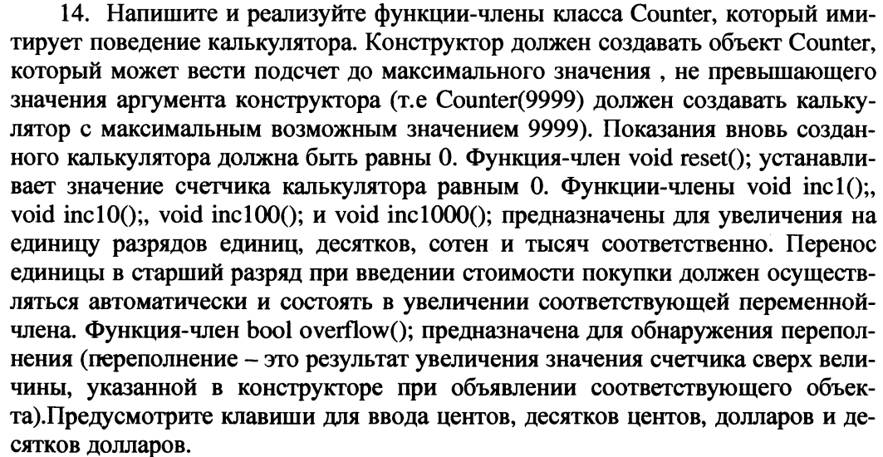

**Листинг**

**public class** Counter {  
  
 **private int maxValue**;  
 **private int value**;  
 **private boolean overflow**;  
  
 **public** Counter(**int** maxValue) {  
 **this**.**maxValue** = maxValue;  
 **this**.**value** = 0;  
 }  
 **public void** reset(){  
 **overflow** = **false**;  
 **value** = 0;  
 }  
 **public void** inc1(){  
 **if**(**value** + 1 >= **maxValue**){  
 **overflow** = **true**;  
 System.***out***.println(**"Counter overflow. Current value: "** + **maxValue**);  
 **value** = **maxValue**;  
 } **else  
 value** = **value** + 1;  
 }  
 **//** **similarly**

}

**public static void** main(String[] args) {  
 Scanner in = **new** Scanner(System.***in***);  
 System.***out***.println(**"Input max value of Counter: "**);  
 **int** maxValue = in.nextInt();  
 System.***out***.println();  
  
 Counter counter = **new** Counter(maxValue);  
  
 **boolean** isEnd = **true**;  
 **while** (isEnd){  
 System.***out***.println(**"Counter: "** + counter.getValue());  
  
 System.***out***.println(**"Please, choose number of action: "**);  
 System.***out***.println(**"1. inc1"**);  
 System.***out***.println(**"2. inc10"**);  
 System.***out***.println(**"3. inc100"**);  
 System.***out***.println(**"4. inc1000"**);  
 System.***out***.println(**"5. reset"**);  
 System.***out***.println(**"6. is overflow"**);  
 System.***out***.println(**"7. end"**);  
  
 **int** actionNumber = in.nextInt();  
 System.***out***.println();  
 **switch** (actionNumber){  
 **case** 1:  
 counter.inc1();  
 **break**;  
 **case** 2:  
 counter.inc10();  
 **break**;  
 **case** 3:  
 counter.inc100();  
 **break**;  
 **case** 4:  
 counter.inc1000();  
 **break**;  
 **case** 5:  
 counter.reset();  
 **break**;  
 **case** 6:  
 System.***out***.println(**"Overflow: "** + counter.isOverflow());  
 **break**;  
 **case** 7:  
 isEnd = **false**;  
 **break**;  
 **default**:  
 System.***out***.println(**"Unexpected value: "** + actionNumber);  
 System.***out***.println();  
 }  
 }

**Результат**



|  |  |  |
| --- | --- | --- |
|  |  |  |
|  |  |  |



Задание 3.1.

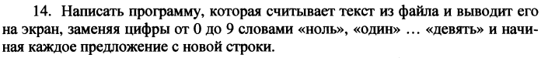

**Листинг**

**public static void** main(String[] args) **throws** IOException {  
 **final** String[] ds = **new** String[] {  
 **"zero"**, **"one"**, **"two"**, **"three"**, **"four"**, **"five"**, **"six"**, **"seven"**, **"eight"**, **"nine"** };  
  
 FileReader fileReader = **new** FileReader(**"sample.txt"**);  
 Scanner scanner = **new** Scanner(fileReader);  
  
  
 String text = **""**;  
 **while** (scanner.hasNextLine()){  
 text = text + scanner.nextLine();  
 }  
 fileReader.close();  
  
 System.***out***.println(**"old text:"**);  
 System.***out***.println(text);  
 **for**(**char** charNumber = **'0'**; charNumber <= **'9'**; charNumber++)  
 text = text.replaceAll(String.*valueOf*(charNumber), ds[charNumber - **'0'**] );  
  
 System.***out***.println(**"new text:"**);  
 System.***out***.println(text);  
  
}

**Результат**



