**Лабораторная работа #5**

**Ткачев Иван**

Вариант 14

Задание 5.1.

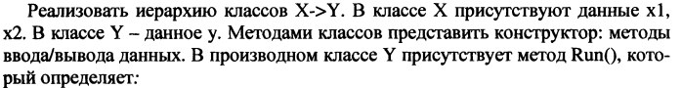



**Листинг**

**public class** X {  
  
 **protected int x1**;  
 **protected int x2**;  
  
 **public** X(**int** a, **int** b){  
 **this**.**x1** = a;  
 **this**.**x2** = b;  
 }  
  
 **public void** enter(){  
 System.***out***.println(**"Enter x1 and x2"**);  
 Scanner in = **new** Scanner(System.***in***);  
 **x1** = in.nextInt();  
 **x2** = in.nextInt();  
 }  
  
 **public void** show(){  
 System.***out***.println(**"x1 = "** + **x1** + **", x2 = "** + **x2** + **"\n\n"**);  
 }  
}

**public class** Y **extends** X {  
  
 **protected int y**;  
  
 **public** Y(**int** a, **int** b, **int** c) {  
 **super**(a, b);  
 **this**.**y** = c;  
  
 }  
  
 **public void** run(){  
 System.***out***.println(**"x1/y + x2*y = "** + ((**double**)**x1**/**y** + **x2**\***y**) + **"\n\n"**);  
 }  
}

**public class** Main {  
  
 **public static void** main(String[] args) {  
 Y y = **new** Y(51,1, 10);  
 y.run();  
 y.enter();  
 y.run();  
 y.show();  
 }  
}

**Результат**

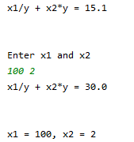

Задание 5.2.

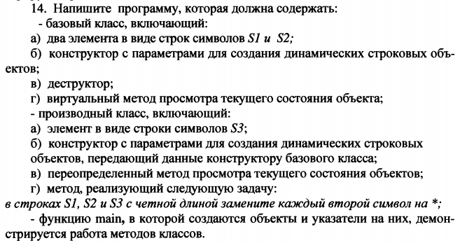

**Листинг**

**public class** Base {  
  
 **protected** String **s1**;  
 **protected** String **s2**;  
  
 **public** Base(String s1, String s2){  
 **this**.**s1** = s1;  
 **this**.**s2** = s2;  
 }  
  
 **public void** show() {  
 System.***out***.println(**"s1: "** + **s1**);  
 System.***out***.println(**"s2: "** + **s2**);  
 }  
}

**public class** First **extends** Base {  
  
 **protected** String **s3**;  
  
 **public** First(String s1, String s2, String s3) {  
 **super**(s1, s2);  
 **this**.**s3** = s3;  
 }  
  
 **public void** show(){  
 System.***out***.println(**"s1: "** + **s1**);  
 System.***out***.println(**"s2: "** + **s2**);  
 System.***out***.println(**"s3: "** + **s3**);  
 }  
  
 **public void** replace(){  
 **s1** = replace(**s1**);  
 **s2** = replace(**s2**);  
 **s3** = replace(**s3**);  
 }  
  
 **private** String replace(String s){  
 **if**(s.length() % 2 == 0){  
 StringBuilder stringBuilder = **new** StringBuilder();  
 **for** (**int** i = 0; i < s.length(); i++) {  
 **if**(i % 2 == 0) {  
 stringBuilder.append(**"*"**);  
 } **else** {  
 stringBuilder.append(s.charAt(i));  
 }  
 }  
 **return** stringBuilder.toString();  
 }  
 **return** s;  
 }  
  
}

**public class** Main {  
  
 **public static void** main(String[] args) {  
 Base base = **new** First(**"asdas"**, **"asdasdasda"**, **"asdasdasd"**);  
  
 base.show();  
 ((First)base).replace();  
  
 base.show();  
 }  
}

**Результат**

