Computer Communications and Networks (COMN) Course, Spring 2011

Coursework: Results Sheet

Forename and Surname: | Ivan Trendafilov
Matriculation #: | 0837795

Question 1 – Experiments with Stop-and-Wait:
Retransmission timeout (ms) | Number of re-transmissions
10 | 604
20 | 311
30 | 216
40 | 97
50 | 52
60 | 65
70 | 59
80 | 52
90 | 53
100 | 61

Question 2 – How does the throughput behave when the retransmission timeout increases and why?

The throughput is a function of the file size to the total transmission time. When the retransmission timeout is large, the Stop-and-Wait sender will wait for longer till it retransmits a lost packet. These delays add up and are reflected in an increase of the total transmission time.
This is also supported by our experimental results – throughput falls from 24.91 for 10ms timeout, through 24.20 for 50ms, to 23.78 for 100ms. This trend will continue if the timeout is further increased.

Question 3 – Experiments with Go-Back-N:
 | Throughput (Kilobytes per second)
Window Size | Delay = 10ms | Delay = 100ms | Delay = 1000ms
1 | 23.84 | 2.46 | 0.26
2 | 47 | 4.70 | 0.43
4 | 77.09 | 8.89 | 0.80
8 | 128.80 | 12.62 | 1.13
16 | 234.15 | 17.05 | 1.66
32 | 397.79 | 42.15 | 4.15
64 | 243.24 | 30.93 | 2.11
128 | 206.34 | 32.51 | 2.58
256 | 179.78 | 32.17 | 2.21

Use the results in the above table to make the following graph:
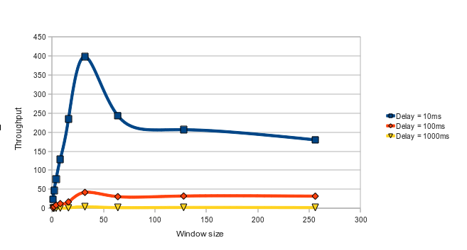
Question 4 – Explain your results from Question 3.
For this experiment, I have used the optimal retransmission timeout from Q1 – 50ms and adjusted it to 500ms and 5000ms for delays of 100ms and 1000ms, respectively.

Unlike in Stop-and-Wait ARQ, with Go-Back-N ARQ, the sender is allowed to transmit multiple packets (within its window) without having to wait for an acknowledgement, but it is constrained to have no more than N unacknowledged packets in the pipeline. This potentially allows the sender to ‘fill the pipeline’. However, if a packet is lost, the sender has to retransmit all N packets within its window. This can be very expensive.
Ideally, the sender must not transmit too fast – N should be bounded by the receiver’s ability to process packets (implicit flow control), and N should be smaller than the number of sequence numbers, in order to be able to verify transmission in case any packet or ACK is lost. As our experiments show, when transmitting over a lossy channel, the window size should be selected to be optimal. If the window size is too large, a very large number of packets will be retransmitted when only a single packet is lost. This increase of time brings down the throughput.
The experiment shows the diminishing returns of increasing the window size. A size of 32 seems to be optimal, as it allows us to fill the pipeline, and yet retransmit relatively few packets on loss. On the other hand, window size of 1 is equivalent to Stop-and-Wait ARQ, whilst a window size of 256 and a large delay may mean that many packets are in the pipeline and a single error can cause GBN ARQ to retransmit a substantial amount of packets, many unnecessarily. As the probability of channel error increases, so does the number of unnecessary retransmissions.

Question 5 – Experiments with Selective Repeat
 | Throughput (Kilobytes per second)
Window Size | Delay = 100ms
8 | 13.545435
16 | 22.795507
32 | 36.68558
64 | 66.53559
128 | 102.16938
256 | 118.34067

Question 6 - Compare the throughput obtained when using “Selective Repeat” with the corresponding results you got from the “Go Back N” experiment and explain the reasons behind any differences.
Selective Repeat ARQ avoids the problem described above by retransmitting only those packets it suspects were lost at the receiver. This makes a better use of the channel, especially when a significant delay is presented, than Go-Back-N, because it avoids filling the pipeline with unnecessary retransmissions.
Our experimental results show that increasing the size of the window has a direct effect on throughput, as the channel is utilised more effectively. It is also necessary that the size of the sending and receiving window to be equal, and half the maximum sequence number - 1. Selective Repeat is also bounded by the receiver’s ability to process packets and the efficiency of implementation – for example, running a selective repeat algorithm with 1024 independent timers on a virtual machine with limited memory and CPU resources, can cause significant performance degradation.

Question 7 – Experiments with iperf
 | Throughput (Kilobytes per second)
Window Size (KB) | Delay = 100ms
8 | 18.37
16 | 27.98
32 | 41.29
64 | 49.55
128 | 74.05
256 | 66.50

Question 8 - Compare the throughput obtained when using “Selective Repeat” and “Go Back N” with the corresponding results you got from the iperf experiment and explain the reasons behind any differences.

Iperf uses TCP to measure the maximum throughput of a network connection. Since in this experiment, we specified maximum segment size of 1024 bytes which can cause IP fragmentation and lead to excessive retransmissions if there is a packet lost. Each packet header has a size of a minimum of 20 bytes and a maximum of 60 bytes (depending on the options), which is significantly more than the 3 bytes we use for header in Selective Repeat and Go-Back-N. This results in lower throughput. TCP manages retransmissions significantly more efficiently than Go-Back-N, however the general trend suggests that it is slower than Selective Repeat over a lossy channel with a larger delay.

