*Lecture 10:*

Union-Find

Quick-Find

Connects elements by making them equvalent.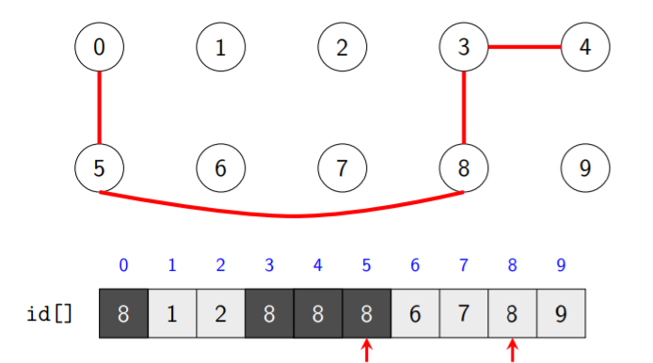

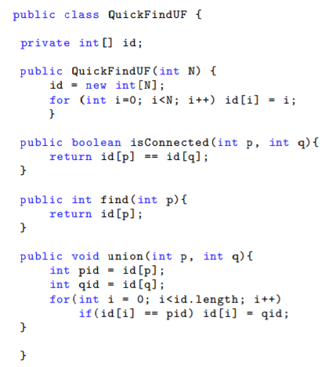

Time complexity:

Initialisation: O (N)

Find: O (1)

Union: O (N)

Quick-Union

Components are stored as trees.

Look at slides for examples and implementation:

Complexity:

Initialisation: O(N)

Find: O(N)

Union: O(N) because the trees can the imbalanced.

This is worse than Quick-Find

<https://www.youtube.com/watch?v=RY7UCusguGg>

Solution: **Weighted Quick-Union**

This is in order to keep the trees balanced.

Again look at slides for all the interesting bits

youtube.com/watch?v=xc9s9wdaSdU