*Lecture 13:*

Quicksort Improvements and Sorting without comparisons

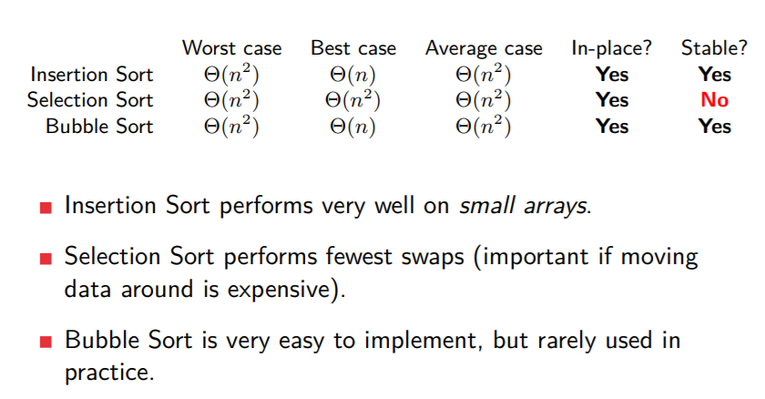

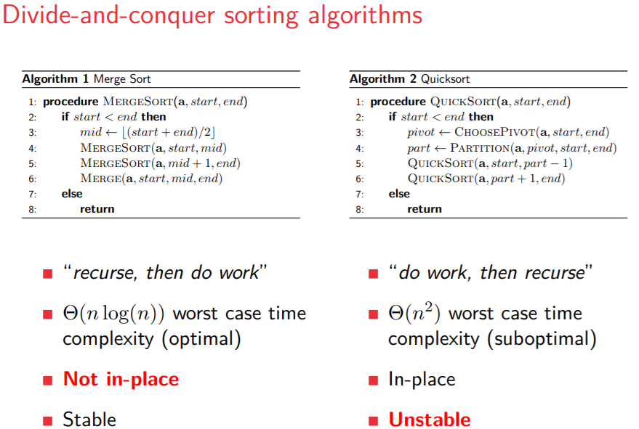

Hybrid sorting algorithms

Combines different algorithms for the best effect.

Quicksort partition

Example and pseudocode in lecture.

Hoare Partition Scheme & Shuffling (don’t know what that is) & Multipivoting

Pseudocode and explanations in lecture.

Radix sort

Pseudocode and example in slides.

* An array of size n.
* Each item in the array is a d-digit number (word length).
* Each digit can take at most k possible values (base/radix).

Counting sort

Pseudocode, properties and example in slides