The paradox of climate policy diffusion

Ivan Savin, Philipp Mundt and Margherita Bellanca

2025-01-20

## SpatialLag.Count.Lag yrsoffc eiec   
## 1.041417 1.131255 1.684513   
## gov_left gov_right Corruption   
## 2.105856 1.742505 16.793588   
## GovEffectiveness GDP_PC GHG_Int   
## 18.985635 3.506869 1.838025   
## Gini   
## 1.928649

## SpatialLag.Count.Lag yrsoffc eiec   
## 1.039436 1.125817 1.586016   
## gov_left gov_right GovEffectiveness   
## 1.979896 1.729034 3.972932   
## GDP_PC GHG_Int Gini   
## 3.506861 1.831303 1.928411

## --------------------------------------------  
## Maximum Likelihood estimation  
## Newton-Raphson maximisation, 5 iterations  
## Return code 2: successive function values within tolerance limit (tol)  
## Log-Likelihood: -1056.75   
## 10 free parameters  
## Estimates:  
## Estimate Std. error t value Pr(> t)   
## Count.Lag 3.620e-02 7.450e-03 4.859 1.18e-06 ***  
## SpatialLag.Count.Lag 4.417e-02 1.088e-02 4.059 4.94e-05 ***  
## yrsoffc -5.059e-03 1.021e-02 -0.496 0.6201   
## eiec 2.859e-01 1.359e-01 2.104 0.0354 *   
## gov_left -6.562e-02 1.145e-01 -0.573 0.5667   
## gov_right -9.317e-02 1.061e-01 -0.878 0.3798   
## GovEffectiveness -2.192e-01 1.515e-01 -1.447 0.1479   
## GDP_PC 1.382e-05 1.049e-05 1.317 0.1879   
## GHG_Int -5.052e-01 4.850e-01 -1.042 0.2975   
## Gini 6.615e+00 1.504e+00 4.397 1.10e-05 ***  
## ---  
## Signif. codes: 0 '***' 0.001 '**' 0.01 '*' 0.05 '.' 0.1 ' ' 1  
## --------------------------------------------

## [1] 0.1447861

## factor value  
## 1 Count.Lag 0.022106828  
## 2 SpatialLag.Count.Lag 0.020310353  
## 3 yrsoffc 0.009392539  
## 4 eiec 0.012597451  
## 5 gov_left 0.008963876  
## 6 gov_right 0.009074788  
## 7 GovEffectiveness 0.009437204  
## 8 GDP_PC 0.014499543  
## 9 GHG_Int 0.015163169  
## 10 Gini 0.023240311

## --------------------------------------------  
## Maximum Likelihood estimation  
## Newton-Raphson maximisation, 4 iterations  
## Return code 8: successive function values within relative tolerance limit (reltol)  
## Log-Likelihood: -347.1117   
## 10 free parameters  
## Estimates:  
## Estimate Std. error t value Pr(> t)   
## Market.Instr.Lag 2.252e-02 8.646e-02 0.260 0.79452   
## SpatialLag.Market.Instr.Lag -1.227e-01 2.024e-01 -0.606 0.54450   
## yrsoffc -3.980e-02 2.912e-02 -1.367 0.17170   
## eiec -6.527e-01 3.208e-01 -2.035 0.04188 *   
## gov_left 2.966e-01 2.957e-01 1.003 0.31593   
## gov_right -1.289e-01 2.599e-01 -0.496 0.62006   
## GovEffectiveness 1.643e-02 4.532e-01 0.036 0.97108   
## GDP_PC 2.385e-05 2.933e-05 0.813 0.41614   
## GHG_Int -1.878e+00 1.729e+00 -1.086 0.27741   
## Gini 1.286e+01 4.425e+00 2.906 0.00366 **  
## ---  
## Signif. codes: 0 '***' 0.001 '**' 0.01 '*' 0.05 '.' 0.1 ' ' 1  
## --------------------------------------------

## [1] 0.1952596

## factor value  
## 1 Market.Instr.Lag 0.01619509  
## 2 SpatialLag.Market.Instr.Lag 0.01611855  
## 3 yrsoffc 0.01772163  
## 4 eiec 0.01901303  
## 5 gov_left 0.01885425  
## 6 gov_right 0.01788599  
## 7 GovEffectiveness 0.01594727  
## 8 GDP_PC 0.02043959  
## 9 GHG_Int 0.02258733  
## 10 Gini 0.03049687

## --------------------------------------------  
## Maximum Likelihood estimation  
## Newton-Raphson maximisation, 5 iterations  
## Return code 8: successive function values within relative tolerance limit (reltol)  
## Log-Likelihood: -630.3274   
## 10 free parameters  
## Estimates:  
## Estimate Std. error t value Pr(> t)   
## Non.Market.Instr.Lag 1.008e-01 2.735e-02 3.687 0.000227 ***  
## SpatialLag.Non.Market.Instr.Lag 1.559e-01 5.056e-02 3.084 0.002045 **   
## yrsoffc -1.165e-02 1.686e-02 -0.691 0.489633   
## eiec 3.818e-01 2.432e-01 1.570 0.116503   
## gov_left -2.586e-01 1.826e-01 -1.416 0.156901   
## gov_right -2.340e-01 1.683e-01 -1.390 0.164562   
## GovEffectiveness -3.098e-01 2.470e-01 -1.254 0.209663   
## GDP_PC 1.581e-05 1.803e-05 0.877 0.380429   
## GHG_Int -1.357e-01 7.530e-01 -0.180 0.856998   
## Gini 7.697e+00 2.274e+00 3.385 0.000711 ***  
## ---  
## Signif. codes: 0 '***' 0.001 '**' 0.01 '*' 0.05 '.' 0.1 ' ' 1  
## --------------------------------------------

## [1] 0.1688229

## factor value  
## 1 Non.Market.Instr.Lag 0.02403130  
## 2 SpatialLag.Non.Market.Instr.Lag 0.02261823  
## 3 yrsoffc 0.01246480  
## 4 eiec 0.01651169  
## 5 gov_left 0.01229443  
## 6 gov_right 0.01210693  
## 7 GovEffectiveness 0.01214534  
## 8 GDP_PC 0.01556889  
## 9 GHG_Int 0.01583837  
## 10 Gini 0.02524288

## --------------------------------------------  
## Maximum Likelihood estimation  
## Newton-Raphson maximisation, 5 iterations  
## Return code 8: successive function values within relative tolerance limit (reltol)  
## Log-Likelihood: -748.0742   
## 10 free parameters  
## Estimates:  
## Estimate Std. error t value Pr(> t)   
## TechSup.Instr.Lag 4.838e-02 1.343e-02 3.603 0.000314 ***  
## SpatialLag.TechSup.Instr.Lag 1.129e-01 2.137e-02 5.282 1.27e-07 ***  
## yrsoffc 8.978e-03 1.439e-02 0.624 0.532585   
## eiec 3.631e-01 2.100e-01 1.729 0.083767 .   
## gov_left 7.751e-02 1.736e-01 0.446 0.655331   
## gov_right 5.878e-02 1.634e-01 0.360 0.718973   
## GovEffectiveness -2.184e-01 2.174e-01 -1.004 0.315243   
## GDP_PC 5.589e-06 1.437e-05 0.389 0.697376   
## GHG_Int -9.949e-01 7.030e-01 -1.415 0.156980   
## Gini 2.805e+00 2.297e+00 1.221 0.222086   
## ---  
## Signif. codes: 0 '***' 0.001 '**' 0.01 '*' 0.05 '.' 0.1 ' ' 1  
## --------------------------------------------

## [1] 0.1505263

## factor value  
## 1 TechSup.Instr.Lag 0.02027062  
## 2 SpatialLag.TechSup.Instr.Lag 0.02886084  
## 3 yrsoffc 0.01115845  
## 4 eiec 0.01380841  
## 5 gov_left 0.01120154  
## 6 gov_right 0.01115056  
## 7 GovEffectiveness 0.01163847  
## 8 GDP_PC 0.01364816  
## 9 GHG_Int 0.01441162  
## 10 Gini 0.01437766

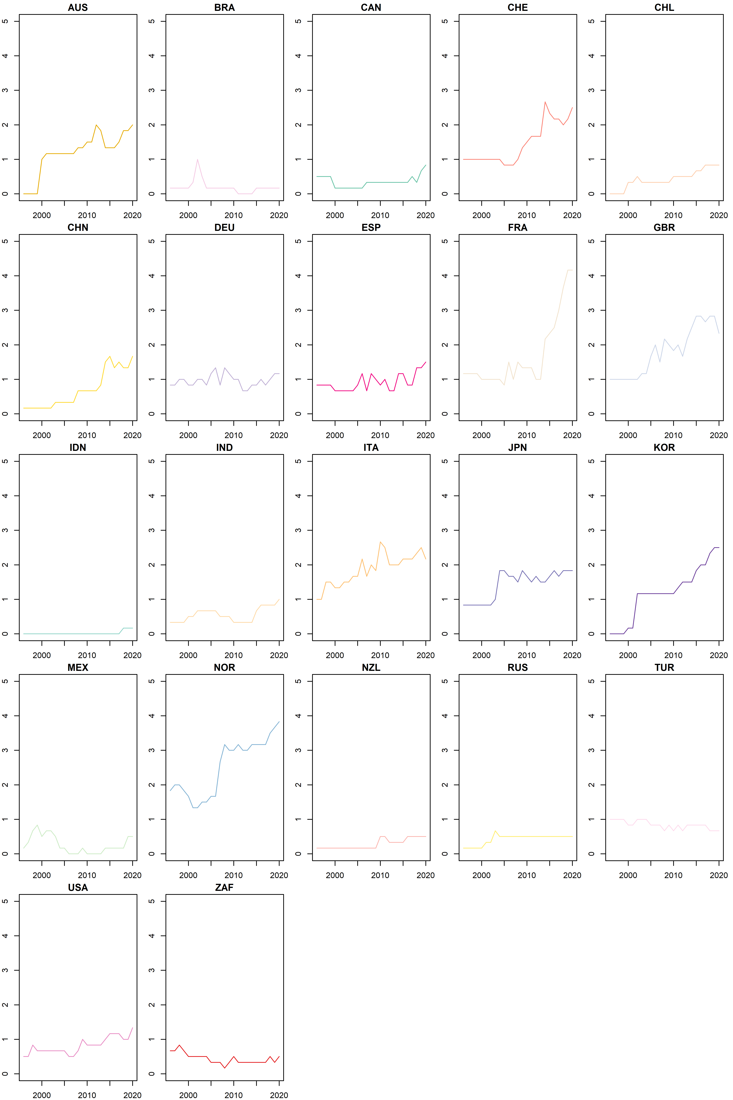

## Twoways effects Within Model  
##   
## Call:  
## plm(formula = EPS ~ EPS.Lag + SpatialLag.EPS.Lag + yrsoffc +   
## eiec + gov_left + gov_right + GovEffectiveness + GDP_PC +   
## GHG_Int + Gini, data = FlowM, effect = "twoways", model = "within",   
## index = c("ISO", "Year"))  
##   
## Balanced Panel: n = 22, T = 24, N = 528  
##   
## Residuals:  
## Min. 1st Qu. Median 3rd Qu. Max.   
## -0.771599 -0.104142 -0.024624 0.078904 1.018704   
##   
## Coefficients:  
## Estimate Std. Error t-value Pr(>|t|)   
## EPS.Lag 8.4438e-01 2.3178e-02 36.4299 < 2.2e-16 ***  
## SpatialLag.EPS.Lag -9.2081e-02 7.2779e-02 -1.2652 0.206413   
## yrsoffc -5.0337e-03 3.3636e-03 -1.4965 0.135186   
## eiec -3.3679e-02 2.8195e-02 -1.1945 0.232880   
## gov_left -1.1033e-01 4.2313e-02 -2.6074 0.009412 **   
## gov_right -1.2517e-01 3.7820e-02 -3.3096 0.001006 **   
## GovEffectiveness 8.7400e-03 5.6256e-02 0.1554 0.876602   
## GDP_PC 8.8793e-06 3.4629e-06 2.5641 0.010651 *   
## GHG_Int 5.3854e-02 1.7660e-01 0.3049 0.760543   
## Gini 4.8008e-01 4.1435e-01 1.1586 0.247185   
## ---  
## Signif. codes: 0 '***' 0.001 '**' 0.01 '*' 0.05 '.' 0.1 ' ' 1  
##   
## Total Sum of Squares: 87.433  
## Residual Sum of Squares: 19.824  
## R-Squared: 0.77326  
## Adj. R-Squared: 0.74738  
## F-statistic: 161.312 on 10 and 473 DF, p-value: < 2.22e-16

##   
## t test of coefficients:  
##   
## Estimate Std. Error t value Pr(>|t|)   
## EPS.Lag 8.4438e-01 4.8826e-02 17.2935 < 2.2e-16 ***  
## SpatialLag.EPS.Lag -9.2081e-02 9.8526e-02 -0.9346 0.350475   
## yrsoffc -5.0337e-03 3.1612e-03 -1.5923 0.111978   
## eiec -3.3679e-02 1.8586e-02 -1.8121 0.070607 .   
## gov_left -1.1033e-01 3.9736e-02 -2.7765 0.005713 **   
## gov_right -1.2517e-01 4.5741e-02 -2.7365 0.006444 **   
## GovEffectiveness 8.7400e-03 3.0112e-02 0.2902 0.771754   
## GDP_PC 8.8793e-06 3.1115e-06 2.8537 0.004510 **   
## GHG_Int 5.3854e-02 1.5806e-01 0.3407 0.733460   
## Gini 4.8008e-01 4.2884e-01 1.1195 0.263497   
## ---  
## Signif. codes: 0 '***' 0.001 '**' 0.01 '*' 0.05 '.' 0.1 ' ' 1

## rsq   
## 0.7732635

## factor value  
## 1 EPS.Lag 0.702136900  
## 2 SpatialLag.EPS.Lag 0.023275317  
## 3 yrsoffc 0.001074011  
## 4 eiec 0.010938519  
## 5 gov_left 0.005932590  
## 6 gov_right 0.004240779  
## 7 GovEffectiveness 0.002293142  
## 8 GDP_PC 0.020002241  
## 9 GHG_Int 0.000860477  
## 10 Gini 0.002509508

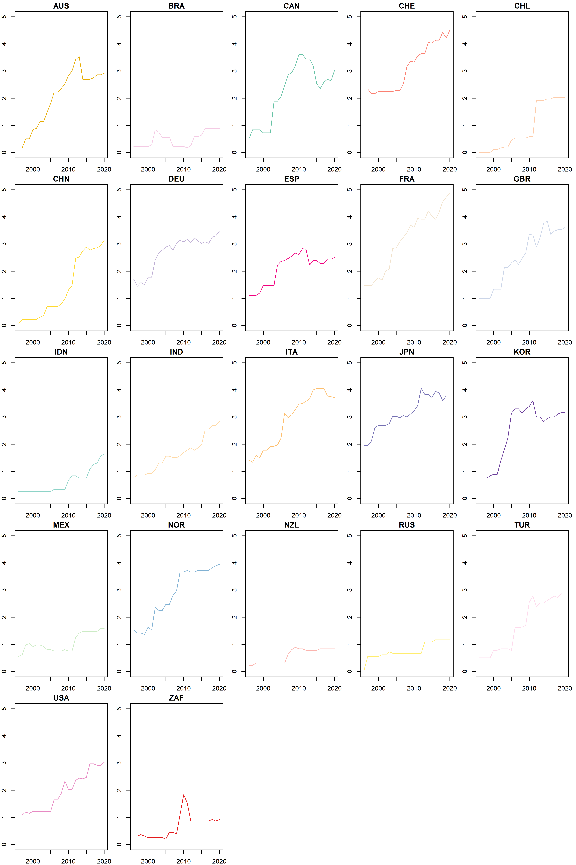

## Twoways effects Within Model  
##   
## Call:  
## plm(formula = EPS_MKT ~ EPS_MKT.Lag + SpatialLag.EPS_MKT.Lag +   
## yrsoffc + eiec + gov_left + gov_right + GovEffectiveness +   
## GDP_PC + GHG_Int + Gini, data = FlowM, effect = "twoways",   
## model = "within", index = c("ISO", "Year"))  
##   
## Balanced Panel: n = 22, T = 24, N = 528  
##   
## Residuals:  
## Min. 1st Qu. Median 3rd Qu. Max.   
## -0.625787 -0.104805 -0.020357 0.076746 0.851033   
##   
## Coefficients:  
## Estimate Std. Error t-value Pr(>|t|)   
## EPS_MKT.Lag 8.5482e-01 2.5237e-02 33.8722 < 2.2e-16 ***  
## SpatialLag.EPS_MKT.Lag -1.9326e-01 9.8171e-02 -1.9686 0.049585 *   
## yrsoffc -9.4243e-04 3.1877e-03 -0.2956 0.767628   
## eiec 1.8352e-03 2.6705e-02 0.0687 0.945239   
## gov_left 1.0391e-02 3.9904e-02 0.2604 0.794658   
## gov_right -2.0978e-02 3.5772e-02 -0.5864 0.557863   
## GovEffectiveness -3.4757e-03 5.2048e-02 -0.0668 0.946787   
## GDP_PC 1.0839e-05 3.3549e-06 3.2307 0.001321 **   
## GHG_Int 1.3088e-01 1.6724e-01 0.7826 0.434255   
## Gini 4.3756e-01 3.9768e-01 1.1003 0.271765   
## ---  
## Signif. codes: 0 '***' 0.001 '**' 0.01 '*' 0.05 '.' 0.1 ' ' 1  
##   
## Total Sum of Squares: 69.284  
## Residual Sum of Squares: 17.854  
## R-Squared: 0.74232  
## Adj. R-Squared: 0.7129  
## F-statistic: 136.258 on 10 and 473 DF, p-value: < 2.22e-16

##   
## t test of coefficients:  
##   
## Estimate Std. Error t value Pr(>|t|)   
## EPS_MKT.Lag 8.5482e-01 5.2025e-02 16.4311 < 2.2e-16 ***  
## SpatialLag.EPS_MKT.Lag -1.9326e-01 1.0126e-01 -1.9085 0.056937 .   
## yrsoffc -9.4243e-04 3.0607e-03 -0.3079 0.758285   
## eiec 1.8352e-03 1.8566e-02 0.0989 0.921299   
## gov_left 1.0391e-02 3.5811e-02 0.2902 0.771813   
## gov_right -2.0978e-02 3.9492e-02 -0.5312 0.595541   
## GovEffectiveness -3.4757e-03 5.1914e-02 -0.0670 0.946649   
## GDP_PC 1.0839e-05 3.7069e-06 2.9239 0.003622 **   
## GHG_Int 1.3088e-01 1.3428e-01 0.9747 0.330215   
## Gini 4.3756e-01 2.0612e-01 2.1229 0.034283 *   
## ---  
## Signif. codes: 0 '***' 0.001 '**' 0.01 '*' 0.05 '.' 0.1 ' ' 1

## rsq   
## 0.7423156

## factor value  
## 1 EPS_MKT.Lag 0.6762678792  
## 2 SpatialLag.EPS_MKT.Lag 0.0081904881  
## 3 yrsoffc 0.0001322654  
## 4 eiec 0.0010400130  
## 5 gov_left 0.0012921129  
## 6 gov_right 0.0010834271  
## 7 GovEffectiveness 0.0043804624  
## 8 GDP_PC 0.0470171156  
## 9 GHG_Int 0.0024173621  
## 10 Gini 0.0004945042

## Twoways effects Within Model  
##   
## Call:  
## plm(formula = EPS_NMKT ~ EPS_NMKT.Lag + SpatialLag.EPS_NMKT.Lag +   
## yrsoffc + eiec + gov_left + gov_right + GovEffectiveness +   
## GDP_PC + GHG_Int + Gini, data = FlowM, effect = "twoways",   
## model = "within", index = c("ISO", "Year"))  
##   
## Balanced Panel: n = 22, T = 24, N = 528  
##   
## Residuals:  
## Min. 1st Qu. Median 3rd Qu. Max.   
## -0.726996 -0.189147 -0.060935 0.070738 3.030505   
##   
## Coefficients:  
## Estimate Std. Error t-value Pr(>|t|)   
## EPS_NMKT.Lag 8.0372e-01 2.5450e-02 31.5802 < 2.2e-16 ***  
## SpatialLag.EPS_NMKT.Lag -9.4832e-02 7.8182e-02 -1.2130 0.225749   
## yrsoffc -3.7244e-03 7.0737e-03 -0.5265 0.598776   
## eiec -9.0151e-02 5.9762e-02 -1.5085 0.132095   
## gov_left -2.3935e-01 8.9531e-02 -2.6734 0.007768 **   
## gov_right -1.8314e-01 8.0319e-02 -2.2801 0.023046 *   
## GovEffectiveness -3.8586e-02 1.1765e-01 -0.3280 0.743084   
## GDP_PC 6.1715e-06 7.2014e-06 0.8570 0.391887   
## GHG_Int -2.1382e-01 3.7287e-01 -0.5734 0.566617   
## Gini 1.4587e+00 8.6755e-01 1.6814 0.093349 .   
## ---  
## Signif. codes: 0 '***' 0.001 '**' 0.01 '*' 0.05 '.' 0.1 ' ' 1  
##   
## Total Sum of Squares: 308.69  
## Residual Sum of Squares: 87.872  
## R-Squared: 0.71534  
## Adj. R-Squared: 0.68284  
## F-statistic: 118.863 on 10 and 473 DF, p-value: < 2.22e-16

##   
## t test of coefficients:  
##   
## Estimate Std. Error t value Pr(>|t|)   
## EPS_NMKT.Lag 8.0372e-01 4.7996e-02 16.7455 < 2.2e-16 ***  
## SpatialLag.EPS_NMKT.Lag -9.4832e-02 8.4839e-02 -1.1178 0.264227   
## yrsoffc -3.7244e-03 7.7851e-03 -0.4784 0.632581   
## eiec -9.0151e-02 4.9540e-02 -1.8198 0.069425 .   
## gov_left -2.3935e-01 8.5175e-02 -2.8101 0.005157 **   
## gov_right -1.8314e-01 7.0019e-02 -2.6155 0.009194 **   
## GovEffectiveness -3.8586e-02 8.2213e-02 -0.4694 0.639035   
## GDP_PC 6.1715e-06 6.5073e-06 0.9484 0.343408   
## GHG_Int -2.1382e-01 4.2919e-01 -0.4982 0.618582   
## Gini 1.4587e+00 6.9329e-01 2.1040 0.035906 *   
## ---  
## Signif. codes: 0 '***' 0.001 '**' 0.01 '*' 0.05 '.' 0.1 ' ' 1

## rsq   
## 0.71534

## factor value  
## 1 EPS_NMKT.Lag 0.6578491331  
## 2 SpatialLag.EPS_NMKT.Lag 0.0078274847  
## 3 yrsoffc 0.0009605037  
## 4 eiec 0.0221213664  
## 5 gov_left 0.0093856079  
## 6 gov_right 0.0038938065  
## 7 GovEffectiveness 0.0031775051  
## 8 GDP_PC 0.0038112074  
## 9 GHG_Int 0.0039454813  
## 10 Gini 0.0023678996

## Twoways effects Within Model  
##   
## Call:  
## plm(formula = TECHSUP ~ TECHSUP.Lag + SpatialLag.TECHSUP.Lag +   
## yrsoffc + eiec + gov_left + gov_right + GovEffectiveness +   
## GDP_PC + GHG_Int + Gini, data = FlowM, effect = "twoways",   
## model = "within", index = c("ISO", "Year"))  
##   
## Balanced Panel: n = 22, T = 24, N = 528  
##   
## Residuals:  
## Min. 1st Qu. Median 3rd Qu. Max.   
## -1.9678163 -0.1663094 -0.0091218 0.1140432 1.7971688   
##   
## Coefficients:  
## Estimate Std. Error t-value Pr(>|t|)   
## TECHSUP.Lag 8.2135e-01 2.8107e-02 29.2220 < 2e-16 ***  
## SpatialLag.TECHSUP.Lag 2.6418e-02 1.2451e-01 0.2122 0.83206   
## yrsoffc -1.1444e-02 6.4448e-03 -1.7757 0.07642 .   
## eiec -2.6480e-02 5.3534e-02 -0.4946 0.62108   
## gov_left -1.2841e-01 8.0245e-02 -1.6002 0.11022   
## gov_right -1.8741e-01 7.1661e-02 -2.6153 0.00920 **   
## GovEffectiveness 7.9879e-02 1.0923e-01 0.7313 0.46496   
## GDP_PC 1.1255e-05 6.5313e-06 1.7232 0.08550 .   
## GHG_Int 2.2526e-01 3.4095e-01 0.6607 0.50913   
## Gini -2.2473e-01 7.8741e-01 -0.2854 0.77546   
## ---  
## Signif. codes: 0 '***' 0.001 '**' 0.01 '*' 0.05 '.' 0.1 ' ' 1  
##   
## Total Sum of Squares: 217.16  
## Residual Sum of Squares: 72.747  
## R-Squared: 0.66501  
## Adj. R-Squared: 0.62676  
## F-statistic: 93.8975 on 10 and 473 DF, p-value: < 2.22e-16

##   
## t test of coefficients:  
##   
## Estimate Std. Error t value Pr(>|t|)   
## TECHSUP.Lag 8.2135e-01 3.9356e-02 20.8701 < 2.2e-16 ***  
## SpatialLag.TECHSUP.Lag 2.6418e-02 1.0276e-01 0.2571 0.797219   
## yrsoffc -1.1444e-02 5.5090e-03 -2.0773 0.038309 *   
## eiec -2.6480e-02 3.4333e-02 -0.7713 0.440934   
## gov_left -1.2841e-01 4.5544e-02 -2.8195 0.005012 **   
## gov_right -1.8741e-01 7.0089e-02 -2.6739 0.007756 **   
## GovEffectiveness 7.9879e-02 5.2470e-02 1.5224 0.128588   
## GDP_PC 1.1255e-05 3.6844e-06 3.0547 0.002380 **   
## GHG_Int 2.2526e-01 2.3487e-01 0.9591 0.337999   
## Gini -2.2473e-01 7.4314e-01 -0.3024 0.762470   
## ---  
## Signif. codes: 0 '***' 0.001 '**' 0.01 '*' 0.05 '.' 0.1 ' ' 1

## rsq   
## 0.6650082

## factor value  
## 1 TECHSUP.Lag 0.6284085955  
## 2 SpatialLag.TECHSUP.Lag 0.0075366972  
## 3 yrsoffc 0.0015998104  
## 4 eiec 0.0002272468  
## 5 gov_left 0.0023732843  
## 6 gov_right 0.0026571262  
## 7 GovEffectiveness 0.0106544741  
## 8 GDP_PC 0.0062031867  
## 9 GHG_Int 0.0040297469  
## 10 Gini 0.0013180423

## --------------------------------------------  
## Maximum Likelihood estimation  
## Newton-Raphson maximisation, 5 iterations  
## Return code 1: gradient close to zero (gradtol)  
## Log-Likelihood: -1056.733   
## 11 free parameters  
## Estimates:  
## Estimate Std. error t value Pr(> t)   
## Count.Lag 3.630e-02 7.471e-03 4.859 1.18e-06 ***  
## SpatialLag.Count.Lag 4.425e-02 1.089e-02 4.064 4.82e-05 ***  
## Trend -1.499e-03 8.102e-03 -0.185 0.853   
## yrsoffc -5.049e-03 1.021e-02 -0.495 0.621   
## eiec 2.895e-01 1.373e-01 2.108 0.035 *   
## gov_left -7.580e-02 1.271e-01 -0.597 0.551   
## gov_right -1.013e-01 1.148e-01 -0.882 0.378   
## GovEffectiveness -2.342e-01 1.717e-01 -1.364 0.173   
## GDP_PC 1.482e-05 1.182e-05 1.254 0.210   
## GHG_Int -5.627e-01 5.763e-01 -0.976 0.329   
## Gini 6.678e+00 1.542e+00 4.330 1.49e-05 ***  
## ---  
## Signif. codes: 0 '***' 0.001 '**' 0.01 '*' 0.05 '.' 0.1 ' ' 1  
## --------------------------------------------

## coef hecse pval ss  
## Count.Lag 3.630255e-02 1.126614e-02 0.001271786 ***  
## SpatialLag.Count.Lag 4.424658e-02 1.367936e-02 0.001218348 ***  
## Trend -1.499438e-03 1.048641e-02 0.886299070   
## yrsoffc -5.049457e-03 1.467836e-02 0.730841025   
## eiec 2.894939e-01 1.630927e-01 0.075893392 *  
## gov_left -7.579374e-02 2.624050e-01 0.772701850   
## gov_right -1.012997e-01 2.095532e-01 0.628806145   
## GovEffectiveness -2.341922e-01 2.267183e-01 0.301620145   
## GDP_PC 1.481884e-05 2.020393e-05 0.463275755   
## GHG_Int -5.626874e-01 6.903937e-01 0.415058608   
## Gini 6.678252e+00 2.733199e+00 0.014550296 **

## [1] 0.1447999

## --------------------------------------------  
## Maximum Likelihood estimation  
## Newton-Raphson maximisation, 4 iterations  
## Return code 8: successive function values within relative tolerance limit (reltol)  
## Log-Likelihood: -346.0784   
## 11 free parameters  
## Estimates:  
## Estimate Std. error t value Pr(> t)   
## Market.Instr.Lag 2.155e-02 8.667e-02 0.249 0.80361   
## SpatialLag.Market.Instr.Lag -9.051e-02 2.052e-01 -0.441 0.65909   
## Trend -3.155e-02 2.193e-02 -1.439 0.15023   
## yrsoffc -4.027e-02 2.926e-02 -1.376 0.16871   
## eiec -5.959e-01 3.246e-01 -1.836 0.06641 .   
## gov_left 8.947e-02 3.303e-01 0.271 0.78650   
## gov_right -3.007e-01 2.854e-01 -1.054 0.29205   
## GovEffectiveness -2.695e-01 4.943e-01 -0.545 0.58552   
## GDP_PC 4.185e-05 3.269e-05 1.280 0.20047   
## GHG_Int -3.703e+00 2.232e+00 -1.659 0.09714 .   
## Gini 1.409e+01 4.536e+00 3.107 0.00189 **  
## ---  
## Signif. codes: 0 '***' 0.001 '**' 0.01 '*' 0.05 '.' 0.1 ' ' 1  
## --------------------------------------------

## coef hecse pval ss  
## Market.Instr.Lag 2.155103e-02 0.0890200851 0.808709093   
## SpatialLag.Market.Instr.Lag -9.049005e-02 0.1654755907 0.584482948   
## Trend -3.154768e-02 0.0175170172 0.071707074 *  
## yrsoffc -4.027139e-02 0.0311449027 0.195999666   
## eiec -5.958608e-01 0.3530184466 0.091429884 *  
## gov_left 8.945530e-02 0.5222676230 0.864001651   
## gov_right -3.006724e-01 0.4518447609 0.505773639   
## GovEffectiveness -2.695333e-01 0.4538977728 0.552632895   
## GDP_PC 4.185346e-05 0.0000647405 0.517968312   
## GHG_Int -3.703140e+00 2.5216494306 0.141957901   
## Gini 1.409138e+01 5.0795552776 0.005534836 ***

## [1] 0.1976554

## --------------------------------------------  
## Maximum Likelihood estimation  
## Newton-Raphson maximisation, 5 iterations  
## Return code 2: successive function values within tolerance limit (tol)  
## Log-Likelihood: -630.3199   
## 11 free parameters  
## Estimates:  
## Estimate Std. error t value Pr(> t)   
## Non.Market.Instr.Lag 1.013e-01 2.763e-02 3.666 0.000246 ***  
## SpatialLag.Non.Market.Instr.Lag 1.568e-01 5.102e-02 3.073 0.002118 **   
## Trend -1.603e-03 1.306e-02 -0.123 0.902313   
## yrsoffc -1.168e-02 1.686e-02 -0.692 0.488640   
## eiec 3.850e-01 2.448e-01 1.573 0.115809   
## gov_left -2.685e-01 1.998e-01 -1.344 0.178972   
## gov_right -2.420e-01 1.805e-01 -1.340 0.180100   
## GovEffectiveness -3.240e-01 2.726e-01 -1.188 0.234673   
## GDP_PC 1.705e-05 2.066e-05 0.825 0.409409   
## GHG_Int -1.847e-01 8.531e-01 -0.217 0.828567   
## Gini 7.763e+00 2.337e+00 3.322 0.000894 ***  
## ---  
## Signif. codes: 0 '***' 0.001 '**' 0.01 '*' 0.05 '.' 0.1 ' ' 1  
## --------------------------------------------

## coef hecse pval ss  
## Non.Market.Instr.Lag 1.013037e-01 3.384669e-02 2.762342e-03 ***  
## SpatialLag.Non.Market.Instr.Lag 1.567913e-01 3.960741e-02 7.537931e-05 ***  
## Trend -1.602582e-03 1.372962e-02 9.070784e-01   
## yrsoffc -1.167599e-02 2.305585e-02 6.125604e-01   
## eiec 3.849684e-01 1.674820e-01 2.152964e-02 **  
## gov_left -2.684630e-01 2.944623e-01 3.619235e-01   
## gov_right -2.419868e-01 2.597287e-01 3.514964e-01   
## GovEffectiveness -3.239792e-01 3.125557e-01 2.999463e-01   
## GDP_PC 1.704736e-05 2.350392e-05 4.682689e-01   
## GHG_Int -1.846439e-01 7.511818e-01 8.058336e-01   
## Gini 7.763287e+00 2.769292e+00 5.057515e-03 ***

## [1] 0.1688328

## --------------------------------------------  
## Maximum Likelihood estimation  
## Newton-Raphson maximisation, 5 iterations  
## Return code 2: successive function values within tolerance limit (tol)  
## Log-Likelihood: -748.056   
## 11 free parameters  
## Estimates:  
## Estimate Std. error t value Pr(> t)   
## TechSup.Instr.Lag 4.820e-02 1.346e-02 3.580 0.000343 ***  
## SpatialLag.TechSup.Instr.Lag 1.129e-01 2.137e-02 5.282 1.28e-07 ***  
## Trend 2.322e-03 1.218e-02 0.191 0.848758   
## yrsoffc 8.893e-03 1.439e-02 0.618 0.536631   
## eiec 3.570e-01 2.123e-01 1.682 0.092576 .   
## gov_left 9.372e-02 1.934e-01 0.485 0.627878   
## gov_right 7.185e-02 1.772e-01 0.405 0.685168   
## GovEffectiveness -1.938e-01 2.529e-01 -0.766 0.443467   
## GDP_PC 4.153e-06 1.620e-05 0.256 0.797662   
## GHG_Int -9.000e-01 8.605e-01 -1.046 0.295657   
## Gini 2.719e+00 2.341e+00 1.162 0.245309   
## ---  
## Signif. codes: 0 '***' 0.001 '**' 0.01 '*' 0.05 '.' 0.1 ' ' 1  
## --------------------------------------------

## coef hecse pval ss  
## TechSup.Instr.Lag 4.820072e-02 0.016660512 3.814457e-03 ***  
## SpatialLag.TechSup.Instr.Lag 1.128613e-01 0.023988163 2.540221e-06 ***  
## Trend 2.325253e-03 0.015231190 8.786633e-01   
## yrsoffc 8.891214e-03 0.021701227 6.820186e-01   
## eiec 3.571109e-01 0.311746243 2.519947e-01   
## gov_left 9.375304e-02 0.244178902 7.010138e-01   
## gov_right 7.187085e-02 0.157834776 6.488539e-01   
## GovEffectiveness -1.937212e-01 0.305560358 5.260896e-01   
## GDP_PC 4.151843e-06 0.000024691 8.664636e-01   
## GHG_Int -8.998968e-01 1.016078680 3.758026e-01   
## Gini 2.719297e+00 3.440183244 4.292643e-01

## [1] 0.150547

## Oneway (individual) effect Within Model  
##   
## Call:  
## plm(formula = EPS ~ EPS.Lag + SpatialLag.EPS.Lag + Trend + yrsoffc +   
## eiec + gov_left + gov_right + GovEffectiveness + GDP_PC +   
## GHG_Int + Gini, data = FlowM, effect = "individual", model = "within",   
## index = c("ISO", "Year"))  
##   
## Balanced Panel: n = 22, T = 24, N = 528  
##   
## Residuals:  
## Min. 1st Qu. Median 3rd Qu. Max.   
## -0.797714 -0.101047 -0.033378 0.059753 1.098514   
##   
## Coefficients:  
## Estimate Std. Error t-value Pr(>|t|)   
## EPS.Lag 8.5748e-01 2.2182e-02 38.6571 < 2.2e-16 ***  
## SpatialLag.EPS.Lag -5.5191e-02 6.1167e-02 -0.9023 0.367336   
## Trend 1.1752e-02 6.4494e-03 1.8221 0.069036 .   
## yrsoffc -4.7835e-03 3.3893e-03 -1.4113 0.158772   
## eiec -2.2035e-02 2.8365e-02 -0.7768 0.437631   
## gov_left -7.3620e-02 4.2163e-02 -1.7461 0.081413 .   
## gov_right -9.6444e-02 3.7778e-02 -2.5529 0.010982 *   
## GovEffectiveness 1.0428e-02 5.6247e-02 0.1854 0.852999   
## GDP_PC 9.0738e-06 3.4040e-06 2.6656 0.007935 **   
## GHG_Int 4.0363e-02 1.7938e-01 0.2250 0.822061   
## Gini 6.6286e-01 4.1716e-01 1.5890 0.112704   
## ---  
## Signif. codes: 0 '***' 0.001 '**' 0.01 '*' 0.05 '.' 0.1 ' ' 1  
##   
## Total Sum of Squares: 305.49  
## Residual Sum of Squares: 21.534  
## R-Squared: 0.92951  
## Adj. R-Squared: 0.92495  
## F-statistic: 593.39 on 11 and 495 DF, p-value: < 2.22e-16

##   
## t test of coefficients:  
##   
## Estimate Std. Error t value Pr(>|t|)   
## EPS.Lag 8.5748e-01 4.3107e-02 19.8921 < 2.2e-16 ***  
## SpatialLag.EPS.Lag -5.5191e-02 7.7288e-02 -0.7141 0.475502   
## Trend 1.1752e-02 8.9973e-03 1.3061 0.192110   
## yrsoffc -4.7835e-03 3.0624e-03 -1.5620 0.118928   
## eiec -2.2035e-02 1.9295e-02 -1.1420 0.254009   
## gov_left -7.3620e-02 4.2061e-02 -1.7503 0.080680 .   
## gov_right -9.6444e-02 4.5093e-02 -2.1388 0.032941 *   
## GovEffectiveness 1.0428e-02 3.0781e-02 0.3388 0.734929   
## GDP_PC 9.0738e-06 3.1964e-06 2.8388 0.004715 **   
## GHG_Int 4.0363e-02 1.6558e-01 0.2438 0.807507   
## Gini 6.6286e-01 3.9546e-01 1.6762 0.094333 .   
## ---  
## Signif. codes: 0 '***' 0.001 '**' 0.01 '*' 0.05 '.' 0.1 ' ' 1

## Oneway (individual) effect Within Model  
##   
## Call:  
## plm(formula = EPS_MKT ~ EPS_MKT.Lag + SpatialLag.EPS_MKT.Lag +   
## Trend + yrsoffc + eiec + gov_left + gov_right + GovEffectiveness +   
## GDP_PC + GHG_Int + Gini, data = FlowM, effect = "individual",   
## model = "within", index = c("ISO", "Year"))  
##   
## Balanced Panel: n = 22, T = 24, N = 528  
##   
## Residuals:  
## Min. 1st Qu. Median 3rd Qu. Max.   
## -0.609066 -0.090980 -0.027974 0.071166 0.890819   
##   
## Coefficients:  
## Estimate Std. Error t-value Pr(>|t|)   
## EPS_MKT.Lag 8.6191e-01 2.4956e-02 34.5377 < 2.2e-16 ***  
## SpatialLag.EPS_MKT.Lag -1.4809e-01 6.8781e-02 -2.1531 0.031795 *   
## Trend 9.3158e-03 3.4223e-03 2.7221 0.006717 **   
## yrsoffc -1.5332e-03 3.2029e-03 -0.4787 0.632365   
## eiec -7.1032e-03 2.6792e-02 -0.2651 0.791025   
## gov_left 1.0093e-02 3.9837e-02 0.2534 0.800097   
## gov_right -2.0305e-02 3.5813e-02 -0.5670 0.571000   
## GovEffectiveness 4.5383e-03 5.2393e-02 0.0866 0.931008   
## GDP_PC 8.5233e-06 3.2229e-06 2.6446 0.008438 **   
## GHG_Int 1.2500e-01 1.7014e-01 0.7347 0.462865   
## Gini 1.8450e-01 3.9256e-01 0.4700 0.638567   
## ---  
## Signif. codes: 0 '***' 0.001 '**' 0.01 '*' 0.05 '.' 0.1 ' ' 1  
##   
## Total Sum of Squares: 105.62  
## Residual Sum of Squares: 19.419  
## R-Squared: 0.81615  
## Adj. R-Squared: 0.80426  
## F-statistic: 199.763 on 11 and 495 DF, p-value: < 2.22e-16

##   
## t test of coefficients:  
##   
## Estimate Std. Error t value Pr(>|t|)   
## EPS_MKT.Lag 8.6191e-01 4.9995e-02 17.2397 < 2.2e-16 ***  
## SpatialLag.EPS_MKT.Lag -1.4809e-01 8.3460e-02 -1.7744 0.076612 .   
## Trend 9.3158e-03 4.9513e-03 1.8815 0.060490 .   
## yrsoffc -1.5332e-03 3.3891e-03 -0.4524 0.651183   
## eiec -7.1032e-03 1.7373e-02 -0.4089 0.682819   
## gov_left 1.0093e-02 3.7667e-02 0.2680 0.788848   
## gov_right -2.0305e-02 4.0422e-02 -0.5023 0.615670   
## GovEffectiveness 4.5383e-03 5.0639e-02 0.0896 0.928624   
## GDP_PC 8.5233e-06 2.9816e-06 2.8587 0.004434 **   
## GHG_Int 1.2500e-01 1.3643e-01 0.9163 0.359968   
## Gini 1.8450e-01 2.3697e-01 0.7786 0.436605   
## ---  
## Signif. codes: 0 '***' 0.001 '**' 0.01 '*' 0.05 '.' 0.1 ' ' 1

## Oneway (individual) effect Within Model  
##   
## Call:  
## plm(formula = EPS_NMKT ~ EPS_NMKT.Lag + SpatialLag.EPS_NMKT.Lag +   
## Trend + yrsoffc + eiec + gov_left + gov_right + GovEffectiveness +   
## GDP_PC + GHG_Int + Gini, data = FlowM, effect = "individual",   
## model = "within", index = c("ISO", "Year"))  
##   
## Balanced Panel: n = 22, T = 24, N = 528  
##   
## Residuals:  
## Min. 1st Qu. Median 3rd Qu. Max.   
## -0.678499 -0.180456 -0.074419 0.033950 3.364863   
##   
## Coefficients:  
## Estimate Std. Error t-value Pr(>|t|)   
## EPS_NMKT.Lag 8.1685e-01 2.4888e-02 32.8214 < 2e-16 ***  
## SpatialLag.EPS_NMKT.Lag -5.5187e-02 6.4921e-02 -0.8501 0.39570   
## Trend 2.3437e-02 1.2568e-02 1.8648 0.06281 .   
## yrsoffc -1.5549e-03 7.1216e-03 -0.2183 0.82726   
## eiec -5.5738e-02 6.0046e-02 -0.9283 0.35373   
## gov_left -2.0640e-01 8.9020e-02 -2.3185 0.02083 *   
## gov_right -1.5368e-01 7.9895e-02 -1.9236 0.05498 .   
## GovEffectiveness -3.2697e-02 1.1795e-01 -0.2772 0.78173   
## GDP_PC 1.0373e-05 7.1348e-06 1.4539 0.14660   
## GHG_Int -2.1943e-01 3.7944e-01 -0.5783 0.56332   
## Gini 1.8968e+00 8.7629e-01 2.1645 0.03090 *   
## ---  
## Signif. codes: 0 '***' 0.001 '**' 0.01 '*' 0.05 '.' 0.1 ' ' 1  
##   
## Total Sum of Squares: 988.32  
## Residual Sum of Squares: 95.674  
## R-Squared: 0.9032  
## Adj. R-Squared: 0.89694  
## F-statistic: 419.854 on 11 and 495 DF, p-value: < 2.22e-16

##   
## t test of coefficients:  
##   
## Estimate Std. Error t value Pr(>|t|)   
## EPS_NMKT.Lag 8.1685e-01 4.5054e-02 18.1303 < 2e-16 ***  
## SpatialLag.EPS_NMKT.Lag -5.5187e-02 8.7931e-02 -0.6276 0.53055   
## Trend 2.3437e-02 1.8780e-02 1.2480 0.21263   
## yrsoffc -1.5549e-03 7.4752e-03 -0.2080 0.83531   
## eiec -5.5738e-02 4.6922e-02 -1.1879 0.23545   
## gov_left -2.0640e-01 8.5583e-02 -2.4116 0.01624 *   
## gov_right -1.5368e-01 6.6514e-02 -2.3106 0.02127 *   
## GovEffectiveness -3.2697e-02 8.0762e-02 -0.4049 0.68576   
## GDP_PC 1.0373e-05 6.8875e-06 1.5061 0.13267   
## GHG_Int -2.1943e-01 4.3332e-01 -0.5064 0.61280   
## Gini 1.8968e+00 7.4522e-01 2.5453 0.01122 *   
## ---  
## Signif. codes: 0 '***' 0.001 '**' 0.01 '*' 0.05 '.' 0.1 ' ' 1

## Oneway (individual) effect Within Model  
##   
## Call:  
## plm(formula = TECHSUP ~ TECHSUP.Lag + SpatialLag.TECHSUP.Lag +   
## Trend + yrsoffc + eiec + gov_left + gov_right + GovEffectiveness +   
## GDP_PC + GHG_Int + Gini, data = FlowM, effect = "individual",   
## model = "within", index = c("ISO", "Year"))  
##   
## Balanced Panel: n = 22, T = 24, N = 528  
##   
## Residuals:  
## Min. 1st Qu. Median 3rd Qu. Max.   
## -1.998549 -0.145994 -0.032805 0.096923 2.012963   
##   
## Coefficients:  
## Estimate Std. Error t-value Pr(>|t|)   
## TECHSUP.Lag 8.2618e-01 2.7519e-02 30.0226 < 2e-16 ***  
## SpatialLag.TECHSUP.Lag 3.5327e-02 6.9399e-02 0.5090 0.61096   
## Trend 6.9805e-03 7.0206e-03 0.9943 0.32057   
## yrsoffc -1.2668e-02 6.5758e-03 -1.9265 0.05462 .   
## eiec -1.9508e-02 5.4573e-02 -0.3575 0.72090   
## gov_left -4.8702e-02 8.1079e-02 -0.6007 0.54833   
## gov_right -1.2851e-01 7.2748e-02 -1.7665 0.07793 .   
## GovEffectiveness 6.7870e-02 1.0917e-01 0.6217 0.53442   
## GDP_PC 1.0325e-05 6.4621e-06 1.5978 0.11073   
## GHG_Int 2.0880e-01 3.4978e-01 0.5970 0.55081   
## Gini 1.4202e-01 8.0063e-01 0.1774 0.85928   
## ---  
## Signif. codes: 0 '***' 0.001 '**' 0.01 '*' 0.05 '.' 0.1 ' ' 1  
##   
## Total Sum of Squares: 394.88  
## Residual Sum of Squares: 80.881  
## R-Squared: 0.79518  
## Adj. R-Squared: 0.78193  
## F-statistic: 174.701 on 11 and 495 DF, p-value: < 2.22e-16

##   
## t test of coefficients:  
##   
## Estimate Std. Error t value Pr(>|t|)   
## TECHSUP.Lag 8.2618e-01 3.8925e-02 21.2248 < 2e-16 ***  
## SpatialLag.TECHSUP.Lag 3.5327e-02 8.9414e-02 0.3951 0.69294   
## Trend 6.9805e-03 8.3339e-03 0.8376 0.40266   
## yrsoffc -1.2668e-02 6.2140e-03 -2.0386 0.04202 *   
## eiec -1.9508e-02 3.5998e-02 -0.5419 0.58813   
## gov_left -4.8702e-02 5.6020e-02 -0.8694 0.38507   
## gov_right -1.2851e-01 7.3223e-02 -1.7550 0.07987 .   
## GovEffectiveness 6.7870e-02 4.0169e-02 1.6896 0.09173 .   
## GDP_PC 1.0325e-05 3.9956e-06 2.5841 0.01005 *   
## GHG_Int 2.0880e-01 2.4816e-01 0.8414 0.40052   
## Gini 1.4202e-01 6.5218e-01 0.2178 0.82770   
## ---  
## Signif. codes: 0 '***' 0.001 '**' 0.01 '*' 0.05 '.' 0.1 ' ' 1

## --------------------------------------------  
## Maximum Likelihood estimation  
## Newton-Raphson maximisation, 4 iterations  
## Return code 8: successive function values within relative tolerance limit (reltol)  
## Log-Likelihood: -988.8696   
## 10 free parameters  
## Estimates:  
## Estimate Std. error t value Pr(> t)   
## Count.Lag 3.192e-02 7.481e-03 4.267 1.99e-05 ***  
## SpatialLag.Count.Lag3 2.529e-02 1.110e-02 2.278 0.022726 *   
## yrsoffc -5.740e-03 1.075e-02 -0.534 0.593553   
## eiec 2.558e-01 1.582e-01 1.617 0.105824   
## gov_left -1.650e-02 1.153e-01 -0.143 0.886160   
## gov_right -6.036e-02 1.073e-01 -0.563 0.573750   
## GovEffectiveness -1.076e-01 1.585e-01 -0.679 0.497321   
## GDP_PC 4.217e-07 1.142e-05 0.037 0.970552   
## GHG_Int -2.030e-01 5.182e-01 -0.392 0.695276   
## Gini 6.056e+00 1.581e+00 3.830 0.000128 ***  
## ---  
## Signif. codes: 0 '***' 0.001 '**' 0.01 '*' 0.05 '.' 0.1 ' ' 1  
## --------------------------------------------

## coef hecse pval ss  
## Count.Lag 3.191978e-02 1.093177e-02 0.00350134 ***  
## SpatialLag.Count.Lag3 2.529358e-02 1.571909e-02 0.10759462   
## yrsoffc -5.739616e-03 1.650767e-02 0.72807013   
## eiec 2.558377e-01 1.133999e-01 0.02406644 **  
## gov_left -1.650516e-02 2.765006e-01 0.95240012   
## gov_right -6.036170e-02 2.374567e-01 0.79934034   
## GovEffectiveness -1.076037e-01 2.209129e-01 0.62619692   
## GDP_PC 4.218341e-07 1.725487e-05 0.98049586   
## GHG_Int -2.029754e-01 6.876464e-01 0.76786090   
## Gini 6.055688e+00 2.732022e+00 0.02665325 **

## [1] 0.1246861

## --------------------------------------------  
## Maximum Likelihood estimation  
## Newton-Raphson maximisation, 4 iterations  
## Return code 1: gradient close to zero (gradtol)  
## Log-Likelihood: -335.2937   
## 10 free parameters  
## Estimates:  
## Estimate Std. error t value Pr(> t)   
## Market.Instr.Lag -3.551e-02 8.217e-02 -0.432 0.6656   
## SpatialLag.Market.Instr.Lag3 3.142e-01 2.163e-01 1.453 0.1463   
## yrsoffc -3.816e-02 3.115e-02 -1.225 0.2206   
## eiec -6.653e-01 3.249e-01 -2.048 0.0406 *  
## gov_left 2.415e-01 2.954e-01 0.817 0.4137   
## gov_right -1.590e-01 2.616e-01 -0.608 0.5433   
## GovEffectiveness 1.273e-01 4.678e-01 0.272 0.7855   
## GDP_PC -8.843e-06 3.091e-05 -0.286 0.7748   
## GHG_Int -1.702e+00 1.766e+00 -0.964 0.3353   
## Gini 1.061e+01 4.552e+00 2.332 0.0197 *  
## ---  
## Signif. codes: 0 '***' 0.001 '**' 0.01 '*' 0.05 '.' 0.1 ' ' 1  
## --------------------------------------------

## coef hecse pval ss  
## Market.Instr.Lag -3.551449e-02 8.349851e-02 0.67059556   
## SpatialLag.Market.Instr.Lag3 3.142119e-01 2.936238e-01 0.28456650   
## yrsoffc -3.815849e-02 3.355462e-02 0.25545256   
## eiec -6.652682e-01 2.706317e-01 0.01396334 **  
## gov_left 2.414875e-01 5.070897e-01 0.63391588   
## gov_right -1.589989e-01 4.641053e-01 0.73190515   
## GovEffectiveness 1.273018e-01 5.640890e-01 0.82145276   
## GDP_PC -8.842451e-06 5.888734e-05 0.88063935   
## GHG_Int -1.701603e+00 2.609888e+00 0.51441201   
## Gini 1.061303e+01 5.053513e+00 0.03571744 **

## [1] 0.1901482

## --------------------------------------------  
## Maximum Likelihood estimation  
## Newton-Raphson maximisation, 5 iterations  
## Return code 1: gradient close to zero (gradtol)  
## Log-Likelihood: -594.3617   
## 10 free parameters  
## Estimates:  
## Estimate Std. error t value Pr(> t)   
## Non.Market.Instr.Lag 8.117e-02 2.812e-02 2.886 0.003901 **   
## SpatialLag.Non.Market.Instr.Lag3 1.277e-01 5.034e-02 2.537 0.011177 *   
## yrsoffc -2.331e-02 1.780e-02 -1.310 0.190288   
## eiec 3.490e-01 2.827e-01 1.234 0.217063   
## gov_left -2.314e-01 1.849e-01 -1.251 0.210773   
## gov_right -2.248e-01 1.720e-01 -1.307 0.191174   
## GovEffectiveness -1.628e-01 2.587e-01 -0.629 0.529168   
## GDP_PC 6.880e-06 1.988e-05 0.346 0.729317   
## GHG_Int -1.155e-02 8.212e-01 -0.014 0.988774   
## Gini 8.240e+00 2.416e+00 3.410 0.000649 ***  
## ---  
## Signif. codes: 0 '***' 0.001 '**' 0.01 '*' 0.05 '.' 0.1 ' ' 1  
## --------------------------------------------

## coef hecse pval ss  
## Non.Market.Instr.Lag 8.116607e-02 3.336934e-02 0.015001016 **  
## SpatialLag.Non.Market.Instr.Lag3 1.277282e-01 5.521569e-02 0.020708439 **  
## yrsoffc -2.331399e-02 2.515885e-02 0.354097057   
## eiec 3.490011e-01 2.896545e-01 0.228246655   
## gov_left -2.313881e-01 3.666302e-01 0.527961154   
## gov_right -2.247608e-01 3.339111e-01 0.500873731   
## GovEffectiveness -1.627769e-01 2.640768e-01 0.537630806   
## GDP_PC 6.880235e-06 2.100267e-05 0.743222757   
## GHG_Int -1.156649e-02 5.500448e-01 0.983223100   
## Gini 8.239979e+00 2.725503e+00 0.002500441 ***

## [1] 0.1612968

## --------------------------------------------  
## Maximum Likelihood estimation  
## Newton-Raphson maximisation, 5 iterations  
## Return code 1: gradient close to zero (gradtol)  
## Log-Likelihood: -712.9915   
## 10 free parameters  
## Estimates:  
## Estimate Std. error t value Pr(> t)   
## TechSup.Instr.Lag 4.887e-02 1.338e-02 3.653 0.000259 ***  
## SpatialLag.TechSup.Instr.Lag3 3.578e-02 2.426e-02 1.475 0.140265   
## yrsoffc 1.138e-02 1.510e-02 0.754 0.451028   
## eiec 4.006e-01 2.501e-01 1.602 0.109188   
## gov_left 1.349e-01 1.742e-01 0.775 0.438543   
## gov_right 1.186e-01 1.646e-01 0.720 0.471327   
## GovEffectiveness -1.494e-01 2.262e-01 -0.660 0.509062   
## GDP_PC -5.173e-06 1.574e-05 -0.329 0.742420   
## GHG_Int -2.610e-01 7.461e-01 -0.350 0.726454   
## Gini 2.074e+00 2.383e+00 0.871 0.383943   
## ---  
## Signif. codes: 0 '***' 0.001 '**' 0.01 '*' 0.05 '.' 0.1 ' ' 1  
## --------------------------------------------

## coef hecse pval ss  
## TechSup.Instr.Lag 4.887262e-02 1.661467e-02 0.003265898 ***  
## SpatialLag.TechSup.Instr.Lag3 3.578071e-02 4.864298e-02 0.461987459   
## yrsoffc 1.138139e-02 2.180000e-02 0.601613203   
## eiec 4.006444e-01 3.112089e-01 0.197961561   
## gov_left 1.349410e-01 1.812499e-01 0.456572512   
## gov_right 1.185974e-01 1.169114e-01 0.310381904   
## GovEffectiveness -1.493752e-01 3.021836e-01 0.621080643   
## GDP_PC -5.173412e-06 2.067106e-05 0.802376093   
## GHG_Int -2.610349e-01 9.968652e-01 0.793432627   
## Gini 2.074357e+00 3.485687e+00 0.551771989

## [1] 0.1317742

## Twoways effects Within Model  
##   
## Call:  
## plm(formula = EPS ~ EPS.Lag + SpatialLag.EPS.Lag3 + yrsoffc +   
## eiec + gov_left + gov_right + GovEffectiveness + GDP_PC +   
## GHG_Int + Gini, data = FlowM, effect = "twoways", model = "within",   
## index = c("ISO", "Year"))  
##   
## Balanced Panel: n = 22, T = 22, N = 484  
##   
## Residuals:  
## Min. 1st Qu. Median 3rd Qu. Max.   
## -0.775628 -0.103227 -0.023261 0.074615 1.031279   
##   
## Coefficients:  
## Estimate Std. Error t-value Pr(>|t|)   
## EPS.Lag 8.3015e-01 2.4796e-02 33.4795 < 2.2e-16 ***  
## SpatialLag.EPS.Lag3 1.8435e-02 7.5107e-02 0.2454 0.806228   
## yrsoffc -6.8555e-03 4.0399e-03 -1.6969 0.090431 .   
## eiec -1.1568e-02 3.9364e-02 -0.2939 0.768993   
## gov_left -1.0879e-01 4.5585e-02 -2.3865 0.017438 *   
## gov_right -1.2042e-01 4.0441e-02 -2.9776 0.003069 **   
## GovEffectiveness 2.2971e-02 6.4139e-02 0.3582 0.720406   
## GDP_PC 7.6609e-06 4.1717e-06 1.8364 0.066989 .   
## GHG_Int -1.8482e-01 2.1757e-01 -0.8494 0.396107   
## Gini 1.3750e-01 4.8442e-01 0.2838 0.776665   
## ---  
## Signif. codes: 0 '***' 0.001 '**' 0.01 '*' 0.05 '.' 0.1 ' ' 1  
##   
## Total Sum of Squares: 74.583  
## Residual Sum of Squares: 18.715  
## R-Squared: 0.74907  
## Adj. R-Squared: 0.7188  
## F-statistic: 128.662 on 10 and 431 DF, p-value: < 2.22e-16

##   
## t test of coefficients:  
##   
## Estimate Std. Error t value Pr(>|t|)   
## EPS.Lag 8.3015e-01 5.0622e-02 16.3991 < 2e-16 ***  
## SpatialLag.EPS.Lag3 1.8435e-02 7.5940e-02 0.2428 0.80831   
## yrsoffc -6.8555e-03 4.1778e-03 -1.6409 0.10154   
## eiec -1.1568e-02 1.7345e-02 -0.6670 0.50515   
## gov_left -1.0879e-01 4.4091e-02 -2.4674 0.01400 *   
## gov_right -1.2042e-01 5.0772e-02 -2.3718 0.01814 *   
## GovEffectiveness 2.2971e-02 4.5152e-02 0.5088 0.61118   
## GDP_PC 7.6609e-06 4.2516e-06 1.8019 0.07226 .   
## GHG_Int -1.8482e-01 1.6375e-01 -1.1286 0.25967   
## Gini 1.3750e-01 4.7767e-01 0.2879 0.77360   
## ---  
## Signif. codes: 0 '***' 0.001 '**' 0.01 '*' 0.05 '.' 0.1 ' ' 1

## Twoways effects Within Model  
##   
## Call:  
## plm(formula = EPS_MKT ~ EPS_MKT.Lag + SpatialLag.EPS_MKT.Lag3 +   
## yrsoffc + eiec + gov_left + gov_right + GovEffectiveness +   
## GDP_PC + GHG_Int + Gini, data = FlowM, effect = "twoways",   
## model = "within", index = c("ISO", "Year"))  
##   
## Balanced Panel: n = 22, T = 22, N = 484  
##   
## Residuals:  
## Min. 1st Qu. Median 3rd Qu. Max.   
## -0.654467 -0.104489 -0.017016 0.077560 0.815171   
##   
## Coefficients:  
## Estimate Std. Error t-value Pr(>|t|)   
## EPS_MKT.Lag 8.3549e-01 2.7536e-02 30.3419 < 2.2e-16 ***  
## SpatialLag.EPS_MKT.Lag3 -5.1025e-02 1.0738e-01 -0.4752 0.634883   
## yrsoffc -3.7590e-03 3.8468e-03 -0.9772 0.329029   
## eiec 1.6770e-02 3.7704e-02 0.4448 0.656697   
## gov_left 2.5632e-02 4.3306e-02 0.5919 0.554244   
## gov_right -2.3753e-03 3.8589e-02 -0.0616 0.950947   
## GovEffectiveness -2.9666e-02 5.9225e-02 -0.5009 0.616692   
## GDP_PC 1.2340e-05 4.0751e-06 3.0280 0.002609 **   
## GHG_Int 2.3919e-01 2.0793e-01 1.1503 0.250653   
## Gini 2.0343e-01 4.7112e-01 0.4318 0.666104   
## ---  
## Signif. codes: 0 '***' 0.001 '**' 0.01 '*' 0.05 '.' 0.1 ' ' 1  
##   
## Total Sum of Squares: 60.545  
## Residual Sum of Squares: 17.118  
## R-Squared: 0.71727  
## Adj. R-Squared: 0.68316  
## F-statistic: 109.341 on 10 and 431 DF, p-value: < 2.22e-16

##   
## t test of coefficients:  
##   
## Estimate Std. Error t value Pr(>|t|)   
## EPS_MKT.Lag 8.3549e-01 5.4154e-02 15.4281 < 2.2e-16 ***  
## SpatialLag.EPS_MKT.Lag3 -5.1025e-02 9.6179e-02 -0.5305 0.596026   
## yrsoffc -3.7590e-03 4.2082e-03 -0.8933 0.372218   
## eiec 1.6770e-02 3.5463e-02 0.4729 0.636522   
## gov_left 2.5632e-02 3.8797e-02 0.6607 0.509175   
## gov_right -2.3753e-03 4.0797e-02 -0.0582 0.953599   
## GovEffectiveness -2.9666e-02 5.1458e-02 -0.5765 0.564571   
## GDP_PC 1.2340e-05 4.1913e-06 2.9441 0.003414 **   
## GHG_Int 2.3919e-01 1.6979e-01 1.4088 0.159623   
## Gini 2.0343e-01 2.9893e-01 0.6805 0.496535   
## ---  
## Signif. codes: 0 '***' 0.001 '**' 0.01 '*' 0.05 '.' 0.1 ' ' 1

## Twoways effects Within Model  
##   
## Call:  
## plm(formula = EPS_NMKT ~ EPS_NMKT.Lag + SpatialLag.EPS_NMKT.Lag3 +   
## yrsoffc + eiec + gov_left + gov_right + GovEffectiveness +   
## GDP_PC + GHG_Int + Gini, data = FlowM, effect = "twoways",   
## model = "within", index = c("ISO", "Year"))  
##   
## Balanced Panel: n = 22, T = 22, N = 484  
##   
## Residuals:  
## Min. 1st Qu. Median 3rd Qu. Max.   
## -0.767238 -0.183948 -0.061620 0.074357 3.003811   
##   
## Coefficients:  
## Estimate Std. Error t-value Pr(>|t|)   
## EPS_NMKT.Lag 7.8319e-01 2.7445e-02 28.5362 < 2e-16 ***  
## SpatialLag.EPS_NMKT.Lag3 -4.3495e-02 8.5969e-02 -0.5059 0.61316   
## yrsoffc -2.9489e-03 8.4694e-03 -0.3482 0.72788   
## eiec -1.0353e-01 8.3015e-02 -1.2472 0.21301   
## gov_left -2.4559e-01 9.5791e-02 -2.5638 0.01069 *   
## gov_right -1.7401e-01 8.5230e-02 -2.0417 0.04179 *   
## GovEffectiveness -4.0045e-02 1.3620e-01 -0.2940 0.76889   
## GDP_PC 3.3859e-06 8.6527e-06 0.3913 0.69576   
## GHG_Int -9.2558e-01 4.5898e-01 -2.0166 0.04436 *   
## Gini 1.3406e+00 1.0126e+00 1.3238 0.18626   
## ---  
## Signif. codes: 0 '***' 0.001 '**' 0.01 '*' 0.05 '.' 0.1 ' ' 1  
##   
## Total Sum of Squares: 265.73  
## Residual Sum of Squares: 81.975  
## R-Squared: 0.69151  
## Adj. R-Squared: 0.65429  
## F-statistic: 96.6141 on 10 and 431 DF, p-value: < 2.22e-16

##   
## t test of coefficients:  
##   
## Estimate Std. Error t value Pr(>|t|)   
## EPS_NMKT.Lag 7.8319e-01 5.0879e-02 15.3931 < 2.2e-16 ***  
## SpatialLag.EPS_NMKT.Lag3 -4.3495e-02 5.8712e-02 -0.7408 0.4592101   
## yrsoffc -2.9489e-03 9.5745e-03 -0.3080 0.7582373   
## eiec -1.0353e-01 6.0602e-02 -1.7084 0.0882748 .   
## gov_left -2.4559e-01 8.8502e-02 -2.7750 0.0057609 **   
## gov_right -1.7401e-01 7.3053e-02 -2.3820 0.0176509 *   
## GovEffectiveness -4.0045e-02 1.0069e-01 -0.3977 0.6910492   
## GDP_PC 3.3859e-06 8.7618e-06 0.3864 0.6993662   
## GHG_Int -9.2558e-01 2.7174e-01 -3.4061 0.0007207 ***  
## Gini 1.3406e+00 7.8963e-01 1.6977 0.0902823 .   
## ---  
## Signif. codes: 0 '***' 0.001 '**' 0.01 '*' 0.05 '.' 0.1 ' ' 1

## Twoways effects Within Model  
##   
## Call:  
## plm(formula = TECHSUP ~ TECHSUP.Lag + SpatialLag.TECHSUP.Lag3 +   
## yrsoffc + eiec + gov_left + gov_right + GovEffectiveness +   
## GDP_PC + GHG_Int + Gini, data = FlowM, effect = "twoways",   
## model = "within", index = c("ISO", "Year"))  
##   
## Balanced Panel: n = 22, T = 22, N = 484  
##   
## Residuals:  
## Min. 1st Qu. Median 3rd Qu. Max.   
## -1.9608093 -0.1763526 -0.0043515 0.1336288 1.7605797   
##   
## Coefficients:  
## Estimate Std. Error t-value Pr(>|t|)   
## TECHSUP.Lag 8.1373e-01 2.9406e-02 27.6725 < 2.2e-16 ***  
## SpatialLag.TECHSUP.Lag3 1.1199e-01 1.2940e-01 0.8655 0.387260   
## yrsoffc -1.4352e-02 7.8105e-03 -1.8376 0.066812 .   
## eiec 3.5762e-02 7.6279e-02 0.4688 0.639429   
## gov_left -1.3403e-01 8.7812e-02 -1.5264 0.127652   
## gov_right -2.0462e-01 7.8142e-02 -2.6185 0.009142 **   
## GovEffectiveness 1.0679e-01 1.2374e-01 0.8630 0.388618   
## GDP_PC 9.1622e-06 7.9913e-06 1.1465 0.252219   
## GHG_Int 6.8150e-02 4.2442e-01 0.1606 0.872506   
## Gini -8.9287e-01 9.3740e-01 -0.9525 0.341382   
## ---  
## Signif. codes: 0 '***' 0.001 '**' 0.01 '*' 0.05 '.' 0.1 ' ' 1  
##   
## Total Sum of Squares: 203.89  
## Residual Sum of Squares: 70.548  
## R-Squared: 0.65399  
## Adj. R-Squared: 0.61224  
## F-statistic: 81.4627 on 10 and 431 DF, p-value: < 2.22e-16

##   
## t test of coefficients:  
##   
## Estimate Std. Error t value Pr(>|t|)   
## TECHSUP.Lag 8.1373e-01 4.2751e-02 19.0343 < 2e-16 ***  
## SpatialLag.TECHSUP.Lag3 1.1199e-01 1.1726e-01 0.9551 0.34007   
## yrsoffc -1.4352e-02 6.5758e-03 -2.1826 0.02960 *   
## eiec 3.5762e-02 4.3198e-02 0.8279 0.40821   
## gov_left -1.3403e-01 5.5710e-02 -2.4059 0.01655 *   
## gov_right -2.0462e-01 8.1298e-02 -2.5169 0.01220 *   
## GovEffectiveness 1.0679e-01 6.5011e-02 1.6427 0.10118   
## GDP_PC 9.1622e-06 4.1849e-06 2.1893 0.02911 *   
## GHG_Int 6.8150e-02 3.2709e-01 0.2084 0.83505   
## Gini -8.9287e-01 9.7166e-01 -0.9189 0.35866   
## ---  
## Signif. codes: 0 '***' 0.001 '**' 0.01 '*' 0.05 '.' 0.1 ' ' 1

At the beginning we observe most countries starting low in climate policies 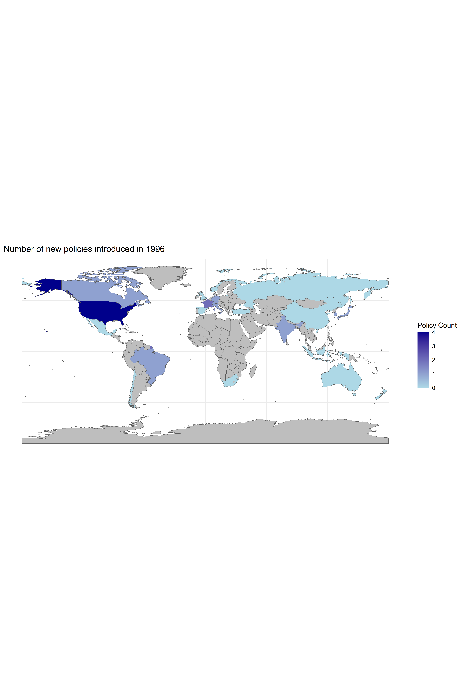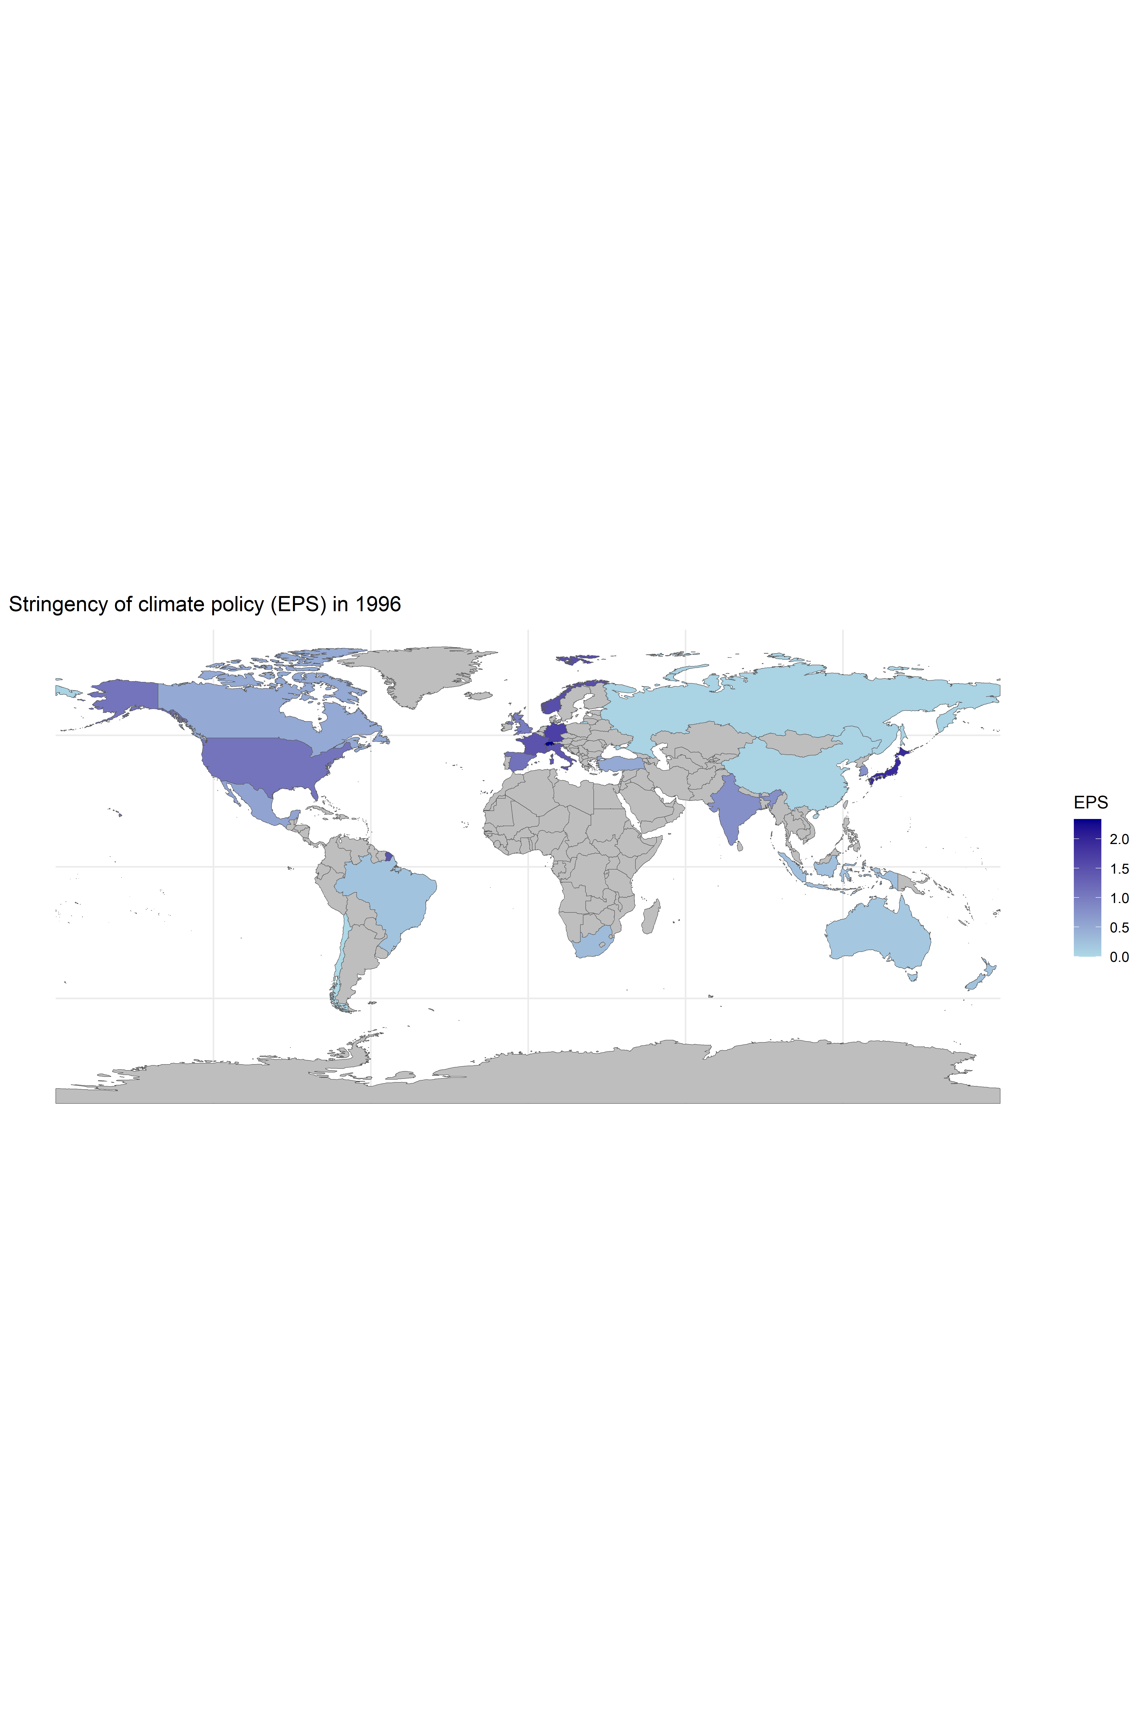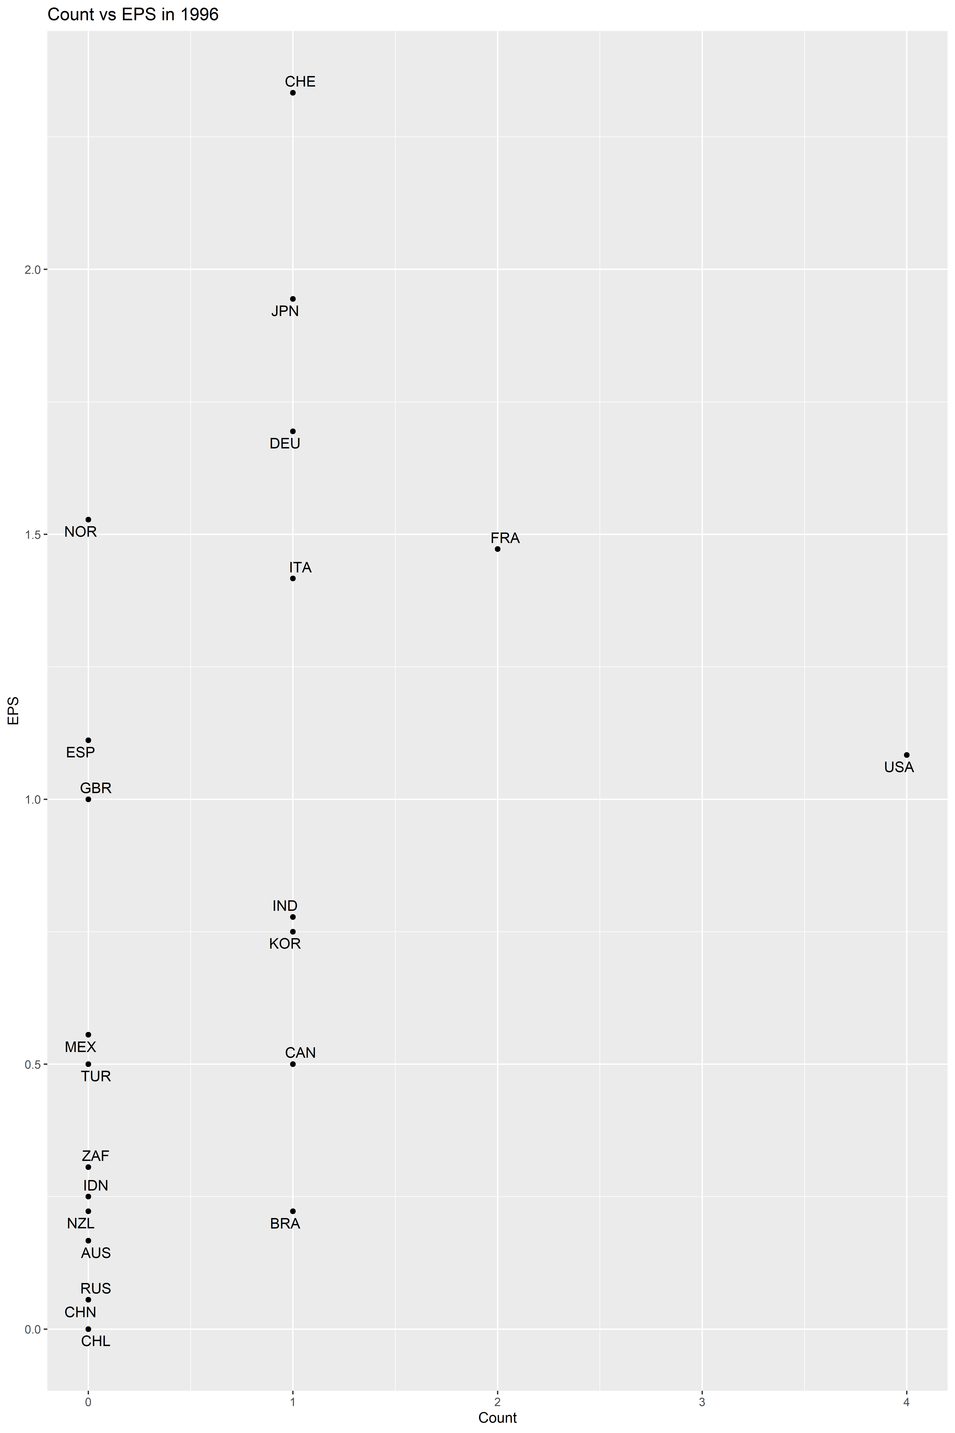

But over time two main clusters develop in EPS (but not in policy count): G7 + Korea + Spain + Australia (developed) vs BRICS + Mexico + Indonesia + Turkey + presumably Saudi Arabia and Argentina (developing). In policy count the countries are much more alike.

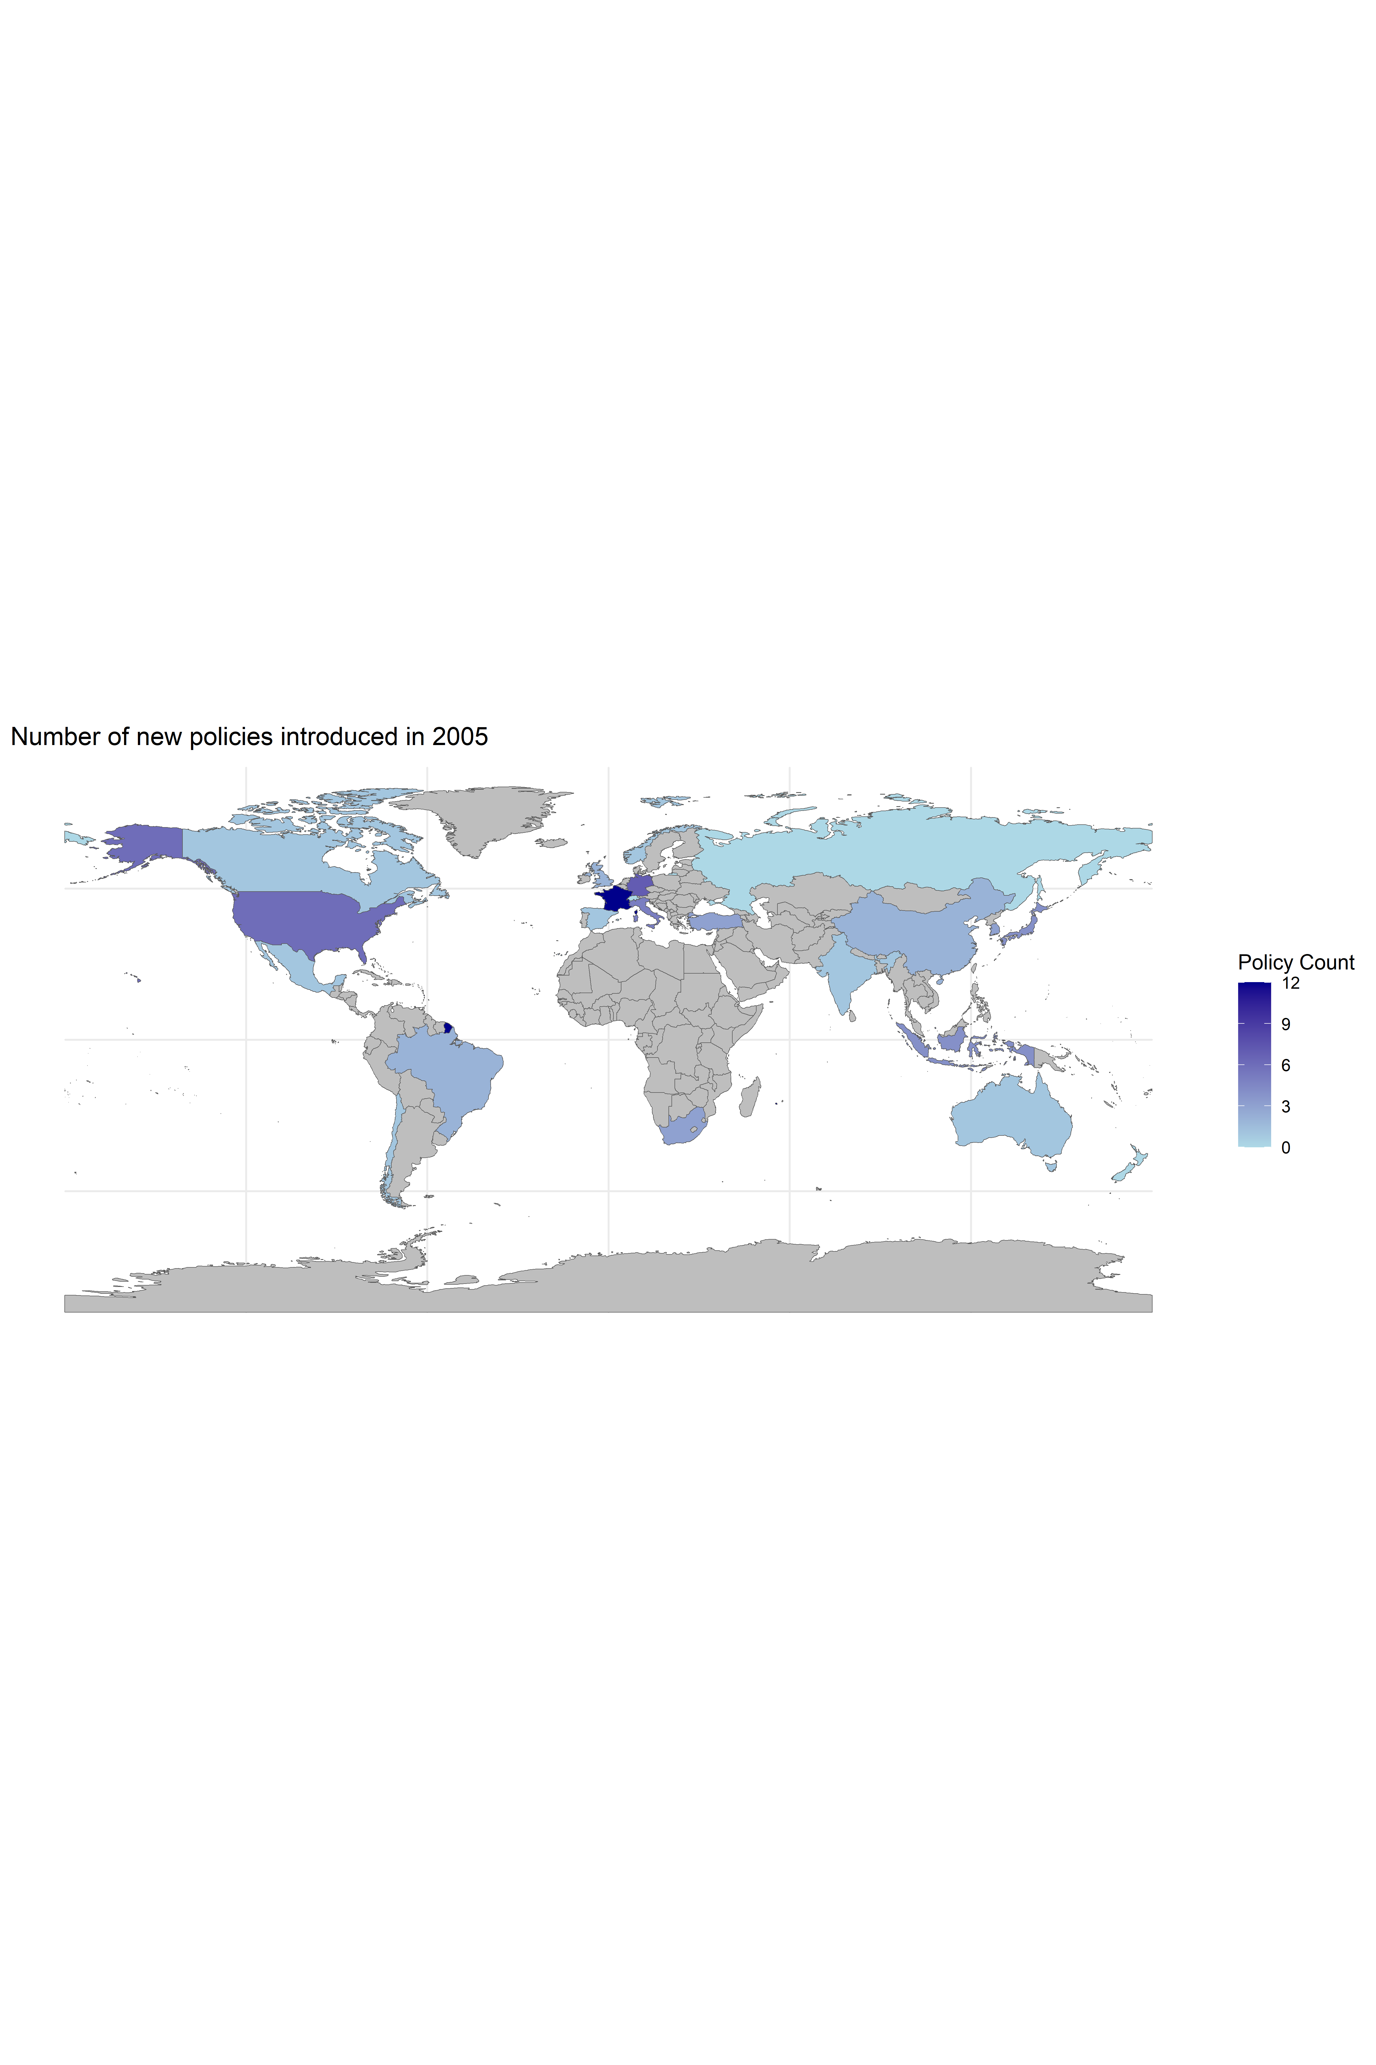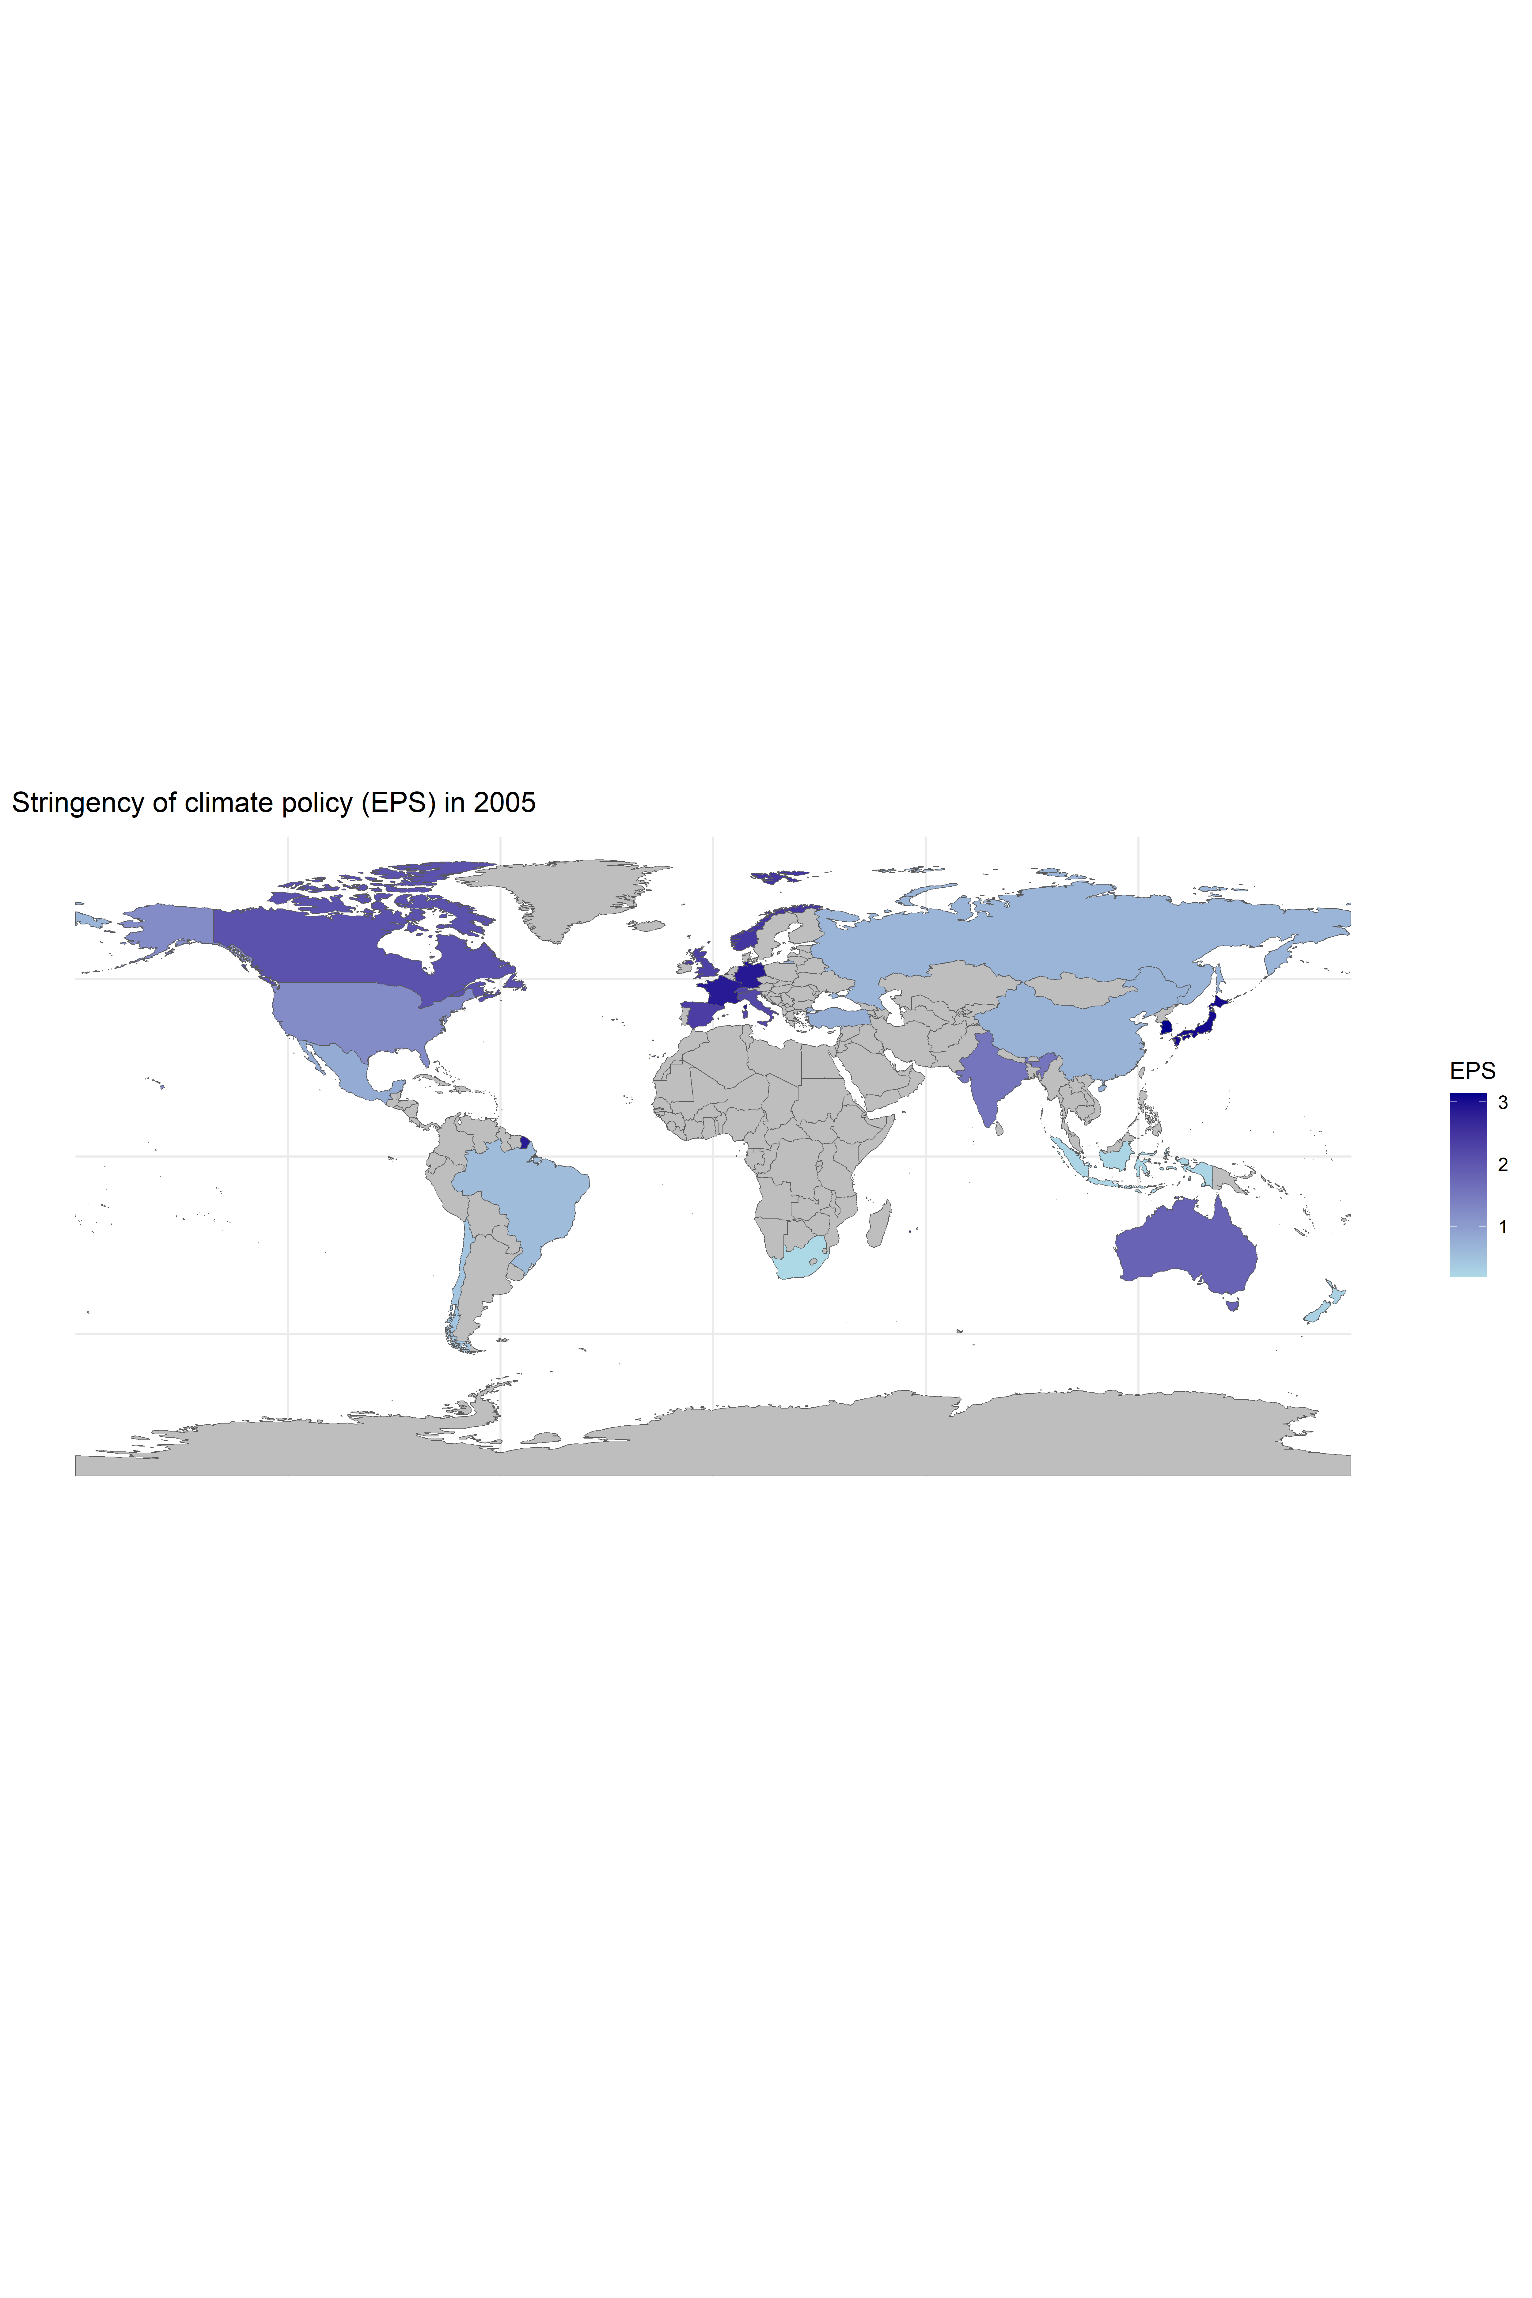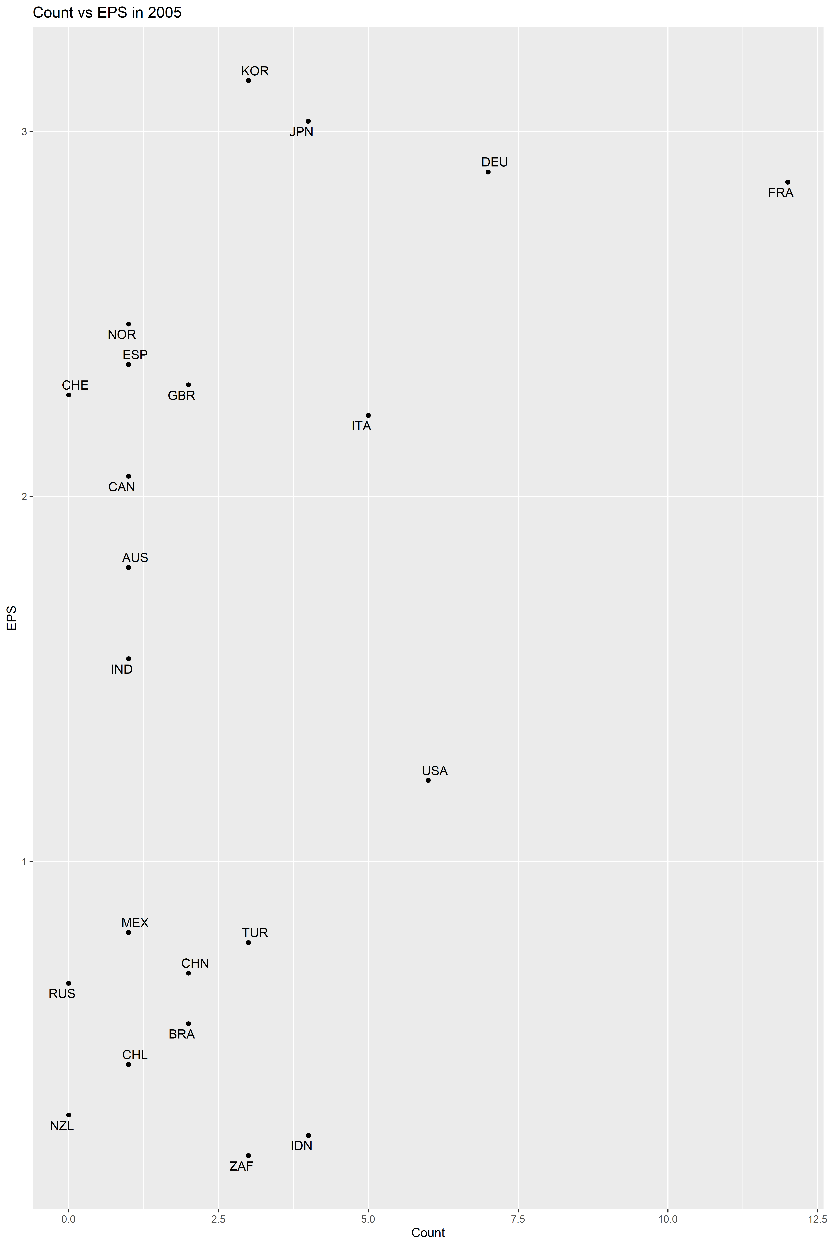

Closer to 2020 the gap between the two clusters in EPS starts to reduce, notably China, India and Turkey increase policy stringency 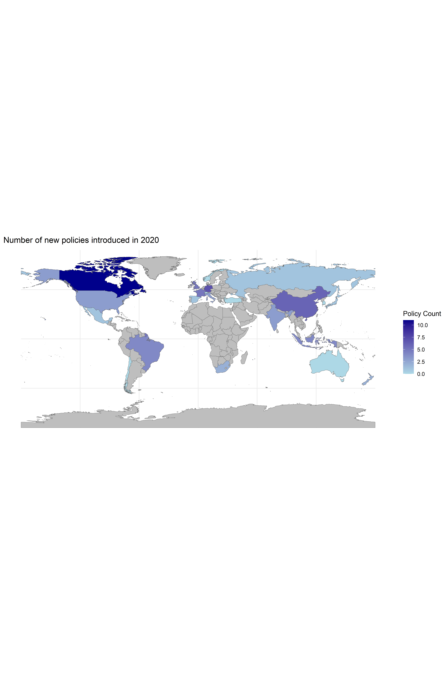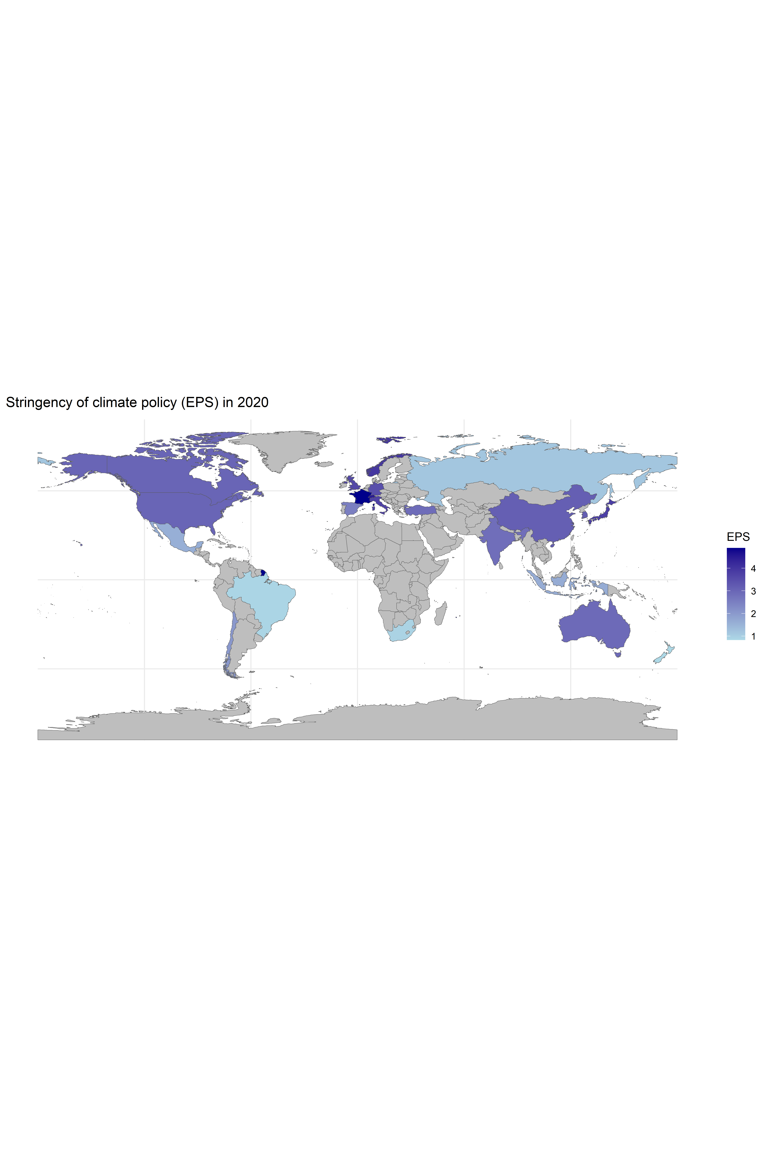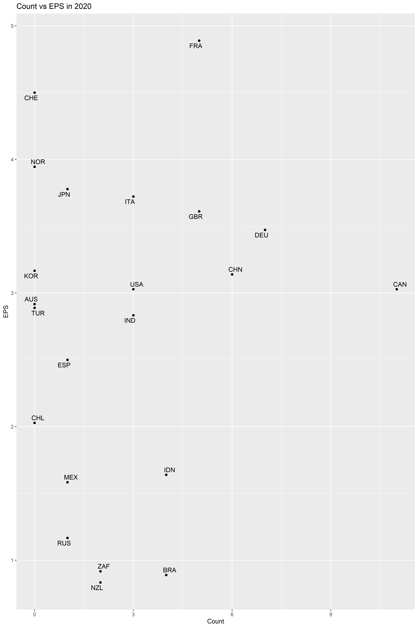

And this is a summary over all years as average 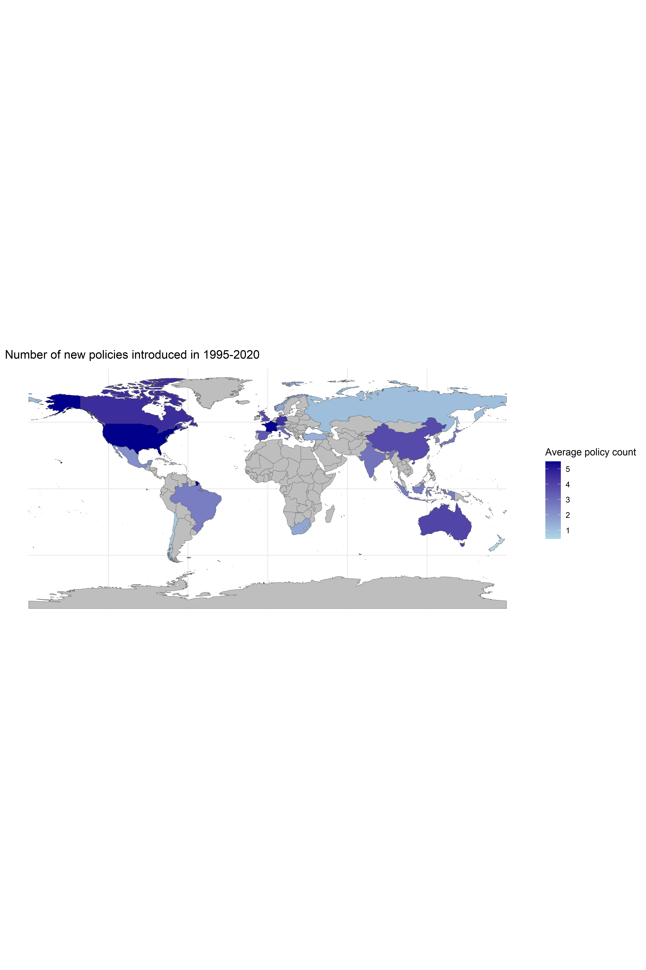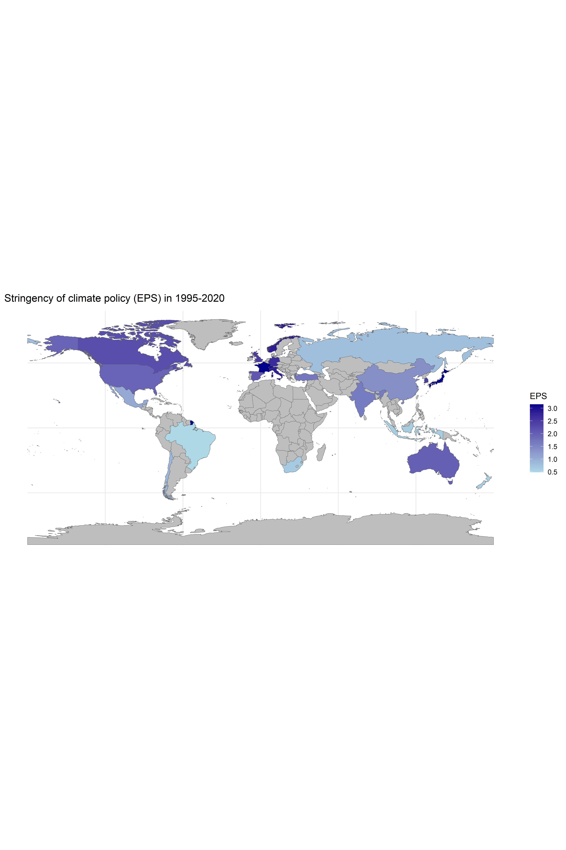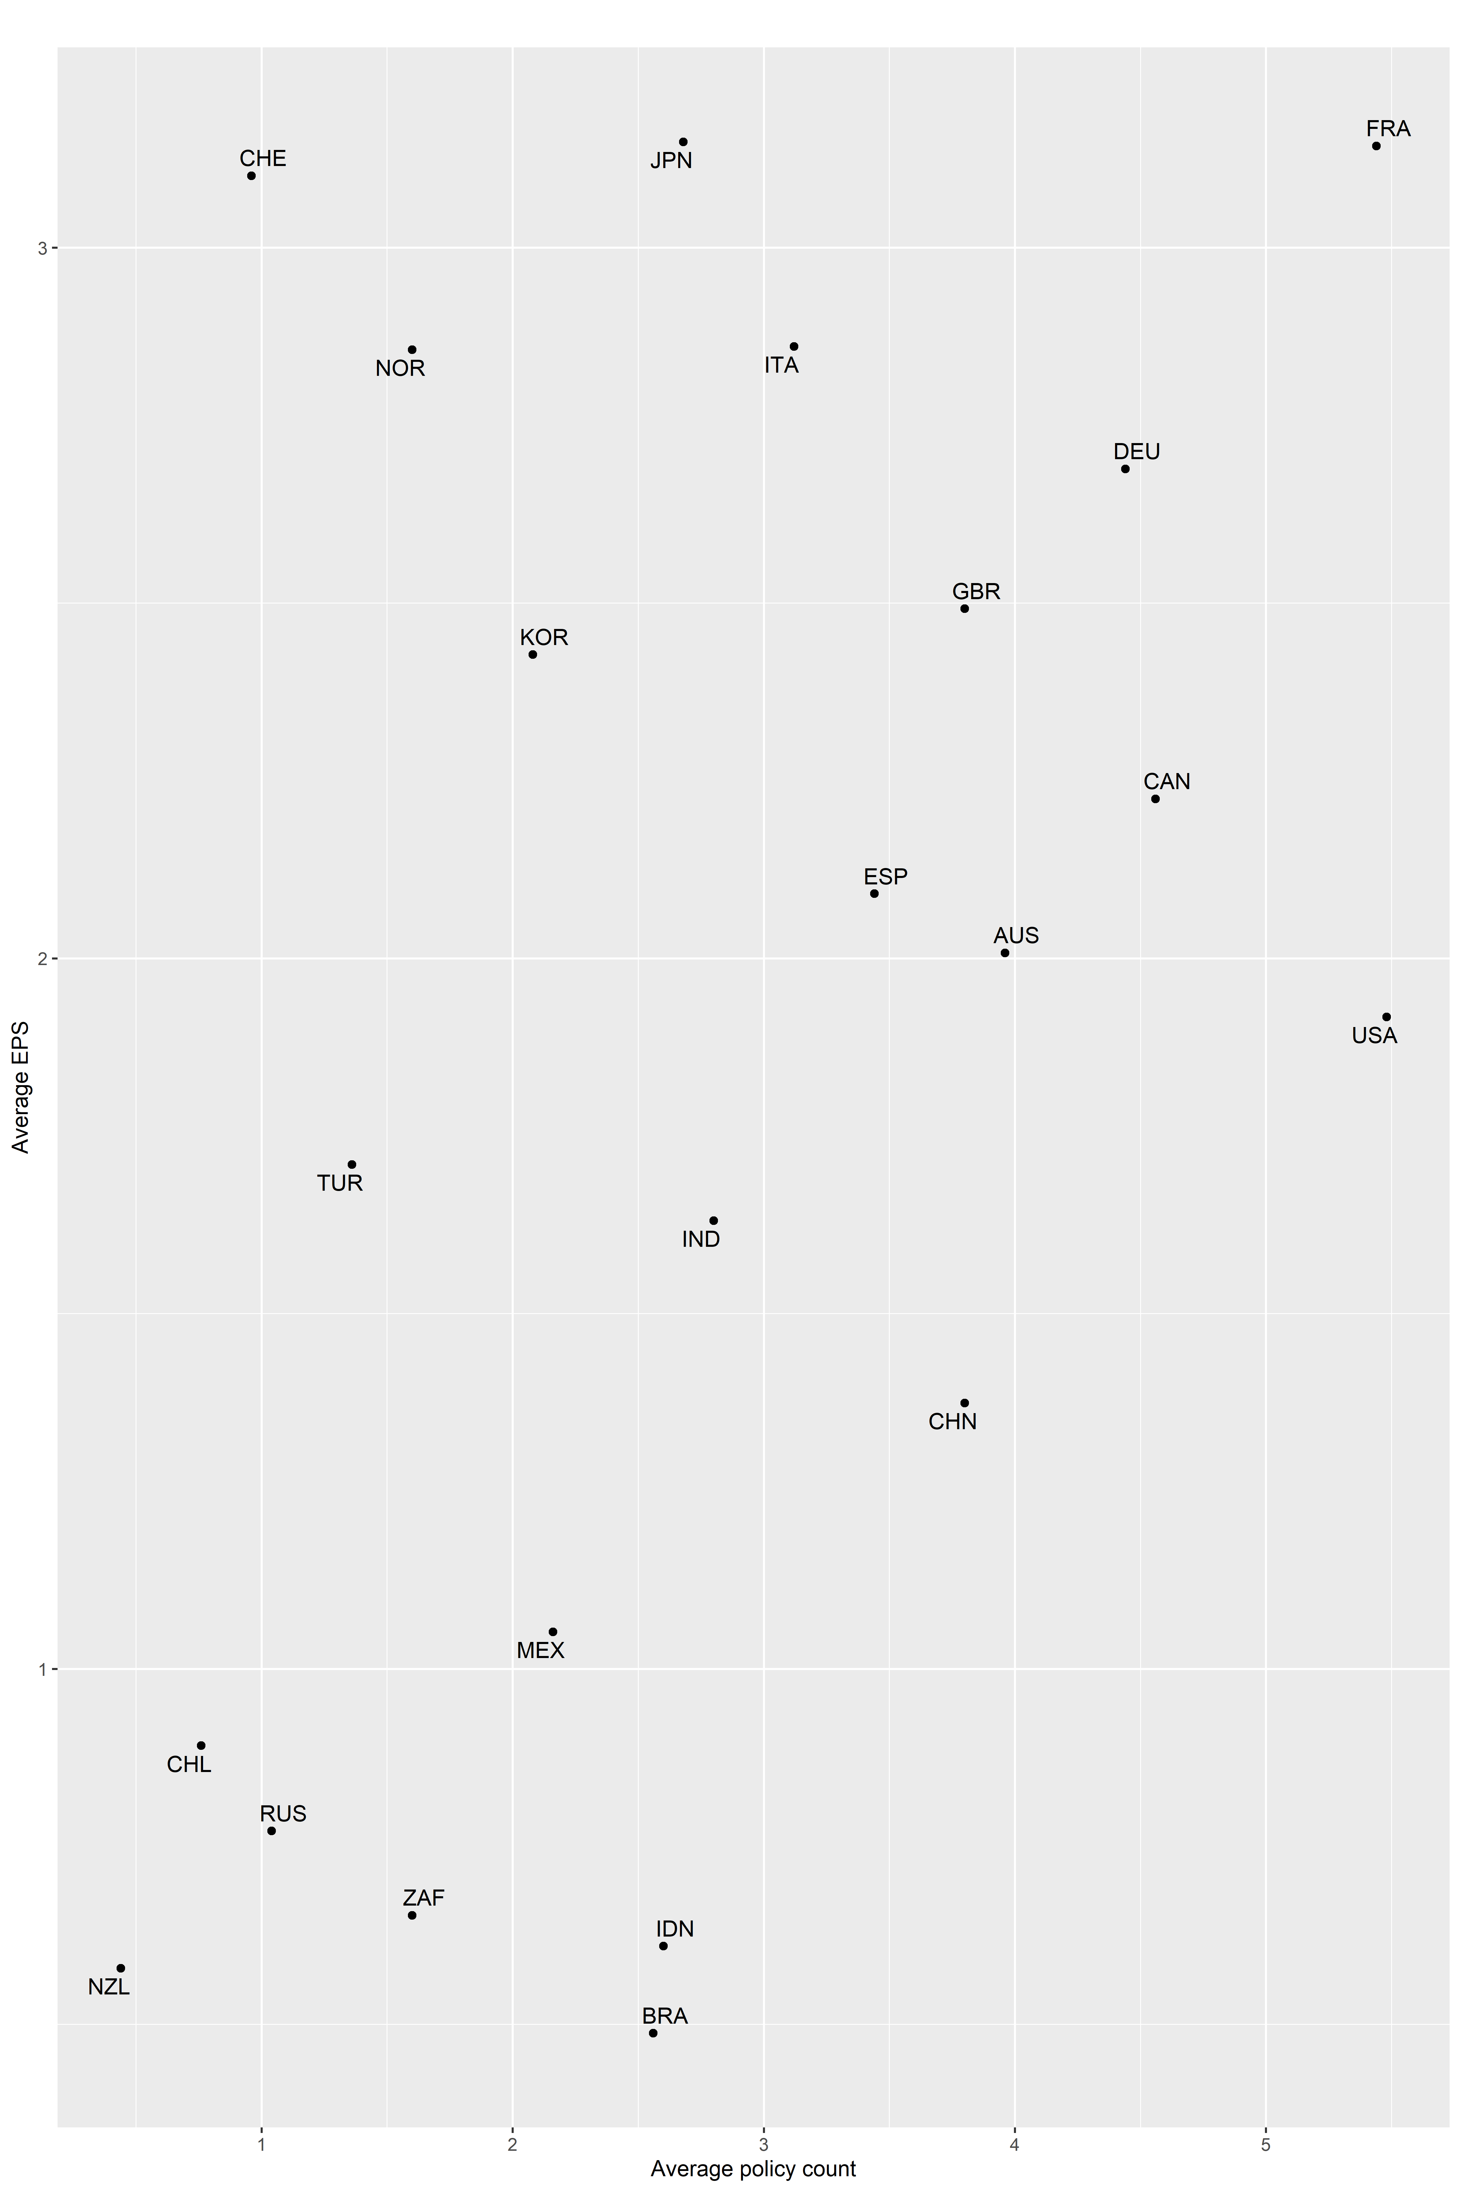

##   
## Pearson's product-moment correlation  
##   
## data: dataset$Count and dataset$EPS  
## t = 6.5611, df = 548, p-value = 1.238e-10  
## alternative hypothesis: true correlation is not equal to 0  
## 95 percent confidence interval:  
## 0.1905708 0.3456838  
## sample estimates:  
## cor   
## 0.2698772