Palette dialog

Copyright: ©1998 Prolog Development Center A/S
Version: 1.0
Build: 008.981112
Tested with: Visual Prolog v.5.1 build 555a

1. Overview
Purpose
Palette dialog is the screen object for displaying and changing the Drawing tools. It may be usefull for the wide range of application programs like raster and vector drawing programs, screen layout editors, etc...
Palette dialog contains 3 groups of pushbuttons (Pattern style buttons, Color buttons and Pen style / Pen width buttons) and Preview window displaying example drawing object. Pressing the pushbuttons with the mouse user may change current drawing tools settings. Color buttons may be pressed in two ways in order to set Pen color or Brush color:
- pressing left mouse button on top of the Color pushbutton forces Brush color setting,
- pressing right mouse button on top of the Color pushbutton forces Pen color setting.

Code structure
The source code consists of PALETTE.DOM (domains declaration), PALETTE.PRE (predicates declaration) and PALETTE.PRO (implementation). The first of these files should be included into the <PROJECT>.INC, the second - into the project modules operating with Palette dialog, implementation files - into one of the project modules. "TEMPLATE" directory contains PALETTE.DOM, PALETTE.PRE, PALETTE.PRO templates.

Integration of the Palette tool with the application by templates
For integration of the Palette editor tool with the application it is necessary to carry out the following actions:
- Copy PALETTE.DOM, PALETTE.PRE, PALETTE.PRO templates to application directory.
- Replace all occurrences of "PALETTE _DIR" string in PALETTE.DOM, PALETTE.PRE, PALETTE.PRO templates with actual path to the PALETTE tool files.
- Replace "PROJECT" string in PALETTE.PRO templates with actual name of the project.
- Include PALETTE.DOM into the <PROJECT>.INC.
- Include PALETTE.PRE into the project modules operating with Palette.
- Add PALETTE.PRO to the list of project modules.

Application
Palette dialog tool allows application programmer to use it in 2 ways:
- Palette dialog with default colorlist (16 colors), predicate: palette_Create\6.
- Palette dialog with custom colorlist and variable number of visible colour buttons, predicate: palette_Create\8.

Interaction between Palette dialog and the application is based on the callback function, notifying application about user actions (pen, pattern, pen color is changed ,etc.).
If callback function fails, then Palette dialog provides default handling.

2. Using Palette dialog in application
To create the Palette dialog, application programmer should use palette_Create/6 or palette_Create/8 predicate:

PaletteWin = palette_Create(ParentWin,PNT,Callback,Title,ShowTitleBar,
ShowCloseButton)

or

PaletteWin = palette_Create(ParentWin,PNT,Callback,Title,ShowTitleBar, ShowCloseButton,ColorButtons,ColorList)

Remarks:
Pictures bellow show that Palette dialog exterior depends upon the ColorList and ColorButtons input arguments.
If number of colors in ColorList is equal to ColorButtons*2:

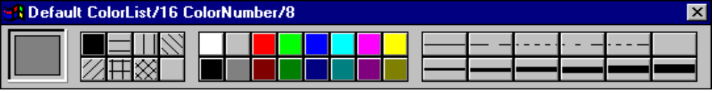

Preview
window
PATSTYLE
buttons
COLOR
buttons
PENSTYLE/PENWIDTH
buttons

If number of colors in ColorList is more than ColorButtons*2:

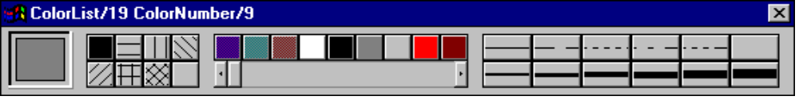

If number of colors in ColorList is less than ColorButtons:

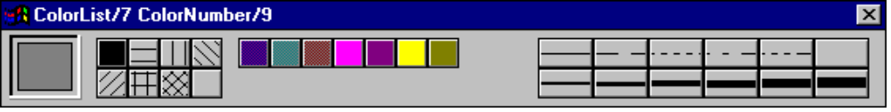

If number of colors in ColorList is more than ColorButtons, but less than ColorButtons *2:

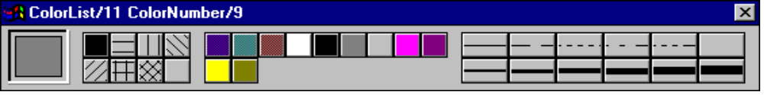

Palette dialog informs an application about user actions occured using callback function of following format:

PALETTE_CALLBACK = determ (WINDOW PaletteWin,PALETTE_EVENT What) - (i,i)

where PaletteWin is the Palette dialog window handle and What is one of the:

change_PATSTYLE(PATSTYLE); % PATSTYLE button is pressed
change_PEN(PENSTYLE,PENWIDTH); % PENSTYLE/PENWIDTH button is pressed
change_PenColor(COLOR); % COLOR button is pressed with right
% mouse button
change_BrushColor(COLOR); % COLOR button is pressed with left
% mouse button
is_ToBeDestroyed % Palette is about to be destroyed

Application may handle or ignore certain events (fails). In latter case Palette tool provides default handling which means:
- automatically changes drawing tools for the Preview window and redraw it to display changes for change_... events,
- closes Palette dialog for is_ToBeDestroyed event.

3. Global predicates.
palette_Create/6
Syntax:
procedure
WINDOW palette_Create(WINDOW, % Parent window
PNT, % LeftTopCorner position
PALETTE_CALLBACK, % Palette callback function
STRING, % Title string
BOOLEAN, % Have title bar
BOOLEAN) % Have close button
Flow pattern:
(i,i,i,i,i,i)
Return value:
Returnes Palette dialog window handle.
Remarks:
Creates Palette modeless dialog with 16 color buttons and default ColorList containing 16 the most common colors.
Fail:
Never fails.
Errors:
Bad parent window.

palette_Create/8
Syntax:
procedure
WINDOW palette_Create(WINDOW, % Parent window
PNT, % LeftTopCorner position
PALETTE_CALLBACK, % Palette callback function
STRING, % Title string
BOOLEAN, % Have title bar
BOOLEAN, % Have close button
INTEGER, % Number of color buttons
COLORLIST) % List of user defined colors
Flow pattern:
(i,i,i,i,i,i,i,i)

Return value:
Returnes Palette dialog window handle.
Remarks:
Creates Palette modeless dialog with custom colorlist and variable number of visible color buttons
Fail:
Never fails.
Errors:
Bad parent window.

palette_Setup/2
Syntax:
procedure
palette_Setup(WINDOW DlgWin,
PALETTE_SET Setup)
Flow pattern:
(i,i)
Remarks:
The predicate set necessary components of dialog, their arrangement or unset them.
The PALETTE_SET domain is shown below:

PALETTE_SET =
preview(PALETTE_ONOFF); % Preview component
pen(PALETTE_ONOFF); % Pen select component
pattern(PALETTE_ONOFF); % Pattern select component
color(PALETTE_ONOFF) % Pattern/Pen color select
% component

PALETTE_ONOFF =
off;
on(PNT Position) % Pnt - left/top corner

Fail:
Never fails.
Errors:
Bad parent window.

palette_SetPreviewPen/2
Syntax:
procedure
palette_SetPreviewPen(WINDOW DlgWin,
PEN Pen)
Flow pattern:
(i,i)
Remarks:
Sets new Pen for preview window and forces its redrawing with new Pen value. Preview window is the small area in the leftmost part of the Palette dialog displaying example drawing object (rectangle). Application has an opportunity to control drawing tool settings for the preview window using palette_SetPreviewPen, palette_SetPreviewBrush or palette_SetPreview global predicates.
Fail:
Never fails.
Errors:
Bad parent window.

palette_SetPreviewBrush/2
Syntax:
procedure
palette_SetPreviewBrush(WINDOW DlgWin,
BRUSH Brush)
Flow pattern:
(i,i)
Remarks:
Sets new Brush for preview window and forces its redrawing with new Brush value. Preview window is the small area in the leftmost part of the Palette dialog displaying example drawing object (rectangle). Application has an opportunity to control drawing tool settings for the preview window using palette_SetPreviewPen, palette_SetPreviewBrush or palette_SetPreview global predicates.
Fail:
Never fails.
Errors:
Bad parent window.

palette_GetPreview/3
Syntax:
procedure
palette_GetPreview(WINDOW DlgWin,
PEN Pen,
BRUSH Brush)
Flow pattern:
(i,o,o)
Remarks:
Gets current Pen and Brush from preview window
Fail:
Fails if the DlgWin does not exist
Errors:
Bad parent window.

palette_SetPreview/3
Syntax:
procedure
palette_SetPreview(WINDOW DlgWin,
PEN Pen,
BRUSH Brush)
Flow pattern:
(i,i,i)
Remarks:
Sets new Pen and Brush for preview window and forces its redrawing with new Brush value
Fail:
Never fails.
Errors:
Bad parent window.

