Visual Prolog Version 5.0

Getting Started

(c) Copyright 1986-1997
Prolog Development Center A/S
H.J. Holst Vej 3A-5A, Copenhagen
DK-2605 Broendby
Denmark

Copyright

The documentation for this software is copyrighted, and all rights are reserved. It may not be reproduced, transmitted, stored in a retrieval system, or translated, either by electronic, mechanical or any other means, without the prior written consent of Prolog Development Center A/S.
The software products described in these manuals are also copyrighted, and are licensed to the End User only for use in accordance with the End User License Agreement, which is printed on the disk packaging. The prospective user should read this agreement carefully prior to use of the software.
Visual Prolog is a registered trademark of Prolog Development Center A/S.
Portions of the Software and Documentation under license from:
- Borland International; Copyright (c) 1986-1988 Borland International.

Other brand and product names are trademarks or registered trademarks of their respective holders.

Table of Contents

Visual Prolog Version 5.0 1
Introduction to the Prolog 1
What can Prolog be used for? 3
The World of Artificial Intelligence 3
...and much more 3
Features 3
How Does Prolog Differ From Other Languages? 20
Prolog uses facts and rules. 20
Prolog can make deductions. 21
About the Visual Prolog Manuals 22
Visual Prolog On-line Help Files 26
The INTRO.HTM file 26
Recommended Reading 27
Manual Conventions 28
Acknowledgments 29
System Requirements 30
Beginning with Visual Prolog 30
Installation and Support 32
Running Visual Prolog directly from a CD-ROM 32
Upgrading from a previous version of Visual Prolog 32
Installation Procedure 32
Support from the Prolog Development Center 34
Guided Tour in Visual Prolog 36
Goal Testing. 36
Start with the Application Expert 41
Use Project | Run. 43
How to Study the Generated Code 44
Important Hot Keys 46
Extending the "Hello World" Application 47
Creating the "Cross Window" 56
Creating the Sweep Window 69
Using a Timer - the Clock Window 90
The Picture Window 92
Creating a Tree Window 93
Creating an Editor Window 95
Handling the Clipboard 99
Printing 100
Adding Controls to the Clock Window 101
Using a List Box 106
Creating a Dialog 111
Doing DDE 119
Creating a Help File 120
Adding On-line Help to the Application 127
Debugging Prolog programs 131
Appendix A 134
The BIN Directory 135
The LIB Directory 137
The VPI Directory 138
The INCLUDE Directory 141
The FOREIGN Directory 142
The WINBIND Directory 142
The PMBIND Directory 143
The SQL Interface 143
The BGI Bindings 144
The VDESRC Directory 145
The SETUP Directory 145
The TXTEXAMP Directory 145
The DOC Directory 146
The UPGRADE Directory 146
The OOP Directory 146
The WWW Directory 147

Introduction to the Prolog

Prolog is the result of many years of research work. The first, official version of Prolog was developed at the University of Marseilles, France by Alain Colmerauer in the early 1970s as a tool for PROgramming in LOGic. The result was a language far more powerful than even today's well known programming languages, like Pascal and C. A Prolog program for a given application will typically require only one tenth as many program lines as the corresponding C++ program.
Today, Prolog is a very important tool in programming artificial intelligence applications and in the development of expert systems. The demand for more "user friendly" and intelligent programs is another reason for Prolog's growing popularity. But the most important benefits of Prolog apply equally well to any application domain: By allowing the programmer to model the logical relationships among objects and processes, complex problems are inherently easier to solve, and the resulting program is easier to maintain through its lifecycle. With Visual Prolog, applications such as customized knowledge bases, expert systems, natural language interfaces, and smart information management systems are now within your programming domain.
Prolog in general has moved out of the artificial intelligence labs, and PDC's Visual Prolog is a commercially competitive, general-purpose development environment. Visual Prolog has increasingly become the tool of choice for many developers, because of the intelligent features that can be so easily added programs or even web sites.
Prolog is what is known as a declarative language. This means that given the necessary facts and rules, Prolog will use deductive reasoning to solve your programming problems. This is in contrast to traditional computer languages, such as C, BASIC and Pascal, which are procedural languages. In a procedural language, the programmer must provide step by step instructions that tell the computer exactly how to solve a given problem. In other words, the programmer must know how to solve the problem before the computer can do it. The Prolog programmer, on the other hand, only needs to supply a description of the problem and the ground rules for solving it. From there, the Prolog system is left to determine how to find a solution.
Because of this declarative (rather than procedural) approach, well-known sources of errors such as loops that carry out one too many or one too few operations are eliminated right from the start. Prolog encourages the programmer to start with a well-structured description of the problem, so that, with practice, Prolog can also be used as both a specification tool, and the implementation vehicle for the specified product.
Visual Prolog addresses the same target market as SQL Database Systems, C++ development systems and other language tools like Visual Basic, Borland's Delphi, or IBM's Visual Age. The trend in many organizations today is to solve everything with database technology, but this approach often leads to bad results in both development time and in the performance of the final system. An application developed in Prolog can have far superior performance and user friendliness along with a shorter development time. PDC's Prolog is particularly well suited for these kinds of traditional database tasks, because Visual Prolog has among its programming capabilities a full, very easy-to-use database engine. Programs created by Visual Prolog are very fast because of the highly optimizing compiler, almost as fast as C++-based applications.
Both the the websupport and the object system contribute heavily to the commercial usefullnes of Visual Prolog. Objects in it self is a very powerful modelling tool, that is almost a defacto standard in languages like Pascal, C++, Smalltalk etc. The websupport is an important new feature. For instance expertsystems written in Visual Prolog, can be attached to webpages, which is almost bound to play an important role in supportdepartments, trade on the internet and several other of the webbased technologies to come.

What can Prolog be used for?
Because of Prologs declarative (rather than procedural) approach, well-known sources of errors - such as loops that carry out one too many or one too few operations - are eliminated right from the start. Not only that, Prolog encourages the programmer to start with a well-structured description of the problem, so that, with practice, Prolog can also be used as both a specification tool, and the implementation vehicle for the specified product.
Although Prolog makes programming much easier, it can also make severe demands on the computer. Visual Prolog Version 5 is the first implementation of Prolog for the IBM PC and compatible personal computers that is both powerful and conservative in its memory and computing requirements.

The World of Artificial Intelligence
Prolog was originally designed to be an artificial intelligence (AI) language, and it is very well suited for expert systems and similar AI applications. Frame or rule-based systems, forward or backward chaining, pattern-matching systems, and constraint-resolution systems; all are natural and elegant expressions of Prolog's underlying semantics.
Many of PDC's customers have been making advisory systems, decision support, diagnostics, expert system shells or natural language applications, within a wide range of areas like banking, airline, healthcare, insurance, medical, industry, etc.

...and much more
Yet, the strengths of Prolog extend far beyond the boundaries of AI. The high level of abstraction, and the ease and simplicity with which complex data structures are represented, allow a declarative approach to programming that benefits any discipline or problem solving strategy.
For this reason, Visual Prolog has also been widely used to make administrative applications, advanced database management, planning and scheduling systems, webbased applications and much more.

Features
Visual Prolog Version 5 provides more features than many other languages, for instance:

Visual Development Environment (VDE)
The VDE combines the compiler with an editor, a resource toolkit, a resource and application Expert, an interactive make facility and various browsing facilities.
After the interactive visual creation of the user interface components, a running prototype is automatically generated. The application Expert creates all the necessary files for a project, and the resource Expert knows how to generate the Prolog code to support all the selected resources.
The VDE is designed to make it easy, convenient and fast to develop applications based on a higher level abstraction of the standard interfaces provided by each of the native operating systems. Functionally identical Visual Prolog Development Environments are available to run on all Windows and OS/2 platforms.
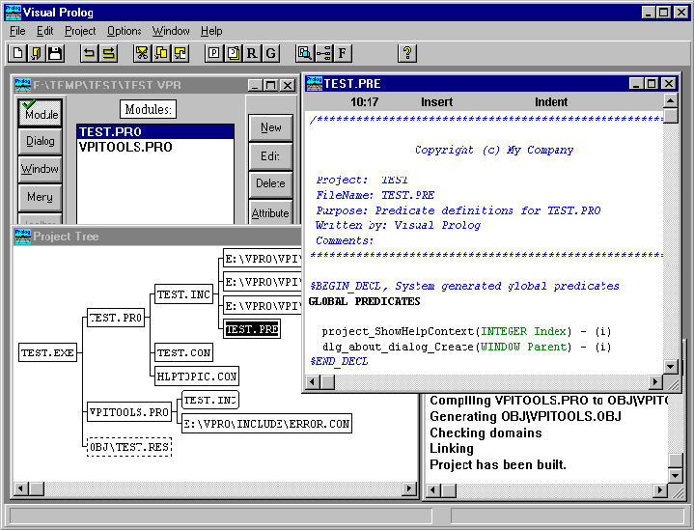

Figure 1 :The VDE.

Code experts
Code Experts that create and maintain the Prolog control code for the resources.
The greatest strength of Visual Prolog is probably the combination of the Layout tools and the Code Experts. The code experts take care of much of the work for you, meaning that you can create a new application in a few minutes, and incrementally enhance this from a prototype to your final application
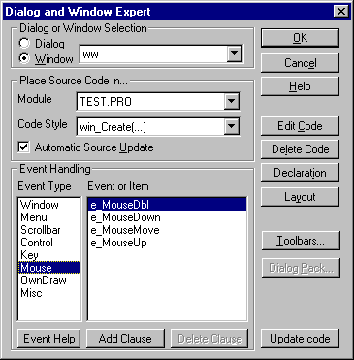

Figure 2: The Dialog and Windows expert

An application expert that generates and configures projects.
The application expert can generate a new project. It accounts for thousands of combinations of Operating systems, UI strategies, C compilers, companion tools etc. When a new project is generated, it will automatically set up all the basic tools like a help file, toolbars, menu's etc.
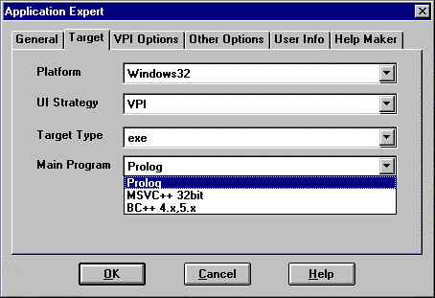

Figure 3: The application expert dialog

Integrated editors for the preparation of resources.
These tools make it possible to visually design and modify the user interface in an interactive way. Use the mouse to lay out controls in dialogs or windows and access attribute settings with a click of the mouse. Resources consist of the Windows, Dialogs, Bitmaps, Icons, Cursors and Strings that are necessary for any application that uses a GUI.

Ability to import resources
Resources can be imported from DLLs, Exe's, RES files, and from other Visual Prolog projects.
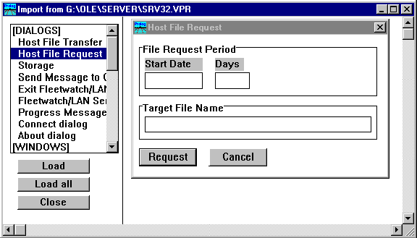

Figure 4: The import ressources dialogbox.

A Language-sensitive text editor
Visual Prolog contains all the features that you expect to find in a modern development environment, for instance a powerful source code editor with color-coding of Visual Prolog keywords and other language elements. The colors make it much easier to differentiate between predicate names, parameters, comments, etc. as, for example, integer constants can be assigned to display in red. The editor supports an unlimited undo and redo facility, search and replace, cut, copy, paste, drag and drop for quick block movements, even hypertext links can be embedded. Moreover, as with previous PDC editors, you can include the editor functionality in your own applications!
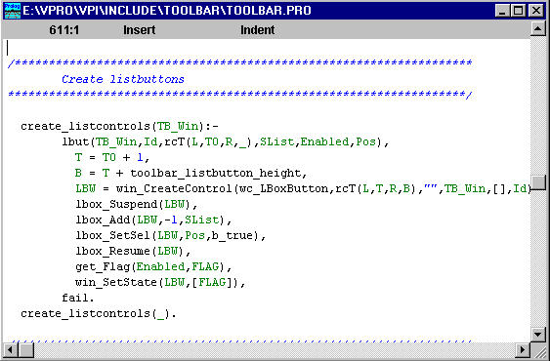

Figure 5: The language sensitive editor.
A unique feature of the editor as used within the VDE is that it knows about all the predicates, user interface components, colors, constants etc. of Visual Prolog. All these things can be readily pasted into the source code with a click of the mouse.

Integrated, state-of-the-art Help Maker
The built-in help authoring system makes it very easy to give your application on-line help. The Help system is based on the PDC Hypertext Abstract Machine (HAM). In the Help authoring system it is possible to enter the help text interactively, mark new links with the mouse, and to follow existing links during the design phase. The help system can output both the Windows .RTF format and the OS/2 IPF format so it is possible to generate native help systems for both OS/2 and Windows.
The Help compiler HC.EXE is not included with Visual Prolog, but can be found in the Visual C++ and the Borland C++ products. If you need a newer version of the Win3.1 help compiler it may be worth checking out the Softlib directory at ftp.microsoft.com or trying the following URL: ftp://ftp.microsoft.com/Softlib/mslfiles/hc505.exe.
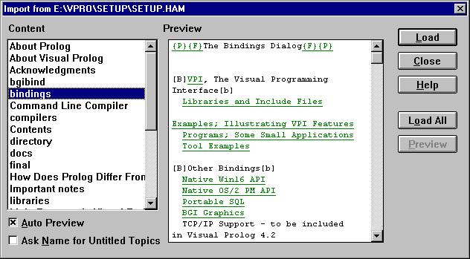

Figure 6: The Visual Prolog help system.

Source Code Browser.
The Visual Prolog compiler generates information for the source code browser, so it is possible to inspect the predicates in a module, browse all the global predicates in the project or locate where any predicate or domain is either declared or defined.

Project sharing and Source control.
With Visual Prolog it's possible to use source control systems like PVCS, MKS and MS-SourceSafe, and it is easy to share resources between several projects as well as to allow multiple programmers to work on the same project

Visual Prolog's large online Help reference.
This help facility offers a complete guide to the operation of the VDE and full reference information for the basic Prolog language and the Visual Programming extensions.
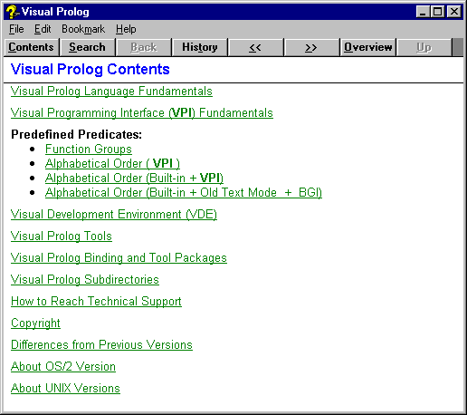

Figure 7: Visual Prolog on-line help.

The Visual Programming Interface (VPI)
A portable Prolog API for graphical user interfaces has been defined. This API is an abstraction of the facilities found in the basic windowing environments of the Windows 3.x, Windows 95, Windows NT, OS/2 PM platforms. This gives the Visual Prolog programmer an API that is both portable and easier to use than
programming to the native API. However, in order not to restrict users, the API also contains platform-specific facilities and options that are not portable. If platform specific facilities are used the application is either not portable, or conditional compilation must be used to provide alternative behavior on different platforms. It is also possible to program directly to the underlying API as in the current WINBIND or PMBIND subdirectories.

High level GUI components
Along with the basic portable API, a number of higher-level GUI components have been implemented on top of the VPI. These components are supplied with source code, and are of course portable to all the platforms supported by the VPI. These tools include a Grid, a Tree window, an Explorer view, Toolbars, Tabbed
dialogs, advanced Report handling, etc.
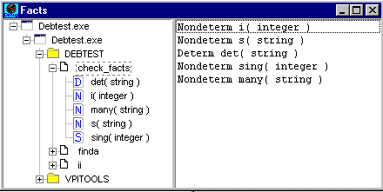

Figure 8: An example of a GUI component.

Fast, highly optimizing compiler.
PDC's compiler generates tight native code that can compete with the code generated by Pascal and C compilers. The compiler performs several different analyses ranging from a global flow analysis and determinism check down to register allocation and peep-hole optimizations.
In addition to generating efficient code, the compiler performs many advanced checks to try and detect potential problems at compile-time. The main analyses are Type checking, global flow analysis, Determinism checking and Possible Fail Detection.
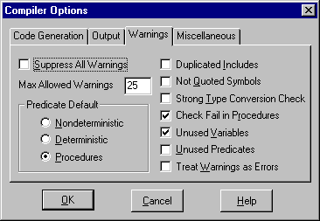

Figure 9: The compiler options dialog.

Type checking system that detects mistakes at compile time.
Many Prologs are un-typed interpreters, but a distinguishing characteristic of PDC's version of Prolog is its type system that provides an extra level of security in programming. The type declarations document the code and allow the compiler to helpfully point out, at the early stages of development, common typing mistakes as well as more serious errors in logic. Moreover, by serving as a type of contract between programmer and development system, type declarations help ensure the integrity of a program over the entire product life cycle. Further, the declarations help the compiler to generate programs that are more efficient and save memory space during execution.

DOMAINS
DETER = none ; deter(string)
NOUNP = nounp(DETER,string,RELCL)
RELCL = none ; relcl(string,VERBP)
VP = vp(string,string)
NP = np(string)
SENTENCE = sent(NOUNP,VERBP) ;
question(VP,NP)
TOKL =string*
VERBP = verb(string) ; verbp(string,NOUNP)

PREDICATES
append(slist,slist,slist)
fillbox(slist)
tokl(string,TOKL)

Debugger
When you work with larger Prolog programs, you will find the Visual Prolog debugger an indispensable tool. The debugger works on the compiled code, and allows setting breakpoints and stepping through the code. While stepping through the code, the variable values can be inspected as well as the contents of the asserted facts.
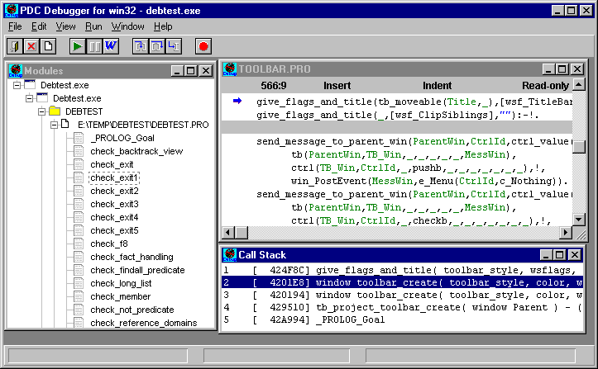

Figure 10: The debugger.

Exception handling and error trapping.
Visual Prolog includes powerful mechanisms for handling error situations, as well as controlling user breaks. The programmer may select among various levels of error checking and error reporting.
check_diskette(S):-
trap(disk(S),ExitCode, errorhandler(ExitCode)).

Classes &Objects.
Often people distinguish between object-oriented and declarative programming languages, but in Visual Prolog you can use features from both paradigms. The Visual Prolog language has support for Objects and Classes in a design similar to C++ implementations.
class aclass
predicates
testpred(STRING)
check()
endclass
implement aclass
FACTS
f(aclass)

CLAUSES
store():-
this(O),
assert(f(ORef)).
check():-
f(ORef),
ORef:testpred("Check Virtual methods"),
testpred(TXT):-
write(TXT),nl.
endclass
GOAL
O = aclass::new(),
O:check().

Portable code
The Visual Prolog system is available on, and can generate programs for, a variety of platforms. Apart from a few operating system-specific facilities and limitations, the Prolog code is portable between all of them. Functions like copying, renaming and deleting files, invoking other programs, returning the date and time, etc. work the same way on all platforms. Applications can be produced for DOS, DOS Extended, Windows 3.x, Windows 95, Windows NT, OS/2 Textmode, OS/2 Presentation Manager, SCO UNIX and Linux (the VPI is not supported under UNIX,DOS, DOS-extended or OS/2 textmode).

An Open Platform.
Visual Prolog is well designed to interface with other programming tools. Visual Prolog can generate routines callable from other languages and can itself call routines written in other languages. The interface is general and supports all compilers that generate standard .OBJ modules. Also, Visual Prolog programs can both call .DLL's and also be placed in .DLL's.
By declaring Global 'prolog' predicates as being of language C calling convention, by declaring the argument types and the input/output flow patterns, it is possible to call the C routines directly (as if they were Prolog) without any special glue code between Prolog and C! This interface works in both directions, when the predicates are being declared as language C, they can be called directly from C language routines!

GLOBAL PREDICATES
procedure LONG vpi_LoadDll( STRING ) - (I) languagec
procedure vpi_FreeDll( LONG ) - (I) language c
procedure LONG vpi_GetDllProc( LONG,
STRING ProcName ) - (I,I) language c

Integrated Make Facility.
The make facility handles all the complexity of compiling, linking, resource compilation and resource binding etc. The make facility checks time stamps in order to recompile only the necessary files. The dependencies can be displayed as a tree in order to visualize the structure of the project.
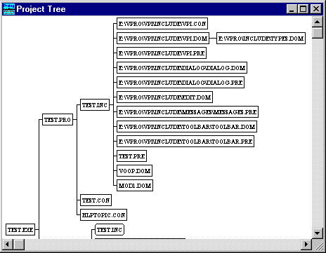

Figure 11: The make facility.

A Powerful database subsystem
A fast and extremely flexible database subsystem makes Visual Prolog a more suitable choice for database applications than many 4GLs. The database system supports a collection of distinct ordered chains of Prolog terms, where database terms can be any abstraction supported by the language itself, from simple records to trees or graphs. The database system can directly access individual terms, or it can backtrack through chains of terms to generate or match particular values. The terms can be stored in any one of three locations: in a file, in memory or in EMS-type expanded memory under DOS. The database also supports B+ trees, which provide fast data retrieval and the ability to change term ordering efficiently.
If you are using the database in a LAN application, you can take advantage of Visual Prolog's support for file sharing in the external database system. Multi-user database access is provided using a mechanism that efficiently serializes file access inside of transactions. This means that a database can be open by several users or processes simultaneously.
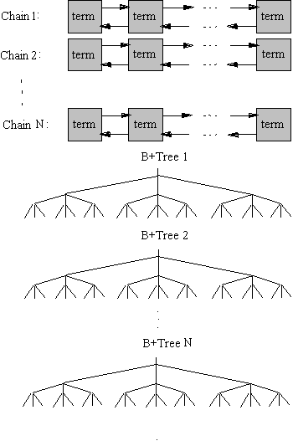

Figure 12 Different types of databases, supported by Visual Prolog

Client - Server architecture
Visual Prolog is a powerful platform for building Client-Server applications. The main avenue for this is currently the TCP/IP bindings, but under OS/2 it is also possible to use Named Pipes and NETDDE is available under Windows. Using any of these facilities, the programmer can send arbitrarily complex Prolog terms between multiple processes on a single machine, or between programs on separate machines over a network. Database or logic servers can easily be constructed with this facility.

ODBC and portable SQL Bindings
Visual Prolog's external database system is often the fastest and most flexible way to store large amounts of data. However, data might already exist in another database system, or the application might need to share data with other applications that can only make use of particular database technology. In such cases, it becomes extremely important to be able to link to external database systems and Visual Prologs portable SQL bindings make this simple for most databases. The portable SQL bindings are based on either ODBC, Oracle's OCI libraries, or DB2 under OS/2. Visual Prolog also contains more extensive direct bindings to Microsoft's ODBC APIs for Windows platforms.

Document handling tools
PDC's DOC tools provide a high-level abstraction for handling richly formatted documents. Using a Prolog structure to represent the document makes it possible to be independent of the actual format whether it is .RTF, HTML or .IPF. There are both generators from the Prolog term format to these formats, as well as parsers to convert any of these formats to the Prolog term format. These tools open up many application possibilities, like generation of Word documents, Internet assistants etc. The tools are found in the doc_tool subdirectory and include an example program where you can see how a .HTML file looks when converted to the .RTF format.

The source code for a Prolog interpreter.
We also include PIE (Prolog Inference Engine): the complete source code to a standard Prolog interpreter written in Visual Prolog. This interpreter is a great tool for learning more about how Prolog works and how you can add meta-language capabilities to your applications. You can modify this interpreter to create your
own specialized logic programming languages, inference engines, expert system shells, or program interfaces.
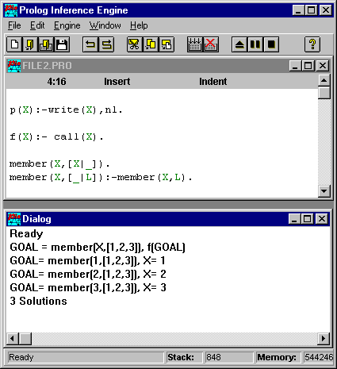

Figure 13: The Prolog inference engine.

Embed the Prolog Compiler into your application !
In VPI\TOOLEXAMP\BUILD, there is an example on how you can integrate the Prolog Compiler and Linker into your application in order to compile rules on the fly. By implementing the rules in a .DLL, you can change your rules even without closing your application !
This is an extremely powerful feature for ex. planning and scheduling applications. But it also requires that you pay a small runtime fee to PDC, and sign an agreement that you will not use it to create an application that compete with the Visual Prolog product. If you own the Professional version of Visual Prolog, you
have all the features needed, and as long as your customers own a licensee to Visual Prolog you can give them your application. Otherwise please contact PDC for more information.

Source code to the Visual Development Environment.
If you have the Professional Version of Visual Prolog, you will find the Prolog source code for the Visual Development Environment in the VDESRC sub-directory. With this, you can do any customization of the VDE you want, or you can study how we have done things, appropriate tools and techniques for your own programs etc.

Installation program.
The installation program that is used to install Visual Prolog is itself written in Visual Prolog, and the source for this is included on the disk. This can be modified to create installation programs for your own applications.
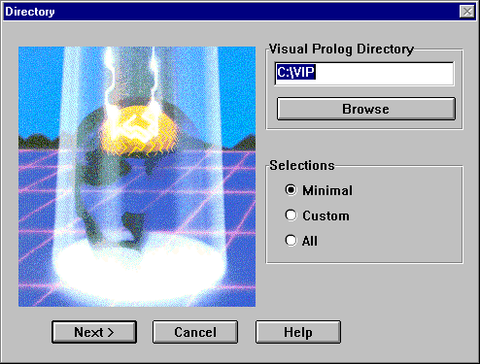

Figure 14: Generation of an installation program.

Expert System for Text Animation (ESTA).
Visual Prolog now includes our Commercial expert system shell ESTA. It is supplied with full source code for you to customize and include in your own applications.
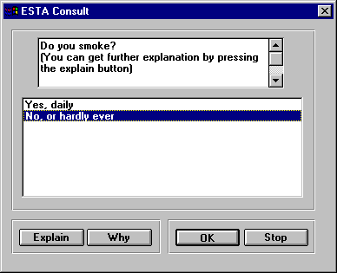

Figure 15: An ESTA consultation.

Many other nice examples included
Among the many examples have a look at the Label Expert, a small application for creating and printing labels. We think you'll find it a nice example, which really shows the power of the VPI tools that are included !

Comprehensive Internet Support
Visual Prolog 5.0 contains many features that make it easy to create Internet-enabled applications.

Bindings to Sockets
This contains basic low-level bindings as well as a higher level interface that makes it easier and safer to use the Sockets interface. Sockets is the API to the TCP/IP protocol that can be used to establish a communication between programs over the Internet as well as internally in a network or between two programs on the same computer.

FTP Support
VIP 5.0 contains an API and example programs that show how it is possible to use the Internet File Transfer Protocol to send and receive Files from an Internet server.

HTTP Support
VIP 5.0 contains API and example programs that demonstrate the use of the Internet HyperText Transfer Protocol. This is the basic protocol used by the World Wide Web. This API can be used to create WWW client and server utilities as well as Internet Agents in Visual Prolog.
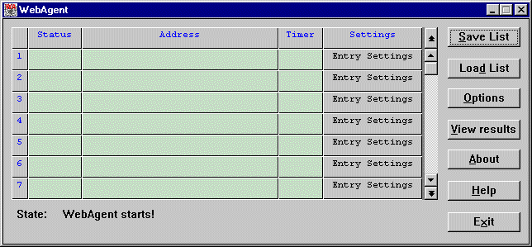

Figure 16: The Webagent program.

CGI Support & Examples
This CGI example shows how it is possible to create Visual Prolog programs that generate dynamic WEB pages.

ISAPI Support and Examples
Visual Prolog's support for Microsoft's ISAPI allows high performance scripts on the Microsoft Information Server or any other HTTP Server that supports the ISAPI interface.

Communication with JAVA applets
We've also included some examples that illustrate how to make a Prolog server communicate with a JAVA applet.

How Does Prolog Differ From Other Languages?
Here's a short look at how Prolog differs from traditional programming languages.

Prolog is descriptive.
Instead of a series of steps specifying how the computer must work to solve a problem, a Prolog program consists of a description of the problem.
Conceptually, this description is made up of two components:
1. descriptions of the objects involved in the problem
2. facts and rules describing the relations between these objects
The rules in a Prolog program specify relations between the given input data and the output which should be generated from that input.

Prolog uses facts and rules.
Apart from some initial declarations, a Prolog program essentially consists of a list of logical statements, either in the form of facts, such as
father("John","Mary")
"John is the father to Mary"
father("John","Sally")
"John is the father to Sally"
father("John","Sam")
"John is the father to Sam"
mother("Jeanette","Mary")
"Jeanette is the mother to Mary""
mother("Mary","Tom")
"Mary is the mother to Tom"
or in the form of rules, such as
sister(X,Y) :- father(Z,X), father(Z,Y).
"X and Y are sisters if they have the same father"
X, Y, Z are here variables, which are used to specify bindings between the different relations. Variables can be any name starting with an uppercase letter.

Prolog can make deductions.
You can give the Prolog program some goals, for example to conditions:
Goal father("John","Mary").
Prolog will answer true because the goal matches the stored facts.
If you use a variable in the goals, Prolog will find the value for the variable:
Goal father(X,"Mary").
Prolog will answer X="Mary" because it can look it up in the facts.
There is no difference between using facts and rules, for example if the goal is:
Goal sister(X,"Mary").
Prolog will answer X="Sally" because "Sally" can satisfy the rule for sister.
Similarly, Prolog can use its deductive ability to find all solutions to the problem:
Goal father("John",X).

Prolog will answer
X="Mary"
X="Sally"
X="Sam"
The solutions are found through backtracking where all combinations are tried. This automatic backtracking mechanism combined with the built-in database (the facts) is one of Visual Prolog's most powerful tools. This release of Visual Prolog is far from the end of the story, and you will see a continuous stream of new features and facilities. You are encouraged to give us feedback on what you think our future priorities should be.

Prolog program execution is controlled automatically.
When a Visual Prolog Version 5 program is executed, the system tries to find all possible sets of values that satisfy the given goal. During execution, results may be displayed, or the user may be prompted to type in some data. Visual Prolog Version 5 uses a backtracking mechanism that, once one solution has been found, causes Prolog to re-evaluate any assumptions made to see if some new variable values will provide new solutions.

Prolog has a very short and simple syntax.
Because of this, it is much easier to learn than the syntax of more complicated, traditional programming languages.

Prolog is powerful.
Prolog is a higher level language than, for instance, C or Pascal. As mentioned before, Prolog typically uses one tenth as many program lines when solving a problem than do C or Pascal. Among other things, this is due to the fact that Prolog has a built-in pattern-recognition facility, as well as a simple and efficient way of handling recursive structures.
This has been a brief overview of Prolog's unique features. As you delve more deeply into this manual and begin writing programs, you'll discover more of Prolog's powerful abilities.

About the Visual Prolog Manuals

The documentation for Visual Prolog Version 5 comes in four manuals: the Visual Prolog Version 5 Getting Started manual (this book), the Visual Prolog Version 5 Language Tutorial, the Visual Prolog Visual Programming Interface manual, and the Visual Prolog Visual Development Environment manual.

The Getting Started Manual (this manual)
The Getting Started manual is divided into five parts: an introduction to Visual Prolog Version 5, installation instructions, a description of the manuals, support arrangements, acknowledgments, and a Guided Tour which will acquaint you with the general capabilities of the whole system in a quick and easy manner. In the appendix there is a descriptions of the files and subdirectories in the Visual Prolog system.

The Language Tutorial
The Language Tutorial manual introduces you to the Visual Prolog language. Many simple examples are included and the source text for them is also provided on disk. The manual includes an introduction to a sub-set of the Visual Development Environment sufficient to compile and run the example programs. It covers the basic concepts of the language only, and does not include any Windows programming information - this is in the Visual Programming Interface manual.
The first eight tutorial chapters teach you how to program in Visual Prolog Version 5, then there are nine more tutorial chapters, then a chapter of example Prolog programs, and a chapter on advanced techniques in Visual Prolog Version 5 completes the manual. Here's a summary of each chapter in this book:

Part 1: Introduction to Visual Prolog Version 5
Chapter 1: Getting Started describes how to run Visual Prolog Version 5 on your system, and takes you through the hands-on steps involved in creating, saving, and running your first Visual Prolog Version 5 program.

Part 2: Tutorial Chapters 2-10: Learning Visual Prolog Version 5
Chapter 2: Fundamentals of Prolog provides a general introduction to Prolog from a natural language perspective and discusses how to convert natural language statements and questions into Prolog facts, rules, and queries.
Chapter 3: Visual Prolog Version 5 Programs covers Visual Prolog Version 5 syntax, discusses the sections of a Visual Prolog Version 5 program, and introduces programming in Visual Prolog Version 5.
Chapter 4: Unification and Backtracking describes how Visual Prolog Version 5 solves problems and assigns values to variables.
Chapter 5: Simple and Compound Objects discusses declaring and building structures in Visual Prolog Version 5.
Chapter 6: Repetition and Recursion explains how to write repetitive procedures using backtracking and recursion; also introduces recursive structures and trees.
Chapter 7: Lists and Recursion introduces lists and their use through recursion, as well as covers general list manipulation.
Chapter 8: The Internal Database discusses Visual Prolog Version 5's internal database for adding facts to your program at run time and for storing global information.
Chapter 9: Objects introduces object oriented programming, how to use object in Visual Prolog and some examples that demonstrates how to use them.
Chapter 10: Arithmetic and Comparison introduces the full range of arithmetic and comparison functions built into Visual Prolog Version 5 and gives examples that demonstrate how to use them.
Chapter 11: Advanced Techniques controlling the flow analysis, using reference variables, pointers to predicates, the binary domain, term conversions, using the dynamic cut, tools and techniques for error and signal handling, and programming style for efficient programs.

Part 3: Tutorial Chapters 12-15: Using Visual Prolog Version 5
Chapter 12: Writing, Reading, and Files introduces I/O in Visual Prolog Version 5; covers reading and writing, and file- and directory-handling.
Chapter 13: String-Handling in Visual Prolog Version 5 covers string manipulation, including string comparison and string conversion, plus constructing and parsing strings.
Chapter 14: The External Database System covers Visual Prolog Version 5's external database system: chained data, B+ trees, storing data (in EMS, conventional memory, and hard disk), and sorting data. Includes examples of constructing real database applications.
Chapter 15: System-Level Programming introduces the low-level control supported within Visual Prolog Version 5: system calls, BIOS, low-level memory addressing, and bit manipulation.
Chapter 16: Example Prolog Programs provides a diverse group of Prolog program examples demonstrating some of the elegant ways Prolog solves complex problems.

Part 4: The Language Reference, and Interfacing to Other Languages.
Chapter 17: Elements of the Language gives a systematic overview of all the features in the Visual Prolog language. The chapter also introduces modular programming.
Chapter 18: Interfacing with Other Languages gives a description on how to interface with C and other languages.

The Visual Programming Interface manual.
This manual describes the Visual Programming Interface (VPI) in detail. VPI is a high-level Application Programming Interface (API) designed for Prolog applications. It allows the Prolog programmer to create applications for graphical user interface platforms. The Resources and Tools needed by such applications - Windows, Menus, Dialogs, Controls, Pens, Brushes, Cursors, Carets, Pictures, etc. all appear as Prolog structures, and these are described in the VPI manual.
The VPI is, basically, platform independent. However, not all facilities of every GUI appear in the VPI, nor is every facility in the VPI fully portable; rather, the VPI tries to support all the features found on each platform in a uniform way. The domains, constants and predicates in the VPI do not change with target platform. To assist developers not interested in portability, but who need maximum flexibility on one platform, the VPI also contains a number of predicates that are not portable, but are very relevant on a given platform. Just as when using other general purpose programming languages, it is possible to write a portable VPI application, but it is also possible to write one that is not portable.
The VPI has supporting tools "Packages" to make GUI programming easier. These include a Dialog package for easy dialog generation and use, an Editor package for creating a simple editor, a Toolbar package for handling toolbars, and a Tree package for hierarchical presentation of data.
The manual has two main parts. Part 1 describes the VPI predicates for handling all GUI elements like windows, controls, menus, events. Part 2 describes the various support packages.

The Visual Development Environment Manual.
This manual consists of 8 chapters and two appendices.
Chapter 1: Using the VDE, and includes Making a New Application and descriptions of the Project Window, the Messages Window, the Code Browser, the Resource Identifier Browser, and the Project Module Tree utility. It also covers Global Options and the three global initialization files (.VPR, .INI and .HAM).
Chapter 2: Application Expert, including Project Naming, the Project Base Directory, the documenting of Authority, Selections that can be made, the VPI options, and includes a description of the Files in a Project.
Chapter 3: Building, Compiling and Linking of Visual Prolog applications. The Project options, Directory options, Compiler options, Code Generator options, the Make Facility with its Symbols, Rules, Scripts (Build, Preview, and Local), the Menu Commands to Compile a File, do a Build, Rebuild All, Stop Compiling, Run a project, Link Only, Test a Goal, and to Build Resource Only.
Chapter 4: Resource Editing. Resource Naming, Resource Linking, Bitmaps, Icons, Cursors, Dialogs, Menus, and Strings are covered. Resources may be imported from other systems. Many kinds of graphics editors are included for the preparation of Windows resources. The Window and Dialog Editor (Creating a Dialog, Editing a Dialog, Dialog Controls, Creating a Window, Editing a Window), the Resource String Editor, the Toolbar Editor, the Menu Editor, the Graphics Editor (Graphics Editor Window, the Title Bar, Menus, The Graphic Field, the Image Screen, Moving, Rotating and Flipping, Undo / Redo, the Cursor Hot Spot, Testing a Cursor, Image Attributes, the Color Palette, Understanding Colors for Bitmaps, Understanding Colors for Cursors, Understanding Colors for Icons, Using the Draw and Edit Tools).
Chapter 5: Code Generation Experts. The Dialog and Window Expert (Generating the Default Code for a Window, Looking at The Generated Default Code for a Window, Event Handling, Code styles), the Dialog Package Expert (Setting Method, Initiation, Variable Bindings, Variable types, String Values, Numerical Values, Item lists, Initial selections, scroll bar control, and Radio Button handling), and the Toolbar Expert.

Chapter 6: Text Editor.
Chapter 7: PDC Help Maker, a very sophisticated tool for generating help files for the various Windows operating systems and for OS/2.
Chapter 8: The PDC Debugger. This chapter contains everything that is needed to use the VIP Debugger.

Visual Prolog On-line Help Files

Reference material for the elements of the basic Visual Prolog language and the VPI is all contained in on-line Help files accessible by predicate, domain, or group from the VDE.

The INTRO.HTM file

An important part of the Visual Prolog documentation is the INTRO.HTM file (former README.TXT), that is supplied on Visual Prolog-CD in HTML-format. Here, in the Exploring Visual Prolog-section, many good examples can be examined and compiled directly. This is probably one of the best ways to get aquatinted with programming in Prolog and the Visual Prolog development environment.

Recommended Reading

These are some books we have found to be valuable additions to these user's guides (Visual Prolog Version 5 is compatible with PDC Prolog and Turbo Prolog):
Prolog Programming for Artificial Intelligence by Ivan Bratko. (Addison-Wesley).
Advanced Prolog. Techniques and Examples by Peter Ross. (Addison-Wesley).
Logic Programming. Systematic Program Development by Yves Deville (Addison-Wesley).
The art of Prolog. Advanced Programming Techniques by Leon Sterling and Ehud Shapiro (The MIT Press).
Artificial Intelligence by Elaine Rich.(McGraw-Hill).
Using Turbo Prolog by Phil Robinson and Advanced Turbo Prolog by Herbert Schildt (Osborne/McGraw-Hill).
Turbo Prolog Primer by Dan Shafer and Mastering Expert Systems with Turbo Prolog by Carl Townsend (Howard W. Sams & Co.).
Turbo Prolog Features for Programmers by Sanjiva Nath (MIS Press).
Introduction to Turbo Prolog and The Turbo Prolog Library by Carl Townsend (Sybex).
Artificial Intelligence Programming with Turbo Prolog by Keith Weiskamp and Terry Hengl (John Wiley & Sons).
Illustrated Turbo Prolog by Mick McAllister (WordWare Publishing).
Turbo Prolog: An Introduction by Paul Chirlian (Merrill Publishing).

Manual Conventions

In addition to normal English usage and the syntax of the Prolog language in the various examples, the following conventions are used throughout this manual.

Convention | Meaning
Plus Sign | Key combinations are indicated by the using the "+" sign, for example: Ctrl+Alt+Del.
Bold Face | Menu items, keys, and Prompts in dialogs are indicated by bold face. Where necessary for clarity in context, the prompts may be normal-face double-quoted.
Italic Face | Used for titles of manuals and other emphasis purposes.
Vertical Bar | " | " is used to indicate a sequence of selections in cascading menus. Example: Options | Project | Directories says that you select Options in the current menu. Then a sub-menu appears, you select Project there and in the following sub-menu you choose the Directories selection.  It is also sometimes used without separating spaces to indicate an "or" condition. Example: -option{+ | - | value}
Initial Capitals | Words written with initial capital letters within the normal text usually refer to tools or names of objects on the screen. Examples: the Application Expert, the Dialog and Window Expert, the Graphic Field of the Graphics Editor, etc.
Full Capitals | Full capitals indicate filenames and path names.
<type> | Indicates a generic type of object such that the entire string must be replaced with the name of an instance of that type of object before being used.
These typographical conventions apply to all the manuals for Visual Prolog

Acknowledgments

We would like to give special credit to the Department of Computer Science at the Technical University of Denmark, where the ideas for the series of Prolog compilers, which have culminated in Visual Prolog, were born.
In 1982 Tom Østerby developed a Prolog interpreter for the VAX computer. In 1983-1984 J¢rgen Fischer Nilsson and Heri Nonfjall developed a Prolog to Pascal compiler in which they introduced a type system for Prolog and implemented a global flow analysis.
In 1984 Jon Hoffmann, Leo Jensen and Finn Gr¢nskov implemented a Prolog Compiler for the IBM-PC.
Major contributions have also come from: Per Gregers Bilse - UNIX version of PDC Prolog, Dan-Ole Johansen - a suite of code-generation routines, and Lars-Henrik Jacobsen - direct bindings to MS Windows and NT and OS/2 libraries.
The package of direct bindings to the OS/2 Presentation manager (PMBIND) has kindly been provided by Gregory Bourassa.
Major contributions to the tools in Visual Prolog have come from Alexander Grachev, Sergey Alexeev and Alexander Butovsky.
Ron Stodden, Albrecht Müller, Henrik Lawætz, Jonathan Lerwill and Claus Witfelt have made contributions in the writing and reviewing of the documentation.
Since 1993 a team in PDC St. Petersburg has been heavily involved in the development of Visual Prolog. The team is lead by Victor Yukhtenko. Alexander Gostintcev, Yury Illin and Yuri Fialkin have been responsible for the implementation of the VPI and the editor, Boris Belov has been responsible for the Visual Development Environment, Oleg Eryomin has been responsible for the Help creation system, Evgeny Akimov and Anna Bogdanova has been responsible for testing, Alexander Doronin and Sergey Mukhin have been responsible for the compiler, debugger and library, Alexander Gorlov has been responsible for the SCO and Linux version, Serge Mironov and Lev Romanov have developed the PDC Linker, Konstantin Ivanov have been working on the SOCKBIND tools, Michael Zaichenko have been working on the Setup utility and the debugger UI and Andrey Kuchukov and Elisabeth Safro have been responsible for the on-line help.
Leo Jensen, Victor Yukhtenko and Michael Alexander have been leading the Visual Prolog Project.

System Requirements

To run the Visual Development Environment you need:
Microsoft Windows operating system version 3.1 or later, Windows for Workgroups, Windows NT version 3.1 or later, Windows 95 or OS/2 Warp.
A personal computer equipped with a Pentium or higher microprocessor is recommended.
At least 8 MB of RAM is necessary, with 32 or more MB recommended.
A hard disk with about 15 MB of free space for a minimum, or about 200 MB for a full installation of the professional edition.
A display with a Super VGA (SVGA) or higher resolution is recommended.

Beginning with Visual Prolog

While it is possible to generate a complete Visual Prolog program which will run - but not do any useful work - without having any knowledge of the language, it is necessary to add Visual Prolog language statements to implement the application logic.
If you have never programmed in Prolog before, you can study the first example in this booklet, but after this, you should do a careful reading of the Language Tutorial manual before you continue with rest of this booklet, that is devoted to the Visual Programming Interface (VPI). You should study the examples and do the exercises. These language tutorial exercises use a subset of the full capabilities of the Visual Development Environment, and instruction in the use of the VDE for this limited purpose is contained in the Language Tutorial manual. The INTRO.HTM file will also be worth a study.
The later chapters become very important as soon as you want to do serious programming. If you program in a procedural programming language such as C, Pascal, or Basic, pay close attention to the procedural discussions. You will find a procedural overview of the material covered in the first three tutorial chapters, and we also provide procedural discussions of recursion.
If you have programmed in other Prologs and have a good understanding of Prolog fundamentals, you won't need much review. However, Visual Prolog Version 5 has several extensions and is different from interpreted Prologs. We recommend that you read the release notes and take the hands-on Guided Tour which you will find later in this manual. The advanced programming chapters provide valuable information that you will need if you plan to do serious programming.
The next step is to learn the Visual Programming Interface and then the Visual Development Environment of Visual Prolog. Here we suggest that you start by working your way through the Guided Tour. If you are a systematic person, you should then do a careful reading of the Visual Development Environment manual and the Visual Programming Interface manual before you attack your own programming problem.
If you have been using previous versions of Visual Prolog Version 5, you should read the notes in the UPGRADE sub-directory detailing the differences and necessary changes that may affect your programs. An automatic upgrade program is provided for previous users of Visual Prolog.
If you want to learn to debug program, please consult section Debugging Visual Prolog programs.
Whatever your approach, welcome to the universe of Visual Prolog Version 5! You will never learn a tool completely before you use it to solve a real problem!

Installation and Support

Running Visual Prolog directly from a CD-ROM
The entire Visual Prolog development environment can be run directly from the distribution CD-ROM. In this case, no installation process is necessary, and the VDE can be invoked immediately by running:

<CDROM>:\RUN\BIN\<OperatingSystem>\VIP.EXE
where <OperatingSystem> is currently WIN\16 or WIN\32 (with more to come).
You may skip forward to "Obtaining Support" if you just run the system from the CD.

Upgrading from a previous version of Visual Prolog

If you upgrade from a previous release of Visual Prolog you should not install this version in the same directory -- instead you should create a new directory.
If you have projects written with a previous version of Visual Prolog you will also need to run the UPGRADE utility program to convert the <project>. VPR file to the correct structure and to modify the project source files. This process is described in UPGRADE.WRI in the UPGRADE sub-directory of the Visual Prolog directory. This UPGRADE directory will be installed if the Upgrade from Previous Version selection box has been checked in the install program.

Installation Procedure

The installation procedure for all versions is essentially the same.
Place the distribution CD-ROM in your CD-ROM drive and depending on your operating system run the corresponding file from the INSTALL subdirectory:
- Windows 3.x: SETUP.EXE
- Win95, Window NT: SETUP32.EXE
- OS/2: SETUPOS2.EXE
If you want to install the Linux or SCO version of Visual Prolog, you should look in the SCO and LINUX subdirectories.
Installing on computers equipped with multiple operating systems where it is desired to run Visual Prolog from more than one operating system may require multiple installation runs, but it should not normally be necessary to select and copy the components more than once.
A maximized screen window will appear first. In this window you will be led through a series of dialogs, each of which has a <Back (except the first) and Next> and Cancel and Help buttons. Therefore you may backtrack and revisit previously made decisions. Check on-line Help if you have any questions or problems during installation.
There is also a Space Indicator window which remains visible and dynamically will show the kilobytes and percent of available space required as a bar graph in green (if installation is feasible, otherwise in red) and the kilobytes and percent of disk capacity available as a bar graph in green. At the beginning of installation, a default set of component assumptions is active and the Space Indicator window will reflect these assumptions.
The following component selection dialogs will appear. In all cases the required size for each component appears in the dialog. These dialogs are numbered below and will select the components for installation. They will not be actually installed until the entire selection process has been completed.
The first dialog requires you to select the drive and the path where Visual Prolog is to be installed. Use the BROWSE button to find a suitable place in your drive directory trees. Then alter or extend the path in the edit box to provide an empty directory. If any directories in the path do not exist, they will be created.
Two groups will appear in this Dialog. The first allows you to select which of the possible Visual Development Environments to install. The second lets you select which of the command line compilers to install.
This dialog permits you to select which of the libraries will be required. Choices are Windows 16 bit, Windows 32 bit, DOS, PharLap DOS Extended, OS/2 16 bit , OS/2 32 bit.
This dialog selects which Bindings to install - native Windows 16 bit, the native OS/2 Presentation Manager, the Portable SQL bindings, and the Borland Graphics Interface bindings for DOS programs. It also selects whether to install the VPI example projects and the VPI tutorial examples.
This dialog selects which Utilities to install - the install program itself, the Mixed Language Programming components, the Prolog source for the VDE (in the Professional version of Visual Prolog), and the Prolog to C header file conversion utility.
This dialog has three groups of selections - the Prolog language (the documentation, answers to the exercises, and examples), the Visual Programming Interface (the documentation and the Guided Tour), and the Visual Development Environment (the documentation).
The final selection dialog gives the accumulated space requirement, the presently available disk space, and asks whether to create a Windows Program Manager Group. This dialog has an Install button.
The Installation in Progress dialog. This has a Cancel button which will stop installation, but does not remove any directories and files already installed, so remember to delete the installation directory and all its contents.
Note that Visual Prolog does not install any .DLLs, modifies no pre-existing .INI files, does not alter registry, etc. In fact, you can remove Visual Prolog entirely from your computer by deleting the directory where it is installed.
The installation program does not create the initialization control file (VIP16.INI or VIP32.INI in the Windows directory) for Visual Prolog. This will be done automatically when you call Visual Prolog the first time.
After the installation is complete, the Windows' Write text editor will appear and show the INTRO-file. This file contains last minute information and we recommend reading it very carefully before using Visual Prolog.
Visual Prolog is now installed and may be run by double-clicking on the VIP16 or VIP32 icon.

Support from the Prolog Development Center

If you have a problem with Visual Prolog, check against the VPI manual and the on-line help. If this does not resolve the problem or you have other questions regarding Visual Prolog you are welcome to contact us. Also we are very interested in your feedback: problems, bug reports, comments, recommendations, ideas, frustrations - or even congratulations.
The Internet has become very popular, and to obtain access you must open an account with one of your local Internet service providers. We prefer that you use e-mail, if at all possible.
Send your support questions to support@pdc.dk, and you will get a quick response. If you have software to use the Internet's World Wide Web (WWW), you should take a look at the PDC home page (http://www.pdc.dk), where patches, bug fixes, hints, examples, information about new versions etc. can be obtained and downloaded.
See the back cover of this manual for Internet addresses, addresses, phone numbers and fax numbers to use for support and for other information

Guided Tour in Visual Prolog

In the following we will show you how to test goals and build a small Windows application in Visual Prolog. We will provide some explanations while we are developing the application, but to get the full explanation you will need to read the VPI and VDE manuals.
If you do not know the Prolog language, you might still be able to work your way through the examples in this chapter, but we do suggest that you start with the Visual Prolog Language Tutorial.
Also, if you have not done it already, now is probably a good time to study the on-line help system of the Visual Prolog Development Environment. In particular you must be able to search for a given predicate, and be able to find and read the overview of the VPI function groups.
The example and the screen dumps as presented here were done under Windows 95/NT, but can equally well be done under Windows 3.1x or OS/2.
Please start the Visual Prolog Development Environment, and have the VPI Guide book nearby.

Goal Testing.

Visual Prolog has a facility which makes it easy to test small predicates. If you open a new "NONAME" window file by using the File | New menu item and type in a goal.
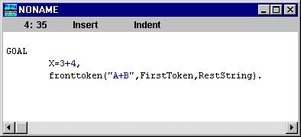

Figure 17: An example of a GOAL.
You can use the menu entry Project | Test Goal, press Ctrl+G, or activate the toolbar button . You should shortly see a window appear with the result:
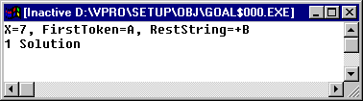

Figure 18: Result of testing a goal.
The GOAL result is actually a separately executing application, you will need to close it before executing a new GOAL.
The GOAL-mode editor is the same as the one used, when developing projects. Let’s try to examine Prolog, using Goal-mode and a little family-relations program. Type in the following little program.

PREDICATES
son(STRING,STRING)

CLAUSES
son("John", "Dan").
son(“Allan”,”Dan”).

GOAL

After the GOAL you can try
son(“John”, “Dan”).

The Prolog system will (of cause) reply
Yes
Because there exists a fact, that makes the predicate-call, son(“John”, “Dan”) true. If you try the following
son(“Richard”, “Alexander”).

The prolog system will answer
No
Because such fact does not exist in the internal list of facts and rules.
These examples is just replication of what we already know. With the use of variables we can produce much more interesting results. In Visual Prolog all variables much be start with capitalized letters like A, Sum or B12.

We can find all Dans sons by stating
son(A, “Dan”)
after a goal, and the Visual Prolog will answer
A=”John”.
A=”Allan”
2 solutions.

Rules
Prolog becomes much more powerful, when we start to add rules.
Open a new window and type in the following program, that is an extension of the family relations, that we have been looking at earlier.

PREDICATES
son(STRING,STRING)
sister(STRING,STRING)
brother(STRING,STRING)
married(STRING,STRING)
sister_in_law(STRING,STRING)

CLAUSES
son("John", "Dan").
sister("Mary","Suzan").
brother("Harold", "Larry").
married("John", "Mary").
married("Larry", "Sue").
married(“Harold”, “Emma”).

CLAUSES
sister_in_law(A,B):-married(A,C), sister(C,B).
sister_in_law(A,B):-brother(A,C), married(C,B).

GOAL
sister_in_law("John",Z).
Lets examine this program in detail to understand how rules in prolog actually works.
There is only one predicate-call after the Goal in this little example: sister_in_law("John",Z). We want Prolog to figure out, who is Johns sister in law!
Prolog looks in the collection of clauses and find, that there are 2 different sister-in-law-rules, that can be used. Be ware, that Prolog is not an algorithmic language. If so, the program would execute the first and after that the second, without bothering about succes or not. Prolog will try the first rule, and if a solution is found, the other rules is never used.
Prolog tries to match the Goal with a rule. To make a rule match, they must have the same number of arguments and if the variables in the arguments has values (we then say that the variables is instantiated), they must not contradict with each other. For example, if A is instantiated to “Peter”, and we try to match child(A) to child(“Emma”), we won’t succed, because the arguments contradict. Neither can we match child(A) with child(A,B), because the number of arguments contradict.
In our small program tries to match sister_in_law("John",Z) with the first rule, sister_in_law(A,B):- married(A,C), sister(C,B). A match is always a match between the heads of the clauses (the parts at left of the colon-dash, :-). There is no contradition, and the number of arguments match, so the variable A is instantiated to “John”, and B is an output-parameter. To make a predicate-call suceed, every part of the body must be instantiated. The body of a clause is everything that is at right of the colon-dash, here married(A,C), sister(C,B).
We have already instantiated A to “John”, so the task is to make a look-up in the internal collection of facts and rules, that matches married(“John”, C). This is possible. Prolog finds a match in the fact married("John", "Mary"). C then gets instantiated to “Mary”. Next the predicate sister(C,B) needs to suceed. C is already instantiated to “Mary”, so the look-up in the collection of facts and rules is actually sister(“Mary”, B). This is also possible, becase a fact sister("Mary","Suzan") exists.
The whole predicate then succedes, which means that every varible can be instantiated. The most important variable is of course the output B. B contains the answer to, who is Johns sister-in-law.
This example is rather straight forward, because this first rule matched and every part of the body could be instantiated just by making look-ups in the database.
If we try the goal sister_in_law(“Harold”, Z), we get a little more interesting situation, that demonstrates Prologs solutionsearching mechanism - backtracking. Prolog tries as in the example before, to instantiate married(“Harold”, C), and Prolog finds out, that Harold has a spouse, Emma (married(“Harold”, “Emma”).). We continue to instantiate sister(“Emma”, B), but there is no facts about such a sister. Prolog then uses the very important backtrackning-mecha-nism!
Prolog frees the variable and winds back to the last succesful predicate, try to find alternative solutions, that can make the whole predicate true. But – there isn’t additional information about Harolds spouses, so Prolog backtracks one more level. The first sister_in_law predicate fails.
Note a very important difference between algorithmic languages like Pascal and declarative languages like Prolog: The order of clauses isn’t sequential. In the first case, only the first clause were ever considered. In pascal both would be executed, no matter weather they suceeded or not. In this case the second clause is considered, because the first didn’t brought us a succesful solution. In this way Prolog restlessly searches for solutios in a much more intelligent way that traditional, algorithmic languages.
The second clause sister_in_law(A,B):-brother(A,C), married(C,B) then comes out with a succesful result. Try to track how Prolog finds this.
Note, that all clauses in a goal can fail so the whole prologprogram will fail, and Prolog answers “No” to the Goal.
To learn more about Prolog, please consult the language manual or study the many examples in the INTRO.HTM-file.

Start with the Application Expert

The Application Expert is used to create a new VPI application. The Application Expert is invoked by selecting the menu entry: Project | New Project:
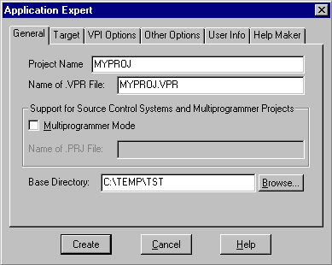

Figure 19: The Application Expert window.
The Application Expert supports many possible combinations of Platform and UI strategy, and for these combinations, several C compilers are supported. You can change these features, by clicking the tabs in the top of this dialog. See the VDE documentation for a detailed description of these possibilities. For now, just accept the default setting (Your current platform, VPI and Prolog as the main program).
You must enter a project name and select a base directory for the project. If you specify a base directory that does not exist, the Application Expert will create a new (sub)directory for you. You will probably not wish to place your project in the directory that the Application Expert suggests by default. To place the project in another existing directory press the Browse button, which will bring up the directory browser where you can browse through the hard disk to find a suitable place for the new project. We will choose the TEMP directory on our C: drive; within that, the project will be placed in its own subdirectory called TST.
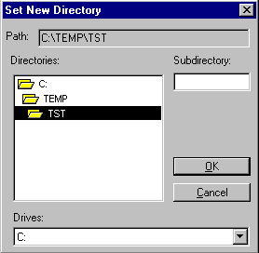

Figure 20: The directory browser.
In the Application Expert, the Options button is used to invoke a dialog where various options for your new project can be specified.
For now, just enable the Tree tool by clicking on the text 'Tree Package', as we will use this tool later in our demo application. Confirm your selections by pressing the OK button.
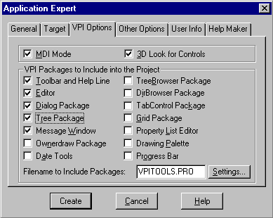

Figure 21: The VPI options dialog.
All the options, with the exception of the "toolbar and the help line", can be changed later. The default toolbars for the project can only be created when Project | New Project is selected. It is possible to go back and enable the selection for toolbars, but to make this work the code and layout has to be built-up "manually" by the Toolbar Editor and the Toolbar Expert.
After the options are set as desired, it's time to press the Create button to generate all the necessary files and set up a default application. The Create button can be found in the bottom center of the Application Expert dialog.
The Project Window should now contain two source modules, VPITOOLS.PRO and MYPROJ.PRO

Use Project | Run.

After the project has been created, pressing the Run button will compile and execute it. Please press the button now. The following little application should come up:
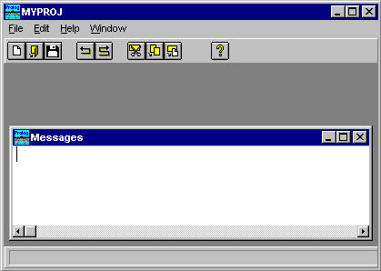

Figure 22: The default application.
At this stage, there is only functionality in some of the menu items. The default project is a framework for building your own application. The Help menu should work, such that you have an About box, and a small help file will also be generated. In addition, your application will have a toolbar, a help line and a Messages window (which you can use for debugging and testing purposes).
Some of the generated menu entries (like File | Save and the Edit menu), have no functionality yet; in this case these entries are disabled (grayed).

How to Study the Generated Code

At this stage, you may wish to study the code and components generated for your default application. This can be done through the Project window.

The Project Window
All components of your application are registered in the Project window. The buttons on the left side of the Project window select the component. The buttons in the right part of the window perform actions on these components.
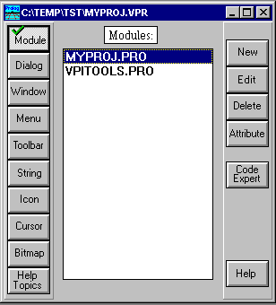

Figure 23: The Project window.

The Generated Source Code
You will see that two files were generated for your project: MYPROJ.PRO, which is the main module and VPITOOLS.PRO, which is a module that includes the tools selected in the Application Expert.
Click the Edit button while MYPROJ.PRO is selected, to see the structure of the code for the main module of the project. You should notice that code is generated for the following items:
Event handling for the Task window.
The main GOAL of the project.
Creation of the toolbar and help line in the project.
Creation of an About box.

The Project Tree
The project tree facility provides an overview of the files used in the project. This can be seen by selecting Project | Tree from the menu, by using the (Ctrl+T) hotkey or by clicking on the tree button. If you double click on the name of a text file within the tree, the VPI editor will be invoked on that file.
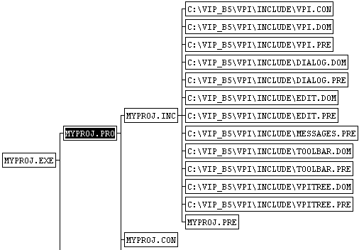

Figure 24: The structure of the program shown in the project tree window.

The Browser
Try to use Project | Browse menu item to invoke the code browser. This is an easy way to locate the clauses, predicates and domain declarations in the project. The browser can also be activated by pressing its button  or by using its hot key Ctrl+B.
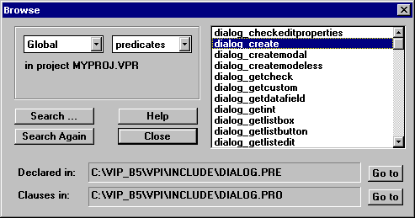

Figure 25: The browser window.

Important Hot Keys

It is a very good idea to learn a few hot keys. Using these keys makes it much faster to work with the system. Also, most windows support a local pop-up menu if you press the right mouse button.
Key | Function
Ctrl+I | Invokes the Identifier browser
Ctrl+T | Invokes the tree display.
Ctrl+B | Invokes the browser
Alt+F9 | Performs a Build project.
F9 | Performs a Build project + Run Application.
Ctrl+C | Performs a copy to clipboard.
Ctrl+V | Performs an insert from the clipboard.
Ctrl+X | Performs a Cut to clipboard.
Ctrl+W | Invokes the Dialog and Window Expert.
Shift+Ctrl+W | Inserts a call to user Window or Dialog creation
Shift+Ctrl+V | Inserts a VPI predicate call
Shift+Ctrl+S | Inserts a standard predicate call
Shift+Ctrl+K | Inserts a Keyword
Shift+Ctrl+C | Finds the Clauses for a marked predicate name
Shift+Ctrl+D | Finds the Declaration for a marked predicate name
Table 2: Some handy Keys.

Extending the "Hello World" Application

The first thing we will try is to make a little dialog with a prompt of "Hello World".
We decide that we want to add a menu item, which when selected, will activate the predefined common dialog dlg_Note.
To accomplish this, we need to do three things:
Add a menu entry.
Add a clause to enable a reaction when the menu item gets selected (the event-handler in the Task menu to catch the event).
In that clause, make a call to the dlg_Note predicate (our reaction to the selection of the menu item).

Modify the Menu in the Menu Editor.
In the Project window, click the Menu button in the left toolbar.
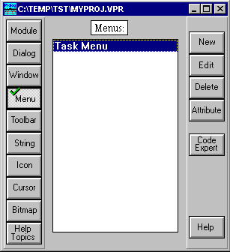
Double Click here

Figure 26: The Project window showing menus.
When the Project window is showing the menus, double-click at the Task Menu to activate the menu editor for the Task Menu.
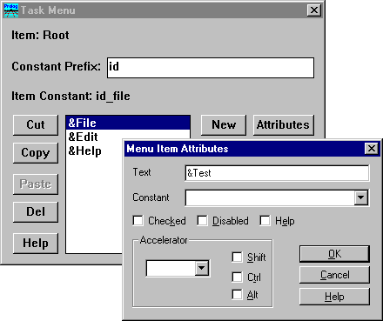

Figure 27: Adding a menu item in the menu editor.
Move the selection down to the Edit menu item, and add a new top-level menu item called Test by pressing the New button. (You do not need to enter a constant name for the menu entry, it will automatically receive the constant 'id_test' by default.) By the way, the '&' character that you see prefixing some of the menu items appears as an underline character when the menu is displayed. This is used to define an accelerator key. A keyboard shortcut can be befined by typing a character in the Acceralator field and clicking an appropriate Shift/Alt and Ctrl-combination.
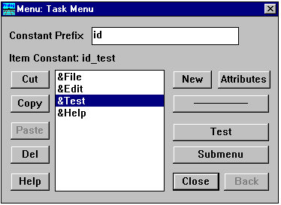

Figure 28: The menu editor after adding the Test menu item.
Next press the Submenu push button followed by the New button to create a sub-menu with a single entry Hello World, which is the entry that we will use to activate the Hello World prompt:
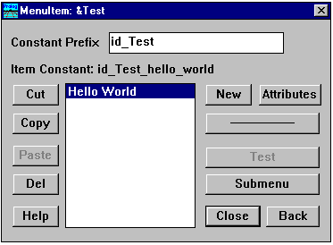

Figure 29: The menu editor in a sub-menu.
You will later connect the menu entry to executable code by using a constant value which we will now define. Push the Attributes button, or double click on the selected menu item, to select the Menu item Attributes dialog. Change the automatically generated constant to id_hello. Press OK to confirm your change.
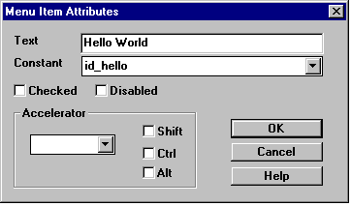

Figure 30: Editing menu attributes.
In the above dialog you can specify that the menu entry will be disabled (grayed) or checked (a little checkmark), or if needed, an accelerator key for the menu entry can be defined.
Now it's time to test your menu. Push the Back button until it becomes disabled, then you can select Test to see a preview of the menu:
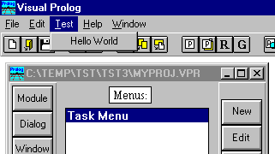

Figure 31: The menu editor in test-mode
To exit the test mode you simply make a click with the mouse in any window outside the menu, or, press the Test button again. Close the menu editor by pressing the Close button.

Using the Dialog and Window Expert
Now we could use the VPI's text editor, and add the small piece of code to create the hello world dialog. But in Visual Prolog it is easier and better to use the Code Experts. The Code Experts can do much of the trivial work, and more importantly, they promote a standard way for organizing your code. Using the Code Experts will make it much easier for you to maintain your code - and for others to take over your code!
We recommend that you always use the Dialog and Window Expert to add the Prolog source code for the menu entries. Try it now. First select Window from the Project window, and then highlight the Task window by clicking on its entry.
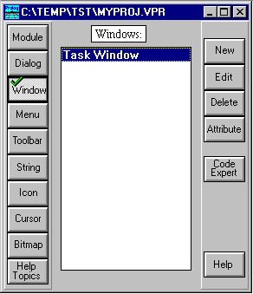

Figure
Figure 32: Invoking the Dialog and Window Expert from the Project window.
Then click on the button at the right called Code Expert (or just press the accelerator key Ctrl+W), to invoke the Dialog and Window Expert.
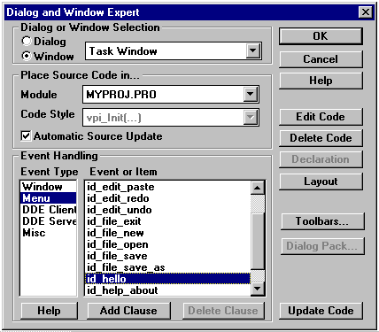
Select id_hello
Select the Menu Event Type

Figure 33: The Dialog and Window Expert creating menu code.
When the Dialog and Window Expert comes up, you should perform the following steps:
Select the Menu item from the Event Type (left) window.
Highlight the item id_hello (Or whatever you gave as a menu constant) in the Event or Item window. (You may need to use the scroll bar in order to find it.)
Push the Add Clause button to generate a Prolog clause for the event. (The text on the Add Clause button changes to Edit Clause when code for an event has been generated).
Push the Edit Clause button.
Pressing the Edit Clause button will bring up the Editor. Note that the following clause has now been added to the event-handler predicate for the Task window:

%BEGIN Task Window, id_hello
task_win_eh(_Win,e_Menu(id_hello,_ShiftCtlAlt),0):-! ,
!.
%END Task Window, id_hello
The %Begin - %End comments are used by the Dialog and Window Expert to locate the code for the user-interface components.
The variable _Win contains a handle to the window, in this case, the Task window. The variable _ShiftCtlAlt contains a flag from which you can derive the combination of the Shift and Ctrl keys that were used when the menu was activated. In both cases, the underscore is a syntactic convention that overrides the compiler warning for single use of variable names (as might often be the case with unused variables).
To add code, you can use the editor Insert menu. Try to place the editor cursor at the point where you want to insert the code (in this case in the beginning of line following the first cut), then click with the right mouse button and select Insert | Predicate Call | Window, Dialog or Toolbar.
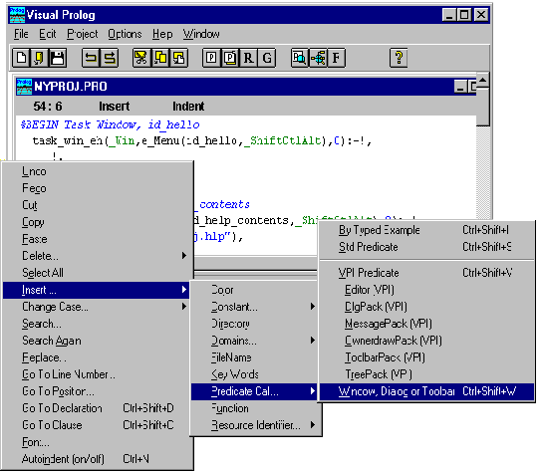
Figure 34: The editor insert menu.
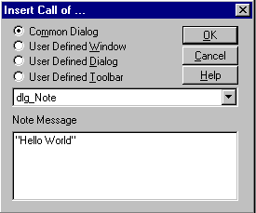

Figure 35: Specifying the predicate to insert.
In the dialog that now appears, use the list button to select the common dialog dlg_Note and type in the string "Hello World" (including the quotation marks).
The call to your message will then be pasted into the source, so that the final code for the clause should now look like:
task_win_eh(_Win,e_Menu(id_hello,_ShiftCtlAlt),0):-!,
Title="Title",
dlg_Note(Title,"Hello World"),
!.
The last cut is not really needed and will automatically be optimized away by the Prolog compiler, but it makes it easier to insert code with the insert menu.
Now select the Project | Run menu item (or press button), and the application should execute as expected. When the menu entry is activated the following dialog will appear if you select the Test | Hello menu item:
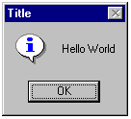

Figure 36: The dialog box that will appear in the application.

Creating the "Cross Window"
`
We will soon make something that is a little more interesting, but first we must understand the basics of the event handling. To get some understanding of this, we will create a little window in which lines are drawn across the diagonals.

Creating a New Source Module.
We will need to add Prolog source code for the Cross window, and since the Cross window will have code that is independent from the rest of the code in the project, we will place this code in a separate (new) module. In Visual Prolog, it is possible to handle multiple windows and dialogs in the same source module - it is up to the application programmer to decide how to organize the project. In this case, we will create a new module. In the Project window press the New button while the Module button is selected.
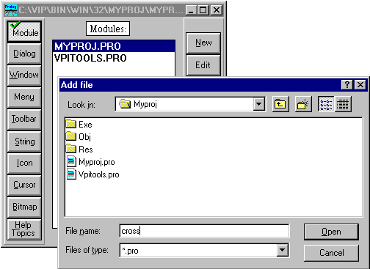 Figure 37: Adding a new source module.
Type in the name
of the new module (CROSS)
When you have entered the name for the new module press OK, a dialog appears where it is possible to specify whether a .DOM and .PRE file should be generated for the module. It is a good idea to put any exported global domain declarations for the module into a .DOM files, and any exported global predicates in the .PRE file.
You should just accept the defaults, but for real projects you should consider the following points:
Do not include any .PRE files in the MYPROJ.INC file. But include the .PRE files in each module, this gives fewer files for the compiler to go through.
The Resource constants file (here MYPROJ.CON) should only be included in a module if it is referred to from that module.
The Help constants file (HLPTOPIC.CON) should only be included in a module if it is referred to from that module.
If you are new to Visual Prolog programming you may not know that .PRE files contain the definitions of Prolog predicates and functions (they have a function similar to .H files in C) or that .DOM files contain information about user defined domains. If so don't worry. These examples do not need an extensive knowledge about Visual Prolog.
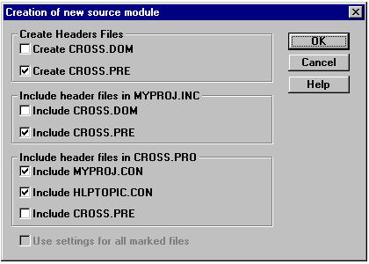

Figure 38: The attributes dialog for a module.
Press OK to accept the defaults. If you examine the newly generated source module, you will see that a header, based on the settings in the Application Expert, has been generated, and that the global include file for the project is included.
/*****************************************************

Copyright (c) Prolog Development Center
Project: MYPROJ
FileName: CROSS.PRO
Purpose: A little Demo
Written by: Leo Jensen
Comments:
**********************************************************/
include "myproj.inc"
include "myproj.con"
include "hlptopic.con"
A new file CROSS.PRE has also been generated, and placed in the project directory. If you look at the global include file, you will see that CROSS.PRE is included at the bottom of this file:
include "cross.pre"
The Dialog and Window Experts place global declarations into .PRE files.

How to Create a New Window
We start by registering a new window in our project. Press the Window button on the left side in the project and press the New button (top right).
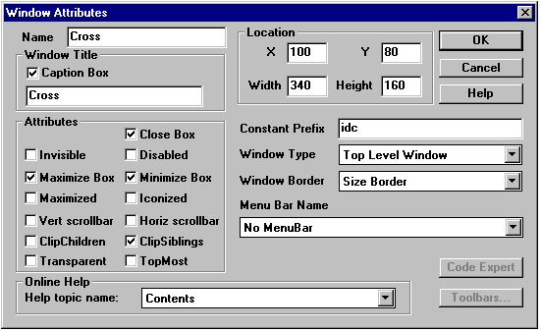

Figure 39: The Window Attributes dialog
When New is selected, the above dialog appears. For this window, you only need to type in the name 'Cross' and press OK.
When the Window Attribute dialog is terminated, the Window Editor will automatically appear. It is used to place controls in windows or change the window size. Since we do not want to do this for our window, we can just close the window (Ctrl+F4).
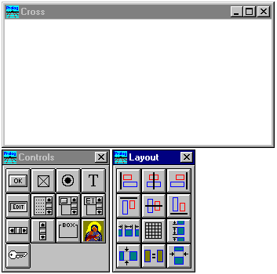

Figure 40: The window editor.

Generating Default Code for the Window
The next thing to do for the Cross window is to generate its default Prolog source code. This source code will provide us with two things: 1) the code to actually create a window with the specified layout attributes and 2) an event-handler predicate that makes it is possible for the window to react to the events (messages) that the GUI system sends when something happens to the window.
The easy way to create and maintain the Prolog source code for the window is to use the Dialog and Window Expert. To activate it you can either press Crtl+W or the Code Expert button, when the Cross window is highlighted in the Project window.
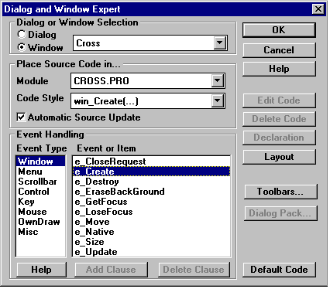

Figure 41: Adding default code in the Dialog and Window Expert.
When the Dialog and Window Expert is invoked you should select a Prolog source module to contain the code for the window. Here you should select the CROSS.PRO source module, by pressing the list button. When this is selected properly, you should press the Default Code button.
If you bring up the editor (Press the Edit Code button), you will see that the following code has been added at the end of the selected module:

%BEGIN_WIN Cross
/**********************************************************

Creation and event handling for window: Cross
**********************************************************/

CONSTANTS
%BEGIN Cross, CreateParms, 12:41:53-22.11.1995, Code automatically updated!
win_cross_WinType = w_TopLevel
win_cross_Flags = [wsf_SizeBorder,wsf_TitleBar,wsf_Maximize,
wsf_Minimize,wsf_Close,wsf_ClipSiblings]
win_cross_RCT = rct(100,80,440,240)
win_cross_Menu = no_menu
win_cross_Title = "Cross"
win_cross_Help = idh_contents
%END Cross, CreateParms
PREDICATES
win_cross_eh : EHANDLER

CLAUSES
win_cross_Create(Parent):-
win_Create(win_cross_WinType,win_cross_RCT,win_cross_Title,
win_cross_Menu,Parent,win_cross_Flags,win_cross_eh,0).

%BEGIN Cross, e_Create
win_cross_eh(_Win,e_Create(_),0):-!,
%BEGIN Cross, InitControls, 12:41:53-22.11.1995, Code automatically updated!
%END Cross, InitControls
%BEGIN Cross, ToolbarCreate, 12:41:53-22.11.1995, Code automatically updated!
%END Cross, ToolbarCreate
!.
%END Cross, e_Create
%MARK Cross, new events
%BEGIN Cross, e_Size
win_cross_eh(_Win,e_Size(_Width,_Height),0):-!,
IFDEF use_tbar
toolbar_Resize(_Win),

ENDDEF
!.
%END Cross, e_Size
%BEGIN Cross, e_Menu, Parent window
win_cross_eh(Win,e_Menu(ID,CAS),0):-!,
PARENT = win_GetParent(Win),
win_SendEvent(PARENT,e_Menu(ID,CAS)),
!.
%END Cross, e_Menu, Parent window
%END_WIN Cross
The Visual Prolog system adds various comments to the source code. The system uses these comments to locate the code later on. If you see a block surrounded with 'Code automatically updated!', it means that the system will automatically update this portion of the code when the layout or parameters are changed in the VDE. For this reason you should not add your own changes to these sections, as they will be overwritten during subsequent updates by the Code Experts. There are actually only a few of these sections that will be updated automatically. You are free to update the rest of the code in any way.
If you do not want to have any code sections updated automatically, go into the Dialog and Window Expert for the window, and disable the option for automatic source update - alternatively you can put a comment around the section so the compiler will not see it.
Now that we have finished creating our window, we just need some way to activate it. Here we will add functionality under the Test menu in our Task window. First we will add one extra menu item for this purpose, and we will call it CrossWin. Use the Menu end Edit buttons in the project window to edit the Task Menu. When the Menu Editor comes up, select the &Test item and press the Submenu button. Use the New button to add en entry for "CrossWin"
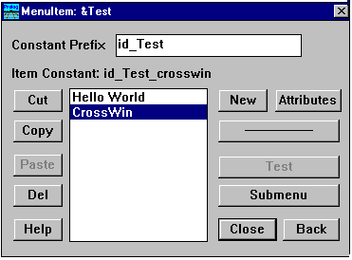

Figure 42: A menu item to activate the Cross window
The functionality for the new menu item can easily be added. First activate the Code Expert for the Task window (by pressing the Window button on the left of the project window, selecting Task Window and pressing the Code Expert button). When the Dialog and Window expert appears highlight the Menu Event Type and the id_Test_Crosswin Event, and then click on the Add Clause button.
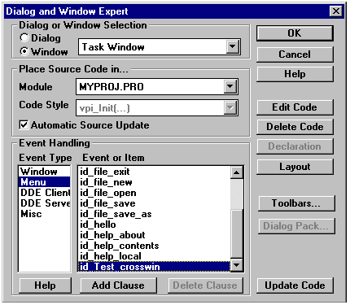

Figure 43: Adding a clause in the Dialog and Window Expert.
After pressing Add Clause press the Edit Clause button to select the editor. You should see that the following clause has been added to the event-handler of your application's main window (the Task window):
task_win_eh(_Win, e_Menu(id_Test_crosswin, _ShiftCtlAlt),0):-!,
!.
Here (at the beginning of the second line) you should use the right mouse button menu selecting Insert | Predicate Call | Window, Dialog or Toolbar (Or press Ctrl+Shift+W). This will bring up the following dialog:
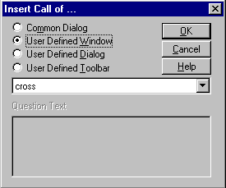

Figure 44: Specifying a predicate to insert, this time a user defined window.
Select the User defined Window option. When you press the OK button here, a predicate call to create the Cross window will be inserted.
task_win_eh(_WiN, e_Menu(iD_Test_Crosswin, _ShiftCtlAlt),0):-!,
win_cross_Create(_Win),
!.
Now Run the application and check that invoking the Test | CrossWin menu entry brings up a little window with the title 'Cross'.

Checking that Events Come to the Window
For the next step, you should try a little experiment. You should locate the beginning of the event-handler predicate in the cross-module, and type in a new first clause which will print out the event and then fail (be careful not to add any cut!). This will have no effects on the logic of the Cross window, but down in the message window you can now see all the events that are sent to the windows event-handler.
win_cross_eh(Win, Event, 0):- % <-- Type these three lines
write(Win, ":", Event),nl,
fail.

%BEGIN Cross, e_Create
win_cross_eh(_Win, e_Create(_),0):-!,
Try to run the application, and perform various actions like creating, moving and resizing the window, typing, clicking and closing the window.
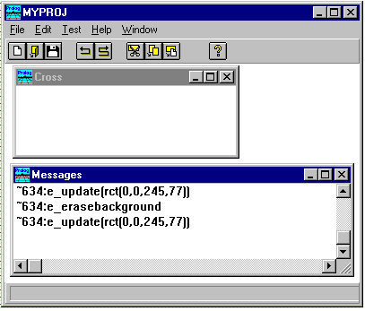

Figure 45: Studying events.
So now you can see that events are sent to the window in various circumstances. It is possible to add code (event-handler clauses) that react (selectively) to each of these events.
We will now look into the basics of drawing in a window. The application must always be prepared to redraw the window. If the window has been covered, and then brought to the foreground again, the contents must be redrawn.
Whenever the window needs to be repainted, the event-handler for the window will receive an e_Update event, and so we need to add code to do this drawing.
As an example, here we will draw a cross between the corners of the window. To do this, we will first go into the Dialog and Windows Expert and add a clause for the e_Update event:
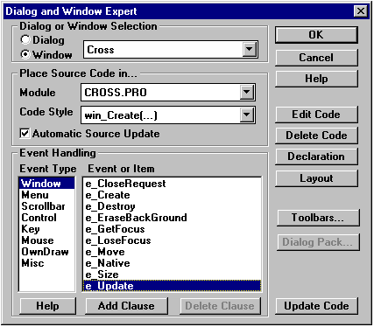

Figure 46: Adding a clause to handle the e_Update event.
To add VPI predicate calls, you should take advantage of the editor's insert facility. This can always be found from the editor insert menu, but there is also an accelerator key Shift+Ctrl+V, which immediately brings up the list of VPI predicates.
To draw the cross between the corners, we must first find the coordinates of the bottom corner. To do this we will retrieve the client rectangle with a call to win_GetClientRect; this rectangle contains in the last two parameters the width and height of the window, so the code to make a cross looks like this:
win_cross_eh(_Win, e_Update(_),0):-!,
RCT = win_GetClientRect(_Win),
RCT = rct(_,_,R,B),
Type these four lines in here, the coordinates are relative to the window, so top left is (0,0)
draw_Line(_Win, pnt(0,0),pnt(R,B)),
draw_Line(_Win, pnt(0,B),pnt(R,0)),
!.
When you run your application, and activate the Test | CrossWin menu entry, you should see the following window appear:
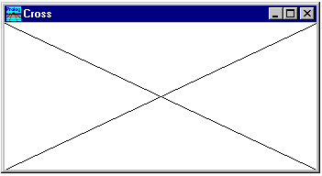

Figure 47: The appearance of the Cross window.
You will see that the window behaves almost correctly, that you can create multiple instances of the window, move the window around, cover it by another window, and make it visible again. However, if you resize the window, you will discover a problem. It does not repaint correctly. You will see that only the newly uncovered area of the window is repainted. This is because the underlying GUI system tries to paint as little as possible, and to do this it sets up a clipping region, so that updates will affect only the new part of the window. This is the correct behavior for many windows like editors, pictures etc. But in our case it is not sufficient, we need to redraw the entire window, when the window gets resized. One way to force this is to make a call to the win_Invalidate predicate in the e_Size event. Use the Window and Dialog editor, and press the Edit Clause button for the e_Size event (there is already some default code). After you have inserted a call to win_Invalidate, your code for the e_Size event should look like:
win_cross_eh(_Win, e_Size(_Width, _Height),0):-!,
win_Invalidate(_Win),

IFDEF use_tbar
toolbar_Resize(_Win),

ENDDEF
!.
If you run the application again, you should find that the window now works as desired.

More Drawing Operations
Now that we are drawing in the update event, we will add a couple of extra drawing predicates. Append the following code to your clause for the e_Update event:
draw_Text(_Win, 55, 20, "This is a text in the Cross Window"),
draw_Ellipse(_Win, rct(30,50,60,100)),
draw_PolyGon(_Win,[pnt(130,130),pnt(180,130),pnt(145,100),
pnt(150,150),pnt(170,110)]),
draw_Rect(_Win, rct(250,50,300,100)),
There are other drawing primitives. It is possible to set font, color, line size, line style, fill-pattern etc., these settings are described in the VPI Guide or in the on-line reference.
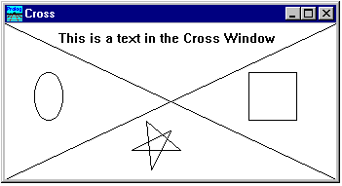

Figure 48: More drawing in the Cross window.

Creating the Sweep Window

To make things a little bit more interesting we will add a window with the following properties:
The window should have its own local menu.
The window should have a toolbar on the right side of the window from which the window can be cleared.
The mouse will be used to create a drawing.
Before creating the window we should create a menu and the toolbar. But before creating the toolbar we must design some bitmaps to use for its button. So we will create the components in that order.

Creating the SWEEP.PRO Module
Again we will create a new source module - since the windows are entirely independent we choose to place them in separate modules. Select modules, press the New button and enter the name 'Sweep' to create the module SWEEP.PRO. The source code for the Sweep window will be placed in this module.

Creating a New Menu (the Sweep Menu)
To create a new menu, we should select Menu in the Project window and click the New button. Give the new menu the name 'Sweep menu', the identifying constant will be inserted by the system. Press the OK button to close the dialog.
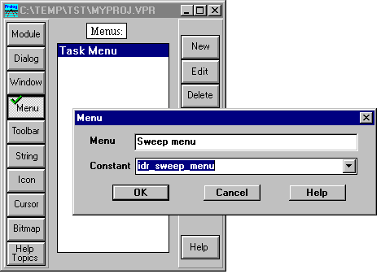

Figure 49: Creating a new menu.
When the name "Sweep menu" appears in the menu list, use the Menu Editor, (activated by pressing the Edit button) to add a single top menu entry called Sweep, (by pressing the New button).
Now use the Submenu and New buttons to create a single sub-menu entry called Clear. The default identifier is id_Sweep_clear. Use the Attributes button to change the constant for the menu entry to id_clear as we will refer to this constant later on.
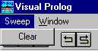
This menu item should have the constant id_clear

Figure 50: The new menu in test mode.

Creating a Bitmap
To create a new bitmap, click on the Project window Bitmap button, and then on the New button. You must now enter a name for the bitmap (mybmp_norm) and the desired size. If you do not specify a constant to identify the bitmap, one will be automatically generated. You can also enter a file name for the .BMP file (if none is given a default name will be generated).
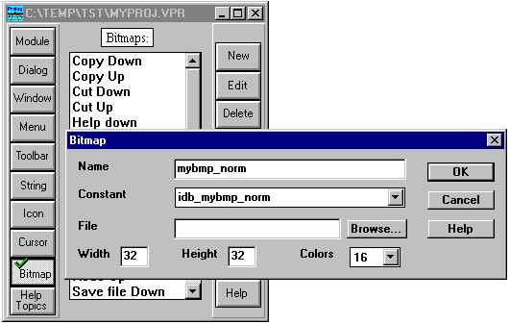

Figure 51: Creating a new bitmap from the Project window.
You should now double click on the newly registered name in order to bring up the icon/cursor/bitmap editor. Now draw a small bitmap which can be used as a button. The graphic editor is quite simple to use, designed especially for small buttons, cursors and bitmaps. It is not particularly well suited for large bitmaps, for these you should use the windows PAINT.EXE, PBRUSH.EXE or other specialized programs.
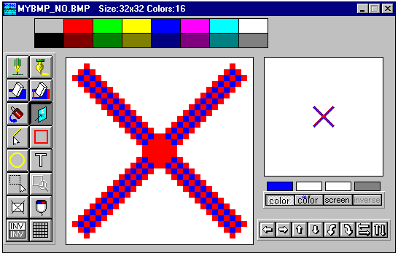

Figure 52: The bitmap editor
When you have finished drawing your special button, you should close the graphic editor, and the drawing will be saved in a file.
Then you should create one more bitmap (mybmp_down) that can be used as the "pressed" (down) version of the button. Make sure that the picture has the same size as the first. (We have copied the mybmp_norm bitmap and used the bitmap editor's invert  button.

Creating a Toolbar
Now that we have made the pictures for a button, the next step is to create a toolbar. Select toolbars in the Project window and click the New button to create a new toolbar. Give the new toolbar the name 'Sweep toolbar'
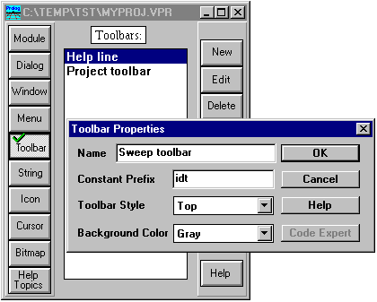

Figure 53: Creating a new toolbar from the Project window.
When you click OK the name of the new toolbar will appear in the list and the Toolbar Editor, with its Control dialog, will pop-up.
There are five types of controls to add to a Toolbar: Push buttons, which are used to invoke an action (sending a menu command), check boxes which are used to indicate a state, a text field, a context sensitive text which provides an explanation for other buttons and finally, a list button which can display a number of choices.
Use toolbar button  to add a push button to the toolbar.
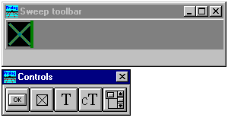

Figure 54: The toolbar editor with a Top Toolbar.
To set the properties for the new push button, you must double click on it. Three bitmaps can be specified for the button, one for each of the three possible states: Released, Pressed and Disabled (grayed).
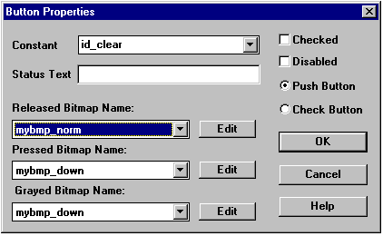
Figure 55: Specifying button properties.
You should also enter a constant for the button, so your program can react when the button is being activated. The default behavior for a toolbar is that it sends the same event as if a menu was activated. This means that if you have created a menu for your window, and inserted some code to handle some menu items, you do not need to create any extra code in order to add some toolbar buttons that correspond to the menu entries. The default value is idt_sweep_toolbar_1. Please change it to id_clear, so that it corresponds to the previous menu entry.
Ensure that the bitmap names refer to the bitmaps that you designed earlier.
The original plan was to have a toolbar at the right side of the window. We can easily change the style of the toolbar by double-clicking inside the toolbar window and changing the Toolbar Style property to Right.
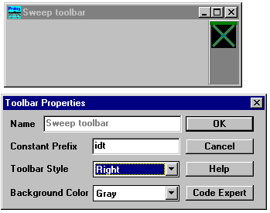

Figure 56: Specifying toolbar properties.

Creating a Window
Now that we have both a menu and a toolbar, it is time to create a window. The procedure is the same as for the other components; select Window and press the New button.

The three changes

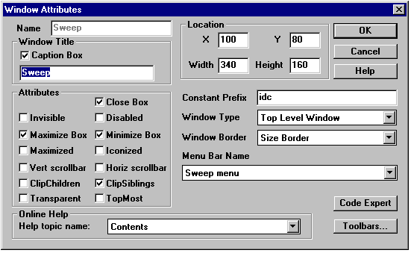

Figure 57: Creating the sweep window.
For the Sweep window, we will specify three things:
The name of the window will be Sweep.
Its menu will be the new menu (Sweep menu).
The toolbar Sweep Toolbar will be associated with this window.
Adding the menu is accomplished by selecting a name from the list under Menu Bar Name.
The window must be created before the toolbar can be attached. Press the OK button to accomplish this, and the Window Editor will appear. A Double click in the client area will bring up the Window Attributes dialog. The Sweep toolbar can now be attached by pressing the Toolbars button as described below.

The Toolbar Expert
To add the toolbar, we click on the Toolbars button to bring up the Toolbar Expert from which toolbars can be added to the window.
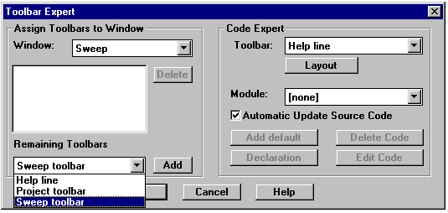

Figure 58: Joining toolbars to windows.
Note that you can add more than one toolbar to your window, though for our example, adding 'Sweep toolbar' will suffice.
Note also that the Toolbar Expert dialog performs two different operations; In the left part of the dialog, it assigns toolbars to a window; in the right part of the dialog, it makes it possible to add the source code to handle a toolbar. As with windows, you must assign a module to contain the toolbar code.
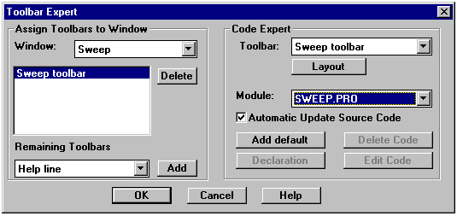

Figure 59: Adding code for a toolbar.
After assigning the 'Sweep toolbar' to the window, you should select the source module for it. The toolbar code should go into the SWEEP.PRO module.
Press the Add default button to generate the necessary code. If you go into the editor and study the generated code, you will see that the following code is generated:
%BEGIN_TLB Sweep toolbar, 17:13:20-17.11.1995, Code automatically updated!
/**********************************************************

Creation of toolbar: Sweep toolbar
**********************************************************/

CLAUSES
tb_sweep_toolbar_Create(_Parent):-

IFDEF use_tbar
toolbar_create(tb_right,0x808080,_Parent,

[tb_ctrl(id_clear,pushb,idb_mybmp_norm,idb_mybmp_down,
idb_mybmp_down,"",1,1)]),

ENDDEF
!.
%END_TLB Sweep toolbar
The next step is to go into the Dialog and Window Expert and create some code for the Sweep window, use Ctrl+w to bring up the Dialog and Window Expert.
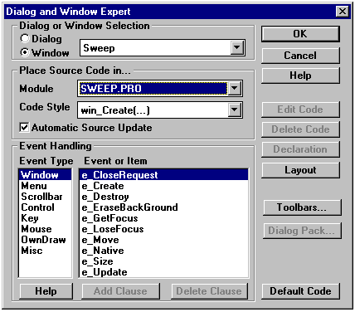

Figure 60: The Dialog and Window Expert creating code for a window.
The first thing is to select the proper dialog or window which we want to work with (here the Sweep window). Next you should select the source module to contain the code (SWEEP.PRO). When these settings are correct, click on the Default Code button to add some basic Prolog source for handling the window.
Now that we have finished creating our window, we just need some way to activate it. In our application we create windows from the Test sub-menu in the Task menu, so you should go into the menu editor and add an extra menu item called Sweep window.
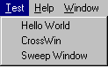

Figure 61: The Test menu with the Sweep menu item added.
Now, as usual, go into the Dialog and Window Editor, and add a clause for the creation of the Sweep window when the menu event Test | Sweep Window arrives in the Task window.
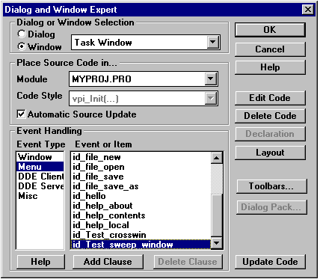

Figure 62: Adding a clause to invoke the Sweep window.
After pressing the Add Clause button, and Edit Clause button, you are placed into the editor at the appropriate clause, and you should press Shift+Ctrl+W to bring up the dialog from which you can insert the call to create the Sweep window. (Remember to move the editor insertion point to the beginning of the second line).
task_win_eh(_Win,e_Menu(id_Test_sweep_window,_ShiftCtlAlt),0):-!,
win_sweep_Create(_Win),
!.
Now you should run your application and study what happens when you activate the Test | Sweep Window menu item.
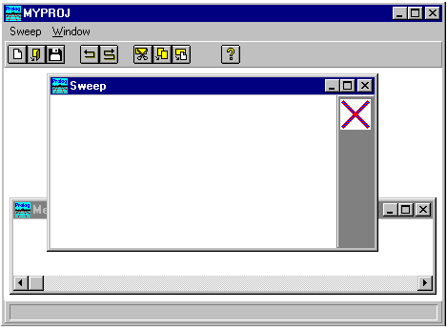

Figure 63: Invoking of the Sweep window for the first time.
Your Sweep window should come up with the added toolbar. But take a careful look at the menu- when the sweep window comes up, the menu in the Task window changes to contain the local menu for the Sweep window. This is the usual behavior in MS-Windows MDI mode -- when the focus changes to a window, the MDI container window displays the menu for the active window. (The behavior of the menu is different for different GUI platforms). When you set focus to a given window, the menu will change to this window. In our application, you have the problem that once in the Sweep window, you need to mouse-click on the message window in order to be able to activate the Cross window!

Drawing a Mouse Sweep
Now we will try to draw in the window. We will try to use the same techniques employed in the demo example SWEEP.PRO under VPI\EXAMPLES. Whenever a mouse button is pressed, the program registers the coordinates of the points that the mouse travels over (by catching the e_MouseMove events from the time that a mouse button is depressed until it is released) and draws a line from each point to the other points. We want to obtain a window like the following:
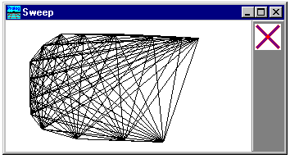

Figure 64: The appearance of the Sweep window.
First we will make some predicates that can draw lines from any point in a list to each of the other points in the list. You should type the following clauses in at the top of the SWEEP.PRO module, they should be placed just below the include statements.
/*************************************************************

Handling pointlist's
*************************************************************/

PREDICATES
connect(WINDOW,pntlist)
drawlines(WINDOW,PNT,pntlist)

CLAUSES
connect(_,[]):-!.
connect(Win,[FROM | REST]):-
drawlines(Win,FROM,REST),
connect(Win,REST).
drawlines(_,_,[]):-!.
drawlines(Win,pnt(X,Y),[pnt(TOX,TOY) | REST]):-
draw_Line(Win,pnt(X,Y),pnt(TOX,TOY)),
drawlines(Win,pnt(X,Y),REST).
The next step is to consider the logic of event handling. We need a database fact to store the mouse positions, we will call this fact "point". Since the e_MouseMove events arrive independently of changes to the mouse button status (the e_MouseMove event arrives as the result of the mouse being moved), we also need to record that a mouse button has been pressed down. The last thing to consider is that we want to have more than one window, each with its own local drawing. The way to handle this is to store the window handle, a value that is guaranteed unique for each window, together with the other data needed in the facts.
Type these lines at the top of sweep.pro, after the include statements:
/******************************************************

Facts for doing the sweep
******************************************************/

DATABASE - apl
nocopy point(WINDOW,PNT)
mouse_isdown(WINDOW)
Now we are down to the core of the functionality. Which events should we capture and how should we react to them? We decide here to handle the following four events, the default code for which should be added (to the SWEEP. PRO module) by using the Dialog and Window Expert.

The e_MouseDown Event
When a mouse button is depressed, we will first retract any facts that may already be asserted for the window, then assert a fact indicating that a mouse button is now being pressed down (in the window), and our last action is to make a call to win_Invalidate, so that if it already contains a drawing, the window will be cleared.
win_sweep_eh(_Win,e_MouseDown(_PNT,_ShiftCtlAlt,_Button),0):-!,
retractall(mouse_isdown(_Win)),
retractall(point(_Win,_)),
Enter these four lines between the two “!” signs.
assert(mouse_isdown(_Win)),
win_Invalidate(_Win),
!.

The e_MouseMove Event
On the mouse move events, if the mouse is in the down state, we will assert the position of the mouse. To show where the mouse has traveled, we also change the color of the pixel.
win_sweep_eh(_Win,e_MouseMove(_PNT,_ShiftCtlAlt,_Button),0):-!,
mouse_isdown(_Win),
assert(point(_Win,_PNT)),
draw_Pixel(_Win,_PNT,color_Black),
!.

The e_MouseUp Event
On the mouse up event, we first remove the flag indicating that a mouse button is down, then we call win_Invalidate so that the window can be redrawn with the created figure.
win_sweep_eh(_Win,e_MouseUp(_PNT,_ShiftCtlAlt,_Button),0):-!,
retractall(mouse_isdown(_Win)),
win_Invalidate(_Win),
!.

The e_Update Event
The update event contains code that clears the window before it collects all the points in a list and connect them with each other.
win_sweep_eh(_Win,e_Update(_Rct),0):-!,
win_Clear(_Win, color_White),
findall(X,point(_Win,X),List),
connect(_Win,List),
!.

Handling the Toolbar
Finally, we want to handle the pressing of the Clear button on the toolbar. When the toolbar push button is pressed, it sends an e_Menu event, so we can use the Dialog and Window Expert to add code for the id_clear menu event:
win_sweep_eh(_Win,e_Menu(id_clear,_ShiftCtlAlt),0):-!,
retractall(mouse_isdown(_Win)),
retractall(point(_Win,_)),
win_Clear(_Win, color_White),
win_Invalidate(_Win),
!.
Now is a good time to open the Sweep toolbar and check that your button has the constant id id_clear, this can be done by selecting the toolbar icon (on the left side of the Project window), double clicking on the name Sweep toolbar and then on the face of your button.
It is one thing to clear the window by calling win_Clear, but you must also remember to retract the facts, so the window will not be redrawn later (in the e_Update event).

Cleaning Up
If the user closes a window, you should retract all facts that have been stored for that window. There is a special event e_Destroy for this purpose. e_Destroy is the last event that is received by a window.
win_sweep_eh(_Win,e_Destroy,0):-!,
retractall(mouse_isdown(_Win)),
retractall(point(_Win,_)),
!.

Changing the Mouse Cursor
The purpose of this application is to experiment, so let's try now to redesign the mouse cursor for the Sweep window! Cursors are registered in the Project window, so you should now select the Cursor icon from the toolbar on the left side of the Project window, and press the New button to create a new cursor with the name 'Sweep'.
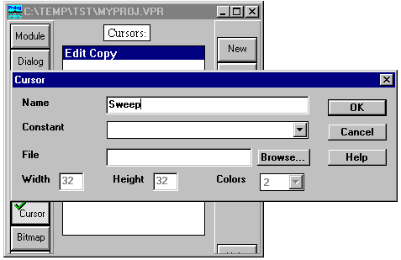

Figure 65: Creating a new cursor.
When the new cursor name appears in the list, you should double click on it in order to activate the cursor editor. Here you should use all your creativity to design an intuitive cursor for the Sweep window.You should notice that you can use four different colors for a cursor: Black, White, Transparent (= screen) and Inverse. Try to use all four selections in the cursor you create so you know in the future that these possibilities exist. However, a mouse cursor is usually created by using only the Screen and the Inverse selections.
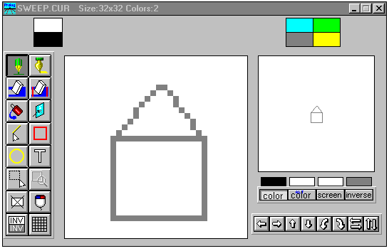

Figure 66: Creating a new cursor.
When you have created a cursor, you should check how it looks, and how it behaves, by selecting Tools | Test cursor:
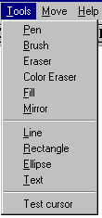

Figure 67: The menu entry to test a cursor.

Setting the Hot Spot for a Cursor
When you have created a cursor, you will also want to set it's hot spot, i.e. the pixel in the cursor where the position of a mouse click will be registered. The setting of the hot spot for a cursor can be done by selecting hot spot from the Edit menu:
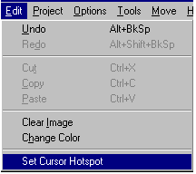

Figure 68: The menu entry to set the cursor hot spot.
When this menu entry is activated, you may click on your cursor image where you want the cursor hot spot to be:
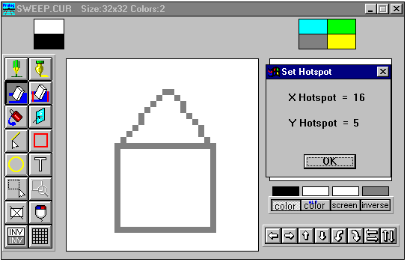

Figure 69: Changing the cursor hot spot.
The last step is to make the code work. This requires only a single predicate call in the create event for the sweep window. With a call to cursor_Set, it is possible to change the cursor for a window.
win_sweep_eh(_Win,e_Create(_),0):-!,
cursor_Set(_Win, idc_sweep),
When you add the call to cursor_Set, you should use the method suggested below:
Activate the Dialog and Window Expert by pressing Ctrl+W, then press Edit Clause for the e_Create event for the Sweep window - Voilá, you are in the right place in the source code.
Use Shift+Ctrl+V to insert the call to cursor_Set.
Highlight the second argument (ResId) in the cursor_Set predicate call. Use the editor menus Insert | Resource identifier | Cursors to insert the name of the cursor.
See how you can actually insert the call typing anything!
Now run your application and see how the mouse behaves now.

Creating a Pop-Up Menu
Many modern applications use the right mouse button to display a local pop-up menu for each window - so - we need to have this feature in our Sweep windows.
Pop-up menus are designed in the menu editor just like normal pull-down menus. You should now create a new (pop-up) menu with the name 'Sweep Pop-up', and define the following four menu entries:
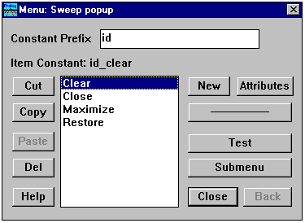

Figure 70: Designing a pop-up menu.
Make sure that the constant used for the Clear entry is the same as the one for the Clear entry you defined in the Sweep menu and the Sweep toolbar (id_clear).
The clause that brings up the pop-up menu when the right mouse button is depressed is very simple. Use the editor and add an extra clause for the e_MouseDown event as shown below. This clause checks to see if the right mouse button is pressed, if not the other clause for the e_MouseDown event will be matched.
Remember to place the new clause before the old one, or, alternatively to change the first line of the old clause so that it reacts to the left mouse button only
win_sweep_eh(_Win,e_MouseDown(PNT,_,mouse_button_right),0):-!,
menu_PopUp(_Win,res_menu(idr_sweep_popup),PNT, align_Right).
win_sweep_eh(_Win,e_MouseDown(_PNT,_, mouse_button_left),0):-!,
..........
Now run the program and try to bring up the window, and use the right mouse button. You will find that the Clear entry already works (unless you forgot to use id_clear as the constant name for the clear entry)
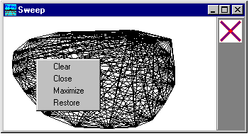

Figure 71: Showing the pop-up menu.
The reason that the Clear menu entry works is that a pop-up menu generates the same e_Menu events as the regular menus and toolbars.
When you attempt to add code for the three new menu items you will discover that they are not among the menu items for the Sweep window as are registered in the Dialog and Window Expert! The reason for this is that we cannot register that a pop-up-menu will be used for the window.
Fortunately, it is possible to type in the three clauses for these events manually, so the proper functionality can be implemented. You should, at the proper place in your event-handler predicate, add the following three clauses:
win_sweep_eh(_Win,e_Menu(id_close,_ShiftCtlAlt),0):-!,
win_Destroy(_Win).
win_sweep_eh(_Win,e_Menu(id_maximize,_ShiftCtlAlt),0):-!,
win_SetState(_Win, [wsf_Maximized]).
win_sweep_eh(_Win,e_Menu(id_restore,_ShiftCtlAlt),0):-!,
win_SetState(_Win, [wsf_Restored]).
Also you may find that a click on the right mouse button conflicts with the behavior of the previously implemented event handling for e_MouseUp. If so, you must change the clause for this to match only when the left mouse button is pressed,
win_sweep_eh(_Win,e_MouseUp(_PNT,_,mouse_button_left),0):-!,
or, alternatively, change the order of the clauses.

Changing the Drawing Color
Any drawing of lines and pixels uses the selected current pen, which has a width, a style (solid or hollow), and a color. The current pen state can be retrieved by a call to win_GetPen and changed by a call to win_SetPen. To select a new color, we can use one of the common dialogs dlg_ChooseColor which takes the current color and returns a new color selected by the user.
We just need a way to invoke the changing sequence and we do this by adding one extra item to our pop-up-menu called Color. It will have the constant name id_color:
win_sweep_eh(_Win,e_Menu(id_color,_ShiftCtlAlt),0):-!,
Pen=win_GetPen(_Win),
Pen = pen(Penwidth,PenStyle,Color),
NewColor = dlg_ChooseColor(Color),
win_SetPen(_Win,pen(Penwidth,PenStyle,NewColor)),
win_Invalidate(_Win).

Using a Timer - the Clock Window

There are many things we still need to learn. Now we will try to create a window that displays the current time. You should know the component actions already, so see if you can now manage the following:
Create a new source module called CLOCK.PRO.
Add a menu item in the Task menu under the Test menu called Clock Window.
Create a new window called CLOCK.
Go to the Dialog and Window Expert and add the default code for the Clock Window in the module CLOCK.PRO.
Use the Dialog and Window Expert to add a clause for the Task window to invoke the Clock Window when the Test | Clock Window menu is invoked.
Run the program and see if you can create the window when you activate Test | Clock Window.
Go back to the Dialog and Window Expert and add a clause for the e_Update event in the Clock Window.

Using Timers
Using a timer is quite straightforward. You can at any time create a new timer for a window with a call to the predicate timer_Set(Window, Milliseconds). Once the timer_Set predicate has been called, the window will at the specified time intervals receive an e_Timer event.

The e_Update Event for the Clock Window
On the update event, we will draw the current time, centered in the window. We can get the time by a call to the time/4 predicate. The first three integers returned by time are then formatted into a string by the format predicate. Finally, the string is drawn centered in the window using a call to draw_TextInRect that is given the entire client rectangle as the rectangle in which to center the text.
win_clock_eh(_Win,e_Update(_),0):-!,
win_Clear(_Win,color_White),
RCT=win_GetClientRect(_Win),
time(Hours,Minutes,Seconds,_),
format(Str,"%02:%02:%02",Hours,Minutes,Seconds),
draw_TextInRect(_Win, RCT, Str, -1,[dtext_center,dtext_vcenter,
dtext_singleline]),

The e_Size Event for the Clock Window
Since we draw something centered in the window, we want to redraw it if the window changes its size. Remember that the proper way to do this is not to redraw it on this event, rather to cause a new e_Update event to be issued for the complete window rectangle
win_clock_eh(_Win,e_Size(_Width,_Height),0):-!,
win_Invalidate(_Win),

The e_Create Event for the Clock Window.
On the e_Create event we start the timer. The interval value of 1000 milliseconds means that we will receive a timer event every second.
win_clock_eh(_Win,e_Create(_),0):-!,
_NewTimerId =timer_Set(_Win, 1000),

The e_Timer Event for the Clock Window
On the e_Timer event we will just invalidate the window. This will force an update of the window - if it is not minimized or covered by another window. (You will find the e_Timer event under the Misc. group in the Dialog and Window Expert).
win_clock_eh(_Win,e_Timer(_TimerId),0):-!,
win_Invalidate(_Win),
Note that in a real application you would probably not invalidate the entire window since it may take too much time to redraw the entire window. If you want your program to be fast and look professional, you will invalidate as little as possible. This takes extra programming effort, and can be done as a stepwise refinement after the basic functionality has been implemented. Note also that timers are a limited system resource. In a real application the timer identifier returned by timer_set should be saved for use in the e_destroy event, where it would be used as an argument to timer_Kill/1.

The Picture Window

Next we will add yet another window, this time where we will display a picture. The pictures in this example are stored in bitmap files, and handling bitmaps is quite easy using the VPI. You should probably take a quick look in the VPI guide to study what can be done with pictures.
Again, we expect you can now perform the following steps:
Create a new source module called PICTURE.PRO.
Add a menu item in the Task menu under the Test menu called Picture window.
Create a new window called PICTURE.
Go to the Dialog and Window Expert and add the default code for the Picture window in the module PICTURE.PRO.
Use the Dialog and Window Expert to add a clause for the Task window to invoke the Picture window when the Test | Picture window menu is invoked.
Run the program and see if you can create the window when you activate Test | Picture window.
Go back to the Dialog and Window Expert and add a clause for the e_Update event in the Clock Window.
Add the following code for the e_Update clause:
win_picture_eh(_Win,e_Update(_),0):-!,

/* Remember to use the correct path to the .BMP file */
Picture = pict_Load("C:\\VP\\BIN\\WIN\\PROLOG.BMP"),
ClntRCT=win_GetClientRect(_Win),
pict_GetSize(Picture, Width, Height, _Size),
pict_Draw(_Win,Picture, ClntRCT, rct(0,0, Width,Height),rop_SrcCopy),
pict_Destroy(Picture),
This clause needs a little explanation:
First the predicate pict_Load is called with a filename that contains a bitmap. The predicate will return with a handle to a bitmap which has been loaded into memory. You can use the Edit | Insert menu to paste in a filename for any bitmap on your disk.
When drawing a picture, it can be stretched to any size, so for this purpose we need to find the size of both the window and the picture.
Third we call the predicate pict_Draw with the handles to the window and the picture, and with the two rectangles. Last parameter to pict_Draw specifies how the picture is combined with the pixels already in the window. Here we just specify that we want to copy the picture to the window (replacing existing pixels).
Finally, we destroy the picture, so it does not take up space in memory.

Creating a Tree Window

Now we will create a window that displays a tree structure. The tree is drawn by a tool found in the VPI\INCLUDE directory, and it is one of the files that can be included in the VPITOOLS.PRO module. Before creating a tree window, you should make sure that the Tree Tool option is enabled under the VPI options in the Application expert.
Now prepare the Tree window by performing the following steps:
Create a new source module called TREE.PRO.

Add a menu item in the Task menu under the Test menu called Tree window
Create a new window called TREE.
Go into the Dialog and Window Expert and specify that the code should go into the TREE.PRO module, but then you should select tree_Create as the style of code for the Code Expert to generate.
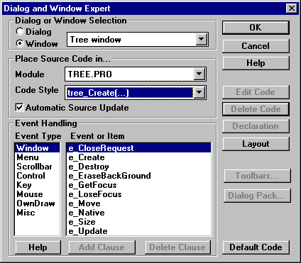

Figure 72: Adding default code for the tree window.
After you have added the default code for the Tree window, you should also add a new item to the Task menu and create a clause to invoke the Tree window.
You should take a short look at the VPITREE header files and a look at how the tree is created. In Prolog it is very easy to create a tree from various data structures such as lists of the files on your hard disk or the records in a database.
win_tree_window_Create(Parent):-

IFDEF use_tree
Tree = tree("0",unmarked,
[tree("3",unmarked,[],0),
tree("2",unmarked,
[tree("4",unmarked,[],0)],0),
tree("1",unmarked,[],0)
],0),
TreeDir = tree_dirright,
Font = font_Create(ff_Fixed,[],10),
TreeWinInfo = tree_WinInfo(Font,TreeDir,[]),
tree_Create(win_tree_window_WinType,win_tree_window_RCT,
win_tree_window_Title,win_tree_window_Menu,Parent,
win_tree_window_Flags,win_tree_window_eh,0,Tree,
TreeWinInfo,[]),

ENDDEF
!.
Notice that even though the Tree window is a special kind of window, the code has the same structure as the windows you create yourself: there is a creation call, and a standard event-handler.

Working with the Tree
When displaying a tree, you would probably like to be able to click on the tree nodes and react when a node is selected. Try to add the following clause for the e_MouseUp event, and see how easily you can get the node information:
win_tree_window_eh(_Win,e_MouseUp(_PNT,_ShiftCtlAlt,_Button),0):-!,
SelectorText=tree_GetSelectedNode(_Win),
dlg_Note("Node Selected",SelectorText),
!.

Creating an Editor Window

As easy as it was to create a window that displays a tree, it's just as easy to create an editor window.
There is a very flexible API defined for the VPI editor, so that Visual Prolog applications can customize and use this editor in many ways. Among its special features, the editor supports token coloring and hypertext fields, and these features can easily be used in your programs as well.
Now prepare the editor window by performing the following steps:
Create a new source module called EDWIN.PRO.

Create a new window called EDITOR.
Go into the Dialog and Window Expert and select that the code should go into the EDWIN.PRO module. Select also that the style of code for the Code Expert to generate will be edit_Create.
Add a menu item to the Task menu under the Test submenu called Edit Window. Insert the code to create the editor window for this event.
Try to run your application: open the editor window, and see if you can now edit some text using the editor.
If you go into the EDWIN.PRO module to take a look at the generated source code you will see that the call to create the editor window has default values set for the various arguments:
win_editor_Create(Parent):-
Text = "",
Font = font_Create(ff_Fixed,[],10),
ReadOnly = b_false, Indent = b_true, InitPos = 1,
edit_Create(win_editor_WinType,win_editor_RCT,win_editor_Title,
win_editor_Menu,Parent,win_editor_Flags,Font,ReadOnly,
Indent,Text,InitPos,win_editor_eh),
!.
You can easily change this code, for example, to load a specific text into the editor:
file_str("D:\\TEMP\\TST\\MYPROJ.CON" ,Text),
In this quick tour we will try adding just a few small features to our editor window.

Clicking on a Token
To illustrate how to make selections in the editor, and retrieve a part of text from the editor, we will implement the feature that double-clicking on a word (token) will bring up a note box with that word.
To accomplish this you will need to use three predicates from the editor. edit_SelectWord will highlight the selected token. edit_GetSelection retrieves the start and the end positions of the current selection, and edit_GetText will return the selected text from the editor.
win_editor_eh(_Win,e_MouseDbl(_PNT,_ShiftCtlAlt,_Button),0):-!,
WordSelected = edit_SelectWord(_Win),
WordSelected = b_True,
edit_GetSelection(_Win,Pos1,Pos2),
Text = edit_GetText(_Win),
NoOfBytes = Pos2-Pos1,
substring(Text,Pos1,NoOfBytes,SubString),
format(Msg,"Got the token: >%<",SubString),
dlg_Note(Msg),

Pasting Text into the Editor
It is very easy to insert text into the editor via predicate calls. The predicate edit_PasteStr can insert a string in any position in the text (the position is one relative).
As an example, we can add the new feature that as soon as you type the beginning of a comment '/*' the termination of the comment '*/' will automatically be inserted. To do this, we will start to look at the characters that are typed. When the user presses a key, an e_Char event is sent to the window which has the focus. So it is very easy to add a couple of clauses that catch the '/' and the '*' characters. When the '/' character is seen a flag is set to register the fact, if it is then immediately followed by a '*' the string will be pasted, otherwise the flag will be retracted. We are using edit_GetPos to find the cursor position in the editor. Finally, as a service to the user, we select the string that is pasted, so if the user does not want this, he can just type any character and it will disappear.
win_editor_eh(_Win,e_Char('/',_),0):-!,
not(commentflag(_Win)), assert(commentflag(_Win)),
fail.
win_editor_eh(_Win,e_Char('*',_),0):-!,
retract(commentflag(_Win)),
Pos = edit_GetPos(_Win),
edit_PasteStr( _Win, Pos, "* */" ),
Pos1 = Pos+1, Pos2 = Pos1 + 3,
edit_SetSelection(_Win, Pos1, Pos2),
NewPos = Pos + 1,
edit_GotoPos(_Win,NewPos),!.
win_editor_eh(_Win,e_Char(_,_),0):-!,
retract(commentflag(_Win)),
fail.
The two clauses above which merely manipulate the flag status also fail, so that the editor itself can do the normal processing for those messages (i.e. to insert the characters, update the display, etc), just as if these clauses had not been present.
To define the database used above, insert the following code at the beginning of the file:

DATABASE - comment
commentflag(WINDOW)

Saving the Current Text
The text in the editor can easily be saved on disk by calling edit_GetText, followed by a call to file_str.
For the editor window, we would like to use the File | Save menu item to invoke saving the text. To do this we need to access the attributes dialog for the editor window and register that the editor window should have the Task window as its menu. Now there is only the small problem that we need to have the File | Save menu item enabled. Since we don't want that when the other windows have focus, we will manually enable this menu choice on the e_GetFocus event clause and similarly disable it in the e_LoseFocus event.:
win_editor_eh(_Win,e_LoseFocus,0):-!,
PWin = win_GetParent(_Win),
menu_Enable(PWin, id_file_save, b_False),!.
win_editor_eh(_Win,e_GetFocus,0):-!,
PWin = win_GetParent(_Win),
menu_Enable(PWin, id_file_save, b_True),!.
win_editor_eh(_Win,e_Menu(id_file_save,_ShiftCtlAlt),0):-!,
Title = win_GetText(_Win),
SaveFileName = dlg_GetSaveFileName(Title,[],"Save File"),
Text = edit_GetText(_Win),
file_str(SaveFileName, Text),
win_SetText(_Win, SaveFileName),
!.

Handling the Clipboard

The clipboard is used to exchange information between applications. Applications should be able to put information on the clipboard and retrieve information from the clipboard. In Visual Prolog it is possible to put text, pictures and private Prolog formats on the clipboard. Text and pictures can be put on the clipboard by just calling cb_PutString or cb_PutPicture, and they can be retrieved from the clipboard by calling cb_GetString or cb_GetPicture.
To illustrate, we can enhance our Sweep window to copy the drawing to the clipboard whenever the character 'c' is pressed and to paste the current picture from the clipboard when the character 'v' is pressed.
Before the picture can be placed on the clipboard, it must be captured from the window in which it was drawn. One method of doing this is by using pict_Open, then performing the drawing operations again so they are collected into a picture which is returned when pict_Close is called. The predicate sweep_Draw just does a findall of the points, and then calls the connect predicate with the list of points, thus redrawing the picture, so we replicate this sequence between the pict_Open and pict_Close.
win_sweep_eh(_Win,e_Char('c',_),0):-!, % Copy window
RCT=win_GetClientRect(_Win),
PictWin = pict_Open(RCT),
findall(X,point(_Win,X),List),
connect(PictWin,List),
Picture = pict_Close(PictWin),
cb_PutPicture(Picture),
pict_Destroy(Picture).
win_sweep_eh(_Win,e_Char('v',_),0):-!, % Paste picture
Picture=cb_GetPicture(),
pict_Draw(_Win,Picture,pnt(0,0),rop_SrcCopy),
pict_Destroy(Picture).
Note that because we copy a bitmap and not the list of points a pasted picture will not be redrawn in the e_Update event.

Printing

Printing in the VPI is quite straightforward. Printing is initiated by calling print_StartJob and terminated by print_EndJob. Each page must be surrounded by a print_StartPage - print_EndPage pair. All drawing predicates work as usual, except that they must be supplied with the print window handle as the Window argument:
PRINTWIN=print_StartJob("Printing Sweep drawing"),
print_StartPage(PRINTWIN),
...Draw to the Printwindow
print_EndPage(PRINTWIN),
print_EndJob(PRINTWIN).
There is usually a much higher resolution on the printer than on a monitor screen, so if you just replicate your screen drawing code, the result will most likely be very small pictures.
The solution for this is found in the mapping predicates. The GUI system can map any coordinates into another coordinate system, in this case scaling the drawing up. The scaling is done by calling the predicates set_MapMode and set_MapScale.
First we find out how wide the window is by calling win_GetClient, then we find out how wide the paper on the printer is by calling vpi_GetAttrVal( attr_printer_width ).
Given this you can do the printing of the sweep window using the following clause:
win_sweep_eh(_Win,e_Menu(id_print,_),0):-!,
ScreenRCT=win_GetClientRect(_Win),
ScreenRCT=rct(_,_,WinSize,_),
PRINTWIN=print_StartJob("Printing Sweep drawing"),
print_StartPage(PRINTWIN),
PrnSize = vpi_GetAttrVal(attr_printer_width),
win_SetMapMode(PRINTWIN,mm_arbitrary),
win_SetMapScale(PRINTWIN,pnt(0,0),pnt(WinSize,WinSize),
pnt(0,0),pnt(PrnSize,PrnSize)),
sweep_Draw(PRINTWIN,_Win),
print_EndPage(PRINTWIN),
print_EndJob(PRINTWIN).
Note carefully that the sweep_Draw predicate has been changed to take two arguments:

PREDICATES
sweep_Draw(WINDOW Win,WINDOW AssertWin)

CLAUSES
sweep_Draw(_Win,AssertWin):-
win_Clear(_Win, color_White),
findall(X,point(AssertWin,X),List),
connect(_Win,List).
The reason is that the "point" facts are stored together with the handle of the Sweep window on the screen. So the predicate needs both the handle to the printer (print window), and the handle window to the window containing the facts. - You will probably need these kinds of techniques in your own applications if you want to be able to open more than one window of the same type.

Adding Controls to the Clock Window

Now it is time to introduce Controls. Controls are specialized Child windows that are normally used in dialogs to perform various input/output tasks. To start, we will add two controls to our Clock Window:
A push button which can start/stop the time.
A check box to select if the time should be displayed.
We can place these controls in the Clock Window using the Dialog and Window editor. In the Project window you should select Window, highlight the Clock Window, and press the Edit button.
When the Window Editor is open, you can click on a Control from the Controls toolbar, and drag it into the window. If you release the mouse button in the window, the control will be placed at the selected position. If you mark a rectangle, the control will be placed in the marked rectangle. When you release the mouse, a dialog activates in which you can specify attributes for the controls. The important thing now is to enter the name of the control.
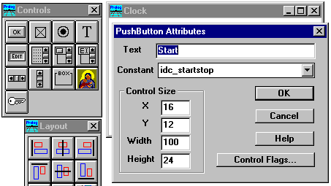

Figure 73: Adding Controls to the Clock Window.
You should create the two controls with the following Title/Constants:

Push button: Title = 'Start', Constant = 'idc_startstop'
Check box: Title = 'Show Time', Constant = 'idc_show_time'
At this point you might test some of the various layout/arrangement features of the Dialog and Window Editor. By dragging an enclosing rectangle or by using Crtl+Click you can mark a group of controls, and change their layout using the layout menu or toolbar.
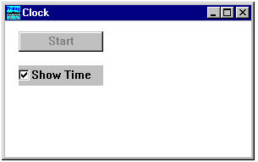

Figure 74: The Clock Window with controls added.
If you now try to run your application, and open the Clock window, you will see that the clock runs as before, and that the two controls are displayed, but don't yet have any functionality.
When you pressed Project | Run, the code for the Clock window was automatically updated by the Code Expert. You can go into the code for the e_Create event for the Clock window, and see that the Code Expert added the following two calls to create the two controls as soon as the parent window is created:
win_CreateControl(wc_PushButton,rct(6,9,106,33),"Start / Stop",_Win, [ctl_Group,ctl_TabStop],idc_startstop),
win_CreateControl(wc_CheckBox,rct(6,44,106,68),"Show Time",_Win,[ctl_Group,ctl_TabStop,ctl_Auto],idc_show_date),

When you want to add functionality for the controls, you should go into the Dialog and Window Expert, and select the Event Type: 'Control'. Then it is possible to add events to handle the actions for the controls in a window.
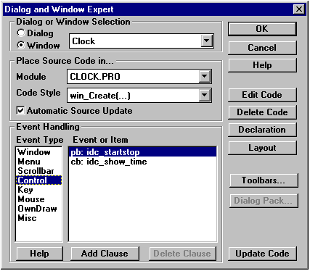

Figure 75: Adding functionality to controls.
Use the Add Clause button to add a clause for each control.
First we will add the code to handle starting and stopping the timer. To make this easier within the event handler, we will define two small helper predicates (startTimer and stopTimer) and a local database (clock):

DATABASE - clock
timer(Window,LONG Id)

PREDICATES
startTimer(Window)
stopTimer(Window)

CLAUSES
startTimer(Win):-
TimerId = timer_Set(Win, 1000),
assert(timer(Win,TimerId)).
stopTimer(Win):-
retract(timer(Win,TimerId)),!,
timer_Kill(TimerId).
Now you should modify the e_Create event for the Clock window; delete the old code for starting the timer, so that the timer must be manually started by pressing the push button.
Now select the event-handler clause for the push button (Edit Clause), and add the following code to start and stop the timer:
win_clock_eh(_Win,e_Control(idc_startstop,_,_CtrlWin,_CtlInfo),0):-
Title = win_GetText(_CtrlWin),
Title = "Start",
startTimer(_Win),
win_SetText(_CtrlWin,"Stop"),
!.
win_clock_eh(_Win,e_Control(idc_startstop,_,_CtrlWin,_CtlInfo),0):-!,
stopTimer(_Win),
win_SetText(_CtrlWin,"Start"),
!.
The code uses the title of the push button to decide whether the timer needs to be started or stopped. Calling win_GetText can retrieve the text of a push button, and calling win_SetText can set new text for the push button.
Note: To change the text, we are referring to a handle for the Control window (_CtrlWin), not the clock Window. This handle is passed inside the e_Control event structure.
As our second change, we would like to update our clock window depending on the state of the check box. For this we use a predicate, win_IsChecked that, given a handle to a check box window, can return a Boolean value which indicates if the box is checked or not.
However, in the e_Update event clause there is the small problem that we do not have the handle to the check box window. To retrieve the handle, we use win_GetCtrlHandle, which given a parent window handle and the constant ID for a control, returns the window handle for the control.
win_clock_eh(_Win,e_Update(_),0):- %Note: no Cut !
/* This must be the first e_Update clause */
_CtrlWin = win_GetCtlHandle(_Win, idc_show_time),
IsChecked = win_IsChecked(_CtrlWin),
IsChecked = b_False,!,
Remember to remove the first Cut "!" of the above clause.
The third change is to remove the original call to timer_set from the e_Create clause:
win_clock_eh(_Win,e_Create(_),0):-!,
_NewTimerId =timer_Set(_Win, 1000), %% <- Remove this line
The last change we need to make is to insure that the window is updated immediately after the selection of the check box is changed. So, when we receive an event for the check box, we will invalidate the window.
win_clock_eh(_Win,e_Control(idc_show_time,_,_CtrlWin,_CtlInfo),0):-!,
win_Invalidate(_Win),
Note: In the above example, we have taken advantage of a feature specific to MS-Windows. When the control was initially created, it has by default the flag ctl_Auto set. This means that the check box will automatically change its state when the user clicks on it. On other platforms, this flag does not work, making it is necessary to add an extra clause that calls the predicate win_Check to change the setting.

Using a List Box

A list box is a special kind of control that is commonly used. A list box displays a number of string elements that can be scrolled.
There are 14 VPI predicates to manipulate list boxes, and their names all start with the 'lbox_' prefix. Please take a quick look at list boxes in either the VPI guide, or in the on-line help.
In this example we will try to make a simple browser for the directories on your hard disk. If we click on a subdirectory, we want to display the files and subdirectories for this directory instead of the present one.
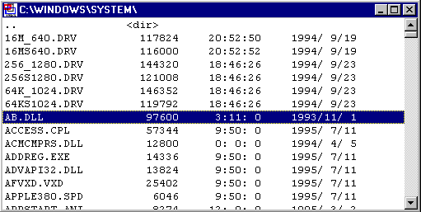

Figure 76: The completed directory window.
As usual, to prepare the code for the Directory Browser window, please perform the following steps:
Create a new source module called DIRLIST.PRO.
Add a menu item in the Task menu under the Test menu called Directory List.
Create a new window called DIRECTORY.
Set its maximized attribute.
Go to the Dialog and Window Expert and add the default code for the Directory window in the module DIRECTORY.PRO
Use the Dialog and Window Expert to add a clause for the Task window to invoke the Directory window when the Test | Directory List menu is invoked.
Run the program and see if you can create the window when you activate Test | Directory List.
Now go to the Window Editor and place a list box in the Directory window. The position and size does not matter since we will resize the list box to fit the window.
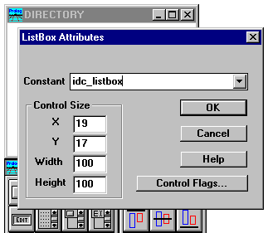

Figure 77: Adding a list box to a window.
When you add the list box make sure that you change the default identifier to idc_listbox. You should then click on the Control Flags push button. There are a large number of options for controls. There is an explanation in the VPI Guide, but for now just ignore the ones you don't know.
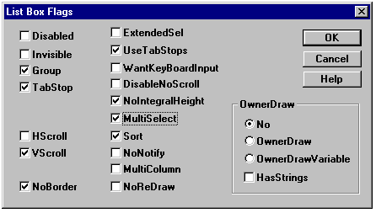

Figure 78: Selecting Control flags for the list box.
There is a particular selection that is important in this example -UseTabStops- since we want to add Tab delimited strings to our list box and be able to set the Tab columns. The MultiSelect option allows more than one item to be selected.
Another option you might want to change is NoBorder. Since we want to have the list box fill the entire window, a border is not needed.

The Code for the Directory Browser
Before proceeding we will add a couple of tool predicates. The first thing we need is a predicate to retrieve the files in a directory. In this example we'll find it convenient to build the following tool predicate on top of the built-in predicate dirfiles.

CONSTANTS
fa_subdir = 0x10 /* Subdirectory */
fa_normal = 0x40 /* Normal file */

DOMAINS
STAMP = s(INTEGER Hour,INTEGER Min,INTEGER Sec,INTEGER Year, INTEGER Month,INTEGER Day,LONG Size); dir

PREDICATES
nondeterm get_files(STRING Path,STRING FileName,STAMP)

CLAUSES
get_files(PATH,SUBDIR,dir):-
concat(PATH,"*.*",PP),
dirfiles(PP,fa_subdir,SUBDIR,_,_,_,_,_,_,_,_),
SUBDIR >< ".".
get_files(PATH,FName,s(Hour,Min,Sec,Year,Month,Day,Size)):-
concat(PATH,"*.*",PP),
dirfiles(PP,fa_normal,FName,_,Hour,Min,Sec,Year,Month,Day,Size).
Next we build a predicate that given a handle to a list box, and a Path, will add the names of the files and subdirectories to the list box. In this predicate we will use two VPI predicates that work on list boxes: lbox_clear, which removes all current entries from the list box, and lbox_add, which adds a string at a given position in the list box. If -1 is given as a position, the element will be added to the end of the list box.

PREDICATES
fill_lbox(WINDOW,STRING PATH)
fill_lbox(WINDOW,STRING FileName, STAMP)

CLAUSES
fill_lbox(Win,Path):-
lbox_Clear(Win),
get_files(Path,FName,STAMP),
fill_lbox(Win,FName,STAMP),
fail.
fill_lbox(_Win,_Path).
fill_lbox(Win,SubDir,dir):-
format(Str,"%\t%",SubDir,"<dir>"),
lbox_Add(Win, -1, Str).
fill_lbox(Win,FName,s(Hour,Min,Sec,Year,Month,Day,Size)):-
format(Str,"%\t%8\t%2:%2:%2\t%4/%2/%2",
FNAME,Size,Hour,Min,Sec,Year,Month,Day),
lbox_Add(Win, -1, Str).
We need only one more helper predicate. When the user clicks in the list box, we want to be able to change the directory. For this purpose we need to be able to pick out the directory from the string at that entry.

PREDICATES
get_path(STRING Item,STRING Path,STRING Rest)

CLAUSES
get_path(Item,Path,Rest):-
searchchar(Item,'\t',Pos),
Len = Pos -1,
frontstr(Len,Item,Path,Rest).
Now for the event handling. The call to create the list box (win_CreateControl) is automatically inserted by the Code Expert, which generates the selected list of flag values.
The first thing we do is to call lbox_SetTabStops to set the Tab positions. Tab positions are specified in Dialog Base Units (for a description of Dialog Base Units see The VPI manual.
The next thing, which is not absolutely needed, is that we change the font for the list box. If we do not want to do complicated formatting, it is easier to select a non-proportional font (ff_fixed).
Then we set the title of the window to show what path we are currently displaying (win_SetText), and fill in the content of the list box (fill_lbox). Add the code below to the e_Create clause. The code should be added after the %END DIRECTORY, ToolbarCreate comment:
LBWIN = win_GetCtlHandle(_Win, idc_listbox),
lbox_SetTabStops(LBWIN, [0,75,125,175,225]),
Font=font_Create(ff_Fixed, [], 10),
win_SetFont(LBWIN,Font),
win_SetText(_Win,"C:\\"),
fill_lbox(LBWIN,"C:\\"),
Another issue we need to address is that we want the list box to fill out the entire window. This is easily accomplished in the e_Size event for the parent window. We simply resize the list box control to the same size as the parent window by calling win_Move:
win_directory_eh(_Win,e_Size(_Width,_Height),0):-!,
LBWin = win_GetCtlHandle(_Win, idc_listbox),
win_Move(LBWin,rct(0,0,_Width,_Height)),
At this point there is only one more thing to do, which is to be able to change the directory when there is a click in the list box. This is left as an exercise for the reader.

Creating a Dialog

Up to this point, we have only been creating windows. However, most applications contain more dialogs than windows. Dialogs are used as forms, or collections of controls. Dialogs are really specialized windows, where your program generally need not do any drawing or updating of the window contents. The controls are used as the user interface to do input, output or modification of values.
There are two kinds of dialogs: modeless and modal. Modeless dialogs are like the windows we created earlier; you can open a modeless dialog, and still continue to work with other windows, however when you create a modal dialog, the system goes into a special mode such that you can't work with other windows or dialogs (within the given application) until you terminate the modal dialog.
The code for handling a dialog can be very similar to that for handling a window. There is a predicate call to create the dialog, and an event-handler predicate which receives all the events for that dialog. On the e_Create event, you can initialize all of the controls, and, when the OK button is pressed, you can retrieve the all values.
However, as one of the project options, there is also a dialog package, which can automate a lot of the trivial work involved in dialogs. It can initialize the controls, retrieve the values after termination, and do data validations. To make things simple, this Dialog Package is supported by the Dialog and Window Expert, so it is possible for each control to specify the content type, the validation requirements and a Prolog variable (to contain the return value).
To make an example using dialogs, please prepare the following:
Create a new source module called dialogs.
Create an extra submenu item called 'Dialog' under the Test menu in the Task menu bar.
Create a dialog called Person.
Put the following controls into the dialog:
Edit control: idc_name
Edit control: idc_age
Radio button: idc_male
Radio button: idc_female
Check box: idc_married
Listbox: idc_skills (Options: Multiselect + Extended selection)
The labels for the Edit controls and the Listbox are 'Static text' controls. The box that surrounds the Male and Female buttons is a Group Box.
Arrange your dialog to look something like:
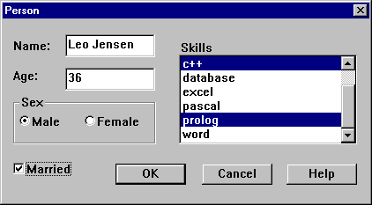

Figure 79: Laying out a dialog.
Next, invoke the Code Expert for the dialog, choose the source module DIALOGS.PRO and choose the code style dialog_Create() before activating the push button Default Code.
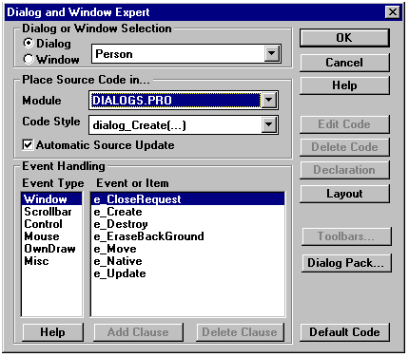

Figure 80: Adding code for a dialog.
To see how the generated default code works, you should now add an extra clause for the Task Window menu event for Test | Dialog, insert the call to create the dialog, and try to run the application.

The Dialog Package Expert
To make the new dialog realistic, you need to supply it with input values, and to return a set of values after the dialog has been terminated. Also, for some of the controls you want to make more specific settings -or supply specific validation rules.
To make all this easier, you can use the Dialog Package Expert - a tool which reflects all the options available in the dialog package. In addition to specifying various dialog package options, you can also use it to name the Prolog variables that will contain input values and receive the output values.
The Dialog Package Expert is most easily activated by selecting a dialog name in the Project window, selecting the Code Expert and then pressing the Dialog Pack button.
The Dialog Package Expert screen is divided into two parts. The left side always contains a list of available controls. Some are prefixed by a '+', which means that a double click on the '+' displays more detailed information. The right side is used to display and change the various settings for the currently selected Control.
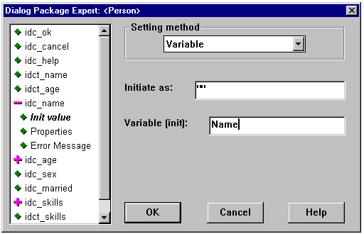

Figure 81: The Dialog Package Expert - The Name field.
Select the control that is to contain the persons name (), the Variable type should be String. Click on the , when it changes to select ,specify the Variable Setting method by using the list box to select that you want the initial value to be set by a variable. Under Variable (init), you should enter the variable name: Name . The dialog should now look like the one above.
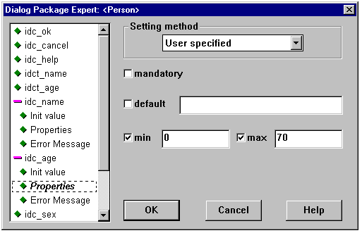

Figure 82: The Dialog Package Expert - The Age field.
For the Age field, you will specify that 1) it is an integer, 2) It will be set by a variable, 3) The variables name will be "Age", 4) The Setting method will be user specified, 5) The minimum value will be "0", 6) The maximum value will be "70".
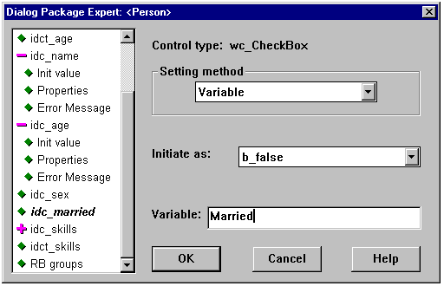

Figure 83: The Dialog Package Expert - The Married field.
The married field is a check box, we specify that it will be set by a variable Married.
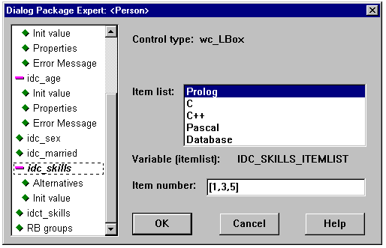

Figure 84: The Dialog Package Expert - The Skills list box.
The next field is a list of skills. This is a multi selection list box because the person can have a number of the possible skills. The intention is that the item list in the list box is always fixed, and the person's skills are selected (highlighted).
Under Alternatives, you can enter the static item list as strings separated by commas. Under Init value, you can specify that the variable Skills will return a list of integers (the index numbers of the selected skills).
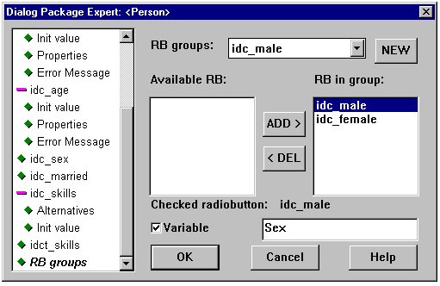

Figure 85: The Dialog Package Expert - The Radio Button group.
The last thing to do in the Dialog Package Expert is to specify which radio buttons belong to which groups - and to give a variable name for each group so that initializing can be done, and a final value retrieved.
New radio button groups are created by pressing the New button, the Add and Del buttons can be used to move radio buttons in and out of groups.

The Generated Code
You should now take a look at the generated code, and understand how things work:
dlg_person_Create(Parent):-

NAME = "",
AGE = void,
MARRIED = b_false,
SKILLS = [1,3,5],
SEX = idc_male,
%MARK Person, new variables
dialog_Create(Parent,[resdlg(dlg_person_ResID,wd_Modal)],
[
%BEGIN Person, ControlList, 09:07:56-20.6.1995, Auto updated!
df(idc_name,editstr(NAME,[]),nopr),
df(idc_age,editint(AGE,[range(0,70)]),nopr),
df(idc_married,checkbox(MARRIED),nopr),
df(idc_skills,listbox(["prolog","c","c++","pascal",

"database","word","excel","basic"],SKILLS),nopr),
df(SEX,radiobuttongroup([idc_male,idc_female]),nopr)

%END Person, ControlList
],
dlg_person_eh,0,_VALLIST,_ANSWER),
dlg_person_update(_VALLIST,_ANSWER).

dlg_person_update(_VALLIST,idc_ok):-!,
%BEGIN Person, Update controls, 09:07:56-20.6.1995, Auto updated!
_NAME = dialog_VLGetstr(idc_name,_VALLIST),
_AGE = dialog_VLGetint(idc_age,_VALLIST),
_MARRIED = dialog_VLGetCheck(idc_married,_VALLIST),
dialog_VLGetListBox(idc_skills,_VALLIST,_ITEMLIST,_SKILLS),

_SEX = dialog_VLGetRadiobutton(idc_male,_VALLIST),
%END Person, Update controls
!.
%MARK Person, new events

%BEGIN Person, idc_help _CtlInfo
dlg_person_eh(_,e_Control(idc_help,_CtrlType,_CtrlWin,_CtlInfo),0):-!,
vpi_ShowHelpContext("myproj.hlp",dlg_person_Help),
!.
%END Person, idc_help _CtlInfo
The important things to know are:
When the Dialog Package Expert adds new variables, it will add default settings before the MARKed insertion point. Note: these variable initializations will not be modified later. This means that you will encounter compiler errors if you modify the type of the controls in the Dialog Package Expert, or if you delete them etc. If you make changes it is up to you to supply a binding for the variable so that it can receive a proper value.
Once the dialog has been terminated, there is always a call to the predicate dlg_person_update, where the resulting values can be retrieved from a list. The intent is that you will modify this predicate to access only those values which you actually require.
The overall intent is that you will ultimately modify generated predicates like dlg_person_Create to pass in particular input arguments for the dialog and to return particular output arguments.
We will now change our source to supply some input values to the dialog, to receive changed output values back, and to store the new values.
For this purpose we declare a fact employee that can store the information about a person.
In this case we decide not to change the global predicate dlg_person_Create, instead we create a local predicate my_person_Create, that has the desired functionality with input and output values for the dialog.
The last modification is to change the dlg_person_update to return the changed values back:

DOMAINS
PERSON = person(STRING Name,DIALOG_INT Age,BOOLEAN Married,
ILIST Skills,DIALOG_CONTROL_ID Sex)

DATABASE - employes
employee(PERSON)

CLAUSES % Initial value
employee(person("",void,b_false,[],idc_male)).

PREDICATES
dlg_person_eh : EHANDLER
dlg_person_update(DIALOG_VAL_LIST,CTLID,PERSON)
my_person_Create(WINDOW Parent,PERSON In, PERSON Out)

CLAUSES
dlg_person_Create(Parent):-
employe(Person),!,
my_person_Create(Parent,Person,NewPerson),
retract(employe(Person)),!,
assert(employe(NewPerson)).
my_person_Create(Parent,person(Name,Age,Married,Skills,Sex),NewPerson):-

%MARK Person, new variables
dialog_Create(Parent,[resdlg(dlg_person_ResID,wd_Modal)],
[
%BEGIN Person, ControlList, 09:07:56-20.6.1995, Auto updated!
df(idc_name,editstr(NAME,[]),nopr),
df(idc_age,editint(AGE,[range(0,70)]),nopr),
df(idc_married,checkbox(MARRIED),nopr),
df(idc_skills,listbox(["prolog","c","c++","pascal",

"database","word","excel","basic"],SKILLS),nopr),
df(SEX,radiobuttongroup([idc_male,idc_female]),nopr)

%END Person, ControlList
],
dlg_person_eh,0,_VALLIST,_ANSWER),
dlg_person_update(_VALLIST,_ANSWER,NewPerson).
dlg_person_update(_VALLIST,idc_ok,
person(_Name,_Age,_Married,_Skills,_Sex)):-!,
%BEGIN Person, Update controls, 09:07:56-20.6.1995, Auto updated!
_NAME = dialog_VLGetstr(idc_name,_VALLIST),
_AGE = dialog_VLGetint(idc_age,_VALLIST),
_MARRIED = dialog_VLGetCheck(idc_married,_VALLIST),
dialog_VLGetListBox(idc_skills,_VALLIST,_ITEMLIST,_SKILLS),

_SEX = dialog_VLGetRadiobutton(idc_male,_VALLIST),
%END Person, Update controls
!.
%MARK Person, new events

%BEGIN Person, idc_help _CtlInfo
dlg_person_eh(_,e_Control(idc_help,_CtrlType,_CtrlWin,_CtlInfo),0):-!,
vpi_ShowHelpContext("myproj.hlp",dlg_person_Help),
!.
%END Person, idc_help _CtlInfo

Note that while we've reorganized the arguments and structure of the generated code, by carefully preserving the %BEGIN / %END comments around automatically updated code, we can continue to maintain that code using the Dialog Pack Expert.

Doing DDE

Visual Prolog supports Dynamic Data Exchange (DDE), so your programs can easily communicate with other applications. Before any DDE predicates can be used, the DDE system must be initialized. This is best done in the e_Create event for the Task window:
task_win_eh(_Win,e_Create(_),0):-!,
dde_Init([ddef_clientonly]),
A small example of using DDE is to send a command to MS-Word to load a new file. Before sending a command to MS-Word, we must establish a DDE connection. This is done by calling the predicate dde_Connect, which returns a connection handle. The predicate dde_Execute can then send a Text command to this connection, and afterwards we just disconnect again.
task_win_eh(_Win,e_Menu(id_Test_dde_test,_ShiftCtlAlt),0):-!,
trap(Conv = dde_Connect("WinWord","System"),_,
write("WinWord not running\n")),
filenamepath(FullName,"","..\\MYPROJ.PRO"),
format(Command,"[FileOpen .Name=\"%\"]",FullName),
write("DDE Command=",Command),nl,
dde_Execute(Conv,Command,0),
dde_DisConnect(Conv).
The command to send to MS-Word is in this case: [FileOpen .Name= "D:\TEMP\GUIDTOUR\MYPROJ.PRO"]. When using DDE you must in each case examine the documentation for the program acting as server to see which DDE commands the program can accept.
It should be mentioned here that 1) DDE is currently not portable to the non-Windows platforms, and 2) under Windows, DDE is quite advanced, and can even work over a network.

Creating a Help File

Visual Prolog contains a help authoring system that allows you to interactively produce on-line help for your applications. It is currently possible to produce both OS/2 help files and MS-Windows help files. PDC also plans to incorporate a completely portable help system based on the PDC Hypertext editor.
To start an on-line help system for an application you press the Help Topics icon in the bottom left corner of the Project window. When the Help Maker is selected, the Project window displays the help topics (or nodes of the help system).
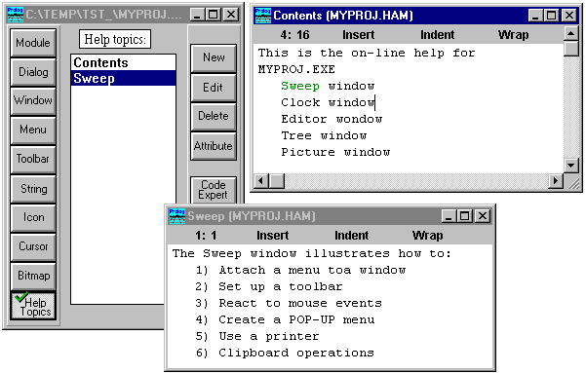

Figure 86: The Visual Prolog Help Creation system.
A help system always begins at the Contents node. The Contents topic is invoked when the Help | Contents menu item is selected. This node will usually be the root in the topic tree, with links to all nodes in the help file.
There are basically two ways to create new nodes:
By pressing the New button while the Help Topics icon (in the Project window) is selected.
By highlighting a piece of text in an existing node, and creating a new node from it.
Each of the help topics has an associated constant that is used to invoke the help system from the application. Given the name of the help file, and the constant associated with the help topic, the Help system can be invoked directly from the program by issuing a call to the vpi_ShowHelpContext predicate:
vpi_ShowHelpContext("myproj.hlp",dlg_person_Help),

Creating a Link to a New Node
The first thing to do is to select the text that is to link to another node:
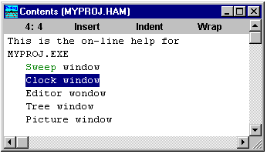

Figure 87: Making a link to another node.
Then use the Topics menu, and invoke the menu item Link To ...
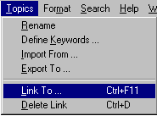

Figure 88: Using the Topics menu to create a new link.
This opens a dialog that includes the possibility of linking to a node in another help file (This might be useful in large projects). In our case we will just press OK to create a new node in the current help file.
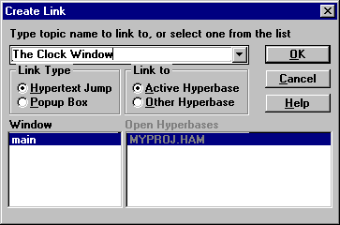

Figure 89: The Dialog to create a new link.
After OK is pressed, a new dialog prompts for the name of the new node. There is a choice between two buttons: Create, that will just create the new node, and Edit, which will first create the new node, and then enter the editor to allow text entry for the newly created node.
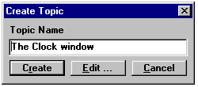

Figure 90: The Dialog to create a new Topic.

Formatting the Text in a Paragraph
There are several formatting commands in the Format menu you should be familiar with.
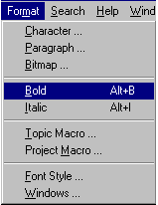

Figure 91: Using the Format Menu to Bold some Text.

Using the Bold or Italics Font Attributes
If you want a piece of text to appear in bold. You should first select the text, and then invoke the Format | Bold menu item. The result is that your text will be surrounded with two markers like: '[B]The Clock Window[b]' where '[B]' means start boldface, and '[b]' means end boldface.

Using Fonts.
Under the menu item Format | Font Style, new font styles can be defined for use in the program's help file.
These font styles can then be applied to the text by selecting the Format | Character menu item.
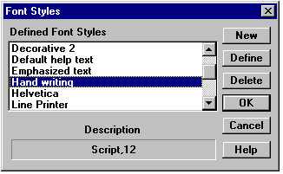

Figure 92: Defining Font Styles.
The result is that a font marker '{F}' is inserted into the text. The '{F}' marker contains hidden information that specifies the selected font. The font can be changed by double clicking on the '{F}' marker (which will bring up the font dialog again). If a block of text is selected before invoking the Format | Character menu. The result is that your text will be surrounded by two markers like: '{F}The main purpose of the Clock window {F}'. The second {F} marker restores the "Default Help Text" font. If you delete the second marker all text will use the new font until a new {F} occurs.

Formatting a Paragraph
To change the formatting of a paragraph, first mark a block of text, and then invoke the Format | Paragraph menu item. This will bring up a dialog containing the following formatting possibilities:
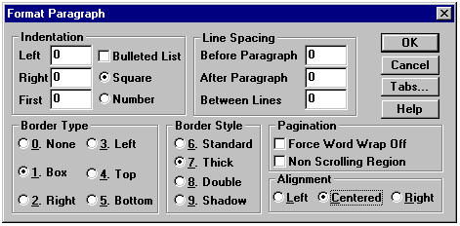

Figure 93: The Paragraph Formatting dialog.
For example, the above dialog specifies that a paragraph is to be centered in a Box with a thick border.

Inserting a Bitmap
To insert a bitmap into your help file invoke the Format | Bitmap menu item. This will bring up a dialog where you can specify the bitmap to include.
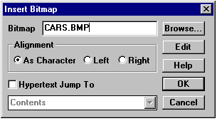

Figure 94: The Dialog to insert a bitmap.

To Test Your Help File.
When a help node is the active window, the Project menu contains some additional menu items to:

Generate a .RTF file

Compile the .RTF file into a .HLP file

Display the .HLP file
If you perform these three steps, you should see the results of the formatting.
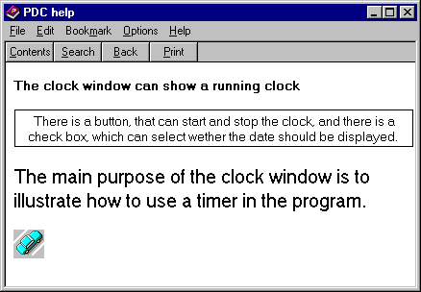

Figure 95: The resulting Help window.

Adding On-line Help to the Application

The integration of the Help Maker into Visual Prolog makes it very easy to support on-line help in your applications.
When selecting Project | Build Visual Prolog will automatically generate the help file, as well as a constant file (HLPTOPICS.CON) that identifies the help topics that exist in the help file.
Any of the help topics can be invoked directly by calling the predicate vpi_ShowHelpContext with the name of the help file and the Help Topic constant.
vpi_ShowHelpContext("myproj.hlp",dlg_person_Help),
Under the menu entry Options | Project | Code Generator, it is possible to specify whether the help file and the help topics files should be generated.
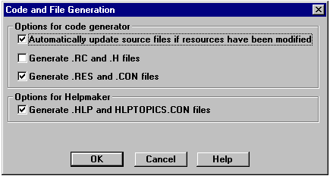

Figure 96: The Code and File Generation dialog.

The Framework for On-line Help
Although it is possible to invoke on-line help in many different ways, Visual Prolog supports a simple framework that makes things a little easier.

A Common Predicate to Invoke the Help
When the Application Expert generates the main module, it will generate a global predicate for the module which should be used to invoke on-line help. In this way, the invocations are centralized and any change can be done in one place. Also using this method the name of the help file will not be spread around over the whole project.
/**********************************************************

Invoking on-line Help
**********************************************************/
project_ShowHelpContext(HelpTopic):-
vpi_ShowHelpContext("tst1.hlp", HelpTopic),!.

The HLPTOPICS.CON File
At each build the file HLPTOPICS.CON will be regenerated if any changes have been made to the help system (.HAM file). This file should be included in every module that needs to refer to it.
/**********************************************************

This file was generated by Visual Prolog a product of:

Prolog Development Center A/S
**********************************************************/

CONSTANTS
% ----- Help topic constants -----
idh_contents = 1
idh_node1 = 2
idh_node2 = 3

The Help Topics for Dialogs and Windows
In the attributes dialog for windows and dialogs, it is possible to register the name of the help topic associated with the particular window or dialog.
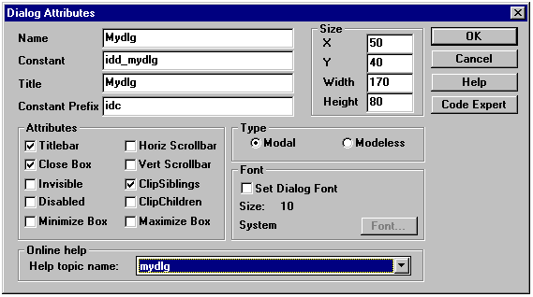

Figure 97: Specifying the Help Topic for a dialog.
If the dialog or window contains a control with the constant idc_help, the Code Expert will recognize this and when Add Clause is selected, it will inserted a call to the global project_ShowHelpContext predicate
dlg_mydlg_eh(_Win, e_Control(idc_help,_,_,_),0):-!,
project_ShowHelpContext(dlg_mydlg_Help),
!.

Invoking Help from the Menus and the Keyboard
The framework for on-line help in Visual Prolog applications suggests that the Help Menu has two entries, one to invoke the Contents topic, and one to invoke the local help for the window. When the Application Expert creates the initial application, it will create two accelerator keys for these menus F1 and Ctrl+F1.
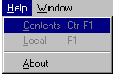

Figure 98: The Help menu for an application.
If a window must support local help, it must catch the menu event for local help:
win_mywin_eh(_Win, e_Menu(id_help_local, _ShiftCtlAlt),0):-!,
project_ShowHelpContext(win_mywin_Help),

Debugging Prolog programs

Finding error in Prologprograms can be a difficult and tedious task. Tracking long chains of nested logically dependent clauses can be very complicated. To help in this troublesome, usually unavoidable proces we have supplied a debugger with Visual Prolog. Lets see how it works!
The VIP Debugger is started from the operating system. You debug the executable programs generated with Visual Prolog. Remember to close the executable, before debugging. To be able to debug a program in Visual Prolog, debug information should be saved with the project. This option is set in Options|Project|Compiler options. Click the Output tab, and click in the Generate Debug information option. You need to compile the project afterwards.
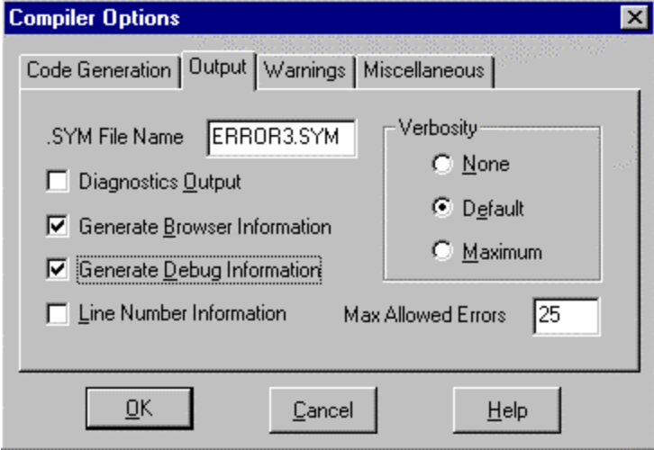
Figure 99: the compiler options dialog.
Go to the operating system, and start the Visual Prolog Debugger. Choose Open, from the Files-menu and open the executable, that you want to debug. The programs starts running in the background. Now it is possible to doubleclick the modules in the program to see the execution of the program. The current execution is marked by a blue arrow just like in other debuggers.
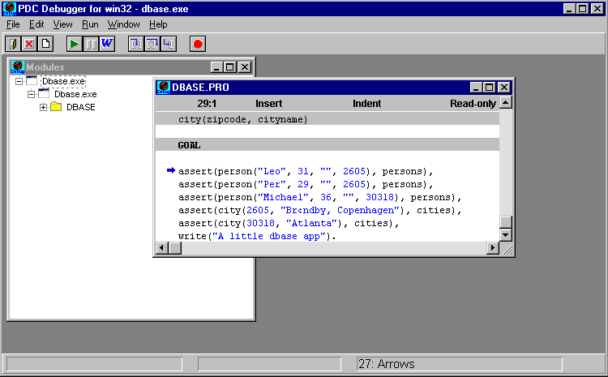

Figure 100: Browsing predicates.
The debugging process can here be helped by two functions: singlestep (F7) and step over (F8). The first step one statement at a time and the former step over the next statement.
Another very nice feature to help isolating the erroneous parts of a program is setting of breakpoints. If a breakpoint is set at some point in the program, the program will execute to this point, and no longer. To set a breakpoint, simply set the cursor a a certain point in the program and click the red button in the panel.

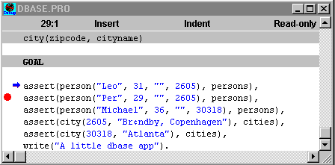
Figure 101: Setting of breakpoints.
Now the program can be run by pressing F9 and the program will run only to the first breakpoint.
One of the thing, that can be hard to figure out, when a prologprogram is debugged, is exactly which facts are asserted at a particular time. This problem can also be solved elegantly by the Visual Prolog Debugger, by opening the module where the program is executed from and choosing Facts from the View-menu.

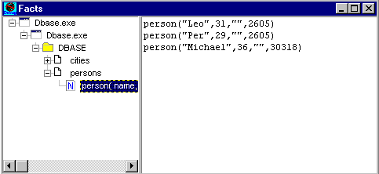
Figure 102: The view facts-dialog.
Precisely as vith the facts, so can also the values of variables be a source to finding errors in a program. These values can be quite difficult to track, but with Visual Prolog debugger, this is very simple: Just point the mouse at a variable for a short while. Don’t move it and don’t click any of the buttons. Then the value of the variable is shown in a little yellow box, just like a standard windows-tooltip.

Appendix A

The Directories
Visual Prolog contains bindings to a number of facilities and other products like the Borland BGI bindings, the portable SQL bindings, direct bindings to the MS-Windows API etc. These bindings with header files and libraries are placed in separate sub-directories also organized by platform and supported C compiler. In this manual, we provide a short description of the contents. Please see the Visual Prolog-helpfile for more information.
If you select a complete installation of Visual Prolog you will have the following files and sub-directories created in your main directory for Visual Prolog:

Table B.1: The sub-directories installed under the Visual Prolog main directory.
File/Directory | Content
[BGIBIND] | Bindings to the Borland BGI
[BIN] | The main executables and supplementary files for Visual Prolog
[DOC] | This directory contains the Word files for the documentation of Visual Prolog.
[DOC_TOOL] | Text formats conversions.
[ESTA] | The PDC expert system for Visual Prolog
[FOREIGN] | Source code and header files for C compiler support
[INCLUDE] | Some general include files
[LIB] | Main libraries and start up modules.
[ODBCBIND] | Support for Microsoft Open Data Base Connectivity (MSWindows).
[PIE] | VVPI implementation of the Prolog Inference Engine.
[PMBIND] | Direct bindings to the OS/2 PM API
[SETUP] | Source code to the Visual Prolog installation program
[SQLBIND] | Bindings to the portable SQL interface
[SOCKBIND] | TCP/IP related APIs and application examples.
[TXTEXAMP] | Some DOS and OS/2 Text Mode examples
[UPGRADE] | If you have been using a previous version of Visual Prolog, You should look in this directory for a tool that can upgrade your .VPR files.
[OOP] | An Object Orientated Prolog interface.
[VDESRC] | Professional version only! The source code to the VDE
[VPI] | The VPI with include directory, libraries and examples
[WINBIND] | Direct bindings to the MS-Windows API
[WWW] | Examples showing how to use VIP to create dynamic HTML pages (requires a WEB server).
INTRO.HTM | Latest information about Visual Prolog
The sub-directories are themselves further subdivided. Whenever there are platform specific differences the separate files are placed in DOS, WIN\16, WIN\32, OS2 sub-directories. Files that have same functionality on the different platforms are named the same, but put into different sub-directories. Files that are the same for different platforms are put into the directory structure above these sub-directories.

The BIN Directory

The BIN directory contains the executable files and files that relate to these. The linker is used both by the Windows and the DOS compilers, so it is placed in the root of the BIN directory. The file PROLOG.ERR is used in all compiler versions.

Table C.2: The files in the BIN (binaries) directory.
File | Purpose
[DOS] | Files that are used when running in a DOS command prompt
[WIN] | All executables and support files for running under Windows. This directory is further subdivided into WIN\16 and WIN\32 sub-directories.
[OS2] | OS/2 executables
PROLOG.ERR | Error messages for the Prolog compiler
The files in the sub-directories under the BIN directory are:

Table D.3: Additional files in the BIN (binaries) directory
File | Purpose
VIP.EXE | The Visual Development Environment
VIP.HLP | The on-line help file of Visual Prolog
PRO.EXE | The command line version of the Prolog compiler
BUILD.BAT | A batch file to do command line compiling and linking of a single module
CHKDOMS.EXE | Command line Tool for checking (before linking) that the global domains are the same in all modules in a project.
ANSIOEM.EXE | A converter between the Windows and the DOS character sets.
VIPDEBUG.EXE | The Visual Prolog debugger
VPRCONV.EXE | A converter to convert a .VPR file to text format and back again. This is needed when shifting between 16 and 32 bit dvelopment environments.
HAM2TXT.EXE | A converter to convert a .HAM file to text format and back again. This is needed when shifting between 16 and 32 bit dvelopment environments.
PROJNAME.HLP | The default help file for a new project
NONAME.ICO | The default icon for a new project
NOTFOUND.ICO | The icon used when a registered icon file is not found.
CAPDOS.TXT | A file used to pass input for command lines
PROJECT.FKB | A frame database used by Visual Prolog
CAPDOS.PFF | A default .PIF file
CTL3DV2.DLL | A .DLL supporting 3D look for controls.
PROLOG.BMP | The startup picture for Visual Prolog
16COLOR.BMP | A startup picture which can be used when running Visual Prolog with a 16 color graphic card.

The LIB Directory

The files in the LIB directory are organized in sub-directories depending on the platform, and depending on which C compiler they support. The Application Expert can be used to set up the correct libraries and object files for linking. The files are named for the different platforms and supported C compilers. The following table gives a brief overview of the purpose of the files:

Table E.4: Purpose of the files in the LIB (libraries) directory.
File | Purpose
PROLOG.LIB | The Prolog library with all standard predicates
COMPILER.LIB | Prolog library but also contains the compiler
INIT.OBJ | Prolog startup file, when C is not used
DLLENTRY.OBJ | Prolog startup file for .DLLs when C is not used
PDCGROUP.OBJ | Required group definitions when linking with C, this file must occur before the first Prolog module during linking.
WIN16.LIB | Windows 16-bit import library
DOSCALLS.LIB | OS/2 16 bit import library
PHAPI.LIB | PharLap 16 bit import library
CMAIN.OBJ | The compilation of FOREIGN\CMAIN.C
GEN.BAT | File to compile the C support files on each platform

The VPI Directory

The VPI sub-directory contains the bindings to Visual Prolog's portable Graphic Programming Interface. It is divided into sub-directories with include files, examples and a library sub-directory which itself is divided into sub-directories for each supported platform:

Table F.5: The sub-directories in the VPI directory.
File | Purpose
[INCLUDE] | This directory contains the header files (.CON, .DOM, .PRE) for the VPI and VPI text editor; its subdirectories contain header and .PRO files for the VPI packages.
[LIB] | The library files for the VPI
[EXAMPLES] | Subdirectories of this directory contain examples illustrating parts of the VPI. Most of the examples can be build and run under 16-bit Windows (you should load <ExmplName.VPR> project file into 16-bit Windows VDE), under 32-bit Windows (you should load <ExmplName32.VPR> project file into 32-bit Windows VDE), and under OS/2 PM (you should load <ExmplNameos2.VPR> project file into OS/2 VDE).
[PROGRAMS] | A few demonstration programs: Towers of Hanoi, symbolic differentiation, a little database example, sentence analyzing, and GEOBASE, which is an example of a natural language interface to a geographic database.
[TOOLEXAM] | Subdirectories of this directory contain examples illustrating VPI packages. Most of the examples can be build and run under 16-bit Windows (you should load <ExmplName.VPR> project file into 16-bit Windows VDE), under 32-bit Windows (you should load <ExmplName32.VPR> project file into 32-bit Windows VDE), and under OS/2 PM (you should load <ExmplNameos2.VPR> project file into OS/2 VDE).
Table G.6: The VPI\EXAMPLES directory.
File | Illustrates
[CLASS] | how to create and use custom controls in Visual Prolog.
[CLIPBRD] | how to handle the clipboard
[COLORS] | Color handling using the VPI
[CONTROLS] | create, destroy, enable, disable, move etc. controls
[CURSOR] | create and handle cursors
[DDE] | using DDE under Windows.
[DLL] | Using Dynamic-Link Libraries (DLL) under Windows
[DRAWING] | handle all the drawing primitives
[PICTDRAW] | Some smart picture drawing capabilities
[EASYWIN] | The EasyWin target
[EDITOR] | How to create an Application handling multiple text editors
[EVENTS] | A good test example for understanding events
[FONT] | How to set and change fonts
[HYPDEMO] | An example with the Hypertext editor
[LISTBOX] | How to handle list boxes
[MAPPING] | How to do panning, scaling and zooming in the VPI
[MDIWIN] | This MDI mode example can be used only under Windows. The example demonstrates how to change the standard "Windows" submenu items with user defined items.
[MEMVIEW] | A little dialog with a memory watcher
[METAFILE] | How to handle metafiles
[HELP] | How to create on-line help.
[OWN_DRAW] | How to owner-drawing of controls
[PICTURE] | How to do picture masking
[PRINT] | How to print graphics
[PRINTTXT] | How to print text files
[RUNTIMER] | How to use timers
[SPEED] | A example to test the speed of various VPI operations
[SWEEP] | How to handle mouse move events.
[TOOLBARS] | How to handle various toolbars
[TREE] | The tree tool
[VBX] | How to use VBX controls. (Requires Borland C++)
Table H.7: The sub-directories in the VPI\INCLUDE directory.
File | Purpose
[AAPLAY] | Autodesk Animation Players
[BMPCTL] | Bitmap control
[DATECUST] | Date Module
[DIALOG] | Dialog Package
[DIRBROWS] | Directory Browser Dialog
[DLGCOLOR] | Color Select Dialog
[GRID] | Grid Custom Control
[MESSAGES] | Message Window Package
[OWN_DRAW] | Ownerdrawing Package
[PALETTE] | Palette Dialog
[PROGRESS] | Progressbar Custom Control. It can be used for graphic representation of dynamic scaling.
[PROPERTY] | Property Editor
[SETUP] | A setup tool
[STARTUP] | Startup example
[SYSTEST] | A little dialog with a memory watcher
[TABDLG] | About designing tabbed dialogs
[TOOLBARS] | How to handle various toolbars
[TREE] | Tree Package
[TREEBRWS] | a tree browser
[VALUESET] | About dialogs with valueset

The INCLUDE Directory
The files in the global include directory are some include files that are not specific to the VPI, BGI, WINBIND, SQLBIND etc. Some support the old text mode windowing system found in previous versions of PDC Prolog:

Table I.8: The files in the INCLUDE directory.
File | Purpose
IODECL.CON | Some constant declarations to do portable file handling
IODECL.PRE | Can be used to redirect the default output from write.
ERROR.CON | Constant definitions for error codes in VPRO
ACS.CON | UNIX key definitions
EDITHOOK.PRE | Hook into the old text editor
ERRHND.PRE | Error routine for old text mode editor
READKEY.CON | Constant definitions for keys
VARARG.DOM | Domain definitions for a variable argument call tool
VARARG.PRE | Predicate declarations for vararg call (See the file)
OSERRM.PRE | Can be used to change the default error handling under Win.

The FOREIGN Directory

This sub-directory contains the files that support the foreign language interface of Visual Prolog. It contains two sub-directories, EXAMPLE and INITS.

Table J.9: The files under the FOREIGN directory.
File | Purpose
[INITS] | The source to the versions of INIT.OBJ
[EXAMPLE] | A command line example of linking to C
[PRO2C] | A tool to convert Global Prolog declarations to C header files.
README.TXT | A little information about linking to C.
PDCRUNT.H | C header file for accessing the Prolog library.
CMAIN.C | C main file to call Prolog.
PDCGROUP.ASM | Required Group definition.
GRP32BOR.ASM | Group definitions for 32 bit for Borland C under OS/2.
GRP32IBM.ASM | Group definitions for 32 bit for IBM C under OS/2.
BCFIRST.ASM | Start up for Borland C under plain DOS.
BCINIT.ASM | Second file for Borland C under plain DOS.
MSCINIT.ASM | Start up for Microsoft C under plain DOS
IBMMAP.H | Some name mapping for IBM C under OS/2
PRAG_ON.H | #pragmas to turn C optimization off
PRAG_OFF.H | #pragmas to turn C optimization off

The WINBIND Directory

This directory contains the direct bindings to the MS Windows API supplied with the previous version of PDC Prolog.

Table K.10: The sub-directories under the WINBIND directory.
Directory | Content
[DEMOS] | Some demo programs
[DLLDEMO] | An example of producing a Prolog .DLL
[INCLUDE] | Header files for WINBIND
[LIB] | The needed libraries
[SOURCE] | Source code for the bindings
[TOOLS] | A couple of tools from the manual
It is possible to use these bindings in conjunction with the VPI libraries. You can include the .CON, .DOM and the .PRE files in VPI Programs.

The PMBIND Directory

This directory contains direct bindings to the OS/2 Presentation Manager. There are some header files, and some demo programs. No C source or extra libraries are needed. There are examples for both 16 bit PM and 32 bit PM. The bindings are kindly provided by Gregory Bourassa in Canada, 1 (613) 749-8017.

The SQL Interface

In the SQLBIND directory you will find the PDC portable SQL bindings. Under Windows, it supports the ODBC standard which connects to nearly any database under Windows. There are under Windows also direct bindings to the Oracle database. Under OS/2 we have support for the IBM DB2 database.
The bindings are supplied with full source code. If you want to connect to a new SQL database that we have not already covered, it should not be too difficult to add new bindings yourself.
The SQL bindings are at the moment only documented in the on-line help.

Table L.11: The sub-directories under the SQLBIND directory.
Directory | Content
[EXAMPLE] | A little example of using the SQL bindings
[INCLUDE] | Header files.
[LIB] | The needed libraries.
[SOURCE] | Source code for the bindings

The BGI Bindings

In this version of PDC Prolog, the Borland Graphic Libraries have been removed from the Prolog library. However, there are header files and bindings supplied so that if you own a copy of Borland C++ 3.x or 4.x, your old PDC Prolog BGI programs can still be compiled using the newest version of the BGI.
The BGI is supported in DOS real mode and in DOS protected mode using the PharLap DOS Extender.
If you are going to use this strategy you should follow these steps:
Install Borland C++ and Visual Prolog.
Using Borland C only, test to be sure you can compile the Borland BGI examples.
Compile and run the Prolog example in the DEMO sub-directory.

Use the Application Expert to create a new BGI project
The BGI bindings documentation is supplied in the on-line help file.

Table M.12: The sub-directories under the BGIBIND directory.
Directory | Content
[DEMO] | A little example of using the BGI bindings
[INCLUDE] | Header files.
[LIB] | The needed libraries.
[SOURCE] | Source code for the bindings

The VDESRC Directory

If you have the Professional Version of Visual Prolog, you will find the Prolog source code for the Visual Development Environment in the VDESRC sub-directory.
You can compile this yourself by loading the Project VIP.VPR or VIP32.VPR and select a Project / Build All. The result will be a new version of the Visual Prolog VDE placed in the sub-directory 0_EXE.
In this way you can do any customization of the VDE you want, or you can study how we have done things, appropriate tools and techniques for your own programs etc. It is a pretty big project, but the Code Browser should be able to assist you in studying the code. You should also know that this project was built before we had the code experts - many things are easier today.
You are also allowed to use some of the tools like the dialog editor or the Graphics Editor in your own projects.
Note that if you include the PDC Prolog compiler from COMPILER.LIB in your application, you need to obtain a special license agreement from PDC. In order to use the Prolog compiler in an application you do also need the PDC Prolog start up files and runtime libraries.

The SETUP Directory

This directory contains the source code for the Prolog program used to install Visual Prolog. It should be relatively easy to modify this to create an Installation program to your own applications.

The TXTEXAMP Directory

This directory contains a collection of the various example programs from previous PDC Prolog versions. Some of these are now in the process of being ported to the VPI platform.

The DOC Directory

This directory contains answers to the exercises in the manual. The files in this directory contain suggested solutions to selected exercises from the manual. The filenames reflect the page upon which the exercise subsection starts. A '_number' suffix reflects which exercise within the section, if more than one.

The UPGRADE Directory

If you have been using one of the previous versions of Visual Prolog, you need to take a look to the UPGRADE directory. You should always take a look at the UPGRADE.WRI, which.

Table N.13: The files in the UPGRADE directory.
File | Purpose
UPGRADE.TXT | short guide for using UPGRADE.EXE.
UPGRADE.EXE | makes source code replacements (described in UPGRADE.INP file) in files specified in a command line. It can be used to upgrade source files (*.PRO, *.PRE, *.DOM, *.CON, *.INC, etc.) in projects created by previous versions of Visual Prolog. (Compare with VIPCONV.EXE).
UPGRADE.INP | standard input file for UPGRADE.EXE. It should be used to upgrade source files of projects created by Visual Prolog versions older then the build 471

The OOP Directory

The OOP directory contains the OOP extensions for the Prolog language. There are currently only examples.

Directory | Content
[SHAPES] | A little example of using OOP and graphics
[TESTSUIT] | Some illustrative examples using OOP

The WWW Directory

The WWW directory includes two subdirectories:
Directory | Content
[CGITEST] | an example showing how to create Prolog applications that can be used as CGI programs, how to receive, examine and decode Web Server's requests and how to generate dynamic HTML pages.
[ISAPI] | tools and examples of ISAPI Server extensions.

