Visual Prolog Version 5.0

Visual Development Environment

(c) Copyright 1986-1997
Prolog Development Center A/S
H.J. Holst Vej 3A-5A, Copenhagen
DK-2605 Broendby
Denmark

Copyright

The documentation for this software is copyrighted, and all rights are reserved. It may not be reproduced, transmitted, stored in a retrieval system, or translated, either by electronic, mechanical or any other means, without the prior written consent of Prolog Development Center A/S.
The software products described in these manuals are also copyrighted, and are licensed to the End User only for use in accordance with the End User License Agreement, which is printed on the diskette packaging. The prospective user should read this agreement carefully prior to use of the software.
Visual Prolog is a registered trademark of Prolog Development Center A/S.
Portions of the Software and Documentation under license from:
- Borland International; Copyright (c) 1986-1988 Borland International.

Table of Contents

Introduction. 1
About this Book 2
Chapter 1 Using the VDE
Menus 3
Local Pop-up Menus 3
Accelerator Keys 3
Toolbar and Help Line 5
The Help Line 6
The Project File 6
Project Window 7
Operations on the Project Components 9
The Messages Window 10
Code Browser 10
Resource Identifier Browser 12
Project Module Tree 12
Global Options and .INI Files 13
Auto save Options 14
Fonts 15
The messages window Options 15
Miscellaneous Options 16
Build Options 16
Presentation Options 16
Editor Options 17
External tool directories 18
Chapter 2 The Application Expert
General Settings 19
Project Name 20
Name of .VPR file 20
Base Directory 20
Support for Source Control Systems and Multiprogrammer Projects 21
Target Selections 22
Platform 23
UI Strategy 25
Target Type 26
Main Program 26
VPI Options 27
Other Options 28
Code Generator 29
Project Directories 30
External Tool directories 33
Compiler Options 34
Environment 34
User Info 35
Help Maker 35
The Files in a Project 36
New Source Modules 37
Chapter 3 Building, Compiling and Linking
The Project Options 40
Compiler options 40
Code generation options 40
Integer Overflow Check 42
Break Check (DOS Text mode only) 42
Stack Overflow Check 42
Compiler Output 42
.SYM File Name 42
Verbosity 43
Diagnostics Output 43
Generate Browser Information 43
Generate Debug Information 43
Line Number Information 43
Maximum Allowed Errors 43
Warnings 44
Suppress All Warnings 44
Maximum Allowed Warnings 44
Predicate Default 44
Duplicated includes 45
Not Quoted Symbols (Checking) 45
Strong Type Conversion Check 45
Check Type of Predicates 45
Unused Variable (Checking) 45
Unused Predicates 45
Treat Warnings as Errors 46
Miscellaneous 46
Check Domains before Linking 46
Pre-defined Constants 46
Stack Size (DOS only) 46
Heap Size (DOS only) 47
Code Generator Options 47
The Make Facility 48
Symbols 49
Make Rules 50
Build Script 50
Preview Script 51
Local Scripts 51
The Build Commands 51
Project | Compile File (Ctrl+F9) 51
Project | Build (Alt+F9) 52
Project | Rebuild All (Ctrl+Alt+F9) 52
Project | Stop Compiling (Alt+F10) 52
Project | Run (F9) 52
Project | Link Only (Shift+F9) 52
Project | Test Goal (Ctrl+G) . 52
Resource | Build Resource Only (Alt+F8) 53
Chapter 4 The Resource Editing
Resource Naming 54
Resource Linking 55
Bitmaps, Icons and Cursors 56
Dialog Resources 56
Menu Resources 56
String Resources 56
Importing Resources 56
The Window and Dialog Editor 57
Creating a Dialog 57
Name 58
Title 58
Constant 58
Constant Prefix 59
Attributes 59
Type 60
Font 60
Size 60
On-line Help 60
Editing a Dialog 60
Dialog Controls 61
Types of controls 61
Inserting the Controls 63
Selecting and Deselecting the Controls 64
Re-sizing Controls 64
Moving Controls 64
Arranging Controls 64
Cut, Copy and Paste, Undo and Redo 65
The GRID 65
Test Mode 66
Tab Stops 66
Visit Order 67
Control Attributes 68
Creating a Window 72
Editing a Window 73
Resource String Editor 73
Toolbar Editor 75
Controls in a Toolbar 77
Push Button and Check Button 78
Text Controls 79
List Button 80
The Menu Editor 80
The Graphics Editor 82
Graphics Editor Window 82
The Title Bar 83
Menus 83
The Graphic Field 84
Image Screen 84
Moving, Rotating and Flipping 85
Undo / Redo 86
Cursor Hot Spot 86
Testing a Cursor 87
Image Attributes 87
Understanding Colors for Bitmaps. 87
Understanding Colors for Cursors 87
Understanding Colors for Icons. 88
The Color Palette 88
Selecting Colors 89
Using the Draw and Edit Tools 89
Pen 90
Brush 90
Eraser 91
Erase Color 91
Fill Contour 91
Line 91
Rectangle 91
Ellipse 92
Text 92
Mirror 92
Marking a Region 93
Paste & Scale into marked region 93
Clear the Graphic Field 93
Change a Selected Color 93
Inverse Colors 94
Converting Bitmaps into Icons and Vice Versa 94
Chapter 5 The Code Experts
Dialog and Window Expert 96
Generating the Default Code for a Window 96
Looking at the Default Code for a Window 97
Event Handling 99
Code styles 100
Code Styles for Window Creation 100
Code Styles for Dialog Creation 101
Code Style for Custom Control Creation 101
Miscellaneous Dialog and Window Expert Information 102
Activation 102
Changing the Source Module 102
Other Buttons in the Dialog and Window Expert 102
Dialog Package Expert 103
Setting Method 104
Initiate as 105
Variable Bindings 105
Variable Type 106
Properties for Edit Controls, String Values 106
Mandatory 106
Upper 106
Lower 106
Default 107
Length 107
Properties for Edit Controls, Numerical Values 107
Min 107
Max 107
Item List for List Boxes, List Edits and List Buttons 107
Initial Selection for List Boxes, List Edits and List Buttons 108
Properties for Scroll Bars 108
Radio Button Groups 109
The Toolbar Expert 110
Chapter 6 The Text Editor
Starting the Editor 112
Editor Commands 113
Cursor Movement Commands 113
Delete Commands 113
Miscellaneous Keyboard Commands 114
Block Commands 114
Selecting Text with the Keyboard 114
Selecting Text with the Mouse. 115
Operations that Affect Selected Text 115
Moving Blocks 116
Copying Blocks 116
Overwriting a Block 116
Changing the Case of a Block 116
Using the Right Mouse Button 116
Searching for a String 116
Text to Find. 117
Options 117
Direction 118
Origin 118
Replacing Strings 118
Change All 119
Going To a Line Number 120
Going To a File Position 120
Undo and Redo Features 121
Editor Options 121
Choosing a Font 122
The Insert Menu 122
Chapter 7 Help Maker
Starting Help Maker 124
The Help Maker Options 124
Creating a Help System 126
Planning the Help System 127
Defining an Audience 127
Planning the Structure 127
Help Topics 128
Creating Help Topics 128
Editing Help Topics 129
Linking Topics 130
Creating a Link 131
Creating a Link from a bitmap 132
Following a Link 132
Deleting a Link 132
Defining Font Styles 133
Formatting characters 134
Formatting Paragraphs 134
Inserting Bitmaps 137
Exporting a Topic to a .TXT file 138
Pasting the content of a file into a Help Topic 138
Assigning Keywords to Topics 138
Assigning Browse Sequences 139
Adding Topics to a Browse Tree 140
Deleting Topics from a Browse Tree 141
Moving Topics across a Browse Tree 141
Assigning Groups 141
Assigning Overviews 141
Creating Browse Sequences 141
Collapsing and expanding Sub-trees 143
Assigning Help Macros 143
Windows Menu Item 143
Renaming Topics 145
Deleting Topics 145
Topic Attributes 146
Importing Help 146
Importing .RTF Files with Graphics 148
Building the Help File 148
Restrictions for OS/2 Help system 150
Help Maker File Menu 151
The Help Maker Search Menu 152
Introduction 153
Chapter 8 The Debugger
Generation of debug info 154
Starting the debugger 154
Loading a program 154
The Views 156
The modules View 156
Source code View 157
The Run menu 158
Setting Breakpoints 158
Variables View 160
Viewing facts 160
Call Stack 161
Trap Points window 162
Backtrack Points window 162
Machine level Views 162
Disassembly 163
Memory 163
Registers 164
Debugger options 164
Index 167

INTRODUCTION

The Visual Prolog (VIP) product consists of several elements. It has an interactive Visual Development Environment (VDE) which includes text and various graphical editors, code generating tools (Experts), build control logic, and extensions to Prolog in the form of a Visual Programming Interface (VPI). It also includes a Prolog compiler, various include files and libraries, a linker, and various example and help files.
The Visual Prolog Environment is designed to make it easy, convenient and fast to develop, test, and modify applications written in Visual Prolog. It supports many platforms, including MS-DOS, PharLap-Extended DOS, MS Windows 3.1, MS Windows 3.11, MS Windows 95, Windows NT, as well as 16 bit and 32 bit OS/2 target platforms using processors from the 80x86 base family.
In the Application Expert, for User Interface Strategy you should select the Visual Programming Interface (VPI). This provides access to a set of Code Experts, resource editors, and additional VPI-specific predicates, definitions, and libraries. The resource editors are used to define, layout, and Edit windows, dialogs, menus, tool bars, help bars, string tables, icons, cursors, bitmaps, and run time on-line help. From these, Code Experts generate the necessary Prolog source code framework to present these components in some presentation space (i.e. in a window). This framework is ready to be compiled, linked, and run.
At the programmer's request, the Code Experts can bring up any part of its generated framework in an editor window for inspection and filling out with application logic to transform the framework into a useful application. This completion process in an editor window is greatly assisted by a variety of commonly needed functions being available at a click of the mouse right button from a multilevel pop up menu of editing, selecting, searching, replacing, and inserting functions. Much code can be accurately generated by use of the insert item of this menu which permits selection of colors, VPI and standard Prolog predicate templates, user-defined predicates for dialogs and windows, domain names, resource identifiers, VPI constants, quoted full path and file names as obtained by directory browsing, file names, key words, and much more.

About this Book

This manual provides a complete in-depth description of the Visual Development Environment (VDE). The VDE is used to develop, test, and maintain Visual Prolog graphical resources and applications.
The VDE Manual does not cover installation of the VDE - this is covered in the Getting Started manual, the contents of which is regarded as pre-requisite knowledge for this manual.

CHAPTER 1

Using the VDE2

Menus

There are many different menus in the Visual Development Environment. They always appear as the menus of the Main Window, which we call the Task window. The available menus, and menu items, will therefore change depending upon the active window. In general, the File, Edit, Project, Options, Help and Window menus will always be available, but, when certain windows are active, these menus might also have some additional items.

Local Pop-up Menus
Most of the windows in the Visual Development Environment have local pop-up menus that can be invoked by either clicking with the right mouse button or pressing Shift+F10. The menu entries in the local pop-up menus will in general display the most common used features for the given situation.

Accelerator Keys
A number of the menu entries have an accelerator key (hot key) associated with them. Learning to use the accelerator keys is a very good idea, because it is much faster than using the mouse to select menu items.

Table 3.1: Useful Accelerator Keys.
Key | Function
Ctrl+I | Invokes the Identifier browser.
Ctrl+T | Invokes the Tree display.
Ctrl+B | Invokes the Browser.
Shft+Ctrl+D | From the editor locates declaration for predicate.
Shft+Ctrl+C | From the editor locates clauses for predicate.
Alt+F9 | Performs Project | Build.
F9 | Performs Project | Run (which includes Build).
Ctrl+G | Executes the goal in the current window.
Ctrl+S | Saves the project and all open files.
Ctrl+C | Performs a copy of the selected information to the clipboard.
Ctrl+V | Performs an insert from the clipboard. The inserted information will replace any selected information.
Ctrl+X | Performs a cut of the selected information to the clipboard.
Ctrl+W | Invokes the Dialog and Window Expert dialog as in its last used state.
Shft+Ctrl+W | Inserts a call to Window or Dialog creation.
Shft+Ctrl+V | Inserts a VPI predicate call.
Shft+Ctrl+S | Inserts a standard predicate call.
Shft+Ctrl+I | Inserts prototype for current predicate name.
Shft+Ctrl+K | Inserts a Keyword.
Alt-F2 | Go to position of last runtime error registered on the clipboard

Toolbar and Help Line
The VDE uses a toolbar in the Task window. The most commonly used menu items can be invoked from the toolbar.
Each of the icons in the toolbar performs the same function as the corresponding menu item:
File | New.
File | Open.
File | Save.
Edit | Undo
Edit | Redo.
Edit | Cut.
Edit | Copy.
Edit | Paste.
Project | Compile file.
Project | Build.
Project | Run
Project | Test Goal
Project | Browse
Project | Tree
Options | Temporary | Font
Help | Local Help.

The Help Line
Across the bottom of the Task window is a help line. The help line is split up into two fields:
The left field is used to display context sensitive information like help for toolbar buttons and dialog editor information about the current control etc.
The rightmost field is used by the make facility to display the current resource generation / compiling / linking state.

The Project File

To produce an application in Visual Prolog you must use the Application Expert (Project | New) to create, if necessary, a dedicated sub-directory, to name the project, and to place a project database file, named <project>.VPR in that sub-directory.
The project database contains all compiler settings, directory setups, the names and locations of all the source modules in the project, the characteristics of the user interface, and many other things. All of the option settings under Options | Project are stored in this database.
The name of a Visual Prolog project (.VPR) file may be supplied to VIP.EXE as a command line parameter at start up. This will start Visual Prolog with the given project opened. Associating the .VPR file extension with Visual Prolog enables double-clicking on any .VPR file name to automatically invoke Visual Prolog with that project pre-loaded, as long as Visual Prolog is not already running.
The utility tool VIPCONV.EXE makes it possible to convert a <project>.VPR database to and from text (<project>.TXT) format. VIPCONV must be used to move projects between 16bit and 32bit platforms since the format of the external database files are different in 16 and 32 bit.
Note, that when working many people on a Project, Visual Prolog can in split the content of the .VPR file up into a .PRJ file which is the overall description of the project, and then a small file for each window, dialog, toolbar etc. The splitting up has two advantages: 1) It allows the same resource to be used in more that one project, and 2) when using source control systems it is possible to lock the resources and save different versions.

Project Window

When a project is opened, this window will automatically appear. If the Project window is closed, the project will be closed. The Project window contains lists of all the components of a Visual Prolog application by type of component.
The following figure shows the Project window. Clicking on a selection at the left side of the window changes the content of the list box in the middle of the window. This list box shows all components of the project that correspond to the component type of the active left button.
One component can be selected from the list, and a click on a button on the right side activates the tool you need to work on the current component. A double-click on the component name activates the editor for that type of component.
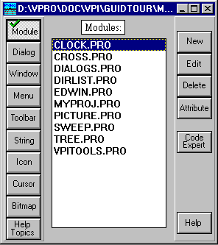

Figure 4.1: Accessing source module through the Project window
The selections at the left side of the Project window are:
Module The list box contains a list of the source modules in the current project. When activating a Project | Build these files will be compiled. In addition to adding Prolog files, it is also possible to register other files. If you register .C or .CPP files, they will be compiled automatically when the project is built. When you double click on a source file in the list, the text editor will open that file. The source modules are stored in ordinary files in the underlying file system. If you register .OBJ files or .LIB files they will be included in the link script. These are not editable.
Dialog The list box contains a list of the dialogs in the project. Double clicking on a dialog brings up the Dialog Editor set to edit that dialog. The layouts of all dialogs are stored entirely in the project .VPR file. The main purpose of the Dialog Editor is to define and layout the controls inside a dialog.
Window The list box contains a list of the windows stored in the project file. Double-clicking brings up the Window editor. Here it is possible to layout windows with title bars, scroll bars, and controls, to connect menus and to add toolbars to windows, etc.
Menu The list box contains a list of the menus in the project. These can be used as either pull-down menus associated with windows, or as pop-up menus. Double-clicking brings up the menu editor.
Toolbar The list box contains a list of the toolbars defined in the project. Double-clicking a toolbar name invokes the toolbar editor.
String The list box contains a list of resource string groups. Double-clicking on an item brings up the Resource String Editor for the given string group.
Icon The list box contains a list of icons in the resources. Before you can use icons in dialogs or toolbars they must be registered in this list. Icons are stored in files. (with an .ICO extension under Windows. Double-clicking invokes the graphics editor.
Cursor The list box contains a list of the registered cursors in the project. (with a .CUR under Windows).
Bitmap The list box contains the registered bitmaps. (with a .BMP extension Double-clicking invokes the graphics editor or, for large bitmaps in MS Windows, the Windows Paintbrush graphics editor.
Help Topics The list box contains the names of help topics for the project. The on-line help is stored in a <project>.HAM file. Double-clicking invokes a text editor window on that topic.
The descriptions of dialogs, menus, strings, icons, cursors and bitmaps are placed in the project database and will eventually be incorporated into the generated resource files (with a .RC or .RES extension)
The description of windows and toolbars will be used to generate Prolog source code to create these during runtime.

Operations on the Project Components
Clicking on one of the buttons at the right side performs an operation on the component selected in the list box. The effects are:
New Add a new component. The information needed for the new component depends on what type of components are selected on the left. If the new component will be kept in the project database, then the attributes of the component are requested, after which it can be created with the appropriate editor.
Edit Activate the editor for the given component.
Delete Delete the currently selected components (several can be selected) from the project. If the component is located in the project database, it will be totally removed. If the component is held in a file then what is being deleted from the project database is the connection between the component file and the project. The file itself is not physically deleted or lost, and may be physically reconnected again to the project by using the New push button.
Attribute Edit the attributes of the selected component, as for example the various flags and resource constants for a dialog, or the name, assigned constant name, or change to another icon file by changing the file name.
Code Expert For windows, dialogs and toolbars this button activates the corresponding code generating expert for the selected component.
For the components that are stored in the project database (menus, dialogs, windows, toolbars, resource strings) you can use the clipboard to make copies of the components. The standard Cut, Copy and Paste operations work on the elements shown in the list box of the Project window. The effect of such operations is that the definition of the selected component is put onto or copied from the clipboard. This mechanism permits the transfer of components between different projects. Note that you cannot undo the effects of Cut, Copy and Paste operations performed within the Project window. It is also possible to use Resource | Import to import components from a .VPR, a .RES, an .EXE, or a .DLL file.

The Messages Window

The Messages window displays various progress messages like when a file or the project is saved, when a module is compiled etc. It forms a transcript or log of VDE events and can be scrolled or re-sized at any time to view more events than are visible in the window.
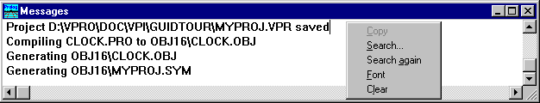

Figure 5.2: The Messages window
It is possible to copy text from the Messages window to the clipboard, and the Font for the Messages window can be changed. Using the right mouse button anywhere in the Messages window will bring up a local pop up menu.
If the Messages window is closed, it can be opened again under Options | Global | Environment. Also in this menu it is possible to set the number of lines to hold in the Messages window, and where it should be positioned.

Code Browser

The compiler generates a file <project>.BRO, which stores information about where domains and predicates are declared and defined. The project must have been compiled before the Code Browser can be used.
You can access the Browser through the Project | Browse menu item, the keyboard accelerator Ctl+B or the toolbar button .
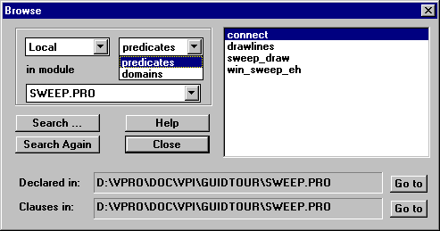

Figure 6.3: The Code Browser.
The Browser can select either global information for the project, or local information in a module. There is a search button which allows you to search for predicates by giving a part of the name.
By clicking on one of the GoTo buttons it is possible to open up an editor window with the cursor pointing at either the declaration or the clauses of the predicate.
Note that the editor has a short-cut for locating the declarations or declaration for a predicate. When the predicate name is highlighted in the editor:
Shift+Ctrl+D: Brings up the editor with the Definition of a predicate.
Shift+Ctrl+C: Brings up the editor with the Clauses of a predicate.

Resource Identifier Browser

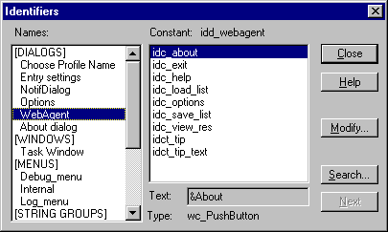

Figure 7.4: The Resource Identifier Browser
The Project Resource Identifier Browser gives an overview of the constants defined for the project resources. For each resource component selected on the left it is possible to see the constants for all the sub-components listed on the right. It is also possible to search for where a constant is defined.
You can access the Project Resource Identifier Browser via the Project | Identifiers menu item or the keyboard accelerator Ctrl+I.

Project Module Tree

Once the project has been compiled, you can open a display of the project file tree that shows the dependency and include structures for the project. Select the Project | Tree menu item, or press the hot key Ctrl+T, or press the toolbar button.
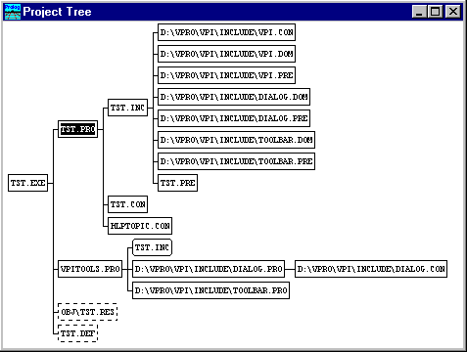

Figure 8.5: The Project Tree window.
You can click on any node in the tree to select it. If you right-click on a node, this produces a 12-item pop-up menu covering dependencies, This is described on page 51 along with the make utility. Double-clicking on any source file node opens that file for editing.

Global Options and .INI Files

In the Windows sub-directory, Visual Prolog creates a file named VIP16.INI or VIP32.INI. The .INI file created stores a number of settings, as well as a list of previously opened projects. Visual Prolog uses the .INI file to automatically re-open a previous opened project. Also all options under Options | Global are stored in the .INI file. This is mainly settings for the editor and some Environment Options. The Options | Global menu contains the following menu items:
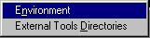

Auto save Options
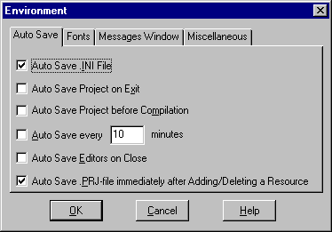

Figure 9.6: Auto save options.
In this group it is possible to specify:
Whether the .INI file should be saved, when Visual Prolog is terminated.
Whether the current .VPR file should be saved when Visual Prolog is terminated.
Whether the current .VPR file should be saved before any compilation.
Whether the entire Project (.VPR files and open editors) should be saved automatically at regular time intervals.
Whether editors should give a prompt about saving the content when the window is closed.
Whether the .PRJ file should be saved to disk as soon as it has been modified.

Fonts
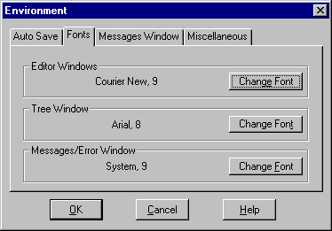

Figure 10.7: Fonts Options
In this dialog it is possible to specify the fonts for the Editor, The tree and the messages window.

The messages window Options
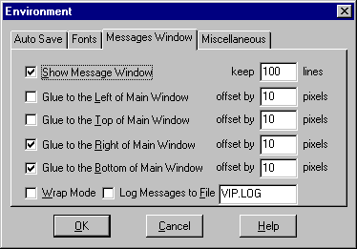

Figure 11.8: Messages Window Options
In this group it is possible to specify where the Messages window should be displayed and located relative to the borders of the Task window, and how many lines it should display.
If a log is needed of all Messages window activity, the name of a file to be used for this information can be entered. A new file is commenced for each compiler run, and any previous one is lost.

Miscellaneous Options
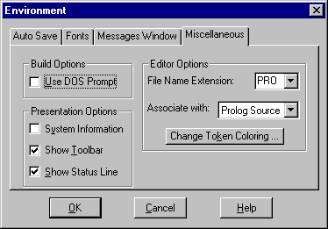

Figure 12.9: Messages Window Options

Build Options
A DOS prompt can be requested for calling DOS command line tools, e.g. like calling the Linker. In some environments this can be needed to link properly. Also in some environments this gives the linking task a higher priority so the link step goes faster.

Presentation Options
You can specify whether the toolbar and the help line should be displayed, and whether to display a little memory watcher on how much memory the VDE uses.
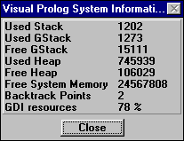

Figure 13.10: The memory watcher window

Editor Options
Here it is possible to specify how each file type (the file extension) should be colored in the editor.
Under Change Token Coloring it is possible to specify the tab size and the colors to be used for the editor's token coloring scheme for each of a range of source file extensions (Prolog source, *.RC, *.DEF, C source, or other).
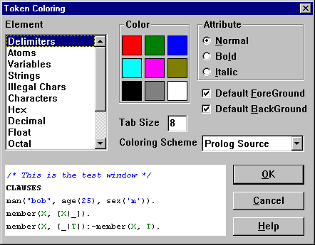

Figure 14.11: Editor Token Coloring Options.

External tool directories
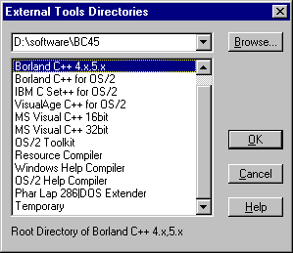

Figure 15.12: External tool directories.
Under the menu entry Options | Global | External Tools Directories is it possible to specify the location of various tools external to the Visual Prolog system. The main purposes are mainly to specify the locations of the C compiler, when C modules are part of the project, or to specify the location of the help compiler since this is not part of Visual Prolog.

CHAPTER 16

The Application Expert
17The Application Expert is a tool to help you create a new Visual Prolog Project, as well as to help you to change certain settings in this Project at a later stage.
A GUI application requires a lot of footwork just to get started. You need to create a large chunk of startup code, many standard event handlers, usually an About Box, as well as resources, menus, .DEF files. These standard tasks could easily take a couple of days to do from scratch, even presuming you are aware of what needs to be done. The Application Expert will help you perform all these operations, based on some options you can set. With the Application Expert, a new Application can be created in less than a minute.

General Settings
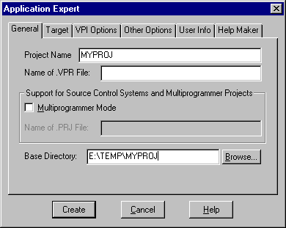

Figure 18.1: General Settings in the Application Expert
When you have selected the needed information in the Application Expert, press the Create button to create the actual files, directory set-up, define symbols, scripts, menus etc.
The minimal information to enter is a name for the project, and a directory where to place the project.
Note: All this information remains available for inspection and alteration through the Options | Project | Application Expert menu item.

Project Name
A new project must always be given a name. This must be a valid file name and also a valid Prolog predicate name. The name is used to store the project in a <project>.VPR file. For portability reasons, it is a good idea to restrict the name to eight characters if the project is ever to be compiled under Windows 3.x.

Name of .VPR file
Each Project is stored in a project file (.VPR extension), which is actually a Prolog external database containing descriptions of the project components. There are: Visual Prolog (and others) source files, Dialogs and Windows, Menus and Toolbars, Icons, Cursors and Bitmaps, Strings and Help Topics. The Application Expert automatically generates the project file when a new Project is created. The default name is <ProjectName>.VPR, but if another name is preferred, it is possible to specify it here.

Base Directory
The directory where the project should be placed must be given. With the Browse button, you can open up a directory browser to find a proper directory for this:
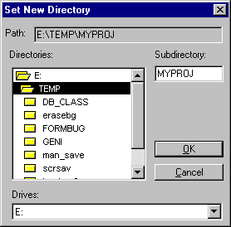

Figure 19.2: Selecting a directory for the project
You should use the directory browser to either:
- Specify an existing sub-directory for the new project, or
- Browse for the parent directory, and in the Sub-directory field, specify the name of a new sub-directory to be created.
Note, that if you choose a directory that already contains files with the same names, the Application Expert will give the warning "These files will be overwritten" after you push the Create button. Therefore, it's a good idea to store each project in its own base directory.

Support for Source Control Systems and Multiprogrammer Projects
The group provides project sharable support that adds several benefits:
- Enabling the use of source control systems like MKS, PVCS or MS-SourceSafe.
- Making it easier to work multiple persons on a project.
- Making it possible to share resources between multiple projects.
The following separate issues accomplish this:
- Possibility to place resources in external files. The resources, which are stored in separate files, can be included in multiple projects.
- Optional support of a textmode .PRJ file that contains all information about the project and refers to the separate resource files. When Visual Prolog is using a .PRJ-file it is said to work in multiprogrammer mode.
- Supporting read-only modes for all text and resource editors, and the .PRJ file.
- Supporting automatic reloading of all file types if the files have been updated on the disk. Files are updated externally by the source control systems when modifications from other users are imported.
It is possible at any stage to change the setting of the multiprogrammer support. The multiprogrammer support is enabled if the Multiprogrammer Mode check box is checked.

When changing an existing project to multiprogrammer support:
- all resources will be saved in separate files
- a .PRJ file will be generated.
When resources are stored in separate files, they will per default be placed in the \RES directory. The default name of the resource file will be the same as the name of the resource, with the corresponding extension.

Target Selections
Visual Prolog is designed to be a very open system, and accommodates many programming strategies. There are also a number of combinations on the other platforms like DOS, DOS extended code, NT and OS/2, using BGI, SQL bindings etc. Furthermore, Visual Prolog can link up several C compilers with different libraries and linking strategies.
Visual Prolog tries to support all these strategies, and the Application Expert can create the correct defaults for most of these combinations. Just choose the combination of Platform, UI strategy, Target Type and the Main program you need. If you need a combination that is not directly supported by Visual Prolog and the Application Expert, just choose the combination that is nearest to the one you need, and then manually modify the scripts generated by the Application Expert.
However, the main feature of Visual Prolog is the VPI layer. This contains the facilities, which make it easy to do programming for Windows and other graphical platforms in Prolog. The biggest benefits are 1) it is a high level Application Programming Interface, 2) it is portable, and 3) the integrated Code Experts can assist in the generation of code.
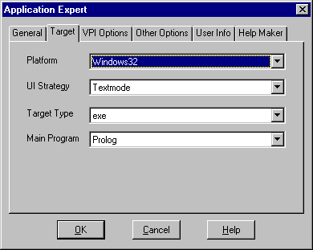

Figure 20.3: Target selections for the Compiler.
The choices are made by four different selections:

Platform
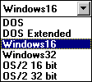

Figure 21.4: Selections for platform
The platform selections are:

DOS
The selection DOS is used to build real mode DOS applications. This setting can compile and build programs that are compatible with the previous PDC Prolog and Turbo Prolog programs. With this selection, the old PDC Prolog text mode windowing system can be used, and when linking to Borland C++, it is also possible to use the Borland Graphic Interface (BGI).

DOS Extended
This setting requires the use of the PharLap 286 DOS Extender. In this mode the programs can run under DOS in Protected mode and use all extended memory in the computer. With only a few exceptions all previous PDC Prolog and Turbo Prolog text mode and BGI programs can be compiled in this way.

Windows 16
This setting is used to build applications that run on the Microsoft Windows 16 bit platform. Windows 3.1x, OS/2-Win, Windows NT and Windows 95 can run these applications. There are a number of choices for programming the UI. The preferred strategy is the VPI, but it is also possible to program directly for the Windows 16 API, or to use some other language like C or Basic for the UI module.

Windows 32
With this setting, it is possible to generate applications that will run under either Windows NT or Windows 95. The applications are true 32 bit programs that use long filenames, extended file naming conventions, etc. The UI choice will be from VPI, EasyWin or Text mode.

OS/2 16 bit
This setting is used to port PDC Prolog or Turbo Prolog Text mode applications to run in 16 bit protected mode OS/2.

OS/2 32 bit
This setting is used to build true 32 bit OS/2 PM applications. The VPI layer is supported as the main strategy, but in the sub-directory PMBIND, you will find some bindings created by Gregory Bourassa that can be used to program directly for the PM API.

UI Strategy
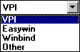

Figure 22.5: Selections for UI Strategy for Windows 16 Platform
Depending upon which target has been selected, there are a number of choices of how to build the user interface for the application. The choices are:

VPI
This is the preferred UI strategy for Visual Prolog. Use of the VPI makes it easy to build Windowed applications that run under Windows 16, Windows 32 and the OS/2 PM. The VDE provides many tools for handling the VPI, and the Code Experts greatly assist in creating the applications.

EasyWin
If there is a small application, that does not need any user interface other than lines of text with pauses for keyboard input, the EasyWin selection can be used. EasyWin works under Windows 16, Windows 32 and OS/2 PM. EasyWin applications run as a real Windows or PM application, but only the readchar, readln, write, writef and nl predicates can be used to do input and output.

WINBIND (Only for Windows 16bit)
The WINBIND strategy is used to build applications that go directly to the Windows 16 API. The header files and libraries from the WINBIND sub-directory are used.

Text mode
Text mode applications for DOS, DOS Extended 16 and OS/2 16 bit can use the PDC Prolog text mode windowing system. For Windows 32 bit and OS/2 32 bit, text mode indicates applications that are run from the Operating System command line.

BGI
For the DOS and the DOS Extended 16 bit platform selections, you can use the Borland Graphics Interface. This requires the presence of Borland C++.

Other
When the selection Other is made, no pre-defined headers or libraries are included, in this case it is up to the user to supply whatever is needed.

Target Type
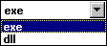

Figure 23.6: Selections for Target Type
On all selections of Platform and UI strategy you can generate an executable application. On the Windows and OS/2 platforms you can alternatively generate a dynamic link library (.DLL) which may be called from an executable application.

Main Program
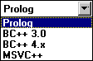

Figure 24.7: Selections for Main Program
The selection for Main Program indicates which language system will be responsible for the initial application startup code. If Prolog, the initialization will be performed in INIT.OBJ. When C is selected, the C startup and the C linker will be used.
Clicking on the Main Program List Button you will receive the drop-down list of supported compilers. Currently they are:
- Prolog
- Borland C++ 3.x
- Borland C++ 4.x,5x
- MS Visual C++16bit
- MS Visual C++32bit
- IBM C++ for OS/2
The list of compiler depends on the chosen Platform. The Application Expert suggests the correct default Main program for the combination of the Platform, the UI strategy and the Target Type.

VPI Options
The Application Expert dialog, has an Options button which calls a dialog where it is possible to specify a number of options for a VPI application:
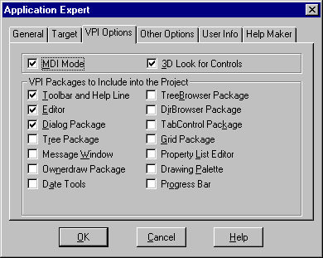

Figure 25.8: Specifying VPI selections.
The possible selections are:
MDI mode Specifies that the application will use the MDI Window menu item to Tile and Cascade windows. Note, that in MDI mode, it is not possible to draw or create controls in the Task window.
Toolbar and Help line Specifies that the application should have a toolbar at the top and a help line at the bottom of its Task window.
3D look for controls Specifies that the controls in dialogs under MS-Windows will have a 3 dimensional look. This requires that the CTL3D.DLL or CTL3DV2.DLL file be present in the WINDOWS\SYSTEM or WINDOWS\SYSTEM32 directory.
Messages window Specifies that the application will have a messages window so it is possible to use the write predicate in the program.

All the other package selections means that the .DOM and the .PRE files for the package will be included in the projects .INC file, and the user can use the tool where ever he wants in the project.

Other Options

Under the Application TAB: other options
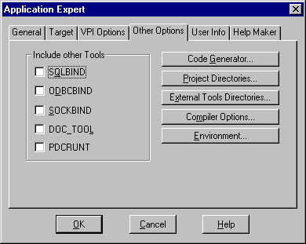

Figure 26.9: More options for a project.
The "Include Other Tools" makes it easy to include the following facilities in you project:
SQLBIND Specifies that the SQL bindings will be used in the project. This will result in the SQLBIND header files being included and the SQLBIND libraries being linked in.
ODBCBIND Specifies that the ODBCBIND, a layer between application program written in Visual Prolog and Microsoft Open Data Base Connectivity (ODBC), will be used in the project. ODBCBIND directory includes full bindings to the ODBC API allowing Windows only applications taking of all the features in the ODBC API.
SOCKBIND Specifies that the SOCKBIND that provides a portable interface between Visual Prolog and sockets will be used in the project. The SOCKBIND directory contains the libraries and declarations that provide this interface.
DOC_TOOL Specifies the DOC_TOOL directory providing tools for both generating of .RTF, .HTML or, .IPF formats, as well as import from these formats.
PDCRUNT Specifies that the two header files PDCRUNT.DOM and PDCRUNT.PRE will be included in the project. These contains some declarations of some extra predicates defined in the prolog library.

Code Generator
The Code Generator button in the Application Expert invokes the Code and File Generation for the CodeExperts dialog. The default settings are:
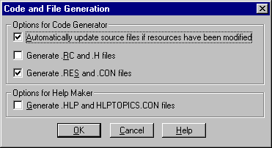

Figure 27.10: Code generation options.
The Code generator options are:
Automatically update source files if resources have been modified
This setting makes it possible to turn off completely any source code updating by the code experts.
Generate .RC and .H files
This specifies that the code generator should generate *.RC and *.H files for the resources in the project. The *.RC files are intended for input to an external resource compiler and the *.H files are header files for use in compiling C modules.
Generate .RES and .CON files
Under Windows these are the normal files to generate for the resources in a Visual Prolog project.

Project Directories
Directory options are used to set up the directories to be used by the compiler, linker, resource generators, etc.
Directory names can refer to the build script symbols. For example, when giving the name $(PRODIR)vpi\include, $(PRODIR) will be automatically expanded to the actual path where the Visual Prolog System is placed.
This approach makes it possible to move the system to another place and still operate without having to redefine the directory structure, and to move a project to another location in the file system without having to modify build scripts.

Source directories
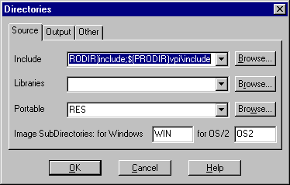

Figure 28.11: The Application Expert

Include
The pull-down list box provides the choice of a number of search paths. Each one is a list of directories, separated by semi-colons, in which the compiler will search for any include filename that does not include a full (absolute) path. A single period indicates the current directory, which is always the project directory. Two periods indicates the parent directory of the current directory.

Libraries
The Libraries setting is a list of library search paths (not filenames - actual libraries can be registered as modules in the project window), separated by semi-colons. It is used to tell the linker where to search for a library if the name given for the library do not include the full path. The value is used to define the symbol LIBDIR, which can be used in the build script.

Resources
This value is used to specify the default location for cursors, icons and bitmaps. This directory (usually RES) will become a subdirectory of the project directory. The directory will have two subdirectories for the nonportable resources like Bitmaps, Icons and Cursors. To port these resources the VIPCONVERT program must be used.

Output directories
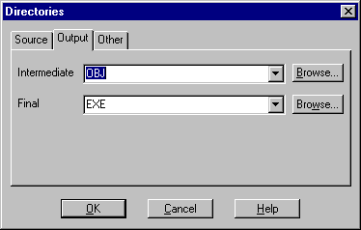

Figure 29.12: Output directories.

Intermediate
This directory is used to place all intermediate files. Examples of intermediate files are: .BRO, .OBJ, .SYM, .MAP, .RC, .RES, .RTF etc. When cleaning up a project, these files can be deleted. This directory (usually OBJ) will become a subdirectory of the project directory

Final
This directory is the place for the final generated executable and help files. This directory (usually EXE) will become a subdirectory of the project directory.

Other directories
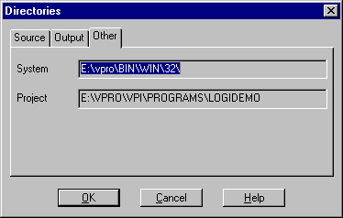

Figure 30.13: Other directories.

System
This directory is read-only, and displays from where the Visual Prolog VDE has been started. This directory defines the value of the $(SYSDIR) symbol.
This directory defines the value of the $(PRODIR) symbol.

Project
This directory is read-only, and serves to display the directory for the project.

External Tool directories
This is the Global setting for the tools, and these settings are NOT stored together with the project, but for convenience there is a link to the dialog.
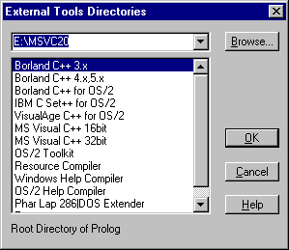

Figure 31.14: External tool directories.

Compiler Options

See next chapter for these settings!

Environment
This is the Global environment settings which are NOT stored together with the project, but for convenience there is a link to the dialog.

User Info
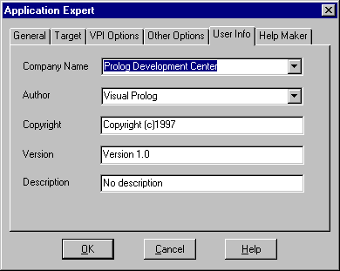

Figure 32.15: User Information.
This information is placed in the headers of the modules and in the default Help | About box.

Help Maker
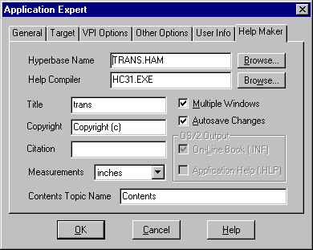

Figure 33.16: Helpmaker Options
This is some information for generating on-line help. This information is stored in the .HAM file.

The Files in a Project
For a project called DEMO that uses the VPI layer, the Application Expert (and the compiler), the following files and directory structure will be generated.

Table 34.1: Files and directories in an example project.
DEMO.VPR | The Project file
DEMO.DEF | A definition file for the linker
DEMO.INC | The main include file
DEMO.PRO | The main source file
DEMO.DOM | Global domain declarations
DEMO.PRE | Headers of global predicates in module DEMO.PRO
VPITOOLS.PRO | The module that include the VPI tool files
HLPTOPIC.CON | Constant declarations for on-line help
DEMO.CON | Constant declarations for the resources
DEMO.BK1 | A backup of the project file
DEMO.GRD | A file VIP creates when a project is open
*.BAK | Backup of other files
EXE\DEMO.EXE | The generated executable.
EXE\DEMO.HLP | The generated help file.
EXE\PROLOG.ERR | A list of Prolog error codes.
OBJ\DEMO.BRO | Browser information
OBJ\DEMO.MAP | .MAP file generated by linker
OBJ\DEMO.RES | The generated resource descriptions
OBJ\*.OBJ | The compiled object files
OBJ\*.DEB | Debugger information for each module.
OBJ\DEMO.SYM | A special object file (symbol table)
RES\*.WIN, *.DLG, *.TB, *.MNU, *.STR | When using sharing, Descriptions of the resources goes into these textfles
RES\WIN\*.BMP | The bitmaps registered in the project
RES\WIN\*.ICO | The icons registered in the project
RES\WIN\*.CUR | The cursors registered in the project
RES\OS2\*.PTR | The OS/2 cursors registered in the project

New Source Modules
Module source files follow a naming and inclusion philosophy. All modules will have an "include <project>.INC" statement. This is to ensure that an identical set of global domains is included in every module of the project.
Each source module may generate global domains. These should be placed in a separate file <module>.DOM, and an include statement for it placed in <project>.INC.
Each source module may generate global predicates. The predicate headers for these should likewise be placed in a separate file <module>.PRE, and an include statement for it placed in <project>.INC.
This will ensure that every module will include all the global domains and global predicate declarations for the entire project. As new modules are added or old ones deleted, or as global domains or predicates are added or old ones deleted, the <project>.INC and <module>.DOM and <module>.PRE files will always be correct and the project building logic will force recompilation as necessary, based on the files' time stamps.
Note, that if selective inclusion of global predicate headers on a where-used basis is required, this must be handled directly by the programmer. This strategy is supported by the language but not by this automatic include generation philosophy. For larger projects, this strategy can be advantageous because it gives less header files to compile.
If your project is named TRANS.VPR, and you create a new module called CALC.PRO, you will get the following dialog:
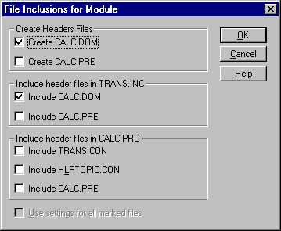

Figure 35.17: Creation of new source module dialog.
The dialog facilitates creating and including the header files for a new module.

Table 36.2: Options when Creating a New Source Module.
Check Box Prompt | Action Performed
Create <module>.DOM | A file will be created in the project base directory. It will contain exported Domains from the module. Create this only this if you plan to export domains from the module.
Create <module>.PRE | A file will be created in the project base directory. It will contain exported Predicates from the module. This should nearly always be generated.
Include <module>.DOM  (In <project>.INC) | An include statement for <module>.DOM will be generated in <project>.INC. If you have a .DOM file for the module you MUST include the module in the .INC file.
Include <module>.PRE  (In <project>.INC) | An include statement for <module>.PRE will be generated in <project>.INC. For larger project, you should include .PRE files in the .PRO files.
Include <project>.CON  (In <module>.PRO) | An include statement for <project>.CON will be generated in <module>.PRO. You should only include this if the module refers to any resource constants.
Include HLPTOPIC.CON  (In <module>.PRO) | An include statement for HLPTOPIC.CON will be generated in <module>.PRO. You should only include this if the module refers to any on-line help constants.
Include <module>.PRE  (In <module>.PRO) | An include statement for <module>.PRE will be generated in <project>.PRO. For larger project, you should include .PRE files in the .PRO files.

CHAPTER 37

Building, Compiling and Linking
38The compile and build commands are invoked from the Project menu, but all settings for directories, the compiler and the make facility are made under the Options | Project menu item.

The Project Options

Compiler options
The Compiler options are used to set up the parameters for compiling the Prolog source code.

Code generation options
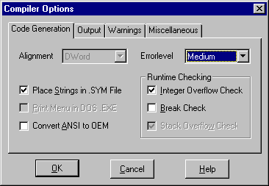

Figure 39.1: Compiler code generation options.

Alignment
This setting shows the data and code alignment done by the compiler. This setting should never be changed.

Errorlevel
This setting controls when the compiler will generate source position information into the executable file for error referral back to the physical position in the appropriate source file at run time.
Minimal | No information stored. This generates the smallest and fastest executable. This should only be used in well-tested applications.
Medium | Source position information is generated before each call to every standard predicate that potentially could encounter a runtime error. This is the default setting.
Maximal | This setting will generate source position information at each predicate call. This setting will always generate a precise error position - including for memory problems like stack overflow.

Place Strings in .SYM File
The compiler will normally place all strings in the symbol table in the .SYM file. This is an optimization, which means, that the same string used in many places will only be stored in one place. However on the 16 bit platforms there is a restriction that the symbol table is limited to 64K. So in very large 16bit VDE projects, it may be advantageous to turn off this feature.

Print Menu in DOS .EXE
For DOS text mode programs, that use the PDC text windowing system, this setting can be used to specify that there should be support for the key combination Alt+P to turn printing on and off.

Convert ANSI to OEM
Enforces the compiler to convert chars between the OEM-defined character set and US ANSI character set. (OEM stands for original equipment manufacturer.). This is mainly used when using the Windows VDE to generate DOS or OS/2 executables.

Integer Overflow Check
This setting can select whether the program will generate run-time errors for numeric overflows.

Break Check (DOS Text mode only)
For DOS text mode programs and EasyWin applications, this setting can enable or disable checking for depression of the break key during run time. If enabled, pressing Break will abort the program.

Stack Overflow Check
This setting can be used to turn off the checking for stack overflow at run time. This should only be done in very well tested applications.

Compiler Output
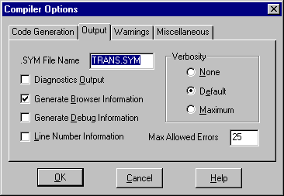

Figure 40.18: Compiler Output Options.

.SYM File Name
With this setting, it is possible to specify a name for the special object file that contains the symbols (atoms) in the project. For example, when linking from the Visual C++ environment, there is a requirement that all object files must have the .OBJ extension.

Verbosity
This setting controls how much information Visual Prolog will provide in the Messages window during compilation. Errors and warnings continue to be presented in the Errors (Warnings) window.
None | Shows project database saving, information from the resource generation process, and the final state of the compilation process.
Default | In addition, shows the start of compilation for each module.
Maximum | In addition, shows the files being included, number of domains and predicates in the module, etc.

Diagnostics Output
This setting causes a list of information about all predicates to be generated for direct inspection after compilation.

Generate Browser Information
This setting controls whether the compiler will produce information about where domains are declared, where predicate headers are located, and where their implementing clauses are located. The browser information is generated in the <project>.BRO file in the OBJ directory.

Generate Debug Information
This setting controls whether to generate and place into target modules debugging information that can be used by the stand-alone VIP Debugger VIPDEBUG.EXE supplied with Visual Prolog. This option is currently only valid for the 32-bit Windows target.

Line Number Information
When this setting is turned on, the compiler will put line number information in the .EXE files. This can be used to follow the execution in traditional C debuggers like CodeView, TD or IPMD.

Maximum Allowed Errors
This value controls how many errors are reported before compilation is automatically stopped.

Warnings
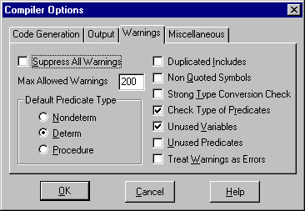

Figure 41.19: Options for Compiler Warnings.

Suppress All Warnings
Enforces the compiler to suppress all warning messages.

Maximum Allowed Warnings
This setting can be used to set a limitation on the number of warnings to accept before stopping compilation.

Predicate Default
This group of radio buttons determines how the compiler will treat predicates that are declared without procedure, determ, nondeterm, failure, erroneous or multi keyword:
Nondeterministic | enforces the compiler to add the keyword nondeterm.
Deterministic | enforces the compiler to add the keyword determ.
Procedures | enforces the compiler to add the keyword procedure.

For Projects that contains large parts of procedural code, it is a very good idea to set the default to be procedures, so the compiler will warn about any potential fails.

Duplicated includes
When this setting is turned on, the compiler will issue a warning at each place where a file is included but is has already been meet.

Not Quoted Symbols (Checking)
The language permits symbols (lower case identifiers) to be taken as strings without compiler comment. If the check for Not Quoted Symbols is turned on, the compiler will give a warning in this situation.

Strong Type Conversion Check
Enforces the compiler to check for dangerous type conversions. The Prolog compiler allows free conversions between the numeric types, but turning on this option will give a warning whenever a "bigger" type is converted to a smaller like real to long.

Check Type of Predicates
Enforces the compiler to check predicate clauses and generate a warning for each predicate to which the compiler cannot guarantee that it corresponds to the declared predicate type. Ex. that procedures can not fail, determ predicates will only give one solution, that erroneous will always exit etc.

Unused Variable (Checking)
When this setting is turned on, the compiler will issue a warning at each place where a variable is used only once in a predicate clause. This usually indicates a mistake. If it is not a mistake, you can start the variable name with a leading underscore to turn off this error message for every occurrence of this variable. A very common example is the use throughout the code experts of "_Win" as a window handle.

Unused Predicates
When this option is turned ON, the compiler will issue a warning for each local predicate that is declared but is not called in the module.

Treat Warnings as Errors

Enforces the compiler treats all warnings as errors

Miscellaneous
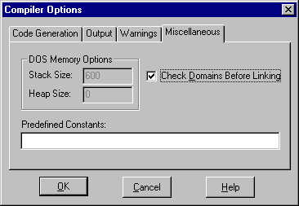

Figure 42.20: Miscellaneous Compiler Options

Check Domains before Linking
This setting should always remain on. It controls whether a check is made to see if the global domains are the same in all modules before linking. Ignoring this check will probably lead to all kinds of serious runtime errors. One easy way to ensure that the same set of global domain definitions is used in all modules is to place them all in one source file, e.g. include this file in every module.

Pre-defined Constants
In this field, you may define some constant identifiers to be referred to by ifdefs in the project. Only identifiers may be present and must be separated by single blanks.

Stack Size (DOS only)
For a real mode DOS application, this setting specifies the stack size. When Prolog is the main program under Windows 16, the stack size will always be 64K.
For other platforms, the stack size is specified in the linker's .DEF file.
Attention: For 32-bit platforms it must be > 70 K. (Default 200 K).

Heap Size (DOS only)
This can be used for DOS real mode terminate and stay resident programs to specify the Heap Size. In all other cases, the Heap will dynamically expand to the memory available.

Code Generator Options
The Visual Prolog system can generate several kinds of resource files:

Table 43.1: The Resource files types that Visual Prolog can generate.
Extension | Description
*.RC | A text description of the resources which this can be compiled by the resource compiler.
*.RES | A binary description of the resources. This can be given directly to the OPTLINKS linker to bind the resources into the executable file
*.HLP | A file for on-line help produced by the Visual Prolog Help Maker.
In addition to these files, a constant definition file is generated. It is used to unify the resource names in the source modules with the identifier names given in the various resource editors:

Table 44.2: The different kinds of constant definition files.
File Name | Description
*.CON | This is the Visual Prolog resource constant definition file.
*.H | This is a C style constant definition file. This will be generated when .RC file generation is selected.
HLPTOPICS.CON | The constants defined in this file identify the help topics in the on-line help.
Selection of which files should be generated can be done from the menu entry: Options | Code Generator.
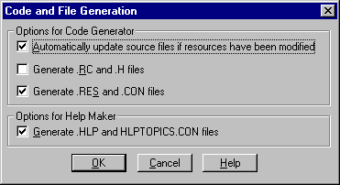

Figure 45.2: Experts Code generation options.
The "Automatically update.." option can be used to disable automatic source updating by the Code Experts when the layout or attributes is changed for windows, dialogs or toolbars.

The Make Facility

The Make facility builds the project by generating the resources, constant files, updating the source code sections for the code experts, compiling and linking all the modules and generating the help file. The Make facility checks the file time stamps to see which files need to be compiled or recompiled. A file needs to be recompiled if the .OBJ file is older than either the source file or any of its include files or does not exist.
The settings for the make facility are placed under Options | Project | Make Options:
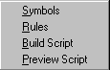

Figure 46.3: The Make Options menu.

Symbols
The make scripts can refer to symbols. The syntax used in the scripts to refer to a defined symbol is: $(<symbol>). These symbols can be either:
- Environment symbols defined by the operating system's SET command.
- Special symbols pre-defined by Visual Prolog.
- Some user-defined symbols which can be set from Options | Project | Make Options | Symbols
The search for the value of a given symbol will be in the reverse of the above order in such a way that if the user specifies a symbol directly, the system will just use that, otherwise it will see if it is defined automatically by Visual Prolog. If this is not the case either, it will try to see if it is defined as an environment symbol in the operating system. If this also fails, a warning will be given.
Remark: A symbol is - with respect to syntax and semantics - roughly equivalent to what a standard make utility such as Microsoft and Borland's make identifies as a macro:
vpilib=$(PRODIR)VPI\LIB\WIN16\VPI.LIB $(PRODIR)VPI\LIB\WIN16\EDIT
prolib=$(PRODIR)LIB\WIN16\PROLOG.LIB $(PRODIR)LIB\WIN16\WIN16.LIB
libs=$(vpilib) $(prolib)
init=$(PRODIR)LIB\WIN16\INIT.OBJ
link=$(PRODIR)BIN\OPTLINKS
linkflags=/RC -K:$(OBJDIR)$*.RES /NOMAP/NOD/REO/AL:512/PACKC/SE:1000

Figure 47.4: Example of symbol definitions.

The pre-defined symbols are:

Table 48.3 Table of pre-defined symbols.
Symbol name | Explanation
PROJECT_OBJ | The list of object files from the project list.
PROJECT_LIB | The list of .LIB files from the project list.
PROJECT_RES | The .RES file.
PROJECT_DEF | The .DEF file.
* | Name of current target file (Extension removed).
LIBDIR | Location of Libraries directory from the directory dialog.
OBJDIR | Location of intermediate directory.
EXEDIR | Location of final directory from the directory dialog.
PRODIR | Location of Visual Prolog.

Make Rules
The Make rules provide some default rules for how to compile files. Each line is the command needed to convert a file with one extension to a file with the other extension.
c->obj: $(cc) $(cflags) $(cvars) $(cdebug) -c $*
rc->res:rc -r -fo $*.res $*.rc
res->rbj:cvtres -$(cpu) $*.res -o $*.rbj
h->con:h2con $*
pro->obj:#$*.pro
As an example, you can see that to do a resource compilation of an .RC file to a .RES file, the following command must be executed:
rc -r -fo $*.res $*.rc
Where $* will be replaced by the name of the actual file.
Referring to # means calling the Prolog compiler with the selected compiler options.
A special note to those familiar with other make utilities: The rules specified here are roughly equivalent to what is known as implicit rules. It is not possible to specify explicit rules here. Use the tree window to specify dependencies and the corresponding actions. Explicit rules specified using the tree window will override the implicit rules here.
It is not possible to specify rules that are more than one line long. A work-around is to create suitable batch files.

Build Script
The Build Script is the main command describing how to build the project.
$(link) @<< $(linkflags) $(initobj) $(PROJECT_OBJ) $(OBJDIR)\test01.sym, $(EXEDIR)\test01.EXE,$(EXEDIR)\test01.map,$(pdclibs),$*.DEF<<
The "<<TEXT<<" syntax means put the TEXT into a temporary file, and substitute the text with the name of the temporary file.

Preview Script
This generates and shows the Build Script in a window for inspection.

Local Scripts
The right mouse button can be used in the tree window to add some dependencies to individual files. For example, a .RES file can be generated from a .RC file. During a build the Option | Project | Make Options | Rules will be used in order to compile the files. It is also possible to register explicitly some include files for a given node. This is necessary for file types that the Prolog system does not know, like C files. Also it is possible to add a special script on how to build to any node.
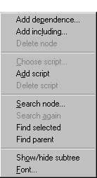

Figure 49.5 The pop-up menu for the project tree.

The Build Commands

Project | Compile File (Ctrl+F9)
This command compiles the file currently selected in the Project window - or if a module is open in an editor window and has focus - this module will be compiled.

Project | Build (Alt+F9)
If any resources have been modified since last build, the code experts might update some sections in the source files before the build.
This command will build the project by checking the time stamps of all the source files in the project, so if any source files or files they include are newer than the .OBJ file, a recompilation will be done.
Build will also build resource files and the Help file if the Help Maker is included.
The project is then linked to produce the executable program.

Project | Rebuild All (Ctrl+Alt+F9)
This option operates the same as Project | Build, except that all files will be regenerated or recompiled and linked irrespective of time stamps.

Project | Stop Compiling (Alt+F10)
This command is used to stop the compilation.

Project | Run (F9)
If necessary, this command will first do a Project | Build, then the generated executable will be started.

Project | Link Only (Shift+F9)
This command is used to do a Link Only.

Project | Test Goal (Ctrl+G) .
This command is used for testing of Goals. The program is compiled in a special mode and then the variables in the Goal are displayed. This feature is a handy way to test the local predicates in a module.
For example, the following goal:

GOAL X = 2; X = 1, Y = X + 1.
Will result in the following output:
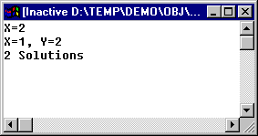

Figure 50.6: Output of the GOAL test mode.

Resource | Build Resource Only (Alt+F8)
When the Project window is active, a Resource menu item appears in the Project menu. Selecting this generates the selected .RC and .RES files and the necessary constant files.

CHAPTER 51

Resource Editing
52The term Resources applies to many things in the computing world. In GUI system environments the term resources refers to all the windows, dialogs, pictures, string tables, icons, cursors, device contexts, pens, brushes, memory allocations, etc. for all active applications.
In Visual Prolog, when we refer to resources we normally mean the descriptions of dialogs, menus, tool and help bars, cursors, bitmaps, icons, and string tables which are created by the various resource editors in the VDE. The layout and the attributes of these resources are stored in the project database (<project>.VPR), and when you request a build, the VDE will generate an industry-standard binary resource file (<project>.RES) and a file of named constants (<project>.CON) for inclusion in source modules.
Alternatively, or in addition, you may request under Options | Project | Code Generator the generation of <project>.RC and <project>.H files, which provide industry-standard text descriptions of the resources. These .RC and .H files may be converted into a .RES file by any of the commercially available tools (an RC compiler or any of the resource preparation tools).
The following things go into the resource file: Dialogs, Menus, Cursors, Bitmaps, Icons and Strings.
For windows, toolbars and help lines, Prolog code is generated directly in the application source modules since such things were not anticipated by the standard .RC or .RES file designs.

Resource Naming
When a resource is created by one of the VDE resource editors, it needs to be named. The VDE supplies a candidate symbol based on a set of rules, and the user can accept, change, or totally replace it. These symbols, which will later become Prolog named constants, will be used by the application to refer to resource items, and at compile time each resolves to a unique integer value which is assigned by the VDE.
During project building, a .RES file, destined for the linker, is generated. Also a .CON file, destined for inclusion in those project source modules which handle resources, is created. The .CON file is the record of the VDE's assignment of a unique integer value to each of the resource item named constants. These numeric values, and not the symbolic constants written in the application, become at run time the actual identification numbers of the resources to the VPI predicates and to the underlying GUI.
There are two other supported ways of naming resources: direct integer constants, and named resources. These two ways are supported for compatibility purposes with old code, foreign custom controls, linking to a foreign language and special purposes. They should not regularly be used.
Integer numbers for resources will for example be used when importing resources from .DLL, .RES or .EXE files. After being imported, the resources will have the numbers they had in the native resource. It is then necessary to go in manually and give the various controls and menu entries symbolic names. For any resource, control or menu item, you can just type an integer number if you want that resource to have a specific number.
It is also possible to enclose the constant name for a resource identifier in quotation marks. In this case the identifier will be inserted into the resource file as is (without substitution of an integer value). But this identifier representation is not supported by VPI. So you can not refer to such a resource in VPI programs. You may receive a symbolic identifier in quotation marks when you import resources from an application that has been using this feature.
Summary:
Normal resource constant name: id_About
Integer constant name: 102
Symbolic named resource: "ABOUTDIALOG"

Resource Linking
The .RES file is linked into the executable file, in which it forms the resource segment(s). When using OPTLINK or some of the newer Borland or Microsoft linkers, this operation can be performed by the linker, otherwise this operation must be achieved by using a resource compiler to bind the resource segment to the .EXE file after the normal linking. During execution, VPI predicates retrieve dialogs, menus, icons, bitmaps, and string table strings from the resource segment of the .EXE.

Bitmaps, Icons and Cursors
These can be created either in the VDE Graphics Editor, or using any third-party tools specifically designed to create, capture or modify graphic images. Unlike dialogs, menus and strings, each definition of an icon, a bitmap or a cursor will exist in a separate file before they are transferred to the .RES file.

Dialog Resources
Dialogs are normally created in the Window and Dialog Editor of the VDE. It removes all the tedious work of positioning and sizing the controls in a dialog. At run time, when a definition exists in the resource segment, a dialog can be produced on the screen by a call to win_CreateResDialog or dialog_Create.

Menu Resources
Menus are normally designed in the VDE Menu Editor. When windows are created by a call to win_Create, the menu for a window is given as a parameter. By giving the alternative: res_menu(ResId), the window will automatically retrieve and use the menu from the resource associated with ResId.

String Resources
Strings are put into string table resources for several reasons. Having them in resources makes it easy to make changes like shifting to another language without having to modify the source code. The application can retrieve the string by a call to vpi_GetResStr.

Importing Resources

Before creating new resource definitions, you should know that you can import resources from existing .VPR, .RES, .EXE or .DLL files. You might have created an application already, and want to move this to the new Visual Prolog environment.
To import resources, you must first invoke the menu entry Resource | Import. This brings up the usual file selection box, where a .VPR, .EXE, .DLL or .RES file must be selected. When a file is selected, a dialog will appear with a list of the resources in the file:
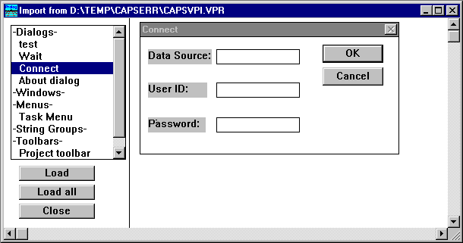

Figure 53.1: Importing resources.
It is possible to scroll up and down in the list of resources to view how they look. When a menu is selected, the menu will be displayed as the main menu in Visual Prolog, here it can be inspected until the mouse is pressed in any other window. When a resource should actually be imported, press the Load button to import the definition into the .VPR project file.

The Window and Dialog Editor

The Window Editor and Dialog Editor are very closely related. The only real difference is that the definitions of dialogs are (normally) put into resource files, whereas windows are always created by code. If the windows contain any controls, these are created by the code in the e_Create event for a window.

Creating a Dialog
When creating a new dialog from the Project window, the Dialog Attributes dialog will appear on the screen:
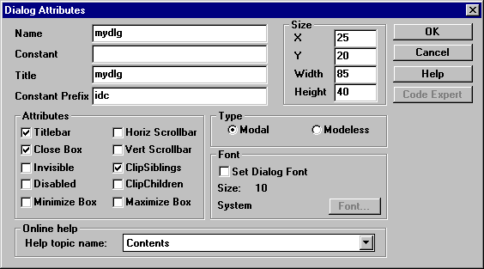

Figure 54.2: The dialog used to create a new dialog.
Normally, you will just type in the name of a new dialog and press the OK button. After clicking OK the new dialog will be created and its name will be added to the list of existing dialogs for the current project. You can always go back and select attributes for the dialog to change any of the dialog attributes.
The possible settings for a dialog are:

Name
This is the name of the dialog. It appear in the Dialogs list of the Project window, and it will be used by the Code Expert in the names of the predicates to handle the code for the dialog.

Title
At run time this text appears in the title of the dialog window. This field is ignored if the Titlebar check box is not checked.

Constant
This is the resource constant for the dialog. When you type in a name, a default constant will be generated, which you can decide to change.

Constant Prefix
The constant prefix used by the Window and Dialog Editor when generating resource identifiers for the controls in the dialog. This can be changed.

Attributes
This group contains the style flags for the dialog, which will control the look of the dialog window.

Titlebar (wsf_TitleBar)
When this value is checked, the dialog will have a title bar.

Close Box (wsf_Close)
When this option is checked, the dialog will have a close box.

Invisible (wsf_Invisible)
Specifies that the dialog will be invisible when first opened. This option is disabled if the dialog type is Modal.

Disabled (wsf_Disabled)
Determines if the dialog is displayed as disabled (grayed) when it is opened. This option is disabled if the dialog type is Modal.

Minimize Box (wsf_Minimize)
Creates a minimize box in the title bar for the dialog window. Disabled if the dialog type is Modal and disabled if Titlebar has not been checked.

Horiz Scrollbar (wsf_HScroll)
When checked, includes a horizontal scroll in the dialog.

Vert Scrollbar (wsf_VScroll)
When checked, includes a vertical Scroll bar in the dialog.

Clip Children (wsf_ClipChildren)
Specifies that drawing over any child windows should be clipped.

Clip Siblings (wsf_ClipSiblings)
Specifies that two dialogs with the same parent window should use clipping.

Type
The Type radio buttons group box contains the Modal and Modeless radio buttons. A modal dialog prohibits the activation of another window or dialog in the same application until the modal dialog has been completed and exited.

Font
This group selects the text style used in the controls of a dialog. When the Set Dialog Font check box is checked, the Font button can be used to specify a font from the standard font dialog. Note that the dialog can not be edited with the selected font, but by using Resource | Test Mode it is possible to see how the dialog will look. The Dialog Base Unit size is scaled by the operating system depending upon the font size - but note that bitmaps and icons are not scaled. Be careful not to specify any fonts that may not exist in the environments where your application might be used.

Size
This group determines the position and size of the dialog. The co-ordinates are given in Dialog Base Units. One unit in the x direction is equal to one quarter of the dialog base width unit. One unit in the y direction is equal to one eighth of the dialog base height unit. The dialog base units are computed from the height and width of the system font.

On-line Help
Here you can determine which (existing) Help Topic will be displayed when the dialog's Help button is selected at run time.
The selection list of the Help Topic Name list button displays the names of help topics contained in the Hyperbase created by the PDC Help Maker.

Editing a Dialog
To edit a dialog, choose the name of dialog in the Project window's list of dialogs and double click on it, or activate the Edit button in the Project window. The Window and Dialog Editor window appears and you can create whatever form of dialog you wish.
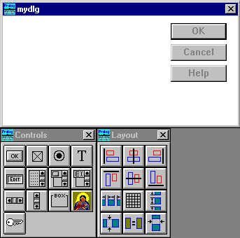

Figure 55.3: The Window and Dialog Editor after creation of a new dialog.
When a new dialog is created, it will by default have the three push button controls: OK, Cancel and Help. These can freely be rearranged or deleted.

Dialog Controls
Each control in a dialog must have an identifying constant which is unique within that dialog. While two controls within one dialog may not have the same constant name or value, it is actually a good idea if controls in different dialogs that perform the same action have the same constant name and value.

Types of controls
. | A PUSH BUTTON control serves to initiate a specialized action in an application.
 | A CHECK BOX control lets you indicate a choice between two alternatives. For example some facility may be switched ON or switched OFF.
 | A group of RADIO BUTTON controls serves to indicate one choice from among a list of alternatives.
 | The VERTICAL SCROLL BAR control and the HORIZONTAL SCROLL BAR control serve to select a value within a scale of values.
 | A STATIC TEXT control reserves an area for the text in the dialog. Although called static, in fact the application can change the text during execution. This is often used for prompts or field names relating to other controls.
 | An EDIT CONTROL reserves an area for text editing (e.g. names, numbers, text constants etc.). Editing text strings with multiple lines is possible.
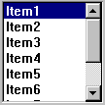 | A LIST BOX allows you to view a list of elements and to select one - or more -elements from this list.
 | A LIST BUTTON control serves for choosing one from the pop-out set of the alternatives revealed by pressing the button. Pressing the button again pops the list back in again.
 | A LIST EDIT control allows single line text editing like an EDIT CONTROL, or selection from a list of elements.
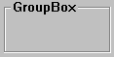 | A GROUP BOX control serves for assembling together a number of controls in a functional group with a Group Name. Its only function is a visual one.
 | An ICON control reserves an area for an icon image.
 | A custom control can either be a window class defined in Prolog by class_Create, or be some custom controls from .DLL's, .VBX's or OCX's.

Inserting the Controls
To insert a new control in a dialog, click the chosen control from the Controls toolbar. Then move the cursor to the position in the dialog where you want the control and place it by clicking the mouse button. Also you can use the Controls menu item in the main menu bar of Visual Prolog VDE. Instead of dropping a control into a dialog with a click, it is possible to drag out the rectangle where the control should be placed.
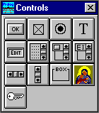

Figure 56.4: The Controls Toolbar.

Selecting and Deselecting the Controls
To select one control click inside it. A frame appears around the selected control.
To select a group of controls move the mouse pointer to the point in the dialog you want to be one corner of the selected area and press and hold the left mouse button. While holding the left mouse button move the mouse until all the desired controls in the dialog are inside the selected area. Then release the mouse button. All controls inside the rectangle will be selected.
Also after one or more controls are already selected, you can include one extra control in the selection by holding down the Ctrl key and click on the control.
To deselect the control or group of controls click outside the selecting frame. Deselected controls lose their frame.

Re-sizing Controls
Once a control has been inserted in the dialog, it has a default size. To re-size a control, first click inside the control area to select it. Then move the cursor to the sizing handles on the selection frame. A new shape of cursor indicates the direction in which you can re-size the control. Press and hold the mouse button, drag until the selected control has the size you want, then release the mouse button.
You can also change the size of a control by double-clicking it to activate the dialog for control attributes setting. Select the position you want to change and after specifying a new position or size, press enter to return to the dialog.
Remark: You cannot change the size of icons. You can only change their location.

Moving Controls
To move a control or a group of controls first select them. Then move the cursor inside the selection frame, press and hold the mouse button, and drag to the new location and release the mouse. Also, when one or more controls are selected, it is possible to use the cursor keys to move the selection in small steps.

Arranging Controls
To arrange a Group of Controls first select the group. Then click a button in the Layout toolbar or a menu item in the Layout menu on the Visual Prolog menu bar.
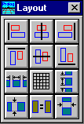

Figure 57.5: The alignment options.

Cut, Copy and Paste, Undo and Redo
You can Cut or Copy a group of selected controls on to the Windows Clipboard, and Paste controls from the Windows Clipboard back into a dialog. Undo and Redo commands serve to delete or restore the last operations in the editing of your dialog.

The GRID
When the menu entry Resource | Grid is activated, or when the  button from the Layout toolbar is pressed, the following dialog appears:
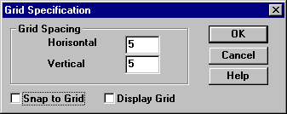
Figure 58.6: The dialog to specify the grid properties.
With a grid in place, arranging the controls inside a dialog is easier. Also it is possible to tell the Window and Dialog Editor by "Snap to grid" that it should only place the controls at the grid intersections to give a satisfactory result.
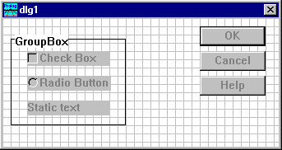

Figure 59.7: Using a grid in the Window and Dialog Editor .

Test Mode
The Window and Dialog Editor has a Test mode, so it is possible to see how the dialog with the created controls behaves. To illustrate the Window and Dialog Editor we will assign some default values to the controls. The test mode is activated and deactivated from the Resource menu.
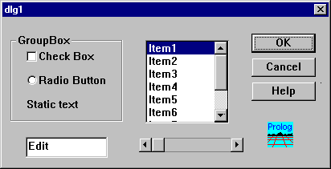

Figure 60.8: Test mode for a dialog.

Tab Stops
When activating the menu entry Resource | Tabstops, it is possible to specify which controls you can Tab to in a dialog. When this menu entry is activated a small button with a + or - appears for each control depending on whether the control has a tab stop or not. By clicking on the small buttons, it is possible to toggle the setting.
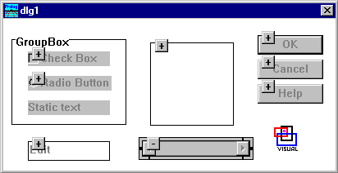

Figure 61.9: Specifying tab stops for a dialog.
To exit the tab stop mode, just click in the dialog but outside of any controls.

Visit Order
When the tab stops have been specified for a dialog, it is then possible to specify the order in which controls will receive focus when tabbing.
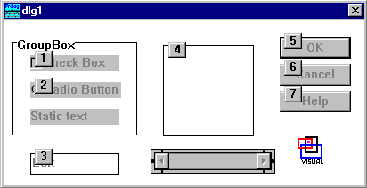

Figure 62.10: Displaying the visit order.
To change the visit order, click on a control that has an incorrect sequence number and this will bring up another dialog to change this sequence:
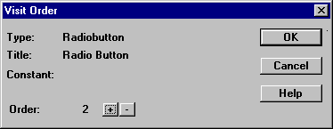

Figure 63.11: Changing the visit order.
To stop the visit order mode, just click in the dialog outside any controls.

Control Attributes
To change the attributes of a control, double-click on it. There are two levels of attributes for controls. First, a general dialog will appear, showing title, constant name, size and position of the control.
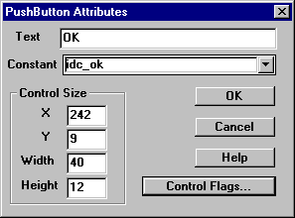

Figure 64.12: The general control attributes.
Then it is possible to activate the push button Control Flags to specify which wsf_ flag values should be specified for the control. The explanation of each of the flag values is found in the VPI manual in the table for General Control Style Flags.
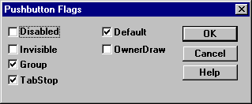
Figure 65.13: The push-button attributes.
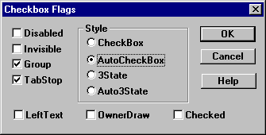
Figure 66.14: Attributes of a check box control.
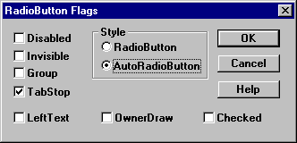
Figure 67.15: Attributes of a radio button control.
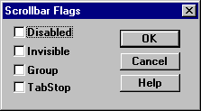
Figure 68.16: Attributes of a horizontal scroll bar control.
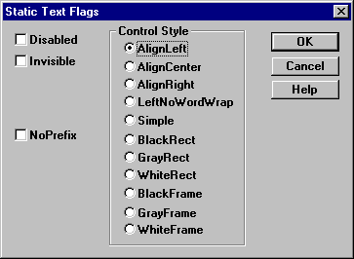
Figure 69.17: Attributes of a static text control.
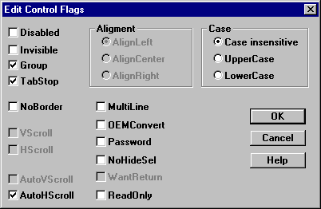
Figure 70.18: Attributes of an edit control.
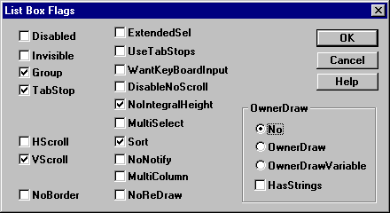
Figure 71.19: Attributes of a list box.
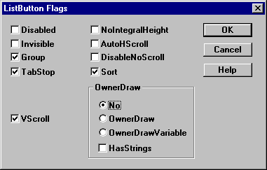
Figure 72.20: Attributes of a list button.
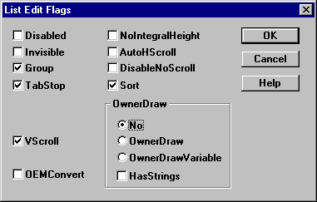
Figure 73.21: Attributes of a list edit control.
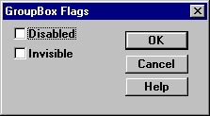

Figure 74.22: Attributes of a group box control.

Creating a Window
To create or edit a window for your application, click the Window button on the Project window toolbar. In the Project window, the list of previously created windows for the current project appears.
To edit the chosen window double click on its name in the list. The window for your application window design appears. To edit a window in your application, you use the same controls and edit commands as for dialogs.
To edit your window attributes click on the Attribute button in the Project window - or double click in the window area of the open Window and Dialog Editor. The following dialog appears:
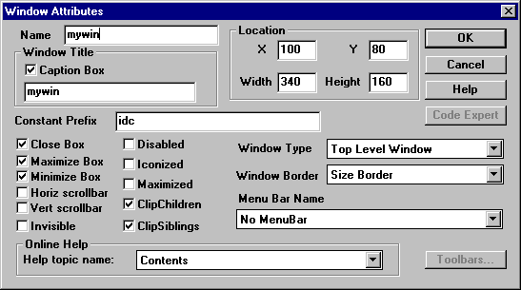

Figure 75.23: Changing window attributes.
In this dialog, you can specify a number of properties for the window: position when created, window title, whether the window has close, minimize, maximize boxes, scroll bars etc., how the window should appear when it is initially created, and what prefix should be used for generating control constants for the window.
There are two window types: A Top-Level window, which can have a menu bar associated, or a Child window, which appears within another window.
If the window is a top-level window, the menu can be selected for the window. The list button contains a list of the menus that are defined in the project.
The Toolbars push button is used to associate toolbars with the window.
The Code Experts for window handling will know when a menu is selected for a window, or when toolbars are joined to the window.
The Help Topic name is used to select which help topic is activated when the Help button for the window is activated.

Editing a Window
While all dialogs have controls, many windows are only used for drawing. But it is still possible to use the Window and Dialog Editor to place controls in a window. While the description of a dialog is normally put in the resource segment for an executable, the controls for a window are normally created in the code by calls to win_CreateControl in the e_Create event for the window.
Editing a window in the Window and Dialog Editor is nearly the same as editing a dialog, the only difference being that tab stops and visit order are not defined since the TAB handling only works for dialogs.

Resource String Editor

The resource string editor is used to create string tables in the resource file. A string table can hold the error messages, prompts, or any other text strings your application needs to display. You can store multiple string tables in your project file. Typically, you will define a separate string table for each logical division of your program.
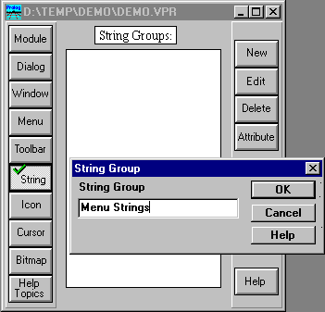
Figure 76.24: Using the Project window to create a new string group.
When clicking on a given string group a new dialog will open. This dialog contains the strings for that group, and it allows you to modify the existing strings, delete old or add new ones. Also cut, copy and paste can be used with strings.
Each resource string must have a project-unique identifier.
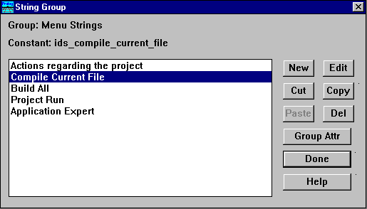

Figure 77.25: Editing resource strings in a string group.

Toolbar Editor

The toolbar editor allows you interactively to create a layout for various kinds of toolbars. In the Project window, there is a special toolbar selection:
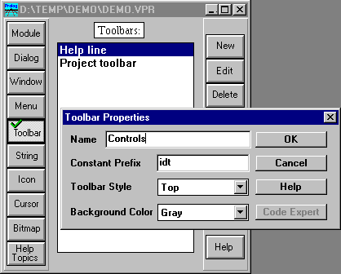

Figure 78.26: Using the Project window to create a new toolbar.
When you click on new to create a new toolbar, you are only prompted for a name, since the toolbars are not placed in the resource files. You can also specify what style the toolbar should have (left, bottom, right, inside, moveable), and what the background color of the toolbar should be.
Clicking on one of the previously registered toolbars brings up the Toolbar Editor. It shows the toolbar as the application will show it.
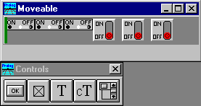

Figure 79.27: Editing a toolbar.
There are several kinds of toolbars. And since the layout of a toolbar merely reflects which controls come after each other, it is easy to change the style of the toolbar.
A click anywhere in the window area outside the toolbar brings up a dialog with the attributes of the toolbar:
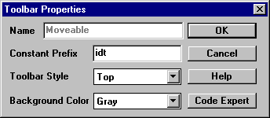

Figure 80.28: Changing toolbar properties.
The Constant Prefix is used by the VDE to name the constants for the controls in the toolbar. The Background Color of the toolbar can be set to one of the sixteen pre-defined colors.

The Toolbar Style can be one of the following:

Table 81.1: Toolbar Styles.
Toolbar Style | Toolbar location
top | Placed at the top of window
left | Placed at the left side of the window.
bottom | Placed at bottom of window.
right | Placed at the right side of the window.
inside | Placed at a fixed location inside the window (The Graphics Editor uses several of these).
movable | A floating toolbar, which the user can move around.
If the previously shown toolbar is changed to have the inside style, it could look like the following:
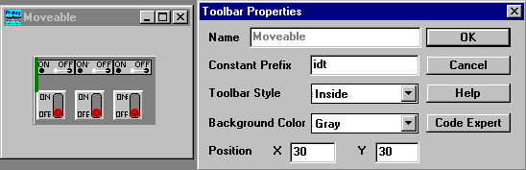

Figure 82.29: Toolbar style changed to "inside".

Controls in a Toolbar
There are several kinds of controls that can go into a toolbar.

Table 83.2: Controls in a Toolbar.
Control | Description
Push Button | This works like a push button: when pressed it sends an e_Menu command to the parent window. Three icons must be registered for the button; a normal, a pressed and a disabled view.
Check Button | This is used for a property that can have three states; either pressed, released or disabled. Again you must register three icons for a check button, one for each state.
List Button | A list button can be used to select from a number of values.
Static Text | Text may be placed in this control initially and also dynamically.
Context Sensitive Text | If a context sensitive control is put into the toolbar, this field will display help information about the control the mouse is currently located over.
Separator | A separator is like a space; it is used to make some space between the other controls, usually to divide them into functional groups.
New Row | New row is relevant only for toolbars with the style inside and movable. A New Row control will cause the current line to break, and the following controls to appear on the next line of toolbar.
The layout of the toolbar can be done both with the keyboard and with the mouse. There is an insertion point that is marked with a colored bar. This insertion point can be moved with the arrow keys, or by clicking the mouse on the new location. When the insertion bar is at a given location, the control to the right of the bar can be deleted by pressing the Del key, and the control to the left can be deleted by pressing the Backspace key.
A new control can be inserted at the insertion point by clicking on an item in the controls menu. After the control is inserted, it is possible to change the attributes for the control by double-clicking on the control.

Push Button and Check Button
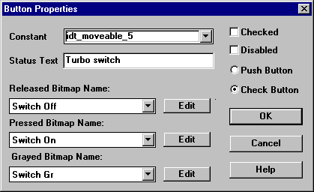
Figure 84.30: Specifying properties of push buttons and check buttons.
As can be seen from the dialog, the first piece of information that must be specified is a Constant name to identify the control. This is the constant that will be used in the e_Menu events.
Next is Status Text which is used for two different purposes. The field can contain two strings separated by a semicolon. The text before the semicolon is used to display a yellow tool tip, the text after the semicolon is displayed if the toolbar contains any context sensitive fields. The text entered into this field will be displayed when the mouse cursor is over the current button. For example, the text "New;New file" will cause "New" to be shown in the yellow tool tip while "New file" will be shown in a context sensitive field when the mouse is over the button.
It is possible after creating a button to change between Push Button and Check Button style. Just select the appropriate radio button.
The three icons for the Released Bitmap Name, the Pressed Bitmap Name and the Disabled Bitmap Name can be selected from the list of icons registered in the Project window. When clicking on the Project window Icons button a list of the registered icons will appear, and the desired icon can be chosen. If the Edit button is pressed, the Graphics Editor will open containing the selected icon allowing you to view and edit the icon.

Text Controls
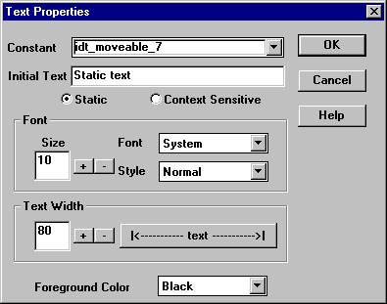
Figure 85.31: Specifying properties of text controls in a toolbar.
For a text control it is possible to select font, size and color for the text. There is a radio button that can select whether the field should be a regular Static text field or a Context Sensitive text field.

List Button
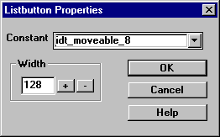
Figure 86.32: Specifying properties of list buttons in a toolbar.
The only property that can be set for a list button in a toolbar is the Width.

The Menu Editor

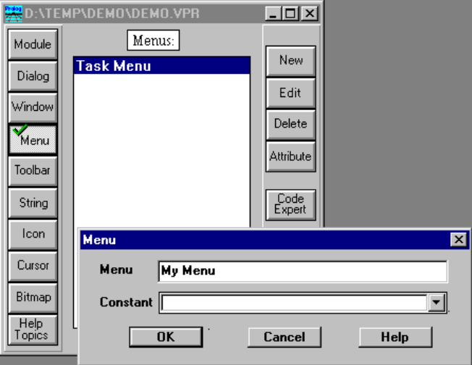
Figure 87.33: Using the Project window to create a new menu.
The Menu Editor can be used to create menus that can be used as both pull-down menus for windows, and as pop-up menus for object oriented user interfaces. When a menu has been created in the Project window, double clicking on it will bring up the Menu Editor.
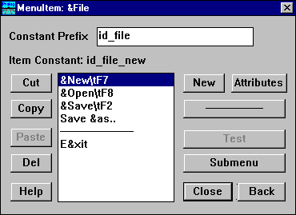

Figure 88.34: Editing a menu.
By pressing the New button, it is possible to create a list of menu items, which can optionally be presented in groups by inserting separators. The Menu Editor can create nested menus to any level by clicking on Submenu.
By pressing Attributes for a selected menu item, you can inspect and change the constant that is used to identify the entry from the Prolog source code.
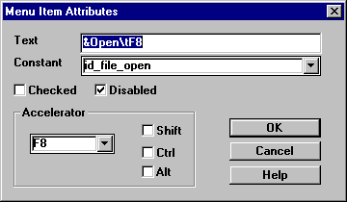
Figure 89.35: Changing attributes of a menu item.
Whether the menu item will be Checked or Disabled at initial display can be controlled here. It is possible to define an Accelerator key (hot key) for a menu item. In the list-edit field, you can type in either a letter, or pick a special character from a list, and in the check boxes the desired combination of Shift, Ctrl and Alt can be specified.

The Graphics Editor

The Graphics Editor is a convenient tool for creating, viewing and editing icons, cursors and small bitmaps. The images can be passed to the Windows Clipboard or saved in files.
The Graphics Editor allows you to create and edit images ranging in size from 4x4 pixels to 64x64 pixels, by using either a 16-color palette or monochrome shadow palette.
The Graphics Editor is invoked from the Project window for Icons, Cursors and Bitmaps. However, when you register large bitmaps in your project, Visual Prolog will call the Windows Paintbrush program instead to edit the bitmap.
When you create a new bitmap in the Project window, you need to specify the size of the bitmap and how many colors it will have.
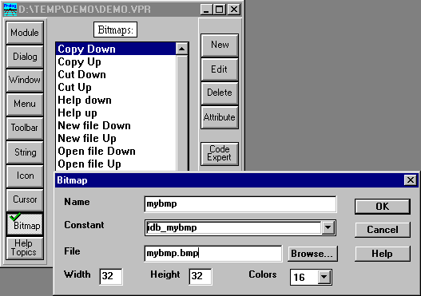

Figure 90.36: Using the Project window to create a new icon.

Graphics Editor Window
After the Graphics Editor is started, the Graphics Editor window will appear on the screen:
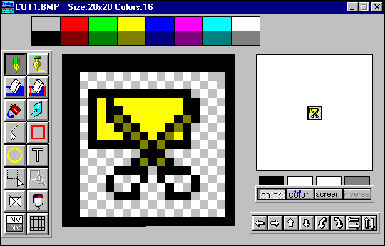

Figure 91.37: The Graphics Editor window.
The Graphics Editor window is divided into several areas. Each area is responsible for a definite function or combines a number of tools which are associated by purpose.

The Title Bar
The Title Bar of the Graphics Editor window serves to display information about the type of the image (icon, cursor or bitmap), the image size in pixels, the number of colors which are available for use, and the name of the file which is opened for the current image.
For example, the title bar in the Graphics Editor window, which is shown above, says that the type of current image is an icon, the size of the current image is 20x20 pixels, 16 colors may be used in the image and the name of the file which is opened for current image is CUT1.BMP.

Menus
When the Graphics Editor window is active, the Visual Prolog menu bar displays the Graphics Editor menus and looks as follows:
Figure 92.38: The Visual Prolog menu bar when the Graphics Editor is active.
Note that there are two entirely new Menu items: Tools and Move, but also Edit and Options are specially tailored for the Graphics Editor, and the File operations refer now to the image files.

The Graphic Field
The Graphic Field is situated in the middle of the Graphics Editor window.
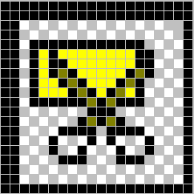

Figure 93.39: Sample contents of the Graphic Field.
The Graphic Field lets you see and edit the current image in expanded mode. The Graphic Field consists of small cells, where each cell corresponds to one pixel on the actual size image. The number of cells in each horizontal row and the number of cells in each vertical column give the image size, which is displayed in the title bar of the Graphics Editor window. It is possible to turn on and off a grid in the Graphic field.

Image Screen
To the right of the Graphic Field you can see the Image Screen, painted in background color. In the middle of Image Screen you can see the current image in actual size on the selected background color. By changing the background color you can see how your current image will look in various surroundings.
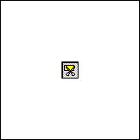

Figure 94.40: The image screen.

Moving, Rotating and Flipping
To the right of the Graphic Field, under the Image Screen, you can see the Image Move toolbar.
Figure 95.41: The toolbar that allows moving, rotating and flipping an image.
By clicking on the appropriate button you can move, rotate or flip the current image.

Table 96.3: Explanation of the icons for moving, rotating and flipping an image.
UP: moves the image one pixel row up. The top row crosses the upper borderline of the Graphic Field and returns to the Graphic Field as the bottom row.
DOWN: moves the image one pixel row down. The bottom row crosses the bottom borderline of the Graphic Field and returns to the Graphic Field as the top row.
RIGHT: moves the image one pixel column to the right. The right edge column crosses the right borderline of the Graphic Field and returns to the Graphic Field as the left edge column.
LEFT: moves the image one column to the left. The left edge column crosses the left borderline of the Graphic Field and returns to the Graphic Field as the right edge column.
TURN CLOCKWISE: rotates the image 90 degrees clockwise around its center.
TURN COUNTER-CLOCKWISE: rotates the image 90 degrees counter-clockwise around its center.
FLIP VERTICAL: flips the image around the horizontal axis.
FLIP HORIZONTAL: flips the image around the vertical axis.
The Move menu contains the same commands as the Image Move toolbar.

Undo / Redo
The Graphics Editor supports Edit | Undo and Edit | Redo operations, just as the other editors do. Undo and Redo are also available from the pop-up menu for a right-button mouse click within the Graphic Field.

Cursor Hot Spot
When working with a cursor, the menu command Edit | Set Cursor Hotspot activates a dialog box:
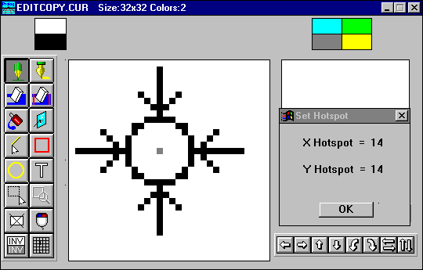
Figure 97.42: Defining a hot spot for a cursor with the Graphics Editor.
As long as this dialog is open you can point to the pixel which is to be the cursor hot spot. This pixel in the cursor will determine the screen pixel which will be acted upon and which will be reported during a mouse action.

Testing a Cursor
When working with a cursor, the Tools | Test cursor menu item allows you to see what your newly designed cursor will look like.

Image Attributes
When the Options | Set Image Attributes menu item is activated from the Task window menu or from the Graphic Field right-click pop up menu, the following dialog appears:
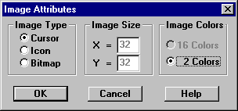

Figure 98.43: Specifying image attributes.
This dialog lets you set the Image Type (cursor, icon or bitmap), the Image Size, and the number of available colors. Remember that for creating cursor images only 2 colors are available - the color black and transparent for background "color".
Note: if you make any changes to the image attributes, your previous image will be cleared.

Understanding Colors for Bitmaps.
The Visual Prolog Graphic editor can create bitmaps with either 2 or 16 colors. A pixel in a bitmap can not have the inverse and screen colors.

Understanding Colors for Cursors
Any pixel in a cursor can have one of four color control values:

Table 99.4: Colors a cursor can use.
Cursor Color | Effect
Black | Pixels will be black.
White | Pixels will be white.
Inverse | Pixels will be converted to the inverse of the original color.
Screen | Pixels will be transparent, they will just keep their old color.
To understand how this works, you should create a little cursor having four areas with these four color control values. Then select Tools | Test cursor, and study how the cursor looks.
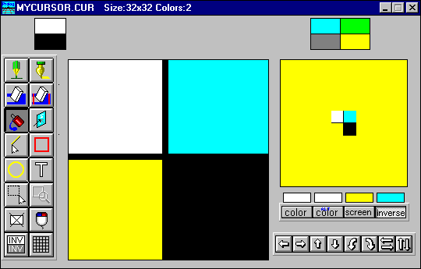
Figure 100.44: Editing a cursor showing all four possible color control values.

Understanding Colors for Icons.
Icons can either have 2 or 16 colors, and in addition to those, the pixels can also use the screen and inverse colors.

The Color Palette
At the top of the Graphics Editor window you can see the Color Palette.

Figure 101.45: The color palette.
The Color Palette lets you choose colors for the drawing operations.

Selecting Colors
To choose colors for the drawing and editing tools you can select one of the following four switches. The color of selection will be used for the drawing. It is possible to choose a new color for the active selection by a click in the Color Palette.
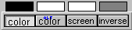
Figure 102.46: The Graphics Editor controls that set the draw and edit colors.
Color and Alt-Color can be used in all drawing operations, the Screen (Or Transparent) and Inverse selections have different purposes depending on the image type.

Table 103.5: Usage's of Screen and Inverse Colors.
 | Screen | Inverse
Bitmaps | Used to set the color of the surrounding area. | Can not be used.
Cursors & Icons | Used to specify transparent pixels. And also used to set the color of the surrounding area. | Used to specify pixels that should get a color inverse of the actual background.

Using the Draw and Edit Tools
The Graphics Editor provides a number of tools to make creating your image easy. The tools can be activated either from the Tools menu or from the Drawing Toolbar. The Drawing toolbar is located to the left of the Graphic Field. It contains the main tools for drawing and editing.
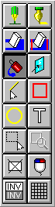

Figure 104.47: The toolbar of the draw and edit tools.

Pen
 The Pen tool can be used to color an individual pixels on the Graphic Field.

Brush
The Brush tool works the same as Pen tool, except that the Brush tool leaves a larger mark than the Pen. The style of the Brush can be changed by selecting the Options | Set Brush Style menu item on the Task window menu or from the Graphic Field right-button pop-up menu.
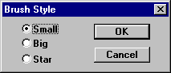

Figure 105.48: Selecting brush styles.

Eraser
To erase a fragment of the image (the same as painting it with the Screen Color), you can use the Eraser Tool in the toolbar.
The size of the Eraser can be changed by selecting the Options | Set eraser style menu item from the Task window menu or from the Graphic Field right-button pop-up menu.
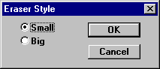

Figure 106.49: Selecting eraser styles.

Erase Color
 The Erase Color tool will erase cells of the selected color without changing the other colors.

Fill Contour
The fastest way to color an area which has an enclosed boundary is to use the Fill Contour tool. Move the cursor into the area to be colored and click the mouse button. The interior of the bounded region will be colored.

Line
 Selecting this button enables you to draw a line between any two points in the image.

Rectangle
 Click on this button if you need a rectangle. Size the Rectangle by drawing it out with the left button held down, then release.

Ellipse
 Choose this tool if you need to draw a circle or an ellipse. Size the circle or ellipse by drawing it out with the left button held down, then release.

Text
 Click on this button to insert some text in your image. Move the cursor to the position on the Graphic Field where you want to start the text and click the mouse button. You will see a text cursor which shows you the height of the letters and digits and the starting point for the current line of text. When you type some text, it will be drawn in the currently selected color, with the currently selected font.
While the text is still selected it is possible to move the starting point of the text by clicking with the mouse on the new position.

Mirror
 To create symmetrical images use the Mirror tool. The Mirror tool sets the points which are the reflections of the cursor trail point relative to the different axes of symmetry. To choose the appropriate axes of symmetry for the Mirror tool select the Options | Set Mirror Style Task window menu item or right-button pop-up menu item.
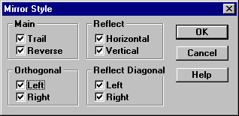

Figure 107.50: The mirror styles.

Marking a Region
 To mark a rectangular fragment of the image on the Graphic Field to be cut, copied or moved, use the Mark Region tool.
You can move the marked region to another part of the Graphic Field by means of "drag and drop": Move the cursor into the marked region and press and hold the mouse button, then, keeping the mouse button depressed, drag the marked fragment to the place of your choice and release the mouse button. Now the marked region is fixed in its new place.
If you want to copy the marked region to another place, do as described under move, but hold down the Ctrl key while pressing the mouse button in the marked region.
When a region is marked you can use Edit | Cut or Edit | Copy (or the right button pop-up menu or the standard accelerator keys) to place it to the clipboard. You can use Edit | Paste (or the Paste tool icon, or the pop-up or accelerator) to scale a image from the clipboard into the region.
Note: When you use Edit | Paste and no region is active, the image fragment will appear in the left top corner of Graphic Field. The region may be moved to another place by the mouse.

Paste & Scale into marked region
 When an image has been copied to the clipboard, this image can be pasted back into another marked area by pressing this button. This button will stay disabled until there is both an image on the clipboard, and a region has been selected.

Clear the Graphic Field
 To clear the Graphic Field, click the Clear button. The color of the Screen selection will be used.

Change a Selected Color
 With this button you can change all pixels that have a given color into another color. The two colors should first be set for the Color and Alt-Color selections.

Inverse Colors
 This button can be used to invert all colors on the image. In this case, any pixels which were colored in background color or in inverse to background color will retain their existing colors.

Converting Bitmaps into Icons and Vice Versa
To convert bitmaps into icons and vice versa push the Bitmap or Icon button in the Project window to choose the source image. Double click the image name or push the Edit button on the right side of the Project window to open the image file. To mark an image to be copied click the Mark Region tool. When a region is marked you can place it to the Clipboard.
Click the Icon button if you want to convert a bitmap into an icon, or Bitmap to convert an icon into a bitmap. Push the New button on the right side of the Project window to create a new image. Double click the new image name or push the Edit button to open the image file. Paste the image from the Clipboard.

CHAPTER 108

The Code Experts
109There are several Code Experts in Visual Prolog. We have already seen the Application Expert, which generates all the default code, resources and make-scripts for an application.
The other Code Experts are 1) the Dialog and Window Expert, 2) the Dialog Package Expert and 3) the Toolbar Expert. These three code experts are used for generating Prolog source code after the layout of resource components have been created.
The advantages of the Code Experts are that 1) it save a lot of typing, 2) it gives a standardized way of handling things, 3) you know your application from the user interface; then by using the code experts, you can easily come to the source code through selection of the user interface component. A slight disadvantage is that the code experts insert some extra comments which they use to be able to locate the generated source code at a later stage.
The Code Experts can automatically update the source code that they generate when the layout or attributes of a user interface component are modified. This automatic updating can be turned on or off for each component, and the automatic updating is always only done inside comment brackets marked by "Code automatically updated" like in:
%BEGIN ww, CreateParms, 10:25:21-7.11.1995, Code automatically updated!
win_ww_WinType = w_TopLevel
win_ww_Title = "ww"
win_ww_Help = idh_contents
%END ww, CreateParms
The code for handling the resources is inserted in the source files, and it is possible to go into a text editor and modify the code. However you should take care not to modify the %BEGIN - %END comments, and you should know that if you put code into the "Code automatically updated" sections, you will lose that code without any warning at the next automatic update.
There is a restriction that the code produced and maintained by the code experts must be in a project module and can not be in an include file.
The major advantage of the code experts comes when somebody else takes over your code - or if you are doing maintenance later on. You may or may not choose to use the generated code for creation of a window, but there should be very good arguments for not using the code experts to manage the window and dialog event handlers.
The Prolog code to be generated by the code experts can be previewed by the Resource | Preview PRO Text menu item.

Dialog and Window Expert
The Dialog and Window Expert is the tool which connects Prolog code to the layout of windows and dialogs. After a dialog or a window is designed, the Dialog and Window Expert can be used to insert the necessary Prolog code to manage window and dialog creation and event handling.
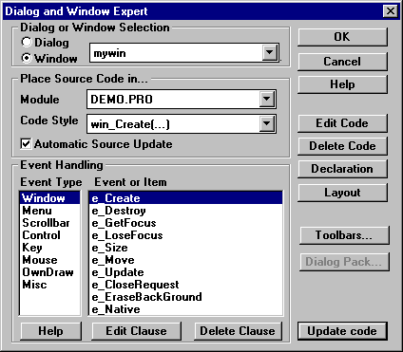

Figure 111.1: The Dialog and Window Expert.

Generating the Default Code for a Window
When a dialog or window is selected in the Project window and the Code Expert button is pressed, the Dialog and Window Expert appears with that window or dialog selected, but that pre-selection may be altered. If entered outside the context of a dialog or window, the first thing to do is to select whether it is a Dialog or a Window that is to be handled, and then select the actual dialog or window.
Next you must select which Prolog Module contains, or is to contain, the generated source code. Using the list button for module, you select the correct module from the list of registered modules.
The next thing to select is the Code Style, which determines how the dialog or window will be created. For now, just choose win_Create, the other possibilities will be explained later.
The check box for Automatic Source Update selects whether or not the code experts should automatically update the source code whenever the layout changes.
When these basic fields are set up properly, the push button Default Code, should be activated. If this button is grayed, an inappropriate code style might have been selected. Pressing Default Code will cause a global declaration for the predicate to create the window to be added to the header file for the module (<module>.PRE) and the creation predicate clauses and the event handling code to be added to the end of the selected module. The button title will then change to Update Code.
The Code Expert updates the source when the Update Code button is pressed, or, if automatic source update has been requested in the Code Expert, before any compilation of a module.

Looking at the Default Code for a Window
Press the Edit Code button in the Dialog and Window Expert to present the module in an editing window with the cursor set at the generated code:

%BEGIN_WIN ww
/**********************************************************************

Creation and event handling for window: ww
**********************************************************************/

CONSTANTS
%BEGIN ww, CreateParms, 10:25:21-7.11.1995, Code automatically updated!
win_ww_WinType = w_TopLevel
win_ww_Flags = [wsf_SizeBorder,wsf_TitleBar,wsf_Close,wsf_Maximize,
wsf_Minimize,wsf_ClipSiblings,wsf_ClipChildren]
win_ww_RCT = rct(100,80,440,240)
win_ww_Menu = no_menu
win_ww_Title = "ww"
win_ww_Help = idh_contents
%END ww, CreateParms

PREDICATES
win_ww_eh : EHANDLER

CLAUSES
win_ww_Create(Parent):-
win_Create(win_ww_WinType,win_ww_RCT,win_ww_Title,
win_ww_Menu,Parent,win_ww_Flags,win_ww_eh,0).

%BEGIN ww, e_Create
win_ww_eh(_Win,e_Create(_),0):-!,
%BEGIN ww, InitControls, 10:25:21-7.11.1995, Code automatically updated!

%END ww, InitControls
%BEGIN ww, ToolbarCreate, 10:25:21-7.11.1995, Code automatically updated!

%END ww, ToolbarCreate
!.
%END ww, e_Create

%MARK ww, new events
<----------- The extra events are added here

%END_WIN ww
When looking at this Default Code, note the following:
- The %BEGIN "Code automatically updated!" and %END markers mark a section of source code in which code experts will - if the check box for Automatic Source Update is checked - automatically update the source code if any selections are changed in the layout editor or in the attributes dialogs.
- The attributes and layout parameters for a window (rectangle, menu, title etc.) are defined as constants in the Constants section CreateParms. These constants can be used or ignored.
- In the header file for the module (<module>.PRE), a global declaration will be inserted for the predicate to create the window.

GLOBAL PREDICATES
%MARK, insertion point for global window creation predicates
win_ww_Create(WINDOW Parent) - (i)
- In most applications, the returned handle to the newly created window needs to be saved and some more arguments might need to be passed into this win_ww_Create predicate. These changes can be made because the code once it has been generated will never be updated by the code experts.
- Hint: If there is some code in a "Code automatically updated" block that you do not need, or you would really like to change, you can just put a /* */ comment around the %-block markings.
- The BEGIN - END WIN_XXX, e_Create marks the place for clauses for handling the create event. These markings are used to later locate the code, and the user can make any modifications needed inside the markings.
- In the clause for the e_Create event, there is a block marked with "%BEGIN ww, InitControls",. This block will be used if there are any dynamically created controls defined in the window. Also the e_Create event clause contains a block %BEGIN ww, ToolbarCreate where creation code for any toolbars in the window will be inserted.

Event Handling
In the Dialog and Window Expert, there is a group box called Event Handling. In this group, it is possible to add (or delete) clauses for the Event Handler predicate of the window.
The events are grouped into various types, so before selecting the actual event, you must select the appropriate type of event.
When an event is selected, it is possible to push the Help button to read a description of the event from the on-line Help file.
If there is not already a Clause for the event, push the Add Clause button to add a new Clause to handle the event. As an example, the following code will be pasted in if you press Add Clause for the e_Update event:

%BEGIN ww, e_Update
win_ww_eh(_Win,e_Update(_UpdateRct),0):-!,
!.
%END ww, e_Update
The Comments: "%BEGIN ww, e_Update" and "%END ww, e_Update" are used to locate the clause later.
You will see that the push button changes from Add Clause to Edit Clause if a clause for the event exists. In this way, it is easy to find the code that handles any particular event.
If the code for an event is no longer needed, you may press the Delete Clause button. This will delete the code between the %BEGIN - %END comments, including those comments. Also it is possible to just go into the editor and delete the code from there.

Code styles
In the Dialog and Window Expert there is a selection called Code Style. With this setting it is possible to specify that the window should be created by the win_Create predicate, or through the use of a WINDEF structure using win_CreateDyn, or to contain an editor, or to contain a tree, or to use the Dialog Package.
The selections refer to the predicates used to create the windows, and it is necessary to take a look at each of these predicates to understand the code styles. The creation code is different for each of the code styles, however the event handler predicates are always the same.
It is possible to change the code style at a later point. The Event handler clauses will be saved. But any code changed in the creation predicate of the window will be lost.
The code styles are named for the VPI predicates used. These predicates are documented in the VPI manual. They form three groups, Window Creation, Dialog Creation, and Custom Control Creation:

Code Styles for Window Creation

win_Create
This code style is the most often used style for windows. The generated code will make a call to win_Create and any controls for the window will be created in the e_Create event in the event handler predicate.

win_CreateDyn
In this case the window is to be created dynamically as specified in a WINDEF structure. The WINDEF structure will be generated in the source module from information in the project database for that window.

edit_Create
This creates a window which will use the VPI editor at run time. In the event handler predicate it is possible to change the default handling for any event.

edit_CreateWrap
This makes a call to the editor in line wrapping mode at run time.

edit_CreateHyper
This creates a window with the VPI Hypertext editor at run time.

tree_Create
This creates a window with the VPI Tree display at run time.

Code Styles for Dialog Creation

dialog_Create
This is mainly used for dialogs but also can be used for Windows. This creates the dialog or window by calling the Dialog Package which has a number of validation and initialization features.

win_CreateResDialog
This is the most common dialog code style and is used to create a dialog from a resource definition. The Dialog Package is not used, so all controls have to be managed individually in the event handler clauses.

win_CreateDynDialog
This creates a dialog from a WINDEF structure. The Dialog Package is not used. The WINDEF structure will be generated in the source module from information in the project database for that dialog.

dialog_Create(DynDialog)
This creates a dialog from a WINDEF structure by using the Dialog Package. The WINDEF structure will be generated in the source module from information in the project database for that dialog

Code Style for Custom Control Creation

class_Create
This is used to create a custom control class. This creates a new control type that can be used in dialogs.

Miscellaneous Dialog and Window Expert Information
You should take notice of the following about the Dialog and Window Expert:

Activation
The Dialog and Window Expert can be activated or recalled by the hot key Ctrl+W. If recalled, the selections will be the same as they were the last time it was used.

Changing the Source Module
You may change the source module for a window or dialog. The Code Expert will ask for confirmation of the move. If approved, it will move the code to the selected module. It will also move the declaration of the global creation predicate to the .PRE file for the selected module.

Other Buttons in the Dialog and Window Expert

Edit Code
Pressing this button will bring you to the predicate that creates the window.

Delete Code
By pressing this button, the code expert will delete all the code for the window, including the global creation predicate in the .PRE file.

Declaration
Pressing this button will bring up an editor with the .PRE file positioned on the declaration of the predicate to create the window or dialog.

Layout
This button will bring you to the Dialog and Window editor.

Toolbars
Pressing this button will bring you to the Toolbar Expert.

Dialog Pack
This button will invoke the Dialog Package Expert for a window or dialog with the dialog_Create code style.

Dialog Package Expert

When the code style for a window or dialog is dialog_Create, the Visual Prolog Dialog Package must have been selected in the Application Expert. The Dialog Package is a tool contained in the files DIALOG.PRO, DIALOG.PRE and DIALOG.DOM in the VPI\INCLUDE sub-directory. The Dialog Package makes it easy to initialize and retrieve the values for a dialog, and it has a number of features for handling and validating the control values. The Dialog Package Expert makes it possible to specify the options for the Dialog Package in some dialogs.
The Dialog Package is described in the VPI guide, and you should also take a look at the Guided Tour example in the Getting Started manual. In these manuals you will see a description of the code generated by the Dialog Package Expert.
The Dialog Package Expert is activated from the Dialog and Window Expert by pressing the button:
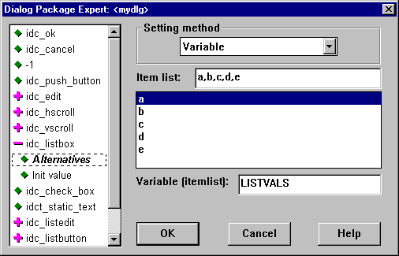

Figure 112.2: The dialog pack expert.
In the left of the dialog there is a list of the controls. Some of the controls types have many settings, and for these the list can be expanded and collapsed by double clicking on the item. The collapsed / expanded state will be indicated by a plus or a minus sign. When the plus sign is selected, the screen will show an overview of the settings, and no values can be changed.
To the right it is possible to select various settings for the selected item.
For some controls, several values might be needed to initialize the control. For example, for a list box we might both need a list of strings and an integer to select which item to highlight.
The general selections for the controls are:

Setting Method
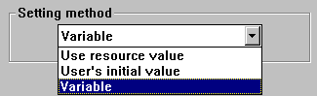

Figure 113.3: Setting methods for dialog variables.
The Setting Method specifies for a given item how it should be initialized. The following figure illustrates the effect of the three different selections for a push button (a push button can have the title set during initialization).
Setting method | Generated code
Use resource value | Nothing generated
User's initial value | df(idc_xx,pushbutton("XX"),nopr)
Variable | df(idc_yy,pushbutton(YY),nopr)
Figure 114.4: The code generated for different setting methods.

Initiate as
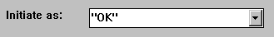

Figure 115.5: Setting initial values for controls.
Enter the initial value for a given item in the Initiate as: field. You should note that for strings, you do need to surround the string with quotes. The reason is that this allows you to specify either a variable or a constant. For multi language applications, the strings should be fetched from the string groups in the resource segment and not occur as literals in the program itself.

Variable Bindings
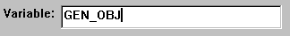

Figure 116.6: Specifying a variable name for a control.
The Variable: field enables you to specify the name of a variable to be used for the given item. The default generated name is the name of the control in uppercase. The variable names will be used both to initialize the value and retrieve the new value after the dialog is terminated.
When a Variable name is specified the first time, it will be initialized to a default value. The initialization code will be inserted right before the marking: "%MARK mydlg, new variables". The intention is that this line will be modified by the programmer to bind the Variable to the real value from a parameter or a fact:
MEMMODEL = idc_huge,

%MARK mydlg, new variables
Note that changing the variable type or deleting the control, etc. will lead to compilation errors if this line is not manually modified.

Variable Type
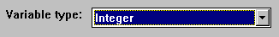

Figure 117.7: Choosing the variable type associated with an edit control.
For Edit controls it is possible to specify the type of data the control will display. Currently the dialog package knows how to handle integers, longs and reals.

Properties for Edit Controls, String Values
The Dialog Package has a number of validation features for edit controls. The settings depends on what type is specified for the edit control.
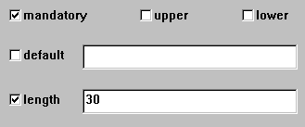

Figure 118.8: The properties of edit controls that contain string variables

Mandatory
If this is checked the Dialog Package will make sure that a value is entered in this field. The OK button for the dialog will be grayed until all mandatory fields are filled out.

Upper
Means that the string will be converted to upper case before the value is returned from the Dialog Package.

Lower
Means that the string will be converted to lower case before the value is returned from the Dialog Package.

Default
In this field, it is possible to give a default value that should be returned by the Dialog Package if the user does not give any value for the field.

Length
Here it is possible to set a maximum length for an input string.

Properties for Edit Controls, Numerical Values
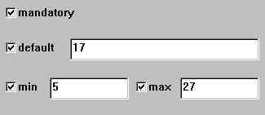

Figure 119.9: Properties of edit controls that contain numerical values

Min
Here a minimum value can be specified for integers, reals and longs.

Max
Here a maximum value can be specified for integers, reals and longs.

Item List for List Boxes, List Edits and List Buttons
It is possible to specify a list of items to initialize a list box by giving a list of comma-separated values.
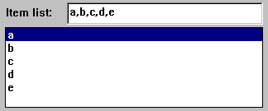

Figure 120.10: Specifying the item list for a list box.

Initial Selection for List Boxes, List Edits and List Buttons
For list boxes it is possible to specify the initial selections. For multi-selection list boxes, it is possible to give a list of values:
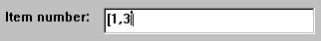

Figure 121.11: Specifying initial selections for a multiple-selection list box.

Properties for Scroll Bars
For a scroll bar, it is possible to set the Minimum and Maximum value for the scroll bar, the initial Position, and the steps that should be made when the Up or Down cursor keys are used (LineInc) or when the PgUp or PgDn keys are used (PageInc).
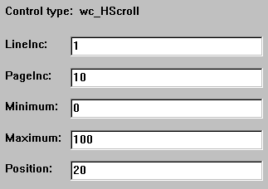

Figure 122.12: Specifying properties for scroll bar.

Radio Button Groups
Radio buttons work in groups, with only one from each group pressed at a time. Pressing any other in the same group releases all the others. The grouping of the radio buttons can be specified in the Dialog and Window Expert under the item RB Groups which is always found in the bottom of the control list. This brings up a dialog where it is possible to add new groups and move radio buttons between groups. To initialize a radio button group, it is possible to specify a variable that should contain the control constant of the initial setting.
Note that under Windows only, groupings of radio buttons can also be handled by specifying the AutoState type for radio buttons and setting the group attribute, but the handling in the Dialog Package Expert is portable to all platforms.
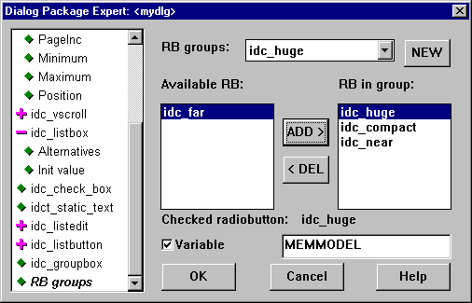

Figure 123.13: Handling radio buttons with the dialog pack(age) expert

The Toolbar Expert
For each toolbar created from the Project window, a Prolog predicate is needed to actually create the toolbar. The source for this predicate can be generated by the Toolbar Expert.
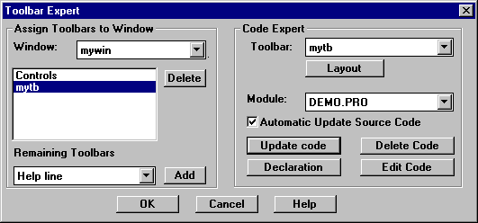

Figure 124.14: The Toolbar Expert
The Toolbar Expert performs two different operations; In the left part of the dialog, it assigns toolbars to a selected window; in the right part of the dialog, it adds the source code for a toolbar.
As with windows, you must assign a module to contain the toolbar code. Then the Toolbar Expert will insert the clause for the generation in that module, and a declaration of the predicate in the corresponding .PRE file
When the check box for Automatic Update Source Code is turned on, the source code will automatically be updated whenever the project is rebuilt.
%BEGIN_TLB Sweep toolbar, 17:13:20-17.11.1995, Code automatically updated!
/***********************************************************************

Creation of toolbar: Sweep toolbar
***********************************************************************/

CLAUSES
tb_sweep_toolbar_Create(_Parent):-

IFDEF use_tbar
toolbar_create(tb_right,0x808080,_Parent,

[tb_ctrl(id_clear,pushb,idb_mybmp_norm,idb_mybmp_down,
idb_mybmp_down,"",1,1)]),

ENDDEF
!.
%END_TLB Sweep toolbar

CHAPTER 125

The Text Editor
126The Visual Prolog text editor allows you to work with text files. It provides multi-window facilities, highlighting of various programming language elements, convenient block operations, undo and redo features, and a insert facility which allows the automatic pasting of predicate names, file names, domains, resource identifiers etc.

Starting the Editor

The text editor is called from many different places in the Visual Prolog development system. You can either open files explicitly from the Files menu (and its accelerator key F8), or click in the Project window or Project Tree to edit a project file. The editor is also used to edit Defines, Rules or Scripts, or to view generated .RC files etc.
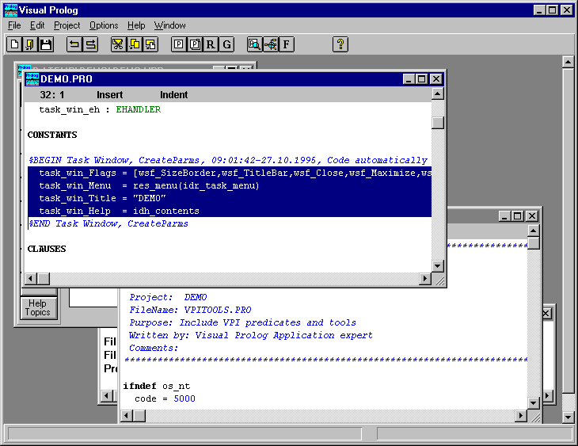

Figure 127.1: The Visual Prolog desktop showing a marked block.

Editor Commands

You enter the text at the insertion point, which is sometimes called the cursor, and sometimes also called the caret. You can set the position of this insertion point either by clicking with the mouse or by the cursor keys on the keyboard.

Cursor Movement Commands

Table 128.1: Cursor Movement Keys.
Cursor movement command | Key
Character left | Left
Character right | Right
Word left | Ctrl+Left
Word right | Ctrl+Right
Line up | Up
Line down | Down
Page up | PgUp
Page down | PgDn
Beginning of line | Home
End of line | End
Top of file | Ctrl+Home
Bottom of file | Ctrl+End

Delete Commands

Table 129.2: Delete Keys.
Delete command | Key
Delete character | Del
Delete character to left | Backspace
Delete line | Ctrl+Y
Delete to end of line | Ctrl+E
Delete to start of line | Ctrl+S
Delete right word | Ctrl+R
Delete left word | Ctrl+L

Miscellaneous Keyboard Commands
This group of commands is used for settings various modes of the Editor.

Table 131.3: Keys to Toggle Insert and Autoindent Mode.
Mode command | Key
Insert mode on/off | Ins
Auto-indent mode on/off | Ctrl+N
The text which you type is inserted if the Insert mode is on. If Insert mode is off, the text you type overwrites existing text. Pressing Ins toggles the insert mode. Pressing Enter when insert mode is on splits the current line. If off, the cursor moves to the start of the next line.
If the auto-indent mode is on and if you press Enter, the cursor is set to the column on the next line whose value equals the number of leading blanks on the previous line. Pressing Ctrl+N toggles the auto-indent mode.

Block Commands
A block is a selected piece of the text being edited. You can select the text using either the keyboard or the mouse

Selecting Text with the Keyboard

Table 132.4: Text Selection Keys.
Text selection command | Key
Left one character | Shift+Left
Right one character | Shift+Right
End of line | Shift+End
Beginning of line | Shift+Home
Same column on next line | Shift+Down
Same column on previous line | Shift+Up
One page down | Shift+PgDn
One page up | Shift+PgUp
Left one word | Shift+Ctrl+Left
Right one word | Shift+Ctrl+Right
End of file | Shift+Ctrl+End
Beginning of file | Shift+Ctrl+Home

Selecting Text with the Mouse.
You can use the mouse to select text. In order to select a piece of text move the mouse to either end of it, hold down the left mouse button, drag the mouse across the text you want to select and release the button. To select a word, double-click on the word. To extend a selection move the mouse to either end of it, and hold down the Shift key while pressing down the left mouse button and drag as above.

Operations that Affect Selected Text

Table 133.5: Keys that Affect Selected Text.
Command | Key
Cut | Ctrl+X (Shift+Del)
Copy | Ctrl+C (Ctrl+Ins)
Paste | Ctrl+V (Shift+Ins)
Clear | Ctrl+Del (Del)
Use the Cut command to remove the selected text and put it on the clipboard. This command is unavailable if you have no selected text. Cutting text to the clipboard replaces anything previously stored there.
Use the Copy command to copy selected text onto the clipboard.
Use the Paste command to insert a copy of the clipboard contents at the insertion point. This command is unavailable if the clipboard is empty.
Use the Clear command to remove selected text.

Moving Blocks
Hold down the left mouse button inside a selected block and drag the mouse to the place where you want to move the block, then release the mouse button.

Copying Blocks
Hold down the Ctrl key and the left mouse button inside a selected block and drag the mouse to the place where you want to copy the block, then release the Ctrl key and the mouse button.

Overwriting a Block
If you currently have a block selected and type in or Paste anything the block is replaced by the new information.

Changing the Case of a Block
When a block is highlighted the following keys can reverse the case of the characters in the block.
Table 134.6: Keys that Change the Case of Selected Text.
Case change command | Key
Upper case | Ctrl+U
Lower case | Ctrl+O
Reverse case | Ctrl+P

Using the Right Mouse Button
The right mouse button can be used in any editor window to bring up a very convenient extended edit menu as a pop-up menu.

Searching for a String
If you want to search for a given string of characters in your text, you can select the Edit | Search Task window menu item or Search in the right-button pop-up menu, or press F4 to bring up the Find Text dialog box to specify the string you want to look for (in the picture default settings are indicated).
If you want to search once more for the same string of characters as you last used, you can select the Edit | Search Again menu item or Search Again in the right-button pop-up menu, or press Shft+F3. These will immediately perform the search.
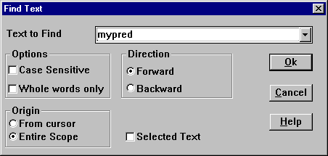

Figure 135.2: The Find Text dialog.

Text to Find.
You enter the search string in the Text to Find input box or you may retrieve a previously used search string from the list box. Press the Down arrow key or press Alt+Down arrow to display the history list associated with the input box.
You can also specify the search string by selecting a block not larger than one line in the text being edited before you call the Find Text dialog box.
Choose OK to begin the search, or choose Cancel to terminate it.

Options
This group of options defines the comparison method that the editor uses when making a search.

Case Sensitive
When the Case Sensitive option is checked, the editor differentiates upper from lower case characters when performing a search.

Whole Words Only
When the Whole Words Only option is checked, the editor searches for words only; to match the search string the candidate text must have punctuation or space characters on both sides.

Direction
The Direction options specify which way you want the editor to search:

Forward
The Forward option searches toward the end of the file. Forward is the default direction setting.

Backward
The Backward option searches toward the beginning of the file.

Origin
The Origin options determine where the search begins:

From Cursor:
The From Cursor option starts the search at the current position of the cursor. The search then proceeds either forward to the end of the file, or backward to the beginning of the file (depending on the Direction setting).

Entire Scope
The Entire Scope option searches the entire file (no matter where the cursor is in the file).

Selected Text
The Selected Text option searches within the selected block only.

Replacing Strings
If you wish to search for one or all occurrences of a string and replace it or them with another string, then select the Edit | Replace menu item, or the Replace item of the right-button pop-up menu, or press Ctrl+F3. The Replace Text dialog will appear and you may specify the text to search for and what to replace it with (on the picture the default settings are indicated).
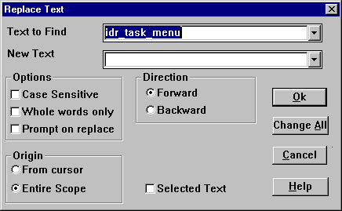

Figure 136.3: The Replace Text dialog.
Most components of the Replace Text dialog and of the Find Text dialog are the same. Both dialogs access the same history list of searched strings.

Change All
Once you have entered the search string and the replacement string in the input boxes, you can choose OK or Change All to begin the search; or choose Cancel to terminate it.
If the editor finds the specified text and Prompt on replace is checked, it will ask if you want to make this replacement. Otherwise the change will be made without prompting.
If you pressed Change All, and checked the Prompt on replace option it asks you for every instance. Otherwise all the changes will be made without any prompting. You can answer Yes, No, All or Cancel to the prompt. All means that all subsequent replacements will be done without prompts.
Cancel can be used to interrupt the search.
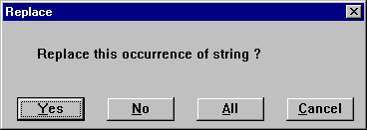

Figure 137.4: The prompt on Replace dialog.

Going To a Line Number
The Edit | Go To Line Number menu item will produce the Go To Line Number dialog to move the cursor to the line number you enter.
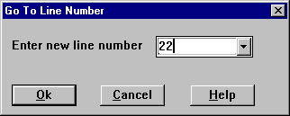

Figure 138.5: The Go To Line Number dialog.
The Go To Line Number dialog consists of an input box with a history list, and the standard OK, Cancel, and Help buttons.

Going To a File Position
The Edit | Go To Position menu item will produce the Go To Position dialog to move the insertion point to the relative character position in the file that you need. This feature is useful for discovering the location of an error in your source code after a runtime error.
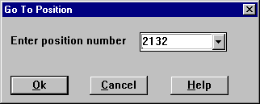

Figure 139.6: The Go To Position dialog.

Undo and Redo Features
All editor modifications can be undone, and if these undos are themselves a mistake, there is also a redo facility so the changes can be put back. The Undo/Redo commands are accessible from the Edit menu or the right-button pop-up menu.
Use the Undo command to reverse the last editing action.
Use the Redo command to reverse the last Undo command.

Table 140.7: The Undo and Redo Keys.
Command | Key
Undo | Alt+Backspace
Redo | Alt+Shift+Backspace

Editor Options
The Options | Global | Editor menu items allow you to define editor options such as File Associations for editor token colorings (as long as no Editor window is open), the tab size, the colors of the Prolog programming language elements, and the font attributes.
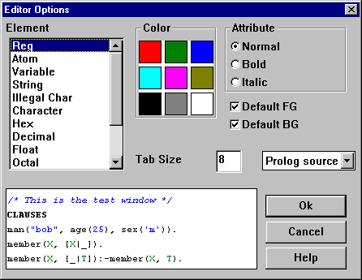

Figure 141.7: The Editor options.
Choose the element for which you want to change the color in the Element list box. Uncheck the Default FG (foreground color) and Default BG (background color). Click the left mouse button in the Color area in order to change the foreground color. For changing the background color click the right mouse button in the Color area.
In order to define the tab size type the value you need in the Tab Size input box.
Press Enter (or click OK) to confirm your choice or Cancel to forget it.

Choosing a Font
You can define the font for the active Edit window by pressing Ctrl+F or from the right-click pop-up menu.

The Insert Menu
In the Edit menu there is a facility to paste in various elements of Prolog code, colors, resource identifiers etc. etc. Try out yourself the many possibilities.
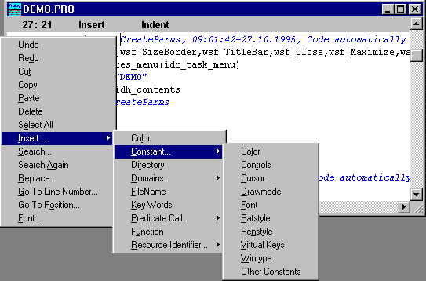

Figure 142.8: Pasting elements of Prolog code using the Insert menu.

CHAPTER 143

The Help Maker
The144 Help Maker is an integral part of the Visual Development Environment (VDE). It provides developers with a set of tools to plan, create, build and test on-line Help for their applications.
The Help Maker can create Help files in both Microsoft Windows and OS/2 Presentation Manager format. There are some restrictions when generating a Help file for the OS/2 Help format.
In order to generate the help files under MS Windows, the Help Maker uses the Microsoft Help Compiler. Similarly, under OS/2 the Help Maker uses the IBM Help compiler. These are not included with Visual Prolog. They are shipped with either the Windows SDK, Microsoft Visual C++ or Borland C++.
Note: In some cases, the Microsoft HC31.EXE help compiler can not compile Help files with large bitmaps. Try using HCP.EXE instead.

Starting Help Maker

To start the Help Maker select the Help Topics button of the Project window. Then a Hyperbase attached to the current project will be opened, and a sorted list of its Help topics will appear in the Project window, and the Edit, New, Delete, and Attribute buttons will operate on the help topics.
If there is no Hyperbase in the current project, the Help Maker will automatically create the Help Hyperbase, and attach it to the current project. The name of the new Hyperbase will be the same as for the project with a .HAM suffix appended. The first topic of a new Hyperbase titled Contents will be generated automatically.

The Help Maker Options

To define specific Help Maker options use the Options | Help Maker menu item that invokes the Help Maker Options dialog:
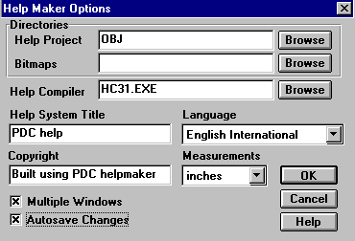

Figure 145.1: Help Maker Options dialog.
The Options | Help Maker dialog has the following controls:

Table 146.1: Help Maker Options dialog fields
Control | Description
Help Project | This box is used to choose the directory where .RTF and .HPJ files are created. These are used when building on-line Windows Help. This will usually be the OBJ directory.
Bitmaps | This box is used to select the directory where bitmaps to be used in creating your on-line Help are located. This will usually be the RES directory.
Help Compiler | This box is used to choose a Help compiler. The default help compiler is HC31 (for Windows).
Help System Title | This option sets the title of the Help window. Windows Help displays the title in its title bar whenever it displays the Help file.
Copyright box | This option places a custom copyright notice in the About dialog of Windows Help. Windows Help system displays the notice below the Microsoft copyright notice.
Multiple Windows | Check this setting if you want to be able to edit several topics simultaneously, with every topic in its own window or to use the Edit button in the Create Topic dialog. Clear this box if you want to edit topics sequentially using just one window.
Autosave Changes | If this box is checked, changes in the Help topic contents will be automatically saved when the editor is closed.
Language | Choose the language you want to use in your Help files. The default language is English.
Measurements | Choose the unit of measurement to be used for topic formatting
When using the Help Maker you should also take notice of following editing options and modes:

Table 148.2: Editing Options and Modes
Editing Options and Modes | Command
Insert/Overwrite mode | Insert
Auto-indent/No-indent mode | Ctrl+N
Some Editor options, like tab size and token coloring. | Global | Editor | Token Coloring
Font for new Edit windows | Global | Editor |Font
Font for the active Edit window | Options | Temporary | Font

Creating a Help System

The creation of an on-line Help system for your application consists of the following major tasks:
- Gathering information for the Help topics.
- Planning the Help system.
- Writing text for Help topics.
- Formatting Help topics by using fonts and typographic styles to improve their appearance.
- Inserting images.
- Creating links between topics.
- Assigning keywords to topics.
- Organizing logical browse sequences to simplify the user's navigation among the topics.

Planning the Help System
The initial task for the Help writer is to develop a plan for creating the system.
This involves the following major tasks: defining the knowledge level of the audience for your application, planning the structure and content of your Help system, and designing the layout and visual appearance of the Help topics.

Defining an Audience
The audience you address determines what kind of information you make available in your Help system and how you present that information.
Users of a Help system might be classified as follows: computer novice, application novice, application intermediate and Application Expert. Each group needs specific information. If you are providing Help for all types of users, you should describe the various tasks, menu and toolbar items, commands, procedures, functions, definitions, features, short-cut keys, and other relevant aspects of your application in several ways, taking each target audience into account.

Planning the Structure
Many Help systems structure topics hierarchically. At the top of the hierarchy is an index, a table of contents, or both. The Index and Table of Contents list individual topics or categories of topics available to the users.
Topics themselves can be related hierarchically. Each step takes the user one level down in the hierarchy of the Help system. Moving through this hierarchy, the user goes from a general idea to a specific piece of information.
A hierarchical structure provides the user with a point of reference within Help. Users should not be restricted to navigate up and down the hierarchy; they can jump from one topic to another, moving across categories of topics. The effect of jumps is to bypass hierarchical relationships.
Users often prefer to search by keywords assigned to Help topics rather than to move through the hierarchical structure. A keyword search provides quick access to all the topics indexed by keywords.
Besides ordering topics hierarchically, you can order them in a logical sequence, a Browse Sequence, that suits your application. This sequence is especially important for users who like to read several related topics at once.
Whichever structure you decide to use, try to minimize the number of lists that users must traverse to obtain information they need. Also, avoid making users move through many levels to reach a topic.

Help Topics

When the user of the Help system seeks a particular piece of information, his destination is a Help topic.
A Help topic is a portion of information that is displayed on the screen and viewed by a Help Viewer. If the chunk of information is larger than the screen can display, scroll bars will appear.
At any given time the Help Viewer is displaying a single topic. In certain cases, a second topic can be displayed in a temporary pop-up window.
A Help topic may include bitmaps as well as various formatted text, and they may also contain links to other topics.

Creating Help Topics
There are three different ways of creating a new topic for your Help system.
- Creating a Help Topic using the VDE's Project window: From the Project window, when the Help Topics selection are active, click the New button on the right side of the Project window.
- Creating a Topic while making a Jump from another Topic: While creating a hypertext jump from an existing topic, type a new topic name in the Create Link dialog.
- Creating a Topic while making a Browse Sequence: While creating a browse sequence the help of the Browse dialog, press the New button.
In all three cases, a Create Topic dialog will appear:
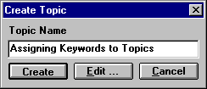

Figure 149.2: Create Topic dialog
In the box labeled Topic Name type the title of a new topic, and then press the Create or Edit buttons.
If you press the Create button, a new topic name will be included into the ordered list of topics in the Project window, and you will just continue editing the current topic.
If you press the Edit button, an editor will come up with the new topic so you immediately can start editing this. Note that you can use this button only if the Multiple Windows check box in the Help Maker Options dialog is checked.

Editing Help Topics
Help Maker Edit windows are where you type and edit your help topics. When you open a new topic, a blank window appears, ready for you to start typing. When you open an existing topic its content will appear in the Edit window.
When you create your Help system, you are not limited to plain, unformatted text. You can use different fonts and point sizes, include graphic images, indent paragraphs to present complex information, and use a variety of other visual effects to present your information.
The Help Maker provides you with a number of useful tools to produce the best appearance.

Table 150.3: Formatting Help Topics
Operation | Command
Formatting text with different fonts | Format | Character
Formatting text with different paragraph styles | Format | Paragraph
Inserting graphic images | Format | Bitmap
Defining Help window appearance options | Format | Windows
Coloring the Help windows | Format | Windows
Using the language appropriated to users | Options | Help Maker
Note that format information is shown with special markers. For the Font and Paragraph markers it is possible to click on the markers to change the formatting information:

Table 151.4: Formatting Markers
Marker | Description
{F} | Font
{P} | Paragraph start
{B} | Bold text beginning
{b} | Bold text end
{I} | Italic text beginning
{i} | Italic text end
{FILENAME.BMP} | Bitmap inserted

Linking Topics
The Help Maker is a hypertext system, which is collections of topics connected into a network with links. Links are the mode of transportation in this hypertext network.
A hypertext link is like an electronic footnote, a cross reference, or a parenthetical phrase. Just as footnotes and references direct readers of a printed text to related points or further topics for research, hypertext links connect you to associated text or elaborated information. Links usually originate at a word, a phrase, or an interactive bitmap called a hot spot. You follow them to go from one topic to another. You do this by activating them with the mouse or a keyboard.
The Help Maker provides the Help writer with easy-to-use, intuitive tools to create links between topics, follow the link, and delete the link. There are two types of links defined: jump and pop-up.

Jump
Jump links cause the Windows Help Viewer to display the destination topic in either the main or a secondary help window. This is the main way the user navigates your help system.

Pop-up
Pop-up links are used to provide a definition of words or an explanation of a phrase. When run under the Windows Help Viewer (WINHELP.EXE), the content of the linked topic will be displayed in a window that pops up over the current help topic. The topic page will not change. Pop-up links are generally used to display a short glossary-like description of a technical term.

Creating a Link
To create a link you should first select the word or phrase in an existing topic that you want to become a hypertext link to another topic. Then choose Topics | Link to..(Ctrl+F11) menu item.
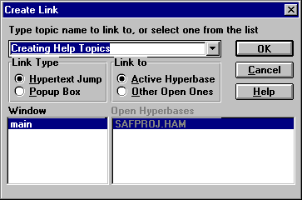

Figure 152.3: Create Link Dialog
The Create Link dialog has following controls:

Table 153.5: The Create Link Dialog
Control | Description
Type Topic Name to Link To | The list box is used to type the destination topic name or to select it from the list. If there is no such topic in the current Hyperbase, the Help writer will be prompted to create it.
Hypertext Link | If this option button is checked, following this link will cause a hypertext link to a specific topic.
Pop-up | If this option button is checked, the linked topic will be displayed in a temporary pop-up window.
Active Hyperbase | If this option button is checked, it establishes a link to another topic in the same Hyperbase.
Other Hyperbase | If this option button is checked, establishes a link to a topic in another opened Hyperbase
Window | The list box shows a type of a window corresponding to the selected link type.
When the link has been created, the text will be displayed in green, indicating a hypertext link.

Creating a Link from a bitmap
When you insert a Bitmap by Format | Bitmap it is possible to create a link to another topic.

Following a Link
To follow a link double click on the green link word or phrase (the hot spot).

Deleting a Link
To delete a link place the caret at the hot spot and Choose Topics | Delete Link (Ctrl+D).
Note: If you had any hypertext links that referred to a deleted topic, they would be automatically be deleted by the Help Maker.

Defining Font Styles
It is possible to define Font Styles that can be used later in the formatting of the Topic text. When you invoke the Format | Font Style menu, the Font Style dialog comes up. In this it is possible to define new styles, modify existing styles, of delete some styles:
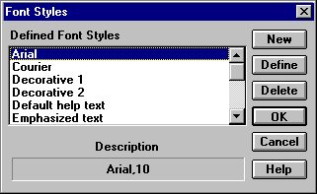

Figure 154.4: Font Styles dialog.
The Font styles are identified by a name, which is used later in the Format | Character command to specify the formatting for some text. When you specify a Font Style, the standard Font dialog will be used:
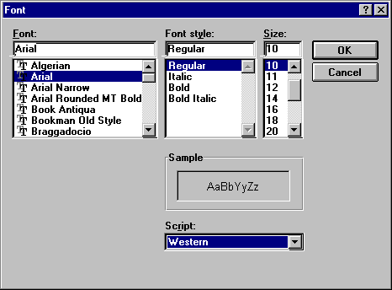

Figure 155.5: Font dialog
If the Help writer uses Windows fonts while creating font styles for the OS/2 version of a Help system, these fonts will be transformed to the OS/2 font families.

Formatting characters
To format text in bold face select a portion of text you want to emphasize and choose the Format | Bold menu item (or the accelerator Alt+B). Text formatted in bold will be preceded with the special marker [B] and followed by the special marker [b].
To format text in italic select a portion of text you want to emphasize with italic and choose the Format | Italic menu item (or the accelerator Alt+I). Text formatted in italic will be preceded (or surrounded) with the special marker {I}.
You can also use some of the defined Font styles (Format | Font Style) to specify the formatting your text should have. First select a piece of text in the Help Topic, and then invoke the menu command Format | Character to select a Font style for it:
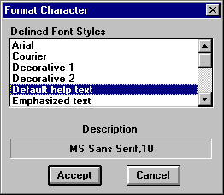

Figure 156.6: Format Character dialog.

Formatting Paragraphs
The Help Maker also supports Paragraph formatting with lists, borders, indentation, alignment etc. Paragraph formatting is changed by first selecting a piece of text in the Topic, and then invoking the Format | Paragraph menu item. This will bring up the Format Paragraph dialog:
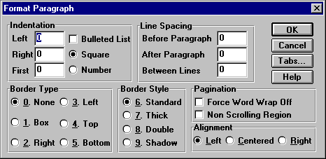

Figure 157.7: Format Paragraph dialog
The Format Paragraph dialog has following fields and controls:
- The Indentation group determines the position of a paragraph in relation to the left and right margins in the measurement units (inches, centimeters or points) defined in the Help Maker Options dialog.
Control | Description
Left | determines left indent.
Right | determines right indent.
First | determines the first paragraph line indent.
Bulleted list | if checked, the paragraph has a bullet at the left side.
Square | if selected, the bullets are small squares.
Number | if selected, the bullets are the digits.
- The Line Spacing group controls the spacing of a paragraph.
Control | Description
Before | determines the space between the current and the previous paragraphs.
After | determines the space between the current and the next paragraphs.
Between | determines the space between the lines inside a paragraph.
- The Border Style group specifies the width of a border around the paragraph and creates a shadowed border or box if the Shadow option button is checked.
- The Border Type group determines the type of a border around the paragraph.
Control | Description
None | Removes all borders from the selected paragraphs.
Box | Inserts a box around selected paragraphs.
Right | Inserts a right border.
Left | Inserts a left border.
Top | Inserts a top border.
Bottom | Inserts a bottom border.
- The Pagination group defines the non-scrolling region and the wrap option for the Windows Help window.
If the Non Scrolling Region check box is checked, a paragraph will not scroll in the Windows Help window. Non-scrolling regions are defined with Paragraph markers.
This option can be assigned only to the paragraphs at the top of a topic. The Windows Help Viewer allows one non-scrolling region per help topic.
If you declare a part of a topic to be non-scrolling, that text is the only text which will appear when the topic is used as the target for a pop-up hot spot.
If the Force Word Wrap Off check box is not checked (the default), the paragraph will be wrapped within its indents. Check this box if you do not want this paragraph to be wrapped. What does not fit inside the right indent will be truncated and will not be visible. Unwrapped paragraphs may be useful for program examples, tables, etc.
- The Alignment group determines the position of the selected text or other content of a paragraph in relation to the indents.
Control | Description
Left | if checked, the paragraph aligns at the left indent.
Right | if checked, the paragraph aligns at the right indent.
Center | if checked, the paragraph will be centered within its indents.
The Tabs button assigns tab stops to a paragraph with the help of the Tab Control dialog.
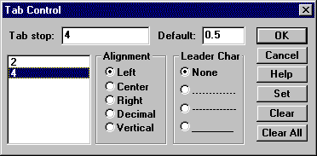

Figure 158.8: Tab Control dialog.

OS/2 Version Paragraph Formatting Restrictions.
The following groups and controls of the Format Paragraph dialog are not accessible while creating the OS/2 version of a Help system: Line Spacing group, Border Style group, Border type group, Pagination group, Alignment group, Tabs button.
OS/2 paragraph formatting allows only left and right indents and adds an empty line between paragraphs.
Some of the formatting facilities that are not compliant with Windows Help and are not realized by the Help Maker can be implemented using IPF tags. These tags, enclosed in brackets, can be directly included in the topics.

Inserting Bitmaps
To insert a bitmap into the current topic do the following:
- Place the caret within the topic where you want to insert a bitmap.
- Choose the Format | Bitmap menu item.
- Select the bitmap to insert using the Insert Bitmap dialog.
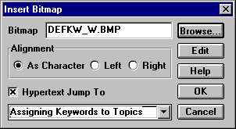

Figure 159.9: Insert Bitmap dialog

Exporting a Topic to a .TXT file
By choosing Topics | Export To it is possible to export the current topic content to an ASCII file.

Pasting the content of a file into a Help Topic
From the Edit menu, you can select the Paste from item. This enables you to place the content of an ASCII file at the insertion point.

Assigning Keywords to Topics
The Help Maker allows the Help writer to assign keywords to the topics. Thus a Help user may search for a topic through the use of these keywords. The Windows Help and provides a Search dialog. Since a keyword search is often the fastest way to access Help topics, the Help writer will probably want to assign keywords to most topics in the Help system. More than one keyword may be assigned to a single topic, and more than one topic may have the same keyword.
You can assign keywords to a topic by either choosing the Topics | Define Keywords menu item, or pressing the Attribute button at the right panel of the Project window. In both cases the Define Keywords dialog will be invoked:
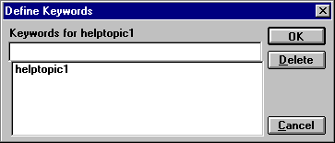
Figure 160.10: Define Keywords dialog.
The edit field allows the assignment of a new keyword to a given topic. If you want to add more than one keyword, separate them with semicolons. Also you can mark a list of the previously defined keywords, and delete them by pressing the Delete button.

Assigning Browse Sequences
In addition to organizing topics in a hierarchical network, you can order them in any logical sequence that suits your audience. Such a logical sequence, or "browse sequence", lets the user navigate directly through topics containing related information.
By clicking on the browse buttons marked "<<" and ">>" at the top of the Help window the user can move between topics. This allows the user to view related topics without the need to initiate a new search or to return to the Contents page.
The Help Maker Search | Browse menu item invokes the Browse dialog - a special facility that allows the Help writer to create and maintain the logical structure of a Help system.
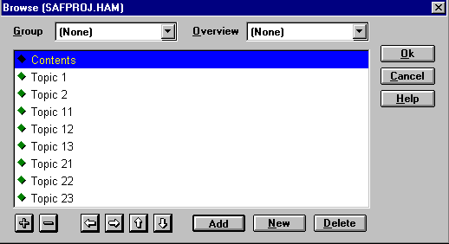

Figure 161.11: Browse dialog
The Browse dialog lets you create and edit a browse tree. You can add topics to the browse tree, move topics from one browse sequence to another, define the order of topics inside the browse sequence, specify overview and group topics, delete topics from the tree, as well as collapse and expand sub-trees.

Adding Topics to a Browse Tree
To add a topic to a browse tree do the following:
- Select the sub-tree to which you want to add a topic as a new leaf.
- Click the Add button of the Browse dialog.
- Select the topic you want to add to the tree using the Select Topic dialog. In this dialog all the topics of the current Hyperbase will be listed, except those already placed in the tree. Topic titles already belonging to a browse sequence do not appear in the list because a topic can belong to only one browse sequence.
If the topic you want to add to the browse tree does not yet exist, you may create it by clicking on the New button of the Select Topic dialog or the New button of the Browse dialog. The Create Topic dialog will appear. The new topic will be added to the browse tree.

Deleting Topics from a Browse Tree
You can delete a topic from the Browse Tree by pressing the Delete button of the Browse dialog. Note that not only this topic, but the entire sub-tree will be deleted from the browse tree. To prevent unwanted deletion, first move all the topics of this sub-tree that you want to remain in the browse sequence into another position.

Moving Topics across a Browse Tree
To move a topic and its sub-tree across the browse tree you can use the following buttons:
Note that not only selected topic, but the entire sub-tree will be moved across the tree. To prevent this, first move unwanted topics to another position.

Assigning Groups
In many cases the Help writer will want to have special group topics with references to other topics. After selecting a sub-tree of topics, you can assign a topic as a group topic for the other topics by selecting it in the Group button.

Assigning Overviews
In many cases the Help writer will want to have special topics that overview some group of other topics. With the Overview button it is possible to specify a Topic, that should function as an overview for the group of selected topics in the Browser dialog.

Creating Browse Sequences
As the Help writer, you make all the decisions regarding whether there is to be a single browse sequence with all the topics, or multiple browse sequences for groups of topics, or any browsing at all.
If you define a single browse sequence for all the topics, the browse buttons on the main Help window will carry the user though the Help system from the first topic to the last and vice-versa.
To define a single browse sequence for all the topics, add topics to the Browse dialog in the order you wish them to be browsed in your Help. If you are not satisfied with this order, you can move these topics in the Browse dialog with the help of the vertical arrow buttons.
For example, if you create the browse sequence for the topics listed in the Topics list box of the Browse dialog shown above, the browse buttons on the main Help window will carry the user though the Help system starting with "Contents" and ending with the "Topic 23".
Because of the tree structure, the Browse dialog is an excellent tool for creating multiple browse sequences. If you create several browse sequences, the browse buttons on the main Help window will carry the user though the group of topics included in the particular browse sequence.
For example, if you create the browse tree shown in the following dialog, you will create three browse sequences.
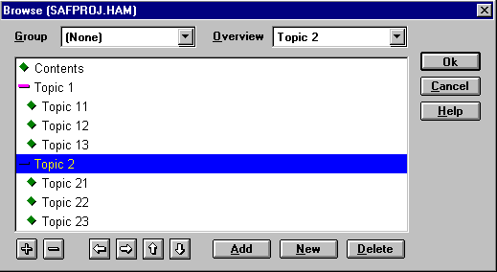

Figure 162.12:Creating Multiple Browse Sequences
Each topic will belong to the browse sequence of the same hierarchical level and the same sub-tree.
The first browse sequence will contain the following topics: "Contents", "Topic 1", "Topic 2".
The second browse sequence will contain: "Topic 11", "Topic 12", "Topic 13".
The third browse sequence will contain: "Topic 21", "Topic 22", "Topic 23".
The user can move through these browse sequences by pressing the browse buttons ("<< " and ">>") on the main Help window.
The browse tree defined in this example will cause the appearance of two additional buttons on the main Help window: Up and Overview.
"Topic 1" will be the "up" topic to the topics of the second browse sequence.
"Topic 2" will be the "up" topic to the topics of the third browse sequence.
"Topic 2" will also be the overview topic to the topics of the third browse sequence.

Collapsing and expanding Sub-trees
A topic with expanded sub-topics is marked with a minus. To collapse it make it the active selection and press the button. A topic with collapsed sub-topics is marked with plus. To expand it make it the active selection and press the button.

Assigning Help Macros
Help macros are functions that provide a powerful tool to make a more sophisticated Help system.
The Windows Help system provides a set of tools that is available for your use in the Help Maker. These tools can assign macros to the entire Help file (Format | Project macro) or to individual topics (Format | Topic Macro).
All defined Project Macros will be executed during Help system start.
A Topic Macro is associated with a topic, and is executed when the topic is displayed. For example, you can define a button that appears only when a specific topic is being viewed, or you can call a function in a .DLL etc.
The Windows Help Macros are described in the Help Compiler Guide from Microsoft.
Help Topic macros are not available in the OS/2 version, but the IPF tags described later can perform similar operations.

Windows Menu Item
The Format | Windows menu item is used to set up the Help windows specifications. These specifications determine how Help windows will look. You specify these settings during creation of a new Topic.
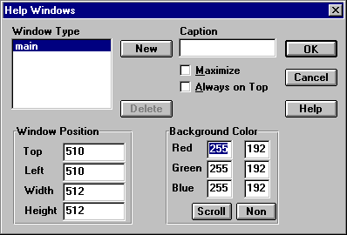

Figure 163.13: Help Windows dialog
The Help Windows dialog has following fields and controls:

Table 164.6: Help Windows Dialog Controls
Control | Description
Window Type | The box lists the defined types of windows. There will always be a "Main" window and it cannot be deleted from the list.
Caption | Enter the desired caption for the selected window in the Caption text box. For the "Main" window only, the caption is also the Help system title, which may also be entered from the Options | Help Maker dialog.
Always on Top | Check this box, if you want the selected Help window to stay on top of all other windows.
Maximize | Check this box to maximize the selected window when it first appears. If the user "normalizes" the window, the sizing specified in Window Position will be used.
Window Position | This area is used to set the initial size and position of the Help window. The height and width may be set by placing the values in the appropriate boxes.  Help Maker always assumes the parent window (the screen - in Windows, the Information Presentation Facility Viewer window - in OS/2) is 1024 help units wide and 1024 help units high, regardless of resolution.  Note, that the window dimensions are in "virtual" values and will be interpreted appropriately when viewed with a Help viewer. These dimensions are relative to the resolution used on the display.  For instance, if a window width is set to 512 its display width will be 320 for VGA resolution and 400 for SVGA. In any case, it will be one half of the screen width. The same is true for the height and the window position.
Background Color | The background colors can be set for both the scrolling and non-scrolling regions. Push the Scroll button for the scrolling region or the Non button for the non-scrolling region. This will bring up a standard Windows color selection dialog.  Non-scrolling regions are defined with the Format | Paragraph menu item.

Renaming Topics
Topics can be renamed either from the Attribute Dialog invoked from by pressing the Attribute button for a Help Topic in the Project window - or by the menu command Topic | Rename.
Note that Topics can freely be renamed without spoiling any links. The new name for a Topic will appear in the alphabetically ordered Help Topics list of the Project window.

Deleting Topics
Topics are deleted by the Delete button of the Project window. If you had any hypertext links that which referenced the deleted topic, they would automatically be deleted.

Topic Attributes
As described above, the Help writer can re-name a topic or assign keywords, macros, change the parent, the group and the overview topic with the help of various menu commands. But all attributes associated with a Topic can also be reached from the Topic Attributes dialog. This is reached by pressing the Attribute... button in the Project window.
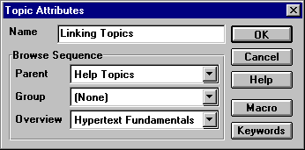
Figure 165.14: Topic Attributes dialog

Importing Help

The Help Maker has an advanced facility to import text and topics from either another .HAM file, from a plain text file, or from an .RTF file. Import is invoked from Topics | Import from, and will bring up a dialog from where it is possible to import individual Topics.
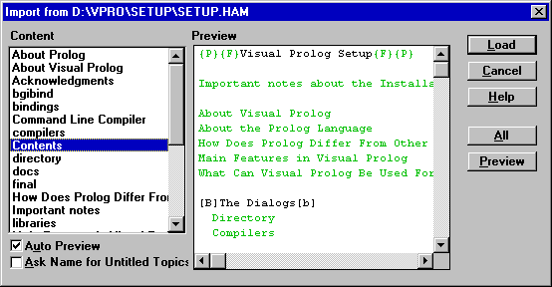

Figure 166.15: Import from dialog
The import feature can parse topics, preview them, preserve formatting, scan for hypertext links and preserve them. The Help Maker tries to resolve these links. However, unresolved links can appear in the imported topics due to the following reasons:
- The imported topics have links to unimported topics in the source file.
- The imported file has links to other files.
- The target topics were renamed while importing. This can occur because source topics having first 25 matching symbols in their titles are considered by the current version of the Help Maker to be duplicated. In this case the Help Maker demands to rename these topics while importing that can cause destroying links to these topics.
To reestablish the lost links it is necessary:
- To find lost links. All unresolved links are marked like (Unresolved link to ....) just after hotspots in the imported topics. You can find topics having this string using Search | String dialog.
- To do one of the following:
- Import all the necessary topics or files.
- Delete unresolved links.
- Redirect links

Importing .RTF Files with Graphics
The current version of the Visual Prolog does not allow to import the .RTF files containing graphics. An attempt to import .RTF file with embedded objects causes the necessity to restart Visual Prolog. Nevertheless, it does not mean you cannot import file with graphics at all, because it is possible to replace embedded objects in the source .RTF file with the references to image files.
To accomplish this you can use a Graphics editor providing this feature (e.g. Robohelp PaintIt Image Editor), or do it manually.
- Find graphic objects in the source .RTF file and save each object like a separate image file.
- Replace graphics in the source .rtf file with references inclosed in braces like: bmc winsock.bmp.
- Copy image files to the directory chosen for bitmaps in the Options | Help Maker Options.
- Import .RTF file

Building the Help File

When a Help text has been designed in the Help Maker, the actual Help file needs to be created. This is done automatically when you do a Project | Build.
Whether the Help Maker generates a Windows or OS/2 help file depends on the Target selection under Options | Application Expert. The Help Maker is able to cross compile the help file to a different platform.
It is also possible to build the Help file manually by three items of the Project menu which are specific to the Help Maker. Here's a summary of these items, and the functions they perform:

Table 167.7: Project Menu Items
Command | Description
Project | Write RTF | This menu item produces the three files needed to build a native Windows Help system:  - a Rich Text Format file (<Hyperbase>.RTF),  - a Help project file (<Hyperbase>.HPJ)and  - a Map file (<Hyperbase>.HMP), that determines the relation between a topic name and its context numbers, and may be useful for the application.
Project | Write IPF | This menu item generates an OS/2 .IPF file from the Help Hyperbase.
Project | Compile Help (Ctrl+F9) | Windows Version: The menu item calls the Microsoft Help Compiler (HC31, HCP, HC) in order to compile the Help project into the final Windows Help file. Combining topics, graphics, and project files, the compiler creates a single Help file (with the file name extension .HLP) that you can open and view by using Windows Help. The path to the Help compiler and its name must be defined in Help Maker Options dialog.  Note that no Help compiler is supplied with Visual Prolog. It is available as part of the Microsoft Windows Software Development Kit.  OS/2 Version: The menu item calls the IBM Information Presentation Facility Compiler (IPFC.EXE) to compile the IPF- tagged file into an .INF file that can be read by the OS/2 Help viewer (VIEW.EXE).  The IPFC requires that the Environment Variable IPFC has been set, for example, SET IPFC=C:\IBMC\IPFC. This is most usually done in the in the CONFIG.SYS file. The path to the Help compiler must be defined in the Help Maker dialog.  Note that the OS/2 Help compiler is not supplied with Visual Prolog.
Project | Display Help File | The menu item calls WINHELP.EXE (for the Windows version) or the VIEW.EXE (for the OS/2 version) to test your Help file.
Sometimes it is useful to compare a certain hyperbase topic with its Help presentation. Topics | Display Help Topic calls WINHELP.EXE (for the Windows version) or the VIEW.EXE (for the OS/2 version) to test the selected topic.. The topic you wish to test will be displayed in the Help window. Using hypertext links and the Help window buttons you can move to other topics of the Help if it necessary.
The use of the Display Help File and Display Help Topic commands makes no sense if Help was not compiled previously. A Help author may compile Help once and display it as many times as he wishes. However, all changes done after the last compiling won't be seen in the Help window until next compiling.

Restrictions for OS/2 Help system

While creating the OS/2 version of the Help system, we came across some restrictions in comparison with the Windows version. They mostly concern paragraph formatting. It is not possible to define topic and project macros for this platform.
Some of the OS/2 Information Presentation Facility features that are not compliant with Windows Help and are not implemented by the Help Maker can be implemented using IPF tags which are specific to the OS/2 Help file (.IPF).
The .IPF file contains a collection of tags, which have following syntax:
:<tag name>[attributes].
Some tags also require a matching "end" tag (e.g., a "begin list" tag needs a matching "end list" tag). Other tags have no attributes. The ending tag name usually matches the beginning tag name preceded by an e (for example, ":sl." and ":esl.").
The IPF tags can be directly included in Help Hyperbase topics and must be enclosed in squared brackets.
It should be noted that the Help Maker, while converting a Help Hyperbase into an .IPF file, includes most of the IPF tags and all the tags that are required in a valid .IPF file (:userdoc., :title., :hl.,:p., euserdoc.) automatically,.
The following is an example of using IPF tags to create an unsorted list of items beginning with bullets under the topic "Paragraph Handling". The IPF tags are marked bold in the text of the topic.

Paragraph Handling
OS/2 Help has restricted features to control paragraph appearance. There are the following:
[:ul compact.
:li.Each paragraph is separated with empty line before.
:li.You can assign left and right indents (margins) for each paragraph (or, using IPF tags for lines within paragraph).
:eul.]
For information about IPF tags see the IPF Reference on-line document that is supplied by IBM with the OS/2 Programmer's Tool kits.

Help Maker File Menu

The PDC-Help Maker is able to open several Hyperbases simultaneously, making it easy to refer to topics in other help files. When the Help Maker is active, the File menu is used to manipulate the .HAM files.

Table 168.8: File Menu Items
Command | Description
File | New | Creates a new Hyperbase. The default extension is ".HAM".
File | Open | Makes an existing Hyperbase the active hyperbase.
File | Close | Closes the active Hyperbase.
File | Save | Saves the active Hyperbase. It flushes all the opened editors and buffers
File | Save as | Writes the active Hyperbase to a new location.
File | Save all | Saves all open Hyperbases.
File | Change active | Changes the active Help file.
File | Print | Prints the content of the current topic.

The Help Maker Search Menu

The Help Maker has various facilities to help you search for topics in a hyperbase. These are:

Table 169.9: Search Menu Items
Command | Description
Search | String | This menu item provides a free text search for a string through all topics.
Search | Keyword | This menu item provides a search for a topic using a keyword. The Help writer can access a topic with assigned keywords using the Search Keyword dialog, which works similarly to its Windows Help counterpart. All keywords of the current Hyperbase are listed. When the Help writer selects one, all the help topics associated with that word will be listed to select the one to edit.
Search | History | This menu item provides a list of topics in the order they were viewed.
Search | Browse | This menu item provides the Browse dialog for creating browse sequences, assigning "overview", "group" and "up" topics.
Search | Index | This menu item creates an "Index" Topic, whose content is an alphabetically sorted list of all topics in the current Hyperbase. This will be assigned as the main index for the Help system if there are no topics either named "Contents" or named with the Hyperbase file name.

CHAPTER 170

Visual Prolog Debugger

Introduction

171 Debugging is the process of finding errors in programs. Some have estimated that correcting errors in program takes about 90% of the total development time. This proves that good tools for debugging is very important.
The PDC debugger can currently debug WIN32 (Target VPI, EasyWin and Textmode). The debugger allows inspection of variables and facts, as well as setting breakpoints and stepping through the source code.
This version of PDC Debugger is a standalone application.
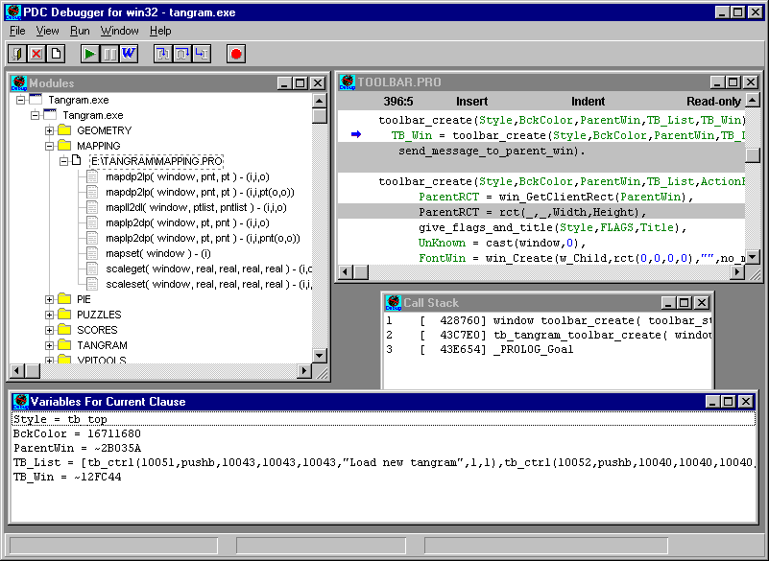

Figure 172.1: The Visual Prolog Debugger.

Generation of debug info
The first thing to do is to turn on the generation of the debugger information in the compiler options dialog.
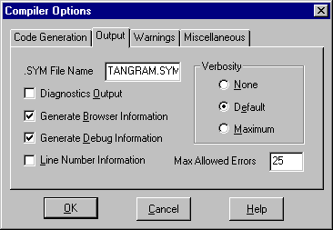

Figure 174.2: Generating Debug Info.
Turning on the "Generate Debug Information" checkbox will force the compiler to generate .DEB files in the .OBJ directory. These .DEB files are used by the debugger to locate Source, Variables, Facts etc. during execution of the program.

Starting the debugger
When Visual Prolog is installed by the setup Program, the setup program will install an icon for the debugger. The debugger is an executable placed under BIN\WIN\32\VIPDEBUG.EXE. There is currently only a WIN32 version of the debugger that can run under Win95 and Windows NT.

Loading a program
Choose Load from the Files-menu, to load an executable program into the debugger. And specify the .EXE file to load. If you have moved the .DEB files, you need to specify where these can be found.
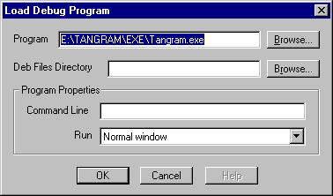

Figure 175.3: Loading a Program into the Debugger.
In the "Command line" field, a string with command line arguments for a debugging program can be specified the "Run"-field allows selecting a mode of running of a program: full, minimized or maximized.
When a program has been loaded into the debugger, the starting point and other information can be viewed (which modules has been loaded, which of them can be debugged, etc.) from the Message-window in the bottom of the screen.
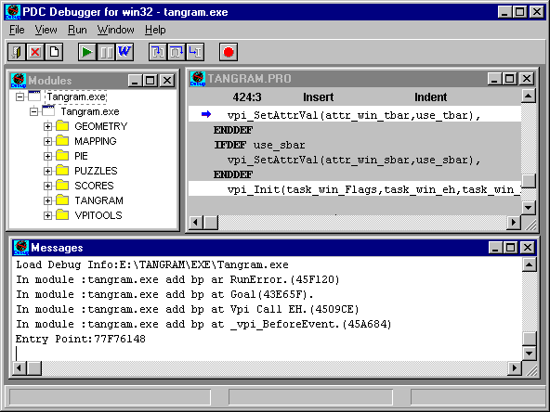

Figure 176.4: The Messages Window.
The program can be started, using the Run-menu or the buttons in the toolbar panel.

The Views
Several windows can be opened in the debugger. These are opened from the Views menu.
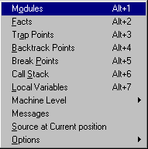

Figure 177.5:The Views menu.

The modules View
When the debugger is started and a program is loaded, the program is displayed in the Modules Window and the structure of the files can be examined by the explore tree.
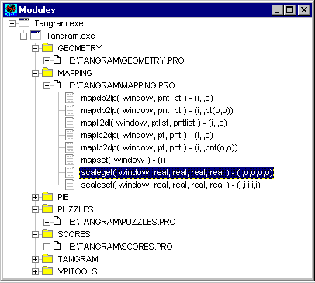

Figure 178.6: The modules View.
In this View it is possible to double click on the files, the project consists of, and double click on the individual predicates. The result will be that a source code window opens up at the selected position.
Note that to be able to see the source code, the program must be written in Visual Prolog. All other programs can though be seen directly in assembler in the disassembly-window.
It isn’t possible to edit code in the PDC-debugger, because it is stand-alone. The most convenient way to correct errors is probably to find the correspondent predicates in both the debugger and Visual Prolog.

Source code View
The menu command View->Source at Current position, sets a cursor to a position of current instruction pointer.
The source code-windows can be opened from almost any menu entry in the Debugger.
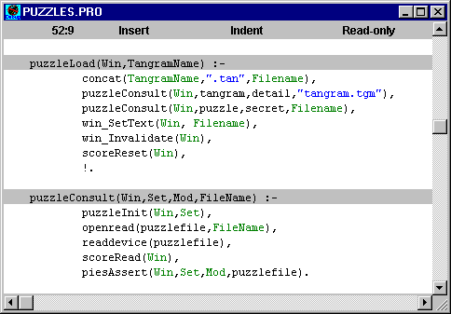

Figure 179.7: The Source code view.
The code will appear in white color at the locations where it is possible to set breakpoints. From the Options dialog, it is possible to turn off the shading of the source code.
With the right mouse button or the Edit, it is possible to copy source code to the clipboard (Copy command), find text (Search command), go to a specific position or line (Go to Line number and Go to position, respectively). The absolute position in the code can be found, by Show Position.

The Run menu
The Run menu is used to control execution of the program to be debugged.
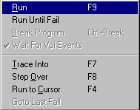

Figure 180.8: The Run Menu.
Run (F9) Issuing the command will start execution of the application. This is normally used in conjunction with setting of breakpoints.
Break Program When a program is running under the debugger, it is possible to break the program to go into the debugger. Then it is possible to inspect the call stack to see what the program is actually doing - or to set a breakpoint where to catch the execution.
Trace Into This is used to step through the source code call by call.
Step Over This is used to skip the execution of a given predicate call.
Run to Cursor This works at setting a breakpoint at the current source position and then doing Run.

Setting Breakpoints
Setting of breakpoints is very important to isolate errors or to verify that a part of a program executes correctly. When a source window is open, it is possible to right click on the line. This will bring up a menu, from where a breakpoint can be set. When RUN(F9) is chosen the program will execute only to this point.
More control over breakpoints can be achieved, by using the Breakpoints-Window. Choosing Breakpoints from the View-menu can open this window.
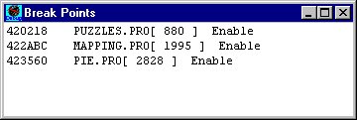

Figure 181.9: The Breakpoints View.
In this list, all breakpoints can be seen and their status can be changed. A status change is removal or toggle. Both are done with the right mouse button. The first removes the breakpoint, the latter switches between enabled/disabled. With the menu point Go to Code, it is possible to go to the source file, where this breakpoint is placed. Another very useful possibility in the right mouse menu is the breakpoint control, which is done by choosing Properties.
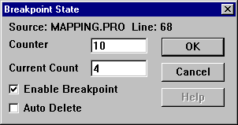

Figure 182.10 Breakpoint properties:.
Here it is possible to se how many times, this breakpoint is reached (in the Counter rectangle), and control, if it is reached XX times, then it is eliminated (in the Current Count).
Another possibility is use to the menu entry "Run->Run to cursor" (F4). Place the cursor an appropriate place in the source code, and activate the command.

Variables View
During execution it is possible to inspect the variables values by opening View->Local Variables
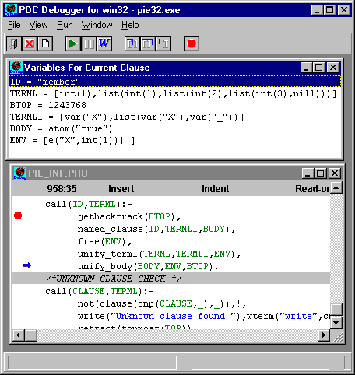

Figure 183.11: Variables View.
Also, when the mouse cursor is pointed at some variable in the source code, it is possible after a short while to see the value of this variable. This can be a handy way to inspect the values without opening the Variables View.

Viewing facts
An important issue in correcting Prolog programs is to ensure that the correct facts have been asserted. The facts of the program can be viewed in the Facts-windows. This window is selected by choosing FACTS from the View menu.
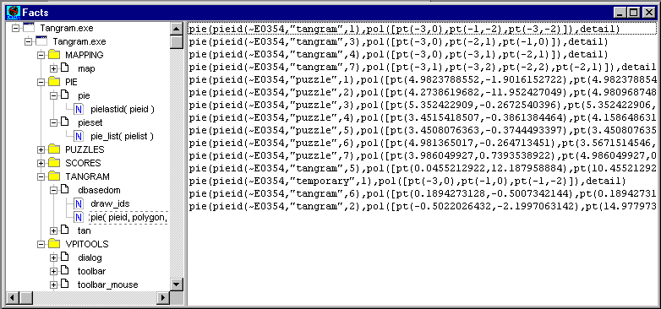

Figure 184.12: Facts View.

Call Stack
Call Stack window shows a list of predicates that have been already called in a debugging program. Double click on a predicate shows the code where a call to a selected predicate occurred.
The windows can be refreshed, if changes have been made, by choosing Refresh from the right mouse menu.
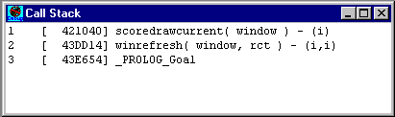

Figure 185.13: Vallstack View.

Trap Points window
Trap Points window shows a list of trap points of debugging program. Double click on a trap point shows a code where this point is placed.
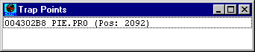

Figure 186.14: Trap Points View.

Backtrack Points window
Backtrack Points window shows a list of backtrack points of debugging program. Double click on a backtrack point shows a code where this point is placed.
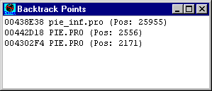

Figure 187.15:.

Machine level Views
It is possible to view assembler codes directly in PDC Debugger, see the register or memory contents.
The main purpose of these is when inspecting non-Prolog code.

Disassembly
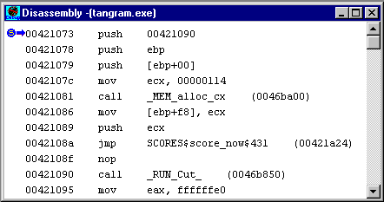

Figure 188.16: Assembler View.

Memory
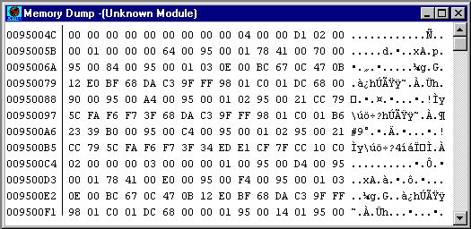

Figure 189.17: Memory View.

Registers
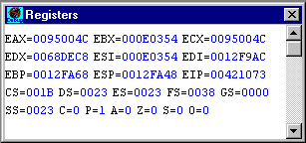

Figure 190.18: Machine Register View.

Debugger options
The options are found under View->Options.
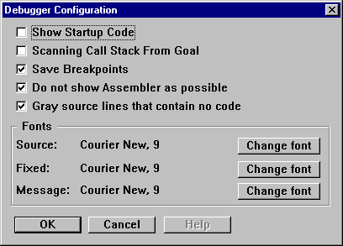

Figure 191.19: Debugger Options.
Show Startup Code – allows debugging of a program code before a call to Goal.
Scanning Call Stack from Goal – if checked then Call Stack window will only contain calls that occurred after a call to Goal.
Save Breakpoints – allows to save breakpoints for a current project in debugger ".ini" file.
Do not show Assembler as possible – references to assembler code and assembler code itself are not shown as much as possible.
Gray source lines that contain no code – lines of source code of a program are grayed where breakpoint can not be set.
Fonts – allows to change fonts for windows of a debugger.

Index

—.—
.BRO, 10
.CON, 47
.DEF, 49
.DLL, 56
.DLL files, 56
.EXE, 56
.EXE, 56
.H, 47
.INI, 13
.RC, 47
.RC file to RES file, 50
.RES, 56
.RES file, 47, 56
.RTF
importing, 146, 148
.SYM, 42
.SYM file
name, 42
.VPR, 6
converting to/from text format, 6
.VPR project file, 57
—4—
4x4 pixels, 82
—6—
64x64 pixels, 82
—A—
About box, 35
Accelerator key, 81
accelerator keys, 3
Alt, 82
Application Expert
options, 27
Application Expert, 19
arrow keys, 78
attributes
image, 87
Attributes
image, 87
menu item, 81
Auto-indent mode
Text Editor, 114
Help Maker, 126
automatic code update, 97
Automatic update of source files, 48
—B—
background color, 84, 94
toolbar, 76
Backspace key, 78
base directory, 20
bitmap, 82, 87
bitmaps
converting into icons, 94
Bitmaps, 82
Black
cursor color, 88
block commands
Text Editor, 114
Borland's make facility, 49
Bottom
toolbar style, 76
Break check (DOS only), 42
BRO file, 10
Brush, 90
brush styles, 90
Build
rules, 50
script, 50
building, compiling and linking projects, 40
buttons
context sensitive, 78
—C—
C
constant definition file, 47
language files, 51
Cancel
default control, 61
case change
Text Editor, 116
Change
color, 93
check box
attributes, 69
check box control, 61
CHECK BOX control, 61
check button, 78
Check Button
toolbar control, 77
check buttons
toolbar
properties, 78
Child window, 73
Clear
button, 93
Graphic Field, 93
clipboard, 93
Clipboard, 82
close box, 73
Code Browser, 10
Code Experts
window handling, 73
code generation options, 48
Code generation options, 29, 40, 96, 105
code insertion menu, Text Editor, 122
color, 79
color palette, 88, 89
colors, 82, 87
bitmaps, 87
cursor, 88
cursors, 87
icons, 88
Colors
cursor, 88
command line parameter for VDE (VIP.EXE), 6
Compile options
integer overflow check, 42
Compiler options, 40
diagnostics output, 43
stack overflow check, 42
compiling a Help file, 149
compiling, building and linking projects, 40
constant
definition files, 47
Constant
C language, 47
menu item, 81
constant name, 78
context sensitive field, 78
Context Sensitive Text
toolbar control, 77
control, 61
constant, 61
Control
toolbar, 78
control attributes
changing, 68
control constants
window, 73
controls
in a toolbar, 77
setting methods, 104
Controls
arranging, 64
binding to variables, 105
insert to a dialog box, 63
menu item, 63
moving, 64
resize, 64
select a group of, 64
select, unselect, 64
toolbar, 63
validation by dialog expert, 106
variable type, 106
variables, 103
variables setting methods, table, 104
converting .VPR files to/from text format, 6
copy
string resources, 74
Copy, 65, 93
CTL3D.DLL, 28
CTL3DV2.DLL, 28
Ctrl, 82
cursor, 86, 87
Cursor
editing, 88
testing, 87
Cursor hot spot, 86
cursor movement
Text Editor, 113
, 113
cursors, 87
Cursors, 82
cut
string resources, 74
Cut, 65, 93
—D—
Debugger, 153
DEF file, 49
Del key, 78
delete commands
Text Editor, 113
diagnostics output, 43
dialog
creating, 57, 60
new, 58
dialog & window editor, 66
Dialog and Window Editor, 57
Dialog and Window Expert, 96
Dialog Box Controls, 61
Dialog editor, 57
Dialog Editor Window, 60
Dialog Package
event handling, 99
Dialog Package Expert
code generation options, 104
control setting and validation see Controls, 104
preview of generated code, 96
dialogs, 57
Disabled state, 79
DOWN
Graphics Editor button, 85
drag and drop, 93
draw and edit tools, 90
draw color, 89
Graphics Editor, 89
draw tools, 89
Drawing Toolbar, 89
—E—
e_Create event, 57
edit
tools, 89
Edit
Graphics Editor, 84
Edit button, 79
edit color
Graphics Editor, 89
edit colors, 89
edit control, 62
attributes, 70
EDIT CONTROL, 62, 63
edit tools, 89
Edit|Set, 86
editing commands
Text Editor, 113
Editor options, 121
Ellipse, 92
Environment options, 15
Environment symbol, 49
Erase Color, 91
Erase Color tool, 91
Eraser, 91
eraser styles, 91
error messages, 73
event handling
Dialog Package, 99
—F—
field names, 62
file associations, 6
files
BRO, 10
INI, 13
project, 6
resource, 9
VPR, 6
files used in project, 36
Fill Contour, 91
FLIP HORIZONTAL
Graphics Editor button, 86
FLIP VERTICAL
Graphics Editor button, 86
flipping
Graphics Editor, 85
font, 79
formatting markers, 130
—G—
global domains, 37
Global options, 13, 15
Go To Line Number
Text Editor, 120
Go To Position
Text Editor, 120
Goal
testing, 52
Graphic Field, 84, 85, 89, 92, 93
graphics
importing into hyperbase, 148
Graphics Editor, 79, 82
Graphics Editor window, 83, 84
grid
Graphic field, 84
Grid, 65
grid properties, 65
grid specification, 65
group box
attributes, 72
GROUP BOX control, 63
Group Name, 63
—H—
headers in modules, 35
Help
default control, 61
importing, 146
Help compilers, 149
help line, 6
Help Maker
browse dialog, 139
Browse dialog, 129
browse sequences, 139
browse tree, 140
Create Link window, 128
Define Keywords dialog, 139
editing modes, 126
editing options, 126
Format Paragraph dialog, 134
formatting markers, 130
formatting topic text, 129
help topics, 128
Help window, 143, 144
Help Windows dialog, 144
hotspots in help topics, 130
hyperbase, converting to RTF or IPF format, 148, 149, 150
hypertext links, 130
Import from dialog, 147
Insert Bitmap dialog, 137
jumps and links, 128, 132
keywords, 138
keywords, 138
marker symbols, 130
multiple windows check box, 129
non-scrolling regions, 136, 145
Options dialog, 124
overview topics, 141
pop-up links, 131, 132
Project menu, 148
, 124
Search menu, 152
starting, 124
system creation, 126
system planning, 127
testing help files, 149
testing Help topics, 150
Topic Attributes dialog, 146
topic Index, 152
topics
group topics, assigning, 141
topics, hierarchical relations, 127
topics, keyword search, 128
Help Maker File Types
.HAM, 151
.HMP, 148
.HPJ, 125, 148
.IPF, 150
.RTF, 125, 148
Help Maker menu items
Browse menu, 139
Format | Project macro menu, 143
Help Maker project file, 148
Help project file, 148
Help system
Index, 152
OS/2 version, 150
structure, 139
testing, 149
title, 144
Help topics
appearance, 129
assigning group topics, 141
assigning keywords, 138
assigning overview topics, 141
browse sequences, 139
creating, 140
defining keywords, 138
deleting topics from a browse tree, 141
formatting topics, 129
hotspots, 132
importing, 146
Index, 152
moving across a browse tree, 141
testing, 150
Help window, 143, 144
HORIZONTAL SCROLL BAR controls, 62
hot key, 81
hot keys
Text Editor, 114
hot spot, 86
cursor, 86
HPJ file, 125
Hypertext
jumps and links, 128, 132
—I—
icon, 87
new, 82
ICON control, 63
icons, 88
converting into bitmaps, 94
size, 64
Icons, 82
identifier names, 47
image attributes, 87
Image Move toolbar, 85
image screen
Graphics Editor, 85
Image Screen, 84, 85
image size, 84
import
resources, 56
Importing resources, 57
include file structure, 37
include statement, 37
Information Presentation Facility Compiler, 149
INI file, 13
Insert mode
Text Editor, 114
Help Maker, 126
insertion point, 78
inside, 78
Inside
toolbar style, 76, 77
inverse
icon color, 88
Inverse
color, 88
cursor color, 88
Inverse Colors, 94
inverse to background color, 94
IPF tags, 150
—K—
keyboard, 78
keywords, assigning to topics, 138
Keywords, assigning to topics, 152
—L—
language
main program, 26
layout, 75
toolbar, 78
Layout toolbar, 65
Left
toolbar style, 76
LEFT
Graphics Editor button, 85
Line, 91
Link to menu command, 131
linker
OPTLINKS, 47
linking, building and compiling projects, 40
links
deleting, 132
Links, 130
List box
attributes, 71
LIST BOX, 62
List button
attributes, 71
List Button
toolbar control, 77
LIST BUTTON, 62
list buttons
properties
toolbar, 80
toolbar, 80
List edit
attributes, 71
LIST EDIT, 63
Load button, 57
—M—
main program
language, 26
Make, 48
Borland's, 49
default rules, 50
rules
explicit, 50
rules, 50
implicit, 50
script
<<TEXT<< symbol, 51
local, 51
preview, 51
temporary files, 51
Make script
symbols in, 49
marked region, 93
marker symbols, 130
marking a Region, 93
maximize box, 73
menu
editor, 81
Menu
new, 80
menu bar
Graphics Editor, 83
menu editor, 80
menu item
attributes, 81
menus, 3
Graphics Editor, 83
local pop-up, 3
Messages window, 10
minimize box, 73
Mirror, 92
mirror styles, 92
Mirror tool, 92
module.DOM file, 37
module.PRE file, 37
modules headers, 35
mouse, 77, 78, 87
mouse cursor, 78
movable, 78
Movable
toolbar style, 76
Move
Graphics Editor, 84
Move menu
Graphics Editor, 86
Moving
Graphics Editor, 85
MS Windows programming, 22
multi language applications, 105
—N—
names, 62
New button
menu editor, 81
New Row
toolbar control, 78
non-scrolling regions, 136, 145
numbers, 62
—O—
object oriented user interfaces, 80
OK
default control, 61
options
VPI, 27
options
Global, 13
Editor, 121
Environment, 15
Help Maker, 124
Project
Compiler options, 40
Options
Graphics Editor, 84
Options -| Set brush style menu, 90
Options | Set eraser style menu, 91
Options|Set Mirror Style menu command, 92
OPTLINKS linker, 47
—P—
Palette, 88
paste
string resources, 74
Paste, 65, 93
Paste & Scale, 93
Pen, 90
pixel, 87
column, 85
row, 85
pixels, 93, 94
Pixels, 88
platform, 23
pop-up links in Help Maker, 131
pop-up menus, 80
Pop-up window in the help system, 132
predefined symbols
*, 50
EXEDIR, 50
LIBDIR, 50
OBJDIR, 50
PRODIR, 50
PROJECT_DEF, 49
PROJECT_LIB, 49
PROJECT_OBJ, 49
PROJECT_RES, 49
predefined symbols, 49
table of, 49
prefix
toolbar constant, 76
prefix, 73
Pressed state, 79
project, 74
converting .VPR files to/from text format, 6
database, 9
name, 20
tree, 12
window, 7
project file, 73
project file name as
command line parameter, 6
, 20
Project Tree window, 12
project window, 80
Project window, 7, 57, 74, 79, 82
Project window toolbar, 72
project.INC file, 37
prompts, 62, 73
properties
of a window, 73
pull-down menus, 80
push button, 78
toolbar control, 77
push button control, 61
PUSH BUTTON control, 61
push buttons
toolbar
properties, 78
—R—
radio button
attributes, 69
radio button control, 62
RADIO BUTTON controls, 62
radio button group, 109
initialization, 109
Rectangle, 91
Redo, 65
Released state, 79
resource
files, 9, 47
Resource | Grid, 65
Resource | Import, 56
Resource | Tabstops, 66
resource editors, 54
resource file, 73
Resource Identifier Browser, 12
Resource menu, 66
resource string, 74
resource string editor, 73
Resource String Editor, 8
resources, 57
import, 56
Rich Text Format file, 148
Right
toolbar style, 76
RIGHT
Graphics Editor button, 85
rotate
image, 85
rotating
Graphics Editor, 85
—S—
screen
icon color, 88
Screen
cursor color, 88
Scripts see Make scripts, 49
scroll bar
attributes, 70
scrollbars, 73
Separator
toolbar control, 77
Shift, 82
size, 79
image, 87
list button, 80
Snap to grid, 65
starting Help Maker, 124
static text
attributes, 70
Static Text
toolbar control, 77
STATIC TEXT control, 62
status text, 78
string
resource, 74
string group, 74
new, 74
string resources
copy, 74
cut, 74
paste, 74
string table, 73
style
of toolbar, 76
toolbar, 76
SYM file name, 42
symbols
environment, 49
in make scripts, 49
predefined, 49
user defined, 49
Symbols
$(SymbolName), 49
—T—
Tab, 66
tab size
Text Editor, 122
tab stop, 66
tab stop mode, 67
tab stops, 67
Dialog and Window editor, 66
Target Type, 26
test mode
dialog editor, 66
testing
cursor, 87
text, 92
Text, 92
text constants, 62
text controls
properties
toolbar, 79
toolbar, 79
text editing, 62
Text Editor, 112
Auto-indent mode, 114
block commands, 114
case change, 116
code insertion menu, 122
cursor movement, 113
delete commands, 113
font selection, 122
Go To Line Number, 120
Go To Position, 120
hot keys, 114
Insert mode, 114
pop-up menu, 116
replacing strings, 118
search method, 117
searching for strings, 116
selecting text, 114
tab size, 122
Undo / Redo features, 121
using the mouse, 115
text strings, 73
time stamps, 48
title bar
Graphics Editor, 83
toolbar, 5, 78, 110
Graphics Editor, 85
properties, 76
toolbar and help line, 5
toolbar editor, 75
Toolbar Expert, 110
toolbar style, 76, 77
toolbar styles
table of, 76
toolbars
and resource files, 75
associate with window, 73
attributes, 76
editing, 75
new, 75
style, 76
Tools
Graphics Editor, 84
Top
toolbar style, 76
Topic Attributes dialog, 146
topics
linking to menu, 131
Topics
defining keywords, 138
Top-Level window, 73
Transparent
color, 88
TURN CLOCKWISE
Graphics Editor button, 86
TURN COUNTER-CLOCKWISE
Graphics Editor button, 86
—U—
UI strategy, 25
preferred, 25
Undo, 65
Undo / Redo buffer
Graphics Editor, 86
Undo / Redo features
Text Editor, 121
UP
Graphics Editor button, 85
—V—
VERTICAL SCROLL BAR control, 62
VIP.EXE, 6
VIP.INI file, 13
visit order, 67
change, 68
display, 67
Visual Development Environment, 3
VPI Options, 27
VPR file, 6
VPRCONV.EXE, 6
—W—
White
cursor color, 88
window
creation, global declaration, 97
default code, 96, 103
handle, 98
types, 73
Window
attributes, 72
Window button, 72
Window editor, 57
windows, 57
Child, 73
Messages, 10
Project, 7
Project Tree, 12
Top-Level, 73
with toolbars, 73
Windows 95, 24
Windows Help file, 131
Windows Paintbrush, 82

