SplitWin tool
Copyright: ©1999 Prolog Development Center A/S
Version: 1.0
Build: 007.990304
Tested with: Visual Prolog v.5.1 build 563

Overview
A split window is a window splitted into a grid of panes each containing a child window. The split window has resize bars between the child windows. The relative size of the child windows can be adjusted by dragging in the resize bars.

Functionality

Geometry
The split window is a window split into an N columns M rows of child windows.
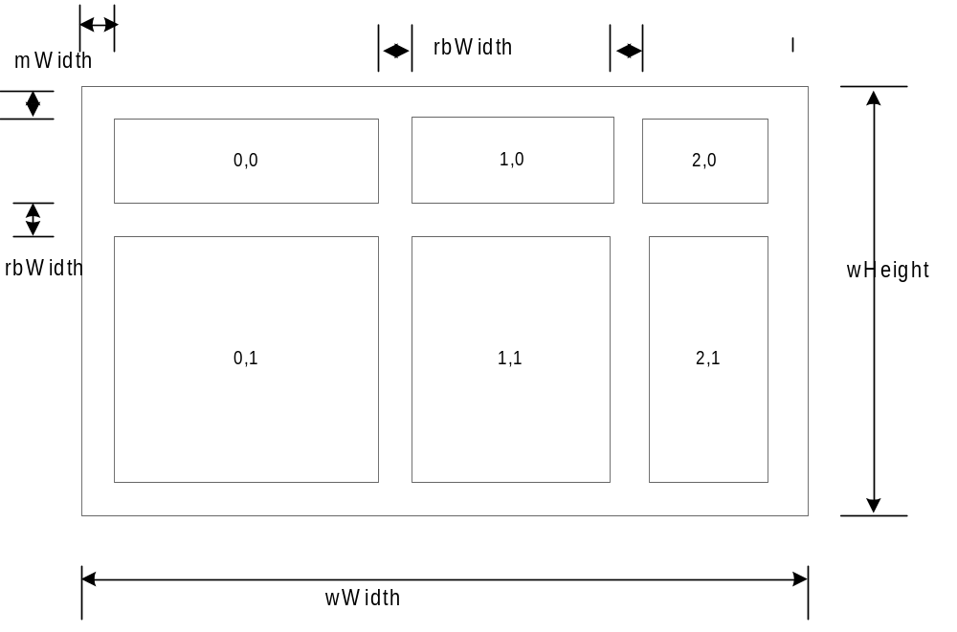
The figure above demonstrates several things about the geometry of the split window.
It’s a splitwindow with a 3 columns 2 rows where the panes are numbered (0,0) to (2,1).
All the resize bars have the same size [rbWidth].
There is a margin [mWidth].

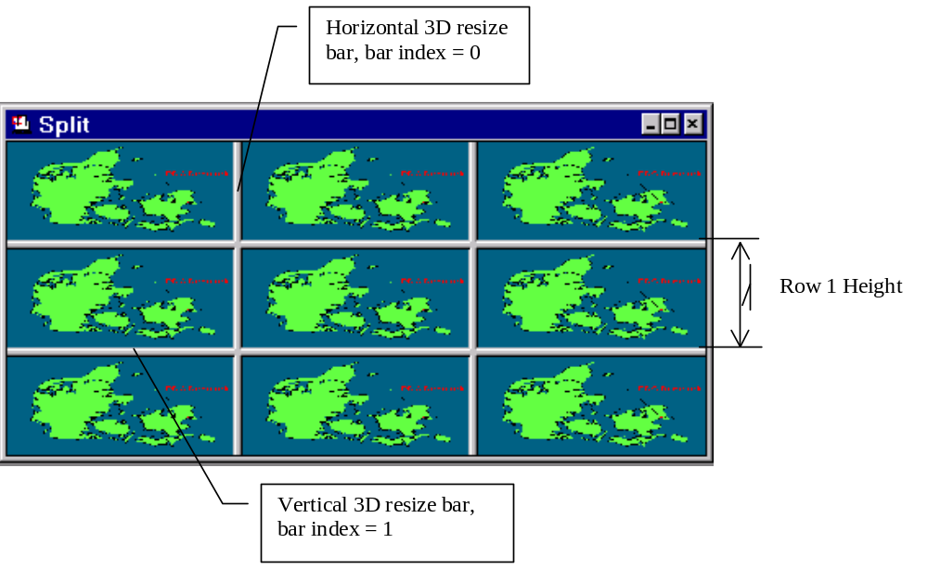

The picture above, from test application, demonstrates split window, where the resize bars are numbered 0 to 1. Row Height = Resize bar Width + Pane Height and Column Width = Resize bar Width + Pane Width.

Visual elements

Panes
The panes are child windows of the split window and the visual appearance of these are their own responsibility.

Margins
The margins are meant to look like half a resize bar. This is only of importance if a 3D look is used for the resize bars. The margins are drawn together with the resize bars.
[see properties: marginWidth]

Resize bars
The resize bars are either flat or 3D.
[see properties: resizebarWidth, resizeBarColor]

Active resize bar
The active resize bar is a line the same size as the resize bar going across the window. It is drawn when the user clicks on a resize bar and follows the cursor when the user drags the mouse.
[Example] look in Word or Outlook.

Resize cursor
When the cursor is above one of the resize bars it changes to a resize cursor. The look of the resize cursor depends on what the resize bar callback predicate returns. Typically it will depend on whether the cursor is above a horizontal resize bar, a vertical resize bar or one of the crosses.

Behaviour

Resizing using the resize bars
- We aim at a model of the split window where the split bars can be thought of as sticks. So when you grab a resize bare and move it only that resize bar moves changing the size of the two windows adjacent to the resize bar.
- If the resizing is greater than the width (or height) of the pane the next pane is resized as well.
- The resize bars are always visible even when the adjacent panes have a width or height of zero.

Visual feedback on resizing
If resizing is allowed (the splitwin_resize_cb doesn’t fail) a resize cursor is drawn. When the mouse is pressed an active resize bar is drawn which follows the cursor, but stays inside the allowable resize area.

Resizing the window
- We treat resizing of the window as if the right and the bottom part of the window was an extra resize bar. The fact that the top or the left side of the window is use to resize the window doesn’t change this it will always be the rightmost column and the bottom row that is resized.
- What happens if the window gets smaller than the administrative space? The administrative space is the space taken by the resize bars and the margins. We just cut of from the right and the bottom. This is the standard behaviour of windows so no special treatment is needed.

Architecture
To facilitate modularity the split window tool is split into two levels, a bottom level and a top level. It should be possible to use the bottom level split window if one wants fine-grained control of the behaviour of the split window. And use the top-level window if one wants the tools to take hand of the details and one can live with the default behaviour. The top level split window is to be implemented on top of the bottom level split window.

Bottom level split window
The bottom level handles the placement of the windows in the split window. It resizes the child windows when the rows and columns change sizes.
The code prefix in the bottom level is “splitwin”.

Split Window Creation
First the split window is created (invisible) then its different properties are set and the panes are created and finally the split window is made visible by the splitwin_Show call.
The bottom level splitwin_create predicate takes the callback predicates as arguments whereas the top level split_create predicate does not.

Resize callback
When the cursor is placed over a resize bar the splitwin_resize_cb predicate is called to find out if the resize bar is fixed and if it’s not how much it should be possible to move it in each direction.
There are three possibilities
- It’s a cross: The relevant horizontal and vertical coordinates each is in the range 0 to N-1 where N is the number of rows or columns respectively.
- It’s a vertical bar: The horizontal coordinate is –1.
- It’s a horizontal bar: The vertical coordinated is –1.
If the callback fails the bar should not be moved. If the allowable movement is negative the bar can be moved freely in that direction.

Update callback
Called to draw the resize bars and the margins. The bottom level asks the top level to draw the resize bars and the margins.

Events callback.
Called to specify window events if splitwin_Create predicate was used for creation.

Setting the Pane Size Programmatically
The problem with setting the pane sizes programmatically is that the total size of the windows will have to fit inside the split window.
Setting the size of a pane works like dragging the right bottom cross of that pane. Of course without the visual feedback

Inserting a Column or a Row
Inserting a column at position N push the column to the right just like resizing does. It also changes the coordinates of all the panes to the right of that column. If we have three columns (numbered 0,1,2) inserting a column at position 1 moves the column 1 and 2 to be column 2 and 3. If the column is inserted as the rightmost column it pushes to the old rightmost column now the column to the left of the newly inserted column.
Insertion of rows works the same way.

Deleting a Column or a Row
Deleting a column changes the coordinates of the columns to the right of the column. If we have a split window with three columns 0,1,2 and delete column 1 column 2 becomes column 1. The column to the right takes the space freed.
Rows are deleted like columns.

Top level split window
In the top level split window you set some properties and it takes care of the communication with the bottom level split window. So a user of the top-level split window should not take care of any callback predicates.

Visual appearance of resize bars
It should be possible to choose between 3D resize bars, plain 2D resize bars.

Using Split tool in application
To use the Split tool in application, programmer should make follow typical steps:
1) Create split window by split_Create(…) predicate or create a window, and then use split_CreateInWindow(…) predicate.
2) Create pane windows.
3) Set panes by split_SetPane(…)predicate.
4) Use the split_Show() predicate.to make split visible.

Example of typical initialization by split_Create predicate
PREDICATES
splitCallback : split_events_cb

CLAUSES

% Retract window on destroy split window, created by split_Create global predicate
splitCallback(SplitWin, e_Destroy(), 0):-
%
%Handle of split window destroying.
%
fail.

constants
split_win_Flags = [wsf_SizeBorder,wsf_TitleBar,wsf_Close,
wsf_Maximize,wsf_Minimize,wsf_ClipSiblings]
split_win_Menu = res_menu(idr_task_menu)
split_win_Title = "splitwin"

clauses

createSplit(ParentWin):-
...
Columns = 3, Rows = 3,
SplitWin = split_Create(
w_TopLevel,
Rect,
split_win_Title,
split_win_Menu,
ParentWin,
split_win_Flags,
splitCallback,
Columns, % Columns
Rows), % Rows
% Creating PaneWin_1 ... PaneWin_6
% as children of SplitWin
...
split_SetPane(SplitWin,0,0,PaneWin_1),
...
split_SetPane(SplitWin,2,2,PaneWin_6),
split_Show(SplitWin).

Example of typical initialization by split_CreateInWindow predicate
..
Creation of split custom control or window and on e_Create event:
..
split_eh(SplitWin, e_Create(_),0):-!,
Columns = 3, Rows = 3,
split_CreateInWindow(SplitWin, Columns, Rows),
% Creating PaneWin_1 ... PaneWin_6
% as children of SplitWin
split_SetPane(SplitWin,0,0,PaneWin_1),
...
split_SetPane(SplitWin,2,2,PaneWin_6),
split_Show(SplitWin),
fail.

Bottom level Global Domains

splitwin_resize_cb
Syntax:

splitwin_resize_cb = determ(
window SplitWin,
integer VertResizeBar,
integer HorzResizeBar,
long LeftWards,
long Rightwards,
long UpWards,
long DownWards,
cursor ResizeCursor)
- (i, i, i, o, o, o, o, o)
Remarks:
Are called when the cursor are placed over at resize bar
Fails if resizing isn't allowed using that bar.
Succeeds and returns the range of legan movements and the resize cursor
if resizing with that resize bar is allowed.
The cursor can be placed i a cross, a vertical or a horizontal resize bar.
If the cursor is in a horizontal resize bar VertResizeBar is -1.
If the cursor is in a vertical resize bar the HorzResizeBar is -1.

splitwin_update_cb
Syntax:

splitwin_update_cb = procedure (window SplitWin) - (i)
Remarks:
Draw the resize bars and the margins.

splitwin_events_cb
Syntax:

splitwin_events_cb = determ(
window SplitWin,
event Event,
long RetCode)
- (i, i, o)
Remarks:
Called to specify window events if splitwin_Create predicate was used for creation.

Bottom level Global predicates
splitwin_Create
Syntax:
window /* SplitWin */ splitwin_Create(
wintype WinType,
rct Rectangle,
string Title,
menu Menu,
window ParentWindow,
wsflags Flags,
splitwin_resize_cb ResizeCallback,
splitwin_update_cb UpdateCallback,
split_events_cb EventCallback,
integer Columns,
integer Rows)
- procedure (i, i, i, i, i, i, i, i, i, i, i)

Remarks:

Creates a split window with the designated number
of Columns and Rows.
The window is created invisible and is made visible by
splitwin_Show.
Errors:
1 WinType is not w_TopLevel or w_Child type
2 Illegal start Columns or Rows

splitwin_CreateInWindow
Syntax:
splitwin_CreateInWindow(
window SplitWin,
splitwin_resize_cb ResizeCallback,
splitwin_update_cb UpdateCallback,
integer Columns,
integer Rows)
- procedure (i,i,i,i,i)
Remarks:
Works like splitwin_Create but in an already created window,
for use with custom controls, or created window.
The created window should not contain the wsf_ClipChildren flag.
Errors:
2 Illegal start Columns or Rows

splitwin_GetPane
Syntax:
window /* PaneWin */ splitwin_GetPane(
window SplitWin,
integer Column,
integer Row)
- procedure (i, i, i)
Remarks:
Returns the child window contained in pane (Column, Row) or NullWin
Errors:
3 Illegal split window

splitwin_Show
Syntax:
splitwin_Show(
window SplitWin)
- procedure (i)
Remarks:
splitwin_Show makes the splitwin Visible
Errors:
3 Illegal split window

splitwin_SetPane
Syntax:
window /* PaneWin */ splitwin_SetPane(
window SplitWin,
integer Column,
integer Row,
window PaneWin)
- procedure (i, i, i, i)
Remarks:
Sets the pane (column, row) to be the childwindow PaneWin.
Returns the previous child window contained in that pane or NULL if
the pane previously was empty.
Errors:
3 Illegal split window
4 Invalid column
5 Invalid row
7 Invalid pane window type

splitwin_SetColumnWidth
Syntax:
splitwin_SetColumnWidth(
window SplitWin,
integer Column,
long Width)
- procedure (i, i, i)
Remarks:
Sets the Width of the Column as if the resize bar to the
right of the column had been moved manually.
But without checking with the resize callback.
If there isn't a resize bar to the right or the resize bar
to the right cannot be moved as desired, because it's limited
by the window size, then as if the resize bar
to the left had been moved manually.
Errors:
3 Illegal split window
4 Invalid column
8 Invalid column width

splitwin_GetColumnWidth
Syntax:
splitwin_GetColumnWidth(
window SplitWin,
integer Column,
long Width)
- procedure (i, i, o)
Remarks:
Gets the Width of the Column.
Errors:
3 Illegal split window
4 Invalid column

splitwin_SetRowHeight
Syntax:
splitwin_SetRowHeight(
window SplitWin,
integer Row,
long Height)
- procedure (i, i, i)
Remarks:
Sets the Height of the Row as if the resize bar below the row
had been moved manually.
But without checking with the resize callback.
If there isn't a resize bar below or the resize bar below cannot
be moved as desired, because it's limited
by the window size, then as if the resize bar above
had been moved manually.
Errors:
3 Illegal split window
5 Invalid row
9 Invalid row height

splitwin_GetRowHeight
Syntax:
splitwin_GetRowHeight(
window SplitWin,
integer Row,
long Height)
- procedure (i, i, o)
Remarks:
Gets the Width of the Column.
Errors:
3 Illegal split window
5 Invalid row

splitwin_GetPaneCoordinate
Syntax:
pnt /* Coordinates */ splitwin_GetPaneCoordinate(
window SplitWin,
window PaneWin)
- procedure (i, i)
Remarks:
Returns the coordinates of the pane containing the PaneWin.
Errors:
6 If there is no such PaneWin

splitwin_SetMarginWidth
Syntax:
splitwin_SetMarginWidth(
window SplitWin,
long WidthInPixels)
- procedure (i, i)
Remarks:
Sets the margin width in pixels
Defailt is 1 pixels
Errors:
3 Illegal split window
13 Invalid margin width (width must be >= 0)

splitwin_GetMarginWidth
Syntax:
splitwin_GetMarginWidth(
window SplitWin,
long WidthInPixels)
- procedure (i, o)
Remarks:
Gets the margin width in pixels
Errors:
3 Illegal split window

splitwin_SetResizeBarWidth
Syntax:
splitwin_SetResizeBarWidth(
window SplitWin,
long WidthInPixels)
- procedure (i, i)
Remarks:
Sets the Resize Bar Width in pixels
Default is 6 pixels
Errors:
3 Illegal split window
12 Illegal resize bar width (width must be > 1)

splitwin_GetResizeBarWidth
Syntax:
splitwin_GetResizeBarWidth(
window SplitWin,
long WidthInPixels)
- procedure (i, o)
Remarks:
Gets the Resize Bar Width in pixels
Errors:
3 Illegal split window

splitwin_GetColumnBarPos
Syntax:
splitwin_GetColumnBarPos(
window SplitWin,
integer Column,
integer Position)
- procedure (i, i, o)
Remarks:
Returns the Column resize bar coordinate,
Including bar -1 (coordinate: Margin + 1)
and bar N (coordinate: client Width - Margin - 1),
where N - number of column bars.
Errors:
3 Illegal split window
4 Invalid column

splitwin_GetRowBarPos
Syntax:
splitwin_GetRowBarPos(
window SplitWin,
integer Row,
integer Position)
- procedure (i, i, o)
Remarks:
Returns the Row resize bar coordinate,
Including bar -1 (coordinate: Margin + 1)
and bar N (coordinate:client Height - Margin - 1),
where N - number of row bars.
Errors:
3 Illegal split window
5 Invalid row

splitwin_ClearPane
Syntax:
window /* PaneWin */ splitwin_ClearPane(
window SplitWin,
integer Column,
integer Row)
- procedure (i, i, i)
Remarks:
Returns the child window contained in pane (Column, Row)
and deletes the Pane from the split window
Errors:
3 Illegal split window
4 Invalid column
5 Invalid row

splitwin_DeleteColumn
Syntax:
splitwin_DeleteColumn(
window SplitWin,
integer Column)
- procedure (i, i)
Remarks:
Deletes a column and destroys all the pane windows in that column.
The contents of the columns to the right moves one to the left.
The column to the immediate right takes up the freed space unless
Column is the rightmost column in which case the column to the
immediate left gets the space
Errors:
3 Illegal split window
4 Invalid column

splitwin_DeleteRow
Syntax:
splitwin_DeleteRow(
window SplitWin,
integer Row)
- procedure (i, i)
Remarks:
Works like splitwin_DeleteColumn
Errors:
3 Illegal split window
5 Invalid row

splitwin_InsertColumnAt
Syntax:
splitwin_InsertColumnAt(
window SplitWin,
integer Column,
long Width)
- procedure (i, i, i)
Remarks:
Creates a new column. Moves the contents of the old column and all
the columns to the right of it one to the right.
It makes room for the new column by pushing the column to the right
unless it's the rightmost columns in which case it pushes the
column to the left.
If width is too big it makes the column as big as possible.
Errors:
3 Illegal split window
4 Invalid column

splitwin_InsertRowAt
Syntax:
splitwin_InsertRowAt(
window SplitWin,
integer Row,
long Height)
- procedure (i, i, i)
Remarks:
Works like splitwin_InsertColumnAt
Errors:
3 Illegal split window
5 Invalid row

Top level Split Window
There is little difference in the API of the top level and the bottom level. The main difference is that the top level sets defaults for the properties and sets the update and the resize callback.
So the top level API is the same as the bottom level API with a few additions. Most of the toplevel predicates can be implemented as simple calls to the bottom level predicates.
The prefix for the top level is “split”

Top level Global Domains
split_events_cb
Syntax:

split_events_cb = determ(
window SplitWin,
event Event,
long RetCode)
- (i, i, o)
Remarks:
Called to specify window events if split_Create predicate was used for creation.

Top level Global Predicates

split_Create
Syntax:

window split_Create(
wintype WinType,
rct Rectangle,
string Title,
menu Menu,
window ParentWindow,
wsflags Flags,
integer Columns,
integer Rows)
- procedure (i, i, i, i, i, i, i, i)

Remarks:
Works like splitwin_Create but set up default handling for
drawing of resizebars and allowable resize.

split_CreateInWindow
Syntax:

split_CreateInWindow(
window SplitWin,
integer Columns,
integer Rows)
- procedure (i,i,i)
Remarks:
Works like split_Create but in an already created window,
for use with custom controls or created window.
The created window should not contain the wsf_ClipChildren flag.

split_Show
Syntax:

split_Show(window SplitWin) - procedure (i)

Remarks:
split_Show makes the splitwin Visible

split_SetPane
Syntax:

window /* PaneWin */ split_SetPane(
window SplitWin,
integer Column,
integer Row,
window PaneWin)
- procedure (i, i, i, i)

Remarks:
Works like splitwin_SetPane.
Sets the pane (column, row) to be the childwindow PaneWin.
Returns the previous child window contained in that pane or NULL if
the pane previously was empty.

split_GetPane
Syntax:

window /* PaneWin */ split_GetPane(
window SplitWin,
integer Column,
integer Row)
- procedure (i, i, i)

Remarks:
Works like splitwin_GetPane.
Returns the child window contained in pane (Column, Row)

split_GetPaneCoordinate
Syntax:

pnt /* Coordicates */ split_GetPaneCoordinate(
window SplitWin,
window PaneWin)
- procedure (i, i)

Remarks:
Works like splitwin_GetPaneCoordinate.
Returns the coordinates of the pane containing the PaneWin.

split_SetStyle
Syntax:

split_SetStyle(
window SplitWin,
split_style Style)
- procedure (i, i)

Remarks:
Sets resize bar 2d/3d Style.
Default is split_style_3D

split_GetStyle
Syntax:

split_GetStyle(
window SplitWin,
split_style Style)
- procedure (i, o)

Remarks:
Gets resize bar 2d/3d Style.
Default is split_style_3D

split_SetMarginWidth
Syntax:

split_SetMarginWidth(
window SplitWin,
long WidthInPixels)
- procedure (i, i)

Remarks:
Works like splitwin_SetMarginWidth.
Sets the margin width in pixels
Defailt is 1 pixels

split_GetMarginWidth
Syntax:

split_GetMarginWidth(
window SplitWin,
long WidthInPixels)
- procedure (i, o)

Remarks:
Works like splitwin_GetMarginWidth.
Gets the margin width in pixels
Defailt is 1 pixels

split_SetResizeBarWidth
Syntax:

split_SetResizeBarWidth(
window SplitWin,
long WidthInPixels)
- procedure (i, i)

Remarks:
Works like splitwin_SetResizeBarWidth.
Default is 6 pixels

split_GetResizeBarWidth
Syntax:

split_GetResizeBarWidth(
window SplitWin,
long WidthInPixels)
- procedure (i, o)

Remarks:
Works like splitwin_GetResizeBarWidth.

split_SetResizeBarColor
Syntax:

split_SetResizeBarColor(
window SplitWin,
color ResizeBarColor)
- procedure (i, i)

Remarks:
Sets the color of the resize bars.
Default is btn_face_color

split_GetResizeBarColor
Syntax:

split_GetResizeBarColor(
window SplitWin,
color ResizeBarColor)
- procedure (i, o)

Remarks:
Gets the color of the resize bars
Default is btn_face_color

split_ClearPane
Syntax:

window /* PaneWin */ split_ClearPane(
window SplitWin,
integer Column,
integer Row)
- procedure (i, i, i)

Remarks:
Works like splitwin_ClearPane.
Returns the child window contained in pane (Column, Row)
and deletes the Pane from the split window

split_DeleteColumn
Syntax:

split_DeleteColumn(
window SplitWin,
integer Column)
- procedure (i, i)

Remarks:
Works like splitwin_DeleteColumn.
Deletes a column and destroys all the pane windows in that column.
The contents of the columns to the right moves one to the left.
The column to the immediate right takes up the freed space unless
Column is the rightmost column in which case the column to the
immediate left gets the space.

split_DeleteRow
Syntax:

split_DeleteRow(
window SplitWin,
integer Row)
- procedure (i, i)

Remarks:
Works like splitwin_DeleteRow

split_SetColumnWidth
Syntax:

split_SetColumnWidth(
window SplitWin,
integer Column,
long Width)
- procedure (i, i, i)

Remarks:
Works like splitwin_SetColumnWidth

split_GetColumnWidth
Syntax:

split_GetColumnWidth(
window SplitWin,
integer Column,
long Width)
- procedure (i, i, o)

Remarks:
Works like splitwin_GetColumnWidth

split_SetRowHeight
Syntax:

split_SetRowHeight(
window SplitWin,
integer Row,
long Height)
- procedure (i, i, i)

Remarks:
Works like splitwin_SetRowHeight

split_GetRowHeight
Syntax:

split_GetRowHeight(
window SplitWin,
integer Row,
long Height)
- procedure (i, i, o)

Remarks:
Works like splitwin_GetRowHeight

split_InsertColumnAt
Syntax:

split_InsertColumnAt(
window SplitWin,
integer Column,
long Width)
- procedure (i, i, i)

Remarks:
Works like splitwin_InsertColumnAt
Creates a new column. Moves the contents of the old column and all
the columns to the right of it one to the right.
It makes room for the new column by pushing the column to
the right unless it's the rightmost columns in which case it pushes
the the column to the left.
If width is too big it makes the column as big as possible.

split_InsertRowAt
Syntax:

split_InsertRowAt(
window SplitWin,
integer Row,
long Height)
- procedure (i, i, i)

Remarks:
Works like split_InsertColumnAt

