**WPP2019: template to interpolate/extrapolate mx by age and sex using the Limited Lee-Carter method and its variants for the period 1950-2020 by 5-year periods** (WPP-style from mid-year t to mid-year t+5)

The template was developed by Nan Li for WPP2010, and updated by PG in Aug. 2018 (see log of changes) – Latest revision 4 Sept. 2018.

Input data:

* Observed Mx (or alternatively Qx or lx) by age and sex for a variable range of years (minimum 3 years, maximum 80 years) in Input_M and Input_F datasheets. The open age group should be 100+, but the template allows to use data only up to age 80-84, and if data are missing at older ages, the template uses Coale-Guo function to extend Mx up to 100+. Extrapolation at older ages is performed selectively for years with missing data.
* Optional extra input: time series of e0 by sex for more recent years if no Mx available.

Intermediate data (computed automatically):

* Input Mx used from Lee-Carter method (in “In_Mx_M” and “In_Mx_F” datasheets): either computed from input Qx or lx, or identical to observed input Mx and/or updated at older ages using Coale-Guo extension if missing observations in some years and older ages.

Output data:

* Interpolated/extrapolated Mx by age and sex for the standard 5-year periods from 1950 to 2020 for WPP in OutMx_M and OutMx_F datasheets, and abridged life tables in Out_LT datasheet
* To check results (OutFigures): life expectancy at birth by sex (and IMR) is computed for the observed Mx for the input years, and the interpolated/extrapolated Mx using the Lee-Carter method for the WPP 5-year periods.

The template can be used to deal with various typical situations as follow:

|  | Type of data used as input |  | Method Parameters to choose |  |  |
| --- | --- | --- | --- | --- | --- |
| **Case** | **Input Mx** | **Input e0** | **Sex-specific (1) or Both sexes (2)** | **Use only Mx (1) or also e0 (2)** | **Note** |
| 1a | Selected years (e.g., 1980, 1991, 1996, 2000, 2010) |  | Use 1 (default) | 1 (default) |  |
| 1b |  |  | Use 2 for Non-Divergent LC in case of sex-crossover |  |  |
| 2 | Recent annual series or for selected years (2003-2014) from HMD or national sources |  | Use 1 (default) | 1 (default) |  |
| 3 | Recent annual series (e.g., WPP or HMD for 2000-2005 and 2005-2010, HMD for 2010-2014, and annual civil calendar years Mx for 2015-2017 from national sources) |  | Use 1 (default) | 1 (default) | Extend 90+ using Coale-Guo function for 2015-2017 due to old-age problems |
| 4 | 1983, 1988, 1993, 1998,… 2010 | 2012.5, 2013.5, 2014.5, 2015.5, 2016.5, 2017.5  [must also provide e0 for years with input mx] | Use 1 (default) | Use 2 |  |

Note: The overall time period used as input for Mx should cover the period of interest to compute the average mortality pattern to use, the overall time trend and rates of mortality changes by age groups.

* If the template is used for interpolation/extrapolation over long time periods (e.g., 1950-2020), as many relevant time periods/years should be provided.
* If the template is used for short term projections/extrapolations (e.g., to complement HMD with more recent national annual series), only the most recent decades should be used (e.g., 1980 or 1990 onward – see example 2).

Examples of use of the template

**Case 1a: Mx for selected years**

Note: in this example, the open age group for the input data is 85+. In this case, Mx is provided as input only up to age 80-84, and the Coale-Guo function will be used for the extension up to age 100+

Step 1: Mx for Males are provided in “Input_M” datasheet with the corresponding decimal year for each mid-period.

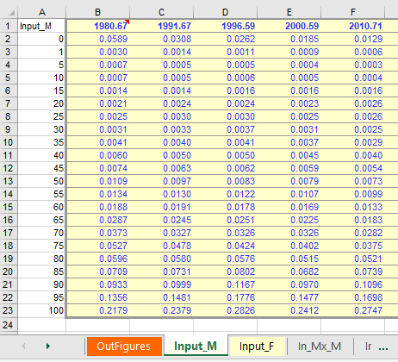

Step 2: Mx for Females are provided in a similar fashion in “Input_F” datasheet. The reference years should be identical as for males.

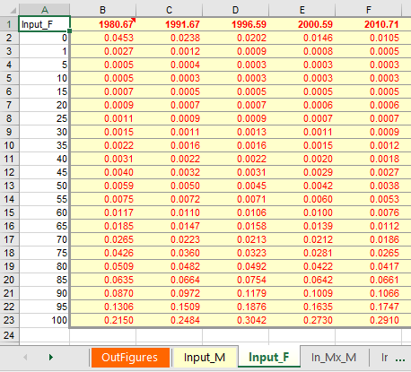

Step 3: Specify the type of method to use for interpolation/extrapolation in the first datasheet called “OutFigures”:

First specify the type of input data you are using, use 1 for Mx, 2 for Qx or 3 for lx. In this example, we use Mx so the type of input is set to 1.

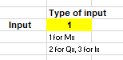

Secondly update as needed the parameter whether you want to use sex-specific information (default = 1).

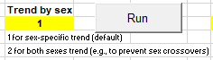

Thirdly since you are only using Mx as input the third parameter should be set to 1 (default)

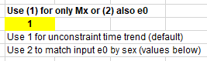

Once you have checked or updated this choice of parameters, click on the RUN button.

The datasheet gets updated with various results:

On the left panels (A and B) you get e0 respectively for (A) the Lee-Carter interpolated/extrapolated Mx for WPP-year periods (in red), and (B) the observed Mx for the input years. Chart in panel C plots e0 by sex for both observed and modelled Mx. Panel D on the right shows similar results for IMR with plot on Figure F.

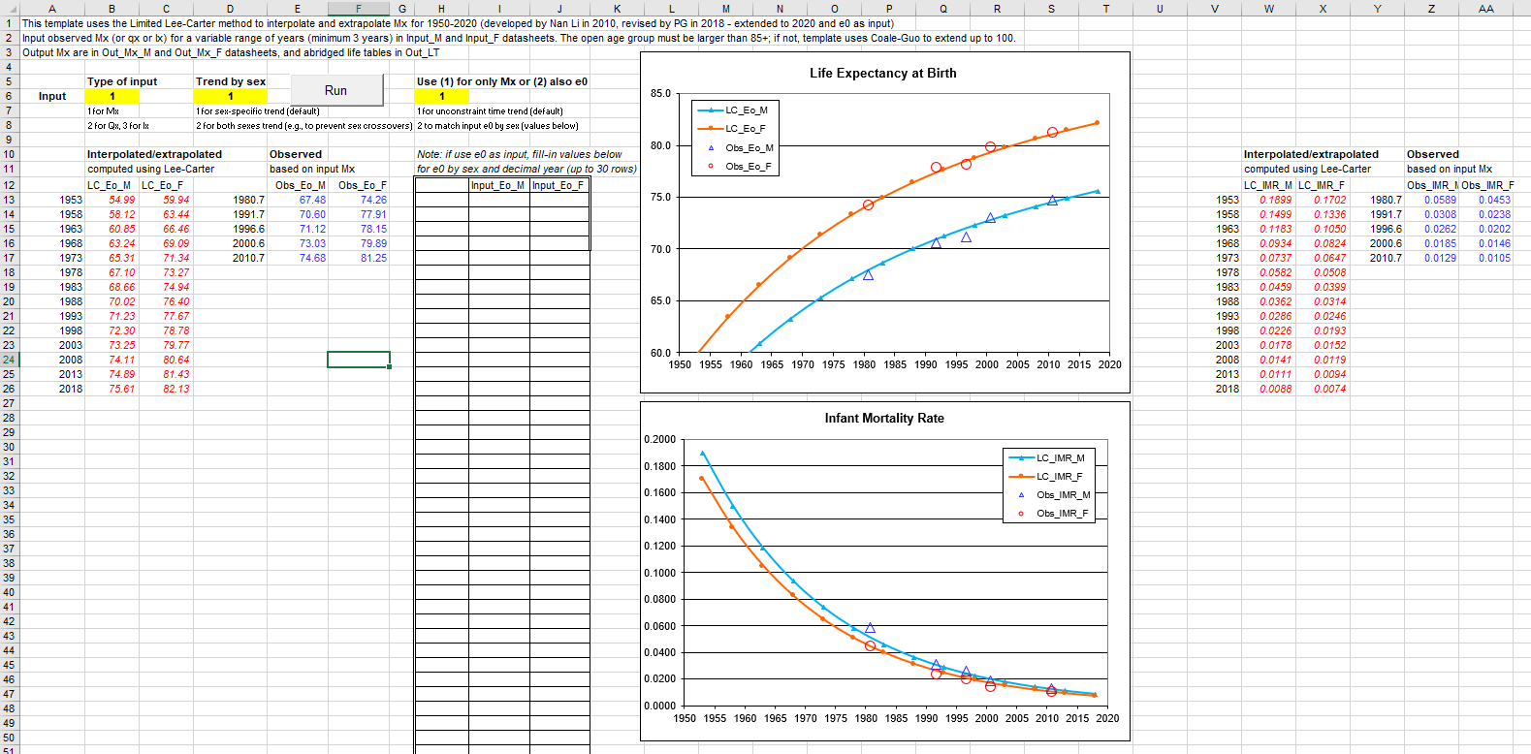

**A**

**B**

**D**

**F**

**C**

Note that in this example since input data were provided stating from 1980 onward, results for earlier periods are back-projections up to 1950, and depending of the context you may want to consider using some of them or not. The template allows to use a variable set of years, and Mx from various data sources, so in cases you need to provide further guidance on earlier years, you may want to use previous WPP Mx estimates.

A closer look at the input datasheets used for the computation (In_Mx_M and In_Mx_F) shows that the input Mx have been extended up to age 100+ (note that if Qx of lx are used as input, the Mx will also get computed and saved in these datasheets):

|  |  |
| --- | --- |
| Male input Mx extended up to 100+ | Female input Mx extended up to 100+ |
|  |  |

Results for Lee-Carter interpolated/extrapolated Mx for WPP-year periods are available respectively for Males and Females in the “OutMx_M” and “OutMx_F” datasheets:

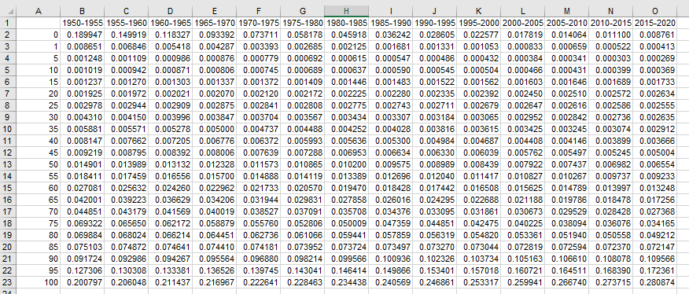

In addition the “Out_LT” provides the abridged life tables stacked up by period and sex for Eagle/R country input files.

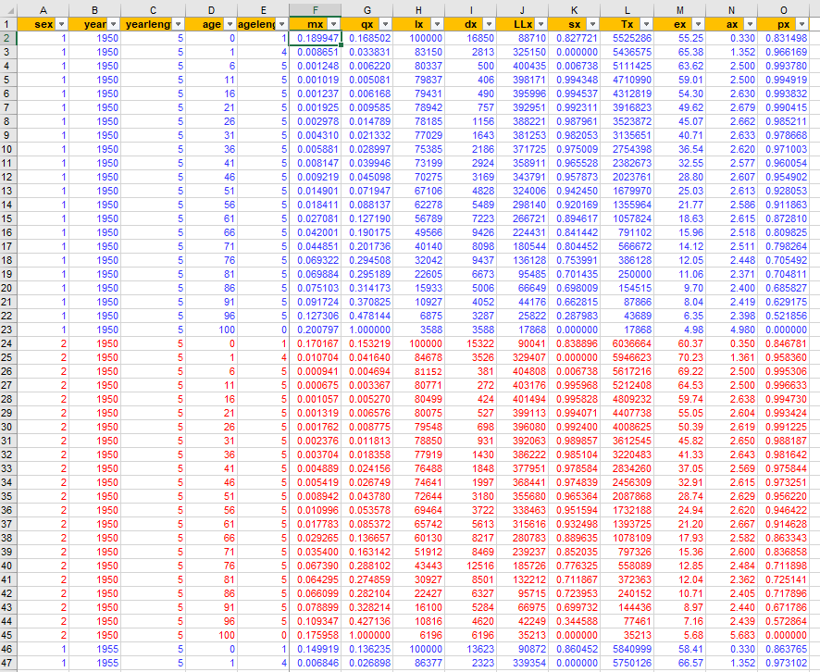

**Case 2: recent annual series (e.g., annual civil calendar years Mx for 2003-2014 from HMD).**

Example of input Mx for Males:

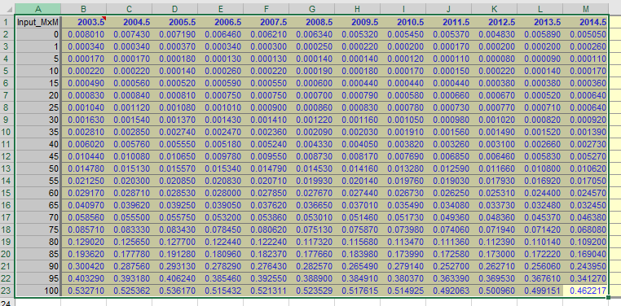

Summary results:

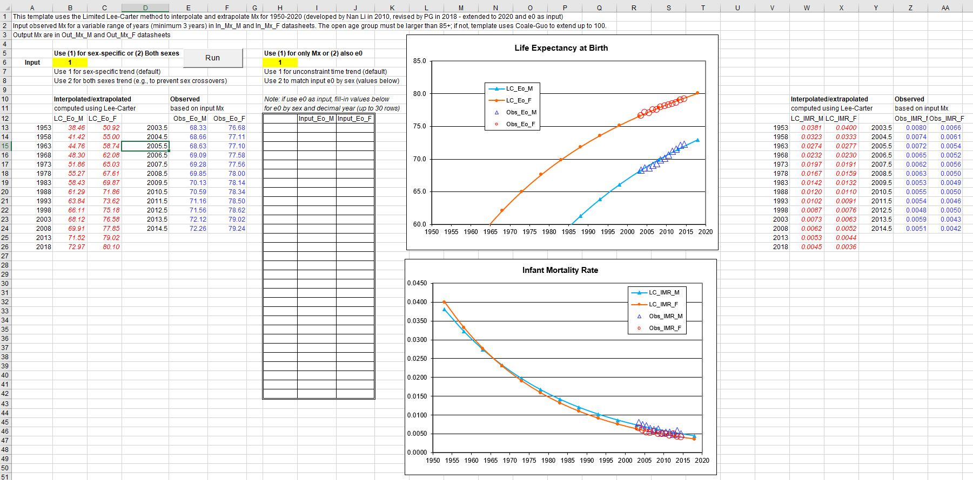

In this example since input Mx have been provided only for 2003-2014, these WPP 5-year estimates should only be used for the periods 2010-2015 and 2015-2020.

**Case 3: recent annual Mx series (e.g., WPP or HMD for 2000-2005 and 2005-2010, HMD for 2010-2014, and annual civil calendar years Mx for 2015-2017 from national sources).**

Example of input Mx for Males:

|  |  |
| --- | --- |
| Male input Mx | Female input Mx |
|  |  |

Initial summary results:

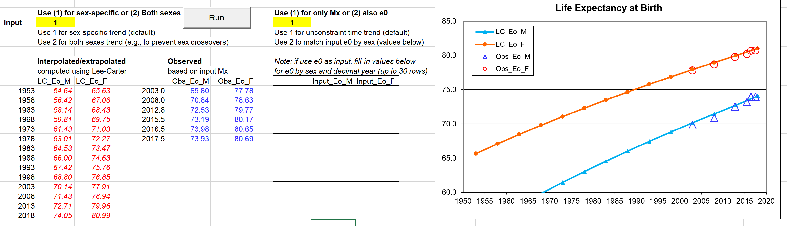

But when inspecting the Mx results by age (“OutMx_M” and “OutMx_F” datasheets) we can notice an abnormal mortality decline at older ages in Mx (from age 90 onward). The problem is with input Mx from the national source at older ages (90 onward).



In such case, the recommend strategy is to discard the empirical Mx from age 90 onward for 2015-2017, and instead use the Coale-Guo function to extend Mx up to age 100+

|  |  |
| --- | --- |
| Male input Mx | Female input Mx |
|  |  |

After rerun, the new summary results are updated as follow:

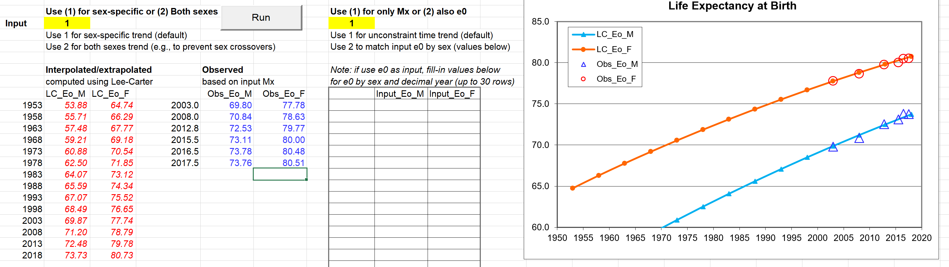

Extended Mx for age 90+ using Coale-Guo function for the 3 most recent years (in “In_Mx_M” and “In_Mx_F” datasheets)

|  |  |
| --- | --- |
| Male input Mx – | Female input Mx |
|  |  |

The estimated/projected values for e0 are slightly adjusted downward for the most recent periods, and the Mx results by age (“OutMx_M” and “OutMx_F” datasheets) are now consistent with the expected age pattern at older ages and with previous periods (based on HMD).



**Case 4: Mx for 1980-2010 from WPP and time series of e0 by sex from national sources for selected years, or annually from 1980 to 2017.**

Example of input Mx for Males:

|  |  |
| --- | --- |
| Male input Mx | Female input Mx |
|  |  |

Initial summary results using only as input Mx without extra e0

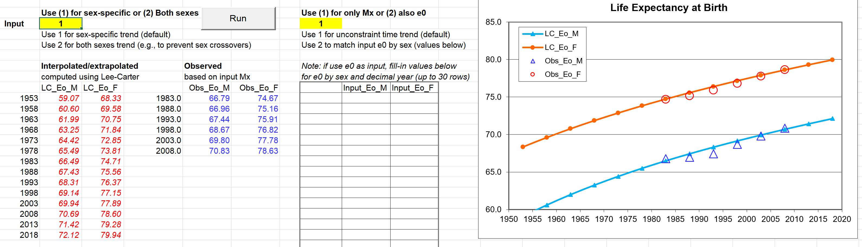

If we add in the first datasheet called “OutFigures” the observed time series of e0 by sex we also want to use as input to constraint the interpolation/extrapolation of Mx (see panel A in the figure below), type as second parameter option 2 to use e0 as input instead of Mx only (panel B in the figure below), we can rerun the template to get the following updated results:

Updated input using e0 by sex with summary results:

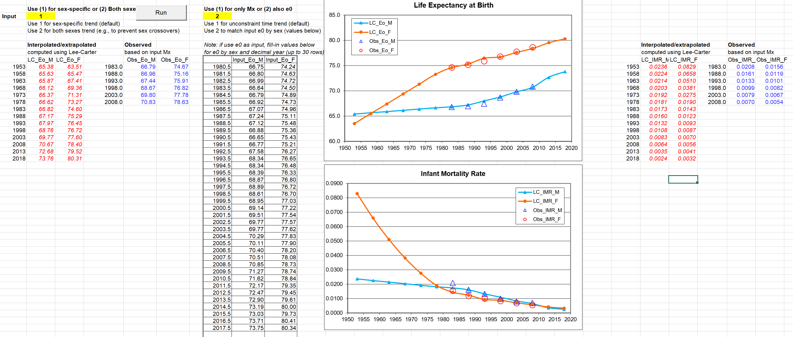

**B**

**A**

Using this option, all output Mx are rescaled to match the input e0 by sex. Note that for IMR a slight sex-crossover occurs when using sex-specific interpolation/extrapolation using the Lee-Carter method in this case for the most recent periods.

Updated summary results using as input both sexes trend by age and e0 by sex:

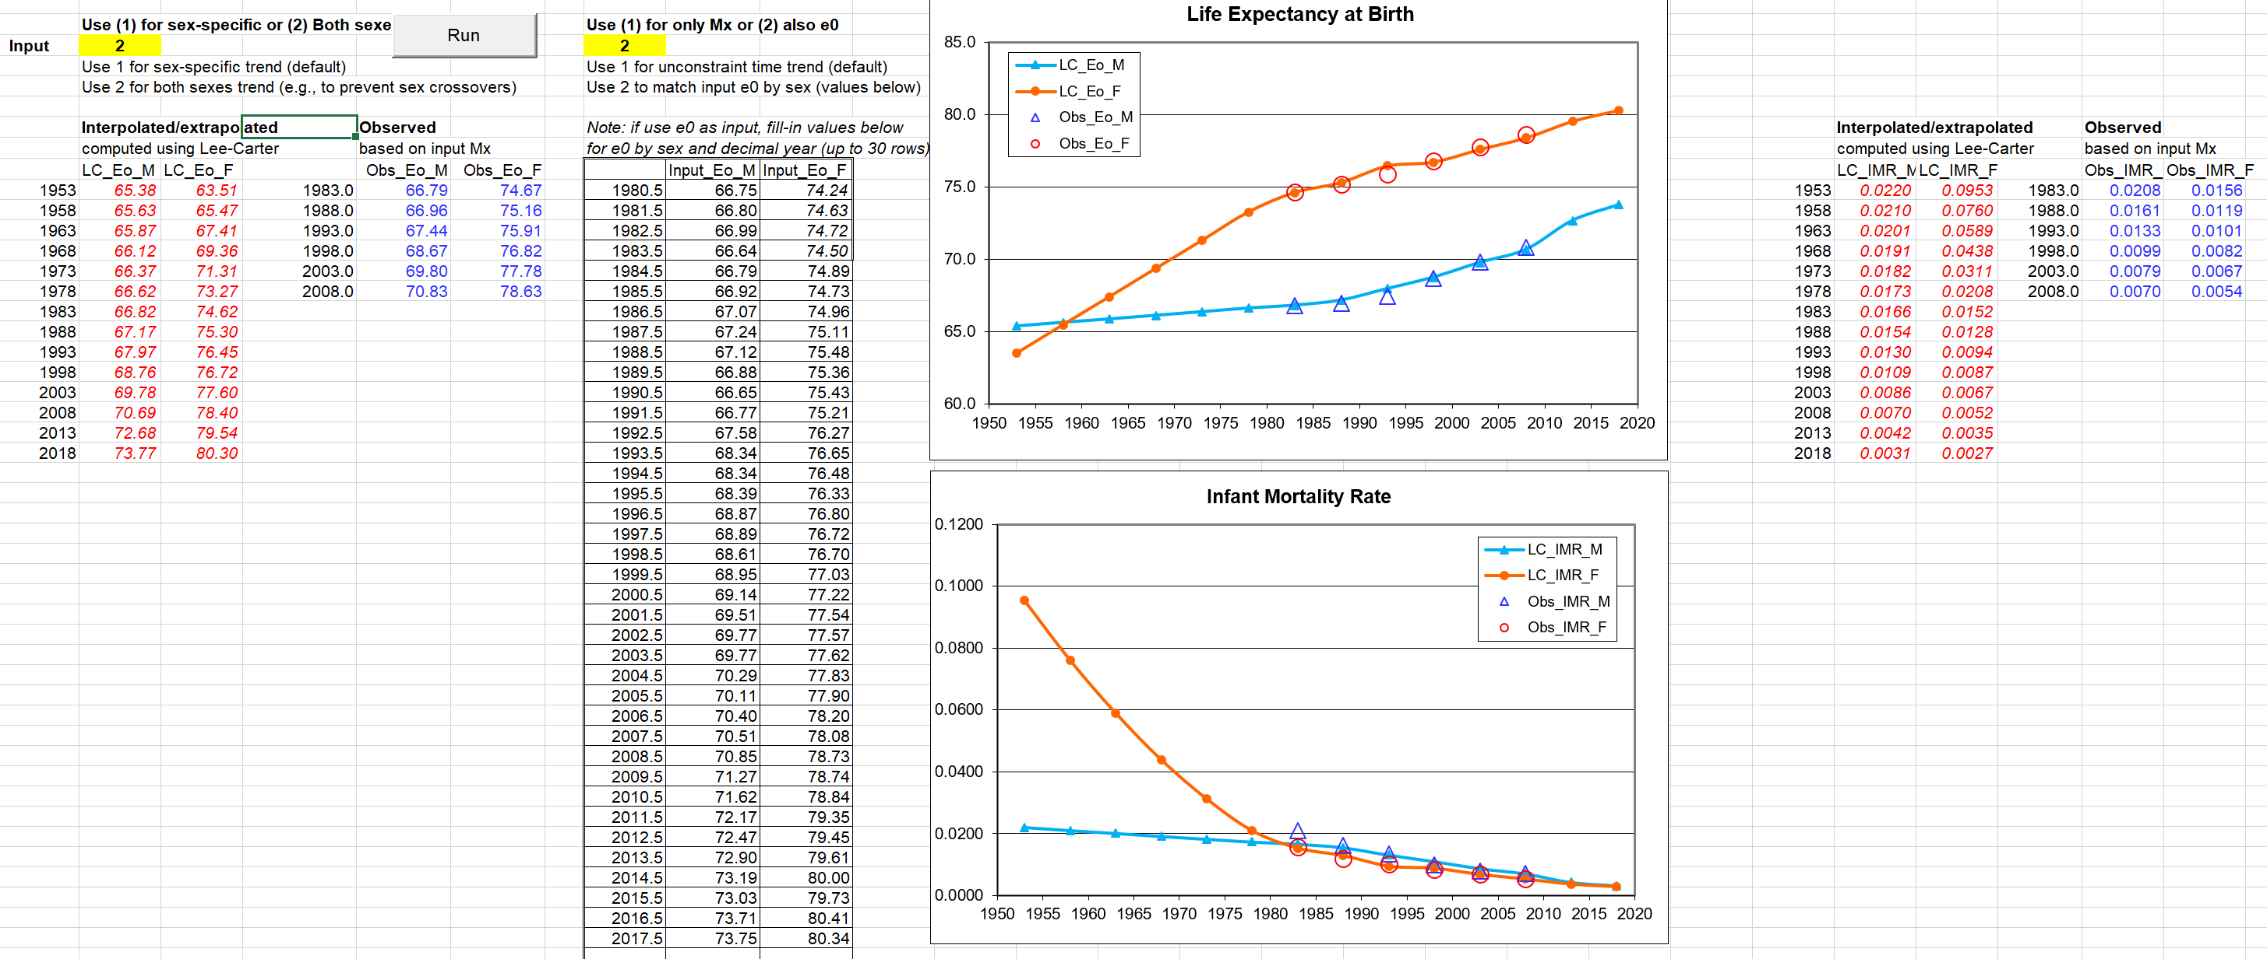

The use of the Both sexes option (2) for Non-Divergent Lee-Carter method in case of sex-crossover helps to mitigate the issue with unexpected sex-crossovers in some ages (e.g. under age 1) as can be seen in the following plot comparing the M/F sex ratio in Mx between the Sex-specific (option #1) and Both sexes (option #2) used for the extrapolation of Mx for 2015-2020 period in this example.



Log of changes made:

* Extended to 2020 for outputs
* Extended up to 80 years for inputs
* Updated to apply Coale-Guo extension selectively only for years and ages with missing data for age 85+
* Corrected WPP mid-period for mx output (i.e., start in 1948 instead of 1947.5)
* Added support for e0 as input to rescale kt and match e0 (Lee-Miller, 2001)
* Added computation of abridged life tables as output
* Added support for qx (or lx) as input instead of only mx

References:

* Limited Lee-Carter method: Li, N., Lee, R., & Tuljapurkar, S. (2004). Using the Lee–Carter method to forecast mortality for populations with limited data. *International Statistical Review*, *72*(1), 19-36.
* Non-divergent Lee-Carter method: Li, N., & Lee, R. (2005). Coherent mortality forecasts for a group of populations: An extension of the Lee-Carter method. *Demography*, *42*(3), 575-594.
* Constrained Lee-Carter method on e0 by sex: Lee, R. D. & Miller, T. (2001). Evaluating the performance of the Lee-Carter method for forecasting mortality. *Demography*, 38, 537:549.