|  |  |  |
| --- | --- | --- |
| USER REQUIREMENTS SPECIFICATIONS | April 21  2015 | |
| LUDO WCF APPLICATION | | 1. GROUP: Todor Tsekov Ivana Raykova Zair Thiel |

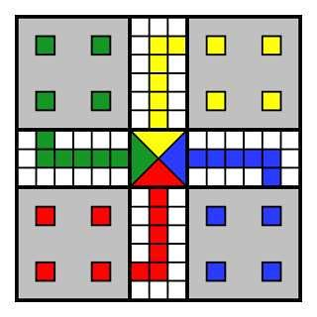

# TABLE OF CONTENT

# 1. INTRODUCTION

The goal of this project is to build a Ludo Application. Ludo is a board game for 2-4 players. Every player is assigned 4 pieces, a dice and one of 4 possible starting areas. The goal is to get all your pieces around the game board to the finish line. Players take turns throwing the dice, which decides how far a piece can be moved. If you get a 6 you get an extra turn or you may enter another staged token to its starting square. When a player lands a piece on top on an opponent’s piece, the opponent’s piece is sent to the starting area. The general strategy is to make sure that your own pieces are not send to your starting area, and at the same time try to send the pieces of your opponents to their starting area. The rolls of a die control the swiftness of the tokens, and entry to the finishing square requires a precise roll from the player. The first to bring all their tokens to the finish wins the game.

# 2. FUNCTIONAL REQUIREMENTS AND USE CASES

# 2.1 REQUIREMENTS

|  |  |
| --- | --- |
| NBR | DESCRIPTION |
| 1 | Any game should be played at least by two players(users) simultaneously. |
| 2 | Player(user) should be able to choose a color of tokens(green, blue, yellow, red). |
| 3 | The player should be able to see the die result. |
| 4 | The player should be able to see if he win or lose. |
| 5 | The player should be able to close the tab and quit the game at anytime. |
| 6 | The player (user) should be able to log in the game. |
| 7 | The player ( user) should be able to register in the game. |
| 8 | There should be a chat between the players who are playing against. |
| 9 | The player (user) should be able to see what the next action is. |
| 10 | The player (user) should be able to see the score board of each player. |

# 2.2 USE CASES

# Registration in the game

|  |  |
| --- | --- |
| Goal- level | Registering in the game |
| Pre-condition | The user is not registered in the game yet |
| Trigger |  |
| Actor | User |
| MSS | 1.The User fills the registering blank with his data  2. The User chooses an username and a password  3. The User clicks on the button “register”  4. System notifies User if his register was successfully |
| Extension | 2.1 If the username already exist, the system notifies the user to choose another username |
| Rule |  |
| Post Condition | The user successfully registered. |

# Log into the game

|  |  |
| --- | --- |
| Goal- level | To log in the game |
| Pre – condition | The user has to be already registered in the game |
| Trigger |  |
| Actor | User |
| MSS | 1. The User types the username 2. The User types the password |
| Extension | * 1. If the User has typed the username wrong, the system will notify the User with a message to retype it   2. If the User has typed the password wrong, the system will notify the User with a message to retype it |
| Rule |  |
| Post Condition | The user successfully logged in the game |

# Chat during the game

|  |  |
| --- | --- |
| Goal- level | To chat with opponent during the game |
| Pre – condition | 1.The game has already started |
| Trigger |  |
| Actor | User |
| MSS | 1.The User type a message in the chat box  2.The User receives a message in the chat box |
| Extension |  |
| Rule |  |
| Post Condition |  |

# 3. GUI