**1 – Convolutions and Filters**

a) Deconvolution is the process of recovering the input kernel or image from the convolved result.

Let I be a 5x5 image:

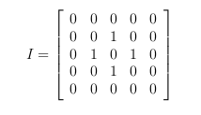

After convolving image I by a 3 × 3 kernel k you obtain the following image J:

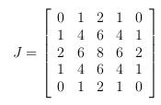

Given J = I ⊗ k, and knowing I, what is the kernel k?

b) Assume we have the following 1D image I and symmetric filter f :



* Convolve I with f assuming around-boundary reflection padding. Show your computations.
* The above filter f is called a box blur. We have typically used a Gaussian blurring filter in this class. Give an example of an application in computer vision in which the Gaussian blur may have an advantage over the box blur.

c.) What is the Laplacian of a Gaussian (LoG) filter?

To which structures would the LoG give strongest positive responses and to which structures would it give strongest negative responses?

**2 - Camera Projection**

a) True or False: The orthographic projection of two parallel lines in the world must be parallel in the image.

b) Under what conditions will a line viewed with a pinhole camera have its vanishing point at infinity?

c) scene point at coordinates (400,600,1200) is perspectively projected into an image at coordinates (24,36), where both coordinates are given in millimeters in the camera coordinate frame and the camera’s principal point is at coordinates (0,0,f) (i.e., u0 = 0 and v0 = 0). Assuming the aspect ratio of the pixels in the camera is 1, what is the focal length of the camera? (Note: the aspect ratio is defined as the ratio between the width and the height of a pixel; i.e., ku/kv .)

**3 – Geometric Transforms:**

a) Using homogeneous coordinates, write the matrix form of the following 2D transformations: translation, similarity (rotation+scaling+translation), affine, and homography. How many degrees of freedom does each transformation have? How many point correspondences are needed to estimate each?

b) A rectangle with corners A = (-1,1), B = (1,1), C = (1, -1), D = (-1, -1) is transformed by a transformation so that the new corners are A’=(1,3), B’=(3,3), C’ =(-2,1), D’=(-6,1), respectively. An affine transformation does not explain the observations perfectly, but there is reason to believe that the transformation is affine and there is noise in the observations. Write down the equations to solve the transformation using the least squares method.

**Note:** You don’t actually have to solve the transformation.

**4 - Geometric Transform 3D**

Let there be three coordinate frames : frame A with axes (Xa, Ya, Za) at center 0a, frame B with axes (Xb, Yb, Zb) at 0b, and frame C with axes (Xc, Yc, Zc) at 0c, as shown in the figure. You will compute the values of the transformation ${}_{C}^{A}T$ which will transform the coordinates from frame C to frame A. Carry out the computations in steps, as explained in a.) to c.)

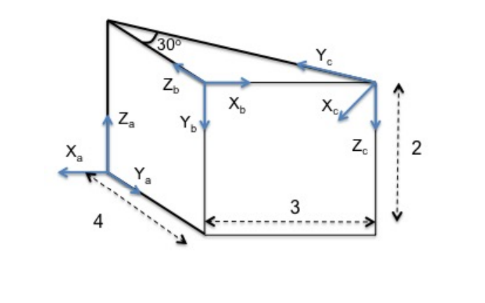

0c

0a

0b

1. Let the vectors Xa, Ya, Za, Xb, Yb, Zb be of unit length, then the rotation matrix taking coordinates from frame B to frame A is computed from the scalar product of these vectors as:

$${}_{B}^{A}R=\left[\begin{matrix}Xb ∙Xa & Yb ∙Xa & Zb ∙Xa \\ Xb ∙Ya & Yb ∙Ya & Zb ∙Ya \\ Xb ∙Za & Yb ∙Za & Zb ∙Za\end{matrix}\right]$$

Derive ${}_{B}^{A}R$ and ${}_{C}^{B}R$.

1. Derive AOb and BOc
2. Derive the complete transformation from C to A, that is ${}_{C}^{A}T$

**5 – Image Features**

a) Briefly describe the main 3-5 steps of the Harris Corner Detector.

b) We say that point descriptors should be both “invariant” and “distinctive”? What do we mean by “invariant” and why is it good?

The value of the descriptor doesn’t change when the region under consideration undergoes changes in appearance (such as rotation, brightness, etc.). This is useful because we often want to match features between different images of the same scene, where there can be small changes in orientation, lighting, etc.

**6. – Image Transforms**

Histogram Equalization

a. Perform histogram equalization on the following image:

|  |  |  |  |
| --- | --- | --- | --- |
| 1 | 2 | 3 | 3 |
| 2 | 3 | 3 | 1 |
| 2 | 1 | 4 | 1 |
| 6 | 2 | 8 | 9 |

a. Assume that all pixel intensities vary between 1 and 9.   Show the histogram,  the CDF of the image, and the image.

b. Perform histogram equalization on the same image, but this time assume  that the intensities could vary between 1 and 16.

**7. – Image Motion**

1. What is normal flow. What is optical flow?
2. Under what conditions conditions is it difficult to compute optical flow? Think of the image regions and the kind of 3D motions.
3. Assume the following scene shown below with a background plane of 5m distance and two objects (a rounded rectangle and a triangle) at 1m distance as drawn below. The camera is receding from the scene with a translation parallel the optical axis. Draw the flow field qualitatively.

**8. – Knowledge questions**

Define the following terms. If necessary, draw a sketch:

a. Intrinsic calibration parameters

b. Extrinsic calibration parameters

c. Homography

d. Fovea, rods and cones

e. Singular Value Decomposition