### **Supplementary Information**

**GLOBathy, the global lakes bathymetry dataset**

Bahram Khazaei1, Laura K. Read1, Matthew Casali1, Kevin M. Sampson1, & David N. Yates1

1. Research Applications Laboratory, National Center for Atmospheric Research, Boulder, CO, 80301, USA

Corresponding author: Bahram Khazaei ([bkhazaei@ucar.edu](mailto:bkhazaei@ucar.edu))

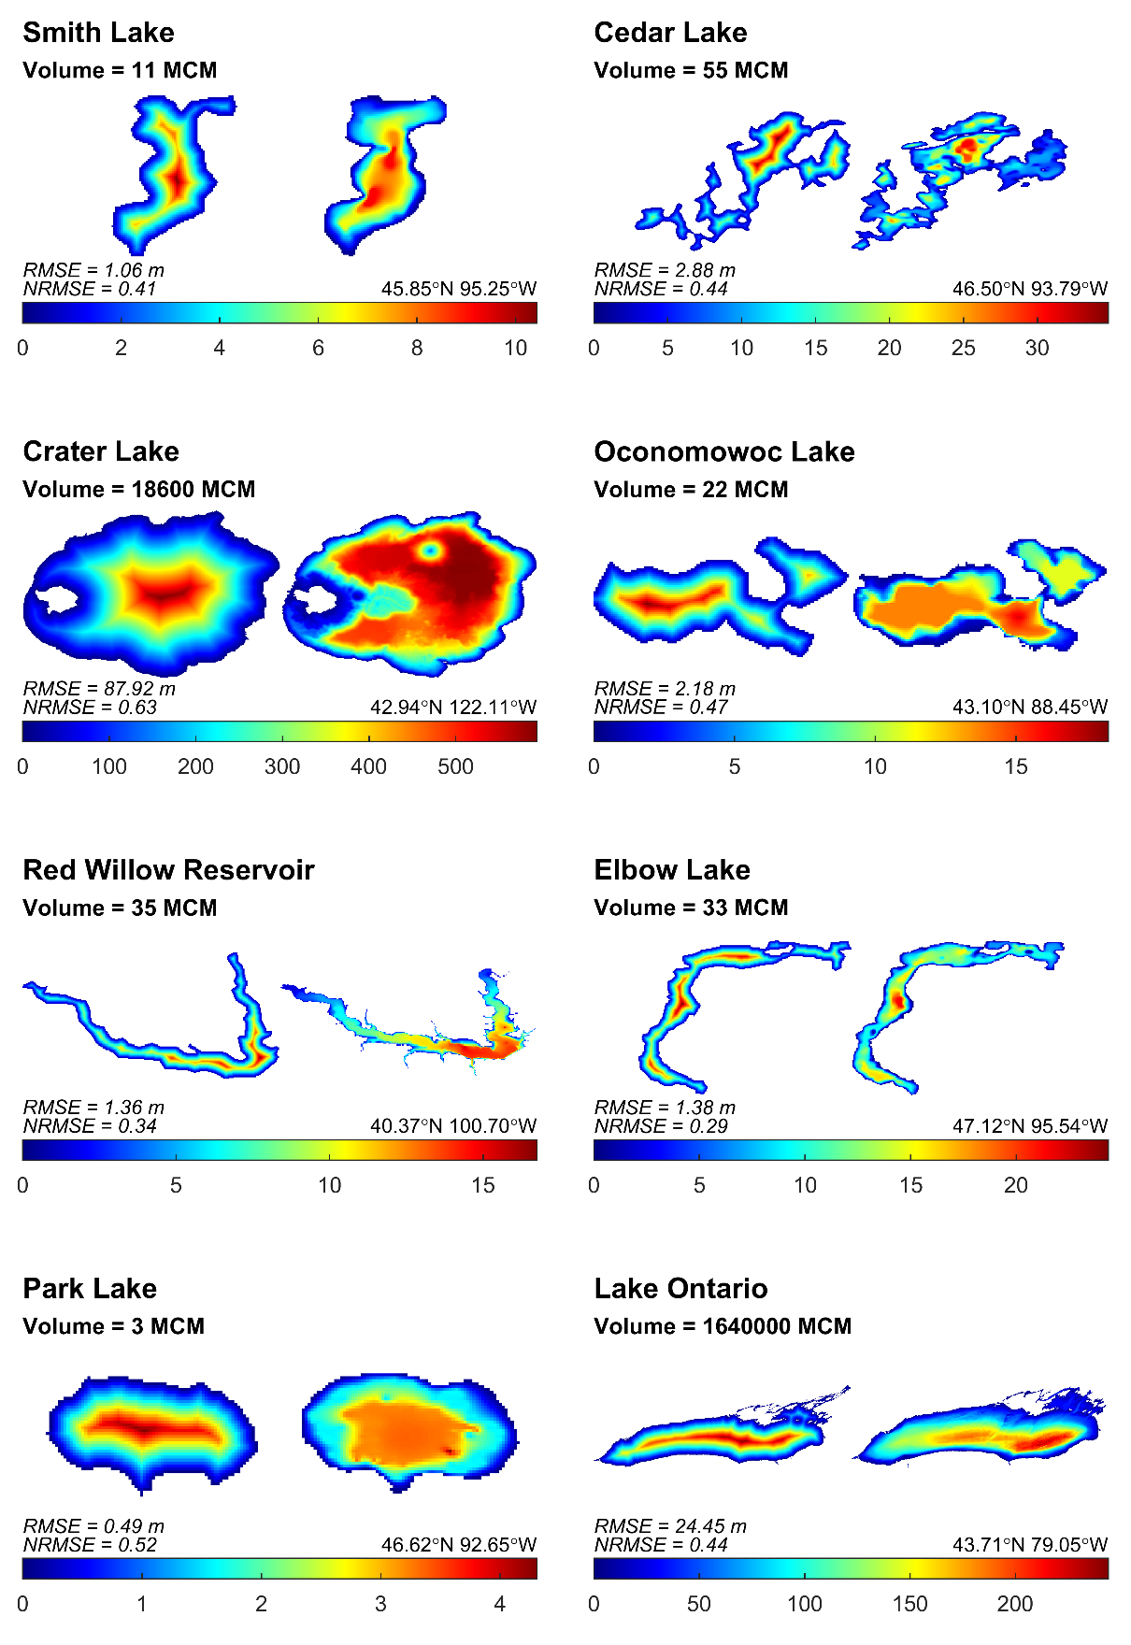

**Figure S1.** Comparison of the observed vs predicted bathymetric maps for selected waterbodies in the GLOBathy dataset. In each subplot, predicted bathymetric map from GLOBathy dataset is shown on the left side and ground-based observational bathymetric map is shown on the right side. The scale bar shows depth in m. Latitude and longitude values show waterbody pour point location.