**Session 2**

**CISCO’s Operating System and**

**Basic Configuration**

# 2.1 Objective

The student learns to employ CISCO’s operating system and how to perform basic system configuration for a network device (switch or router).

# 2.2 Before the lab session

CISCO network devices, like switches or routers, employ propietary hardware and operating system. For this session, the student needs to research the di↵erent types of memory that CISCO network devices have. This information is described in Chapter 7 of reference [3].

## 2.2.1 Required for the lab session

The student must provide a written answer to the following question:

1. What is the di↵erence between RAM and NVRAM memory?

*R. NVRAM is nonvolatile RAM that stores the startup configuration (startup-config) which is used when the switch is powered on/reloaded. As opposite, RAM stores current configuration (running-config).*

1. In a CISCO device, which memory stores the operating system?

*R. RAM memory is basically used for all system operational storage requirements. NVRAM—On the routerNVRAM is used to store the startup configuration.*

1. Where does a CISCO device expects to find the configuration file?

*R. The phone expects to find its configuration file on the TFTP server, as well as any firmware upgrades.*

1. What is a roll-over cable used for?

*Rollover cable (also known as a Yost cable, Cisco cable, or a Console cable) is a type of null-modem cable that is often used to connect a computer terminal to a router's console port. This cable is typically flat (and has a light blue color) to help distinguish it from other types of network cabling.*

1. What type of cable is needed to connect a PC to a switch?, and to a router?

*R. Ethernet cable is used to connect a switch and for router we use  A straight-through cable is used in local area networks to connect different devices like a computer to a network hub such as a router, router and switch, PC and switch,*

1. In a CISCO device, what is the *user* mode and how do you distinguish this mode from the others?

*R.User Mode is the first mode a user has access to after logging into the router. The user mode can be identified by the > prompt following the router name. This mode allows the user to execute only the basic commands*

1. What is the *privileged* mode and how do you distinguish it?

*R. the major difference is that you can ping other devices from****privileged mode****but you cannot do that from****user-mode****.*

1. What is the *global configuration* mode and how do you distinguish it?

*R. Global configuration mode is for configuring global parameters. This is the default mode when you enter configuration mode. Some commands will cause you to enter a more specific configuration mode. Line configuration mode (similar to interface configuration mode) is entered when you specify a line to configure.*

1. What is the *interface configuration* mode and how do you distinguish it?

*R. In this mode, only configuration of interfaces are done. Assigning an IP address to an interface, bringing up the interface are the common tasks done in this mode.*

# 2.3 Theoretical framework

Most of the information needed for this session is provided in Chapters 2 and 3 of the CCNA Routing and Switching 200-120 O cial Cert Guide book [3].

This session will employ CISCO’s Packet Tracer software, which allows to build and simulate networks, devices and configurations. The following subsection is a brief introduction to this software.

## 2.3.1 Introduction to Packet Tracer

Packet Tracer is a network simulator software produced by Cisco Systems, Inc. It generates two di↵erent types of files to save network models and simulations:

**.pkt files** These files have no restrictions and can be freely modified.

**.pka files** These files allow the person that originally created the network model to disable some features and restrict edition. This is the type of file that instructors will provide to students in this Lab.

To configure a network in Packet Tracer, first it is necessary to build a network topology:

1. Using a mouse, drag and drop the di↵erent *network elements* that need to be included in the network model. Packet Tracer’s network elements are represented by the icons shown at the bottom of the window.
2. At the bottom of Packet Tracer’s window, select the *Connections* button and link each network element using the regular network connection which is the black cable icon. See Figure 2.1.

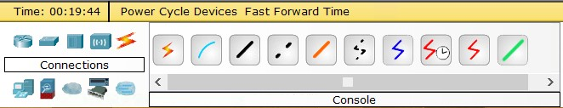

### Figure 2.1: Network connections at Packet Tracer

After the network topology has been built, it is necessary to configure each network element. There are three di↵erent choices to perform these configurations:

**Serial communication** This type of configuration requires to define a serial cable communication between the network device and a computer (PC). Use the following instructions to implement this configuration:

1. Using a mouse select the blue Console cable which should also be available at the bottom of the Packet Tracer window. See Figure 2.1.

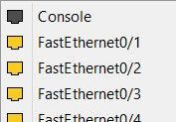

Figure 2.2: Setting up a Console cable at Packet Tracer, part 1

1. Click over the network element that needs to be configured. This will bring up a menu that shows di↵erent options to which connect the cable. An example is shown in Figure 2.2. Select *Console*.
2. Click over the PC that will be used to enter the configuration commands. This will also bring a menu, as shown in Figure 2.3. Select *RS-232*.

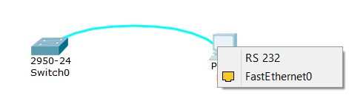

Figure 2.3: Setting up a Console cable at Packet Tracer, part 2

1. Click on the PC, this will bring up a configuration window. Select the *Desktop* tab. Click on the *Terminal* icon and accept the default configuration. See Figure 2.4.

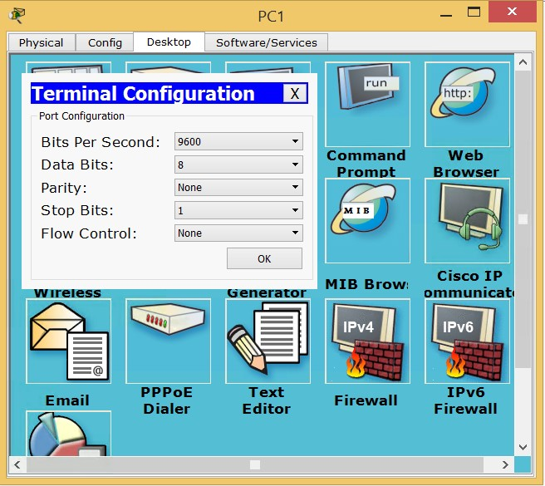

Figure 2.4: Terminal configuration at Packet Tracer

1. The command line interface window should display.

**Using the simulator** To employ this type of configuration, the user only needs to point the mouse over the network device, double-click on it and a configuration window will display. Then, select the CLI tab which should bring up a command line interface window (Figure 2.5).

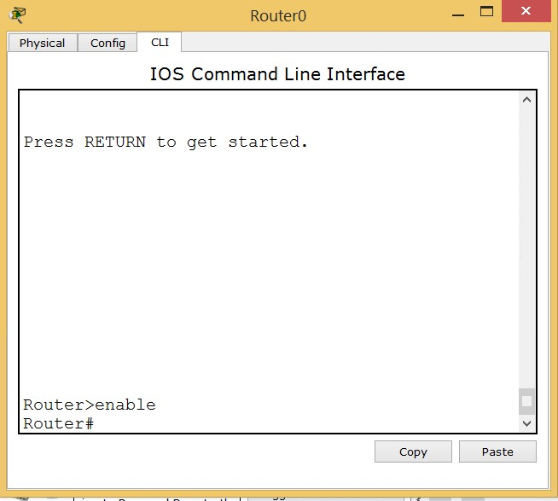

### Figure 2.5: Command line interface at Packet Tracer

**Remote communication using telnet or ssh** This type of configuration requires that the user configures either a telnet or an ssh service in the network device and an IP address. After these have been defined, the user may login to the network device using any command line interface program and the IP address previously defined.

# 2.4 Procedure

The following instructions will help you to review the commands needed to perform a basic system configuration in a CISCO network device.

## 2.4.1 Basic system configuration

1. Use Packet Tracer to assemble the network shown in Figure 2.6.
2. Employ the following command to access the privileged mode at the LRT switch:

|  |
| --- |
| Switch> enable Switch# |

1

2

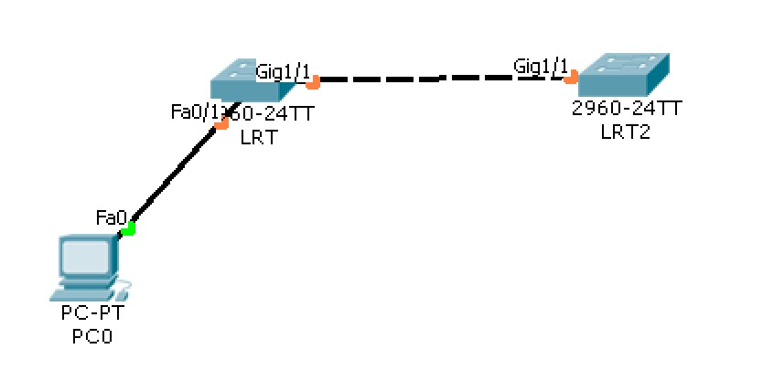

### Figure 2.6: Network topology

1. CISCO’s operating system provides some help when using the following commands:

|  |
| --- |
| Switch> show ?  Switch> enable  Switch# show ? |

1

2

3

1. The default (startup) configuration of a CISCO system is saved at the *startupconfig* file. While configuration changes made by the system administrator are saved in the *running-config* file. The following commands display these files:

|  |
| --- |
| Switch# show running-config  Switch# show startup-config |

1

2

1. Commands for naming a network device:

|  |
| --- |
| Switch# configure terminal  Switch(config)# hostname LRT  LRT(config)# exit  LRT# |

1

2

3

4

1. Setting up a password for the console login:

|  |
| --- |
| LRT# configure terminal  LRT(config)# line console 0  LRT(config-line)# password redesa  LRT(config-line)# login  LRT(config-line)# exit  LRT(config)# exit |

1

2

3

4

5

6

1. Close the console session and log back in to verify that the password is now requested:

|  |
| --- |
| LRT# exit |

1

1. Setting up a password for the privileged access mode:

|  |
| --- |
| LRT> enable  LRT# configure terminal  LRT(config)# enable secret labredes  LRT(config)# exit |

1

2

3

4

1. Close the session again and log back in. The device will ask for the console password first. Then, access the privileged mode and the device will ask for the password defined in the previous step:
2. Use the following command to verify the device configuration:

|  |
| --- |
| LRT# show running-config |

1

1. Notice that the console password can be read, while the privileged access password is encrypted. Run the following command to encrypt all passwords:

|  |
| --- |
| LRT# config t  LRT(config)# service password-encryption  LRT(config)# exit |

1

2

3

1. Verify again the device configuration file:

|  |
| --- |
| LRT# show running-config |

1

1. Notice how all passwords are now encrypted.
2. The following commands allow the administrator to configure an access banner that will display every time a user starts a session. This example employs the “#” character to limit the banner message, but other symbols may be used as well:

|  |
| --- |
| LRT# config t  LRT(config)# banner motd #Unauthorized Access to this device will be prosecuted#  LRT(config)# exit |

1

2

3

1. Close the session and log back in to verify that the banner displays properly:
2. At this point, changes made to the system will be lost when the device gets powered down. Therefore, it is necessary to copy the contents of the *running-config* file into the *startup-config* file. This procedure will save the current configuration:

|  |
| --- |
| LRT# copy running-config startup-config Destination filename [startup-config]? [Enter] |

1

2

## 2.4.2 Additional configuration

1. When a configuration command is misspelled, the device will try to process the erroneous command and the system will hang for a few seconds. To avoid this problem, it is necessary to disable the DNS lookup by using the following commands:

|  |
| --- |
| LRT # configure terminal  LRT (config) # no ip domain-lookup |

1

2

1. Use the following command to verify the device’s time:

|  |
| --- |
| LRT# show clock |

1

1. Use the following command to set the correct time in the device.

|  |
| --- |
| LRT# clock set ? |

1

1. Use the clock command again to verify that the time has been set correctly.

## 2.4.3 Configuring the LRT2 switch

Repeat the same instructions in subsections 2.4.1 and 2.4.2 but for the LRT2 switch.

Once you have completed the configuration for the LRT2 switch, save your network model file using your name and the *.pkt* format.

# 2.5 Report

The report for this Session is the .pkt file generated after all the procedures have been completed.