Hardware

A computer's hardware consists of its physical parts, including its internal pieces and connected external devices. Hardware components perform a computer's tasks like calculating [data](https://techterms.com/definition/data), storing information, processing [input](https://techterms.com/definition/input), and providing [output](https://techterms.com/definition/output). Any part of a computer that you can physically touch is hardware.

All hardware devices, whether internal or external, include chips on a circuit board to perform a function. All hardware also requires a way to [interface](https://techterms.com/definition/interface) with the rest of the computer, usually by connecting to a port, socket, or wireless radio. After that, pieces of hardware will include other parts that help them fulfill their function, like buttons, sensors, protective cases, or even cooling fans to prevent overheating.

**Internal Components**

Internal hardware parts may also be called "[components](https://techterms.com/definition/component)." These consist of everything inside a computer's case, including the following examples:

* A [motherboard](https://techterms.com/definition/motherboard) is the main system board every other component connects to, consisting of a large [circuit board](https://techterms.com/definition/pcb) with many integrated [chipsets](https://techterms.com/definition/chipset) and controllers. Motherboards also include sockets, slots, and ports that you can use to connect new components.
* A [CPU](https://techterms.com/definition/cpu) is the brain of a computer that processes instructions and controls the rest of the hardware.
* [Memory](https://techterms.com/definition/memory), or [RAM](https://techterms.com/definition/ram), temporarily stores information for the CPU to process.
* Storage devices like [hard drives](https://techterms.com/definition/hdd) and [solid state drives](https://techterms.com/definition/ssd) hold the computer's applications and files. Unlike memory, which temporarily holds data, storage devices keep data even after the computer is powered off.
* [Controller cards](https://techterms.com/definition/controller_card) and [expansion cards](https://techterms.com/definition/expansioncard) plug into special slots on a motherboard to expand a computer's capabilities. Examples include more powerful [video cards](https://techterms.com/definition/videocard), additional [network interfaces](https://techterms.com/definition/nic), and extra ports.
* A [power supply](https://techterms.com/definition/powersupply) converts the alternating current from a wall socket into a direct current that powers a computer's components.

**External Peripherals**

External hardware devices, meanwhile, are usually called "[peripherals](https://techterms.com/definition/peripheral)." These include everything that connects to a computer by one of its ports or plugs, including these common examples:

* [Monitors](https://techterms.com/definition/monitor) display the output of a computer's video card to provide a graphical user interface that someone can use to monitor and control the computer.
* [Keyboards](https://techterms.com/definition/keyboard) and [mice](https://techterms.com/definition/mouse) accept input from the person operating the computer, allowing them to enter text, issue commands, and manipulate objects displayed on the screen.
* Speakers and headphones play the sounds generated by a computer.
* [Printers](https://techterms.com/definition/printer) allow a person to print a document from their computer onto paper, while [scanners](https://techterms.com/definition/scanner) allow them to create a digital copy of a document or photograph. Multi-function printers that combine these functions are now common.
* External storage devices store data just like internal storage devices do, but you can easily disconnect one from one computer and reconnect to another to move data between computers.

You can add new hardware to a computer to extend its functionality. You need to turn the computer off before installing new internal components, but external peripherals are often [plug-and-play](https://techterms.com/definition/plugandplay). Most hardware requires [drivers](https://techterms.com/definition/driver) — data files containing instructions for the computer's [operating system](https://techterms.com/definition/operating_system) on how to control the new hardware — either provided on a disc bundled with the hardware or available for download from the manufacturer's website.

**NOTE:** While hardware refers to a computer's components, [software](https://techterms.com/definition/software) refers to the programs and applications that run on a computer.

<https://techterms.com/definition/hardware>

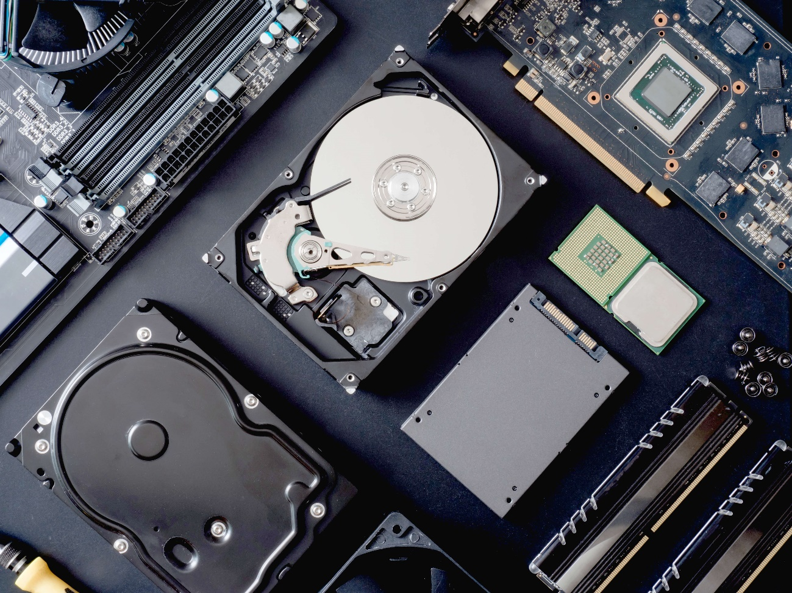

<https://techterms.com/quiz/hardware/easy/2023/1?q=6>

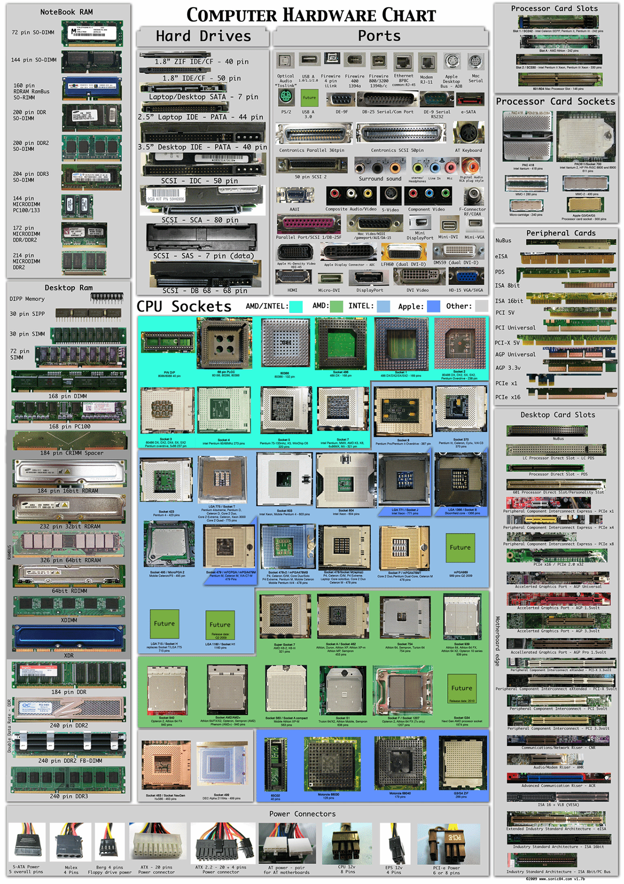

VIDEO

https://www.youtube.com/watch?v=_2MB8F9JSa8&t=29s