**WEB-BASED PROPERTY PRICE PREDICTION: COMPARATIVE ANALYSIS OF MACHINE LEARNING MODELS**

**IVANSLER CHYRELL BIN CHRISTOPHER**

**FACULTY OF COMPUTING AND INFORMATICS UNIVERSITY MALAYSIA SABAH**

**2024**

**WEB-BASED PROPERTY PRICE PREDICTION: COMPARATIVE ANALYSIS OF MACHINE LEARNING MODELS**

**IVANSLER CHYRELL BIN CHRISTOPHER**

**THESIS SUBMITTED IN PARTIAL FULFILLMENT FOR DEGREE OF BACHELOR OF COMPUTER SCIENCE WITH HONOURS**

**(SOFTWARE ENGINEERING)**

**FACULTY OF COMPUTING AND INFORMATICS UNIVERSITY MALAYSIA SABAH**

**2024**

**NAME** : IVANSLER CHYRELL BIN CHRISTOPHER

**MATRIC NUMBER** : BI18160290

**TITLE :** WEB-BASED PROPERTY PRICE PREDICTION: COMPARATIVE ANALYSIS OF MACHINE LEARNING MODELS

**DEGREE :** BACHELOR OF COMPUTER WITH HONOURS

(SOFTWARE ENGINEERING)

**VIVA’S DATE :** 18 NOVEMBER 2024

**CERTIFIED BY;**

1. **SUPERVISOR** Signature

TS. NORDIN SAAD

18 NOVEMBER 2024

# DECLARATION

I hereby declare that the material in this thesis is my own except for quotations, equations, summaries and references, which have been duly acknowledged.



18 NOVEMBER 2024

IVANSLER CHYRELL BIN CHRISTOPHER BI18160290

# ACKNOWLEDGEMENT

# Firstly, I would like to acknowledge and thank my supervisor, Dr. TS. Nordin Saad for all of his guidance throughout the project. Dr. TS. Nordin Saad has been a very good and helpful mentor to me as he not only given me academic support but also moral support to complete my project.

# Secondly, I would like to acknowledge and thank all my lecturers and friends that have been part of this project. All my lecturers and friends have been very helpful and supportive by sharing information and knowledge with me throughout this degree course.

# Finally, My acknowledgement and gratitude goes to my family that has been very understanding and caring towards me while completing this project.

# IVANSLER CHYRELL BIN CHRISTOPHER

# 18 NOVEMBER 2024

# ABSTRACT

Web based property price prediction is a website that will implement machine learning algorithms that will train the system for price prediction ,a number of house attributes will be required by the system from the user which will be use d by the system to predict the price. The target user of property price prediction are house sellers, buyers and agents within Malaysia. The current methods of predicting property prices are inaccurate and unreliable due to manual analysis of limited data. This leads to overvaluation or undervaluation of properties, misallocation of resources, and inefficient pricing. The web based property price prediction enables users to predict property prices based on various inputs. Users can fill out a form with details such as property type, number of bedrooms, number of bathrooms, size, location, and amenities. Once the form is submitted, the system calculates and displays the predicted property price. Futhermore,The website have user-friendly interface, real-time data processing and have responsive design for various devices.

**ABSTRAK**

**RAMALAN HARGA HARTANAH BERASASKAN WEB: ANALISIS PERBANDINGAN MODEL PEMBELAJARAN MESIN**

Ramalan harga hartanah berasaskan web ialah laman web yang akan melaksanakan algoritma pembelajaran mesin yang akan melatih sistem untuk ramalan harga, beberapa atribut rumah akan diperlukan oleh sistem daripada pengguna yang akan digunakan oleh sistem untuk meramalkan harga. Sasaran pengguna ramalan harga hartanah ialah penjual rumah, pembeli dan ejen di Malaysia. Kaedah semasa meramalkan harga hartanah adalah tidak tepat dan tidak boleh dipercayai kerana analisis manual data terhad. Ini membawa kepada penilaian berlebihan atau penilaian rendah hartanah, salah pengagihan sumber dan penetapan harga yang tidak cekap. Ramalan harga hartanah berasaskan web membolehkan pengguna meramalkan harga hartanah berdasarkan pelbagai input. Pengguna boleh mengisi borang dengan butiran seperti jenis hartanah, bilangan bilik tidur, bilangan bilik mandi, saiz, lokasi dan kemudahan. Setelah borang diserahkan, sistem mengira dan memaparkan harga hartanah yang diramalkan. Tambahan pula, Laman web ini mempunyai antara muka mesra pengguna, pemprosesan data masa nyata dan mempunyai reka bentuk responsif untuk pelbagai peranti.

**TABLE OF CONTENT**

PAGE

**TITLEE I**

**DECLARATION III**

**ACKNOWLEDGEMENT IV**

**ABSTRACT V**

**ABSTRAK VI**

**LIST OF FIGURES IX**

**LIST OF TABLES**

**[CHAPTER  1](https://docs.google.com/document/d/1BadursU5t4K_ocHM-hkH1pXuub-BGuvoJ5tuLihv7Rg/edit" \l "heading=h.phm2jwvwuy54)** [1](https://docs.google.com/document/d/1BadursU5t4K_ocHM-hkH1pXuub-BGuvoJ5tuLihv7Rg/edit" \l "heading=h.phm2jwvwuy54)

**[1](https://docs.google.com/document/d/1BadursU5t4K_ocHM-hkH1pXuub-BGuvoJ5tuLihv7Rg/edit" \l "heading=h.phm2jwvwuy54)[INTRODUCTION](https://docs.google.com/document/d/1BadursU5t4K_ocHM-hkH1pXuub-BGuvoJ5tuLihv7Rg/edit" \l "heading=h.695q8aycw83k)** [1](https://docs.google.com/document/d/1BadursU5t4K_ocHM-hkH1pXuub-BGuvoJ5tuLihv7Rg/edit" \l "heading=h.695q8aycw83k)

[1.1  Introduction 1](https://docs.google.com/document/d/1BadursU5t4K_ocHM-hkH1pXuub-BGuvoJ5tuLihv7Rg/edit" \l "heading=h.uvuoymuome3g)

[1.2  Problem Background 1](https://docs.google.com/document/d/1BadursU5t4K_ocHM-hkH1pXuub-BGuvoJ5tuLihv7Rg/edit" \l "heading=h.qexq5ioi9h57)

[1.3  Problem Statement 2](https://docs.google.com/document/d/1BadursU5t4K_ocHM-hkH1pXuub-BGuvoJ5tuLihv7Rg/edit" \l "heading=h.9hamddosg3yk)

[1.4  Project Objective 2](https://docs.google.com/document/d/1BadursU5t4K_ocHM-hkH1pXuub-BGuvoJ5tuLihv7Rg/edit" \l "heading=h.fhwtexl6lnzx)

[1.5  Project Scope 2](https://docs.google.com/document/d/1BadursU5t4K_ocHM-hkH1pXuub-BGuvoJ5tuLihv7Rg/edit" \l "heading=h.icsx41qf5cm4)

[1.6 Organization of Project](https://docs.google.com/document/d/1BadursU5t4K_ocHM-hkH1pXuub-BGuvoJ5tuLihv7Rg/edit" \l "heading=h.icsx41qf5cm4)  4

1.6.1 Chapter 1 Introduction 4

1.6.2 Chapter 2 Literature Review 4

1.6.3 Chapter 3 Methodology 4

1.6.4 Chapter 4 System Analysis and Design 4

[1.7  Summary 4](https://docs.google.com/document/d/1BadursU5t4K_ocHM-hkH1pXuub-BGuvoJ5tuLihv7Rg/edit" \l "heading=h.xpfvl9jfofjh)

**[CHAPTER 2](https://docs.google.com/document/d/1BadursU5t4K_ocHM-hkH1pXuub-BGuvoJ5tuLihv7Rg/edit" \l "heading=h.rfjjeohhdx4q)** [5](https://docs.google.com/document/d/1BadursU5t4K_ocHM-hkH1pXuub-BGuvoJ5tuLihv7Rg/edit" \l "heading=h.rfjjeohhdx4q)

**[LITERATURE REVIEW](https://docs.google.com/document/d/1BadursU5t4K_ocHM-hkH1pXuub-BGuvoJ5tuLihv7Rg/edit" \l "heading=h.c6r5ermgf2dv)** [5](https://docs.google.com/document/d/1BadursU5t4K_ocHM-hkH1pXuub-BGuvoJ5tuLihv7Rg/edit" \l "heading=h.c6r5ermgf2dv)

[2.1 Overview of Houses 5](https://docs.google.com/document/d/1BadursU5t4K_ocHM-hkH1pXuub-BGuvoJ5tuLihv7Rg/edit" \l "heading=h.vgni4aijn0lo)

[2.2 House Price Prediction 5](https://docs.google.com/document/d/1BadursU5t4K_ocHM-hkH1pXuub-BGuvoJ5tuLihv7Rg/edit" \l "heading=h.yskprppm10cr)

[2.3 Factors Affecting House Price 6](https://docs.google.com/document/d/1BadursU5t4K_ocHM-hkH1pXuub-BGuvoJ5tuLihv7Rg/edit" \l "heading=h.np7prsxmnvss)

2.3.1 Features 6

2.3.2 Concept 6

2.3.3 Location 6

[2.4 Related Work 6](https://docs.google.com/document/d/1BadursU5t4K_ocHM-hkH1pXuub-BGuvoJ5tuLihv7Rg/edit" \l "heading=h.w7aholols3vs)

[2.5 Improvement that can be done based on the literature review 11](https://docs.google.com/document/d/1BadursU5t4K_ocHM-hkH1pXuub-BGuvoJ5tuLihv7Rg/edit" \l "heading=h.w7aholols3vs)

[2.5.1 Feature Selection and Engineering 11](https://docs.google.com/document/d/1BadursU5t4K_ocHM-hkH1pXuub-BGuvoJ5tuLihv7Rg/edit" \l "heading=h.w7aholols3vs)

[2.5.2 Model Comparison and Selection 11](https://docs.google.com/document/d/1BadursU5t4K_ocHM-hkH1pXuub-BGuvoJ5tuLihv7Rg/edit" \l "heading=h.w7aholols3vs)

[2.5.3 Evaluation Metrics 11](https://docs.google.com/document/d/1BadursU5t4K_ocHM-hkH1pXuub-BGuvoJ5tuLihv7Rg/edit" \l "heading=h.w7aholols3vs)

[2.5.4 Dataset Size and Quality 11](https://docs.google.com/document/d/1BadursU5t4K_ocHM-hkH1pXuub-BGuvoJ5tuLihv7Rg/edit" \l "heading=h.w7aholols3vs)

[2.5.5 Context-Specific Insights 12](https://docs.google.com/document/d/1BadursU5t4K_ocHM-hkH1pXuub-BGuvoJ5tuLihv7Rg/edit" \l "heading=h.w7aholols3vs)

[2.6 Conclusion](https://docs.google.com/document/d/1BadursU5t4K_ocHM-hkH1pXuub-BGuvoJ5tuLihv7Rg/edit" \l "heading=h.w7aholols3vs) 13

**[CHAPTER 3](https://docs.google.com/document/d/1BadursU5t4K_ocHM-hkH1pXuub-BGuvoJ5tuLihv7Rg/edit" \l "heading=h.jioo2eid9cxn)** [1](https://docs.google.com/document/d/1BadursU5t4K_ocHM-hkH1pXuub-BGuvoJ5tuLihv7Rg/edit" \l "heading=h.jioo2eid9cxn)3

**[METHODOLOGY](https://docs.google.com/document/d/1BadursU5t4K_ocHM-hkH1pXuub-BGuvoJ5tuLihv7Rg/edit" \l "heading=h.cgif8ee8fvar)** [1](https://docs.google.com/document/d/1BadursU5t4K_ocHM-hkH1pXuub-BGuvoJ5tuLihv7Rg/edit" \l "heading=h.cgif8ee8fvar)3

[3.1 Introduction 1](https://docs.google.com/document/d/1BadursU5t4K_ocHM-hkH1pXuub-BGuvoJ5tuLihv7Rg/edit" \l "heading=h.z4urea7pmjgg)3

[3.2 Waterfall Model Approach 1](https://docs.google.com/document/d/1BadursU5t4K_ocHM-hkH1pXuub-BGuvoJ5tuLihv7Rg/edit" \l "heading=h.59wc8io1j1ew)3

[3.2.1 Requirements Analysis 1](https://docs.google.com/document/d/1BadursU5t4K_ocHM-hkH1pXuub-BGuvoJ5tuLihv7Rg/edit" \l "heading=h.x44u4lhfr85n)4

[3.2.2 System Design 1](https://docs.google.com/document/d/1BadursU5t4K_ocHM-hkH1pXuub-BGuvoJ5tuLihv7Rg/edit" \l "heading=h.p1g72dhcw17o)4

[3.2.3 Implementation 1](https://docs.google.com/document/d/1BadursU5t4K_ocHM-hkH1pXuub-BGuvoJ5tuLihv7Rg/edit" \l "heading=h.uunfpa2buobt)4

[3.2.4 Testing 15](https://docs.google.com/document/d/1BadursU5t4K_ocHM-hkH1pXuub-BGuvoJ5tuLihv7Rg/edit" \l "heading=h.c2jpn5z60dbb)

[3.2.5 Deployment: 16](https://docs.google.com/document/d/1BadursU5t4K_ocHM-hkH1pXuub-BGuvoJ5tuLihv7Rg/edit" \l "heading=h.c2jpn5z60dbb)

[3.2.6 Maintenance 1](https://docs.google.com/document/d/1BadursU5t4K_ocHM-hkH1pXuub-BGuvoJ5tuLihv7Rg/edit" \l "heading=h.c2jpn5z60dbb)6

3.3 Machine learning models 16

3.3.1 Linear Regression 17

3.3.2 Lasso Regression 17

3.3.3.1 Data Collection 18

3.3.3.2 Data Preprocessing 19

3.3.3.3 Model Training 19

3.3.3.4 Evaluation 19

3.4 Flowchart of activities [20](https://docs.google.com/document/d/1BadursU5t4K_ocHM-hkH1pXuub-BGuvoJ5tuLihv7Rg/edit" \l "heading=h.h8y05unbs4pa)

[3.6 Milesstone and Dates 21](https://docs.google.com/document/d/1BadursU5t4K_ocHM-hkH1pXuub-BGuvoJ5tuLihv7Rg/edit" \l "heading=h.5onwv9h3vr1x)

**[CHAPTER 4](https://docs.google.com/document/d/1BadursU5t4K_ocHM-hkH1pXuub-BGuvoJ5tuLihv7Rg/edit" \l "heading=h.jioo2eid9cxn)** [2](https://docs.google.com/document/d/1BadursU5t4K_ocHM-hkH1pXuub-BGuvoJ5tuLihv7Rg/edit" \l "heading=h.jioo2eid9cxn)[2](https://docs.google.com/document/d/1BadursU5t4K_ocHM-hkH1pXuub-BGuvoJ5tuLihv7Rg/edit" \l "heading=h.u5g3svsvmya7)

**[SYSTEM ANALYSIS AND DESIGN](https://docs.google.com/document/d/1BadursU5t4K_ocHM-hkH1pXuub-BGuvoJ5tuLihv7Rg/edit" \l "heading=h.cgif8ee8fvar)** [2](https://docs.google.com/document/d/1BadursU5t4K_ocHM-hkH1pXuub-BGuvoJ5tuLihv7Rg/edit" \l "heading=h.cgif8ee8fvar)[2](https://docs.google.com/document/d/1BadursU5t4K_ocHM-hkH1pXuub-BGuvoJ5tuLihv7Rg/edit" \l "heading=h.u5g3svsvmya7)

[4.1 Introduction 2](https://docs.google.com/document/d/1BadursU5t4K_ocHM-hkH1pXuub-BGuvoJ5tuLihv7Rg/edit" \l "heading=h.z4urea7pmjgg)[2](https://docs.google.com/document/d/1BadursU5t4K_ocHM-hkH1pXuub-BGuvoJ5tuLihv7Rg/edit" \l "heading=h.u5g3svsvmya7)

[4.2 Use Case Diagram 2](https://docs.google.com/document/d/1BadursU5t4K_ocHM-hkH1pXuub-BGuvoJ5tuLihv7Rg/edit" \l "heading=h.59wc8io1j1ew)[2](https://docs.google.com/document/d/1BadursU5t4K_ocHM-hkH1pXuub-BGuvoJ5tuLihv7Rg/edit" \l "heading=h.u5g3svsvmya7)

[4.2.1 Use Case Description 2](https://docs.google.com/document/d/1BadursU5t4K_ocHM-hkH1pXuub-BGuvoJ5tuLihv7Rg/edit" \l "heading=h.x44u4lhfr85n)[3](https://docs.google.com/document/d/1BadursU5t4K_ocHM-hkH1pXuub-BGuvoJ5tuLihv7Rg/edit" \l "heading=h.u5g3svsvmya7)

[4.3 Context Diagram 2](https://docs.google.com/document/d/1BadursU5t4K_ocHM-hkH1pXuub-BGuvoJ5tuLihv7Rg/edit" \l "heading=h.p1g72dhcw17o)[9](https://docs.google.com/document/d/1BadursU5t4K_ocHM-hkH1pXuub-BGuvoJ5tuLihv7Rg/edit" \l "heading=h.u5g3svsvmya7)

[4.3.1 User input 30](https://docs.google.com/document/d/1BadursU5t4K_ocHM-hkH1pXuub-BGuvoJ5tuLihv7Rg/edit" \l "heading=h.u5g3svsvmya7)

[4.3.2 User output 30](https://docs.google.com/document/d/1BadursU5t4K_ocHM-hkH1pXuub-BGuvoJ5tuLihv7Rg/edit" \l "heading=h.u5g3svsvmya7)

[4.3.3 Admin input 30](https://docs.google.com/document/d/1BadursU5t4K_ocHM-hkH1pXuub-BGuvoJ5tuLihv7Rg/edit" \l "heading=h.u5g3svsvmya7)

[4.3.4 Admin output 30](https://docs.google.com/document/d/1BadursU5t4K_ocHM-hkH1pXuub-BGuvoJ5tuLihv7Rg/edit" \l "heading=h.u5g3svsvmya7)

[4.4 Data Flow Diagram 30](https://docs.google.com/document/d/1BadursU5t4K_ocHM-hkH1pXuub-BGuvoJ5tuLihv7Rg/edit" \l "heading=h.uunfpa2buobt)

[4.4.1 User Authentication Module 31](https://docs.google.com/document/d/1BadursU5t4K_ocHM-hkH1pXuub-BGuvoJ5tuLihv7Rg/edit" \l "heading=h.c2jpn5z60dbb)

[4.4.2 The Prediction Module 32](https://docs.google.com/document/d/1BadursU5t4K_ocHM-hkH1pXuub-BGuvoJ5tuLihv7Rg/edit" \l "heading=h.c2jpn5z60dbb)

[4.4.3 Saved Predictions Module 32](https://docs.google.com/document/d/1BadursU5t4K_ocHM-hkH1pXuub-BGuvoJ5tuLihv7Rg/edit" \l "heading=h.c2jpn5z60dbb)

[4.4.4 Feedback Module 32](https://docs.google.com/document/d/1BadursU5t4K_ocHM-hkH1pXuub-BGuvoJ5tuLihv7Rg/edit" \l "heading=h.c2jpn5z60dbb)

[4](https://docs.google.com/document/d/1BadursU5t4K_ocHM-hkH1pXuub-BGuvoJ5tuLihv7Rg/edit" \l "heading=h.c2jpn5z60dbb)[.4.5 Admin Module 32](https://docs.google.com/document/d/1BadursU5t4K_ocHM-hkH1pXuub-BGuvoJ5tuLihv7Rg/edit" \l "heading=h.u5g3svsvmya7)

[4.4.6 Notification System 32](https://docs.google.com/document/d/1BadursU5t4K_ocHM-hkH1pXuub-BGuvoJ5tuLihv7Rg/edit" \l "heading=h.u5g3svsvmya7)

[4.5 Entity Relationship Diagram 33](https://docs.google.com/document/d/1BadursU5t4K_ocHM-hkH1pXuub-BGuvoJ5tuLihv7Rg/edit" \l "heading=h.u5g3svsvmya7)

[4.6 Data dictionary 33](https://docs.google.com/document/d/1BadursU5t4K_ocHM-hkH1pXuub-BGuvoJ5tuLihv7Rg/edit" \l "heading=h.u5g3svsvmya7)

[4.7 User Interface Design 3](https://docs.google.com/document/d/1BadursU5t4K_ocHM-hkH1pXuub-BGuvoJ5tuLihv7Rg/edit" \l "heading=h.u5g3svsvmya7)5

4.8 Machine Learning Process 40

4.8.1 Dataset 40

4.8.2 Data Pre-processing 40

4.8.3. Evaluation 40

4.9 Conclusion 42

**REFERENCES** 43

# APPENDIX 46

# LIST OF FIGURE

|  |  |
| --- | --- |
|  | **PAGE** |
| Figure 1: Waterfall Model | 13 |
| Figure 2: Machine learning process | 18 |
| Figure 3: Flowchart of activities | 20 |
| Figure 4 Use case diagram | 22 |
| Figure 5: Contex Diagram of Property Price Prediction System | 30 |
| Figure 6: Data flow diagram | 31 |
| Figure 7 : Entity relationship diagram | 33 |
| Figure 8: Dictionary for User | 34 |
| Figure 9 : Dictionary for Saved Prediction | 34 |
| Figure 10: Dictionary for Prediction | 34 |
| Figure 11: Dictionary for Feedback | 35 |
| Figure 12: Dictionary for Admin | 35 |
| Figure 13: Data Dictionary for notification | 35 |
| Figure 14: Hompage | 36 |
| Figure 15: Sign in | 36 |
| Figure 16: Create account | 37 |
| Figure 17: Dashboard | 37 |
| Figure 18: Saved Prediction | 37 |
| Figure 19: Make Prediction | 38 |
| Figure 20: Manage account | 39 |
| Figure 21: Feedback | 39 |
| Figure 22: Admin dashboard | 40 |
| Figure 23 : Preview of the dataset(first 10 row) | 41 |
| Figure 24:Result of both Models from Pycharm | 41 |
| Figure 25: Route for user login | 45 |
| Figure 26: The route for user sign up | 46 |
| Figure 27: Route for user dashboard | 46 |
| Figure 28: Route for user saved prediction | 46 |
| Figure 29: Route for user prediction with ML | 47 |
| Figure 30: Route for user setting | 47 |
| Figure 31: Route for user feedback | 48 |
| Figure 32: Route for admin dashboard | 48 |
| Figure 33: Required libraries | 49 |
| Figure 34: Pre-trained model and encoders load | 50 |
| Figure 35: Retrieving categorical feature options | 50 |
| Figure 36: Prediction logic | 51 |
| Figure 37: Storing and display prediction | 51 |
| Figure 38: Database connection | 52 |

|  |  |
| --- | --- |
|  | **PAGE** |
| Table 1: Project Scope | 3 |
| Table 2: Summary of 6 past study | 10 |
| Table 3: Programming Tool | 15 |
| Table 4:Milesstone and date | 21 |
| Table 5: Description for Use Case 1 | 23 |
| Table 6: Description for Use Case 2 | 24 |
| Table 7: Description for Use Case 3 | 25 |
| Table 8: Description for Use Case 4 | 26 |
| Table 9: Description for Use Case 5 | 26 |
| Table 10: Description for Use Case 6 | 28 |
| Table 11: Description for Use Case 7 | 29 |
| Table 12: Evaluation Report | 41 |
| Table 13: User Login test case | 54 |
| Table 14: Admin login test case | 55 |
| Table 15: User register test case | 56 |
| Table 16: User prediction test case | 58 |

**LIST OF TABLE**

**CHAPTER 1**

**INTRODUCTION**

# **Introduction**

Nowdays, the real estate market is a big part of the economy worldwide. It is known for being complicated and sometimes changing. Property prices are very important in deciding where to invest and how the market behaves. Figuring out these prices accurately has always been tough, so people are looking into better ways to do it, by using computer programs. But for regular people who are looking to buy a house, it's still hard. They must consider their preferred location, how big a property they need, what extras they want, and how much budget they can afford. Plus, there often aren't many houses that match what they're looking for, which can be frustrating. Besides that, knowing what prices houses might be rising in the future is very important for buyers. It will help them to plan wisely based on the market price and make good decisions. Leveraging machine learning models to predict price movements and identify properties this can make the whole process easier for buyers.

Property price prediction will be implemented using machine learning algorithms that will train the system ,a number of house attributes will be required by the system from the user which will be use d by the system to predict the price. The system will be used only within Malaysia. It will be used by House sellers, buyers and agents. The locations in the system will be that of thearea in Kuala Lumpur. The house sellers will use the system to predict the price and communicate back to a customer who may want to make enquiries directly from them, using the system to predict the price will save the time of getting back to the customer.The buyers will use the system to find out the price of the house he may be interested in, which will enable him work properly on his budget before.

The web based property price prediction can make accurately property price predictions. The website have user-friendly interface, real-time data processing and have responsive design for various devices.

* 1. **Problem Background**

Figuring out these prices accurately has always been tough, so people are looking into better ways to do it, by using computer programs. But for regular people who are looking to buy a house, it's still hard. They must consider their preferred location, how big a property they need, what extras they want, and how much budget they can afford. Plus, there often aren't many houses that match what they're looking for, which can be frustrating. Besides that, knowing what prices houses might be rising in the future is very important for buyers. It will help them to plan wisely based on the market price and make good decisions. Leveraging machine learning models to predict price movements and identify properties this can make the whole process easier for buyers.

**1.3 Problem Statement**

Current methods of predicting property prices are inaccurate and unreliable due to manual analysis of limited data. This leads to overvaluation or undervaluation of properties, misallocation of resources, and inefficient pricing. As a result, stakeholders make poor investment decisions, leading to financial losses.

Traditional methods of predicting property prices are extremely time-consuming, taking weeks or even months to collect and analyze data. This delay causes opportunities to be missed, deals to be lost, and resources to be wasted. The slow pace of analysis makes it challenging for stakeholders to respond to changes in the market or adjust their strategies accordingly.

The current process lacks transparency, making it difficult for users to understand how predictions are made and what factors are considered. This lack of clarity leads to mistrust and confusion, making it challenging to identify biases and errors. As a result, stakeholders are unable to make informed decisions, and the entire process is plagued by inaccuracies and inefficiencies.

**1.4 Project Objectives**

1. To compare and evaluate the performance of Linear Regression and Lasso Regression models for property value prediction in terms of Root Mean Squared Error (RMSE), Mean Absolute Error (MAE), Mean Squared Error (MSE), and R-Squared (R2).
2. To develop and deploy a web-based platform with integrated machine learning to predict property prices.
3. To implement and evaluate the property price prediction accurancy using System Usability Scale.(SUS)

**1.5 Project scope**

This project involves the development of a web-based system designed to predict property prices using machine learning algorithms. The main users include house sellers, buyers, and real estate agents. The scope of the system, including user roles, features, functionalities, and constraints, is outlined in Table 1.1.

**Table 1: Project Scope**

|  |  |
| --- | --- |
| **Type** | **Description** |
| User | House Sellers, Buyers, Real Estate Agents within Kuala Lumpur, Malaysia |
| Feature | 1. Accurate property price predictions 2. User-friendly interface 3. Real-time data processing 4. Responsive design for various devices |
| Functionality/Module | 1. User Registration and Login 2. Property Price Prediction 3. User Dashboard (View Predictions, Manage Account, Send Feedback) 4. Admin Dashboard (Manage Users, View Reports, System Monitoring) |
| Constraint | 1. Only for properties in Kuala Lumpur, Malaysia 2. Requires internet access to function 3. Initial version web-based only (no mobile app) |

**1.6 Organization of Project**

The flow organization of the project are shown in the following chapters.

**1.6.1 Chapter 1 Introduction**

This chapter explains the background idea of the project title that is being proposed. The problem background, problem statements and objectives of this project are described in this chapter. This chapter also gives a brief explanation on what the system could do.

**1.6.2 Chapter 2 Literature Review**

This chapter shows some examples of the existing system similar to the system proposed in this paper. The idea of the previously conducted research was acknowledged and comparison has been made towards the modules and techniques involved in each research. Furthermore, this chapter also discusses the Machine Learning techniques that was used for the prediction model and reviewed the experiment that has been done to overview the performance of each technique to predict the property price.

**1.6.3 Chapter 3 Methodology**

This chapter discusses the methodology that will be conducted for this project, which is the waterfall prototyping model, and each phases are explained on the activities that will be performed. Besides, types of software and hardware tools that used in this system are also mentioned in this chapter.

**1.6.4 Chapter 4 System Analysis and Design**

This chapter will analyse the design of the proposed system. The analysis will be explained in the form of use case description, use case diagram, context diagram and data flow diagram. The database involved will be illustrated in the entity relationship diagram and data dictionary. Moreover, this chapter will also introduce the user interface design for the system.

**1.7 Summary**

The purpose of this chapter is to present the main idea from the problem background and problem statement that motivates to the development of the system proposed. The explanation for the objectives and scope of the project are also included in this chapter.

# CHAPTER 2

# LITERATURE REVIEW

# 2.1 Overview of Houses

# House is one of the basic needs of human existence. It protects us from the vagaries of nature, from threats, natural or otherwise. A house provides a sense of security and wellbeing, along with an economic standing in society. A house is not only a mere physical structure but also a symbol of power, authority and a host of other things that come along with it. Nowadays a house is no longer treated as something that is just a shelter but has metamorphosed into a symbol of economic prosperity, a vulgar display of wealth and a classist expression.

# Houses come in various styles, forms and shapes; from mansions to bungalows to terraces. These different types of houses all have some uniqueness about them. Over the years, some housing styles have gone in and out of fashion. As it everywhere, safe affordable housing is a basic necessity for every family, (Tracy, 2019).

# 

# **2.2 House Price Prediction**

# A house is not only the basic need of a man but today it also represents the riches and prestige of a person. Investment in house generally seems to be profitable because their property values do not decline rapidly. Changes in the house price can affect various household investors, bankers, policymakers, and others. Investment in the housing sector seems to be an attractive choice for investments. The relationship between house prices and the economy is an important motivating factor for predicting house prices. House prices trends are not only the concerns for buyers and sellers, but they also indicate the current economic situations. Therefore, it is important to predict the house prices without bias to help both buyers and sellers make their decisions (Wu, 2017). Thus, predicting a house price is an important economic index. It involves considering some major features of a house and coming up with and estimation which may not be exactly the actual price of the house but close to it.

# A house is based on the idea of subjectivity and mutual connection with the person who lives in it and within a right architectural scope, resulting in a good arrangement of the internal function, (Zakaria , 2020).

# 

# **2.3 Factors Affecting House Price**

# There are three main factors which determine house prices they include Features, concept and location, but house prices can be explained as a general income function (Imran et al., 2021).

# **2.3.1 Features**

# The features of a house include the physical attributes of a house, the features include the number of bathrooms, the roof style, roof material and so on. They have a great influence on house prices.

# **2.3.2 Concept**

# The concept of a house is the house style and can be the purpose of the house, a house can be used for many purposes like a place to live for shelter, for political purposes and etc.

# **2.3.3 Location**

# The location of a house means a place or position where a house is situated. Locations range from developed, developing and under developed areas. Houses located in developed areas tend to have greater prices compared to houses in less developed areas.

# 2.4 Related Work

This literature review investigates Property Price Prediction systems utilizing supervised machine learning techniques, specifically Linear Regression and Lasso Regression. These methods are explored for their predictive capabilities in property price estimation.

Linear Regression is employed to forecast a dependent variable (property price) using multiple independent variables (property size, location, number of bedrooms, number of bathrooms, amenities, and year built). It operates by fitting a linear equation to the observed data, minimizing the sum of squared differences between predicted and actual property prices.

Lasso Regression extends upon Linear Regression by incorporating regularization, which penalizes the magnitude of regression coefficients. This technique aids in feature selection by shrinking less influential predictors' coefficients to zero, thus simplifying the model and enhancing interpretability without compromising prediction accuracy.

The review evaluates how both Linear Regression and Lasso Regression models perform in property price prediction. It assesses their ability to handle various predictor variables effectively and compares their predictive accuracy against actual property prices. This comparative analysis highlights the strengths and limitations of each method in different property market contexts.

Linear Regression provides a straightforward approach to property price prediction by fitting a linear relationship between variables, Lasso Regression offers added benefits through regularization, making it suitable for handling complex datasets and improving model interpretability.This revision includes both Linear Regression and Lasso Regression in the context of property price prediction systems, highlighting their respective strengths and applications.

In a study by Bansal et al. (2021), a comparison of two regression models was conducted to assess their performance. The selected models were multiple linear regression and linear regression, with a focus on predicting employee salaries and house prices. The authors emphasized the importance of considering multiple factors influencing outcomes. Specifically, to accurately predict house prices, it was deemed crucial to incorporate all relevant features of a house. To achieve their goals, the researchers utilized a support vector machine (SVM) implemented with Python libraries such as Pandas, Numpy, Matplotlib, and Graphlab. The findings showed that multiple linear regression outperformed linear regression. Additionally, the authors suggested using a larger dataset size to improve understanding of the employed regression models. The dataset consisted of 4600 records and was sourced from Sydney and Melbourne, Australia.

In another study, Mohd et al. (2019) utilized machine learning techniques to forecast house selling prices in Petaling Jaya town, employing various regression models including random forest, decision tree, ridge, linear, and lasso. Their investigation revealed that including irrelevant features could reduce prediction accuracy. Therefore, they advocated for feature selection on the dataset to focus on essential features. Initially, the dataset comprised 19 features, and to streamline this, the authors utilized the correlation matrix to exclude dependent features. Ultimately, their research findings demonstrated that random forest models exhibited superior accuracy compared to other models.

Jha et al. (2022) utilized multiple machine learning algorithms, including logistic regression, random forests, voting classifiers, and XGBoost, to address real estate market challenges. By combining these algorithms with item coding, they developed an accurate property sales price prediction model, assessing whether the negotiated sales price would surpass or fall short of the advertised sales price. Evaluation of the model's performance included metrics such as accuracy, precision, findability, F1 rating, and error rate. Among the tested algorithms, XGBoost demonstrated superior performance and robustness compared to others.

Shinde et al. (2018) employed machine learning algorithms, including logistic regression, support vector regression, Lasso regression, and decision tree, to construct a predictive model for house prices. Their dataset comprised information from 3,000 properties, and they achieved high R-squared values for logistic regression, SVM, Lasso regression, and decision tree, indicating strong performance.

Ho et al. (2021) investigated three machine learning algorithms—support vector machine (SVM), random forest (RF), and gradient boosting machine (GBM)—for predicting property prices. They conducted their analysis on a dataset of 40,000 property transactions in Hong Kong spanning 18 years and evaluated the models using metrics such as mean squared error (MSE), root mean square error (RMSE), and mean absolute percentage error (MAPE).

Zou (2023) developed a predictive model using logistic regression, support vector regression, Lasso regression, and decision trees, focusing on predicting house prices in Jinan, China. Their study, based on data from 3,000 properties, utilized R-squared to assess the effectiveness of these algorithms. The research provides valuable insights into the application of machine learning for accurately predicting house prices in a specific context.

These reviewed studies collectively emphasize the significance of machine learning algorithms in property price prediction, offering insights into model selection, feature engineering, and evaluation metrics. Each study contributes unique perspectives on enhancing prediction accuracy in real estate market

|  |  |  |  |  |
| --- | --- | --- | --- | --- |
| **Study** | **Machine Learning Models Assessed** | **Dataset Used** | **Evaluation Metrics** | **Findings** |
| Bansal et al. (2021) | Multiple Linear Regression, Linear Regression | Sydney and Melbourne Property Dataset | Mean Squared Error (MSE), Root Mean Square Error (RMSE) | Multiple linear regression outperformed linear regression in predicting house prices. Larger dataset size improved understanding of regression models. |
| Mohd et al. (2019) | Random Forest, Decision Tree, Ridge, Linear, Lasso | Petaling Jaya Town Property Dataset | R-squared, Mean Absolute Error (MAE) | Random forest models exhibited superior accuracy compared to other models. Feature selection improved prediction accuracy. |
| Jha et al. (2022) | Logistic Regression, Random Forests, Voting Classifiers, XGBoost | Property Sales Dataset | Accuracy, Precision, Findability, F1 Score | XGBoost demonstrated the best performance and model robustness compared to other algorithms. |
| Shinde et al. (2018) | Logistic Regression, Support Vector Regression, Lasso Regression, Decision Tree | Property Dataset | R-squared | Decision tree model achieved the highest R- squared value among the models assessed. |
| Ho et al. (2021) | Support Vector Machine (SVM), Random Forest (RF), Gradient Boosting Machine (GBM) | Hong Kong Property Transactions Dataset | Mean Squared Error (MSE), Root Mean Square Error (RMSE), Mean  Absolute Percentage Error (MAPE) | Random forest exhibited competitive performance compared to SVM and GBM models. |
| Zou (2023) | Logistic Regression, Support Vector Regression, Lasso Regression, Decision Trees | Jinan Property Dataset | R-squared | Decision trees showed promising effectiveness in predicting house prices in Jinan, China. |

**Table 2: Summary of 6 past study**

The table 2 presents a summary of six past studies, including the machine learning models assessed, datasets used, evaluation metrics employed, and key findings related to property price prediction.

**2.5 Improvement that can be done based on the literature review**

Based on these literature review, there are improvement can be done when throughout the project.

## 2.5.1 Feature Selection and Engineering

The research examines feature selection and engineering, focusing on identifying and analyzing the most influential features or developing new ones to improve property price prediction. This involves considering factors like location, property size, amenities, market trends, and economic indicators.

**2.5.2 Model Comparison and Selection**

The study aims to explore and compare two commonly used machine learning algorithms, namely linear regression and lasso regression, for property price prediction.

**2.5.3 Evaluation Metric**s

Assessing the algorithms' performance involves using suitable metrics for regression tasks. Metrics like mean squared error (MSE), root mean squared error (RMSE), mean absolute error (MAE), R-squared, among others, are utilized to compare the predictive accuracy of both models.

**2.5.4 Dataset Size and Quality**

Expanding the dataset size is vital to improve the comprehension of regression models within the project. Moreover, emphasizing dataset quality and relevance, as highlighted in prior research, is essential for achieving precise property price predictions.

**2.5.5 Context-Specific Insights**

By analyzing factors such as location, economic conditions, and local market dynamics, my project aims to incorporate these insights to enhance the accuracy and relevance of predictive models for property price prediction.

**2.6 Conclusion**

Based on the research that have been reviewed, the project will concentrate on improving how to predict property prices using linear regression and lasso regression algorithms. By learning from past studies, the plan is to refine the process of selecting features, adjust model settings, and thoroughly assess how well these algorithms forecast prices. This focused effort aims to fill gaps in existing research and enhance the accuracy and reliability of property price predictions.

# CHAPTER 3

# METHODOLOGY

**3.1 Introduction**

This chapter will give an overview of the methodology used for developing Property Price Prediction. A definition of a methodology and a brief explanation of each phase will be given, along with a more in-depth look at each part throughout the course of the process.

## 3.2 Waterfall Model Approach

In developing this proposed project, the development cycle or strategy that will be use is the Waterfall Model Approach. This methodology is the soonest SDLC (Software Development Life Cycle) approach in programming or web advancement. In waterfall model approach, the whole process of development is divided into separate phases.

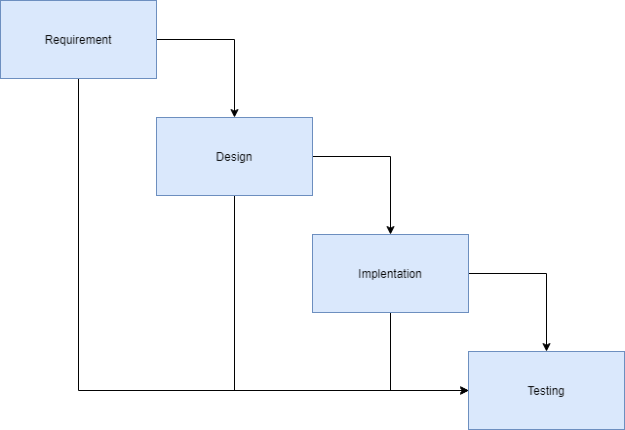

**Figure 1 Waterfall Model**

**3.2.1 Requirements Analysis**

During the initial phase, the primary objective is to gather comprehensive requirements for the property price prediction website while selecting an appropriate machine learning model. Stakeholder meetings will be conducted to thoroughly understand their needs and expectations. Functional and non-functional requirements for the website will be documented, alongside identifying essential data sources such as housing data and relevant prediction features. An initial dataset will be collected and preprocessed for model training purposes. Machine learning algorithms suitable for property price prediction, including Linear Regression and Lasso Regression, will be selected and evaluated. This evaluation will include comparing their performances using metrics like accuracy, mean squared error, and R-squared score based on the preliminary dataset.

**3.2.2 System Design:**

Following the Requirements Analysis phase, the next step is to design the system architecture comprehensively. This includes defining both high-level and detailed designs. The architecture will cover components such as front-end interfaces, back-end logic, database structures, and necessary APIs. Additionally, wireframes and mockups will be developed to visualize the user interface design, ensuring alignment with the gathered requirements and use cases

**3.2.3 Implementation:**

With the system design finalized, the development phase begins by implementing the actual code for the website based on the design documents. Front-end development will focus on implementing the user interface using technologies like HTML, CSS, and JavaScript, possibly utilizing frameworks such as React or Angular for enhanced functionality. Back-end development will involve implementing server-side logic, integrating with databases using tools like Node.js, Django, or Ruby on Rails, and establishing APIs to facilitate data exchange between front-end and back-end components. This phase will also include integrating the selected machine learning model into the system and conducting unit tests and integration tests to ensure code quality and functionality.

**Table 3 : Programming Tools**

|  |  |  |
| --- | --- | --- |
| Tool | Description | Purpose |
| HTML | Standard markup language for documents designed to be displayed in a web browser | Ensure proper formatting of text and images for web display |
| CSS | Style sheet language for describing presentation of a document written in a markup language like HTML | Control the layout, fonts, texts, colors, backgrounds, and margins of web pages |
| Python | High-level, interpreted, and general-purpose dynamic programming language | Carry out the study due to its support for web applications, built-in functions, extensive support libraries, and user-friendly data structures |
| PyCharm | Dedicated Python Integrated Development Environment (IDE) | Provide a convenient environment for productive Python, web, and data science development; used for HTML, CSS, and scripting |
| Jupyter Notebook | Open-source web application for creating and sharing documents with live code, equations, computational output, visualizations, and multimedia resources | Train the model and integrate code, equations, and visualizations with explanatory text |
| XAMPP | Free and open-source cross-platform web server solution stack package | Develop and test database-driven web applications, including MySQL database management |

**3.2.4 Testing:**

After implementing the system, rigorous testing will be conducted to verify its functionality and performance. Functional testing ensures all specified requirements are met, while non-functional testing evaluates aspects such as performance, security, and usability. System testing validates the integration and interaction of system components, while user acceptance testing (UAT) allows stakeholders to evaluate the system against their expectations and provide feedback for necessary adjustments. Collecting feedback from users about the usability and effectiveness of the property price prediction feature is crucial during this phase.

**3.2.5 Deployment:**

Following successful testing and approval, the system will be prepared for deployment to a live environment. This phase includes final preparations to ensure all components are ready for deployment, followed by the actual deployment process to make the system accessible to users. Post-deployment activities, including smoke testing, will be performed to confirm the system's operational readiness and identify any immediate issues requiring resolution.

**3.2.6 Maintenance:**

The final phase focuses on maintaining and supporting the deployed system over its lifecycle. Continuous monitoring will be conducted to proactively identify and address any issues or bugs that arise. Regular updates and patches will be applied to enhance system performance, security, and functionality based on user feedback and evolving requirements. Ongoing user support will be provided to ensure optimal system operation and user satisfaction. Continuous collection of feedback from users about the usability and effectiveness of the property price prediction feature will also be an integral part of this phase.

By following this structured approach, each phase is carefully planned and executed to ensure the development of a robust and reliable property price prediction website.

# 

## 3.3 Machine learning models

In this section, two machine learning methods are introduced for the project: linear regression and Lasso regression. The rationale behind selecting these methods is twofold. Firstly, by employing both Lasso Regression and Linear Regression, the project aims to compare their performance and identify the most effective approach for property price prediction. Additionally, utilizing these two techniques aims to provide valuable insights into property price prediction and contribute to the advancement of predictive modeling in real estate markets. This approach allows for a comprehensive analysis of different machine learning algorithms and their applicability in solving real-world problems in the real estate sector.

## 3.3.1 Linear Regression

## Linear Regression is chosen for its simplicity and efficiency as a prediction method. This model offers straightforward interpretations of coefficients and is computationally efficient, making it suitable for initial exploration and baseline comparison. However, while Linear Regression is commonly employed for prediction tasks, uncertainties exist regarding its suitability for property price prediction. Therefore, further investigation needed to uncover both the advantages and potential limitations of Linear Regression in this context, ensuring a comprehensive understanding of its applicability.

Linear regression is a widely utilized statistical model that enables the prediction of dependent variables based on the input of multiple independent variables. By employing least squares, linear regression establishes a linear equation. This equation effectively describes the relationship between the independent and dependent variables, serving as the foundation for constructing the prediction model.

Equation: y = mx + b

y is dependent variable. x is independent variable. m is estimated slop.

b is estimated intercept.

**3.3.2 Lasso Regression**

The word “LASSO” denotes Least Absolute Shrinkage and Selection Operator. Lasso regression follows the regularization technique to create prediction. It is given more priority over the other regression methods because it gives an accurate prediction. Lasso regression model uses shrinkage technique. In this technique, the data values are shrunk towards a central point similar to the concept of mean.

The lasso regression algorithm suggests a simple, sparse models (i.e. models with fewer parameters), which is well-suited for models or data showing high levels of multicollinearity or when we would like to automate certain parts of model selection, like variable selection or parameter elimination using feature engineering. Lasso Regression algorithm utilizes L1 regularization technique It is taken into consideration when there are more number of features because it automatically performs feature selection, (Melkumova & Shatskikh, 2017).

**3.3.3 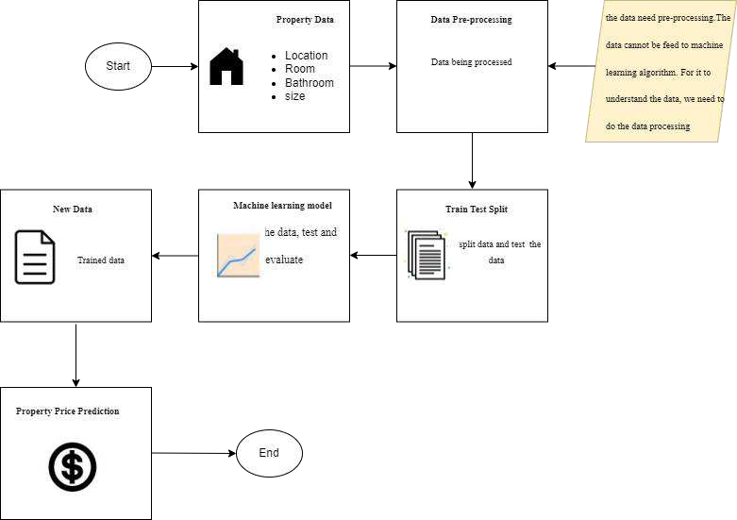Process of machine learning**

**Figure : 2 machine learning process**

**3.3.3.1 Data Collection**

In first stage, the dataset used in this study, comprises property listings in Kuala Lumpur, Malaysia from Kaggle. The dataset contains detailed information about properties available in Kuala Lumpur, including attributes such as property type, location, size, amenities, price, and other relevant features.

## 3.3.3..2 Data Preprocessing

The second stage clean the data, handle missing values, and perform feature engineering to extract meaningful information from the raw dataset. This could involve techniques like normalization, Feature Selection, data cleaning, Data Splitting, and dimensionality reduction.

**3.3.3.3 Model Training**

The third stage, by using a waterfall model, which typically consists of multiple stages or models stacked sequentially, with each stage refining the predictions made by the previous one.

Start with linear regression to make initial predictions based on basic features like property size and location. Then use a more complex model using Lasso regression to capture additional patterns in the data that the base model might miss. Lasso regression, which stands for Least Absolute Shrinkage and Selection Operator, not only helps in improving the prediction accuracy by incorporating more detailed features but also performs feature selection by constraining the coefficients of less significant features to zero. This model will include more nuanced factors such as amenities, neighborhood characteristics, and historical sales data. By doing so, it helps to identify the most influential variables and improves the overall prediction accuracy.

**3.3.3.4 Evaluation**

The fourth stage, valuate and compare the performance of the linear regression and lassso regression using appropriate metrics, such as mean absolute error (MAE), mean squared error (MSE), or coefficient of determination (R-squared), on a validation dataset. This will helps identify which model give the most to the highest predictive accuracy.

# 3.4 Flowchart of activities

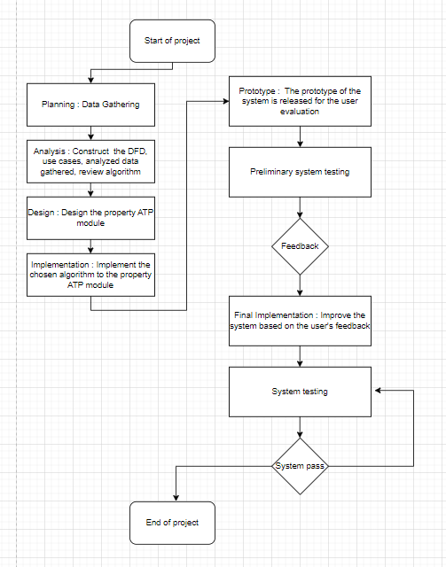

**Figure 3 : Flowchart of activities**

**3.5 MILESTONE AND DATES**

**Table 4 : Milesstone and Date**

|  |  |  |  |
| --- | --- | --- | --- |
| **No.** | **Task** | **Date** | **Duration** |
| **1** | Planning   * Define the project objective, scope and problem statement. * Literature review | 09 MAC - 22 MAC 2024 | 14 days |
| **2** | Requirement Analysis   * Writing Project Summary & Proposal | 22 MAC– 26 APR 2024 | 40 days |
| **3** | Design   * Perform system design and analysis. | 06 MAY – 28 JUN 2024 | 54 days |
| **4** | Development   * Implement research findings. * Create prototypes. * Develop the final product. | 1JUL – 15 NOV 2024 | 138 days |
| **5** | Testing | 18 NOV – 17 JAN 2025 | 61 days |
| **6** | Deployment   * Presentation * Demo | 20 JAN – 24 JAN 2025 | 5 days |

**CHAPTER 4**

**SYSTEM ANALYSIS AND DESIGN**

**4.1 Introduction**

This chapter will discuss the system design and database design for the web-based property price prediction. According to the requirements analysis that has been done from the existing system, use case diagram and description, context diagram, data flow diagram will be created for the system design. The database design will be further explained in entity relationship diagram and data dictionary. User interface design that will be developed for the proposed system also shown in this chapter.

**4.2 Use Case Diagram**

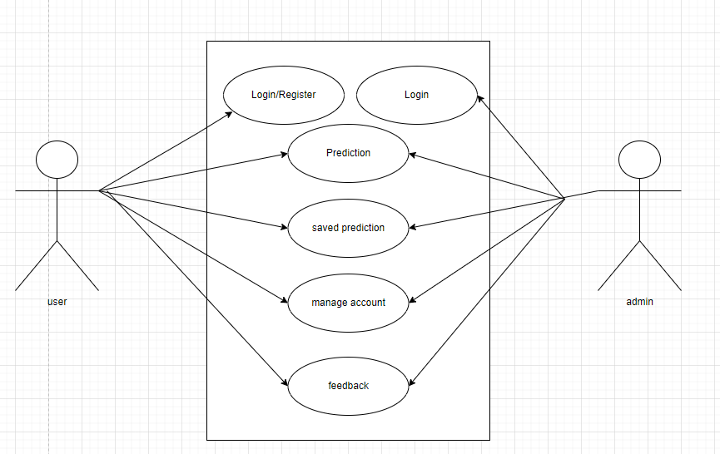

**Figure 4 : Use Case Diagram**

**4.2.1 Use Case Description**

**Table 5 : Description for Use Case 1**

|  |  |  |  |  |  |
| --- | --- | --- | --- | --- | --- |
| Use Case Name: User Login | | | ID: UC-1 | | Priority: High |
| Actor: user | | | | | |
| Description: User logs into the property price prediction system. | | | | | |
| Trigger: User intends to access their account and utilize system features.  Type: External / Temporal | | | | | |
| Preconditions: User account must exist. | | | | | |
| Normal Course:   1. User navigates to the login page. 2. User enters their credentials (ID/Email, Password). 3. System verifies the credentials. 4. User gains access to the system. | | Information For Steps:  User details (ID/Email, Password) provided during login. | | | |
| Alternative Course:   * Invalid credentials: * System prompts user to re-enter correct credentials. | |  | | | |
| Postconditions:  1) User successfully logs into the system. | | | | | |
| Exceptions: - | | | | | |
| Summary  Inputs Source Outputs Destination | | | | | |
| * ID/Email: Provided by the user. * Password: Entered by the user. | user |  | | System dashboard | |

**Table 6 : Description for Use Case 2**

|  |  |  |  |  |  |
| --- | --- | --- | --- | --- | --- |
| Use Case Name: Create Account | | | ID: UC-2 | | Priority: High |
| Actor: user | | | | | |
| Description: This use case outlines the process of a new user creating an account in the property price prediction system. | | | | | |
| Trigger: User decides to create a new account to utilize system features.  Type: External / Temporal | | | | | |
| Preconditions: - | | | | | |
| Normal Course:   1. User navigates to the registration page. 2. User fills out the registration form with the following their requsted details: | | Information For Steps:  User input during the registration process. | | | |
| Alternative Course: - | |  | | | |
| Postconditions: User's account is successfully registered in the system. | | | | | |
| Exceptions: - | | | | | |
| Summary  Inputs Source Outputs Destination | | | | | |
| User Details   * D/Email * Password * Full Name * Additional Details | user |  | | User database in the system | |

**Table 7 : Description for Use Case 3**

|  |  |  |  |  |  |
| --- | --- | --- | --- | --- | --- |
| Use Case Name: Saved Prediction | | | ID: UC-3 | | Priority: High |
| Actor: user | | | | | |
| Description: The user saves a property price prediction result to view or manage later. | | | | | |
| Trigger: The user makes a property price prediction and decides to save the result.  Type: External / Temporal | | | | | |
| Preconditions: · The user must be logged into the system and made a property price prediction | | | | | |
| Normal Course:   1. **User** navigates to the prediction page. 2. **User** enters criteria for property price prediction. 3. **System** processes the prediction and displays the result. 4. **User** chooses to save the prediction result. 5. **System** saves the prediction result in the "Saved Predictions" table. 6. **User** navigates to the "View Saved Predictions" section. 7. **System** displays the list of saved predictions. 8. **User** clicks on a saved prediction to view details or delete it. 9. If the user chooses to delete:  * **System** removes the saved prediction from the database. | | Information For Steps:  User provides criteria such as location, number of rooms, etc. Then usser chooses to save the prediction result. User selects a saved prediction for detailed view or deletion. | | | |
| Alternative Course: Invalid input - System prompts user to correct the input criteria. | |  | | | |
| Postconditions:The prediction result is successfully saved and can be managed by the user. | | | | | |
| Exceptions: - | | | | | |
| Summary  Inputs Source Outputs Destination | | | | | |
| Prediction | user | Saved prediction list | |  | |

**Table 8 : Description for Use Case 4**

|  |  |  |  |  |  |
| --- | --- | --- | --- | --- | --- |
| Use Case Name: Prediction | | | ID: UC-4 | | Priority: medium |
| Actor: user | | | | | |
| Description: This use case outlines the process of a user making property price predictions using the system. | | | | | |
| Trigger: User decides to predict property prices.  Type: External / Temporal | | | | | |
| Preconditions: User is logged into the system. | | | | | |
| Normal Course:   1. User navigates to the prediction section. 2. User enters details such as property type, number of bedrooms, bathrooms, etc. 3. System processes the prediction based on provided data. 4. Predicted price is displayed to the user | | Information For Steps:  Prediction details entered by the user. | | | |
| Alternative Course: Prediction Data Incomplete.  System prompts the user to provide all required details. | |  | | | |
| Postconditions: User receives the predicted property price. | | | | | |
| Exceptions: - | | | | | |
| Summary  Inputs Source Outputs Destination | | | | | |
| Prediction details (property type, bedrooms, bathrooms, etc.) provided by the user. | user | Predicted property price | | User interface | |

**Table 9 : Description for Use Case 5**

|  |  |  |  |  |  |
| --- | --- | --- | --- | --- | --- |
| Use Case Name: Manage Account | | | ID: UC-5 | | Priority: Medium |
| Actor: user | | | | | |
| Description: This use case outlines the process of a user managing their account settings within the system. | | | | | |
| Trigger: User decides to update their account details or password.  Type: External / Temporal | | | | | |
| Preconditions: User is logged into the system. | | | | | |
| Normal Course:   1. User navigates to the account settings section. 2. User updates their account details (name, email, password, etc.). 3. Changes are saved by the system. | | Information For Steps:  Updated account details provided by the user. | | | |
| Alternative Course: User specifically changes their password. | |  | | | |
| Postconditions:  User's account details are updated successfully. | | | | | |
| Exceptions: - | | | | | |
| Summary  Inputs Source Outputs Destination | | | | | |
| Updated account details provided by the user. | user |  | | User database in the system | |

**Table 10 : Description for Use Case 6**

|  |  |  |  |  |  |
| --- | --- | --- | --- | --- | --- |
| Use Case Name: Feedback | | | ID: UC-6 | | Priority: Medium |
| Actor: user | | | | | |
| Description: This use case describes the process of a user providing feedback about the property price prediction system. | | | | | |
| Trigger: User decides to submit feedback.  Type: External / Temporal | | | | | |
| Preconditions: User is logged into the system. | | | | | |
| Normal Course:   1. User navigates to the feedback section. 2. User fills out the feedback form with rating and comments. 3. User submits the feedback. | | Information For Steps:  Feedback details (rating, comments) provided by the user. | | | |
| Alternative Course: | |  | | | |
| Postconditions:  Feedback is successfully submitted. | | | | | |
| Exceptions: - | | | | | |
| Summary  Inputs Source Outputs Destination | | | | | |
| Feedback details (rating, comments) provided by the user. | user |  | | Feedback database in the system | |

**Table 11 : Description for Use Case 7**

|  |  |  |  |  |  |
| --- | --- | --- | --- | --- | --- |
| Use Case Name: Admin Functions | | | ID: UC-7 | | Priority: Medium |
| Actor: admin | | | | | |
| Description: This use case outlines various administrative functions available to the system administrator. | | | | | |
| Trigger: User decides to update their account details or password.  Type: External / Temporal | | | | | |
| Preconditions:Admin credentials are authenticated. | | | | | |
| Normal Course:   1. Admin logs into the system. 2. Admin accesses admin dashboard. 3. Admin performs tasks such as: 4. Managing user accounts. 5. Viewing system logs. 6. System maintenance tasks. | | Information For Steps:  Updated account details provided by the user. | | | |
| Alternative Course: | |  | | | |
| Postconditions:  Admin successfully completes administrative tasks. | | | | | |
| Exceptions: - | | | | | |
| Summary  Inputs Source Outputs Destination | | | | | |
| Admin credentials for login. | admin |  | | Admin dashboard | |

**4.3 Context Diagram**

### The context diagram shown in figure 7 explains the process involved in the entire system of property price prediction with its environment. There are two external entities involved which are the user and the admin. The inputs and outputs of the data in the process are as follows: -

**4.3.1 User input**

The user input are create account, login account, view saved prediction, make prediction and give feedback.

**4.3.2 User output**

The user output are display saved prediction and isplay prediction result.

**4.3.3 Admin input:**

The admin input are login account manage user account and view feedback.

**4.3.4 Admin output**

Admin output is display feedback.

### 2

**Figure 5: Context Diagram of Property Price Prediction System**

**4.4 Data Flow Diagram**

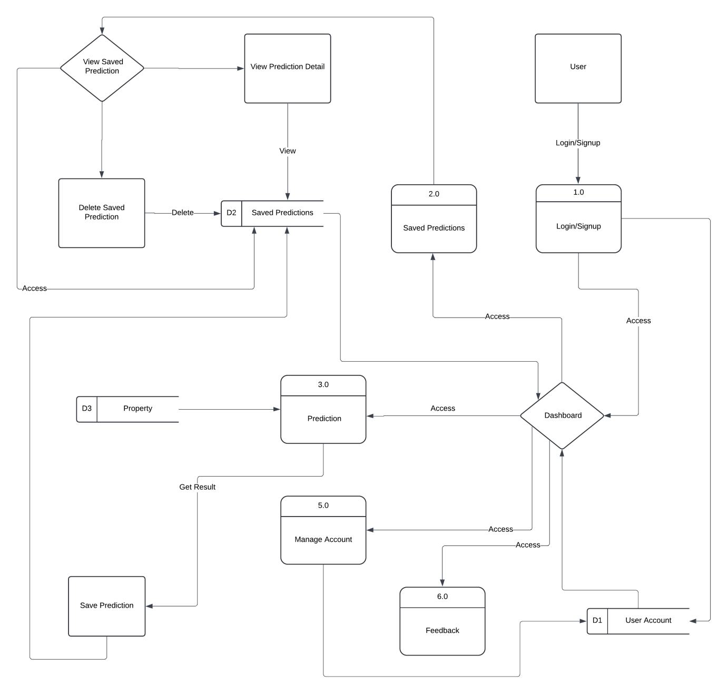

**Figure 6 : Data Flow diagram**

**4.4.1 User Authentication Module**

**The User Management Module** facilitates the creation, authentication, and management of user accounts. Users can register by providing their name, email, password, phone number, address, and birthdate. Upon registration, they can log in with their email and password, gaining access to the system. The module also allows users to manage their profiles, updating their personal information as needed.

**4.4.2 The **Prediction Module****

The p**rediction module** enables users to predict property prices based on various inputs. Users can fill out a form with details such as property type, number of bedrooms, number of bathrooms, size, location, and amenities. Once the form is submitted, the system calculates and displays the predicted property price. Users can then choose to save the prediction for future reference.

**4.4.3 Saved Predictions Module**

The s**aved predictions module** handles the storage and management of predictions that users save. Users can view all their saved predictions, seeing details and predicted prices. If they no longer need a saved prediction, they can delete it from the list.

****4.4.4 Feedback Module****

The f**eedback module** allows users to provide feedback on the system. Users can rate their experience and leave comments, which are stored in the system for review. This helps improve the system based on user suggestions and issues.

**4.4.5 **Admin Module****

The a**dmin module** is designed for system administrators who have a special login. Once logged in, admins can access a dashboard that allows them to manage user accounts, view and respond to feedback, and monitor system performance. This module ensures the system runs smoothly and efficiently, addressing any user or technical issues that arise.

****4.4.6 Notification System****

The n**otification system** sends updates to users and admins. Users receive notifications about their account activity, saved predictions, and responses to feedback. Admins receive notifications about new feedback, user activities, and system alerts. This keeps all parties informed about important events and updates within the system.

### 4.5 Entity Relationship Diagram

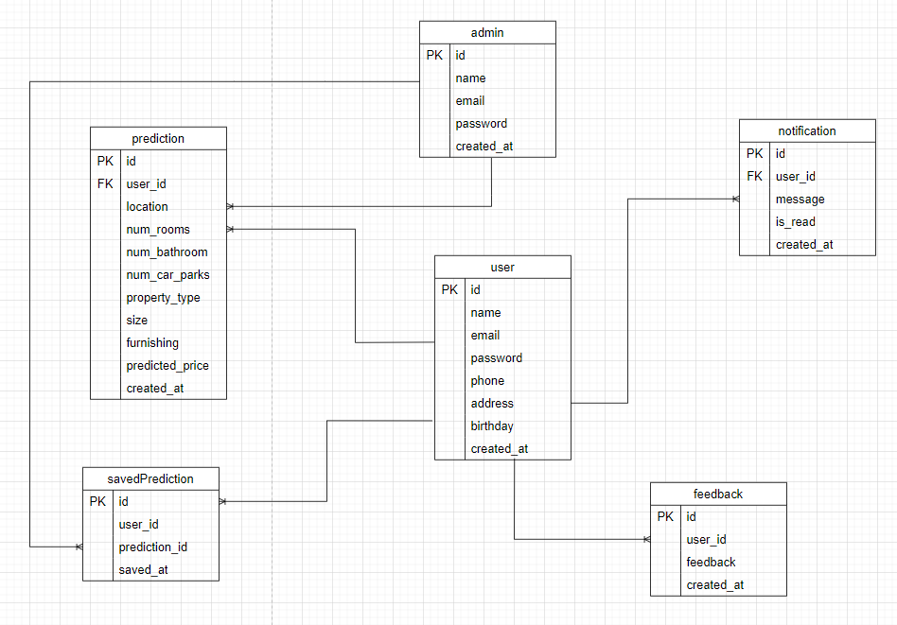

**Figure 7 : Entity relationship Diagram**

### 4.6 Data dictionary

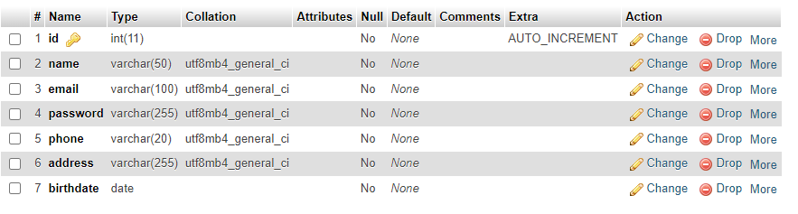

**Figure 8: Data Dictionary for User**

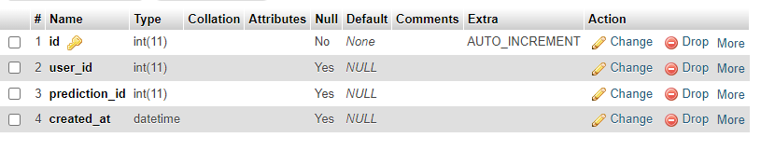

**Figure 9: Data Dictionary for Saved Prediction**

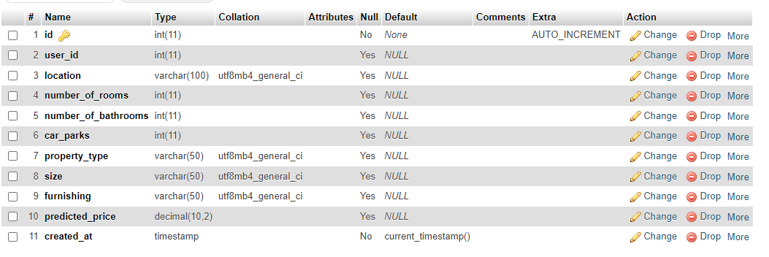

**Figure 10: Data Dictionary for Prediction**

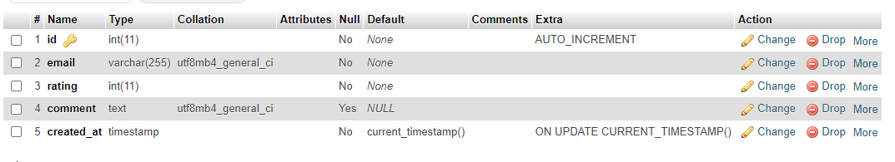

**Figure 11: Data Dictionary for Feedback**

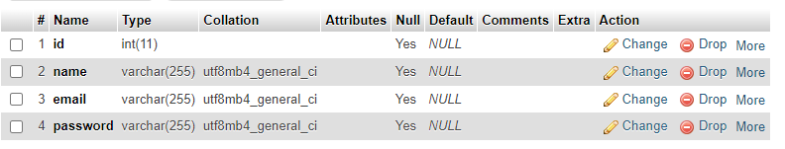

**Figure 12: Data Dictionary for Admin**

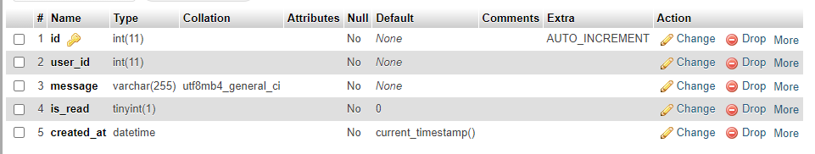

**Figure 13: Data Dictionary for notification**

**4.7 User Interface Design**

In this section, the interface design for the property price prediction system will be shown. The designs are made by taking into consideration of the familiarity of the system, consistency, and ease of navigation it had. The goals are to maximize user experience as much as possible. The system prototype is designed using by using html and css.

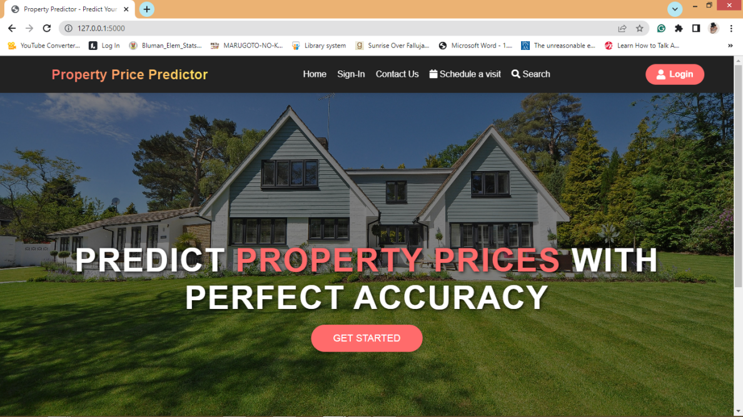

**Figure 14: Homepage**

Figure 14 show the homepage of property price prediction where user can login and signup to get the system access.

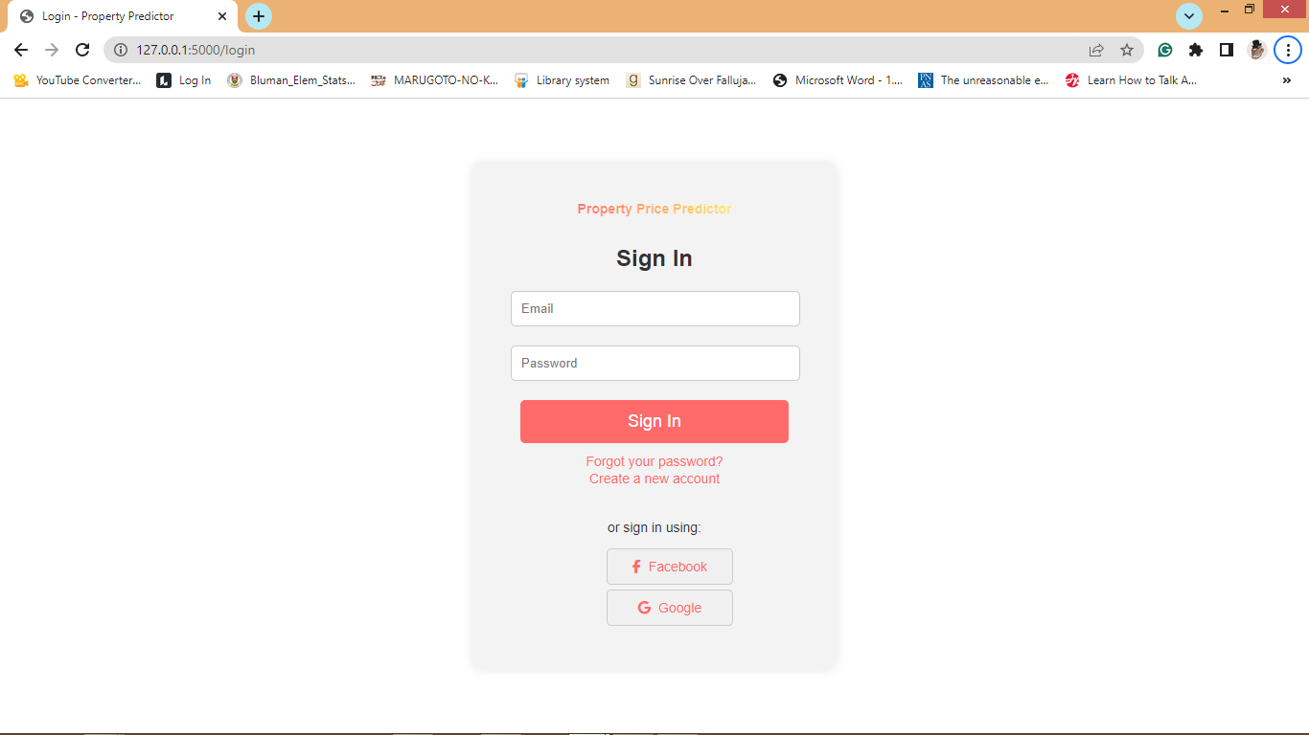

**Figure 15: Login**

Figure 15 show the login page of property price prediction. User can fill their login detail to login and get the system access.

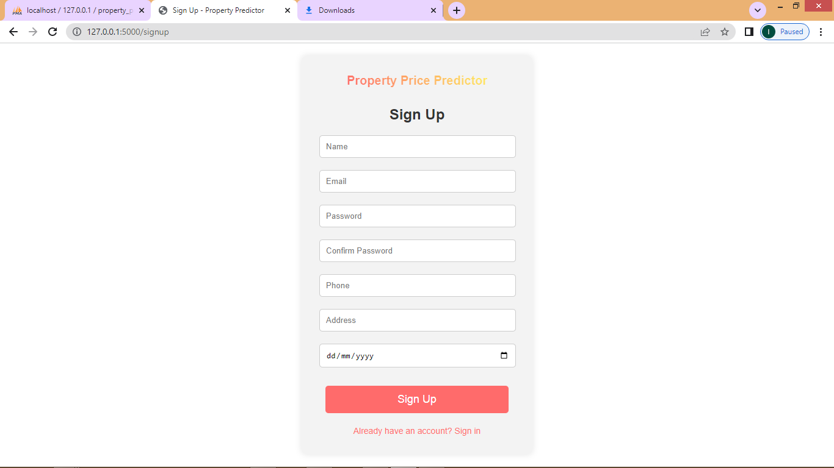

**Figure 16: Create account**

Figure 16 show the create account page of property price prediction. User can fill their information that required . Upon success sign up, user can navigate to login page.

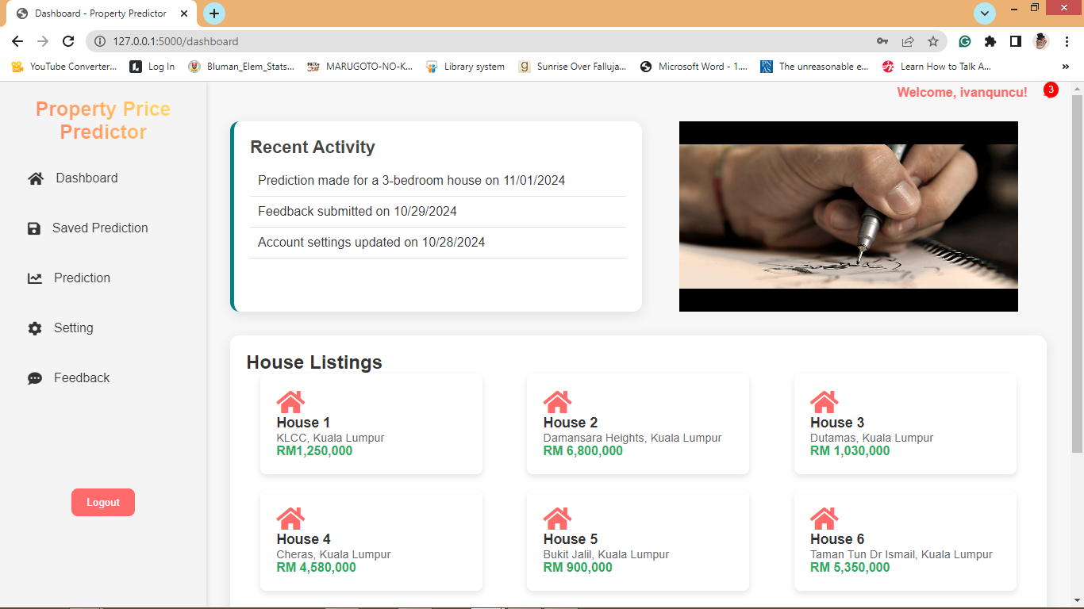

**Figure 17: Dashboard**

Figure 17 show the dashboard page of property price prediction. User can navigate to saved prediction, prediction,setting and give feedback.

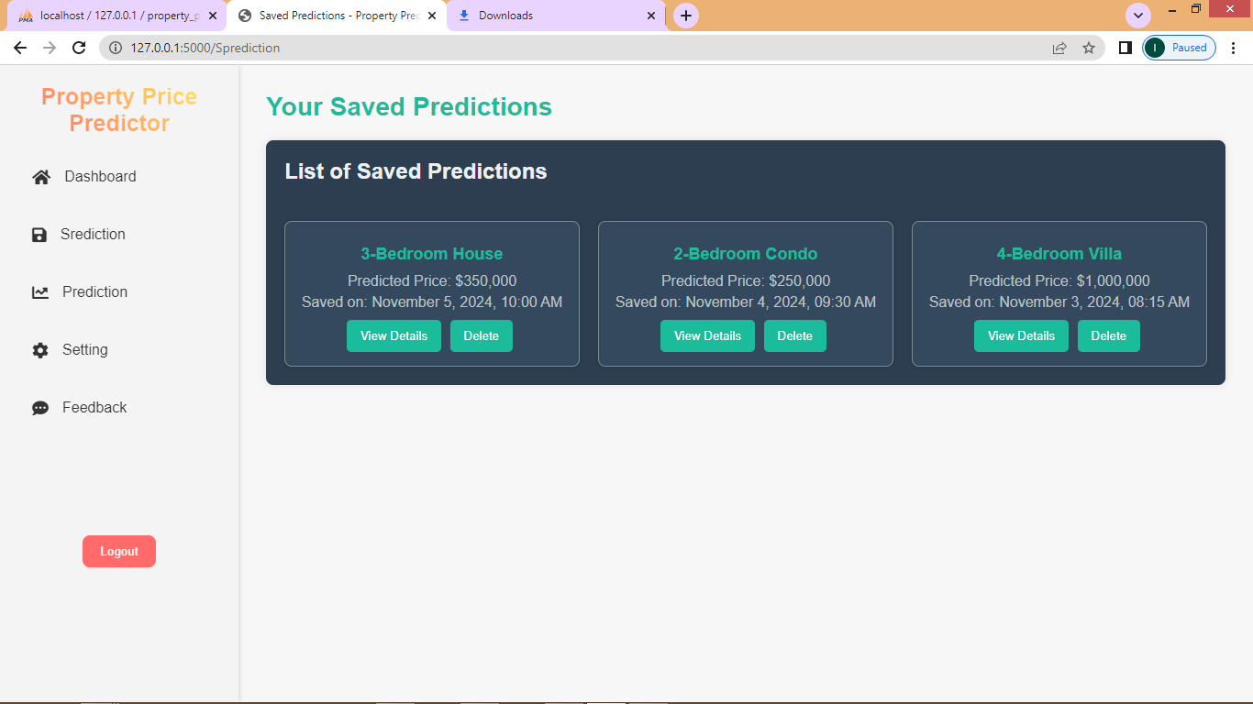

**Figure 18: Saved Prediction**

Figure 18 show the saved prediction page of property price prediction. Prediction result made by user and saved by them can be view in the saved prediction page. User can click more detail or delete the saved prediction.

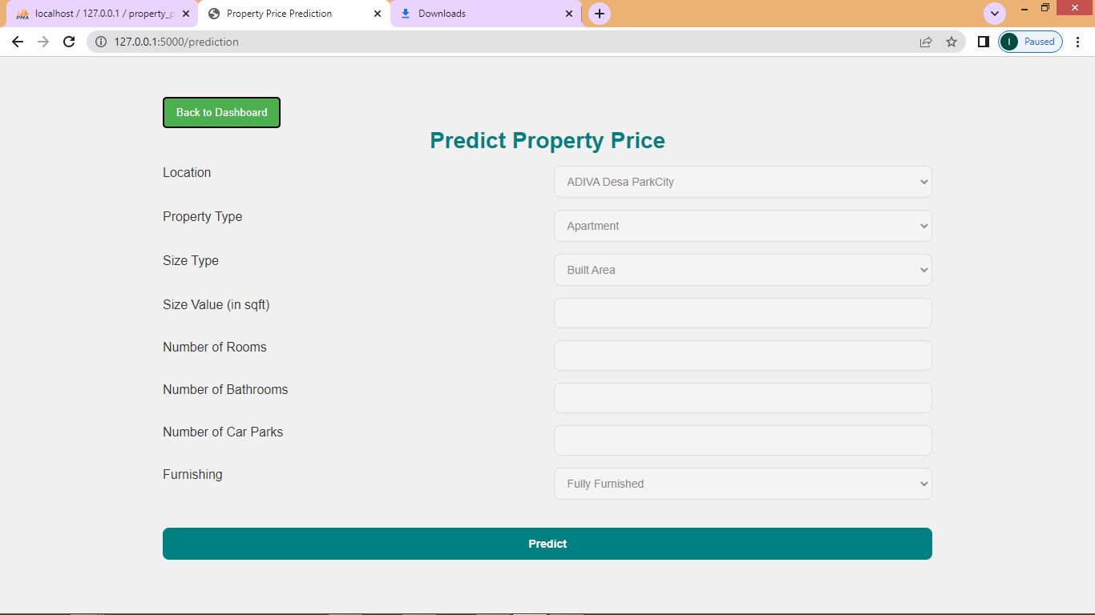

**Figure 19: Prediction**

Figure 19 show the main function of property price prediction which is Prediction page. User can make their prediction and after the result is shown, user can choose to save their prediction(which can be view in saved prediction page) or ignore(nothing will be saved).

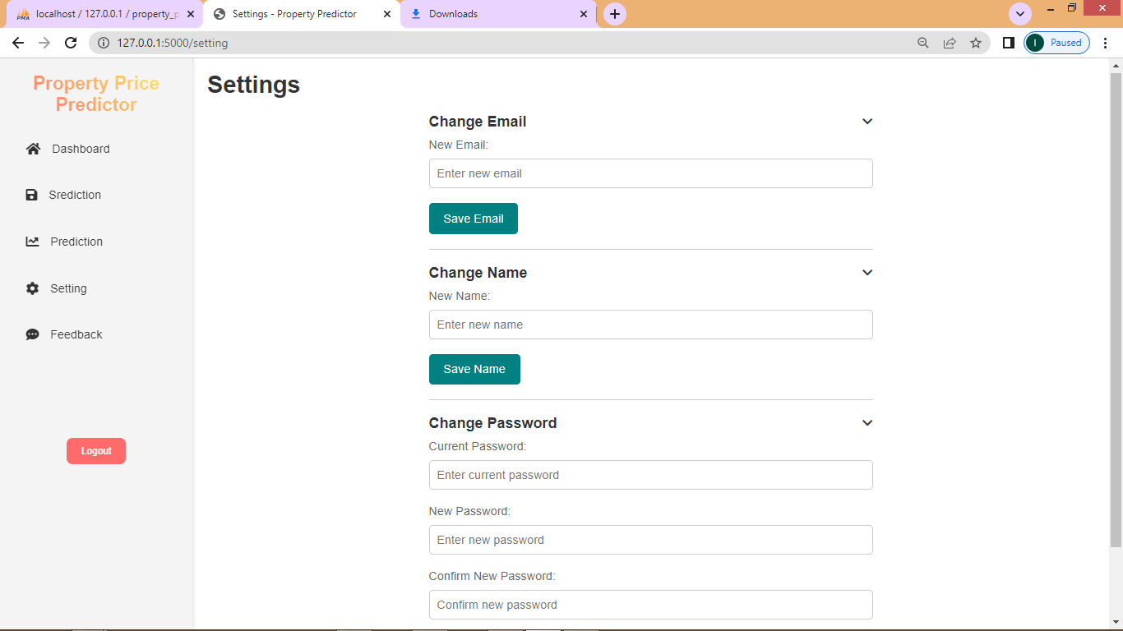

**Figure 20: Manage account**

Figure 20 show the manage account page of property price prediction. User can update their information

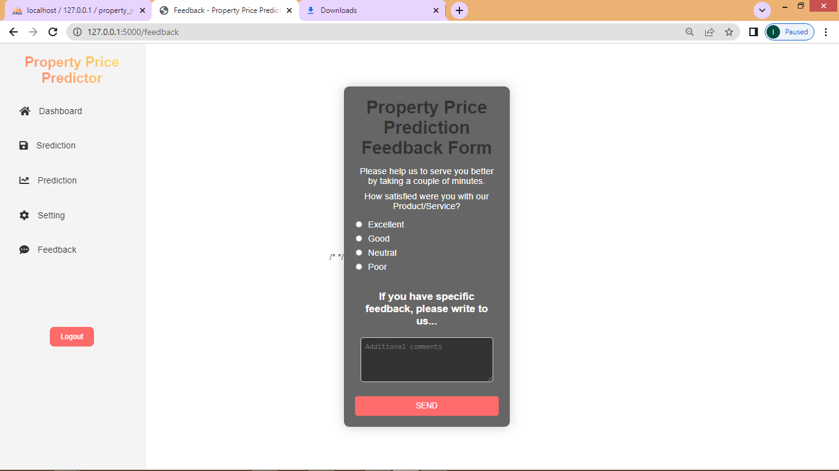

**Figure 21: Feedback**

Figure 21 show the feedback page of property price prediction. User can give their feedback about how their experience when using the system. They can give any idea to help improve the system.

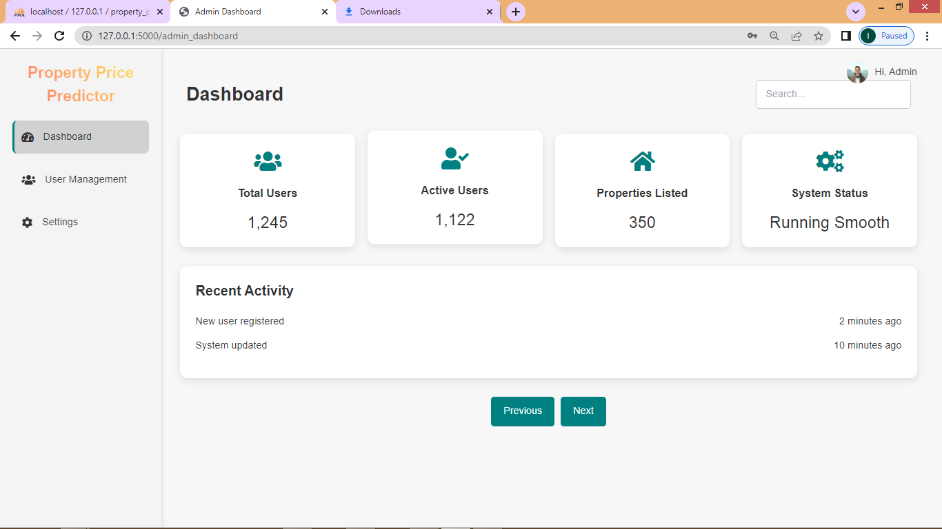

**Figure 22: Admin dashboard**

Figure 22 show the admin dashboard page of property price prediction. Admin will access to the admin dashboard to get the overview of all users and their saved predictions. This page only accessible to the admin, verified by checking if the logged-in user's username matches the admin’s credentials. If the user is the admin, the route fetches all users and their saved predictions from the database and displays them in the admin dashboard. This allows the admin to monitor and manage user activity and predictions across the platform.

**4.8 Machine learning process**

**4.8.1 Dataset**

Dataset used in this study, comprises property listings in Kuala Lumpur, Malaysia from Kaggle. The dataset contains detailed information about properties available in Kuala Lumpur, including attributes such as property type, location, size, amenities, price, and other relevant features.

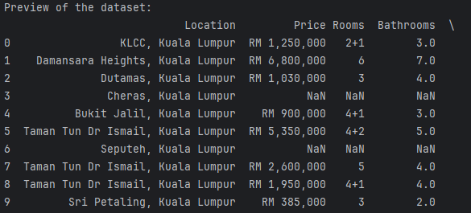

**Figure 23 : Preview of the dataset(first 10 row)**

## 4.8.2 Data Pre-processing

The next step is clean the data, handle missing values, and perform feature engineering to extract meaningful information from the raw dataset. This could involve techniques like normalization, Feature Selection, data cleaning, Data Splitting, and dimensionality reduction.

**4.8.3 Evaluation**

The fourth stage, valuate and compare the performance of the linear regression and lassso regression using appropriate metrics, such as mean absolute error (MAE), mean squared error (MSE), or coefficient of determination (R-squared), on a validation dataset. This will helps identify which model give the most to the highest predictive accuracy.

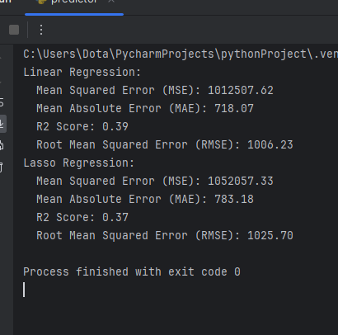

**Figure 24 : Result of both Models from Pycharm**

**Table 12: Evaluation Report**

|  |  |  |  |  |
| --- | --- | --- | --- | --- |
| **MODEL** | **Mean Squared Error (MSE)** | **Mean Absolute Error (MAE)** | **R2 Score** | **Root Mean Squared Error (RMSE)** |
| **LASSO REGRESSION** | **1052057.33** | **783.18** | **0.37** | **1025.70** |
| **LINEAR REGRESSION** | **1012507.62** | **718.07** | **0.39** | **1006.23** |

**4.8.3.1 Comparison and explaination**

Based on the table, we can see that linear Regression has a lower MSE (1012507.62) and RMSE (1006.23) compared to Lasso Regression. This means that, on average, the Linear Regression model's predictions are closer to the actual values in terms of squared difference.

Lasso Regression has a lower MAE (783.18) compared to Linear Regression. This means that, on average, the Lasso Regression model's predictions are closer to the actual values in terms of absolute difference. Both models have a similar R2 score (around 0.37), indicating that both models are able to explain approximately 37% of the variance in the dependent variable.

The Linear Regression model seems to perform slightly better in terms of MSE and RMSE, while the Lasso Regression model performs slightly better in terms of MAE. The choice of which model to use would depend on the specific requirements of the application, such as the relative importance of minimizing error in different directions.

**4.9 Conclusion**

### In conclusion, the system design is keep simple for user to use. All modules that is included in this system will be developed according to the user requirements. The prototype design of the system is clearly shown in this section and is associated with each users’ modules. Based on the design, the student will be able to view saved prediction, make a prediction, manage their account and provide feedback. In term of machine learning, While Lasso Regression has a lower MAE, the difference is not significant enough to outweigh the advantages of Linear Regression in this case. Additionally, Lasso Regression is a more complex model that requires more hyperparameter tuning, which can be time-consuming and may not lead to significantly better results.

Therefore, based on the available information, Linear Regression is the most suitable to use for the property price prediction. However, it's always a good idea to perform additional analysis and validation to ensure that the chosen model is suitable for the specific problem and data at hand.

**CHAPTER 5**

**IMPLEMENTATION**

**5.1 Introduction**

This chapter presents the implementation of the designed system. It is divided into three main sections. The first section demonstrates how the property price prediction website functions for both administrators and users, covering key features such as login, signup, dashboard, saved predictions, property prediction, account settings, and feedback. The second section focuses on the machine learning model implementation, detailing how predictions are generated based on user inputs. Finally, the third section discusses the implementation of the database, including its structure and how it integrates with the web application.

**5.2 System Design**

The Property Price Prediction website is developed using Python, with Flask as the backend framework. Flask is chosen for its simplicity, flexibility, and ability to enhance development speed. It facilitates seamless routing and request handling, which are critical for the core features of the system. These features include user login, signup, dashboard management, saved predictions, property price prediction, account settings, and feedback submission. Flask efficiently manages user sessions, handles dynamic content, and integrates with the database to provide users with personalized experiences and real-time property predictions.

**5.3 Website**

The main function of the property price prediction website is to provide users with the ability to register and authenticate before accessing its features. Once registered, users can fully utilize the site’s core functionality: predicting property prices. Upon logging in, users are directed to a dashboard that includes a tutorial, guiding them on how to use the property price prediction tool effectively. The dashboard also features a list of properties, allowing users to browse and identify those that suit their preferences.

The primary feature of the website, the property price prediction tool, enables users to input their criteria, such as location, size, and budget, and receive an estimated property price. This feature assists users in making informed decisions about potential property purchases based on their financial capacity and preferences.

Additionally, the website allows users to save their predictions, enabling them to compare different properties and make a more informed choice. Users can manage their account details through the account settings section, where they can update personal information. There is also a feedback section where users can provide comments or suggestions for improvement, helping developers enhance the website's functionality and user experience.

5.3.1 User section

5.3.1.1 User login Route

The Login route is implemented to handle both GET and POST requests. When the user accesses the /login page via a GET request, the login form is rendered. If the user submits the form with a POST request, their credentials, such as username and password, are checked against the database. If a match is found, the username is stored in the session, and the user is redirected to the dashboard page. If the credentials are invalid, an error message is displayed. This ensures that only authenticated users can access the dashboard.

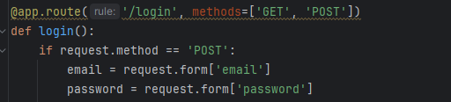

**Figure 25: Route for user login**

5.3.1.2 User sign up route

The Sign Up route handles user registration. It accepts GET and POST requests. When the user visits the /signup page, the registration form is displayed. If the user submits the form with a POST request, the entered username, email, and password are inserted into the database, creating a new user record. After successful registration, the user is redirected to the login page, where they can authenticate and access their account.

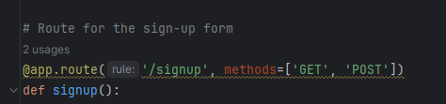

**Figure 26: The route for user sign up**

5.3.1.3 User dashboard route

The Dashboard route ensures that only logged-in users can view their dashboard. If the user is not logged in, they are redirected to the login page. Upon successful login, the route fetches the user's saved predictions from the database using their username and displays them in the dashboard. This gives users an overview of their saved predictions and allows easy access to their past searches.

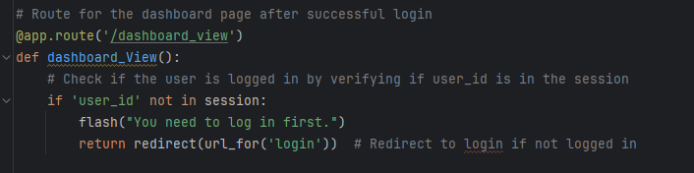

**Figure 27: Route for user dashboard**

5.3.1.4 User saved predicton route

The Saved Predictions route is similar to the dashboard route but specifically focused on showing the list of predictions a user has saved. When a logged-in user accesses this route, their saved predictions are retrieved from the database and displayed. This route allows users to view, manage, or refer back to predictions they have saved earlier.

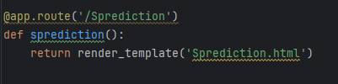

**Figure 28: Route for user saved prediction**

5.3.1.5 User prediction Route

The Prediction route enables users to input property details such as location, property type, size type, rooms, bathrooms, car parks and furnishing. Then they will get the of predicted property price. After the user submits the form with the necessary details, the backend processes this data and uses the machine learning model to generate a prediction. The predicted price is then displayed to the user, helping them understand the potential value of properties based on their inputs.

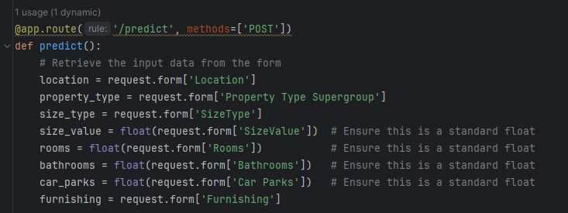

**Figure 29: Route for user prediction with ML**

5.3.1.6 User setting route

The setting route allow users to change their account detail.

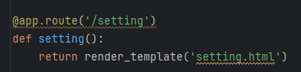

**Figure 30: Route for user setting**

5.3.1.7 User feedback route

The Feedback route allows users to submit their feedback on the website or its services. When a user accesses the /feedback page, they are presented with a form. Upon submitting the form, the feedback text is saved in the database along with the username of the user submitting it. After submission, the user is shown a confirmation or success page, indicating that their feedback has been successfully received.

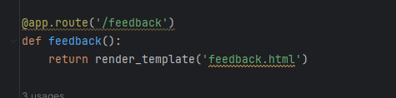

**Figure 31: Route for user feedback**

5.3.2 Admin section

5.3.2.1 Admin dashboard route

The admin section is the dashbord for administrators to manage users, prediction, and feedback. User management enables administrators to view user account details such as usernames, full names, genders, and emails. Next, for prediction, admins can view the user prediction. For feedback, admins can view the feedback that given by the users. As for improvement, admin can view the users idea about improvement that can be made or feedback that contain unstattisfied by user which can also noted as things that can be improve. All section that can be access by admin are shown in Figure.

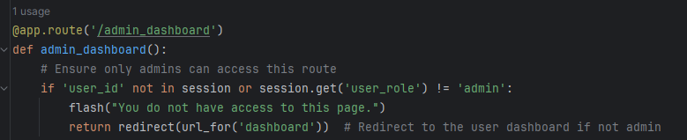

**Figure 32: Route for admin dashboard**

**5.4 Machine Learning model implementation**

Dataset used in this study, comprises property listings in Kuala Lumpur, Malaysia from Kaggle. The dataset contains detailed information about properties available in Kuala Lumpur, including attributes such as property type, location, size, amenities, price, and other relevant features. The target variable for the prediction is 'Price'."

**5.4.1 Data Preprocessing**

The dataset underwent several preprocessing steps. Missing values were handled by imputing them with the mean for numeric features and mode for categorical features. Categorical variables such as ‘Location’, 'Property Type', ‘SizeType’, and 'Furnishing' were encoded using one-hot encoding. Numeric features were standardized to ensure the model treats them equally. Finally, the dataset was split into 80% training data and 20% testing data for model evaluation."

5.4.3 Model Deployment

Once the model was trained and evaluated, it was serialized using joblib to save the model for deployment on the website. This allows the model to be loaded and used for predictions without retraining.

5.4.4 Import Required Libraries

Before loading the trained model, we import the necessary libraries to handle machine learning, Flask, and database interactions.

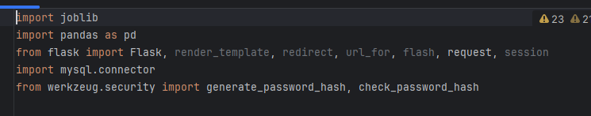

**Figure 33: Required libraries**

5.4.5 Loading the Pre-Trained Model and Encoders

The loaded encoders are used to get the list of possible categories for location, property type, furnishing, and size type, which are later displayed as options in the form on the website. This allows users to select from a predefined set of choices when making predictions.

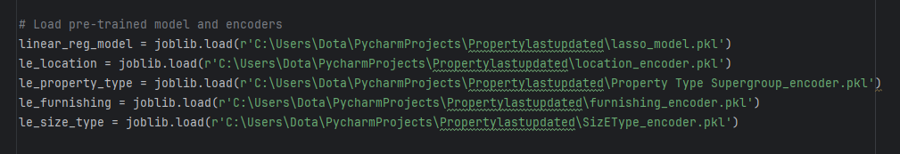

**Figure 34: Pre-trained model and encoders load**

5..4.6 Retrieving Categorical Feature Options

These values are passed to the HTML template to populate the form fields, ensuring users can only select from valid options.

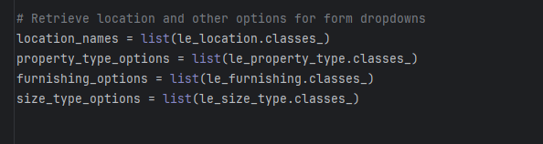

**Figure 35: Retrieving categorical feature options**

5.4.7 Prediction Logic

When a user submits the form with input data, the application processes the data to ensure it matches the format expected by the model. It then encodes categorical features using the pre-loaded encoders and prepares the input data for prediction.

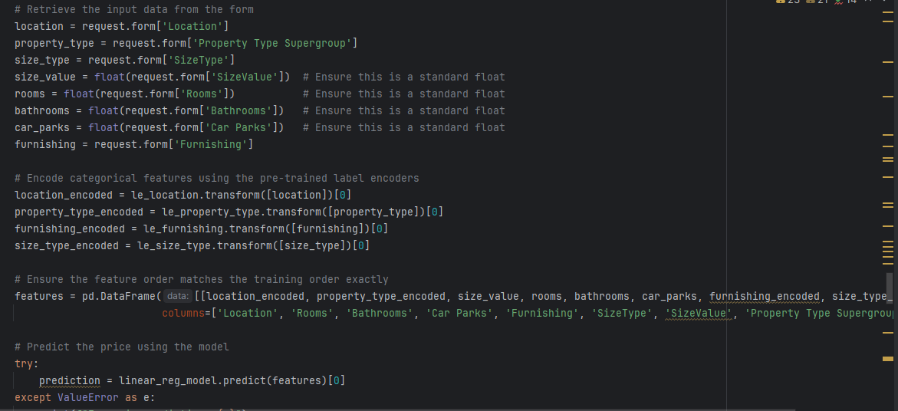

**Figure 36: Prediction logic**

5.4.8 Storing and Displaying the Prediction

After generating the prediction, the result is stored temporarily in the user session, allowing the user to view the prediction on the result page.

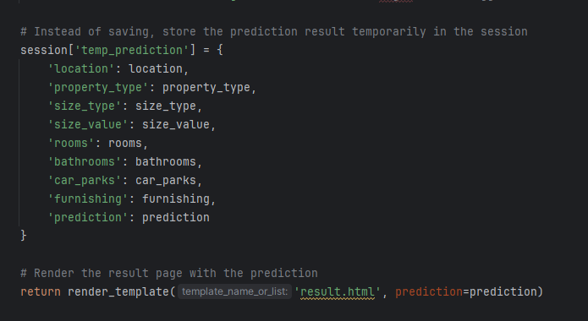

**Figure 37: Storing and display prediction**

**5.5 Database implementation**

In this project, **MariaDB** database is used to store and manage data related to property listings, user accounts, and predictions. The database serves as the central data store for the application, facilitating dynamic content such as property prices, details, and user-generated data like saved predictions and feedback. This section outlines the database structure, connection methods, and how the data is managed and interacted with through the web application.

5.5.1 Database Connection

The application uses **MySQL Connector** for Python to establish a connection with the **MariaDB** database. The connection is established by defining a function that connects to the database and allows querying. Below is a sample of how the connection is implemented:

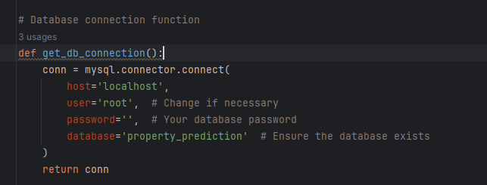

**Figure 38: Database connection**

This function establishes a connection to the database using the credentials provided. Once the connection is made, the application can interact with the database to perform actions such as inserting, updating, and retrieving data.

**5.6 Conclusion**

In conclusion, this chapter has outlined the implementation of the key features of the property price prediction website. The system allows users to register, log in, and access a range of functionalities, including property price predictions, saved predictions, account management, and feedback submission. The implementation of these features ensures that users have a seamless experience when navigating the website, from property browsing to making informed purchasing decisions based on their personal preferences and budget. Additionally, the feedback mechanism provides a means for ongoing improvement, ensuring that the system can evolve based on user input. Through a combination of a user-friendly interface and powerful prediction capabilities, the property price prediction system serves as a comprehensive tool for potential buyers.

**CHAPTER 6**

**TESTING**

**6.1 Introduction**

This chapter will provide a brief description of the project, including the goal of the property price prediction website and the machine learning model used to predict property prices based on user inputs.The objective of this chapter is to verify the functionality, accuracy, and usability of the machine learning model and its integration into the website.

**6.2 System functionality test**

The purpose of system functionality testing is to verify the core system functions and the importance of these areas in achieving a stable and efficient work environment. The functionalities to test are login, register and prediction.

**6.2.1 Login**

Login module where user and admin can use to authenticate to their account. Tables 6.1 show admin and user login functionality. This testing applies to website.

**Table 13: User Login test case**

|  |  |  |  |  |  |  |
| --- | --- | --- | --- | --- | --- | --- |
| ID | Test Case  Description | Test Steps | Test Data | Expecte  d Result | Actual  Results | Pass  /Fail |
| 1 | Login with  correct  data | 1. Enter email  2. Enter  password  3. Enter login  button | Email:  ivanquncu@gm  ail.com  Password:  9613 | Redirect  to login  page | As  expecte  d,  result | pass |
| 2 | Login  validation  check | 1. Enter email  only  2. click login  button | Email:  ivanquncu@gm  ail.com  Password: | Rise input  alert  required | As  expecte  d,  result | pass |
| 3 | Incorrect  login data | 1. Enter email  2. Enter  password  3. Enter login  button | Email:  ivanquncu@gm  ail.com  Password:  123 | Login fail | As  expecte  d,  result | pass |

**Table 14: Admin login test case**

|  |  |  |  |  |  |  |
| --- | --- | --- | --- | --- | --- | --- |
| ID | Test Case  Description | Test Steps | Test Data | Expecte  d Result | Actual  Results | Pass  /Fail |
| 1 | Login with  correct  data | 1. Enter email  2. Enter  password  3. Enter login  button | Email:  admin@gm  ail.com  Password:  9613 | Redirect  to admin dashbord | As  expecte  d,  result | pass |
| 2 | Login  validation  check | 1. Enter email  only  2. click login  button | Email:  admin@gm  ail.com  Password: | Rise input  alert  required | As  expecte  d,  result | pass |
| 3 | Incorrect  login data | 1. Enter email  2. Enter  password  3. Enter login  button | Case1.  Email:  admin@gm  ail.com  Password:  123 | Login fail | As  expecte  d,  result | pass |

**6.2.2 Register**

Register module where only a user or non-admin can use this functionality. The user must enter appropriate data to register in the system. Table 6.2 shows the user register functionality.

**Table 15: User register test case**

|  |  |  |  |  |  |  |
| --- | --- | --- | --- | --- | --- | --- |
| ID | Test Case  Description | Test Steps | Test Data | Expecte  d Result | Actual  Results | Pass  /Fail |
| 1 | Register  appropriat  e required  data | 1. Enter new  name  2. Enter new  email  3. Enter passowrd and confirm password  4. Enter  Phone  5. Enter adress  6. Enter date birth  7. Click submit. | Name:  Ivanquncu Email:  ivanquncu@gm  ail.com  Password:123  Confirm password:123  Phone: 0134435345  Adress: kg, kayau  Date birth:13/10/1996 | Resgister success | As  expecte  d,  result | pass |
| 2 | Register  validation  check | 1. Enter name and email  only  2. click submit  button | Name:  Ivanquncu Email:  ivanquncu@gm  ail.com | Rise input  alert  required | As  expecte  d,  result | pass |
| 3 | Register  with exist  username  in system | 1. Enter new  name  2. Enter old  email  3. Enter new passowrd and confirm password  4. Enter new  Phone  5. Enter new address  6. Enter new date birth  7. Click submit. | Name:  Kucu  Email:  ivanquncu@gm  ail.com  Password:1234  Confirm password:1234  Phone: 014995583  Adress: kg, kabang  Date birth:13/10/1995 | Email already exist | As  expecte  d,  result | pass |

**6.2.3 Prediction**

To ensure the accuracy and functionality of the property price prediction feature on the website, tests focusing on different aspects of user input and model response was conducted. The goal of these tests was to validate that the system handles various inputs correctly and delivers reliable results in a user-friendly manner.

**Table 16: User prediction test case**

|  |  |  |  |  |  |  |
| --- | --- | --- | --- | --- | --- | --- |
| ID | Test Case  Description | Test Steps | Test Data | Expecte  d Result | Actual  Results | Pass  /Fail |
| 1 | Valid Input - Standard | Enter valid input to the price property prediction | Location:"Damansara", property type “Bungalow”, size type “Land”, Sizevalue: 1200 , Rooms: 3, bathrooms 3, car parks 3, Furnishing: "Fully Furnished" | Price is within range | Price is out range | Fail |
| 2 | Valid Input - Large House | Enter larger input to the price property prediction | Location: "Damansara", property type “Bungalow”, size type “Land”, Sizevalue: 12000000 , Rooms: 300, bathrooms 300, car parks 300, Furnishing: "Fully Furnished" | Higher predicted price for large property | As  expecte  d,  result | Pass |
| 3 | Invalid Input - Empty | All fields empty | No input | Error message: "Please enter required fields" | As  expecte  d,  result | Pass |
| 4 | Invalid Input - Negative | Input negative values | Location: "Damansara", property type “Bungalow”, size type “Land”, Sizevalue: -1200 , Rooms: -3, bathrooms -3, car parks -3, Furnishing: "Fully Furnished" | Error message: "Invalid input" | Give out negtive values of price | Fail |
| 5 | Prediction Save Test | Save the prediction | Location:"Damansara", property type “Bungalow”, size type “Land”, Sizevalue: 1200 , Rooms: 3, bathrooms 3, car parks 3, Furnishing: "Fully Furnished" | Prediction saved to "Saved Predictions" section | As  expecte  d,  result | Pass |
| 6 | Error Handling | Server down during prediction | Error message: "Prediction unavailable" | Error message: "Prediction unavailable" | As  expecte  d,  result | Pass |
| 7 | Model Response Time | Make prediction | Input:  Location: "Damansara", property type “Bungalow”, size type “Land”, Sizevalue: 1200 , Rooms: 3, bathrooms 3, car parks 3, Furnishing: "Fully Furnished" | Prediction should be returned within 1-2 seconds | As  expecte  d,  result | Pass |

**CHAPTER 7**

**CONCLUSION**

**7.1 Introduction**

This chapter will summarize and conclude the whole project based on the objectives and will explore further work that will be done to overcome the limitations of the current developed system.

**REFERENCES**

* 1. R[awool, A. G., Rogye, D. V., Rane, S. G., & Bharadi,](https://www.irejournals.com/paper-details/1702692) D. V. A. (2021). House Price Prediction Using Machine Learning. IRE Journals, 4(11), 29–33. https://[www.irejournals.com/paper-details/1702692](http://www.irejournals.com/paper-details/1702692)
  2. D[agar, A., & Kapoor, S. (2020). A comparative study on house price prediction.](https://www.researchgate.net/publication/347369616_A_Comparative_Study_on_House_Price_Prediction) International Journal for Modern Trends in Science and Technology, 6(12), 103-107. https://[www.researchgate.net/publication/347369616_A_Comparative_Study_on_Ho](http://www.researchgate.net/publication/347369616_A_Comparative_Study_on_Ho) use_Price_Prediction
  3. el Mouna, Lale & Hassan, Silkan & Haynf, Youssef & Nann, Mohamedade & Koumetio Tekouabou, Cédric Stéphane. (2023). A Comparative Study of Urban House Price Prediction using Machine Learning Algorithms. https://[www.researchgate.net/publication/373200743_A_Comparative_Study_of_Urb](http://www.researchgate.net/publication/373200743_A_Comparative_Study_of_Urb) an_House_Price_Prediction_using_Machine_Learning_Algorithms
  4. Bansal, U., Narang, A., Sachdeva, A., Kashyap, I., & Panda, S. P. (2021). Empirical analysis of regression techniques by house price and salary prediction. IOP C[onference Series: Materials Science and En](https://doi.org/10.1088/1757-899x/1022/1/012110)gineering, 1022, 012110. https://doi.org/10.1088/1757-899x/1022/1/012110
  5. Mohd, T., Masrom, S., & Johari, N. (2019). Machine learning housing price prediction in [Petaling Jaya, Selangor, Malaysia. Int. J. Recent Technol. Eng, 8(2), 542–546.](https://www.ijrte.org/wp-content/uploads/papers/v8i2S11/B10840982S1119.pdf) https://[www.ijrte.org/wp-content/uploads/papers/v8i2S11/B10840982S1119.pdf](http://www.ijrte.org/wp-content/uploads/papers/v8i2S11/B10840982S1119.pdf)
  6. Balila, A. E., & Shabri, A. B. (2024). Comparative analysis of machine learning algorithms for predicting D[ubai property prices. Frontiers in Applied Math](https://doi.org/10.3389/fams.2024.1327376)ematics and Statistics, 10, 1327376. https://doi.org/10.3389/fams.2024.1327376
  7. Ho, W. K., Tang, B. S., & Wong, S. W. (2021). Predicting property prices with machine learning algorithms. Journal of Property Research, 38(1), 48-70. https://hub.hku.hk/bitstream/10722/294145/1/content.pdf?accept=1
  8. Zou, C. (2023). The House Price Prediction Using Machine Learning Algorithm: The Case of Jinan, China. Highlights in Science, Engineering and Technology, 39, 327- 333.

h[ttps://www.researchgate.net/publication/369876875_The_House_Price_Prediction_](https://www.researchgate.net/publication/369876875_The_House_Price_Prediction_Using_Machine_Learning_Algorithm_The_Case_of_Jinan_China) Using_Machine_Learning_Algorithm_The_Case_of_Jinan_China

* 1. [12] Jha, S. B., Pandey, V., Jha, R. K., & Babiceanu, R. F. (2020). Machine learning approaches to real estate market prediction problem: a case study. arXiv preprint arXiv:2008.09922.

# APPENDIX

1. Appendix A: Turnitin Plagiarism Full Report
2. Project Summary Review Comments + Reply to Comments

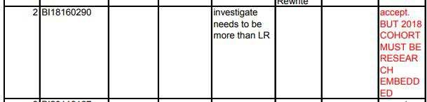

1. Meeting logs

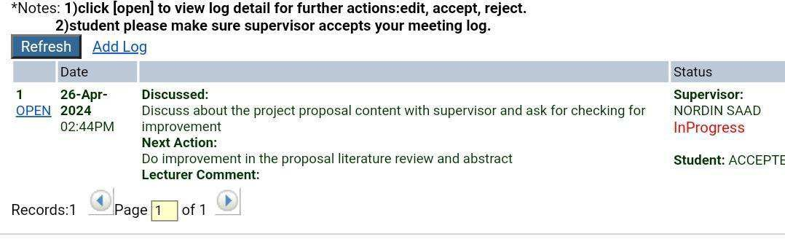

1. Borang Deklarasi

