Contain

License agreement 1

Acknowledgments 2

All rights to the above software belong to the authors or other copyright holders of this software who are not related to the authors and/or the copyright holders of StructureHelper 2

Cross-Section 2

Primitives 3

General information 3

Host primitive 3

Prestressing 4

Templates 5

Actions 6

Materials 7

Elastic 7

Concrete 9

Reinforcement 10

Carbonfiber 12

Partial safety factors 14

Behavior diagrams 15

Moment-curvature diagram 15

Interaction diagram 16

Examples 18

Analysis of hollow core slab 18

# License agreement

This software is provided under MIT public license

Copyright (c) 2023 Redikultsev Evgeny, Ekaterinburg, Russia

Permission is hereby granted, free of charge, to any person obtaining a copy of this software and associated documentation files (the "Software"), to deal in the Software without restriction, including without limitation the rights to use, copy, modify, merge, publish, distribute, sublicense, and/or sell copies of the Software, and to permit persons to whom the Software is furnished to do so, subject to the following conditions:

The above copyright notice and this permission notice shall be included in all copies or substantial portions of the Software.

THE SOFTWARE IS PROVIDED "AS IS", WITHOUT WARRANTY OF ANY KIND, EXPRESS OR IMPLIED, INCLUDING BUT NOT LIMITED TO THE WARRANTIES OF MERCHANTABILITY, FITNESS FOR A PARTICULAR PURPOSE AND NONINFRINGEMENT. IN NO EVENT SHALL THE AUTHORS OR COPYRIGHT HOLDERS BE LIABLE FOR ANY CLAIM, DAMAGES OR OTHER LIABILITY, WHETHER IN AN ACTION OF CONTRACT, TORT OR OTHERWISE, ARISING FROM, OUT OF OR IN CONNECTION WITH THE SOFTWARE OR THE USE OR OTHER DEALINGS IN THE SOFTWARE.

# Acknowledgments

The authors of this software admit, that software uses next free libraries:

Live chart library <https://v0.lvcharts.com/>

# All rights to the above software belong to the authors or other copyright holders of this software who are not related to the authors and/or the copyright holders of StructureHelper

# Cross-Section

Cross-section of beam, according to assumptions of strength of material, characterize geometry of infinitely small part of beam,

As usual, cross-section in Structure Helper includes next groups:

* Actions (loads, for example),
* Primitives,
* Calculators.

Each cross-section may contain any amount of those primitives, for instance, you can create T-shape beam from two different primitives – rectangle of web and rectangle of flange of T-beam. Note, than you can assign different material for each of those primitives and obtain combined structure if you want that.

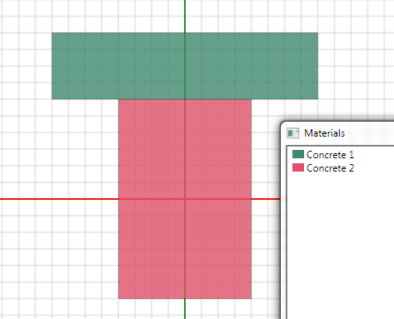

Composite cross-section of T-shape with 2 different materials

# Primitives

## General information

Primitives are just simple geometry objects. Currently, you can use few types of primitives, as follow:

* Rectangle,
* Circle,
* Point,
* Reinforcement point.

There are number of ways to create new primitives, for instance you can create new primitive via main menu, context menu of Geometry panel or via context menu of work plain of cross-section.

Therefore, you can use templates for adding number of standard primitives with their materials.

## Host primitive

Some primitives (rectangle and circle) may play a role a host for other ones. Term “host” means, that main primitive contain any count of slave primitives. For example, when you create cross-section of reinforced concrete column, you rebars will have a host – rectangle or circle with concrete material. Host primitive is required to gain many important properties of concrete when RC member is calculated, for instance for obtaining of lapping length for rebars.

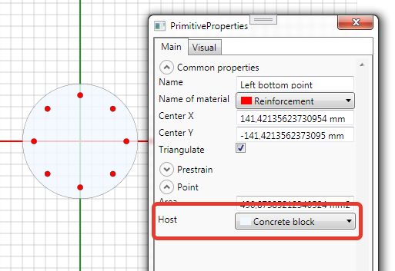

Host primitive for rebar

## Prestressing

Prestress is a widely known way to create initial (before applying a load) stress or strain in structures. Since Structure Helper operate with not only linear elastic material, it is assumed, that you have to assign initial strain instead initial stresses. In the simplest case of linear elastic material you can calculate initial strain (prestrain) from follow expression:

In Structure Helper you can assign 3 components of initial strains (prestrain):

* Curvature about X-axis (Kx),
* Curvature about Y-axis (Ky),
* Strain along Z-axis.

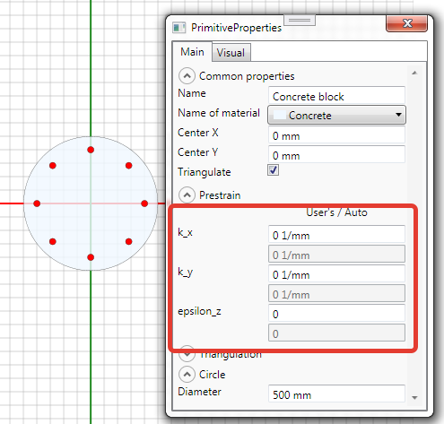

Fig. Prestrain for primitive

Prestrain may be assigned for any type of primitive and any material, for instance, you can consider for concrete and reinforcement simultaneously, also you can consider different value of prestrain for each of rebars.

After triangulation of primitive, for every elementary part of fiber model will be assigned prestrain as below:

,

where x and y – coordinates of elementary part along x-axis and y-axis respectively.

## Templates

Sometimes, it is quite difficult to create primitives manually with their coordinates and geometry properties like width and height. Templates are extremely useful tools for simplification of creating of primitives, materials, actions and calculators. For instance you can use template of RC circle-shape element instead of manual calculation of coordinates of each rebar in cross-section.

Also, template creates example of action, materials and calculator. As result, you can solve your problem instantaneously after using template. Sure, using of template doesn’t restrict your opportunities for manual creating of primitives, materials etc., and you can use number of templates one by one if you want.

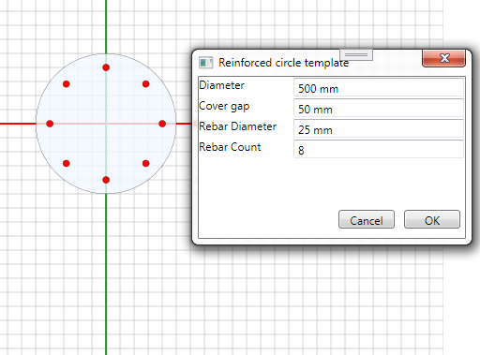

Template of circle-shape or RC member

Currently, you can use next kinds of templates:

* Template of rectangle RC beam,
* Template of rectangle RC column,
* Template of rectangle RC slab (with default width 1m).
* Template of circle RC member.

# Actions

You can create many different actions and combine them in calculation as you want.

In actual version of Structure Helper you can use 2 types of action:

* Force action for user defined combination of force,
* Force action by factor of long term load and partial safety factor for ultimate limit state.

In fact, calculator uses load set which it obtains from some actions. As usual, load set includes 4 different combinations – one for short term load, second one for long term load and both of them for service limit state (SLS) and ultimate limit state (ULS).

User defined force action is used when you need to consider many different combination which will combined in one load set. Thus, this type of action, as rule, requires to assign 12 values for each action (3 components of force – Mx, My, Nz for each of 4 combinations).

The second type of action requires significantly less number of values – 3 value of force and 2 factors (one for long term load and second one as partial safety factor for ULS). On the other hand, this kind of action is suitable only for situations, where all 4 combination of result load set will be proportional one to another.

# Materials

Material in Structure Helper is a way to describe mechanical behavior of real materials in mathematical expressions. Thus, main property of material in Structure Helper is a diagram of that material, which describes function of stresses depending on strains. Structure Helper’s calculation methods are based on hypothesis of plain cross-section and do not take into account large deformations.

For you purposes you can use prescribed materials from library (like concrete and reinforcement materials) or create your own linear material with limit stress.

To estimate behavior of material you can see diagram of this material

## Elastic

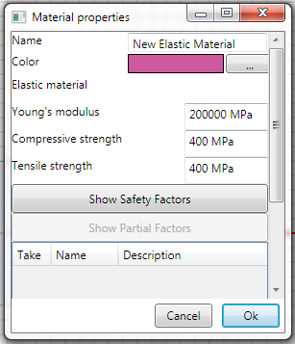

Elastic material properties

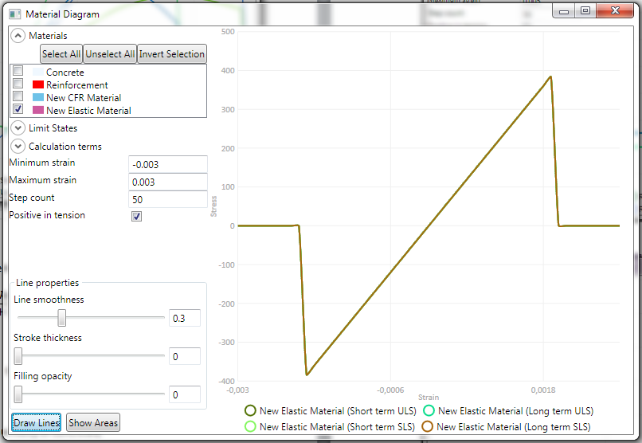

Stress-strain diagram for elastic material with restriction of stress

## Concrete

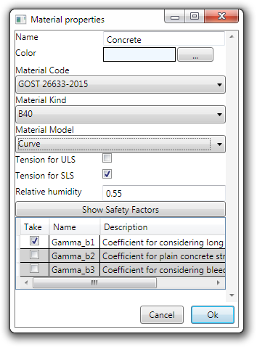

Concrete properties

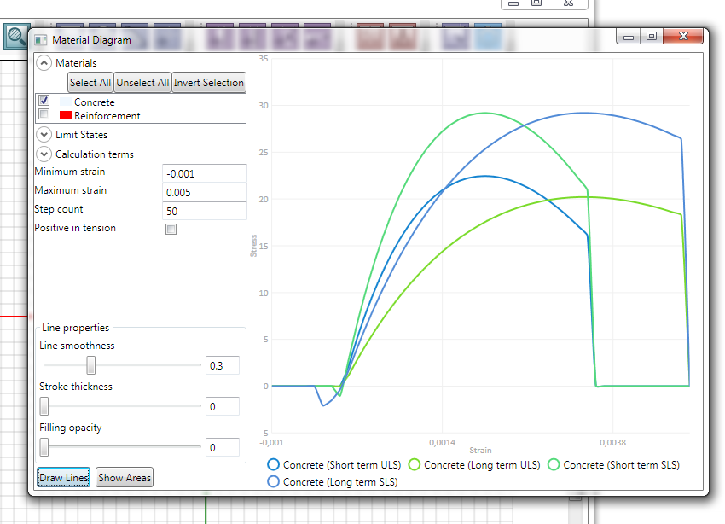

Stress-strain diagram for concrete

Nowdays, the only model, available in StructureHelper is curve model obtained from next expression:

Where

–strain corresponding peak stress for short term loading

For long term loading depends on relative humidity of concrete

## Reinforcement

There are 2 available codes for reinforcement material:

GOST 34028-2016 for hot rolled steel, and

GOST 53772-2010 for high strength cold deformed wires

There are 2 models for reinforcement steel:

Bilinear (with ideal plastic yielding),

Triplelinear

Note, both model are available for any type of reinforcement steel, please choose model type, which is more suitable for your reinforcement type depending on its mechanical properties.

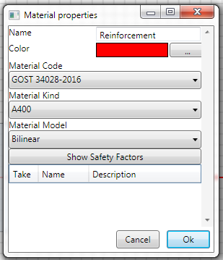

Reinforcement material properties

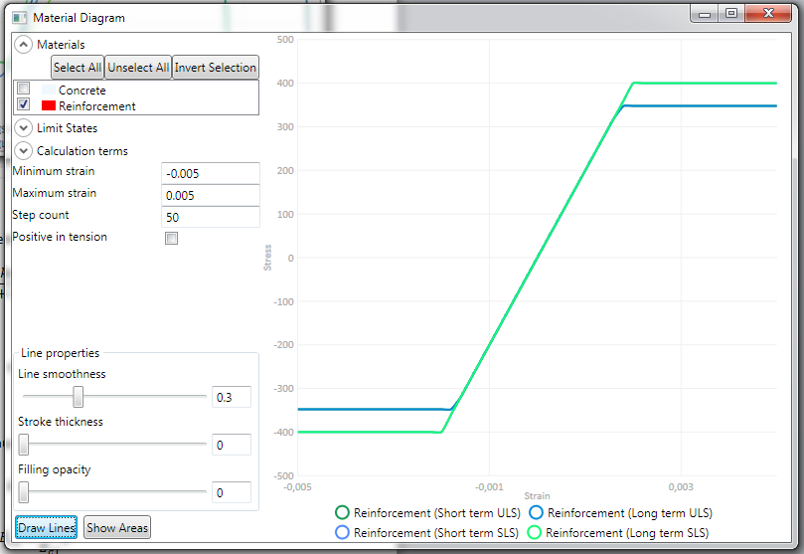

Stress-strain diagram for reinforcement

## Carbonfiber

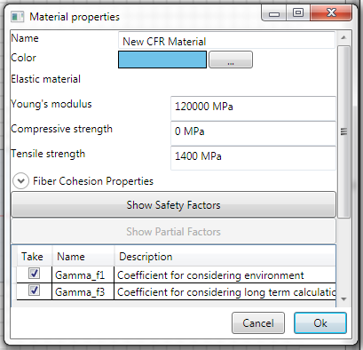

Carbon fiber material properties

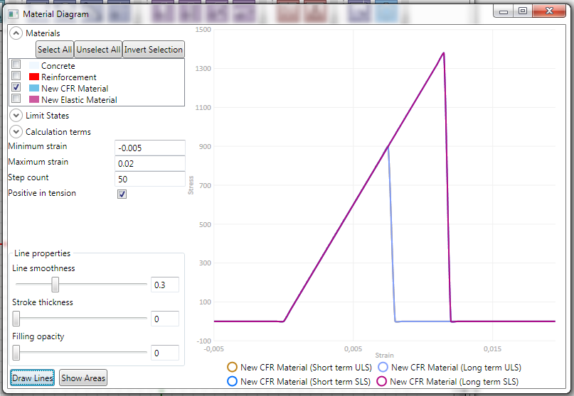

Stress-strain diagram for carbonfiber material/

Since, the carbon fiber is brittle material, assumed linear behavior of material before crushing

## Partial safety factors

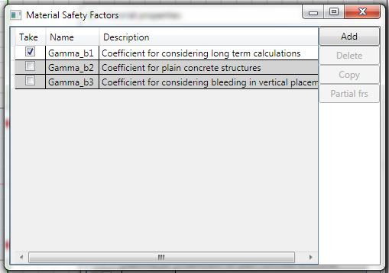

Partial safety factors

You can create ant turn on any count of partial safety factors

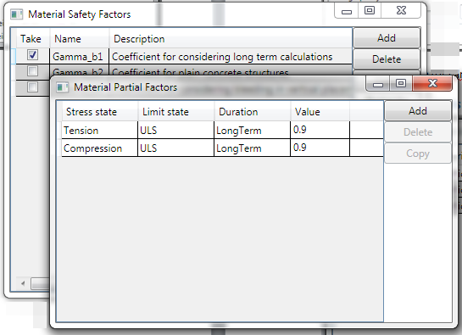

# Behavior diagrams

## Moment-curvature diagram

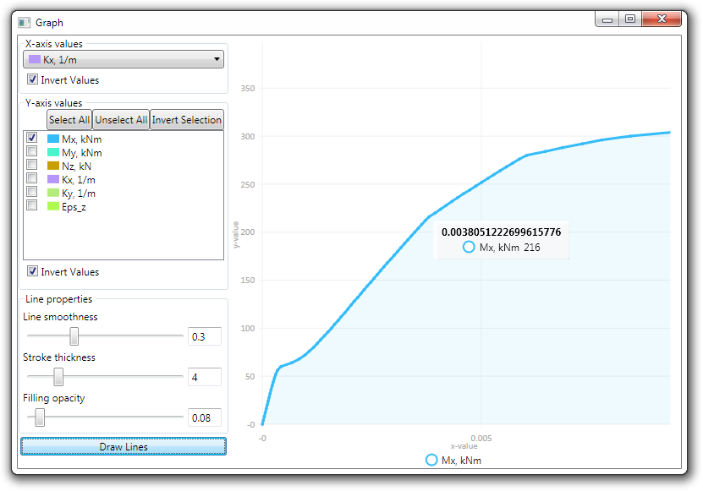

Typical moment-curvature diagram for reinforced concrete cross-section (for cross-section of crack)

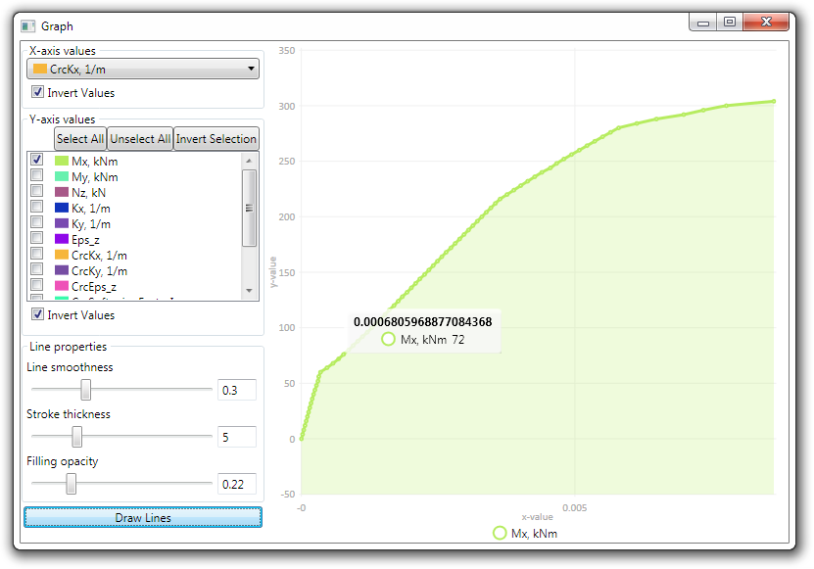

Typical moment-curvature diagram for reinforced concrete cross-section (average between cracks)

## Interaction diagram

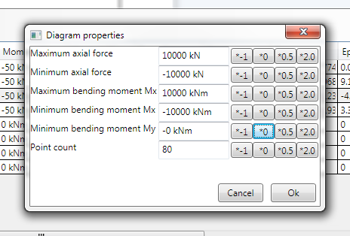

Properties of interaction diagram

Note, points of diagram are uniformly distributed for assigned range of forces, for that reason try to assign minimum and maximum forces (both axial force and bending moment, for both signs of forces) extremely closely to maximum bearing capacity, as far as possible.

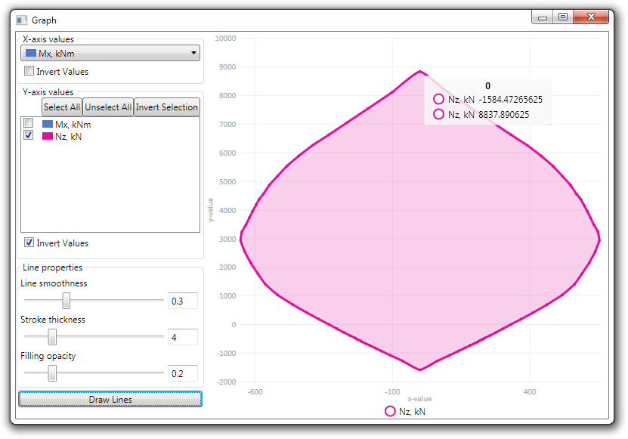

Typical interaction diagram (for N-Mx axis) for reinforced concrete cross-section

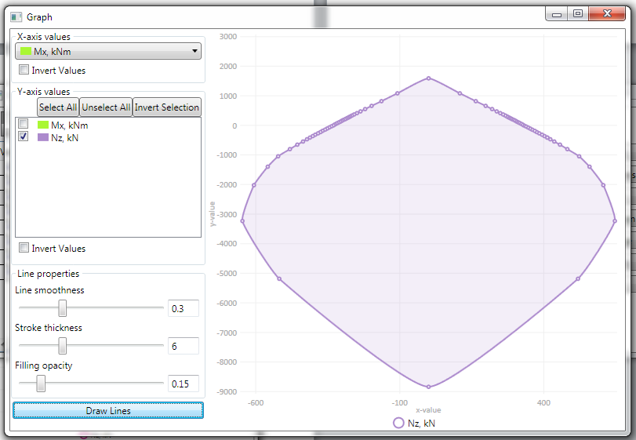

Poor assigning of range of forces of diagram (too wide range for axial force in tension and for bending moment), most of point are located in tension part of diagram.

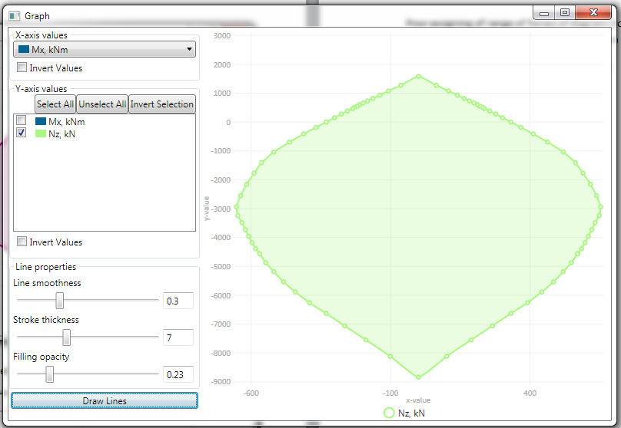

Good assigning of range of forces of diagram, almost uniform distribution of points of diagram.

# Examples

## Analysis of hollow core slab

Note, this is example of calculation for bending moment only, you have to check other parameters of slab (i.e. strength for shear force according to corresponding codes).

Given:

Let’s create a cross-section of hollow core reinforced concrete slab with next properties:

Nominal width = 1200mm, width of compressed flange = 1160mm, Height = 220mm, cross-section has 6 openings with diameter = 150mm.

Concrete grade – B40, Reinforcement - 7 bars with diameter = 16mm, grade = A800. Prestress of bottom bars = 700MPa

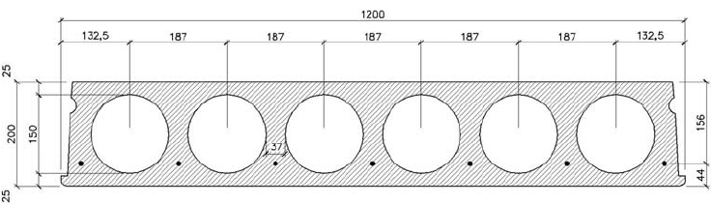

Find:

1. Limit bending moment for ultimate limit state.
2. Moment-curvature diagram for serviceability limit state.
3. Bending moment of cracking.

Solution:

1. As first step, let’s create slab with reinforcement via template

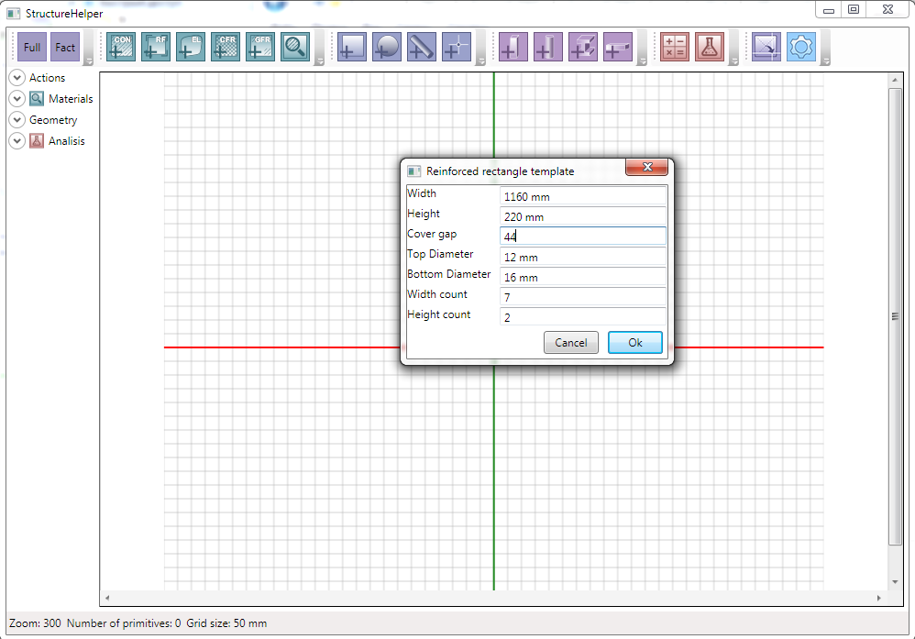

As result, we can see next cross-section of slab

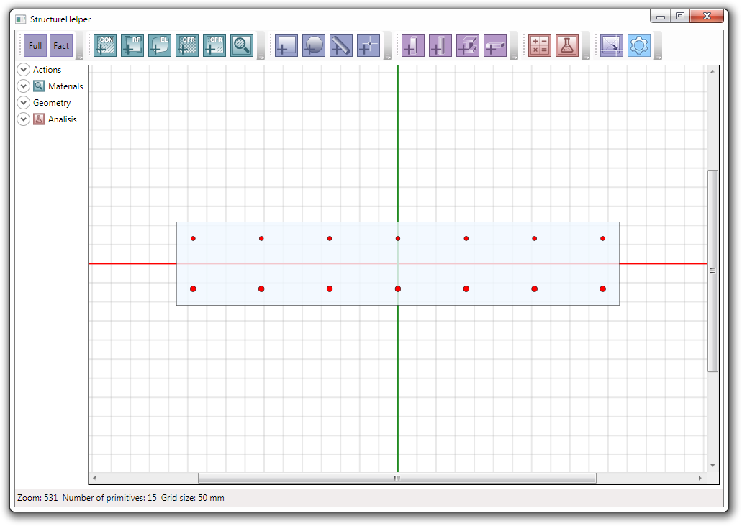

1. Delete primitives of top reinforcement

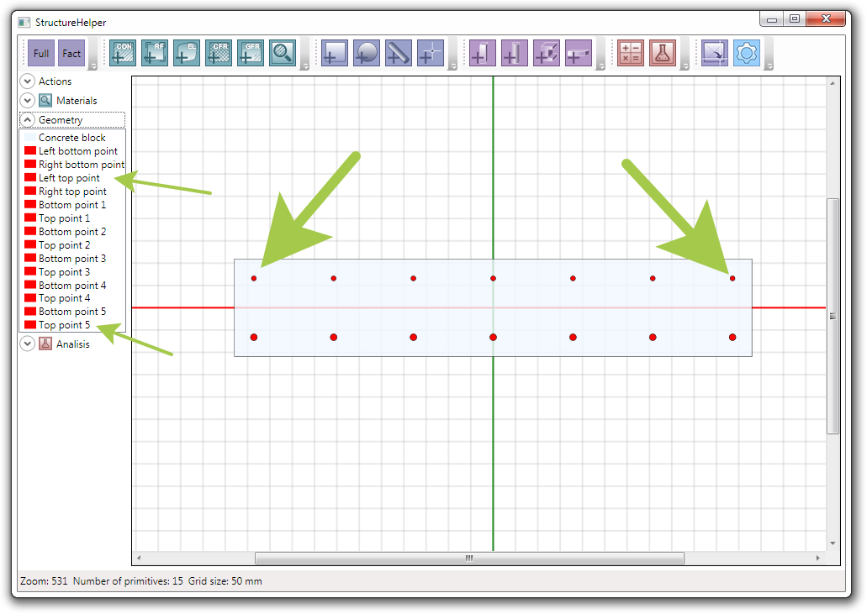

Note, actually, you can just remove top bars from calculator

1. Create primitive for openings (circle primitive) and

* change its diameter to 150mm.
* set center od circle to 93.5mm
* set checkbox “Clear underlying” to delete elementary parts of main slab
* remove checkbox “Triangulate”, since we do not need to create elementary parts of openings

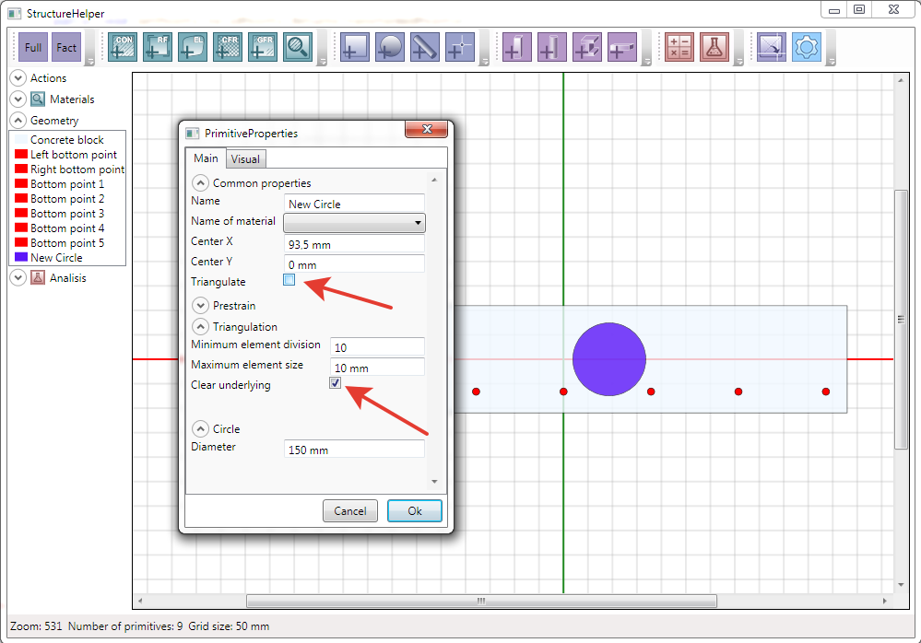

1. Copy other circles

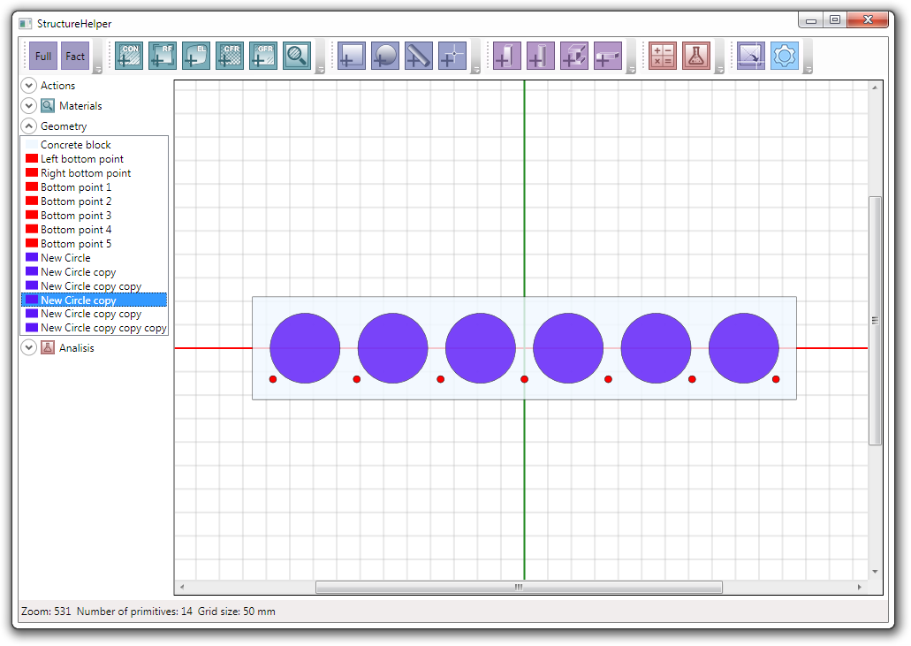

1. Change properties for reinforcement steel

Choose grade of reinforcement as A800 and assign Triplelinear model for material

1. Assign Prestress of bottom bars

Since, initial stress of bars is 700MPa and Young’s modulus is 200GPa, initial strain is 0.0035

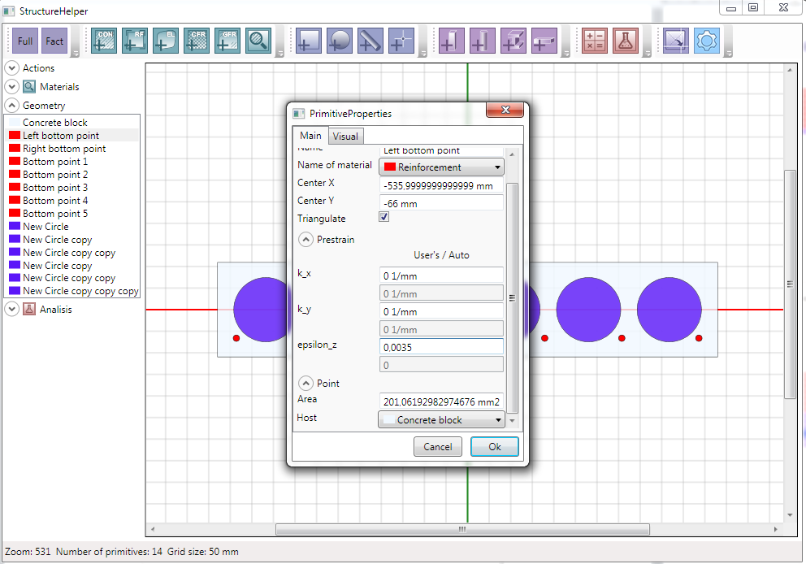

1. Delete force action and edit factored load

Set characteristic bending moment arbitrary X-axis as 200kN*m

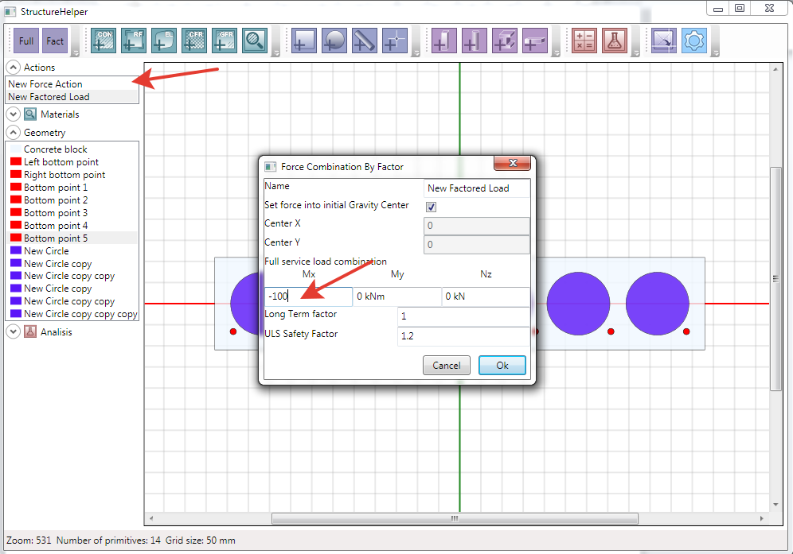

1. Edit calculator and add primitives of openings to calculator

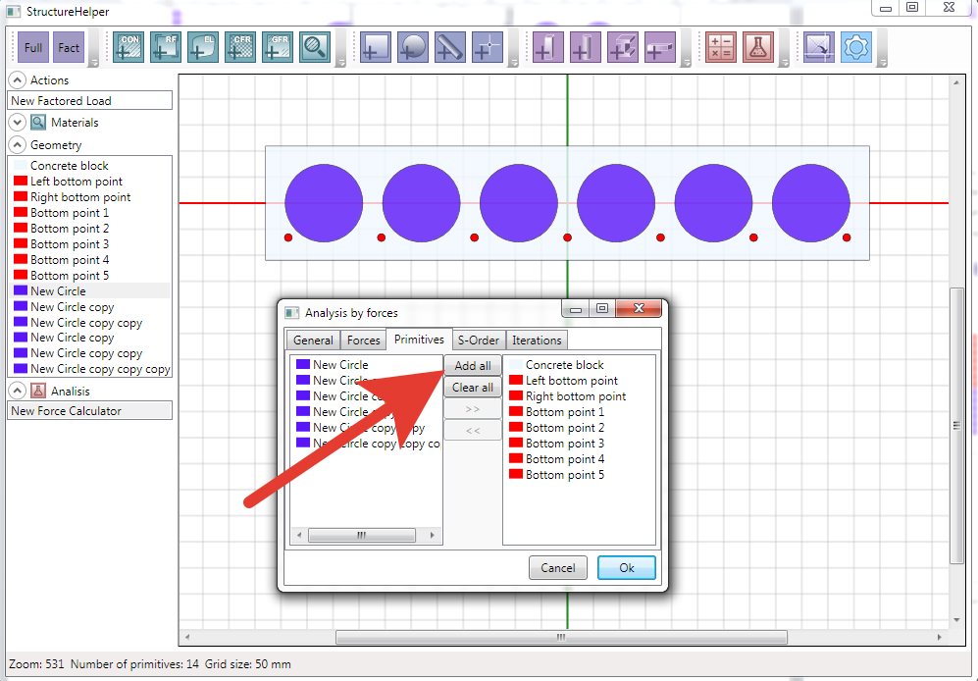

1. Run calculator and look at the result

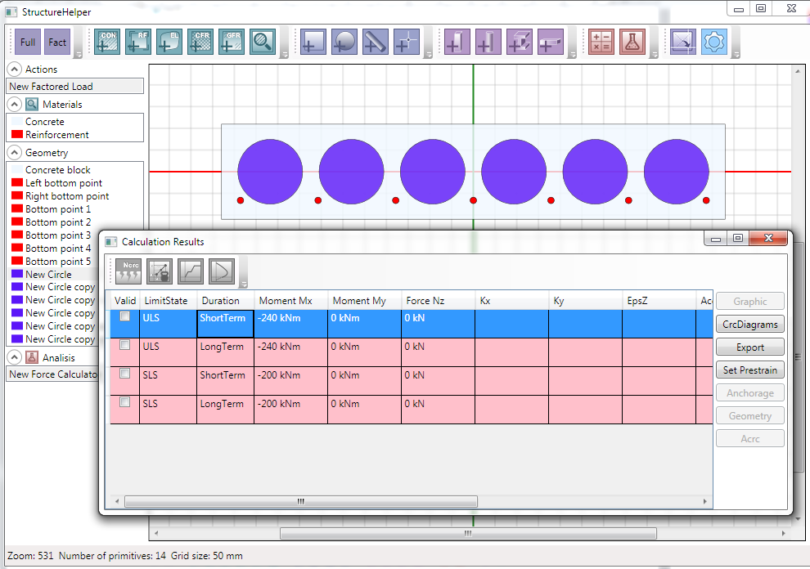

As we can see, bearing capacity of slab is not enough.

Note, rows with lack of bearing capacity were filled with pink color.

Let’s interpolate solution by force. Select first line (short term loading for ultimate limit state).

Use properties of interpolation according to default ones.

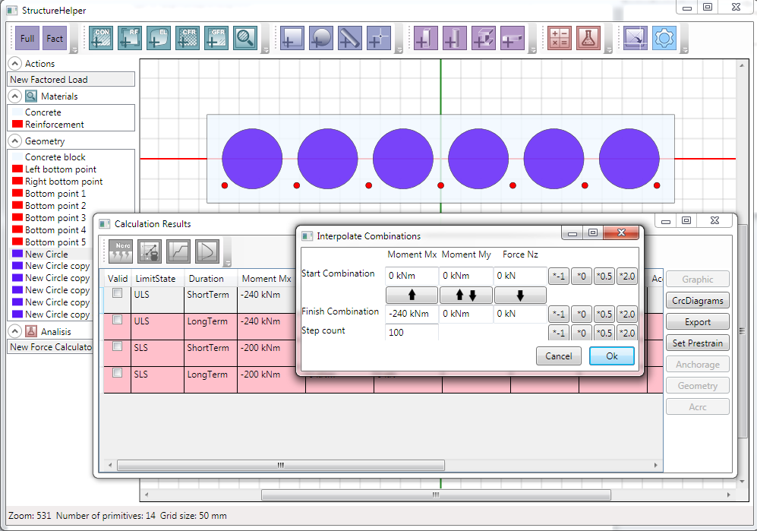

Scroll down results list to first pink row.

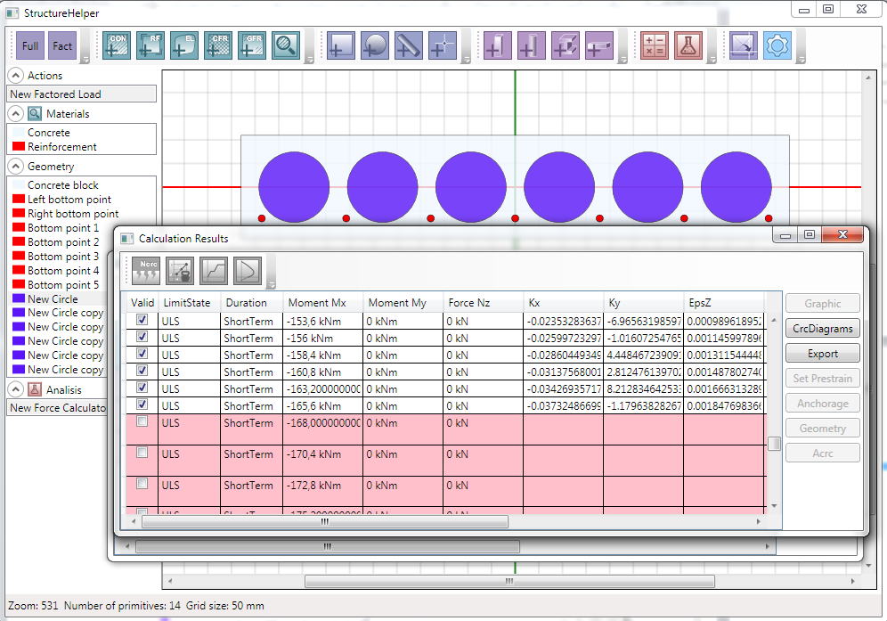

As we can see from result, maximum bending moment where bearing capacity is good is 165.6kN*m. So, it is limit bending moment for ultimate limit state.

1. Let’s see graphic result and check strain for selected row

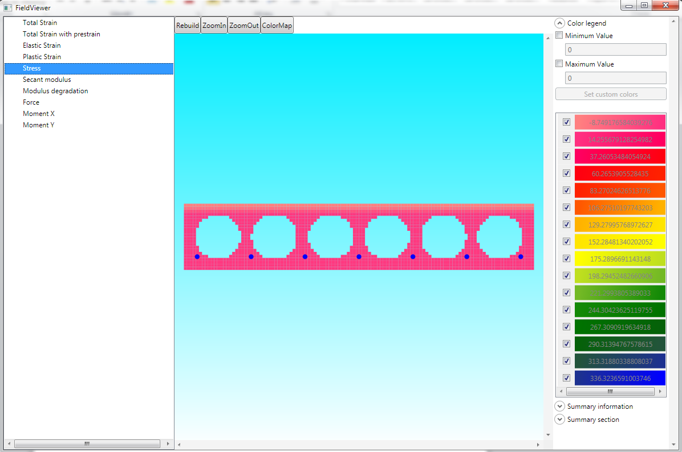

Also, you can see other graphic result – strain, for example.

Probably, you have considered that mesh of elementary parts is quite coarse. In this case you can change parameters of triangulation for primitive of concrete.

1. Select row for short term serviceability state and build moment-curvature diagram

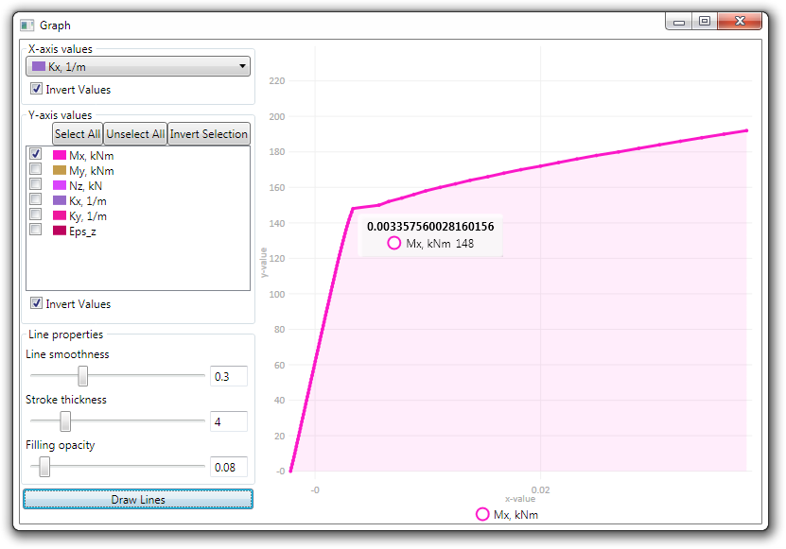

1. As we can see from the chart, moment of cracking is 148kN*m