Universitatea Tehnica a Moldovei

FCIM

Lucrarea de laborator Nr. 4

la

MIDPS

Tema: Dezvoltarea unei aplicații mobile

A realizat: st.gr.TI-151 Ivasisin Ivan

A verificat: Gojin Victor

Chisinau 2017

**Obiective:**

- Cunostinte de baza privind arhitectura unei aplicatii mobile

- Cunostinte de baza ale platformei SDK

**Sarcina:**

Elaboreaza o aplicatie sofisticata la alegere.

Mersul lucrarii:

actyvite_main.xml

*<?***xml version="1.0" encoding="utf-8"***?>*<**LinearLayout xmlns:android="http://schemas.android.com/apk/res/android"  
  
 xmlns:tools="http://schemas.android.com/tools"  
 android:id="@+id/LinearLayout1"  
 android:layout_width="match_parent"  
 android:layout_height="match_parent"  
 android:orientation="vertical"** >  
  
  
 <**Chronometer  
 android:id="@+id/chronometer"  
 android:layout_width="wrap_content"  
 android:layout_height="wrap_content"  
 android:layout_gravity="center"** />  
  
 <**Button  
  
 android:id="@+id/startBtn"  
 android:layout_width="wrap_content"  
 android:layout_height="wrap_content"  
 android:layout_gravity="center"  
 android:text="Start"** />  
 <**Button  
 android:layout_width="wrap_content"  
 android:layout_height="wrap_content"  
 android:id="@+id/stopBtn"  
 android:layout_gravity="center"  
 android:text="Stop"** />  
 <**Button  
 android:layout_width="wrap_content"  
 android:layout_height="wrap_content"  
 android:id="@+id/resetBtn"  
 android:layout_gravity="center"  
 android:text="Reset"** />  
  
  
</**LinearLayout**>

MainActyvity.java:

**package** com.example.ivasi.chronometer;  
  
**import** android.os.SystemClock;  
**import** android.support.v7.app.AppCompatActivity;  
**import** android.os.Bundle;  
**import** android.view.View;  
**import** android.widget.Button;  
**import** android.widget.Chronometer;  
**public class** MainActivity **extends** AppCompatActivity {  
  
 @Override  
 **protected void** onCreate(Bundle savedInstanceState) {  
 **super**.onCreate(savedInstanceState);  
 setContentView(R.layout.activity_main);  
  
 **final** Chronometer chronometer =(Chronometer) findViewById(R.id.chronometer);  
 **final** Button start = (Button) findViewById(R.id.startBtn);  
 **final** Button stop = (Button) findViewById(R.id.stopBtn);  
 **final** Button reset = (Button) findViewById(R.id.resetBtn);  
  
 start.setOnClickListener(**new** View.OnClickListener(){  
 @Override  
 **public void** onClick(View v){  
 chronometer.start();  
 }  
 });  
 stop.setOnClickListener(**new** View.OnClickListener(){  
 @Override  
 **public void** onClick(View v){  
 chronometer.stop();  
 }  
 });  
 reset.setOnClickListener(**new** View.OnClickListener(){  
 @Override  
 **public void** onClick(View v){  
 chronometer.setBase(SystemClock.elapsedRealtime());  
 }  
 });  
 }  
}

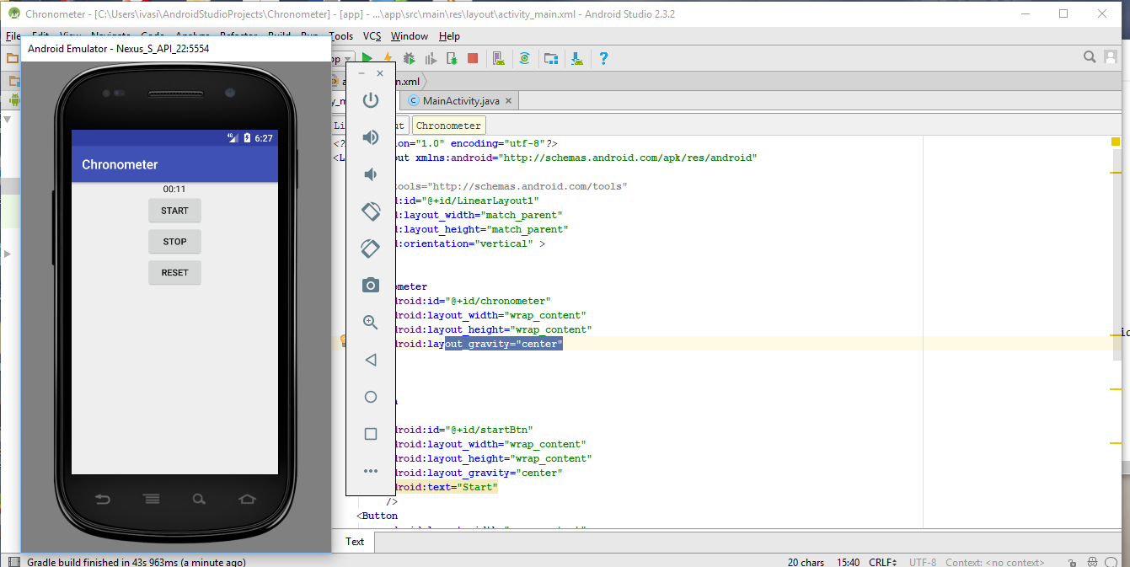

**Concluzie:**

In urma efectuarii lucrarii de laborator am facut cunostinta cu un nou IDE: Android Studio, emulator android, Genymotion si Virtual Box. Am creat o aplicatie android, testind-o pe versiunea API 16. Am studiat structura unei aplicatii android, ciclul de viata.