Universitatea Tehnica a Moldovei

FCIM

Lucrarea de laborator Nr. 5

la

MIDPS

Tema: **Lucru in echipa. Aplicatie complexa**

A realizat: st.gr.TI-151 Ivasisin Ivan

A verificat: Irina Cojanu

Chisinau 2017

**Obiectivele lucrarii :**Crearea unei aplicatii complexe in echipa. Divizarea

sarcinilor pe membrii echipei.

**Scopul lucrarii de laborator :** Lucrul in echipa.Aplicarea tehnicilor, limbajelor de programare si IDE-uri studiate inlaboratoarele precedente.

**Mersul lucrarii:**

**Butonul search:**

<form action="search.php" method="POST">

<center><table>

<tr class="search">

<td><input type="text" name="name" class="placeforsearch" placeholder="Search..."></td>

<td><input type="submit" name="submit" class="submit" value="Search"></td>

</tr>

</table></center>

</form>



**Algoritmul de cautare:**

<!DOCTYPE html>

<html>

<head>

<?php

$title= "Telefoane pentru toti";

require_once "bloks/head.php" ?>

<link rel="stylesheet" href="http://maxcdn.bootstrapcdn.com/bootstrap/3.3.7/css/bootstrap.min.css">

<!-- jQuery library -->

<script src="https://ajax.googleapis.com/ajax/libs/jquery/1.12.4/jquery.min.js"></script>

</head>

<body>

<?php

$conn = mysqli_connect("localhost", "root", "");

mysqli_select_db($conn,"magazin");

//search code

//error_reporting(0);

if($_REQUEST['submit']){

$name = $_POST['name'];

if(empty($name)){

$make = '<h4>You must type a word to search!</h4>';

}else{

$make = '<h4>No match found!</h4>';

$sele = "SELECT * FROM products WHERE p_name LIKE '%$name%'";

$result = mysqli_query($conn, $sele);

if($mak = mysqli_num_rows($result) > 0){

while($row = mysqli_fetch_assoc($result)){

?>

<p> </p>

<p> </p>

<div class="col-md-3">

<form method="post" action="shop.php?action=add&id=<?php echo $row["id"]; ?>">

<div style="border: 1px solid #eaeaec; margin: -1px 19px 3px -1px; box-shadow: 0 1px 2px rgba(0,0,0,0.05); padding:10px;" align="center">

<img src="<?php echo $row["image"]; ?>" class="img-responsive">

<h5 class="text-info"><?php echo $row["p_name"]; ?></h5>

<h5 class="text-danger">$ <?php echo $row["price"]; ?></h5>

<input type="text" name="quantity" class="form-control" value="1">

<input type="hidden" name="hidden_name" value="<?php echo $row["p_name"]; ?>">

<input type="hidden" name="hidden_price" value="<?php echo $row["price"]; ?>">

<input type="submit" name="add" style="margin-top:5px;" class="btn btn-default" value="Add to Bag">

</div>

</form>

</div>

<?php

}

}else{

echo'<h2> Search Result</h2>';

print ($make);

}

mysqli_free_result($result);

mysqli_close($conn);

}

}

?>

</body>

</html>

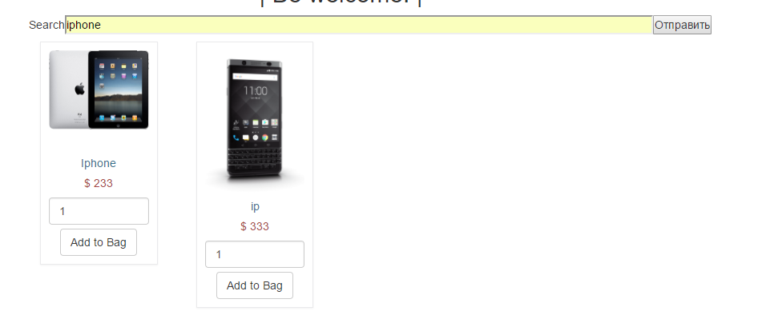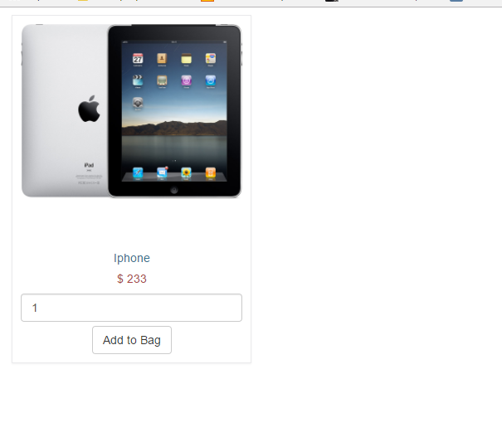

**Algoritmul de adaugare in cutie:**

<?php

session_start();

$connect = mysqli_connect("localhost", "root", "", "magazin");

if(isset($_POST["add"]))

{

if(isset($_SESSION["cart"]))

{

$item_array_id = array_column($_SESSION["cart"], "product_id");

if(!in_array($_GET["id"], $item_array_id))

{

$count = count($_SESSION["cart"]);

$item_array = array(

'product_id' => $_GET["id"],

'item_name' => $_POST["hidden_name"],

'product_price' => $_POST["hidden_price"],

'item_quantity' => $_POST["quantity"]

);

$_SESSION["cart"][$count] = $item_array;

echo '<script>window.location="principala.php"</script>';

}

else

{

echo '<script>alert("Products already added to cart")</script>';

echo '<script>window.location="principala.php"</script>';

}

}

else

{

$item_array = array(

'product_id' => $_GET["id"],

'item_name' => $_POST["hidden_name"],

'product_price' => $_POST["hidden_price"],

'item_quantity' => $_POST["quantity"]

);

$_SESSION["cart"][0] = $item_array;

}

}

if(isset($_GET["action"]))

{

if($_GET["action"] == "delete")

{

foreach($_SESSION["cart"] as $keys => $values)

{

if($values["product_id"] == $_GET["id"])

{

unset($_SESSION["cart"][$keys]);

echo '<script>alert("Product has been removed")</script>';

echo '<script>window.location="principala.php"</script>';

}

}

}

}

?>

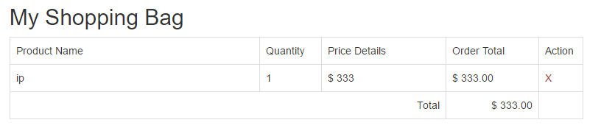

**Concluzie:**

In lucrarea data am invatat sa lucreze cu echipa, este ceva neobisnuit si dirt-o parte greu deoarece trebue sa te lamureste si in codul colegilor. Dar aceasta o fost o experienta buna sin oi neam descurcat. Din partea mea a fost realizat shopping bag si cautarea.