**Test Case ID: 1  
Test Case Step Name: Set User Name  
  
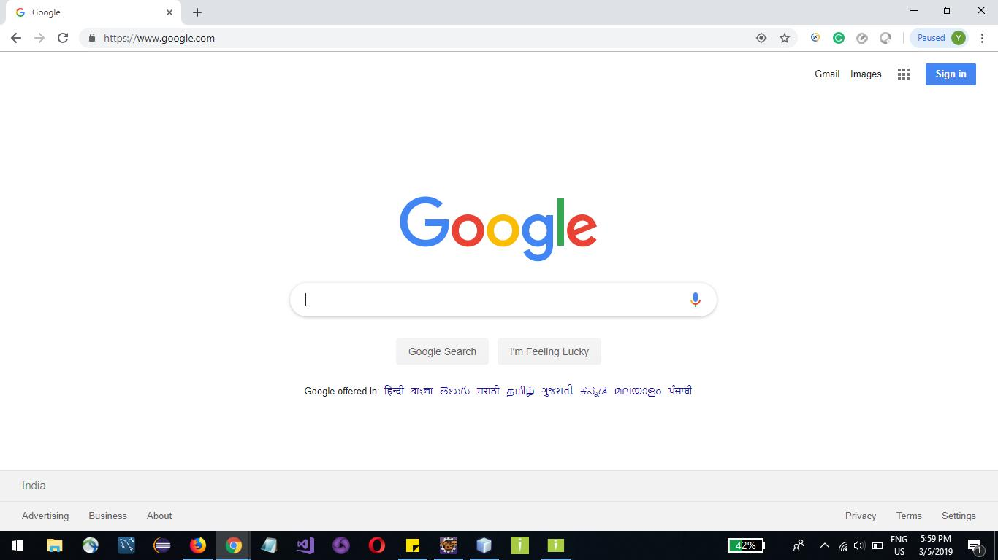**

**Test Case ID: 1  
Test Case Step Name: Set User Password  
  
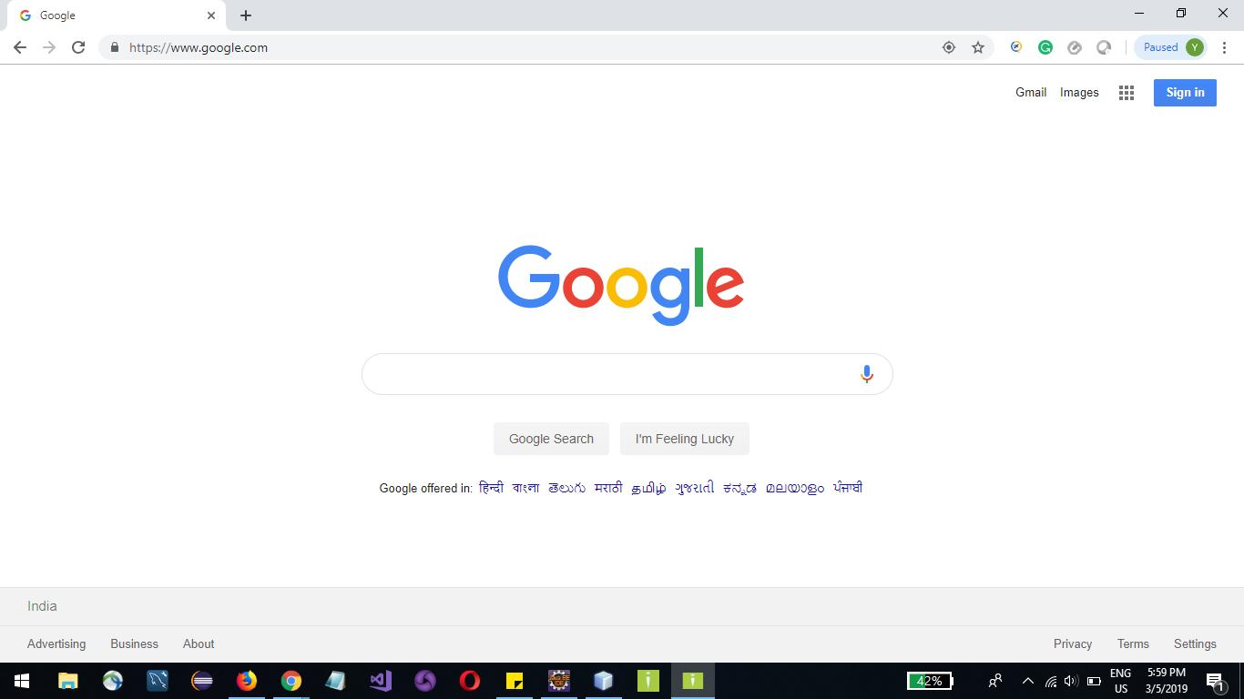**

**Test Case ID: 1  
Test Case Step Name: Verify Login Page  
  
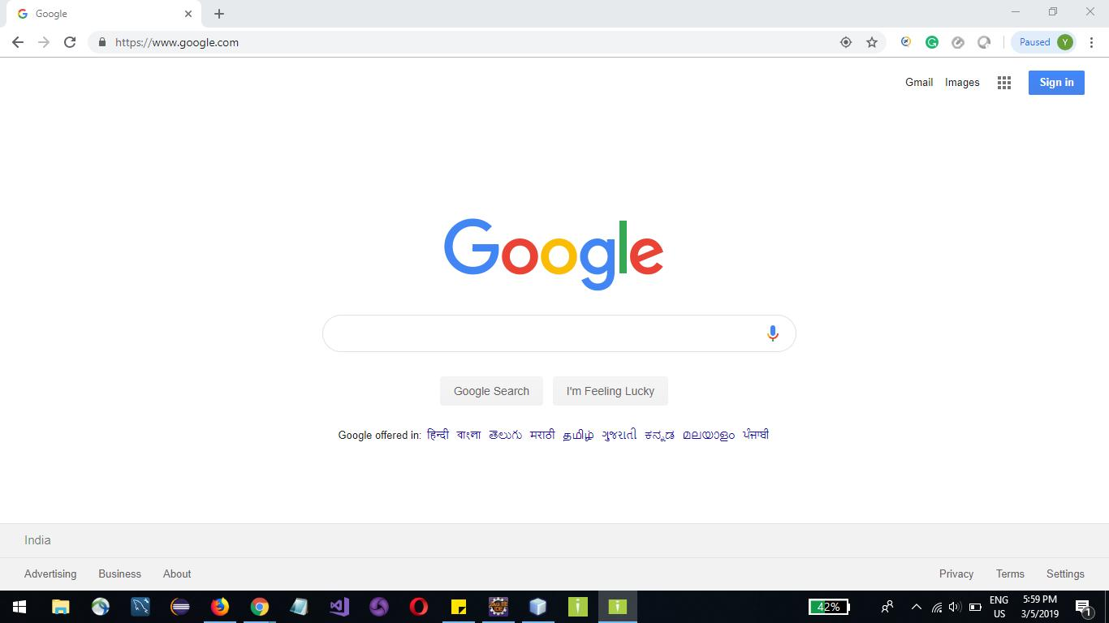**

**Test Case ID: 1  
Test Case Step Name: Ok  
  
**