HTML Tables

Problem 1. HTML Tables
- Create Web Pages like the following using tables:

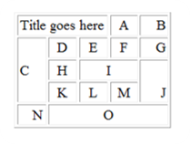

Problem 2. HTML Form
- Create a Web Page like the following using forms:


Problem 3. Calculator
- Create a Calculator-like table. You should use a HTML 5 form for the Calculator.
  - Buttons for all the numbers and operators (+, -, etc.)
  - Textbox for the result
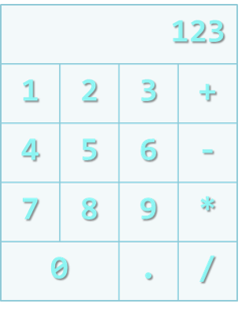
Note: Do not make the same styles as the example
Note: Do not implement functionalities

