Problem E. Overlaying a Box

A box with dimensions X × Y × Z is given, where X, Y and Z are integers, X ≥ Y ≥ Z. To overlay the box with a single layer means: to cover all faces of the box, using cubes with edge length 1, in such a way that no part of the faces can be seen. Overlaying of the box with k layers is similar kind of covering of the shape, obtained after covering the box with k – 1 layers. For instance, to overlay a box with dimensions 3 × 2 × 1 with a single layer, a total of 22 cubes are needed (see the figure). To overlay the same box with two layers, another 46 cubes will be necessary.

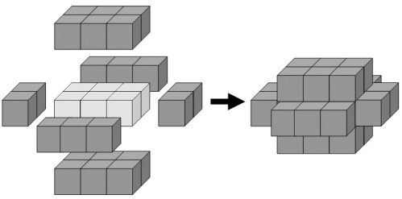

Write a program that, for given number of cubes, finds a box which can be overlaid with one or more layers using all of the cubes. If there are more than one boxes satisfying this condition, choose the one with the smallest surface area, if more than one such exists – the one with the smallest volume.

On the first line of the standard input the number of the tests will be given. For each test, on a separate line the number N of the cubes that can be used for the overlaying will be given (0 < N < 10000).

For each test, on a separate line on the standard output the program should print the dimensions of the box found in the format XxYxZ, if such box exists. If not, the program has to print –1.

EXAMPLE
Input | Output
5  68  25  44  1164  8000 | 3x2x1  -1  -1  96x1x1  6x6x4

