Introduction:

Network & Cloud (Lovro)
Design: Webapp runs on Microsoft Azure and is split into three parts: the frontend, the backend and the database. Updates are published automatically from GitHub.
- Frontend (PWA): hosted as a static website on an Azure Storage Account. Residents, landlords and maintenance workers open it in the browser or install it on their phone.
- Backend (API): runs on Azure App Service (Linux, Python). The frontend sends all requests here over HTTPS.
- Database: Azure SQL Database stores maintenance requests, complaints and household tasks. Only the backend connects to it.
- Deployment: when code is pushed to the main branch on GitHub, GitHub Actions publishes it to the backend automatically.
- Monitoring and cost: Application Insights tracks requests and errors, and a budget alert warns the team before the student credit runs low.
Security choices: All traffic uses HTTPS. The backend only accepts browser requests from the frontend's address (CORS). The database password is kept in the Azure settings, not in the code, and the database firewall only lets in Azure services and approved IP addresses.
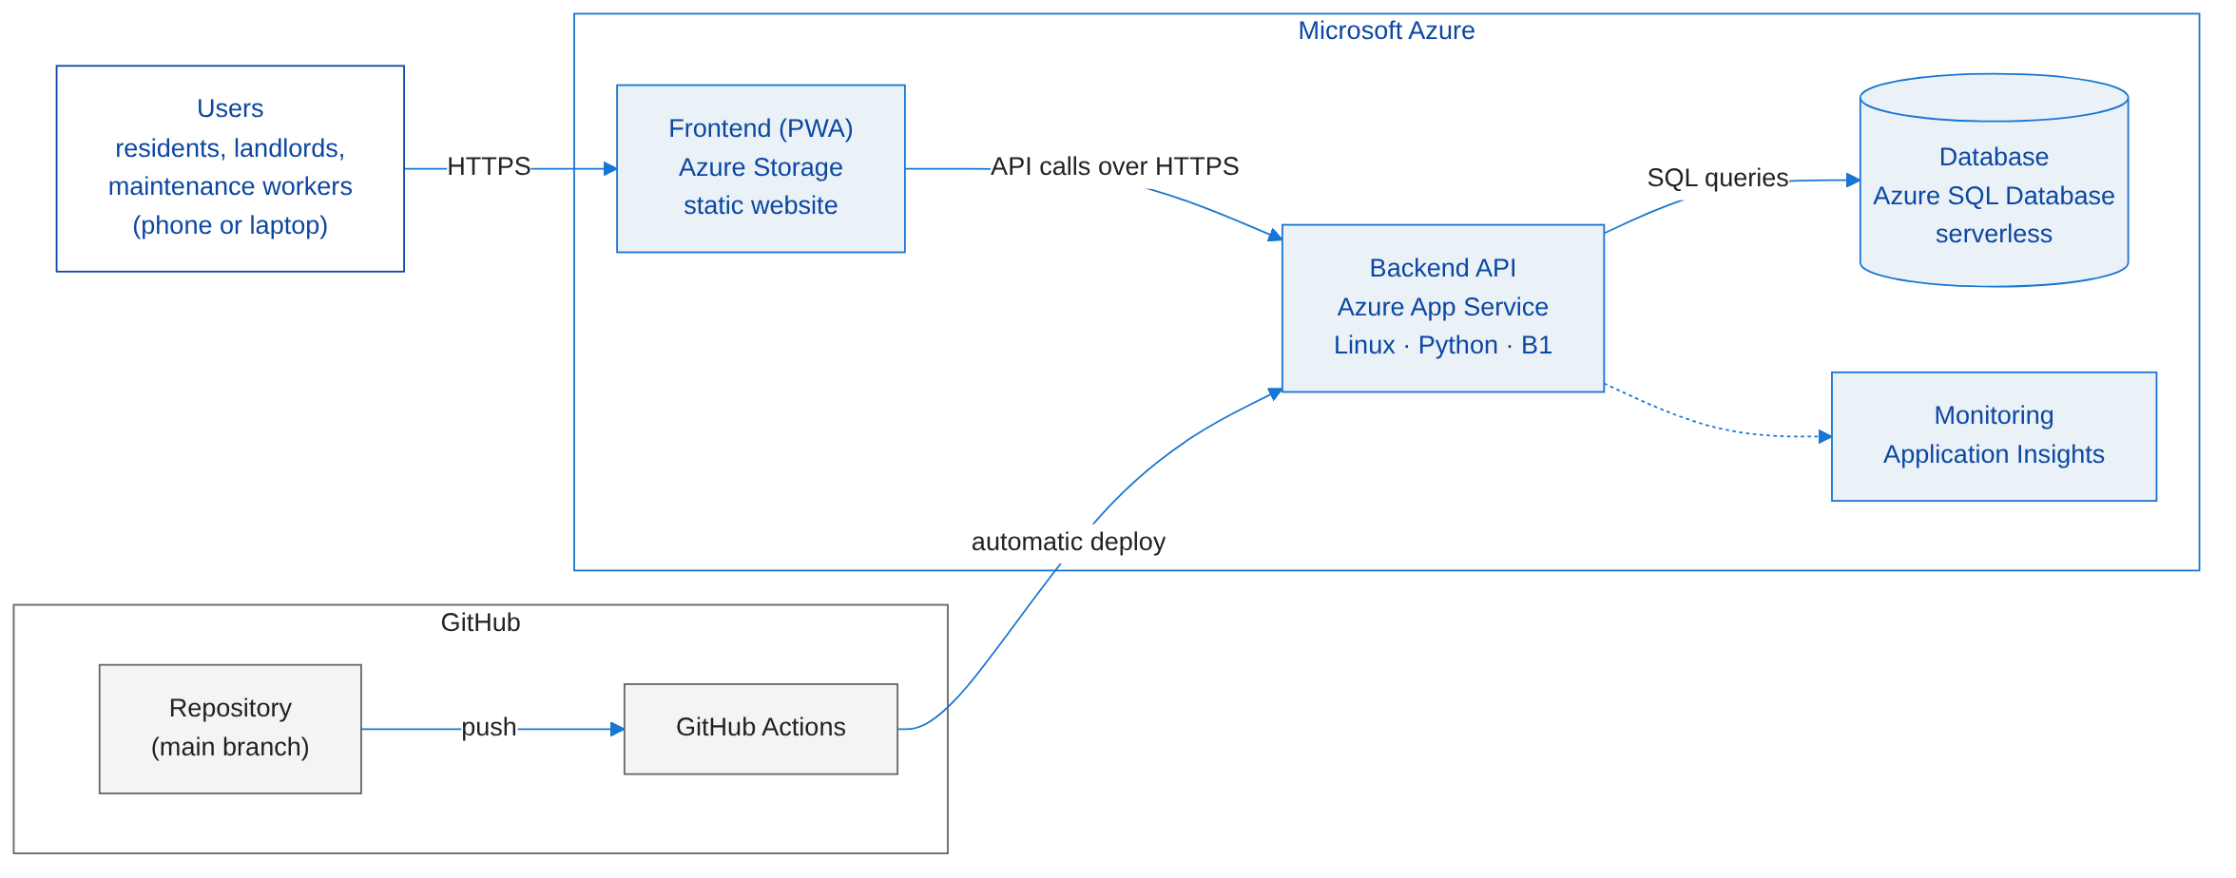

  - Web Application – Cyber Security - Eszter

Purpose
This document describes the security design I will use when developing and protecting the Student Housing web application. It covers login, session management, access control, API protection and security testing. The design focuses on the React and FastAPI application, while the database and Azure infrastructure are separate project areas.

1. Security architecture
The React frontend runs in the user’s browser. Because requests can be changed outside the interface, I will place the main security checks in the FastAPI backend. Protected endpoints will check the user’s login, role and access to the requested record before data is returned or changed. The backend will be the only application component communicating with the SQL database.
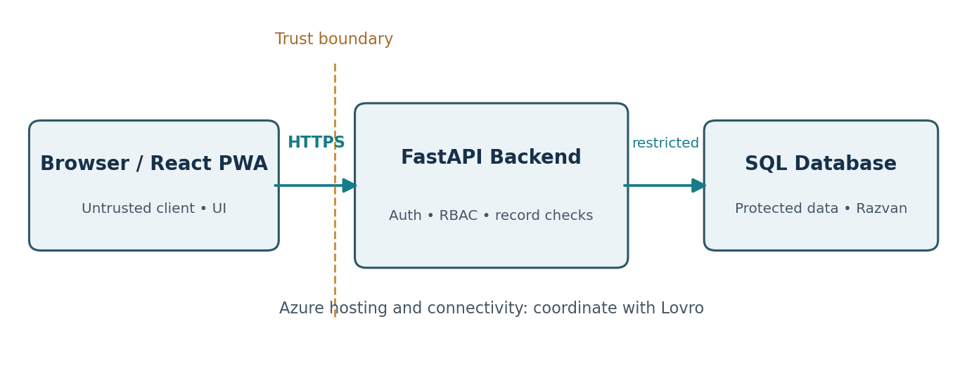
Figure 1. Web application security architecture (planned).
The trust boundary is between the browser and the backend. Even if React hides a button, FastAPI must check permissions. HTTPS will protect communication between the browser and the deployed application.

2. Authentication and session design
I will design the initial login process around email and password. FastAPI will verify passwords against Argon2 hashes and create an authenticated session. Login attempts will return a general error when credentials are incorrect, without revealing whether an account exists. Passwords and session secrets must not be written to logs.
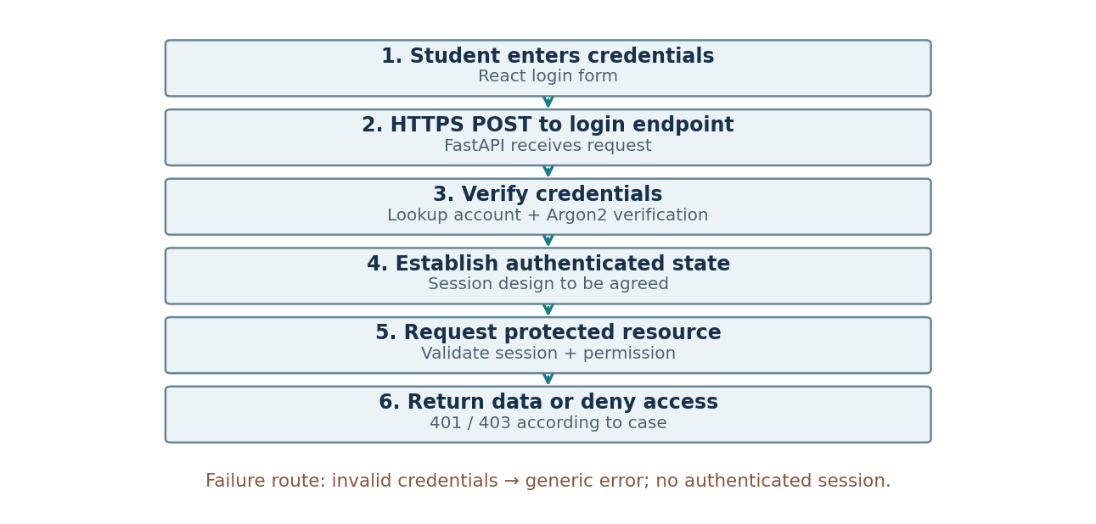
Figure 2. Planned login and access-control flow.

Session security requirements
- Set Secure and HttpOnly on authentication cookies and select SameSite according to the frontend/backend origin design.
- Set a session expiry and invalidate the session on logout. Provide a secure account-recovery process without exposing account information.
- Protect state-changing requests against CSRF when browser cookies are used.
- Rate-limit repeated login attempts and avoid revealing whether an email account exists.
Passkeys are a possible later feature. For the first version, I will focus on password login and secure sessions. If passkeys are added, I will use WebAuthn instead of storing facial images in the web application.

3. Authorization design
I will use Role-Based Access Control (RBAC) for Students, Property Managers and Maintenance Technicians. FastAPI will also check which student, property or technician a record belongs to. A student may not access another student’s private information simply because both have the same role.

Permission matrix – designed access rules
Action | Student | Property manager | Maintenance technician
View own profile | Own only | Own only | Own only
View / complete assigned chore | Own assigned chore | View tasks in managed properties | No
View private groceries | Own items only | No by default | No
Create maintenance report | Own property | Review reports for managed properties | No by default
Assign maintenance worker | No | Own properties | No
Update maintenance request | View own reports | Own properties | Assigned requests
View residents’ private data | No | Only necessary data for managed properties | No
The matrix defines the intended access rules. Manager access is limited to managed properties, and technicians can update only requests assigned to them.

Example backend authorization flow
- Receive GET /maintenance/{request_id} with authenticated user context.
- If no valid session exists, return 401 Unauthorized.
- Load the requested record only through the authorized backend data layer.
- Check the user’s role and whether the record belongs to an accessible property or assigned request.
- If access is not allowed, deny the request (usually 403, or 404 to avoid revealing record existence).
- Record security-relevant changes without logging sensitive information.

4. API and frontend security controls
Control | Proposed implementation | Reason
Input validation | Pydantic request models and business-rule checks in FastAPI | Reject invalid structure and values
SQL injection prevention | Parameterized SQL / safe ORM query parameters | Keep input separate from SQL commands
XSS prevention | Render user text as plain React content; avoid unsafe HTML injection | Protect users viewing maintenance descriptions
CORS | Allow only agreed frontend origin(s); set credentials deliberately | Limit cross-origin browser access
HTTPS | TLS from user browser to deployment endpoint | Protect network traffic
Notification privacy | Target notifications to authenticated accounts and limit exposed content | Avoid leaking private data
Important: Pydantic validation does not by itself stop SQL injection; CORS is not authentication; and HTTPS does not replace authorization. These controls solve different problems and must work together.

5. Security verification plan
I will use these test cases to check the security controls after implementation. They describe expected results, not completed tests. I will test in the project’s authorized development environment with test accounts and dummy data.
ID | Scenario | Expected result
SEC-01 | Protected API call without login | Access denied (401)
SEC-02 | Student requests another student’s private grocery record | Access denied without data disclosure
SEC-03 | Student calls manager-only maintenance assignment endpoint | Access denied (403)
SEC-04 | Technician edits a job not assigned to them | Access denied
SEC-05 | Send invalid maintenance report body | Validation error; no unsafe data stored
SEC-06 | Inspect login cookie configuration in browser | Secure, HttpOnly and appropriate SameSite
SEC-07 | Log out and reuse prior authenticated state | Session is no longer accepted
SEC-08 | Test displayed user-provided description | No script execution from untrusted text
Evidence for Validate: test ID, request and response (with secrets removed), expected and actual result, pass/fail, and a screenshot or Burp Suite note where useful.

  - Web Application – Artificial Intelligence - Manuel

AI System Overview
The AI component of Roomify aims to provide students with an alternative way to verify their identity using facial recognition. Instead of manually taking a photograph, students will be able to activate their smartphone's camera, allowing the system to automatically capture and analyse facial images.
The system will use DeepFace, a Python library with pre-trained Deep Learning models, to compare the captured face with previously registered facial data. OpenCV will assist with face detection, while FastAPI will handle communication between the AI component and the React web application.
The main objective is to create a convenient and user-friendly facial verification experience. The initial implementation will focus on accurate face detection and verification, with additional security measures required before the system can be considered suitable for real authentication.

System Architecture
The facial recognition system will follow a client-server architecture, connecting the React web app with the Python FastAPI backend.
When a student selects the facial verification option, React will activate the smartphone's front camera and automatically capture facial images. These images will be sent securely to the FastAPI backend, where the AI component will process them.
OpenCV will assist with face detection, while DeepFace, using VGG-Face model, will compare the captured facial features with the student's previously registered facial data.
The backend will then return the verification result to React, allowing the application to display whether the facial comparison was successful.
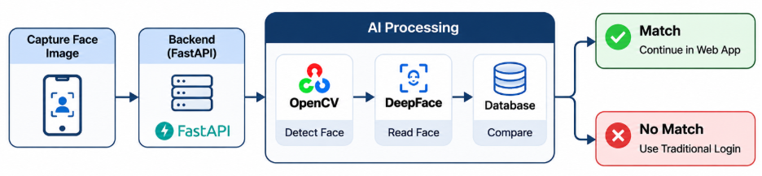

Facial Recognition Workflow
The facial recognition process will consist of two main workflows: Face Registration and Face Verification.
Face Registration: Before using facial recognition, students must register their facial data, which will be associated with their account. The system must ensure that a valid face is detected before completing the registration.
Face Verification: When students attempt to verify their identity, the system will compare their current facial features with the registered data. If the similarity meets the required threshold, the verification will be considered successful. Otherwise, students will be given the option to retry or use a traditional login method.

Face Registration Workflow
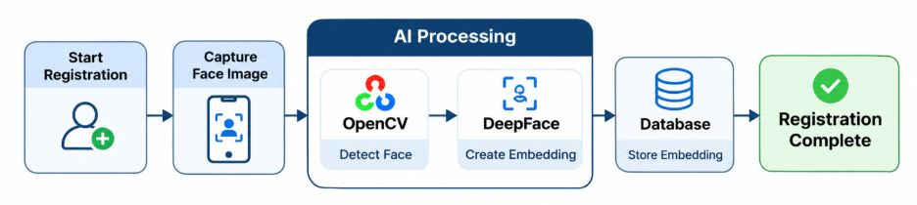

AI Model & Data Design
The system will use the pre-trained VGG-Face model through the DeepFace library to extract numerical representations of facial features, known as face embeddings. Each embedding consists of 4096 numerical values representing the characteristics of a face.
During Face Registration, the extracted embedding will be stored in the database and linked to the student's account, without requiring the original photograph to be permanently stored.
During Face Verification, a new embedding will be generated and compared with the previously registered one. The system will calculate the distance between both embeddings and use a predefined threshold to determine whether the faces match.
Since facial embeddings contain sensitive biometric information, they must be securely stored and protected against unauthorized access.

