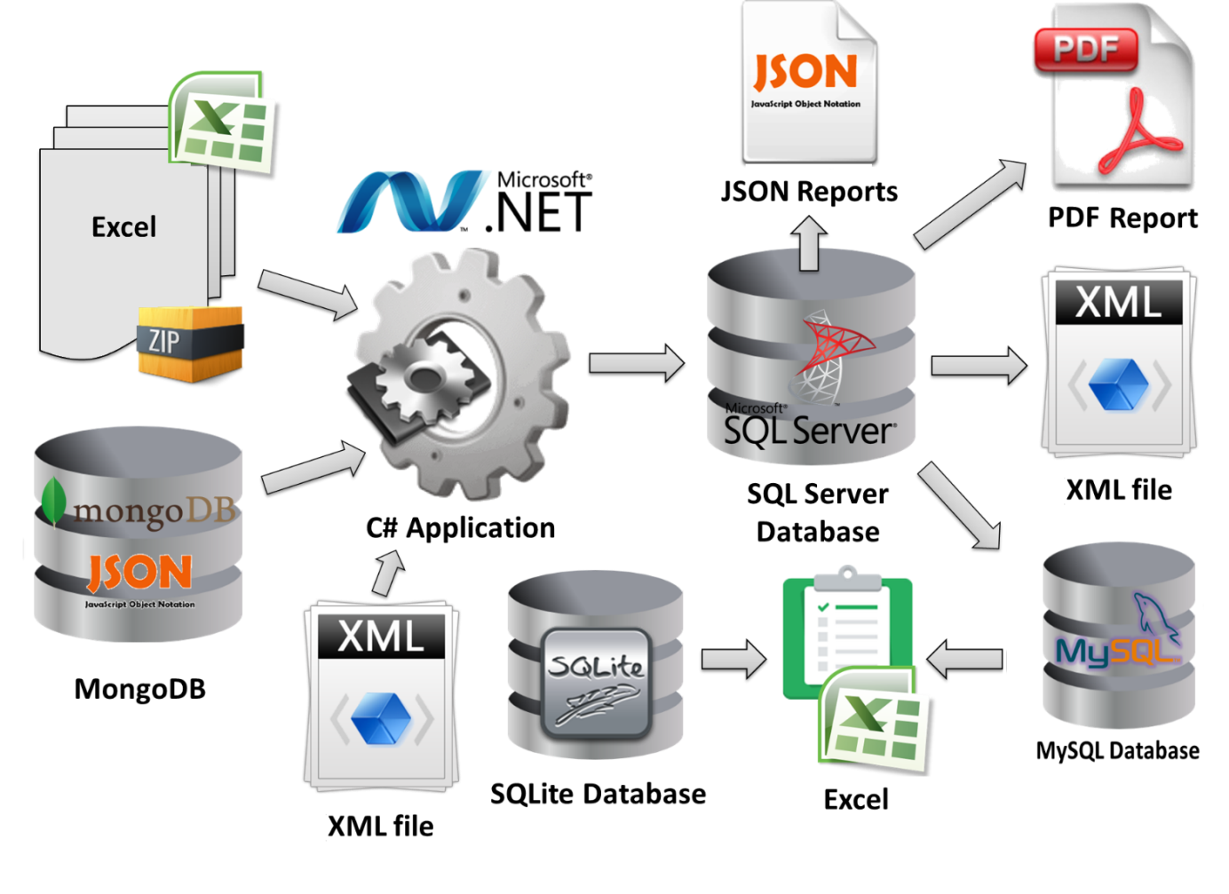

**All primary**

**data**

**Visits**

**Food**

**consumption**

**per ship per day**

**Fuel**

**consumption**

**Total distance**

**Food gathered**

**By Visits**

**Fuel**

**consumption**

**Reachable**

**Planets**

**Distance**

**by visits**

**Bunnies**

**Meals**