## Problem 3 – SoftUni Registration

Create a web page (**HTML5** + **CSS3** + **images**) that looks and behaves like the screenshots below:

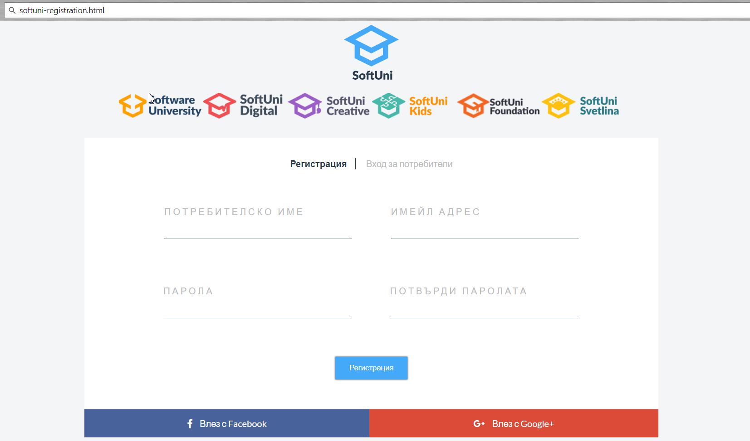

You are given the above screenshots + all required images + text.

### Output

The output should be valid **HTML5** + **CSS3** + **images** that implement the above web page.

### Constraints

* Use google font **Lato** - [https://fonts.google.com/specimen/**Lato**](https://fonts.google.com/specimen/Lato)
* Use font awesome for icons
* Use **semantic HTML**
* The site should open correctly in the latest version of Chrome
* Pixel-perfect implementation is not required
* Implement hover effects