**Team “Grossularite”**

**Member’s list**

* **Moshekov91** - Ивайло Мошеков
* **tisho** – Тихомир Ангелов
* **Stefan_petrov** – Стефан Петров
* **Аnna.Ianakieva** – Aнна Янакиева
* **Pepinho24** – Петър Милчев

**Requirements**

Define and implement:

* At least **3 interfaces**
* At least **10 classes**
* At least **1 abstraction class**
* At least **1 exception class**
* At least **1 structure**
* At least **1 enumeration**
* At least **1 event**
* At least **1 design pattern**
* Use **Subversion (SVN)** to keep your source code and for team collaboration

Optionally:

* Use **static members, constants, generic types, indexers, operators**
* **Lambda expression** and **LINQ**
* Implementation of **IEnumerable<T>**, **ICloneable**, **ToString()** override
* **Namespaces**

**Project purpose**

The ESchoolDiary application helps schools to run their teaching better. It consists a database with all the students, teachers and the headmaster of a given school.

As a **headmaster** you can:

* Add new students and teachers to the system
* Delete existing students or teachers from the system
* Search the database for any existing student or teacher

As a **teacher** you can:

* Add notes to any given student
* Add marks to any given student
* Search the database for student’s information

As a **student** you can:

* View a page of your personal data plus your notes and marks.
* Change the logging data of your account to keep it private, although your parent will always know your login information.

**Realization**

**SVN repository**

<https://code.google.com/p/eschooldiary/>

**Demo**

**Student’s window**

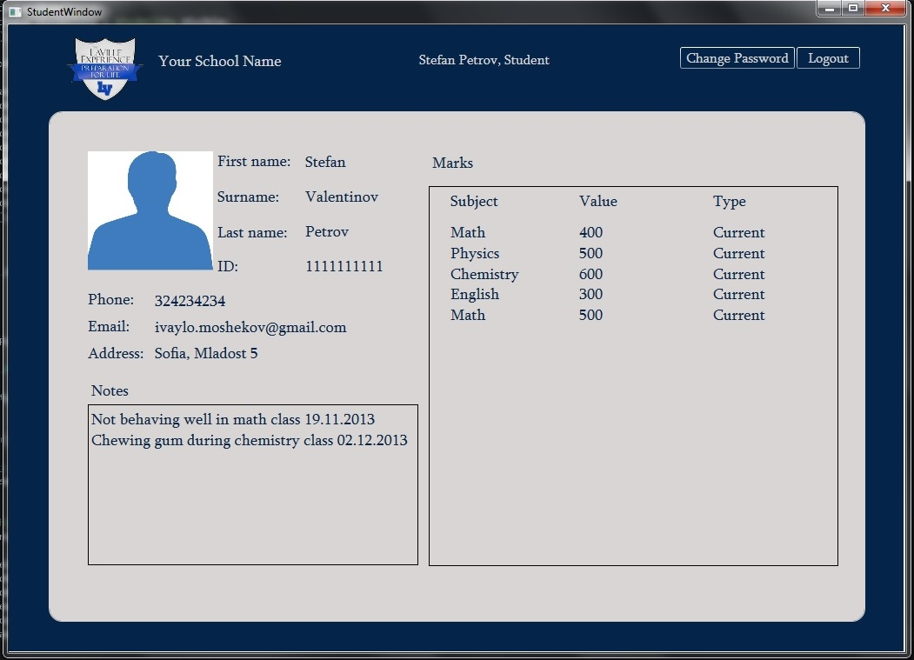

**Add new student window**

