DENVER LAUNCH READINESS
A milestone-gated supplier decision | GreenThreads Operations | Analysis date: August 12, 2026 | Opening: October 12, 2026
Lucas Diverdi | AI.205: AI Integration in Business I | Prof. Jeff Eyet | Homework #3
DECISION REQUEST: Approve exception control for Active Shorts and Bamboo Joggers now; release expedite or backup-source spend only after a verified milestone slip or failed two-week buffer test.
01 SIGNAL
Both Vietnam suppliers were late on every completed order. Across 80 received purchase orders, Song Hong and Mekong were late on 100% of shipments, averaging 12.1 and 6.9 days, respectively, while Andes and Delta averaged 0.5 and 0.8 days, respectively. Frequency and severity are both reported because they answer different questions: Mekong matches Song Hong's late rate on a larger base and has 9 of 9 in-transit orders already past promise. At the same time, Song Hong is the more severe delay. No shipment in the file has ever arrived early, so an on-time rate alone would flatter every supplier.
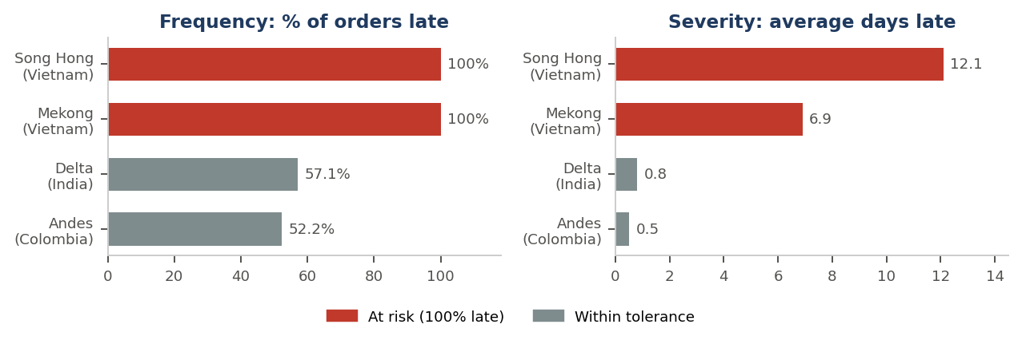
02 EXPOSURE
Half of Denver's launch retail value is tied to those two suppliers.
Launch product | Supplier | Units | Retail value | Avg late | Control implication
EcoFleece Hoodie | Andes Knitworks | 850 | $83,300 | 0.5 d | Monitor deadline; verify carton quantity.
Classic Tee | Delta Organics | 1,600 | $60,800 | 0.8 d | Monitor deadline; verify carton quantity.
Active Shorts | Mekong Textile Co. | 1,200 | $69,600 | 6.9 d | Exception control: milestones, buffer test, contingency quote.
Bamboo Joggers | Song Hong Apparel | 950 | $74,100 | 12.1 d | Exception control: milestones, buffer test, contingency quote.
EXPOSED | 2 Vietnam suppliers | 2,150 | $143,700 | 49.9% | of $287,800 total launch retail value
Planning inference, not a forecast: applying Song Hong's 12.1-day mean to SH-2291's October 3 promise implies roughly an October 15 receipt, three days after opening. Operations must confirm the required in-store date and obtain dated milestones before spending or changing the order.
03 DECISION
Choice | Operating move | Trade-off/limitation | Position
A. Observe | Rely on promised dates and routine monitoring. | No control at all for two suppliers with 100% late histories. | Reject
B. Control | Require ex-factory, container-load, booking, and weekly milestones on both Vietnam launch POs; test the SOP two-week buffer. | Earlier visibility at no freight cost, but monitoring alone creates no backup if a milestone slips. | Partial
C. Gate | Adopt B, secure partial-expedite and backup-source quotes now, release spend only on a verified trigger, and set a standing rule that any supplier averaging over 3 days late gets an automatic two-week buffer. | Preserves action time and prevents recurrence; requires cross-functional coordination, and the final cost remains quote-based. | APPROVE
Recommendation: Approve Choice C. It targets the two suppliers with verified 100% late rates, avoids paying to rush units that would sell weeks after opening, and turns a one-time save into a standing rule tied to the Functional Brief goal of an on-time Denver opening.
Tools, Method & Verification. Shipment and catalog files analyzed in ChatGPT Work (reasoning tier) and Claude (Opus / Sonnet 4.6), independently recomputed in Python/pandas, and reproduced as live formulas in the linked workbook, so no figure rests on a number a model typed. Cleaning found 0 duplicate POs, 0 required-field gaps, 0 date/status conflicts, 0 line-cost errors, 0 catalog-mapping errors, and 0 Days_Late mismatches across 80 received rows; 16 in-transit blanks were preserved as valid unknowns and measured against the analysis date rather than zeroed; 3 launch buys were flagged as partial cartons for confirmation rather than silently changed. Supplier-name normalization is retained in the pipeline after an earlier export split one supplier across two spellings. Spot checks: PO-4400 = 400 x $26 = $10,400 and 8 days late; PO-4401 = 0 days late; PO-4402 blanks valid in transit. Decision rights: Operations owns escalation; Procurement owns spend and sourcing; Legal owns contract terms; AI calculates and flags, but a human reviews every trigger and makes the final call—supporting analysis: linked Google Sheets workbook.

