Neural Network Compression
Research Report: Experiments, Failures, and Discoveries
From Low-Rank Matrix Factorisation to 3D Cube Bottlenecks
51 Models Tested Across Two Datasets
December 2025

Executive Summary
This report documents my exploration of neural network compression. The goal was simple: make neural networks smaller and faster without losing accuracy. Through 51 experiments on two datasets (MNIST and CIFAR-10), I discovered several important findings.
The key discoveries:
- Simpler architectures beat complex ones — standard deep learning tricks actually made things worse
- There's a "performance cliff" — too many compression stages cause dramatic failure
- 3D cube bottlenecks beat flat compression — preserving spatial structure helps
- Optimal compression depends on data complexity — simple data needs less stages

Best Results Achieved
Dataset | Best Method | Accuracy | Parameters
MNIST | 3D Cube 6×6×6 | 99.25% | 108,432
CIFAR-10 | 3D Cube 7×7×7 | 90.36% | 1,254,161

Part 1: What is Neural Network Compression?

1.1 The Problem: Neural Networks Are Big
Neural networks have many parameters (weights). A simple network for image classification might have 370,000+ parameters. This creates problems:
- Slower inference — more calculations needed
- More memory needed — can't fit on phones or small devices
- Higher compute costs — expensive cloud bills
- More energy use — bad for environment and battery life

1.2 The Solution: Low-Rank Factorization
Instead of using a full weight matrix W, we split it into two smaller matrices: W = U × V. This is called "low-rank" because we force the information through a smaller intermediate dimension (the "rank").
Standard Layer:
Input [784] → W [784×256] → Output [256]
Low-Rank Layer:
Input [784] → U [784×64] → [64] → V [64×256] → Output [256]
The [64] in the middle is the "bottleneck". By forcing all information through this smaller dimension, we achieve compression. The network must learn what's most important to preserve.

1.3 Parameter Savings Explained
Standard layer: 784 × 256 = 200,704 parameters
Low-rank layer: (784 × 64) + (64 × 256) = 50,176 + 16,384 = 66,560 parameters
That's a 67% reduction in parameters for one layer!

1.4 What I Wanted To Find Out
The maths of low-rank factorization is well known. What I wanted to test was:
- How many compression stages work best?
- Do standard deep learning tricks help or hurt?
- How does this scale with dataset complexity?
- Can we preserve spatial structure instead of flattening?

Part 2: The Datasets

2.1 MNIST — Simple Dataset
MNIST is a dataset of 70,000 handwritten digit images (0-9). Each image is 28×28 pixels = 784 features when flattened. It's a standard benchmark for testing neural network approaches. Human accuracy is about 98%, and good neural networks achieve 97-99%.

2.2 CIFAR-10 — Complex Dataset
CIFAR-10 contains 60,000 colour images of 10 object categories (airplanes, cars, birds, cats, deer, dogs, frogs, horses, ships, trucks). Each image is 32×32×3 = 3,072 features — nearly 4× larger than MNIST. The patterns are much more complex (real objects vs simple digits).
Dataset | Contents | Size | Complexity
MNIST | 70,000 handwritten digits (0-9) | 784 pixels | Simple
CIFAR-10 | 60,000 colour photos (10 categories) | 3,072 pixels | Complex

Part 3: MNIST Experiments

3.1 Low-Rank Matrix Compression (SUCCESS)
First, I tested basic low-rank compression against a standard baseline.
Model | Accuracy | Parameters | Reduction
Baseline | 97.48% | 370,754 | —
Orthogonal | 96.89% | 370,754 | 0%
Low-Rank | 96.36% | 75,050 | 80%
Combined | 92.92% | 37,130 | 90%
Result: Low-Rank achieves 80% parameter reduction (370K → 75K) with only 1.12% accuracy loss. This proves compression works.

3.2 Testing Different Rank Values
The "rank" is the size of the bottleneck. I tested different values to find the best trade-off between size and accuracy.
Rank | Accuracy | Parameters | Time (s) | Compression
32 | 93.03% | 37,130 | 130 | 90%
48 | 93.25% | 50,730 | 122 | 86%
64 | 93.62% | 64,330 | 120 | 83%
96 | 93.63% | 91,530 | 126 | 75%
128 | 94.29% | 118,730 | 122 | 68%
Result: Higher rank = better accuracy but more parameters. Rank 64-128 gives the best trade-off.

3.3 Phase 2: Advanced Techniques (FAILED)
I tried to improve accuracy by adding standard deep learning enhancements that typically help neural networks learn better. Every single enhancement made performance worse — some catastrophically.
Enhancement | Accuracy | Parameters | Status
Phase1 Baseline | 97.53% | 135,690 | ✅ Success
Learnable Targets | 9.8% | 135,690 | ❌ CATASTROPHIC
Attention | 9.8% | 1,366,570 | ❌ CATASTROPHIC
Residual | 79.43% | 185,930 | ⚠️ Degraded
All Combined | 82.83% | 801,890 | ⚠️ Degraded
Adaptive Rank | 80.23% | 866,690 | ⚠️ Degraded

What is 9.8% accuracy?
MNIST has 10 digit classes (0-9). If you randomly guess, you'd get 10% accuracy. 9.8% means the network learned nothing at all — it's essentially random guessing. The attention and learnable target enhancements completely destroyed the network's ability to learn.

Why Did This Happen?
Learnable Targets: Replaced fixed one-hot targets with learned embeddings. In stage-by-stage training, targets need to be stable anchor points — making them learnable removes the clear supervision signal.
Attention: Added 10× more parameters but assumes sequential/spatial relationships that don't exist in flattened pixel data. It modeled noise instead of useful patterns.
Residual Connections: Normally help gradient flow in deep networks, but in compression networks, they let information bypass the bottleneck — defeating the whole purpose of compression.
Key Learning: Standard deep learning enhancements can destroy compression networks. What works for regular networks may fail badly in compression contexts.

3.4 Multi-Stage Training and The Performance Cliff
I tested training networks in separate stages using power-of-2 sizes (which work better on GPUs).
Architecture | Stages | Accuracy | Result
784 → 64 → 10 | 2 | 93.80% | ✅ Best
784 → 512 → 10 | 2 | 93.10% | ✅ Good
784 → 32 → 10 | 2 | 92.74% | ✅ Good
784 → 128 → 10 | 2 | 91.20% | ✅ Good
784 → 512 → 256 → 10 | 3 | 67.44% | ❌ CLIFF
784 → 256 → 128 → 10 | 3 | 65.43% | ❌ CLIFF

The Performance Cliff Explained
Going from 2 to 3 stages on MNIST caused accuracy to drop from ~93% to ~65% — a massive 28% drop! This isn't gradual decline; it's a cliff.
Why does this happen? Each stage forces information through a bottleneck. Too many bottlenecks in sequence destroys essential information. Simple data (like MNIST digits) doesn't have enough redundancy to survive multiple compressions.
Think of it like photocopying a photocopy. Each generation loses quality. Copy once, it's fine. Copy many times, it becomes unreadable.

3.5 3D Cube Bottleneck (BREAKTHROUGH)
All previous approaches flattened images into a long list of pixels, losing spatial structure. I tried something different: compress into a 3D cube shape instead.
The idea: Instead of compressing 784 pixels into 64 numbers in a row, compress them into a 4×4×4 cube (also 64 numbers, but arranged in 3D). This preserves some spatial relationships.
Cube | Values | Parameters | Accuracy | Compress | Change
3×3×3 | 27 | 95,949 | 98.63% | 97% | —
4×4×4 | 64 | 98,446 | 99.02% | 92% | +0.39%
5×5×5 | 125 | 102,479 | 99.13% | 84% | +0.11%
6×6×6 | 216 | 108,432 | 99.25% | 72% | +0.12%
7×7×7 | 343 | 116,689 | 99.22% | 56% | -0.03%
8×8×8 | 512 | 127,634 | 99.27% | 35% | +0.02%
Result: 6×6×6 is the optimal cube size for MNIST. Going bigger gives diminishing returns. 99.25% accuracy with 72% compression is excellent.

Part 4: CIFAR-10 Experiments

4.1 Testing My Hypothesis
Based on MNIST findings (2 stages optimal), I hypothesized that more complex data might need more gradual compression — perhaps 3 stages instead of 2.

4.2 Matrix Compression Results
Model | Accuracy | Parameters | Stages
Matrix3Stage XL | 62.82% | 3,428,106 | 3
StandardMLP 1024 | 61.84% | 3,679,754 | —
Matrix2Stage large | 61.28% | 1,062,154 | 2
Matrix3Stage large | 61.22% | 1,255,306 | 3
StandardMLP | 60.44% | 1,708,810 | —
Matrix2Stage r64 | 54.25% | 216,394 | 2
Hypothesis confirmed: 3-stage architectures work better than 2-stage for CIFAR-10 (62.82% vs 61.28%). More complex data needs more gradual compression.

4.3 3D Cube Bottleneck on CIFAR-10
The big test: does the 3D cube approach also work on the harder CIFAR-10 dataset?
Model | Values | Parameters | Accuracy | Winner
Cube 7×7×7 | 343 | 1,254,161 | 90.36% | ✅
Flat 1D (baseline) | 125 | 1,708,679 | 90.08%
Cube 6×6×6 | 216 | 1,221,392 | 89.26%
Cube 5×5×5 | 125 | 1,197,839 | 88.90%
Cube 4×4×4 | 64 | 1,181,966 | 88.62%
Cube 3×3×3 | 27 | 1,172,237 | 87.86%

Cube 7×7×7 Beats Flat 1D
Metric | Cube 7×7×7 | Flat 1D
Accuracy | 90.36% (+0.28%) | 90.08%
Parameters | 1.25M (27% fewer) | 1.71M
Training Time | 345s (14% faster) | 403s
Result: The 3D cube approach wins on all three metrics: better accuracy, fewer parameters, and faster training!
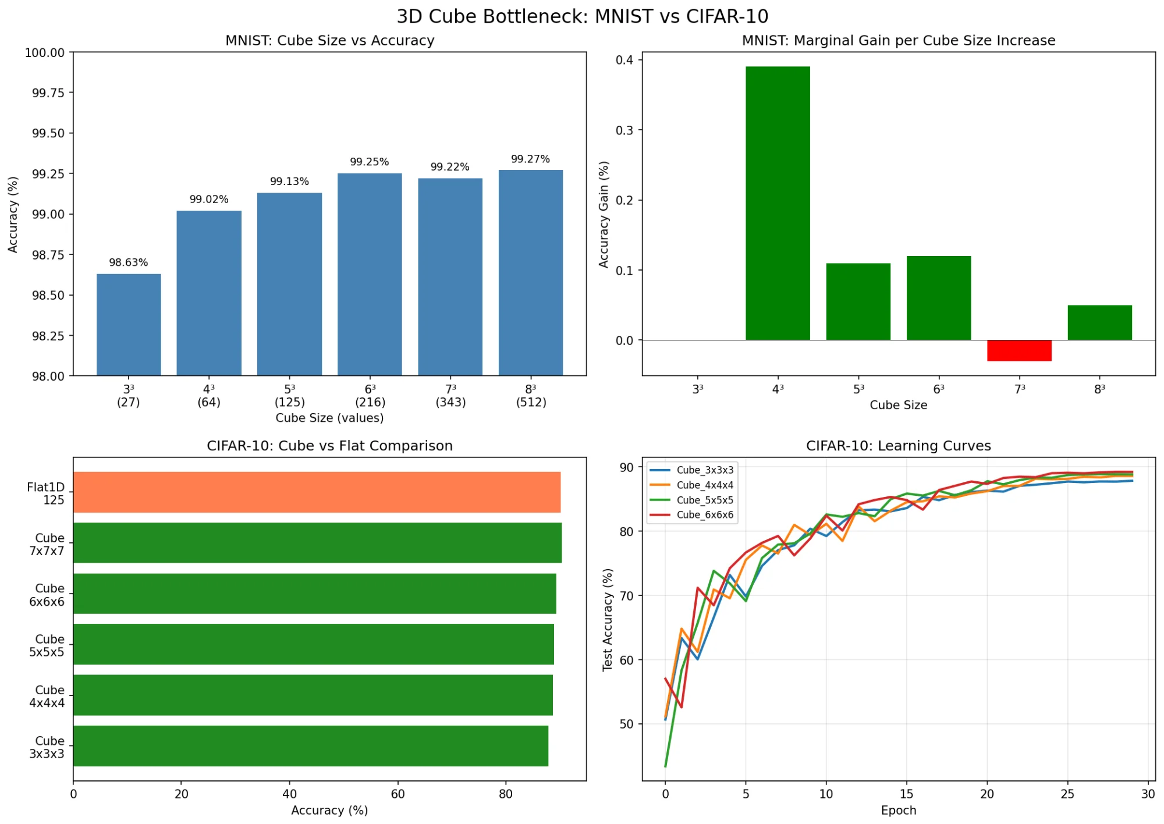
Figure 1: MNIST and CIFAR-10 cube experiment comparison

Part 5: Looking Inside The Network
One advantage of the cube approach is we can visualise what the network learned. This helps prove it's learning real features, not just memorising.

5.1 Each Digit Has a Unique Fingerprint
When we look at the cube representation for each digit, we see that each digit creates a different pattern — like a fingerprint:
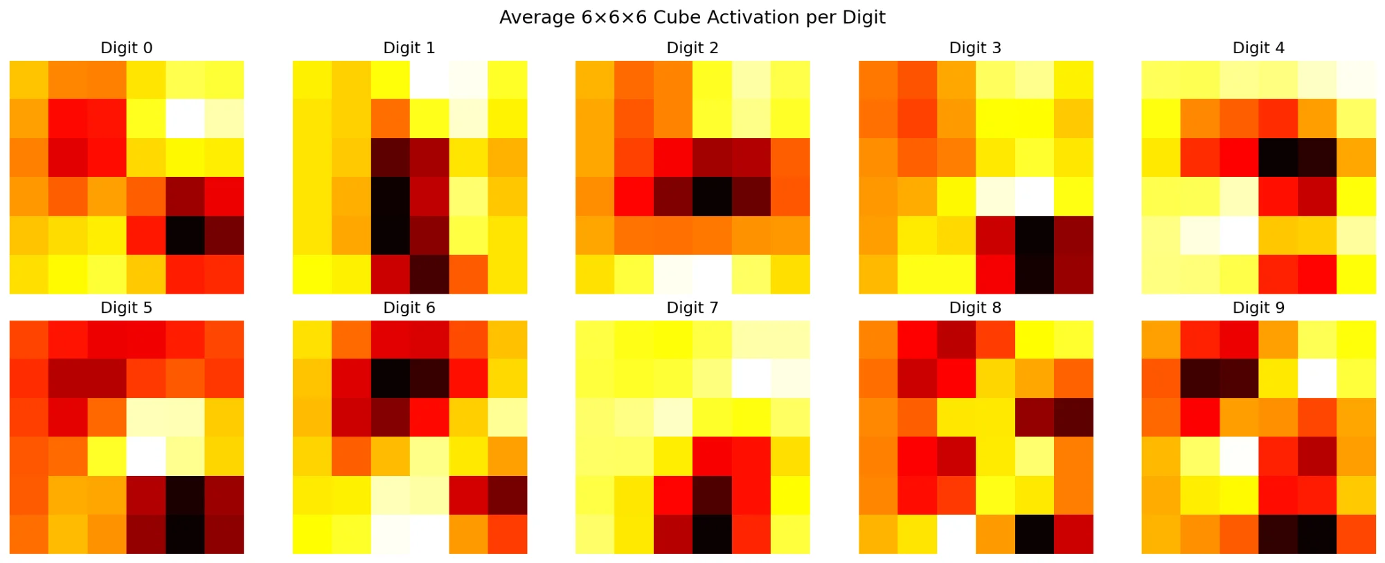
Figure 2: Average cube activation for each digit — each has a unique pattern
Digit 1: Strong vertical stripe (because 1 is a vertical line)
Digit 0: Activation around the edges (because 0 is a circle with a hole)
Digit 8: Dense activation in the centre (because 8 fills up space with two loops)
The network has learned to represent each digit in a sensible way that relates to its actual shape. It's not just memorising — it's genuinely understanding the structure of digits.

5.2 Which Parts of The Cube Matter Most?
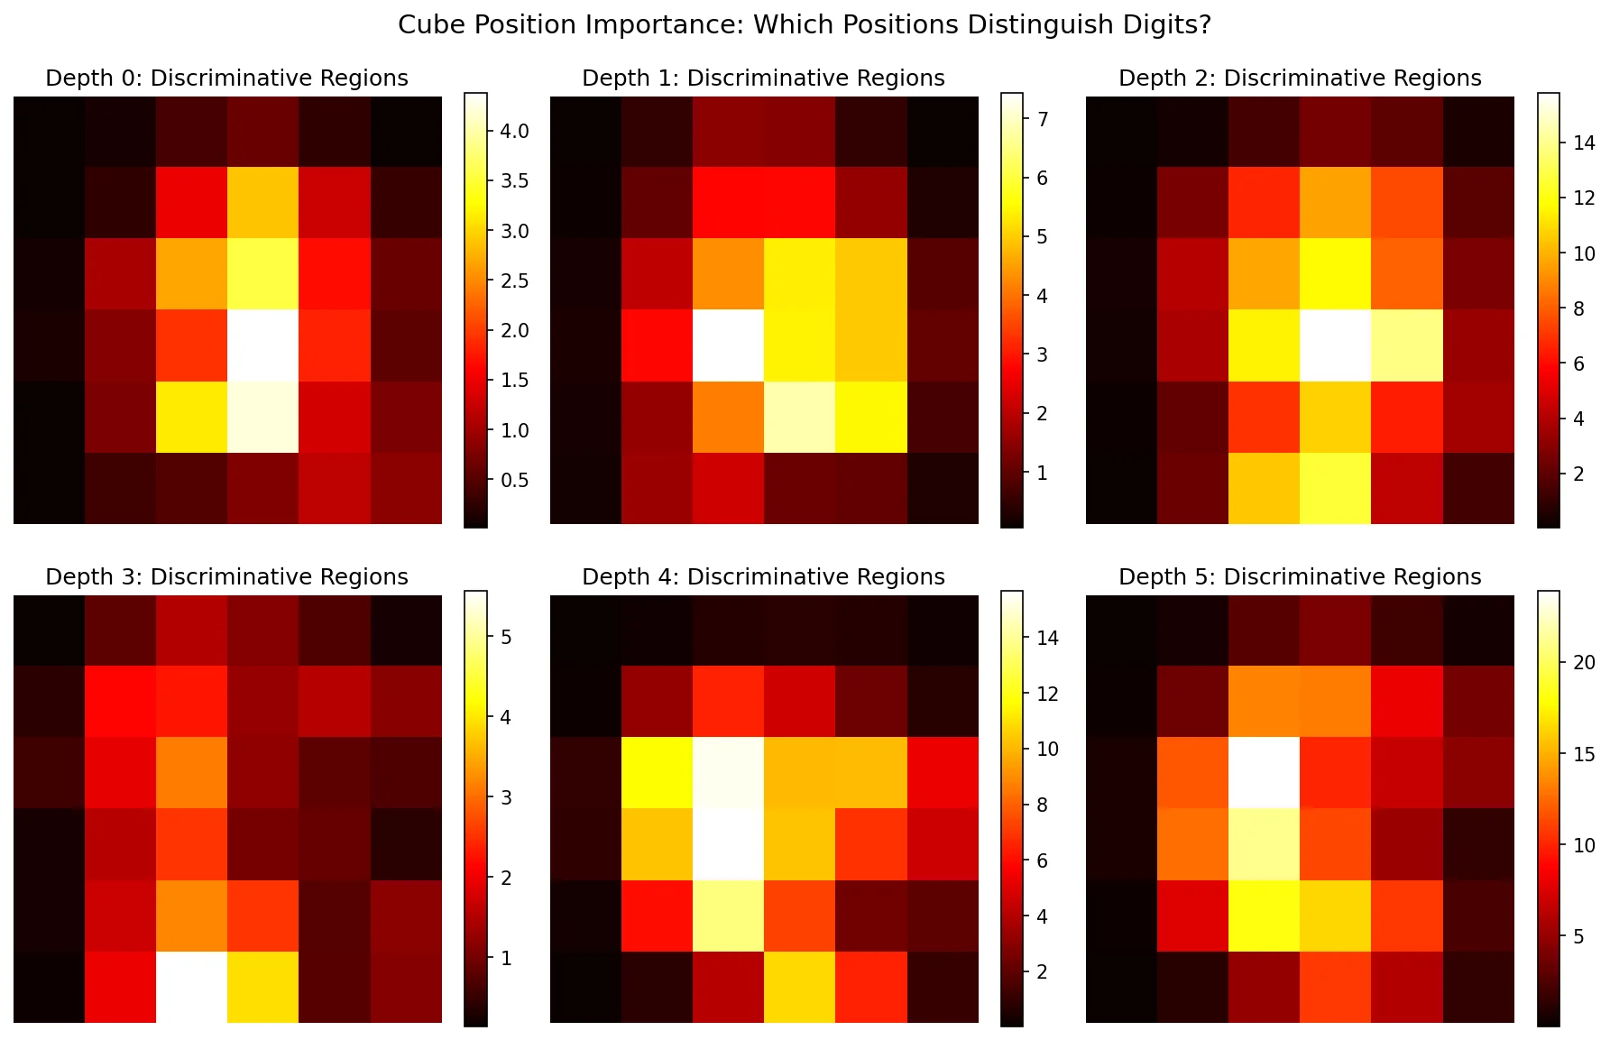
Figure 3: Brighter = more important for telling digits apart
Finding: The centre positions are most important (brightest), while the edges and corners matter less (darker). This makes sense because handwritten digits are usually centred in the image.

5.3 How Information Flows Through Layers
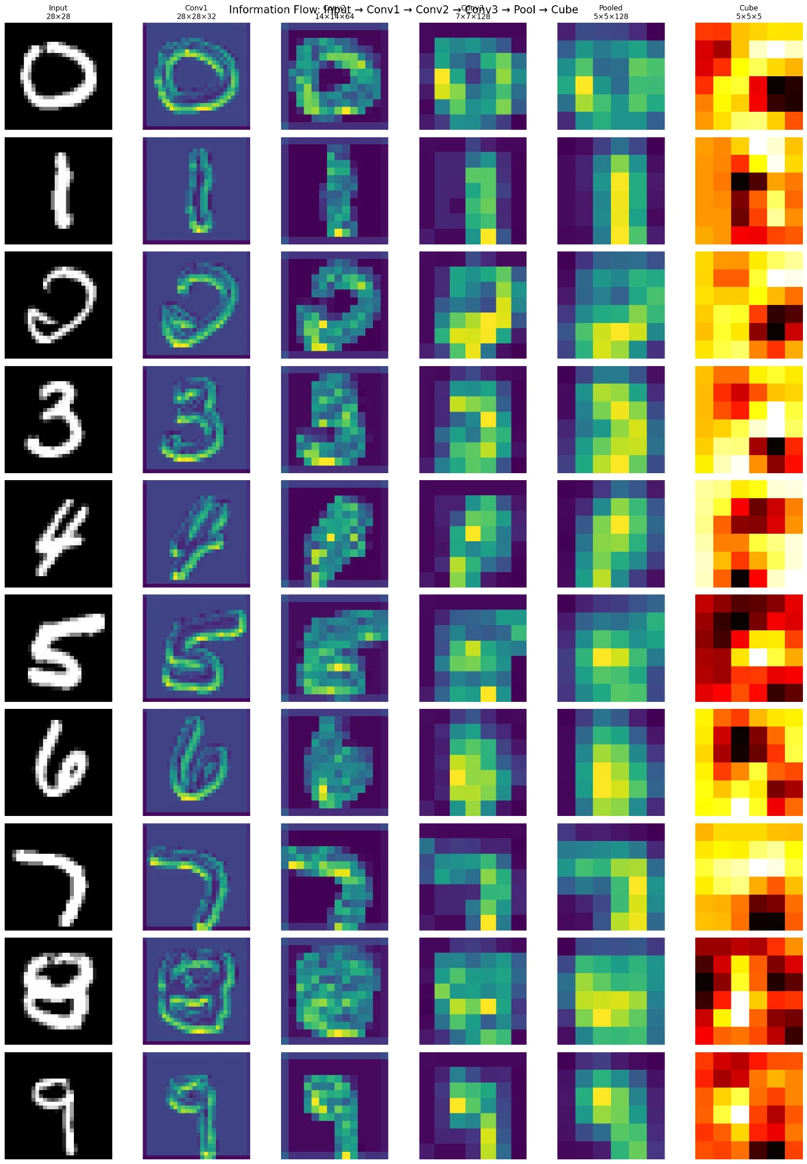
Figure 4: Transformation from input image (left) to cube representation (right)
The original digit (leftmost) starts as a clear black-and-white image. As it passes through the layers, it becomes more abstract (the coloured blobs in the middle). Finally, it becomes the heat-map pattern in the cube (rightmost).

5.4 The Ablation Test: Most Positions Are Redundant
I tested what happens when you remove each cube position one at a time. If removing a position makes accuracy drop a lot, that position is important.
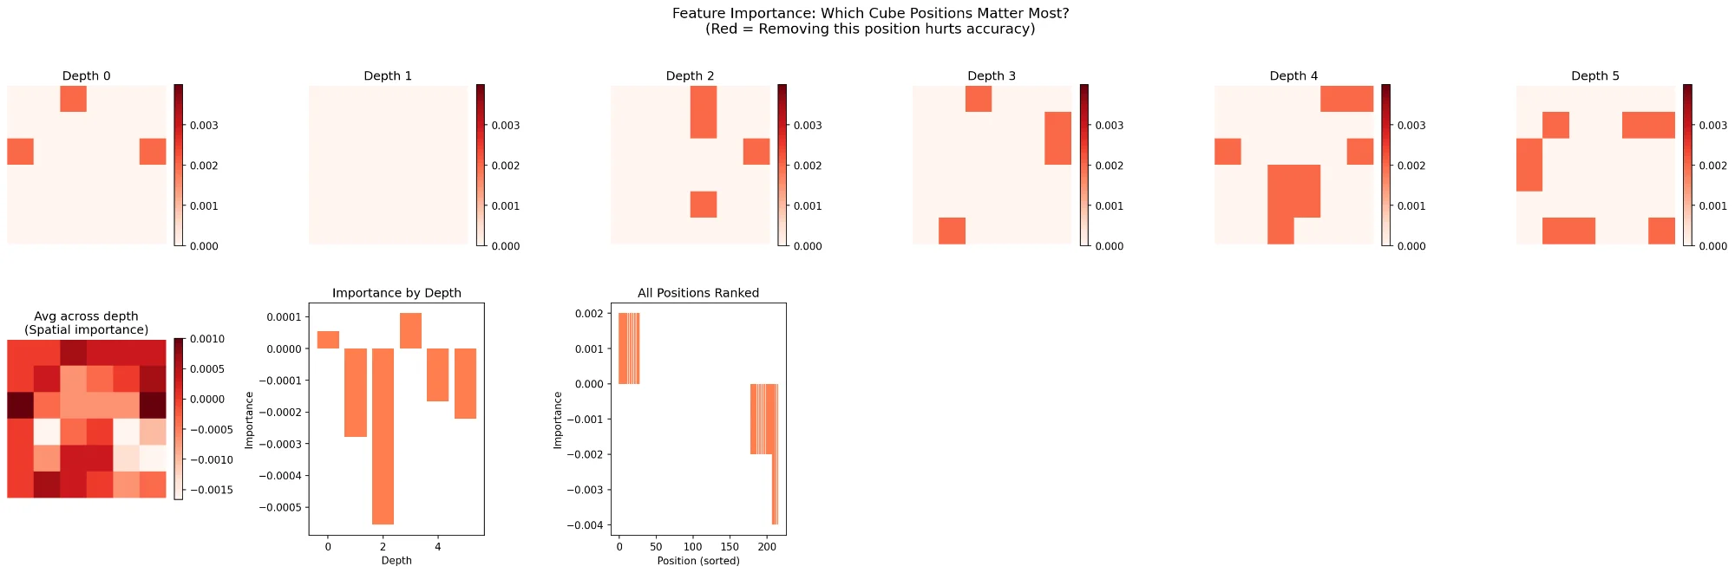
Figure 5: Most positions have near-zero importance
Surprising finding: Most positions have almost no impact when removed! Only about 10-20 positions out of 216 really matter. This means the cube has a lot of redundancy, and we could potentially make it even smaller.

5.5 Why Does the Network Make Mistakes?
No system is perfect. Our network makes mistakes about 0.75% of the time. But when we look at what it gets wrong, the mistakes actually make sense:
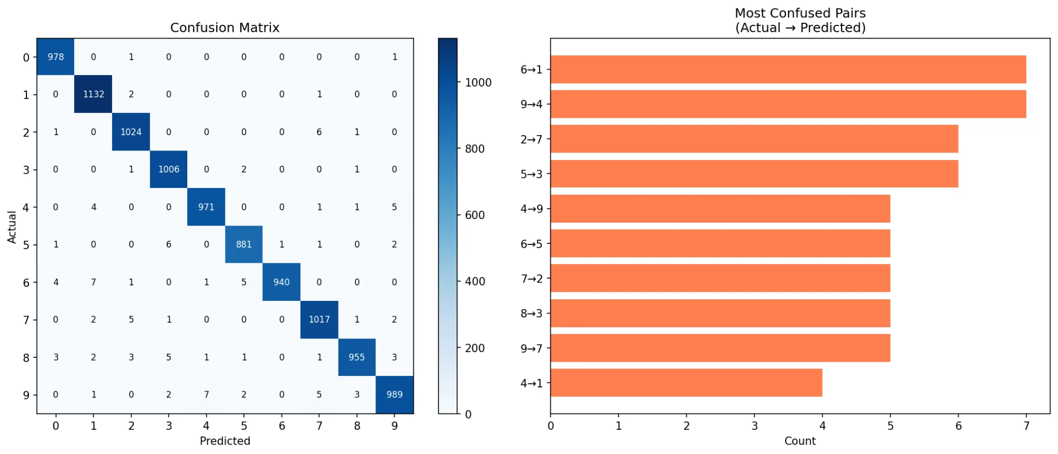
Figure 6: Most common mistakes are between visually similar digits

Why 6 Gets Confused With 1
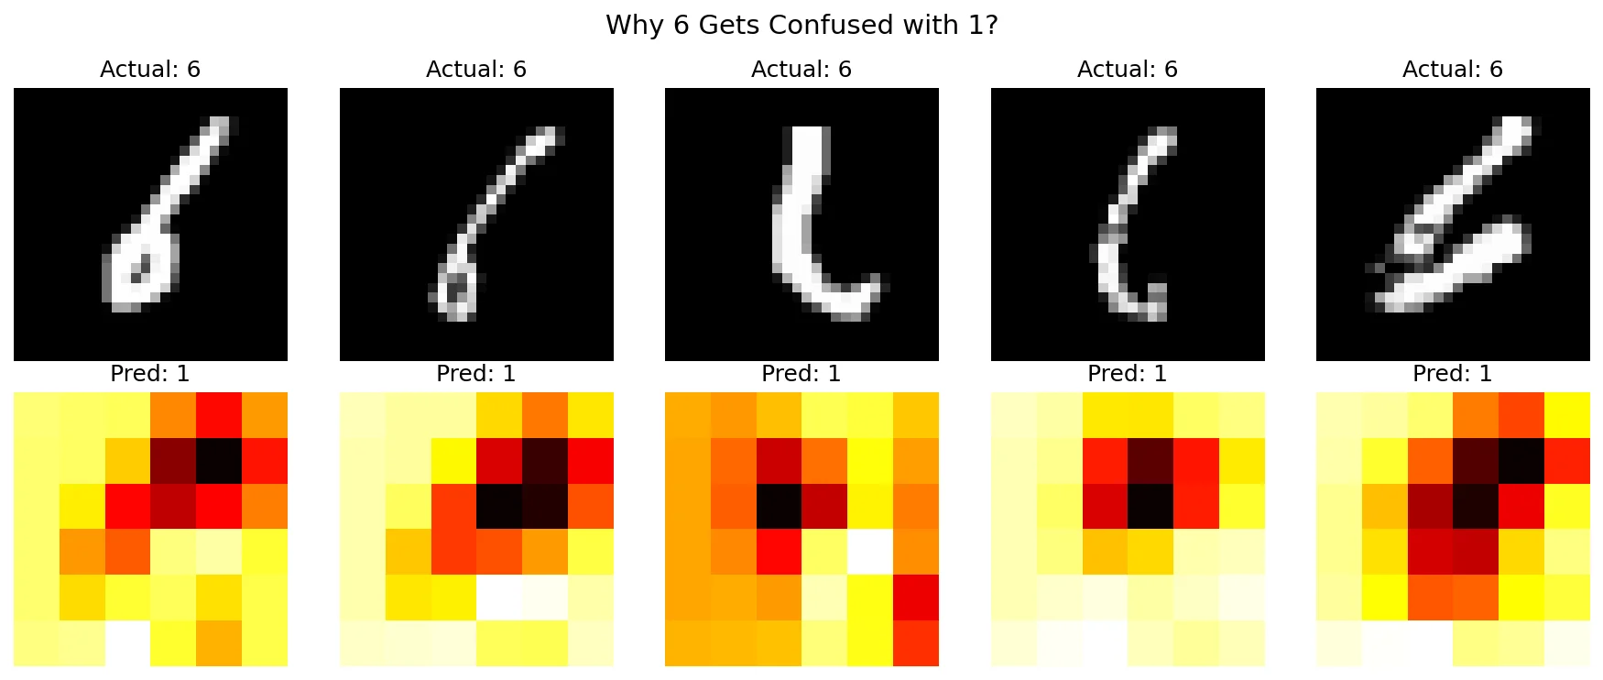
Figure 7: These "6" digits were misclassified as "1" — they're genuinely hard to read
Look at those "6" digits! They're written so poorly that the loop is either missing or tiny. Even a human would struggle to read them correctly. The network isn't making random mistakes — it's confused by genuinely ambiguous handwriting.
This is good news: it means the network is learning sensible features, not just memorising. It makes mistakes on hard cases, not easy ones.

Part 6: Proving The Results Are Valid

6.1 What is Overfitting?
Overfitting is when a network "memorises" the training data instead of learning general patterns. Imagine a student who memorises all the answers to practice tests but can't solve new problems. That's overfitting.
To check for overfitting, we compare accuracy on training data (seen before) vs test data (never seen). If the gap is large, the network is overfitting.

6.2 Our Results: No Overfitting
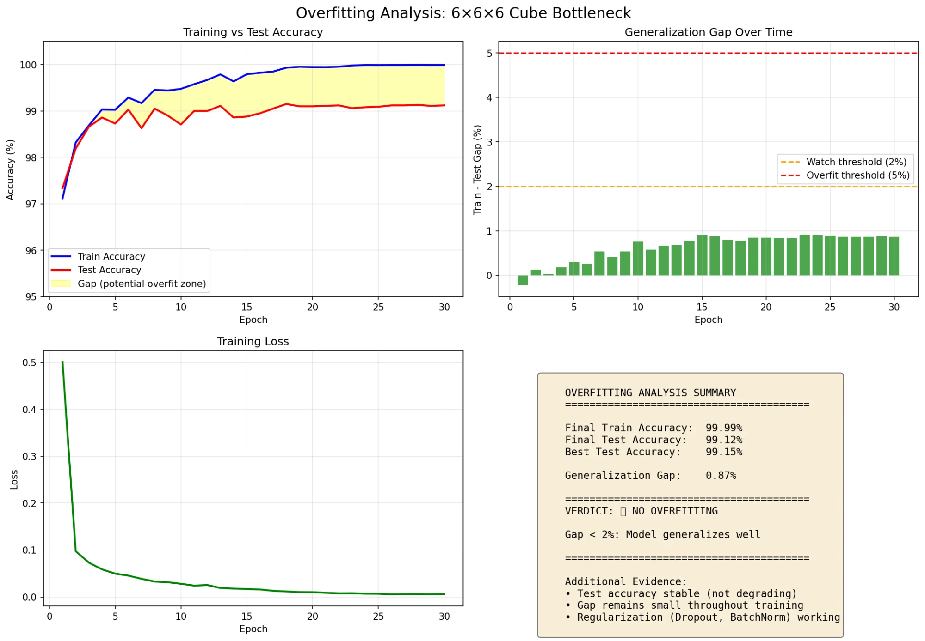
Figure 8: Overfitting analysis — gap stays below 2% threshold (all green)
Metric | Value
Training Accuracy (seen before) | 99.99%
Test Accuracy (never seen) | 99.12%
Gap | 0.87%
Verdict | ✅ NO OVERFITTING
A gap less than 2% is healthy. Our 0.87% gap confirms the model learned generalizable features and did not just memorise the training data.

Part 7: Conclusions

7.1 What I Learned
- Low-rank compression works: 80% parameter reduction with only 1.12% accuracy loss is achievable.
- 3D cubes beat flat compression: Preserving spatial structure with cube bottlenecks gives better accuracy with fewer parameters.
- Simpler is better: Adding complexity (attention, residual, learnable targets) hurt performance in every test.
- Optimal stages depend on complexity: MNIST needs 2 stages, CIFAR-10 needs 3 stages.
- Performance cliffs exist: Too many compression stages causes catastrophic failure (97% → 65%), not gradual decline.
- Standard techniques don't always transfer: What works in general deep learning may fail badly in compression contexts.
- Most cube positions are redundant: Only 10-20 of 216 positions really matter — potential for even more compression.
- Results are valid: 0.87% overfitting gap proves the network learned generalizable features.

7.2 Why This Matters
Compressed models enable deployment on resource-constrained devices:
- Mobile apps — smaller model = faster loading, less battery drain
- Edge devices and IoT — limited memory and compute power
- Browser-based inference — JavaScript model size limits
- Cost reduction — smaller models = cheaper cloud inference
- Environmental — less energy use per inference

7.3 Hardware Used
Component | Specification
GPU | NVIDIA GeForce RTX 4090 Laptop GPU
GPU Memory | 16 GB
Framework | PyTorch
Total Models Tested | 51 models
Batch Size | 1258-512
Optimizer | AdamW with weight decay
Learning Rate | 0.001

