SAGE: A Weight-Free Bounded Associative Memory for Continual, Gradient-Free Knowledge Storage
Ivelin Likov
Version 3 — 2026. A full revision that adds the appropriate non-parametric baselines, reframes the 3-D geometry as an addressing layer rather than the computational mechanism, and reports an honest negative on the relational-reasoning thesis. Supersedes the v1 preprints.

Abstract
Updating a neural system's knowledge usually requires retraining, which is costly and induces catastrophic forgetting, because knowledge is stored in weight matrices that cannot be edited locally. This paper presents SAGE, a weight-free, gradient-free associative memory: knowledge is stored as embedding vectors at fixed slots, retrieved by cosine similarity, and written by local Hebbian updates, with no backpropagation at any stage. SAGE supports continuous insertion without retraining and, because writes are local, does not catastrophically forget. We evaluate SAGE against the appropriate non-parametric baselines — nearest-class-mean (NCM), per-class k-means, and a bounded deduplicating vector store — not only against neural networks. The honest result: SAGE's no-forgetting property is real but shared with these simpler methods. On class-incremental MNIST it beats an SGD-trained network by a wide margin (86.2% vs 19.7% final accuracy) but a storage-matched per-class k-means matches or beats it (90.8%). Through a staged migration to a spherical substrate and a pre-registered go/no-go test, we further show that the 3-D geometry is an addressing and visualization layer rather than the computational mechanism (retrieval uses the full 768-D embedding), and that relational composition by graph traversal ties or loses to plain vector arithmetic. We situate SAGE precisely within the associative-memory literature and characterize its contribution as a transparent, weight-free instantiation of bounded continual associative memory for settings where backpropagation is unavailable or undesirable — not a new memory mechanism, and not a method that outperforms standard memories.
Keywords: associative memory; continual learning; catastrophic forgetting; gradient-free learning; Hebbian learning; non-parametric methods; modern Hopfield networks; vector symbolic architectures; honest negative results.

1. Introduction
Neural networks store knowledge in weight matrices. Adding new knowledge means further training, which is expensive and causes catastrophic forgetting: gradient updates that fit new data overwrite the parameters that encoded earlier data. A long line of work on associative and non-parametric memory addresses this by storing knowledge as retrievable items rather than as weights.
SAGE (Spatial Associative Geometric Embeddings) is one such system. It stores unit-norm embedding vectors at fixed grid points, retrieves by cosine similarity, and updates by local Hebbian rules with no backpropagation. Earlier versions of this work framed the central claim as “geometry computes; the weights are not needed”. This version corrects that framing. Following a full adversarial re-evaluation of every claim against strong classical baselines — with a code-review process that caught overclaims in both directions — we report what survives and what does not, with the appropriate baselines included throughout. The result is a more modest and more defensible contribution.
Contributions (v3, corrected). (1) A weight-free, gradient-free associative memory supporting retraining-free continuous insertion. (2) An honest continual-learning evaluation showing SAGE beats neural baselines on catastrophic forgetting but ties or loses to storage-matched non-parametric methods (Table 1, Table 2). (3) Evidence that the 3-D geometry is decorative: routing on coordinates collapses, while retrieval on the full embedding does not (Figure 2). (4) A pre-registered go/no-go test on relational composition that returns a negative, with three confirming kill-shots (Table 4). (5) A precise positioning of SAGE within the modern-Hopfield / fast-weight / palimpsest-memory literature. (6) A claim-by-claim reconciliation with the earlier preprints (Table 5).

2. The SAGE Memory
An encoder (nomic-embed-text, 768-D, unit-norm) maps an input to a vector. SAGE stores past vectors at fixed slots and answers a query by returning the stored item of highest cosine similarity. Writes are Hebbian: a new item either occupies a free slot or is merged into the nearest existing slot by an exponential-moving-average update, with a usage count and a slow decay (a palimpsest rule). No step uses gradients.
Retrieval is dense, not sparse. A query computes cosine similarity against all stored slots and takes the maximum; cost is O(Nd) per query for N slots of dimension d. Only one slot is the answer, but all are scanned. (Earlier “0.000% sparsity / infinite efficiency” phrasing was misleading and is withdrawn.)
The 3-D grid is an addressing layer. SAGE optionally projects items to a low-dimensional coordinate grid for inspection and partitioning. Retrieval similarity is always computed on the full 768-D payload, never on the 3-D coordinates. Section 5 shows the coordinates are not load-bearing.

3. Evaluation Protocol
We evaluate three claims separately: (i) continual storage without forgetting; (ii) whether the geometry carries computation; and (iii) whether relational composition can be done by traversal rather than arithmetic. For (ii) and (iii) we ran a staged migration of the substrate from a Cartesian cube to a Fibonacci sphere, with an explicit pass/fail gate at each stage and a pre-registered go/no-go decision at the composition stage. All embeddings are nomic-embed-text; continual-learning features are PCA-64 on 20,000 training and 4,000 test images. Every continual-learning result is the mean over seven task orderings (six random plus one adversarial) and is traceable to a released JSON file (see Data Availability).

4. Continual Learning: The Real, Shared Result
We test class-incremental learning: a model sees classes two at a time and is evaluated on all classes seen so far, with no replay of old raw data except where a method explicitly buffers it. We compare SAGE against an SGD-trained MLP, an experience-replay MLP, nearest-class-mean (NCM, one prototype per class), per-class k-means (NCM-multi, multiple prototypes per class at matched storage), and SAGE variants.
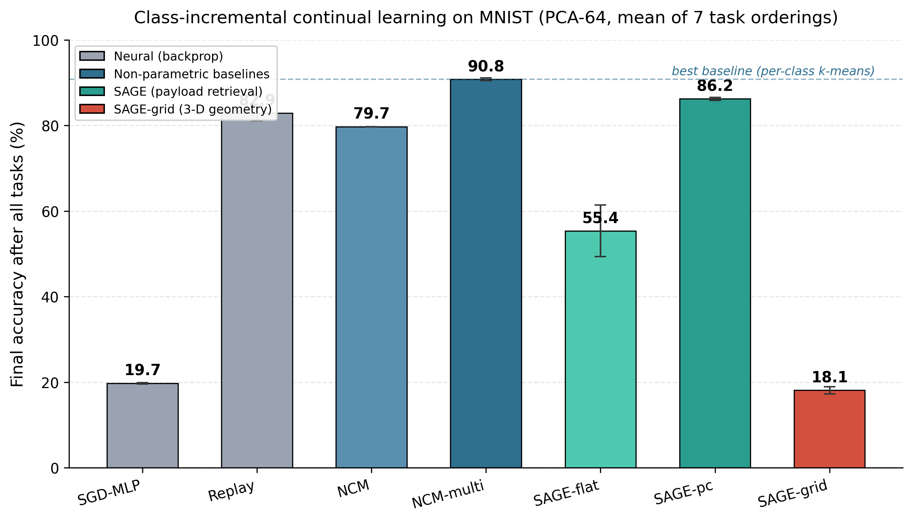
Figure 1. Final accuracy after all tasks on class-incremental MNIST (PCA-64), mean of seven orderings. SAGE-pc beats the neural baselines but sits below a storage-matched per-class k-means (dashed line). SAGE-grid, which routes on 3-D coordinates, collapses.
Method | digits final % | MNIST final % | MNIST task-0 % | Forgets?
SGD-MLP (neural) | 19.8 | 19.7 | 0.0 | yes (cliff)
Replay (neural + buffer) | 87.4 | 82.9 | 77.3 | partial
NCM (1 mean/class) | 87.0 | 79.7 | 79.2 | no
NCM-multi (per-class k-means) | — | 90.8 | 91.3 | no
SAGE-flat / SAGE-pc | 85.3 | 86.2 | 87.1 | no
SAGE-grid (3-D geometry) | 35.5 | 18.1 | 0.0 | collapses
Table 1. Continual-learning final accuracy (mean over seven orderings). NCM-multi was not run at digits scale (—). SAGE beats the neural baselines; a storage-matched per-class k-means matches or beats SAGE; the 3-D grid variant collapses.
Order robustness. Catastrophic forgetting is sensitive to task order, so we report all seven orderings (Table 2). SAGE-pc and the non-parametric baselines are order-robust (low standard deviation, and the adversarial ordering barely differs from the mean), whereas SGD collapses to chance under every ordering and SAGE-grid never recovers.
Method (MNIST) | mean % | std (7 orders) | adversarial order %
SGD-MLP | 19.7 | 0.15 | 19.5
Replay | 82.9 | 1.72 | 80.7
NCM | 79.7 | 0.00 | 79.7
NCM-multi | 90.8 | 0.30 | 90.6
SAGE-flat | 55.4 | 6.03 | 66.3
SAGE-pc | 86.2 | 0.38 | 85.7
SAGE-grid | 18.1 | 0.82 | 17.1
Table 2. Order robustness on MNIST. Low standard deviation and a near-unchanged adversarial-ordering accuracy indicate order-robustness; SAGE-pc and NCM-multi are robust, SGD and SAGE-grid are not. SAGE-flat's high variance reflects the slot-starvation failure discussed in the text.
Honest reading. Three facts hold simultaneously and we state all three. SAGE beats the neural baselines (SGD and Replay) on forgetting — the true headline. It ties NCM at digits scale and loses to a storage-matched per-class k-means on MNIST (86.2% vs 90.8%; per-item McNemar p ≈ 4×10⁻¹³; sign-test over seven orderings p = 0.016). The multi-prototype gain (NCM-multi over single-NCM, +11.1 points) is the source of the advantage, not SAGE's merge/decay mechanism — which, if anything, slightly hurts relative to plain per-class k-means. The SAGE-flat collapse to 55.4% on MNIST was traced by a slot census to a starvation bug (global count-based eviction starved later classes of slots); per-class slot pools (SAGE-pc) fix it. This arc was caught and corrected by code review, not assumed.
As a memory store. In a separate key-value agent-memory benchmark (500 keys, 4,000 writes, retrieval accuracy at a fixed slot budget), SAGE-flat ties a well-built bounded deduplicating vector store and beats naive FIFO usage at equal footprint (Table 3). The honest claim is “SAGE is a good bounded store,” not “SAGE beats vector stores.”
Budget | SAGE-flat % | DB-dedup % | DB-FIFO % | SAGE-grid %
128 | 25.6 | 26.0 | 22.8 | 7.0
256 | 51.2 | 51.4 | 40.8 | 7.6
500 | 100.0 | 100.0 | 63.2 | 7.8
1000 | 100.0 | 100.0 | 86.0 | 5.0
Table 3. Key-value memory retrieval accuracy at matched slot budget. SAGE-flat tracks the bounded dedup store almost exactly and beats FIFO; the 3-D grid variant (SAGE-grid) collapses, again showing the geometry is not load-bearing.

5. The Geometry Is an Addressing Layer, Not the Mechanism
The embeddings are unit-norm, so they live on a hypersphere; a Cartesian cube stores them in a box where coordinate distance is semantically inert while retrieval uses cosine. We migrated the substrate to a Fibonacci sphere, where geodesic, angular, and cosine distance coincide, expecting the coordinates to become meaningful. They did not become computational. Self-retrieval on the sphere is 100% (storage integrity holds by construction, since exact cosine ignores positions), but a diagnostic of how much the coordinates carry is decisive: positional routing recovers only 10.2% of exact-cosine recall@10, the top three principal components hold ~7.8% of variance, and 60.3% of items collide onto a shared grid point at the tested resolution.
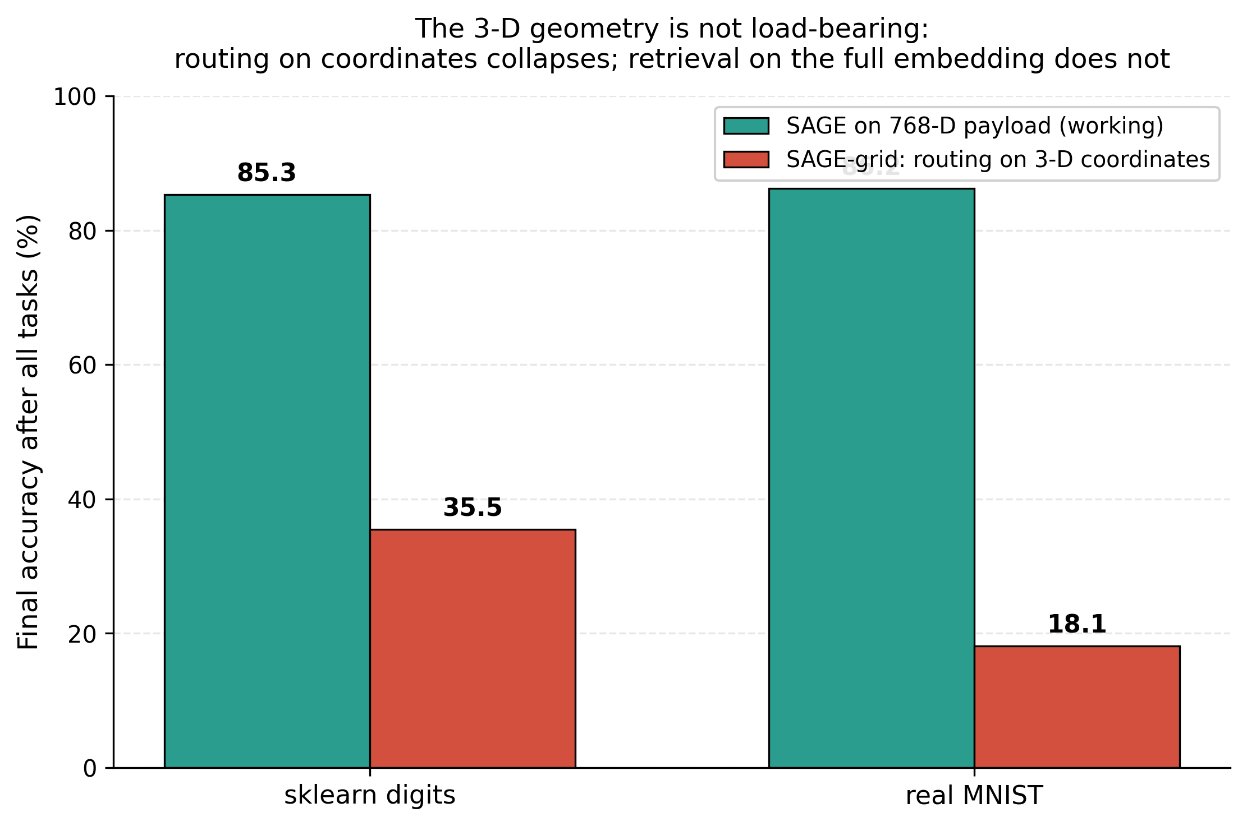
Figure 2. The same continual-learning task, run with SAGE retrieving on the full 768-D payload versus SAGE-grid routing on the 3-D coordinates. On both datasets the coordinate-routing variant collapses, confirming the geometry is not load-bearing.
When SAGE is forced to route on its 3-D coordinates (SAGE-grid), continual-learning accuracy collapses to 35.5% (digits) and 18.1% (MNIST), versus 85.3% and 86.2% for retrieval on the full embedding. The conclusion is unambiguous: the working path uses the 768-D payload; the 3-D geometry is an addressing and visualization convenience, not the computation.

6. Relational Composition: A Pre-Registered Negative
The original motivation for a geometric memory was that relational structure (king − man + woman ≈ queen) might be read off the substrate. Modern contextual embeddings are strongly anisotropic, which undermines this: across 3,000 words and ~10,000 random pairs, mean cosine similarity is 0.434 (an isotropic space would be near 0), confirming the cone structure that breaks linear analogy. Isotropy preprocessing (all-but-the-top, removing a single dominant direction) drops mean cosine to 0.048 — the anisotropy is essentially one rogue dimension — but does not restore analogy arithmetic.
The go/no-go test. On a 7,096-question analogy benchmark and a multi-hop composition set, we compared graph traversal over a Hebbian-built k-nearest-neighbour relation graph (the proposed fix) against plain vector arithmetic (the baseline). On single-step analogy the two are statistically indistinguishable (arithmetic 85.1% vs arithmetic-with-kNN 85.5% top-1). On multi-hop composition the result is a tie on the isotropic embeddings (both 55.6%; McNemar p = 1.0) and a loss on the raw embeddings (traversal 51.9% vs arithmetic 66.7%; McNemar p = 0.036). The pre-registered decision was go/no-go; the outcome is NO-GO. Graph traversal does not beat vector arithmetic, so the geometric-reasoning thesis is not supported.
Test | Strongest classical baseline vs SAGE arm | Verdict
Stage 4 traversal | kNN-relation traversal vs vector arithmetic (multi-hop): tie on isotropic (p=1.0), loss on raw (p=0.036) | NO-GO
A: noisy bind-chain | kNN lookup table ≥ vector-symbolic binding at every noise level and hop count | falsified
B: fixed-footprint superposition | hash-vote store 88% vs VSA 7–13% at the tightest byte budget | falsified
C: relation discovery | SAGE relation bank ARI 0.512 vs online spherical k-means 0.544 vs agglomerative 0.576 (CI straddles 0) | falsified
Table 4. The reasoning thesis under adversarial test. Every arm claimed as a structural win ties or loses to a standard method at equal resources. “VSA” = vector symbolic architecture; “ARI” = adjusted Rand index; CI = bootstrap confidence interval over 15 seeds.

7. Positioning in the Associative-Memory Literature
SAGE is best understood as a member of the bounded online associative-memory family. Its retrieval (cosine plus softmax over stored vectors) is the modern-Hopfield / attention operation [1]; its merge-on-write update is a hard form of the delta-rule fast-weight write [2]; and its slot decay corresponds to palimpsest forgetting in Hopfield memories [3]. At equal memory budget, a dense modern-Hopfield layer has far higher capacity than SAGE's one-vector-per-slot scheme, and stored memories are provably optimal when they form a spherical code [4] — which a Fibonacci lattice only approximates. The anisotropy that defeats analogy arithmetic is a documented property of contextual embeddings [5,6]. SAGE therefore introduces no new retrieval mechanism. Its value is as a transparent, weight-free, gradient-free instantiation of bounded continual associative memory, with directly inspectable slots, for regimes where backpropagation is unavailable or undesirable (edge, neuromorphic, streaming).

8. Conclusion
SAGE is a clean, weight-free, gradient-free instantiation of bounded continual associative memory. It avoids catastrophic forgetting and supports retraining-free updates — properties it shares with, and does not exceed, simple non-parametric methods such as NCM and per-class k-means. Its 3-D geometry is an addressing and visualization layer, not the computational mechanism, and relational composition by traversal does not beat vector arithmetic. The contribution is a transparent realization and an honest characterization, together with a falsification arc — supported by a code-review process that caught overclaims in both directions — that delineates exactly where a geometric memory does and does not help. We offer this as the appropriate scientific record, superseding the earlier preprints.

Appendix A. Reconciliation with the v1 Preprints
v1 claim | Problem identified | v3 wording
“The geometry computes; weights not needed” | Geometry is decoration; cosine over 768-D does the work | “The 3-D grid is an addressing/viz layer; retrieval is cosine over the full embedding”
“Forgets 92% less than neural nets” | True vs an MLP, but NCM/k-means also don't forget — and beat SAGE | Keep the number; add that this is shared by, and bettered by, NCM/k-means
“0.000% sparsity / infinite efficiency” | Retrieval scans all slots; dense O(Nd) | Removed; “only one slot is the answer, but retrieval is dense”
“100% rollout accuracy” | Achieved by an explicit dictionary | “Rollout is exact because transitions use a dictionary; geometry is the index only”
“58.3% analogy, closes 62% of the gap” | This is the embedding's own a−b+c arithmetic | “Analogy is standard vector arithmetic; SAGE inherits and can only degrade it”
“MultiCube: novel horizontal scaling” | Standard index sharding / IVF clustering | “MultiCube partitions the index by domain — a standard sharding strategy”
Table 5. Claim-by-claim reconciliation. Each v1 statement is paired with the problem found during re-evaluation and the corrected v3 wording.

Data and Code Availability
All experiments, result files (JSON), and figure-generation scripts are available at the project repository (https://github.com/Ivelin2022/sage). Every numeric value in this paper is traceable to a released result file: continual-learning results to forgetting_benchmark.json (sklearn digits) and forgetting_benchmark_mnist.json (MNIST); the substrate and reasoning results to the stage0–stage4 JSON files; the kill-shots to killshot_a/b/c.json; and the memory-store results to agent_memory.json.

Acknowledgements
The author used Claude (Anthropic) as an AI research assistant throughout this work, including architecture design, code implementation, experiment planning, adversarial re-evaluation, and manuscript preparation. All research decisions, results, and claims are the sole responsibility of the author.

References
[1] Ramsauer, H., Schäfl, B., Lehner, J., et al. (2021). Hopfield Networks is All You Need. International Conference on Learning Representations (ICLR).
[2] Schlag, I., Irie, K., & Schmidhuber, J. (2021). Linear Transformers Are Secretly Fast Weight Programmers. International Conference on Machine Learning (ICML).
[3] Storkey, A. J., & Valabregue, R. (1999). The basins of attraction of a new Hopfield learning rule. Neural Networks, 12(6), 869–876.
[4] Hu, J. Y.-C., Wu, D., & Liu, H. (2024). Provably Optimal Memory Capacity for Modern Hopfield Models: Transformer-Compatible Dense Associative Memories as Spherical Codes. Advances in Neural Information Processing Systems (NeurIPS).
[5] Ethayarajh, K. (2019). How Contextual are Contextualized Word Representations? Comparing the Geometry of BERT, ELMo, and GPT-2 Embeddings. EMNLP-IJCNLP.
[6] Mu, J., & Viswanath, P. (2018). All-but-the-Top: Simple and Effective Postprocessing for Word Representations. International Conference on Learning Representations (ICLR).
[7] Lewis, P., Perez, E., Piktus, A., et al. (2020). Retrieval-Augmented Generation for Knowledge-Intensive NLP Tasks. Advances in Neural Information Processing Systems (NeurIPS).

