Swift Academy – Homework #2

Send html/css files with all additional resources (if necessary) to address: [dimitrov.webmaster@gmail.com](mailto:dimitrov.webmaster@gmail.com) before 06.03.2016 18:30:00.

For subject type: [SWIFT][HW2] – CSS homework

Ex.1 Create your own CV using HTML and CSS for styling. Inline styling is forbidden. HTML tables are forbidden (use: div, p, span, ul, li, etc – html elements) and css properties and attributes.

Ex2. Create pretty register form (you can user your exercise 5 from previous homework). Make input filed looks nice.

Ex3. Write HTML and CSS page like the following:

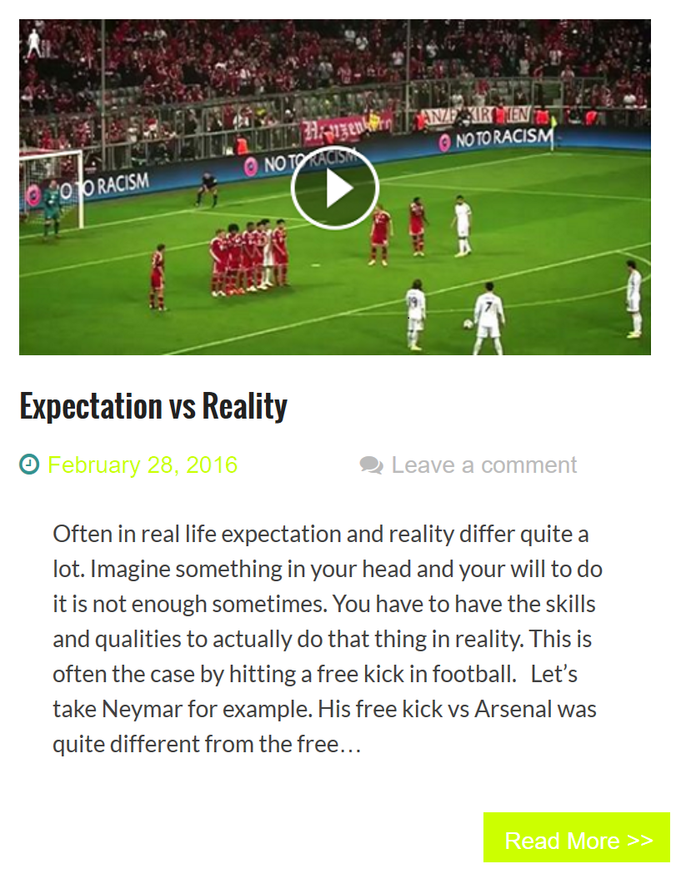

You can are any image, do not try to include video in the web page.

Ex4. Fix files in “files” directory to become just like image below:

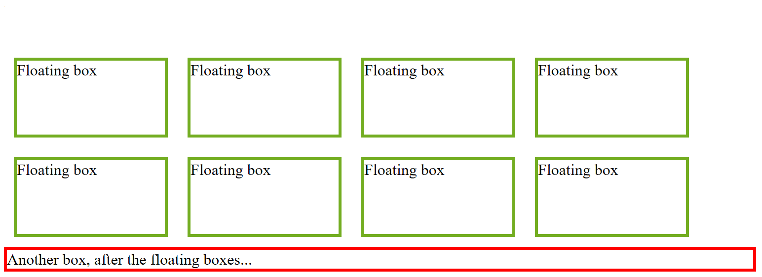

Ex5. Create menu like on the screenshot below:

