Save all of the executed queries! (CTRL+S)  
  
1. Create new table- Persons

**CREATE** **TABLE** **IF** **NOT** **EXISTS** persons (

id **INT** **AUTO_INCREMENT** **PRIMARY** **KEY**,

firstname **VARCHAR**(255),

lastname **VARCHAR**(255),

gender **VARCHAR**(10),

jobtitle **VARCHAR**(255),

department **VARCHAR**(255),

room **VARCHAR**(10),

phoneextension **VARCHAR**(10),

supervisor **VARCHAR**(10)

);

2. Right click on the Database and then select ‘New query’.  
  
  
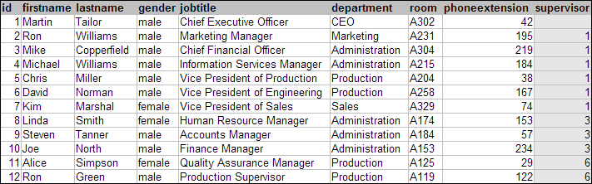  
  
3. Add records to the tables.

**INSERT** **INTO** persons **VALUES** ('2','Martin', 'Tailor','male', 'Chief Executive Officer', 'CEO', 'A302','42','1');

4. Add new column to some of the table.  
5. Delete a column from some of the tables.  
6. Create a simple table and DROP it.  
7. Select first 2 records from one of the tables (using two approaches).  
  
За **домашно** изпълнете следните заявки и ги изпратете до мен като email.  
  
1. Заявка, която да ни покаже само записите за служители, които работят в Administration.

**select** * **from** persons

**where** department = 'Administration'

2. Заявка, която да покаже само служители, които са жени.

**select** * **from** persons

**where** gender = 'female'

3 Заявка, която да преброи колко мъже работят във фирмата.

**SELECT** **COUNT**(gender)

**FROM** persons

**where** gender = 'male'

4. Заявка, която да подреди служителите по първо име в реда от Z до A.

**SELECT** *

**from** persons

**order** **by** firstname **desc**

5. Заявка с която да се промени стаята на 'Sales' от 'А329' на 'A234'.

**UPDATE** persons

**set** room = 'A234'

**where** department = 'sales'

6. Завка, с която да се премахне от базата данни Chris MiLler, тъй като вече не работи във фирмата.

**DELETE** **from** persons

**where** id = '5'

7. Заявка, която да създаде нова таблица на име *Supervisors*с три колони - ID, SupervisorName, StartDate (тук трябва да помислите какви стойности ще се съхраняват в колоните и да изберете подходящите типове данни за тях).

**CREATE** **TABLE** **IF** **NOT** **EXISTS** supervisors (

id **INT** **AUTO_INCREMENT** **PRIMARY** **KEY**,

SupervisorName **VARCHAR**(255),

StartDate **DATE**

);

8. Добавете два нови записа в таблица Supervisors.

**INSERT** **INTO** supervisors **VALUES** ('6', 'Bob Dilan', '2020-10-14');

**INSERT** **INTO** supervisors **VALUES** ('3', 'Nina Secret', '2019-04-26');

**INSERT** **INTO** supervisors **VALUES** ('1', 'Beth Nicols', '2022-09-19');

Може да използвате за помощ <https://www.w3schools.com/sql/default.asp>  
  
  
Допълнителна информация:  
  
**Microsoft SQL Server** is a relational database management system developed by Microsoft. As a database server, it is a software product with the primary function of storing and retrieving data as requested by other software applications—which may run either on the same computer or on another computer across a network.  
 **SQL Server Management Studio** is a software application first launched with Microsoft SQL Server 2005 that is used for configuring, managing, and administering all components within Microsoft SQL Server.  
  
---  
Read more:

https://ssl.gstatic.com/ui/v1/icons/mail/images/cleardot.gif**Oracle Database** is a proprietary multi-model database management system produced and marketed by Oracle Corporation. It is a database commonly used for running online transaction processing, data warehousing and mixed database workloads.  
  
  
**Oracle SQL Developer** is an Integrated development environment for working with SQL in Oracle databases. Oracle Corporation provides this product free; it uses the Java Development Kit.

**Interesting articles:**  
  
<https://database.guide/microsoft-access-vs-sql-server/>  
  
<https://www.sqlshack.com/sql-server-code-review-checklist-for-developers/>  
  
<https://code.tutsplus.com/tutorials/10-essential-sql-tips-for-developers--net-5274>