**Title:** Some items have incorrect discount

**User system role(s)**:  
regular user

**Environment**: production environment

**The affected application you were using**: https://obuvki.bg/

**Steps to reproduce**:  
***Given*** I load the site https://obuvki.bg/  
***When*** I search for item “Часовник Style Code One AOSY22027 Silver Stainless Steel”  
***And*** select one of them

***Then*** I see the item with higher price

**Expected Result**: I should be able to see the item with correct discount

**Notes**: [BUGS-1](https://iv987.atlassian.net/browse/BUGS-1)

**Added screen shots at the bottom**

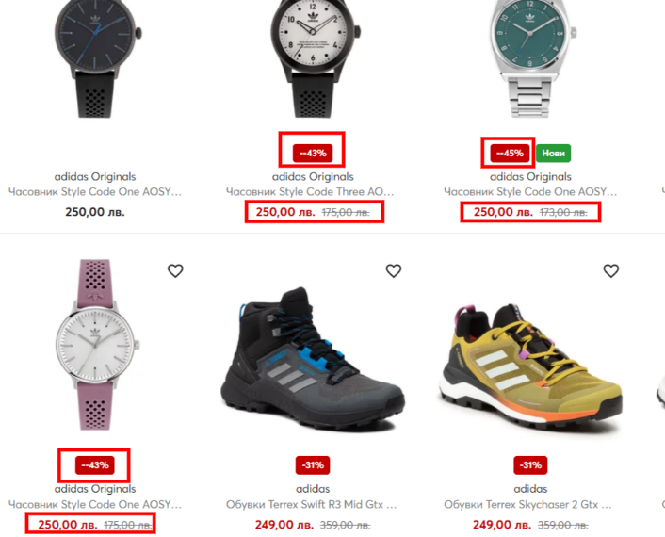 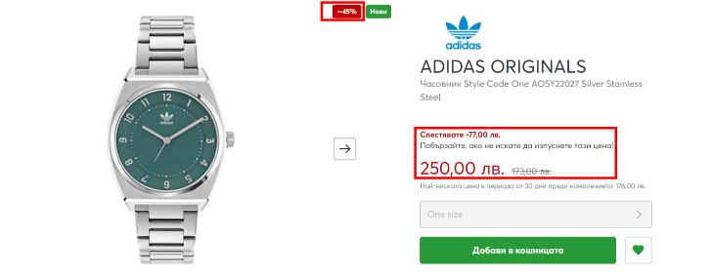

**Impacted company(ies)/country(ies) (***if applicable***)**: Bulgaria

**Is it a blocker or there is a workaround**: No

**How often does this happen (***select with X***)**:

* [ ] every time
* [ ] from time to time ( more than 50-90% of the time)
* [x] rarely ( less than 1-50% of the time )
* [ ] once