**Title:** Redirection of the shops is wrong

**User system role(s)**: regular user

**Environment**: production environment

**The affected application you were using**: https://paradise-center.com/

**Steps to reproduce**:  
***Given*** I am on the site https://paradise-center.com/bg/shops/100-grama-sladki_i1  
***When*** I open the page for the shop “100 GRAMA SLADKI”

***And*** I click on the link of the shop

***Then*** I am redirected to wrong site <https://paradise-center.com/bg/shops/www.100gr-sladki.com>

***And*** I see error page "404 Not Found"

**Expected Result**: I should be redirected to the page of the “100 GRAMA SLADKI” shop

**Notes:** [**BUGS-2**](https://iv987.atlassian.net/browse/BUGS-2)

**Attachments**:

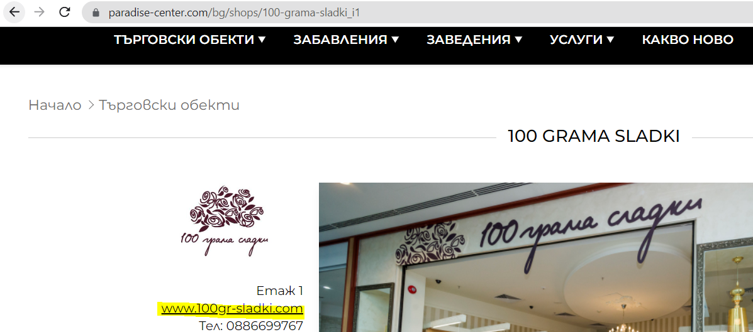  
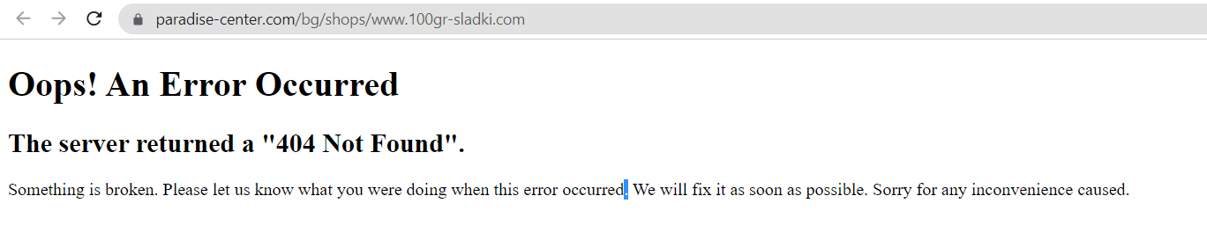

**Impacted company(ies)/country(ies) (***if applicable***)**: Bulgaria

**Is it a blocker or there is a workaround**: Blocker; **Workaround:** I can openthe page of the “100 GRAMA SLADKI” shop in another page tab by entering the link https://100gramasladki.com/

**How often does this happen (***select with X***)**:

* [x] every time
* [ ] from time to time ( more than 50-90% of the time)
* [ ] rarely ( less than 1-50% of the time )
* [ ] once