**Johanna Aubrey Q. Arceo IV – ACSAD**

**Elective 4 Christian Michael Mansueto**

**Objective:**

This assignment aims to familiarize students with GitHub, its fundamental features, and its role in version control and collaboration in software development. By the end of this assignment, students should be able to create repositories, use GitHub to manage project files, and understand basic version control concepts.  
  
**Instructions:**

1. **Reading Material:**
   * Review the official GitHub Documentation to understand GitHub basics.
   * Watch introductory videos or tutorials on GitHub and Git from platforms like YouTube, Udemy, or Coursera.
   * Study examples of real-world open-source projects hosted on GitHub.
2. **Assignment Tasks:**

**Task 1: Introduction to Git and GitHub**

* Explain what Git is and how it differs from GitHub.
* Describe the purpose of version control in software development.
* Briefly explain the basic concepts of Git (e.g., repositories, commits, branches, pull requests, and merging).

**Task 2: Setting Up GitHub**

* Create a GitHub account if you don’t already have one.
* Install Git on your local machine (if it’s not already installed) and configure it with your GitHub account.

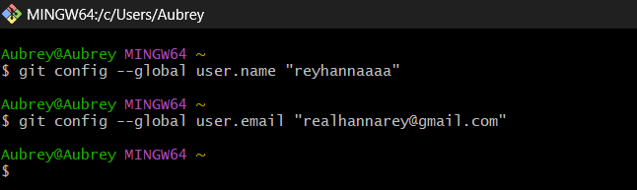

* Take a screenshot of your GitHub profile page and include it in your submission.

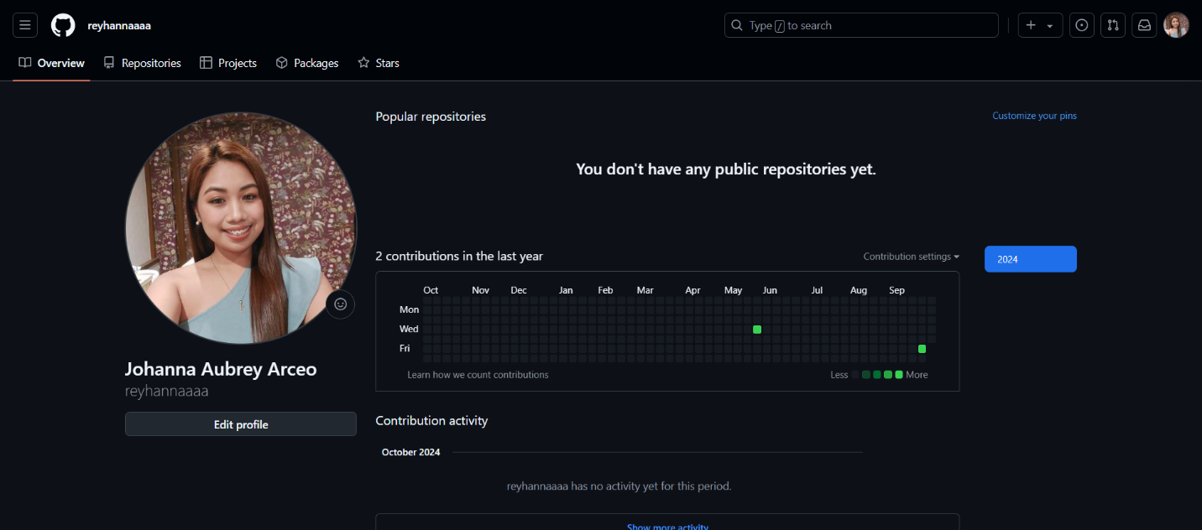

**Task 3: Creating and Managing a Repository**

* Create a new GitHub repository. Name the repository appropriately (e.g., "Intro-to-GitHub").
* Write a short README.md file describing the purpose of the repository.
* Upload at least three files (e.g., code files, documents, images) to the repository.
* Take screenshots showing the repository creation process, file uploads, and the final repository page.

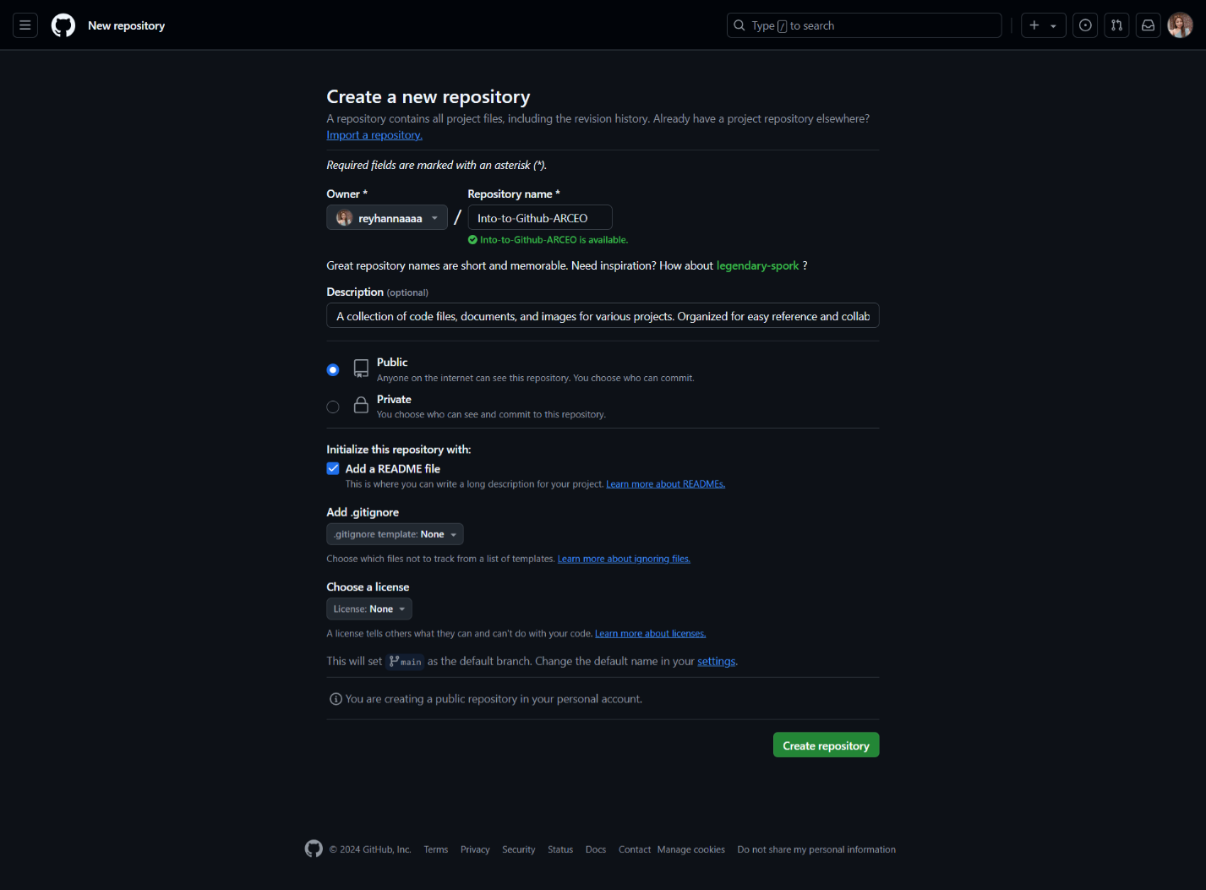

**Task 4: Using Git Locally with GitHub**

* Clone your GitHub repository to your local machine using Git.
* Make changes to the files in your local repository and commit the changes.
* Push the changes from your local repository back to the GitHub repository.
* Include a screenshot of the terminal/command prompt showing the clone, commit, and push commands, as well as the updated GitHub repository.