Exercise 2

Name: Patalinghug Iverson Kobe D. Date: 3/1/23

Requirements:

Storage: 50 GB

2 logical partitions: Disk 0: 30GB

Disk 1: 20GB

Memory: 4GB

OS: Ubuntu 22.10 64bit

User accounts: (Create two user accounts) The first account is for you with your complete details and the 2nd account is for a guest user.

Install Ubuntu OS (guide on another file) and answer/complete the following questions:

1. What is the purpose of the Ubuntu installer's "Try Ubuntu" option?

- The goal of the "try ubuntu" option is to allow the user to test out the Linux distribution on their device. Without having to install the OS on their system, the user may use a bootable device to test the distro to see whether it works well with their device and if it is to their satisfaction. But using try ubuntu will not save what changes you had made when you restart it.

2. How can you partition a hard disk during the Ubuntu OS installation process?

- I create partition during the installation by clicking something else during the installation type. After that is I just click the new partition tab and press continue, next is that I just point the free space and create efi partion with the size of 500mb, / partition with the size 30gb and home partition with the size of 20gb.

3. How can you install additional software packages after Ubuntu OS installation?

I can add new software packages through Ubuntu using their built-in "Ubuntu software," or I may surf the web for particular software packages based on my needs, with the majority of it being installed through terminal using the code given for the software package. The internet would be required since it would be downloaded through it and "sudo" would be used to install items that require administrator rights.

4. Screenshot of the login screen with the two user accounts

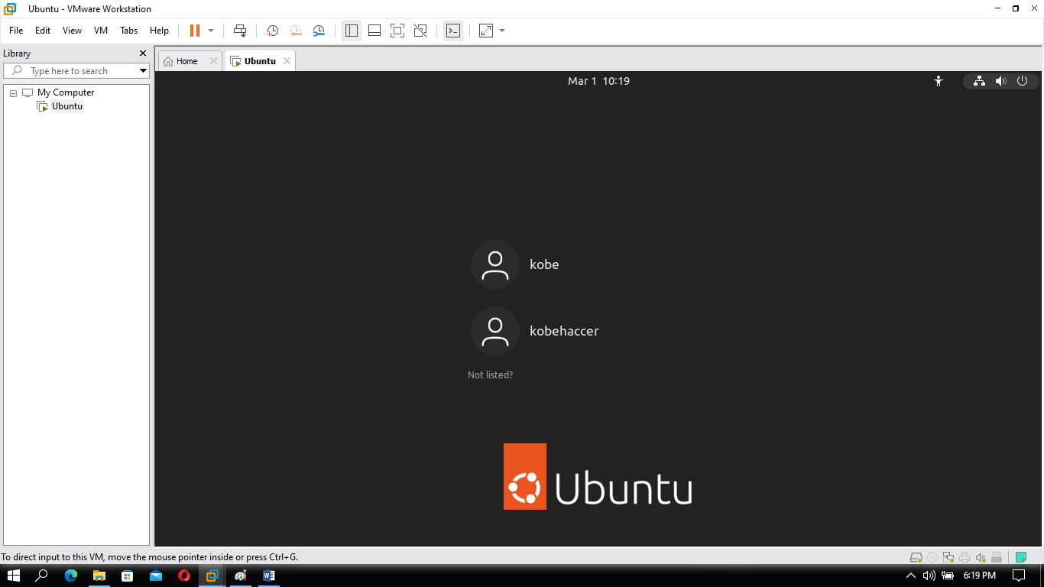

5. Screenshot of the logical drives

